**Máster Universitario en Big Data y Ciencia de Datos**

**ASIGNATURA: 05MBID *Minería de datos***

*Actividad 1 – Tareas portafolio*

Alumno: **Bru Montes, Israel**

Edición **Octubre 2024 – Grupo A** a 8/11/2024

# Tareas

1.- Crear una base de datos MongoDB en la nube usando MongoDB Atlas (https://www.mongodb.com/)

Nos vamos a descargar el GUI compass para poder administrar la base de datos desde una aplicación de escritorio, para ello cogemos la url de conexión y cambiamos el parámetro <password>

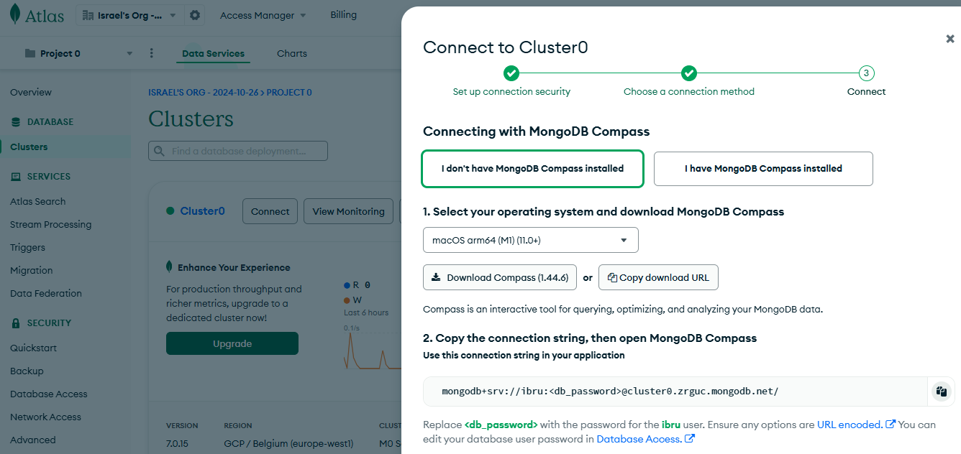

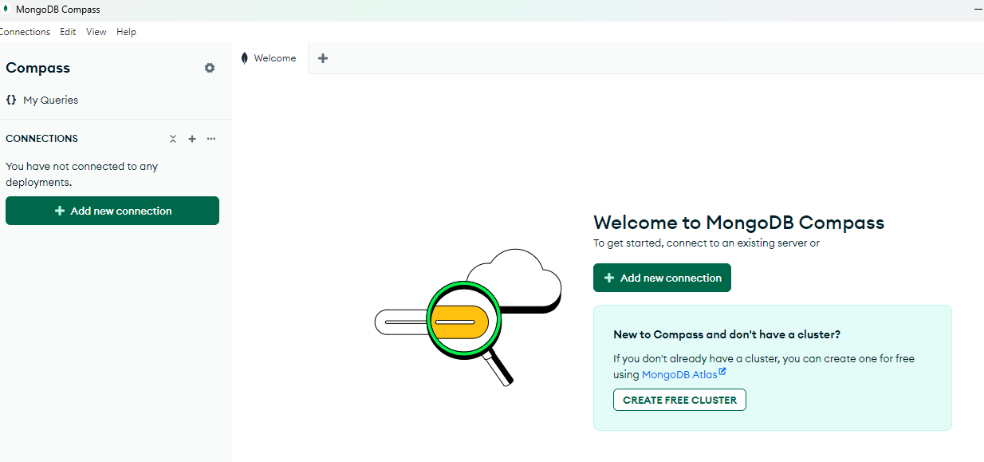

Pulsamos sobre “add new connection”

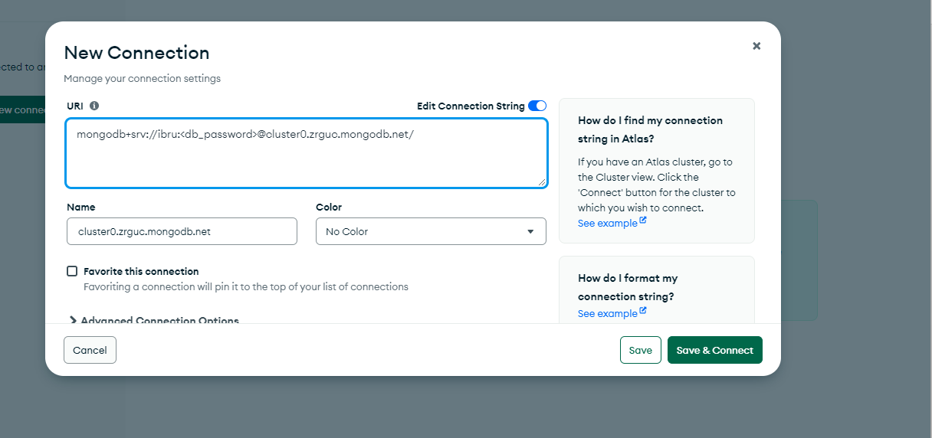

A través del botón “+”

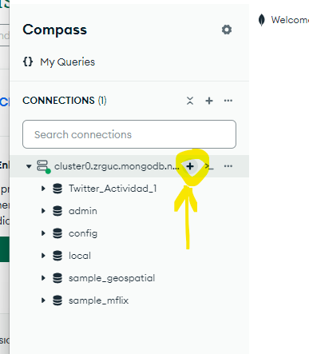

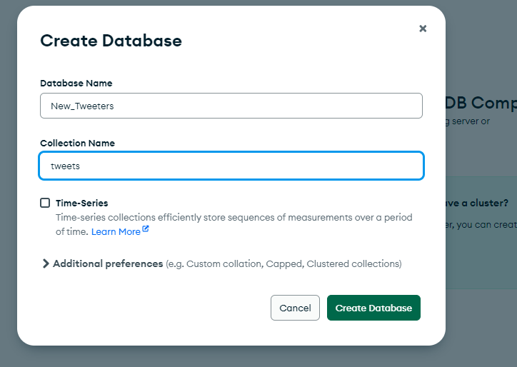

2.- Crear las colecciones

<https://co2cars.apps.eea.europa.eu/?source=%7B%22track_total_hits%22%3Atrue%2C%22query%22%3A%7B%22bool%22%3A%7B%22must%22%3A%7B%22bool%22%3A%7B%22must%22%3A%5B%7B%22range%22%3A%7B%22m__kg_%22%3A%7B%22from%22%3A%221200%22%2C%22to%22%3A%221600%22%7D%7D%7D%2C%7B%22range%22%3A%7B%22Ewltp__g_km_%22%3A%7B%22from%22%3A%2255%22%2C%22to%22%3A%22235%22%7D%7D%7D%2C%7B%22constant_score%22%3A%7B%22filter%22%3A%7B%22bool%22%3A%7B%22must%22%3A%5B%7B%22bool%22%3A%7B%22should%22%3A%5B%7B%22term%22%3A%7B%22year%22%3A2023%7D%7D%5D%7D%7D%2C%7B%22bool%22%3A%7B%22should%22%3A%5B%7B%22term%22%3A%7B%22scStatus%22%3A%22Final%22%7D%7D%5D%7D%7D%5D%7D%7D%7D%7D%5D%7D%7D%2C%22filter%22%3A%7B%22bool%22%3A%7B%22should%22%3A%5B%7B%22term%22%3A%7B%22Mp%22%3A%22BMW%22%7D%7D%2C%7B%22term%22%3A%7B%22Mp%22%3A%22FORD%22%7D%7D%2C%7B%22term%22%3A%7B%22Mp%22%3A%22KIA%22%7D%7D%2C%7B%22term%22%3A%7B%22Mp%22%3A%22MERCEDES-BENZ%20AG%22%7D%7D%2C%7B%22term%22%3A%7B%22Mp%22%3A%22RENAULT-NISSAN-MITSUBISHI%22%7D%7D%2C%7B%22term%22%3A%7B%22Mp%22%3A%22VOLKSWAGEN%22%7D%7D%2C%7B%22term%22%3A%7B%22Mp%22%3A%22SUBARU-SUZUKI-TOYOTA%22%7D%7D%5D%7D%7D%7D%7D%2C%22display_type%22%3A%22tabular%22%7D>

Fuente de datos

# CO2 emissions from new passenger cars

### CO2 emissions from new passenger cars registered in EU27, Iceland (from 2018) and Norway (from 2019) – [Regulation (EU) 2019/631.](http://eur-lex.europa.eu/legal-content/en/ALL/?uri=CELEX:32019R0631)