Name: ibrahim alshayea, ID: 202176470, date: 3/16/2024

Task1:
Method 1 (rotateRight):
This method performs a single right rotation on the AVL tree, adjusting node positions and heights to correct left-heavy imbalances efficiently.
Code:
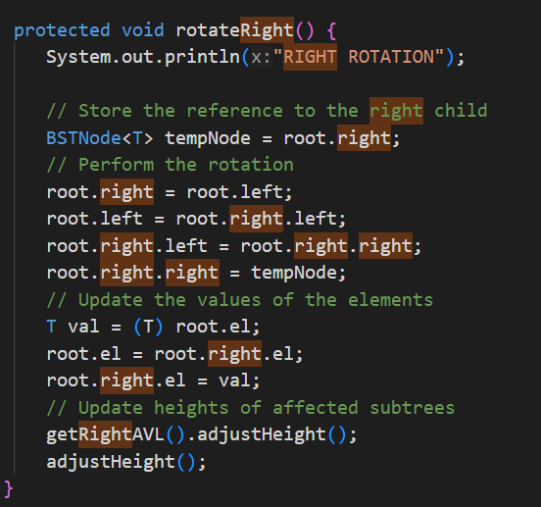

Method 2 (rotateRightLeft):
This method executes a double rotation: first a right rotation, then a left rotation. It's utilized to rebalance nodes with a left-heavy right subtree.
Code:
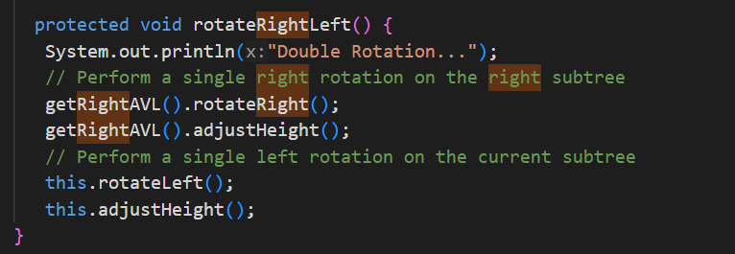

Method 3 (delete):
This method removes a node from the AVL tree while maintaining balance. It handles cases based on the number of node children and rearranges the tree as needed to uphold AVL properties. If the deleted node has two children, it replaces it with the inorder successor.
Task1 output:
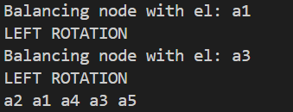
Code:
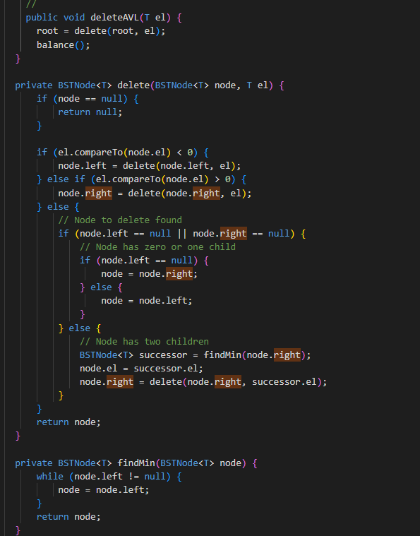

Task2:
I created an AVL tree of integers and populates it with predefined values. It then prompts the user to input three integers to delete from the AVL tree. After deletion, it prints both the original and modified AVL trees in breadth-first order to demonstrate the effect of the deletion operation.

Task 2 ouput:
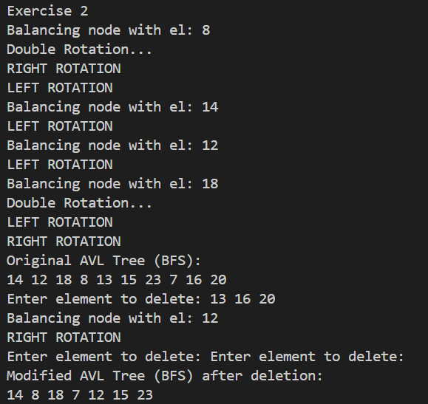

Code:
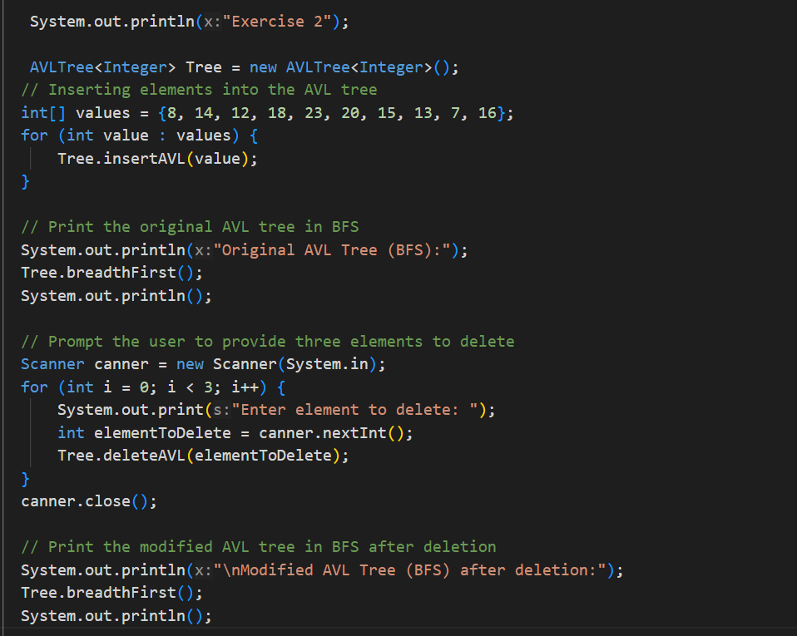

Task3:
This code reads a text file containing words, converts them to lowercase to ensure case insensitivity, and inserts unique words into an AVL tree. Before insertion, it checks if the word already exists in the AVL tree to avoid duplicates. After inserting unique words, it prints the AVL tree using inorder traversal to display the words in sorted order. If the file is not found, it prints a message indicating so.

Task 3 output (it is long so I will provide a sample):
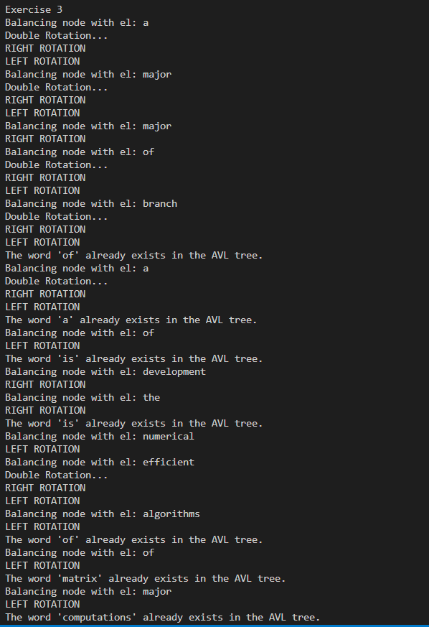
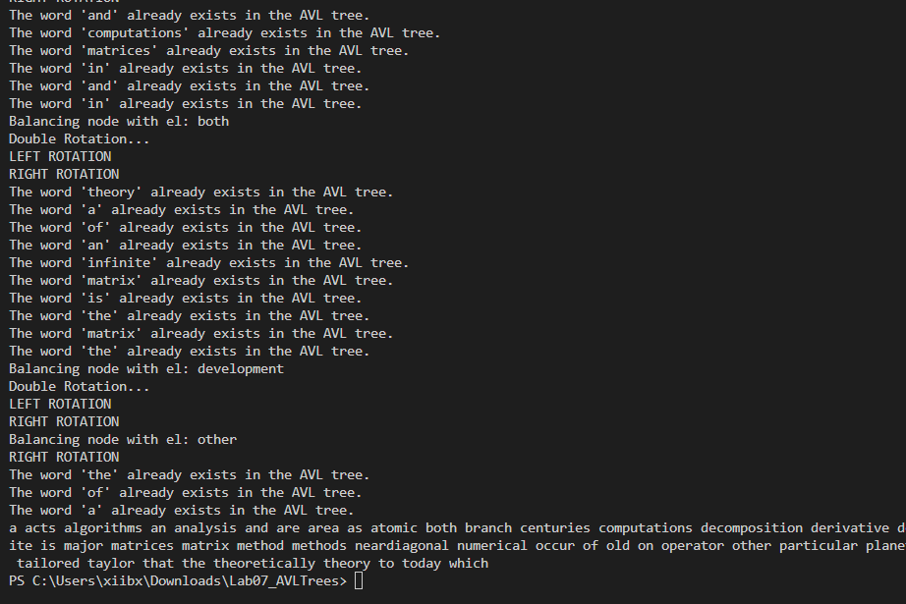
Code:
