“About Us” Section:

* I would liked to mimic a design detailed below (landing page has a background photo with a quote overlapping and below that is the about us write up)
* FOLLOW THIS FORMAT THAT I PUT TOGETHER BELOW FOR THE ABOUT US SECTION!!!!

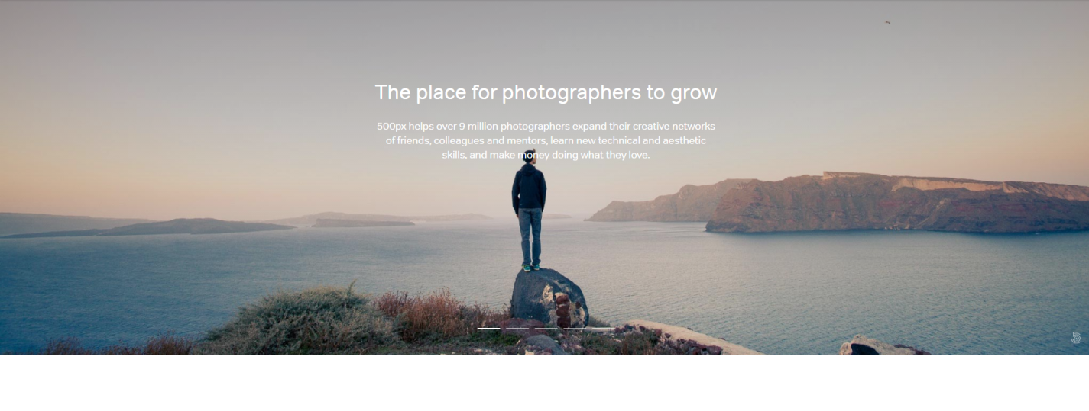

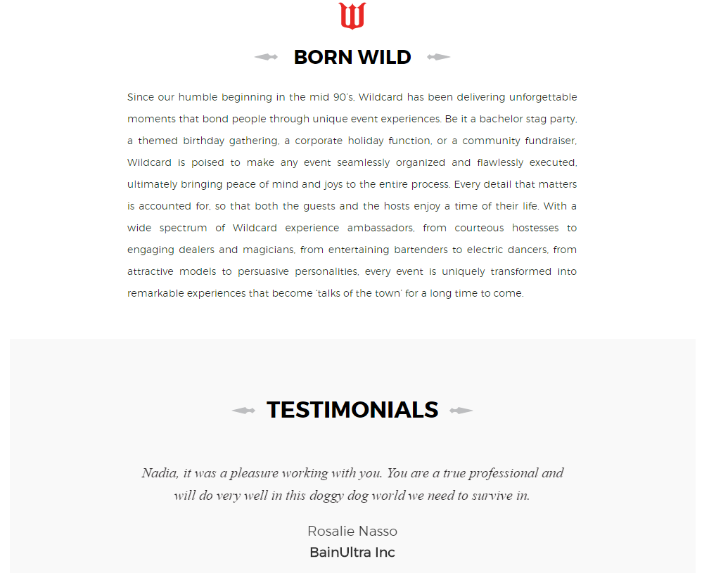

* **Here is the write up I would like you to use:**
  + *Originating in Toronto, E11even Events & Entertainment is a new wave of event production that goes above the paradigms of Stag Entertainment. Just like the name suggests we ensure that our service, quality and hostesses are all Eleven out of Ten. We treat each and every event, be it a Stag, Fundraiser, Casino Night or Corporate Function with the same meticulousness and pride that the client deserves. Regardless of the endeavor, clients defer to professionals for service and adequate advice – the staff at E11even are comprised of such professionals. Every detail that matters is accounted for, so that both the guests and the hosts experience a time of their life. Since 2012 we have ran countless successful and enjoyable events and we have every intention of continuing this theme.*
* I have attached to the e-mail the landing image photo on the “About Us” section that I would like to use

Testimonials (Home Page and “About Us”) section:

* Add in the testimonials underneath just like detailed above and I want them on a rotator/slider
  + First testimonial will say in italics – “*E11even is so great to work with, professional through and through. I will always recommend their services to clients looking to host Stags, Fundraisers, Casino Nights etc.” –* Eugene Iozzo **Chateau Le Jardin, Sales Consultant**
  + Second testimonial will say in italics – “*Julian delivered. He promised a successful, fun and seamless Stag event and it was just that. He handled everything and was a pleasure to work with. Definitely recommend E11even!” –* Frank Perna, **Stag Event, May 2016**