The Effects of Climate Change on Marine Biodiversity

Abstract
Climate change poses a significant threat to marine biodiversity, affecting ecosystems, species distributions, and overall ocean health. This report examines the various impacts of climate change on marine life, focusing on rising temperatures, ocean acidification, and deoxygenation. The implications for marine ecosystems, fisheries, and coastal communities are discussed, supported by data and visualizations.

1. Introduction
The world's oceans are experiencing unprecedented changes due to climate change. As the largest carbon sink, the ocean absorbs much of the excess heat and carbon dioxide produced by human activities. This report explores how these changes are impacting marine biodiversity, with a focus on specific ecosystems and the species that inhabit them.

1.1 Background
Climate change affects marine life through a variety of mechanisms. Key among these are ocean warming, acidification, and deoxygenation, often referred to as the 'deadly trio.' These factors can lead to habitat loss, shifts in species distributions, and changes in community structures.

1.2 Objectives
This report aims to provide a comprehensive overview of the effects of climate change on marine biodiversity, highlighting the most vulnerable ecosystems and species. It also seeks to inform stakeholders about the potential consequences for fisheries and coastal communities.

2. Impacts on Marine Ecosystems
The impacts of climate change on marine ecosystems are profound and multifaceted. This section explores the main effects, including ocean warming, acidification, and deoxygenation.

2.1 Ocean Warming
Rising ocean temperatures have been linked to coral bleaching events and shifts in species distributions. Marine heatwaves are becoming more frequent, with significant implications for biodiversity. For example, the frequency of coral bleaching events has increased, jeopardizing the survival of coral reefs.
Year | Average Temperature Increase (°C)
2010 | 0.6
2015 | 0.9
2020 | 1.1

2.2 Ocean Acidification
As CO2 levels rise, ocean acidification reduces the availability of calcium carbonate for marine organisms. This affects species such as corals and shellfish, which struggle to maintain their structures in more acidic waters.
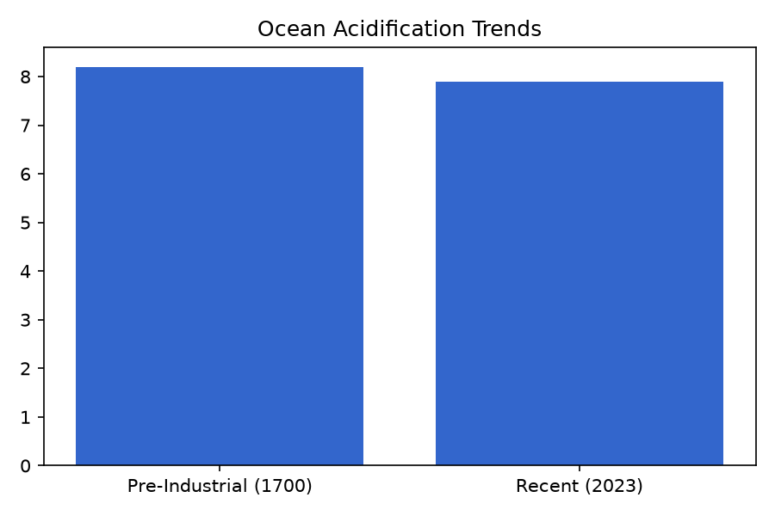

2.3 Deoxygenation
Deoxygenation is a critical issue facing marine ecosystems. Reduced oxygen levels can lead to dead zones, where marine life cannot survive. Areas affected by hypoxia are increasing globally, impacting fish populations and overall biodiversity.

3. Case Studies
This section presents case studies of specific regions and species affected by climate change.

3.1 Coral Reefs
Coral reefs are among the most affected marine ecosystems. The Great Barrier Reef, for example, has experienced severe bleaching events linked to rising sea temperatures. These events have led to significant biodiversity loss and habitat degradation.
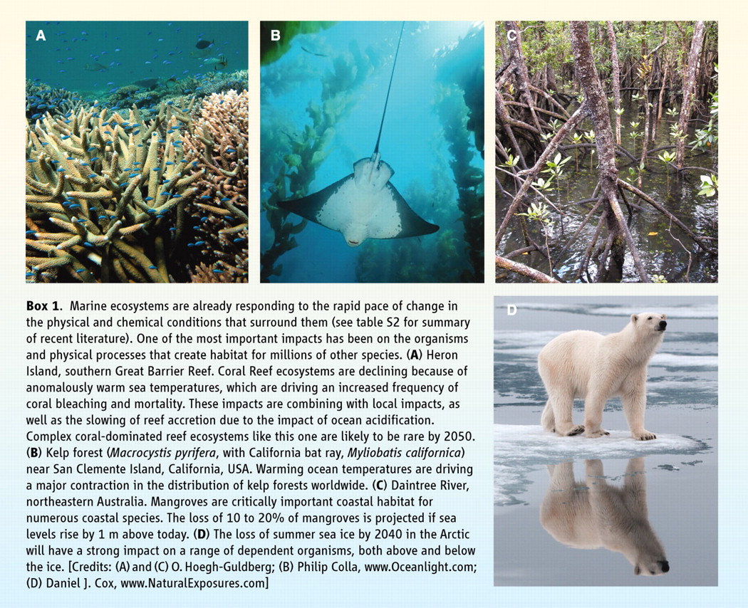
Figure 1. Impact of Climate Change on Coral Reefs

3.2 Fisheries
Fisheries are heavily impacted by climate change, with many fish species migrating to cooler waters, leading to shifts in fishery yields. These changes threaten food security for millions of people dependent on fish for protein.

4. Conclusion
The effects of climate change on marine biodiversity are profound and far-reaching. Addressing these challenges requires global cooperation and sustainable practices to protect marine ecosystems and the communities that rely on them.

5. References
European Environment Agency. (2023). How climate change impacts marine life. Retrieved from [EEA](https://www.eea.europa.eu/en/analysis/publications/how-climate-change-impacts-marine-life)
United Nations. (2023). How is climate change impacting the world’s ocean. Retrieved from [UN](https://www.un.org/en/climatechange/science/climate-issues/ocean-impacts)
Additional sources will be included in the final document.

