James Webb Space Telescope Overview

James Webb Space Telescope (JWST)
The James Webb Space Telescope (JWST) is a revolutionary space telescope designed to conduct infrared astronomy. Launched on December 25, 2021, it has become the largest telescope in space, equipped with high-resolution and high-sensitivity instruments, enabling it to observe objects that are too old, distant, or faint for the Hubble Space Telescope.

Key Features
- Largest telescope sent into space
- Optimized for infrared observations
- High-resolution imaging capabilities
- Ability to observe the early universe

Mission Objectives
JWST aims to explore a variety of astronomical phenomena, including the formation of stars and planets, the evolution of galaxies, and the study of exoplanets.

Recent Discoveries
Since its launch, JWST has made several groundbreaking discoveries, such as imaging distant galaxies formed shortly after the Big Bang and analyzing the atmospheres of exoplanets for potential habitability.
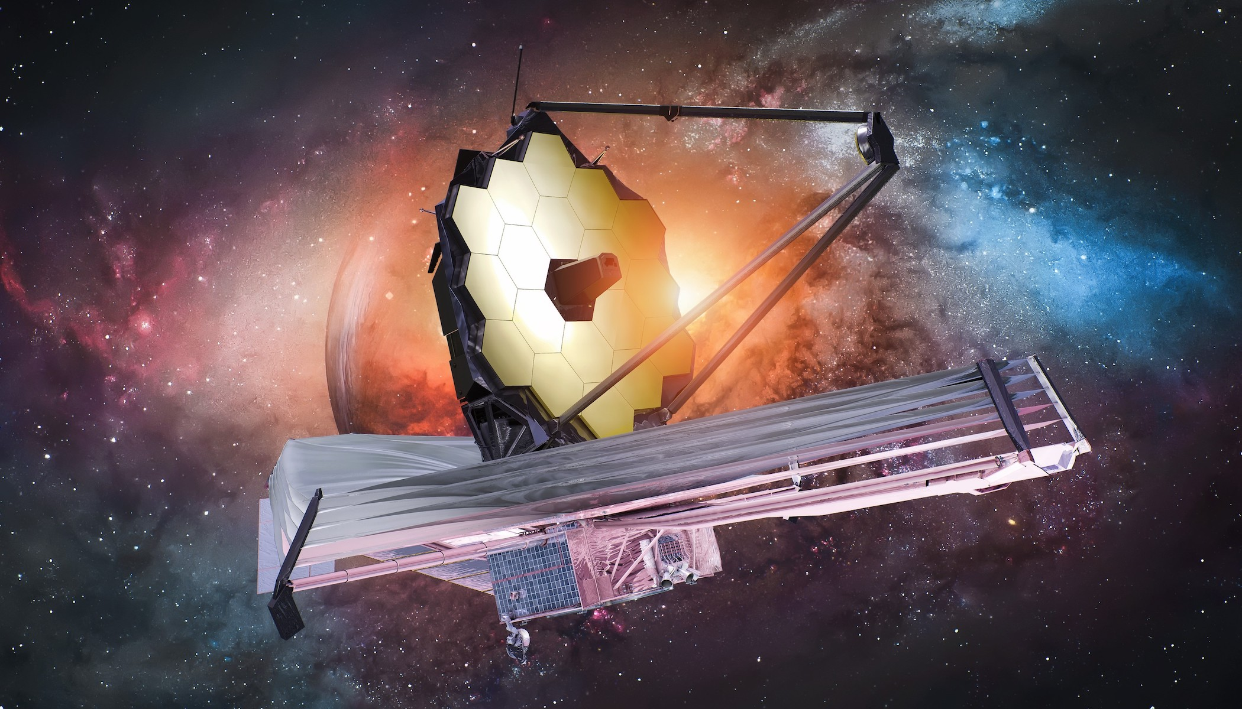
James Webb Space Telescope
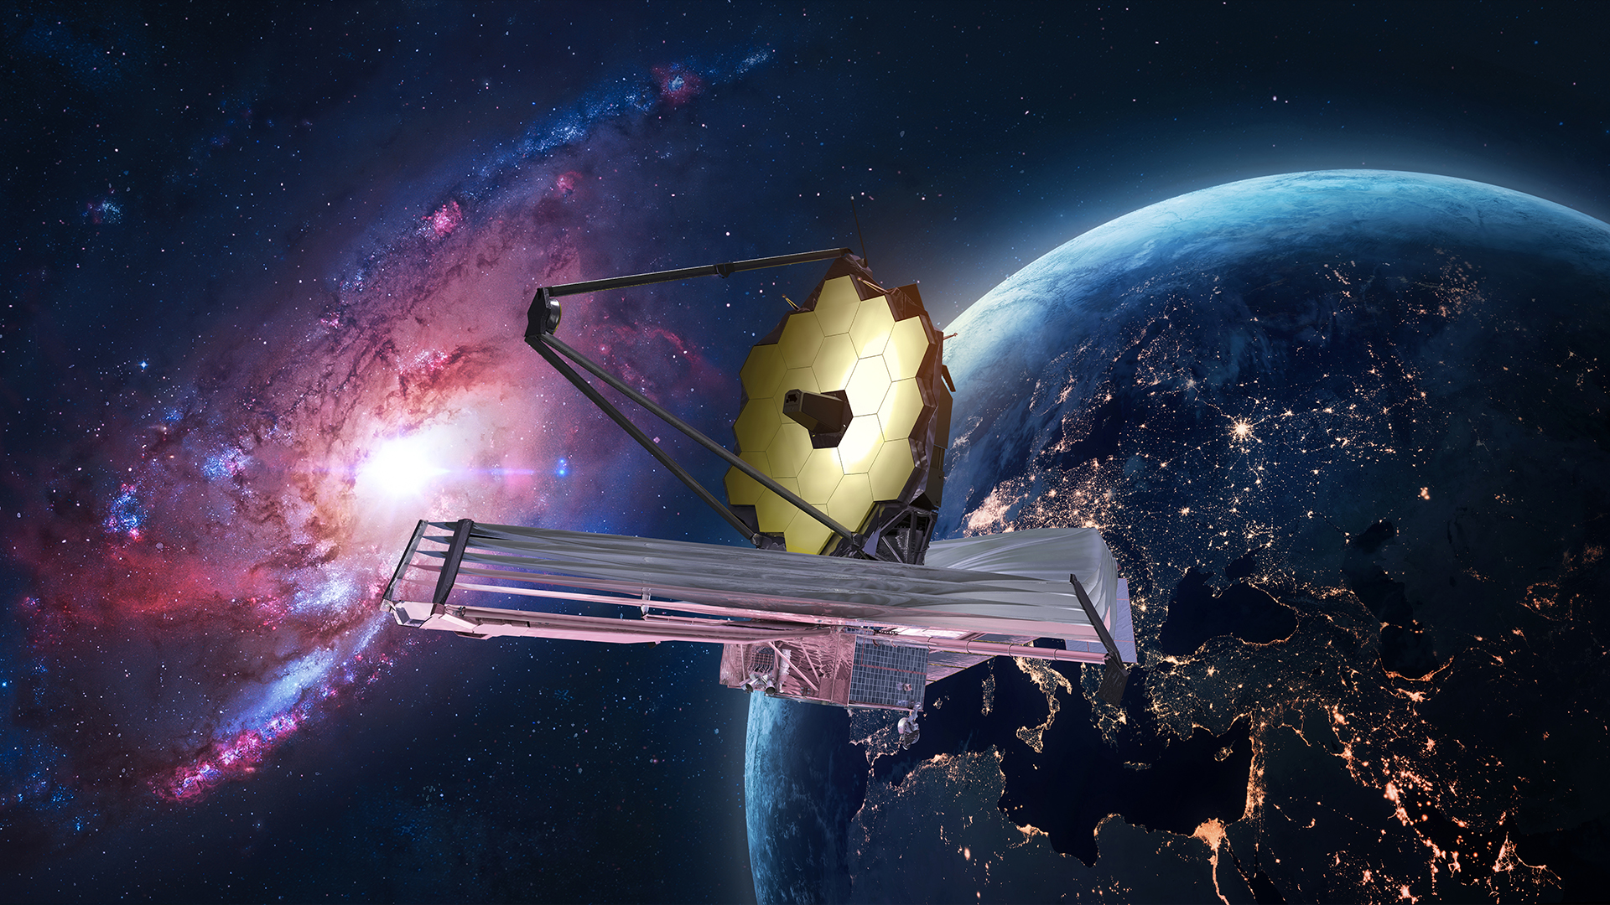
Stunning image captured by JWST

Conclusion
The James Webb Space Telescope continues to revolutionize our understanding of the universe, providing clear, detailed images and data that will shape astronomy for years to come.

