Climate Change Effects on Marine Biodiversity

Climate Change Effects on Marine Biodiversity

Abstract
Climate change is a significant threat to marine biodiversity, impacting ecosystems and species distribution. This report examines the various effects of climate change on marine life, including rising temperatures, ocean acidification, and deoxygenation. It discusses the implications for marine ecosystems, case studies, and the necessity for effective conservation strategies.

Introduction
Marine biodiversity encompasses the variety of life forms found in oceanic environments, including species diversity, ecosystem diversity, and genetic diversity. Climate change, driven by human activities, poses severe challenges to these ecosystems. This report aims to elucidate the impacts of climate change on marine biodiversity and highlight the urgent need for mitigation and adaptation strategies.

Overview of Climate Change
Climate change refers to long-term alterations in temperature, precipitation, wind patterns, and other elements of the Earth's climate system. The primary driver of climate change is the increase in greenhouse gases (GHGs) in the atmosphere, primarily due to fossil fuel combustion, deforestation, and industrial processes. The ocean, which absorbs a significant portion of these gases, experiences rising temperatures and altered chemistry, resulting in profound ecological consequences.

Impact of Climate Change on Marine Ecosystems

Ocean Temperature Rise
Rising sea temperatures lead to changes in species distributions, often resulting in warm-water species migrating poleward while cold-adapted species retreat. This phenomenon, known as tropicalization, disrupts existing ecosystems and alters community structures.

Ocean Acidification
The absorption of increased atmospheric CO₂ causes ocean acidification, which impairs calcifying organisms such as corals and shellfish, disrupting food webs and overall ecosystem health.

Deoxygenation
Deoxygenation, particularly in stratified regions, reduces the available habitat for aerobic marine species, leading to biodiversity loss and altered predator-prey dynamics.

Effects on Marine Species

Coral Reefs
Coral reefs, often referred to as the ocean's rainforests, are highly sensitive to temperature changes. Increased sea temperatures lead to coral bleaching, resulting in loss of biodiversity and habitat for numerous marine species.

Fish Populations
Changes in ocean temperatures and habitats affect fish populations, leading to shifts in commercial fish stocks and impacting fisheries globally.

Case Studies

Great Barrier Reef
The Great Barrier Reef is experiencing severe impacts from climate change, including coral bleaching events and shifts in species composition. These changes threaten the ecological balance of this UNESCO World Heritage site.

Arctic Marine Ecosystems
Arctic regions are warming faster than the global average, leading to changes in species distribution and the melting of ice habitats, which are critical for many marine species.

Tables and Charts
Impact Type | Description
Temperature Rise | Shifts in species distributions and increased tropicalization.
Ocean Acidification | Impaired calcifying organisms affecting food webs.
Deoxygenation | Reduced aerobic habitats for marine species.

Images
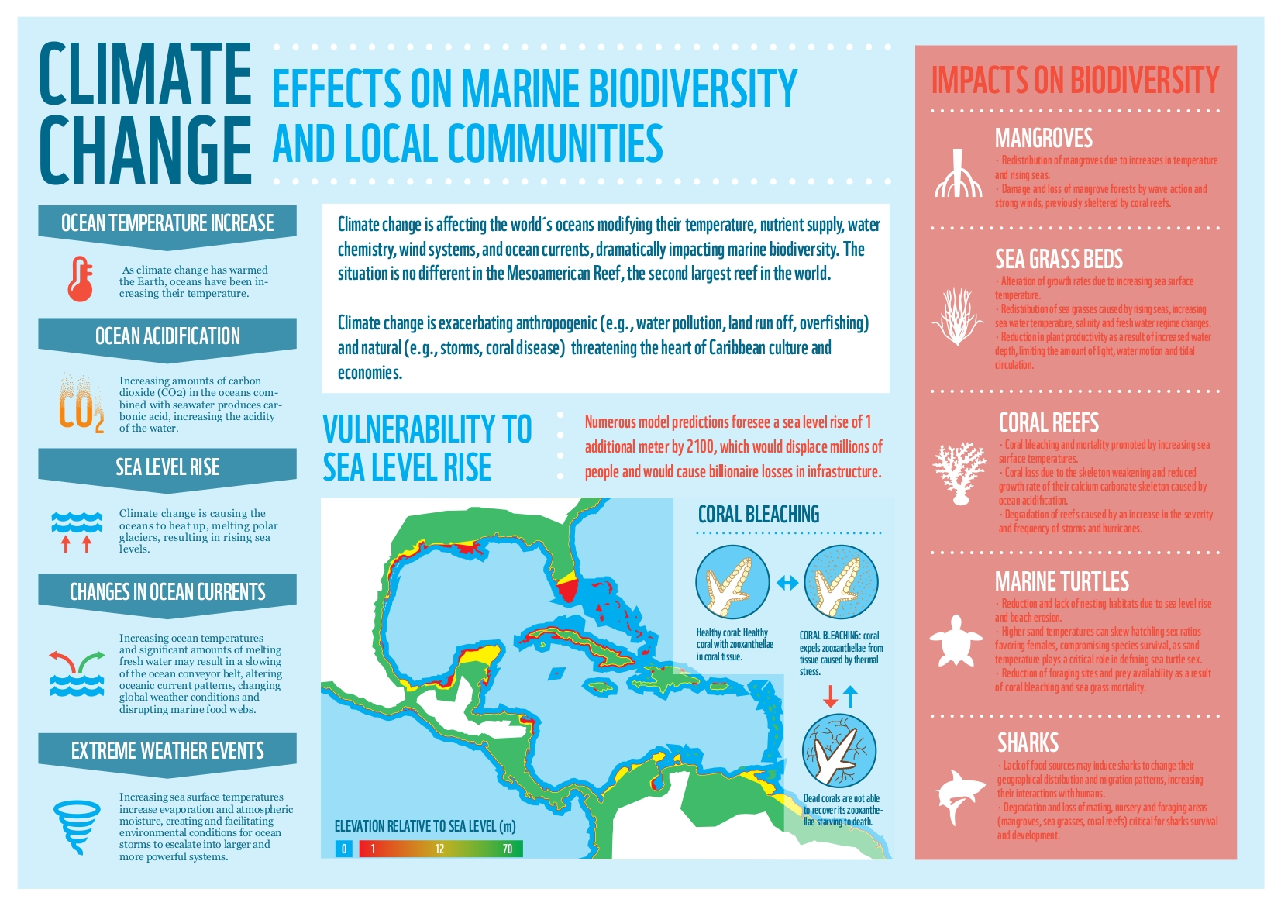
Climate Change Effects on Marine Biodiversity
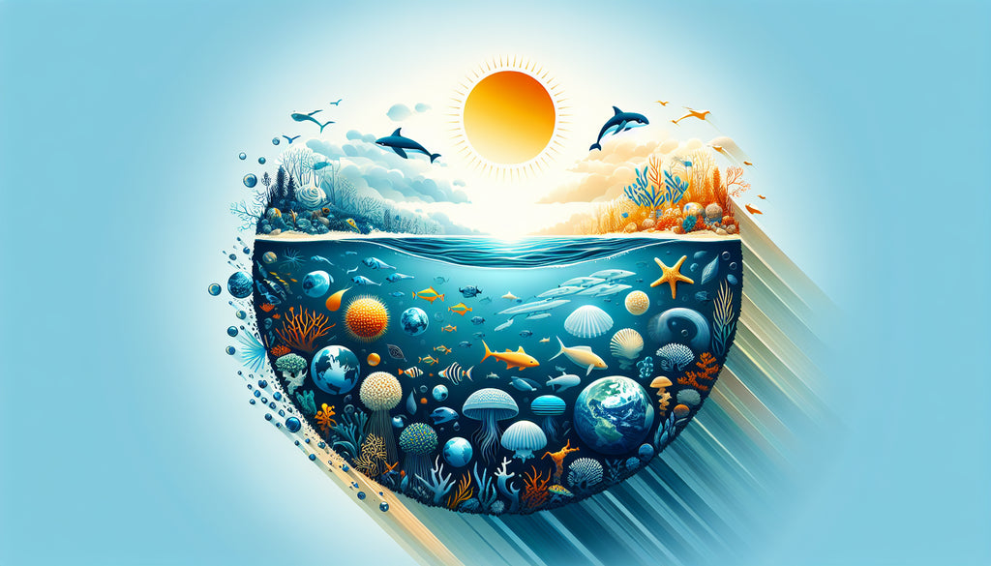
Understanding the Impact of Climate Change on Marine Biodiversity
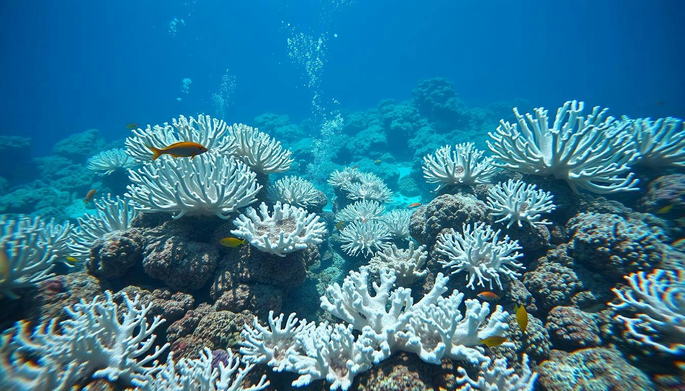
Impact of Climate Change on Marine Biodiversity

