The James Webb Space Telescope: Unveiling the Universe

Abstract
The James Webb Space Telescope (JWST) represents a monumental leap in our ability to explore the universe through infrared astronomy. Launched on December 25, 2021, JWST is designed to observe the most distant galaxies, study the formation of stars and planets, and investigate the atmospheres of exoplanets, enhancing our understanding of the cosmos.

Introduction
The JWST is the largest space telescope ever built, equipped with advanced technologies to study phenomena beyond the capabilities of its predecessor, the Hubble Space Telescope. This document outlines its design, scientific goals, and significant achievements since its launch.

History and Development
The concept of JWST began in the late 1990s, with its development involving collaboration among NASA, the European Space Agency (ESA), and the Canadian Space Agency (CSA). After numerous delays and budgetary challenges, the telescope was successfully launched aboard an Ariane 5 rocket from Kourou, French Guiana, in December 2021.

Design and Technology
The JWST features a 6.5-meter primary mirror, composed of 18 hexagonal segments, allowing it to capture faint infrared light. Its instruments include the Near Infrared Camera (NIRCam), Near Infrared Spectrograph (NIRSpec), and the Mid-Infrared Instrument (MIRI), which collectively enable a broad range of scientific observations.

Scientific Goals
JWST's primary scientific goals include studying the formation of the first stars and galaxies, understanding stellar evolution, and characterizing exoplanet atmospheres. It aims to provide insights into the origins of the universe and the potential for life beyond our solar system.

Launch and Deployment
The launch of JWST marked a significant milestone in space exploration. After launch, the telescope underwent a complex deployment sequence, which included unfolding its sunshield and primary mirror, successfully reaching its operational orbit at the second Lagrange point (L2).

Scientific Achievements
Since its commencement of operations, JWST has captured stunning images and data, revealing previously unseen cosmic phenomena. Its first images, released in July 2022, showcased the telescope's capabilities in observing distant galaxies, nebulae, and exoplanets, reaffirming its role as a groundbreaking scientific instrument.

Future Prospects
As JWST continues its mission, future observations will explore the formation of planetary systems and the chemical compositions of distant worlds, contributing to our understanding of the universe's evolution and the potential for life elsewhere.

Conclusion
The James Webb Space Telescope stands at the forefront of astronomical research, providing invaluable data that will shape our understanding of the universe for years to come. Its innovative design and advanced technology have set a new standard for space exploration, promising to unveil the mysteries of the cosmos.

References
1. NASA. (2021). James Webb Space Telescope. Retrieved from https://science.nasa.gov/mission/webb/
2. Britannica. (2021). James Webb Space Telescope (JWST). Retrieved from https://www.britannica.com/topic/James-Webb-Space-Telescope
3. Wikipedia. (2021). James Webb Space Telescope. Retrieved from https://en.wikipedia.org/wiki/James_Webb_Space_Telescope
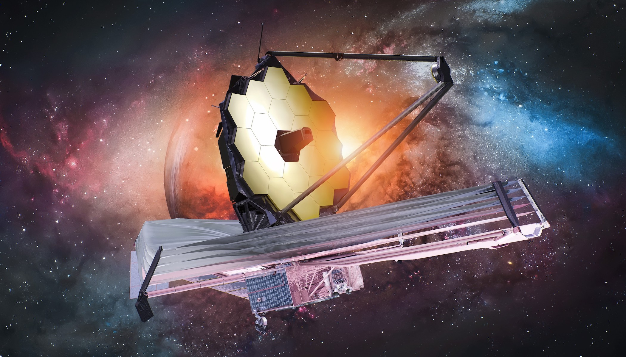
James Webb Space Telescope during deployment.
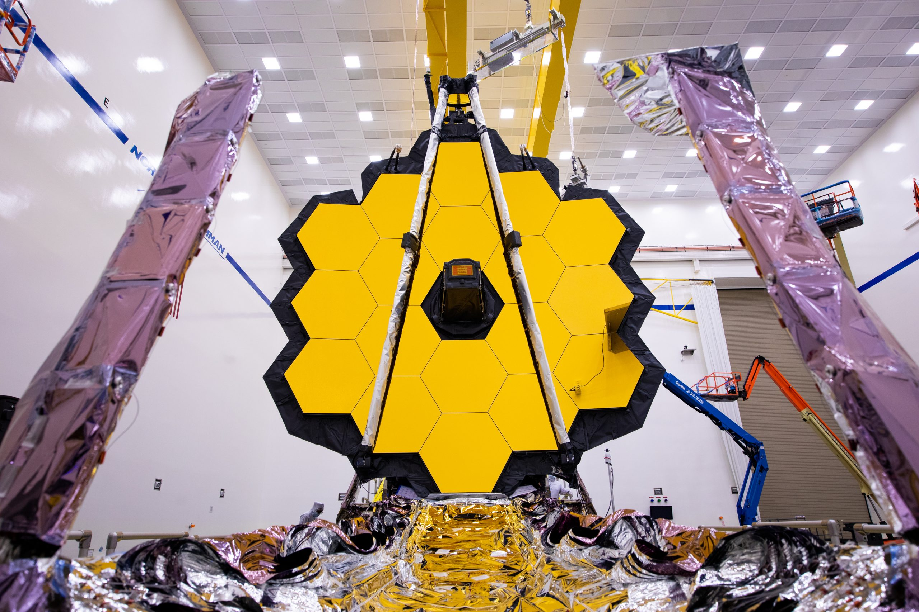
An artist’s impression of the James Webb Space Telescope in space.

