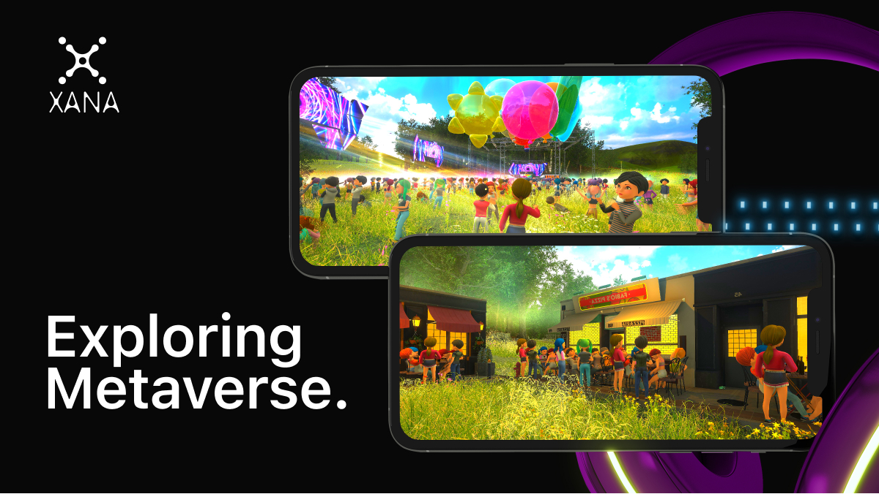

**Exploring Metaverse - A Virtual Bubble with XANA**

It all started from innovation, revolution, digitalization to decentralization, visualization, and BOOM. Here comes virtual socialization, virtual work, virtual games, Metaverse. XANA is a metaverse technology that operates on the ethereum sidechain.

Does it fascinate you to give an interview on Metaverse? Businesses and institutions have already considered XANA the preferred technology for their work. If you are also the one who want to join this virtual world of joy, productivity, and profit then,

**Welcome to XANA Metaverse World:**

A technology that will enable you to play, earn and work on Metaverse, this is what**XANA Metaverse** is.

* A super-fast
* Visually real
* Laser-focused technology

**Virtual Space Remote:**

**XANA VR Platform** is a virtual space remote that will enable you to meet, play, stay and earn in virtual space. Further, it will enable you to;

* **Create Virtual World XANA:**

For those who have always dreamed of being a Landlord.**XANA VR Platform** has something to say to you; Hello, Millennials! XANA has over 150,000 virtual properties and lands with verifiable ownership. You must have listened to buying property on the Moon. The virtual**world XANA** has enabled its users to buy, trade land with other users, and earn metaverse profit by providing services.

* **Your own Company of Virtual Real Estate:**

XANA makes it happen for investors and real estate builders to buy and sell property with profit on **Virtual World XANA.**

* **Held an Exhibition:**

Gone are the days when heading an exhibition costs lots of labor work, or attending an exhibition requires you to get up, burn your petrol, and go to the venue. **Online Virtual Exhibition by XANA** lets you present your services and products to niche audiences and boost your sales and business.

* **Work Behind Entertainment Ahead:**

Games lovers! What will be more exciting or thrilling than experiencing the metaverse games on land experience? The combo of joy and entertainment to the next level of visualization makes you ignore your present hustle and play to solve the puzzle of your missions in games. Global brands have issued avatars to XANA. **NFT’s gamefi Metaverse** enables you to play ultra graphics and your favorite games with more excitement than ever before!

Now here comes the question, want to experience the Metaverse? Why XANA?

1. **Fleet-footed:**

The custom layer-2 built for Metaverse enables **XANA** to build and boost infrastructure and jobs in the metaverse economy, which will benefit gaming developers and developers of NFT transactions for brands.

1. **Cost-effective:**

XANA is made up of custom layer-2, and it has proof of stake that lessens the computational work for blocks verification and transaction. Thus, providing a **secure NFT**.

1. **Laser-focused:**

Unlike other blockchains, XANA is built for Metaverse and has **SDKs** to

Create user-oriented features and applications.

If you have chosen XANA for the best**metaverse experience**, the road-way to entertainment, profitability, and luxury has not ended here. There is much more to come in XANA;

* **Ethereal Avatar:**

The dream of looking whatever you want to be like, avatars will make your dream true. Brands and creators are interested in providing exclusive avatars for **XANA**for the revenue stream.

* **Introduction of Metaverse through your favorite characters:**

Though the Metaverse concept is mind-blowing yet a bit new, XANA is looking for your favorite brands and characters that will illustrate Metaverse in their own beautiful and thrilling way that would be more interesting and eye-catching.

* **Lands and Properties Available:**

150,000 virtual lands are available on the**XANA VR platform** that can be bought and traded and earn revenue.

**End-Notes:**

XANA is an emerging and well-established technology in the field of the Metaverse. The reason why people interested in Metaverse should use it is,

* It is compatible with all popular wallets that are being used for saving cryptocurrencies associated with every major blockchain.
* Big organizations and institutions have already adopted it for trustworthy and reliable services.
* It has completed its testing period of 2 years, and during this period, it has strengthened its roots among the largest institutions and partnered with The **Olympics, Fuji Group, Top-Anime Brand**, and more agencies and customers to come in a row.

We all are familiar that**Facebook** has officially changed its company name to Meta, which clarifies that the concept of the Metaverse is no longer hidden to anyone and**XANA metaverse** is the first in this row.