**SOFTWARE CONSTRUCTION**

**Lab 13**

**NAME:** MUHAMMAD IBTESAM

**CLASS:** BESE – 5B

**CMS ID:** 111011

**DESCRIPTION:**

In this lab, we were given a csv file.

We had to upload the csv file into the hadoop file system.

We then had to run a command on the uploaded file.

We had to create a relationship between caller and callee.

We then had to make a graph which represents this relationship.

**HOW TO RUN:**

You upload the csv into the hadoop filesystem.

You then run the wordcount command on the csv file.

You go to the specified folder in which you placed the output file.

You then run the cat command to check the contents.

**SCREENSHOT:**

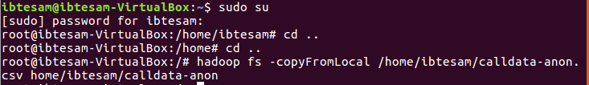

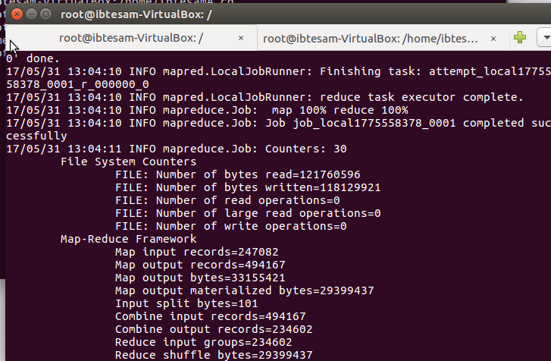



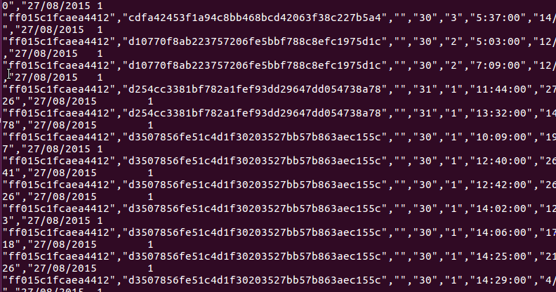

**GitHub Link:**

<https://github.com/ibtesam101/ib>