Report:

**Part-1:**

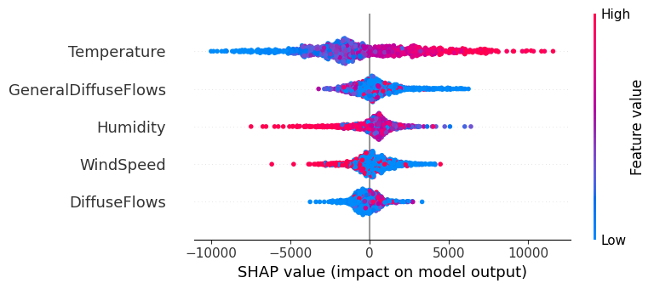

Key Features in the Dataset & Their Relevance to Power Consumption

* Temperature: Higher temperatures, which are colored red, have a strong positive impact on power consumption, while lower temperatures (blue) reduce consumption.
* GeneralDiffuseFlows & DiffuseFlows: Represent solar radiation; they impact power consumption, possibly due to their influence on heating/cooling needs.

### Challenges in Forecasting This Time Series Data

* Feature Correlations: Temperature, humidity, and solar radiation may be highly correlated. This makes it harder for models to differentiate their individual effects.
* Non-Stationarity: The dataset likely exhibits seasonal and trend-based variations.

### Impact of Weather on Power Consumption

* Temperature: Strongest influence—higher temperatures generally lead to higher power usage. SHAP values are ±10000 showing a significant impact on predictions.
* Humidity: Moderate impact; high humidity (red) tends to increase power consumption slightly. SHAP values are ±5000, showing a weaker but noticeable effect.
* Wind Speed: Minimal impact; most SHAP values are clustered around zero. SHAP values rarely exceed ±2000, indicating low contribution.

**Part 2: Data Preprocessing**

For time series forecasting, it's crucial to maintain the temporal order when splitting

the dataset. A common approach is:

Training Set: 70% of data

Validation Set: 15% of data

Test Set: 15% of data

### **Part 5: Evaluation and Visualization**

#### **Performance Metrics**

To assess forecasting accuracy, we employed the following metrics:

* Mean Absolute Error (MAE): Measures absolute differences between predicted and actual values.
* Root Mean Square Error (RMSE): Evaluates prediction errors while penalizing large deviations.

#### **Visualizations**

Actual vs. Predicted Power Consumption: Line plots for each zone were created to compare predictions with ground truth values.

**Results using vanilla transformer:**

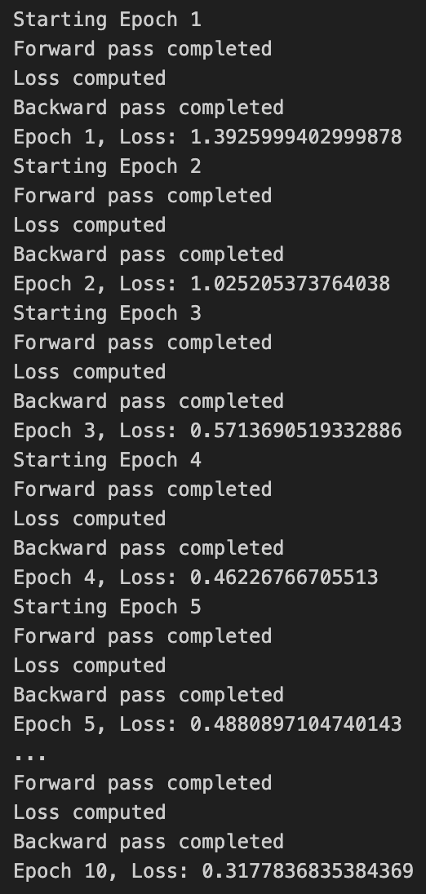

**References**:

Almost all of the code was provided by DeepSeek and ChatGPT. Some of the segments of the code were taken from this, <https://www.kaggle.com/code/damlapeker/prediction-of-electric-power-consumption>

I am sorry that I couldn’t properly perform the tasks. My 4-2 term final is ongoing. I hope you will consider my case.