Chapter Two
Theoretical Background

2.1 Introduction
The rapid development of digital imaging technologies and high-resolution acquisition devices has substantially increased the volume of image data generated, stored, and transmitted. Images are extensively used in multimedia communication, medical imaging, and other data-intensive applications. This continued growth imposes considerable requirements on storage capacity and transmission bandwidth, making efficient image compression essential for modern digital imaging systems [19], [20]. Digital images often contain redundant information that can be exploited to reduce the data required for representation while maintaining acceptable reconstruction quality. Nevertheless, reducing the data size may introduce distortion or remove visually significant details. Therefore, a compression method should be evaluated by considering compression efficiency, reconstructed-image quality, and computational cost rather than relying on data reduction alone [19], [21], [22]. A typical image compression framework may incorporate lossy data-reduction techniques together with lossless coding stages. Vector quantization represents image vectors using a limited codebook of representative codewords [4], [23], [24]. The resulting vector-quantization indices can subsequently be processed using lossless entropy-coding methods such as Huffman coding to reduce their statistical redundancy without introducing additional reconstruction loss [25], [26].This chapter reviews the fundamental concepts of image compression, lossless and lossy coding, vector quantization, the Linde–Buzo–Gray algorithm, differential and Huffman coding, compression and reconstruction-quality metrics, multicore architectures, parallel computing, and the Message Passing Interface.
2.2 Image Compression Techniques

Image compression techniques are generally classified as lossless or lossy, depending on whether the original image data can be recovered exactly after decompression. The selection of an appropriate compression category depends mainly on the required reconstruction fidelity, achievable data reduction, and intended application [2].
2.2.1 Lossless Compression
Lossless image compression reduces the amount of data required to represent an image without discarding any original information. Therefore, the decompression process can reconstruct an image identical to the original. Lossless methods primarily exploit statistical redundancy through coding techniques such as run-length encoding, arithmetic coding, and Huffman coding. These techniques suit applications where exact data preservation is essential, although they generally achieve lower compression ratios than lossy methods.
2.2.2 Lossy Compression
Lossy image compression achieves greater data reduction by permanently discarding information considered less significant to image perception. Consequently, the reconstructed image is an approximation rather than an exact copy of the original. Lossy methods can provide higher compression ratios, but removing too much information may introduce visible distortion and reduce reconstruction quality. Therefore, their performance involves a trade-off between compression efficiency and image fidelity.

2.3 Vector Quantization

Vector quantization (VQ) is a lossy compression technique that represents multidimensional input vectors using a finite set of representative vectors known as a codebook. The individual vectors within the codebook are referred to as codewords. In image compression, the input image is divided into non-overlapping blocks, each converted into a training vector. During encoding, every input vector is assigned to the codeword that minimizes a specified distortion measure, typically the squared Euclidean distance. The resulting codeword index is stored or transmitted instead of the complete input vector. During decoding, each index is replaced by its corresponding codeword to reconstruct the image. This representation can substantially reduce the required data because multiple input vectors are represented by a limited number of codewords. However, since each input vector is replaced by an approximate representative, VQ generally introduces quantization distortion, and the reconstructed image is not identical to the original image [27].

The quantization operation can be expressed as [27], [28]

$Q\left(x\right)=arg min ‖x - c_j‖²$ , c_j ∈ C (2.1)

where x is an input vector, C = {c_1, c_2, …, c_K} is the codebook, and c_j is the codeword that minimizes the distortion between the input vector and the available codewords.
For color images, vector quantization can be applied independently to the red, green, and blue channels. Each channel is treated as a grayscale image and uses a separate codebook. The VQ indices are generated and decoded separately for each channel, after which the three reconstructed channels are combined to form the output color image.
2.4 Linde-Buzo-Gray (LBG)
The Linde–Buzo–Gray (LBG) algorithm, also referred to as the Generalized Lloyd Algorithm (GLA), is a clustering-based technique commonly used to generate codebooks for vector quantization. It identifies representative codewords from a set of training vectors and iteratively minimizes the distortion between these vectors and their corresponding codewords [4], [27], [28].
The algorithm begins with an initial codebook and repeatedly applies assignment and update operations. During the assignment operation, each input vector xi is allocated to the nearest codeword C_{j} using the squared Euclidean distance [27]:
$d\left(X_{i},C_{j}\right)={‖X_{i}-C_{j}‖}_{2}^{2}$ (2.2)
After all vectors have been assigned, each codeword is updated as the centroid of the vectors belonging to its cluster [27]:
$C_{j}=\frac{1}{N_{j}}⁢\sum_{X_{i}∈S_{i}}{X_{i}}$ (2.3)
Where, $S_{i}$ denotes the set of input vectors assigned to the j-th codeword, and $N_{j}$ is the number of vectors in that set. The average quantization distortion is then calculated as [27]:
$$D=\frac{1}{N_{b}}⁢\sum_{i=1}^{N_{b}}{{‖X_{i}-C_{j\left(i\right)}‖}_{2}^{2}}$$
Where $N_{b}$ represents the total number of training vectors and $C_{j\left(i\right)}$ is the codeword assigned to $X_{i}$.
The assignment and centroid-update operations continue until the relative change in distortion falls below a predefined convergence threshold [28].
The codebook may be expanded through binary splitting, in which each existing codeword is divided into two slightly modified codewords [27].
$C_{j}^{±}=C_{j}⁢\left(1±δ\right)$ (2.4)
here δ denotes a small splitting factor. The expanded codebook is subsequently refined through the same assignment and centroid-update operations until the required codebook size is obtained [27].
Although LBG provides an effective approach to codebook generation, its iterative training process involves repeated distance calculations between the training vectors and codewords. Consequently, the computational cost increases as the training set and codebook sizes grow, which can lead to longer execution times [4], [13].

2.5 Delta Coding
Delta coding, also known as differential coding, is a lossless technique that represents a data sequence using the differences between successive values rather than encoding each value independently [28], [29]. In the compression framework considered in this study, the first VQ index is stored in its original form, while each subsequent index is represented by:
$Δ_{i}=L_{i}-L_{i-1}$ ,i =2, 3,…, Nb (2.5)
where $L_{i}$ and${ L}_{i-1}$ denote the current and previous VQ indices, respectively, and Δi is the resulting difference.
When successive indices exhibit statistical dependence, delta coding produces a difference sequence with a more concentrated symbol distribution, improving the efficiency of the subsequent entropy-coding stage. The original indices are reconstructed exactly; therefore, this stage introduces no additional reconstruction distortion.

2.6 Huffman Coding
Huffman coding is a lossless coding technique that generates an optimal prefix code for a specified source probability model [30]. A prefix code is constructed so that no codeword is a prefix of another, allowing the encoded sequence to be decoded without ambiguity. The algorithm assigns shorter codewords to higher-probability symbols and longer codewords to lower-probability symbols, reducing the average number of bits required to represent the source [28].

The Huffman code is constructed by repeatedly combining the two symbols with the lowest probabilities. Each resulting symbol is assigned a probability equal to the sum of its components. This procedure continues until a single binary tree containing all source symbols is formed, after which binary labels are assigned to the tree branches to determine the codeword associated with each symbol [28].
The information content and entropy of the source are defined in [28] as
$I(s_i)=-log₂(p_i)$ (2.6)

$H(S) =-Σ p_i log₂(p_i)$ , i = 1, 2, …, M (2.7)

where I(s_i) denotes the self-information of symbol s_i, p_i is its probability of occurrence, M is the number of distinct symbols, and H(S) is the source entropy measured in bits per symbol.

A standard Huffman tree requires at least two distinct symbols to construct a branching structure. When the input contains only one distinct symbol, no branching is required. In this case, all input symbols are identical and can be represented without additional codeword bits.

Huffman coding has been employed as an entropy-coding stage in recent image-compression methods to reduce the coded data size by exploiting differences in symbol occurrence frequencies [31]. It has also been applied specifically to the lossless recompression of VQ index tables, where frequently occurring index symbols are represented by shorter codewords [25].

2.7 Compression and Performance Metrics

A- Compression Ratio (CR)

The compression ratio measures the reduction in data size achieved after compression and is defined as [28]:

CR =$\frac{B original}{B compressed}$ (2.8)
The sizes of the original and compressed images are denoted by B_original and B_compressed, respectively.

B. PEAK SIGNAL-TO-NOISE RATIO(PSNR)
The maximum peak signal-to-noise ratio (PSNR) is the ratio of the highest possible signal value to the strength of the distorting noise that affects the quality of its representation. The two images must have identical dimensions. The mathematical representation of the maximum signal-to-noise ratio is as follows [28]:
$PSNR=10log10( \frac{ {Maxi}^{2} }{MSE})$ (2.9)

C. MEAN SQUARE ERROR(MSE)
The mean square error quantifies the average squared pixel
difference [28]:
$MSE=\frac{1}{M*N} \sum_{i=0}^{M-1}{\sum_{j=0}^{N-1}{[I\left(i,j\right)-K\left(i,j\right) ]^{2}}}$ (2.10)
Where M: Number of rows (image height), N: The number of columns (the width of the image), I( i, j): The value of the pixel at row i and column j in the original image, Ī(i,j): The reconstructed or compressed pixel value at row i and column j. Lower MSE values indicate better reconstruction accuracy.

D. STRUCTURAL SIMILARITY INDEX MEASURE(SSIM)
SSIM is a well-known quality metric that assesses how similar two images are to one another and is thought to be connected with how the human visual system perceives. SSIM values closer to 1 indicate greater structural similarity [32]:
SSIM (x , y) =$\frac{((2μxμy + C1)(2σxy + C2)) }{((μx^2 + μy^2 + C1)(σx^2 + σy^2 + C2))}$ (2.11)
$μx$, $μy :Mean intensity of image x and y$,$σx,σy :Variance of x and y,$
$σxy :Covariance between x and y$ ,$C1,C2 :$ Small constants to stabilize the division.
    - Parallel Performance Metrics.

- Speedup
Speedup measures the performance gain of the parallel implementation relative to the sequential implementation, whereas parallel efficiency indicates how effectively the available processing resources are utilized [33], [34]. These metrics are defined as follows:
$S(p) = \frac{Ts}{Tp}$ (2.12)
where T's and Tp indicate the execution times for sequential and parallel processes, respectively.
- Parallel Efficiency (2.13)
$E(p) =\frac{S\left(p\right)}{p} × \%100$
Where P represents the number of MPI processes.

- Throughput
$Throughput =\frac{Isize}{Ttotal}$ (2.14)
where I size is the original image size in MiB, and Total is the total execution time.

- Karp-Flatt Metric
The Karp–Flatt metric estimates the experimentally observed serial fraction, including the combined effects of inherently sequential computation and parallel overhead. It is calculated as follows [35].

$e(P)=\frac{P/S(P)-1}{P-1}$ (2.15)

where e (P) is the experimentally determined serial fraction, S(P) is the measured speedup, and P is the number of processes. A lower e(P) value indicates better scalability and less influence from serial execution and parallel overhead.

2.8 Parallel Computing

Parallel computing is a computational approach in which a problem is divided into smaller components that multiple processing elements can execute concurrently. Its primary objective is to reduce execution time and provide the computational capacity required for large or computationally intensive problems. A parallel computing system can be viewed as two complementary components: parallel hardware, which provides the processing resources for concurrent execution, and parallel software, which decomposes the computation, distributes the workload, and coordinates communication and synchronization among the processing elements [33], [36].

2.8.1 Parallel Hardware
Parallel hardware provides multiple processing elements that can execute operations concurrently. Flynn’s taxonomy classifies computer architectures according to the number of instruction and data streams they process. In a Single Instruction, Multiple Data (SIMD) architecture, the same instruction is applied concurrently to multiple data elements, making this model suitable for regular data-parallel computations. In contrast, a Multiple Instruction, Multiple Data (MIMD) architecture allows independent processing elements to execute different instruction streams on different data. Modern multicore processors are generally classified as MIMD systems because their cores can execute independently [33].

Parallel architectures can also be classified according to their memory organization. In a shared-memory system, multiple processing elements access a common address space and communicate through shared data. In a distributed-memory system, each processing element has its own private memory, and data are exchanged explicitly through message-passing mechanisms. Memory organization is independent of Flynn’s classification; therefore, a MIMD architecture may employ either shared or distributed memory [33].

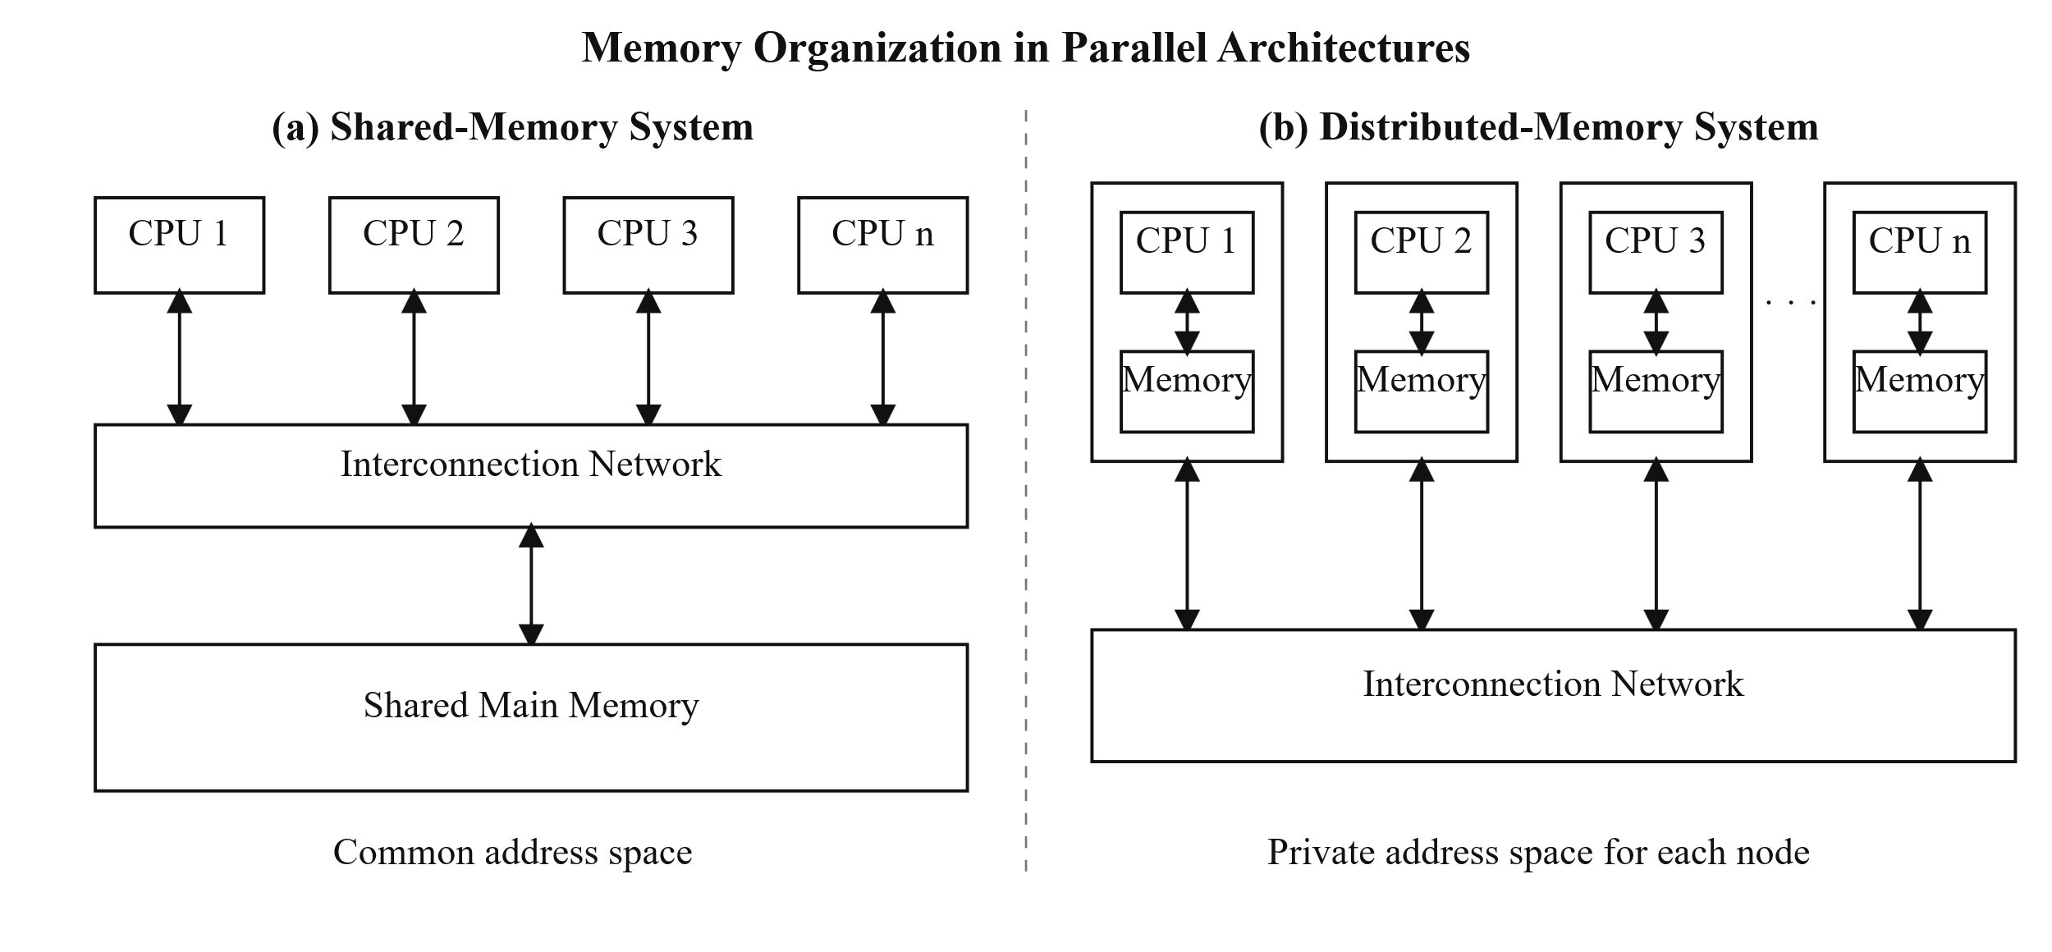
Figure 2.1. Memory organization in parallel architectures: (a) shared-memory system and (b) distributed-memory system (adapted from [33]).
Parallel architectures are commonly classified by memory organization, as shown in Figure 2.1. In a shared-memory system (Figure 2.1a), all processing units access a common main memory, whereas in a distributed-memory system (Figure 2.1b), each processing unit has its own local memory and exchanges data through messages over an interconnection network [33]. A multicore processor integrates two or more processing cores within a single processor package. These cores generally share access to the main memory, while cache levels may be private to individual cores or shared among multiple cores. Multicore architectures allow multiple processes or threads to execute in parallel. However, the achieved performance depends on workload distribution, synchronization, communication overhead, and memory-access behavior [33].
Multicore processors may be homogeneous or heterogeneous. A homogeneous architecture consists of cores with similar computational characteristics, whereas a heterogeneous architecture integrates core types with different performance and energy characteristics. Recent hybrid processors may combine performance-oriented cores, commonly called P-cores, with energy-efficient cores, commonly called E-cores, within the same processor [7], [37]. Because these core types may execute identical workloads at different rates, equal workload distribution can leave faster processing elements idle while they wait for slower ones at synchronization points. Consequently, workload allocation and task scheduling are important factors in the performance and energy efficiency of parallel applications executed on heterogeneous multicore systems [37].

2.8.2 Parallel Software
Parallel software organizes a computation so that multiple processing elements can perform useful work concurrently. A parallel program is commonly decomposed into processes or threads. Processes have separate address spaces and communicate through explicit mechanisms, whereas threads within the same process share an address space and can communicate through shared variables. In both cases, coordination is required to maintain correct execution and manage dependencies among concurrent operations [36].
Work can be decomposed using data parallelism or task parallelism. In data parallelism, the input dataset is divided into subsets, and the processing elements apply similar operations to their assigned data. In task parallelism, different processing elements execute different tasks or stages of a computation. The appropriate decomposition method depends on the algorithm's structure, the dependencies between operations, and the characteristics of the target hardware. Communication and synchronization are essential when concurrent operations exchange intermediate results or must reach a particular execution point before continuing. In shared-memory programs, communication generally occurs through shared variables, while synchronization mechanisms regulate concurrent access to these variables. In distributed-memory programs, processes communicate explicitly by sending and receiving data. Excessive communication, synchronization, or workload imbalance can reduce the performance gains from parallel execution [38].
Parallel programming models provide software mechanisms for managing concurrent execution. Pthreads and OpenMP are commonly associated with shared-memory systems, whereas message-passing models coordinate processes with separate address spaces. The Message Passing Interface (MPI) provides standardized communication routines and can be used on distributed-memory clusters as well as multicore systems in which each MPI process maintains a logically separate address space [39]. A hybrid programming model combines distributed-memory and shared-memory parallelism. In this model, MPI is typically used for communication between processes or computing nodes, while OpenMP or Pthreads provides thread-level parallelism within each multicore node [40], [41].
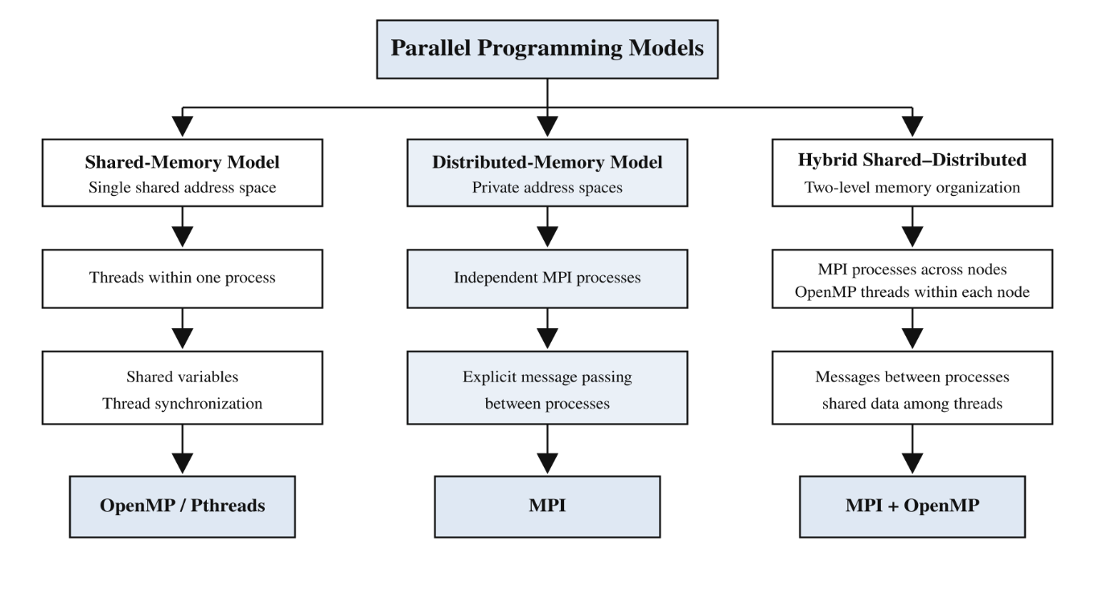
Figure 2.2. Classification of parallel programming models and associated programming tools, developed by the author based on [33]
Figure 2.2 presents a classification of parallel programming models and the associated programming tools. This thesis employs MPI to distribute the LBG training vectors and coordinate codebook training among multiple processes. Therefore, the following section presents the MPI programming model and the communication operations relevant to the parallel compression framework.

2.8.3 Amdahl's Law

Amdahl’s Law describes the speedup limit of a parallel program [42]. The speedup depends on the fraction of the program that remains sequential. If f_s denotes the sequential fraction and P denotes the number of processes, the theoretical speedup is:
$S(P) =\frac{1}{f_{s}+\frac{1-f_{s}}{p}}$ (2.16)

As P increases, the speedup approaches the upper limit 1/$f_{s}$. This limit remains even when you add more processes [42], [34]. Therefore, a sequential part can limit a parallel program.

Amdahl's Law highlights the importance of identifying and parallelizing the computationally dominant part of an application. Sequential operations, along with communication and synchronization overhead, can limit overall performance gains as the number of processing elements increases.

2.9 Message Passing Interface (MPI)
The Message Passing Interface (MPI) is a standardized library specification, not a programming language. It defines a collection of routines that can be called from C and Fortran programs to enable independent processes to exchange data and coordinate their execution. Although MPI is primarily associated with distributed-memory programming, multiple MPI processes can also execute on a shared-memory multicore system [33], [43].
MPI organizes processes into groups called communicators. The predefined communicator MPI_COMM_WORLD contains all processes launched during program execution, and each process within the communicator is assigned a unique integer identifier called a rank. The total number of processes and the rank of the calling process can be obtained using MPI_Comm_size and MPI_Comm_rank, respectively [33], [43].

This study classifies MPI communication operations as point-to-point and collective communication. Point-to-point communication transfers data between two specified processes, whereas collective communication requires participation from all processes belonging to a communicator [43].

2.9.1 Point-to-Point Communication
Point-to-point communication transfers a message from a specified source process to a specified destination process. The fundamental blocking operations used for this purpose are MPI_Send and MPI_Recv. An MPI message is identified by its source, destination, tag, and communicator, while the transferred data are described by a buffer, an element count, and an MPI datatype. The receive operation additionally returns a status object containing information about the received message [33], [43].
The simplified syntax of these operations is:
MPI_Send(buffer, count, datatype, destination, tag, communicator)
MPI_Recv(buffer, count, datatype, source, tag, communicator, status)
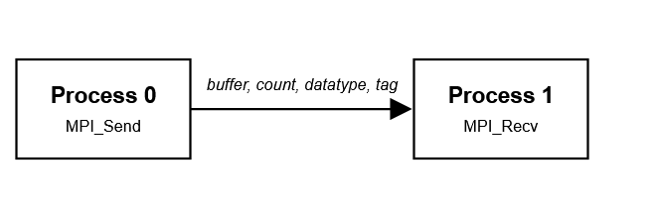
Figure 2.3. Point-to-point communication using MPI_Send and MPI_Recv.
Although point-to-point operations provide the fundamental mechanism for direct communication between MPI processes, the proposed parallel compression framework primarily uses collective communication operations.

2.9.2 Collective Communication
All processes within a communicator call collective communication operations to perform coordinated data movement, computation, or synchronization. However, a collective operation does not necessarily act as a global synchronization barrier unless the operation explicitly defines it as such [43].
The collective operations relevant to the proposed framework are described below.
A. Broadcast
MPI_Bcast distributes the contents of a buffer from a designated process, called the master (root) process, to every process in the communicator. After the operation has completed, all participating processes contain a copy of the broadcast data [43].

The simplified syntax is:

MPI_Bcast(buffer, count, datatype, root, communicator)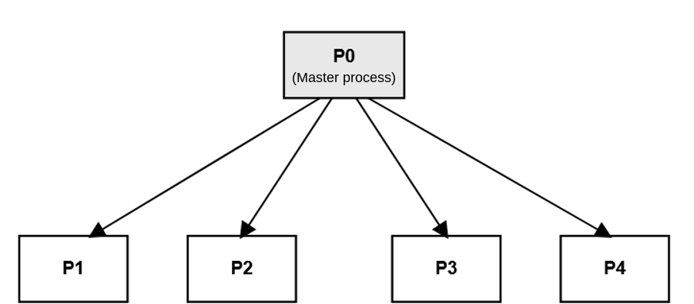
Figure 2.4. Data broadcasting from a root process to all processes in an MPI communicator.
B. Variable-Size Scatter and Gather
MPI_Scatterv distributes data from the master process to all processes in a communicator. Unlike MPI_Scatter, which sends an equal number of elements to every process, MPI_Scatterv allows the master process to send a different number of elements to each process. The sendcounts and displs arrays define the amount and location of the data assigned to each process, respectively [43].

The simplified syntax is:

MPI_Scatterv(sendbuf, sendcounts, displs, sendtype, recvbuf, recvcount, recvtype, root, communicator)

Conversely, MPI_Gatherv collects variable-sized contributions from all processes and stores them in the receive buffer of the master process. The number and location of the elements received from each process are specified by the recvcounts and displs arrays [43].

The simplified syntax is:

MPI_Gatherv (sendbuf, sendcount, sendtype, recvbuf, recvcounts, displs, recvtype,root,communicator)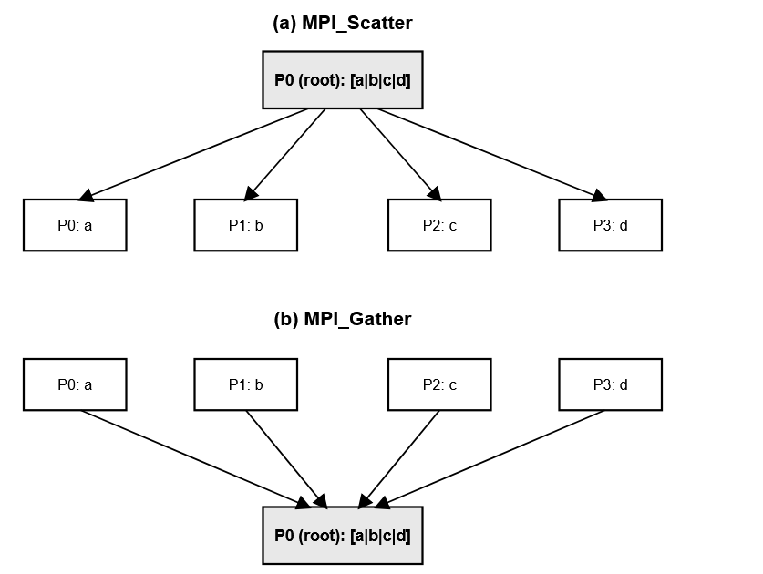
Figure 2.5.1 Variable-size data distribution and collection using MPI_Scatterv and MPI_Gatherv.
These variable-size collective operations suit the proposed framework because they support both Equal and Adaptive distribution of the LBG training vectors. MPI_Gatherv is subsequently used to collect the resulting VQ indices at the root process.

C. Allgather
MPI_Allgather collects an equal-sized contribution from every process and distributes the complete concatenated result to all processes within the communicator. As a result, every participating process receives the contributions from all other processes [43].
The simplified syntax is:
MPI_Allgather(sendbuf, sendcount, sendtype, recvbuf, recvcount, recvtype, communicator)

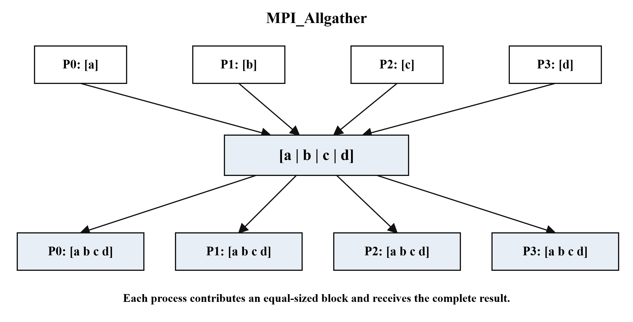
Figure 2.6. Data collection and distribution among all processes using MPI_Allgather

In the Adaptive distribution strategy, MPI_Allgather exchanges the computation rate measured for each MPI process before distributing the training vectors.

D. Allreduce Routines
MPI_Allreduce combines the local values contributed by all processes using a specified reduction operator and makes the resulting value available to every participating process. Common predefined reduction operators include summation, minimum, and maximum. Unlike MPI_Reduce, which returns the result only to a designated root process, MPI_Allreduce returns an identical result to every process within the communicator [43].
The simplified syntax is:
MPI_Allreduce(sendbuf, recvbuf, count, datatype, operation, communicator)
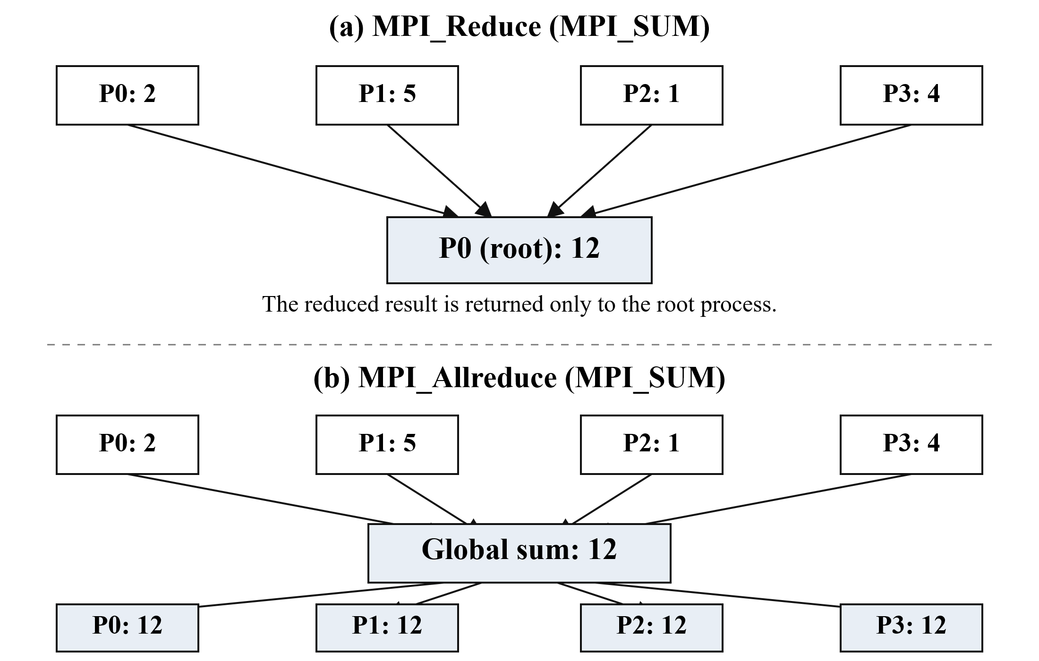
Figure 2.7. Global reduction and result distribution using MPI_Allreduce

In the parallel LBG training stage, MPI_Allreduce combines the locally computed codeword sums, cluster counts, and distortion values. This operation lets all processes update and maintain a consistent global codebook across successive training iterations.
E. Barrier Synchronization
MPI_Barrier is a collective synchronization operation that blocks each participating process until all processes in the communicator have reached the barrier. A process can continue beyond the barrier only after every other participating process has entered the same operation [43].
The simplified syntax is:
MPI_Barrier (communicator)
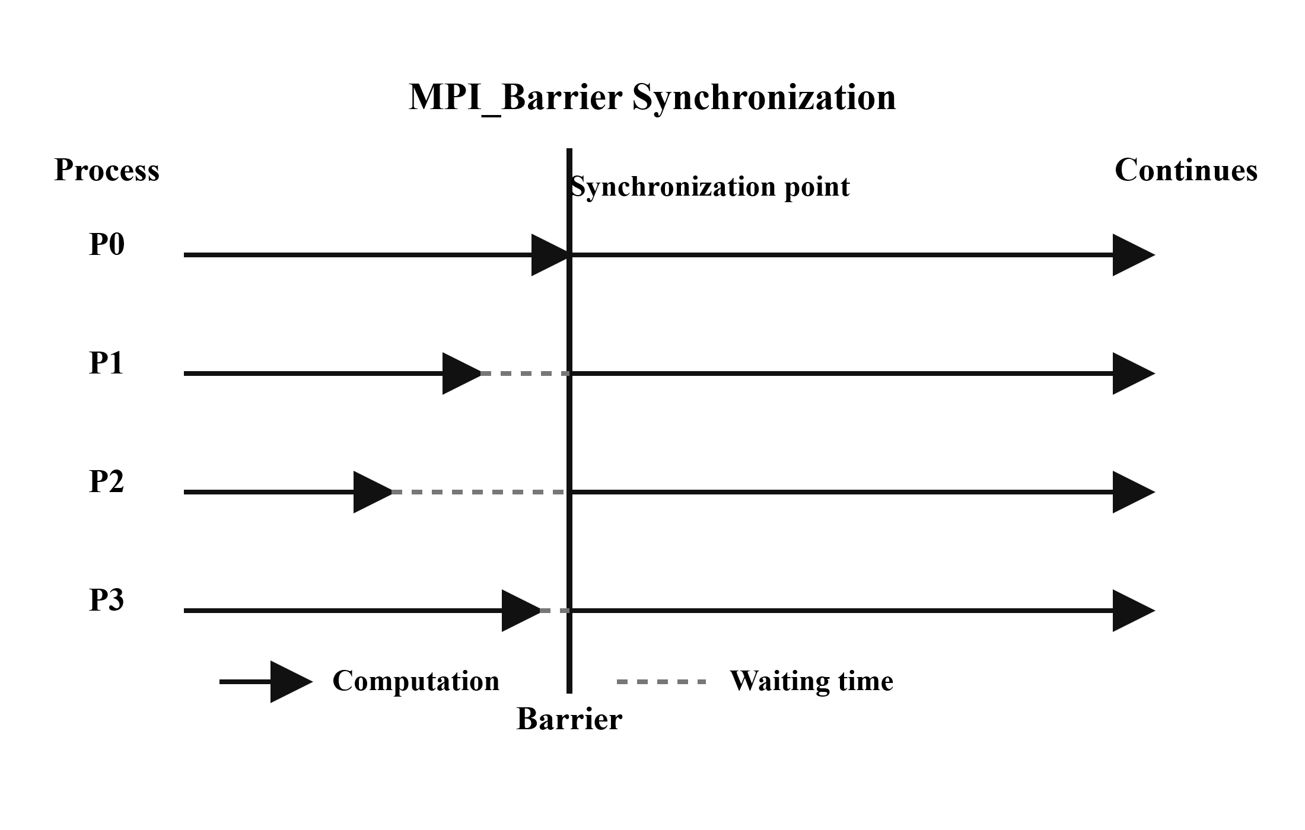
Figure 2.8. Synchronization of MPI processes at a global barrier.

2.10 Load Balancing in a Parallel System

Load balancing distributes computational work among parallel processes to improve resource utilization and reduce execution time. Load-balancing strategies are commonly classified as static or dynamic. Static load balancing uses information about the workload or computing system before execution, whereas dynamic load balancing relies on information collected during execution to detect imbalance and redistribute work at runtime [44].
Load imbalance occurs when parallel processes require different amounts of time to complete their assigned work. It may result from unequal task distribution, variations in computational complexity, conditional execution paths, or differences in the underlying hardware's processing capabilities. Consequently, some processes may finish earlier and remain idle while waiting for slower processes at communication or synchronization points [45].
The objective of load balancing is to minimize differences in process completion times while maintaining acceptable communication and redistribution overhead. In heterogeneous computing environments, achieving this objective may require assigning different workload sizes according to the processing capability of each computational resource [44], [45]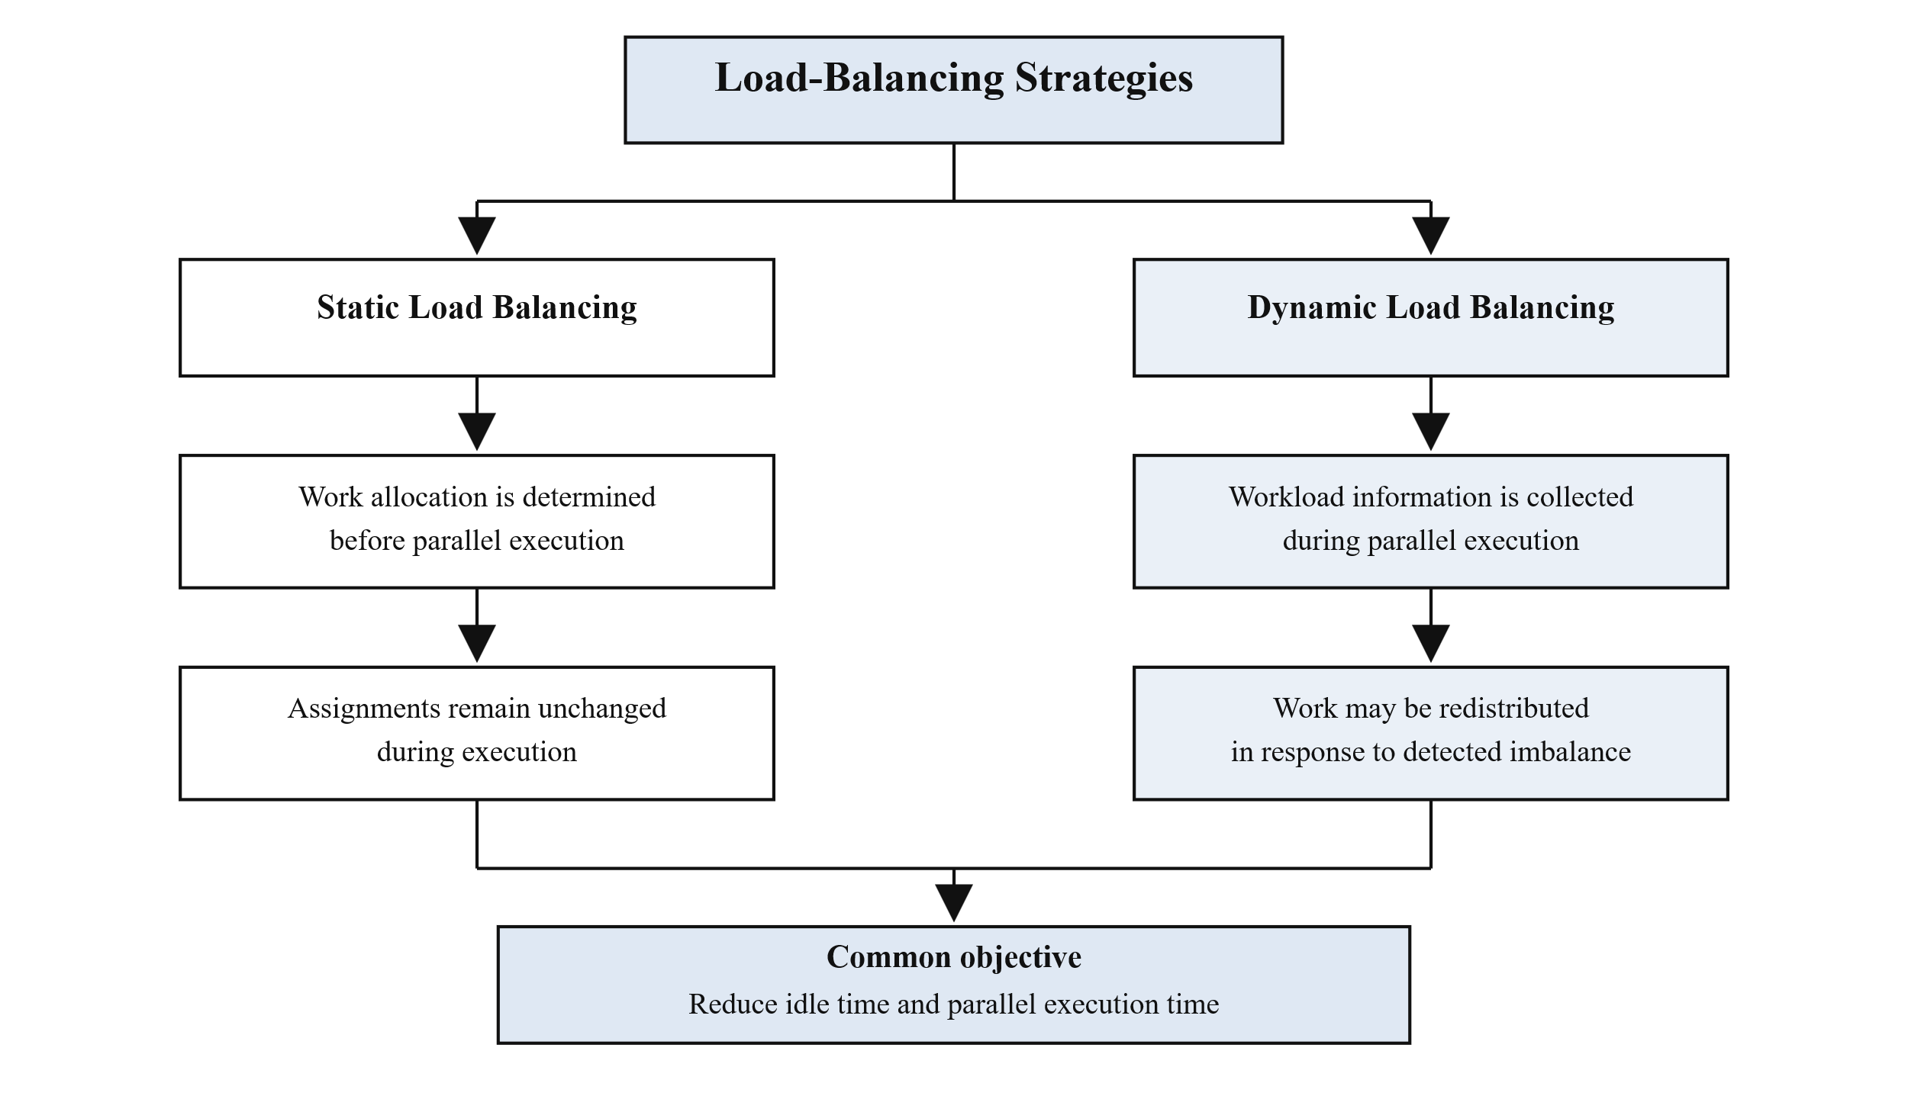
Figure 2.9. General classification of load-balancing strategies in parallel computing.

2.11 Summary
This chapter presented the theoretical background of the proposed parallel image compression framework. Image compression was classified as lossless or lossy. This chapter introduced vector quantization as a lossy compression method and described the Linde–Buzo–Gray (LBG) algorithm as an iterative codebook-generation method. For color images, vector quantization was described by treating each RGB channel separately and training a separate codebook for each channel.

The chapter presented delta coding and Huffman coding as lossless coding stages that reduce the statistical redundancy of the quantization indices. The single-symbol case in Huffman coding was also discussed. The chapter then defined the compression and image-quality metrics used in the evaluation, including CR, MSE, PSNR, and SSIM. The chapter also defined parallel performance metrics, including speedup, parallel efficiency, throughput, and the Karp–Flatt metric.

The second part of the chapter focused on parallel computing concepts relevant to the proposed implementation. The chapter reviewed Flynn's taxonomy and shared- and distributed-memory architectures. The chapter also discussed homogeneous and heterogeneous multicore systems, emphasizing how differences in processing capability affect workload distribution. The text then introduced data parallelism, task parallelism, and common parallel programming models.

Amdahl's Law was presented to explain how a program's sequential fraction can limit parallel speedup. The Message Passing Interface (MPI) was then discussed, together with the main communication operations relevant to the proposed framework, including Broadcast, Scatterv/Gatherv, Allgather, Allreduce, and Barrier. Finally, the chapter discussed static and dynamic load-balancing strategies, providing the theoretical basis for workload distribution on heterogeneous processing resources.

Building on these theoretical foundations, Chapter Three presents the proposed parallel hybrid image compression framework and its MPI-based implementation of the LBG training stage.

References
[1] S. Thomas, A. Krishna, S. Govind, and A. K. Sahu, "A novel image compression method using wavelet coefficients and Huffman coding," Journal of Engineering Research, vol. 13, no. 1, pp. 361-370, 2025, doi: 10.1016/j.jer.2023.08.015.
[2] V.-I. Ungureanu, P. Negirla, and A. Korodi, "Image-compression techniques: Classical and 'region-of-interest-based' approaches presented in recent papers," Sensors, vol. 24, no. 3, Art. no. 791, 2024, doi: 10.3390/s24030791.
[3] R. Ranjan and P. Kumar, "An improved image compression algorithm using 2D DWT and PCA with canonical Huffman encoding," Entropy, vol. 25, no. 10, Art. no. 1382, 2023, doi: 10.3390/e25101382.
[4] M. Bilal, Z. Ullah, O. Mujahid, and T. Fouzder, "Fast Linde-Buzo-Gray (FLBG) algorithm for image compression through rescaling using bilinear interpolation," Journal of Imaging, vol. 10, no. 5, Art. no. 124, 2024, doi: 10.3390/jimaging10050124.
[5] V. Severo, F. B. S. Ferreira, R. Spencer, A. Nascimento, and F. Madeiro, "On the initialization of swarm intelligence algorithms for vector quantization codebook design," Sensors, vol. 24, no. 8, Art. no. 2606, 2024, doi: 10.3390/s24082606.
[6] M. Hu, K. Li, J. Wan, T. Chen, and Z. Xiang, "Research on a parallel algorithm for video image compression of transmission line inspection," in Proc. Int. Conf. Big Data Mining and Information Processing (BDMIP '23), 2023, doi: 10.1145/3645279.3645280.
[7] N. Velugoti, J. Manzano, N. Tallent, and K. Hale, "Effects of hybrid CPU and cache architectures on parallel HPC/cloud applications," arXiv:2608.23165, 2026.
[8] A. Fernandez-Fraga, J. Gonzalez-Dominguez, and M. J. Martin, "Applying dynamic balancing to improve the performance of MPI parallel genomics applications," in Proc. 39th ACM/SIGAPP Symp. Applied Computing (SAC '24), 2024, doi: 10.1145/3605098.3635986.
[9] P. Piscaglia, B. Macq, and P. Maes, "Distributed optimization of codebooks," Signal Processing: Image Communication, vol. 7, pp. 211-223, 1995, doi: 10.1016/0923-5965(94)00026-F.
[10] H. M. Abbas and M. M. Bayoumi, "Parallel codebook design for vector quantization on a message passing MIMD architecture," Parallel Computing, 2002.
[11] G. Campobello et al., "LBGS: A smart approach for very large data sets vector quantization," Signal Processing: Image Communication, 2004.
[12] A. Wakatani, "Parallelization of VQ codebook generation by two algorithms: Parallel LBG and aggressive PNN," in Proc. Data Compression Conf. (DCC), IEEE, 2005.
[13] R. Annaji and S. Rao, "Parallelization of the LBG vector quantization algorithm for shared memory systems," International Journal of Image Processing, vol. 3, no. 4, pp. 170-183, 2009, arXiv:0910.4711.
[14] F. J. Hernandez-Lopez and O. Muniz-Perez, "Parallel fractal image compression using quadtree partition with task and dynamic parallelism," Journal of Real-Time Image Processing, vol. 19, no. 2, pp. 391-402, 2022, doi: 10.1007/s11554-021-01193-w.
[15] J. Pang, J. He, H. Guo, and M. Chen, "A parallel compression framework for fractal images using DCT block classification," in Proc. IEEE IUCC/CIT/DSCI/SmartCNS, 2022, pp. 245-253, doi: 10.1109/IUCC-CIT-DSCI-SmartCNS57392.2022.00047.
[16] H. M. Zangana, "Design and implementation of a novel parallel algorithm for efficient image compression in high-performance computing," EAI Endorsed Transactions on AI and Robotics, vol. 4, 2025, doi: 10.4108/airo.7832.
[17] M. Li and K. U, "Fast fractal image compression using non-uniform partition," Electronics, vol. 15, no. 5, Art. no. 922, 2026, doi: 10.3390/electronics15050922.
[18] O. Bystrov, R. Pacevic, and A. Kaceniauskas, "Hybrid parallelization of discrete element software for heterogeneous resources," in Proc. 7th Int. Conf. Parallel, Distributed, GPU and Cloud Computing for Engineering, Civil-Comp Conferences, vol. 4, Paper 4.1, 2023, doi: 10.4203/ccc.4.4.1.
[19] P. Kulkarni and M. Dixit, "Enhancing visual perception in image compression through an adaptive DCT-SVD hybrid algorithm," Results in Engineering, vol. 28, Art. no. 107205, Dec. 2025, doi: 10.1016/j.rineng.2025.107205.
[20] Y. Mao, J. Wang, N. Guan, and C. J. Xue, "WISE: A framework for gigapixel whole-slide-image lossless compression," in Proc. IEEE/CVF Conf. Computer Vision and Pattern Recognition (CVPR), Nashville, TN, USA, 2025, pp. 29342-29351, doi: 10.1109/CVPR52734.2025.02732.
[21] Y. Vijaywargiya and R. K. Pandey, "Hybrid image compression algorithm based on singular value decomposition and discrete wavelet transform," Procedia Computer Science, vol. 260, pp. 1043-1051, 2025, doi: 10.1016/j.procs.2025.03.289.
[22] S. Mohammadi, M. Jenadeleh, J. Sneyers, D. Saupe, and J. Ascenso, "Evaluation of objective image quality metrics for high-fidelity image compression," IEEE Access, vol. 14, pp. 35651-35668, 2026, doi: 10.1109/ACCESS.2026.3669417.
[23] F. Abedi and A. F. Al-Baghdadi, "Multi-objective optimization for vector quantization via genetic algorithm," Optics Continuum, vol. 3, no. 5, pp. 808-822, May 2024, doi: 10.1364/OPTCON.517311.
[24] F. D. Camacho-Gonzalez, D. Lima-Lopez, S. Zapotecas-Martinez, and L. Altamirano-Robles, "Vector quantization-driven image compression through multi-objective evolutionary algorithms," Expert Systems with Applications, vol. 261, Art. no. 125512, 2025, doi: 10.1016/j.eswa.2024.125512.
[25] Y. Lin, J.-C. Liu, C.-C. Chang, and C.-C. Chang, "Lossless recompression of vector quantization index table for texture images based on adaptive Huffman coding through multi-type processing," Symmetry, vol. 16, no. 11, Art. no. 1419, Oct. 2024, doi: 10.3390/sym16111419.
[26] Y. Lin, J.-C. Liu, C.-C. Chang, and C.-C. Chang, "An innovative recompression scheme for VQ index tables," Future Internet, vol. 16, no. 8, Art. no. 297, 2024, doi: 10.3390/fi16080297.
[27] Y. Linde, A. Buzo, and R. M. Gray, "An algorithm for vector quantizer design," IEEE Transactions on Communications, vol. 28, no. 1, pp. 84-95, Jan. 1980.
[28] K. Sayood, Introduction to Data Compression, 3rd ed. San Francisco, CA, USA: Morgan Kaufmann, 2006.
[29] H. Shiba, Z. Zhu, P. Finnerty, and C. Ohta, "Delta coding with dead-zone quantization for bandwidth-efficient split computing on video streams," IEEE Access, vol. 14, pp. 68357-68375, 2026, doi: 10.1109/ACCESS.2026.3690477.
[30] D. A. Huffman, "A method for the construction of minimum-redundancy codes," Proceedings of the IRE, vol. 40, no. 9, pp. 1098-1101, Sep. 1952.
[31] Y. Zhu, Y. Liu, Y. Zhu, M. Huang, J. Jiang, and Y. Zhang, "Lossy infrared image compression based on wavelet coefficient probability modeling and run-length-enhanced Huffman coding," Sensors, vol. 25, no. 8, p. 2491, Apr. 2025, doi: 10.3390/s25082491.
[32] Z. Wang, A. C. Bovik, H. R. Sheikh, and E. P. Simoncelli, "Image quality assessment: From error visibility to structural similarity," IEEE Transactions on Image Processing, vol. 13, no. 4, pp. 600-612, Apr. 2004.
[33] P. S. Pacheco and M. Malensek, An Introduction to Parallel Programming, 2nd ed. Cambridge, MA, USA: Morgan Kaufmann, 2021.
[34] G. Schryen, "Speedup and efficiency of computational parallelization: A unifying approach and asymptotic analysis," Journal of Parallel and Distributed Computing, vol. 187, Art. no. 104835, 2024, doi: 10.1016/j.jpdc.2023.104835.
[35] A. H. Karp and H. P. Flatt, "Measuring parallel processor performance," Communications of the ACM, vol. 33, no. 5, pp. 539-543, May 1990.
[36] A. Pousa, V. Sanz, M. Naiouf, and A. De Giusti, "Trends in high performance computing and quantum computing," Journal of Computer Science & Technology, vol. 24, no. 2, pp. 111-119, Oct. 2024, doi: 10.24215/16666038.24.e11.
[37] Y. Idouar, A. Cassagne, L. L. Pilla, J. Sopena, M. Bouyer, D. Orhan, L. Lacassagne, D. Galayko, D. Barthou, and C. Jego, "Energy-aware scheduling strategies for partially-replicable task chains on heterogeneous processors," Parallel Computing, Art. no. 103206, 2026, doi: 10.1016/j.parco.2026.103206.
[38] J. Huang, S. Di, X. Yu, et al., "An optimized error-controlled MPI collective framework integrated with lossy compression," in Proc. IEEE Int. Parallel and Distributed Processing Symp. (IPDPS), 2024, pp. 752-764, doi: 10.1109/IPDPS57955.2024.00072.
[39] G. Mitterrutzner, P. Thoman, and P. Gschwandtner, "A high-level API for end-to-end data compression in multi-GPU cluster applications," International Journal of Parallel Programming, vol. 54, no. 14, 2026, doi: 10.1007/s10766-026-00818-6.
[40] A. Daher, "Enhancing computational efficiency of PSU-WOPWOP through MPI-based parallelization," M.S. thesis, Dept. Aerosp. Eng., Pennsylvania State Univ., University Park, PA, USA, 2025.
[41] S. T. Ogunji, M. Sanchez-Adame, O. H. Montiel, and J. J. Tapia, "Performance analysis of parallel programs with RAPIDS as a framework of execution," EPiC Series in Computing, vol. 104, pp. 243-267, 2024.
[42] G. M. Amdahl, "Validity of the single processor approach to achieving large scale computing capabilities," in Proc. AFIPS Spring Joint Computer Conf., vol. 30, 1967, pp. 483-485.
[43] Message Passing Interface Forum, MPI: A Message-Passing Interface Standard, Version 4.1, Nov. 2, 2023. [Online]. Available: https://www.mpi-forum.org/docs/mpi-4.1/mpi41-report.pdf
[44] M. T. Chung, J. Weidendorfer, K. Furlinger, and D. Kranzlmuller, "From reactive to proactive load balancing for task-based parallel applications in distributed memory machines," Concurrency and Computation: Practice and Experience, vol. 35, no. 24, Art. no. e7828, 2023, doi: 10.1002/cpe.7828.
[45] J. B. Fernandes, I. A. S. de Assis, I. M. S. Martins, T. Barros, and S. Xavier-de-Souza, "Adaptive asynchronous work-stealing for distributed load-balancing in heterogeneous systems," arXiv:2401.04494, Jan. 2024.

