Chapter 4 numeric tables and Section 4.7 text
Every number below was generated by code from final_results.xlsx and then re-read from this file and compared with the source. Image names for the two color brain images are provisional (MRI/PET to be decided).
Table 4.3. Compression and reconstruction quality of the grayscale images.
Image | CR (×) | BPP | MSE | PSNR (dB) | SSIM | LBG iterations
Lena | 23.50 | 0.3404 | 58.77 | 30.44 | 0.8431 | 160
Boat | 26.54 | 0.3014 | 70.46 | 29.65 | 0.8522 | 151
Cameraman | 28.88 | 0.2770 | 56.66 | 30.60 | 0.9031 | 155
Peppers | 24.75 | 0.3232 | 61.51 | 30.24 | 0.7875 | 132
Chest X-ray | 23.39 | 0.3420 | 25.05 | 34.14 | 0.8890 | 125
Mammogram | 31.56 | 0.2535 | 13.81 | 36.73 | 0.9392 | 98
Lung CT | 24.63 | 0.3248 | 83.81 | 28.90 | 0.8666 | 197
Brain MRI | 33.49 | 0.2389 | 23.08 | 34.50 | 0.9474 | 142

Table 4.4. Compression and reconstruction quality of the color images (RGB).
Image | RGB CR (×) | BPP | RGB MSE | RGB PSNR (dB) | Mean SSIM | LBG iterations (R+G+B)
Color Lena | 24.00 | 0.3333 | 75.25 | 29.37 | 0.7733 | 476
Retinal fundus | 34.07 | 0.2348 | 5.97 | 40.37 | 0.9541 | 493
Brain axial | 25.05 | 0.3194 | 94.94 | 28.36 | 0.8793 | 495
Brain sagittal | 22.24 | 0.3597 | 53.82 | 30.82 | 0.8995 | 502

Table 4.5. Sequential execution time of the grayscale images.
Image | LBG time (s) | Total time (s) | LBG iterations
Lena | 0.2639 | 0.3483 | 160
Boat | 0.2322 | 0.3169 | 151
Cameraman | 0.2374 | 0.3226 | 155
Peppers | 0.2808 | 0.3651 | 132
Chest X-ray | 0.2331 | 0.3175 | 125
Mammogram | 0.2086 | 0.2922 | 98
Lung CT | 0.2909 | 0.3760 | 197
Brain MRI | 0.2452 | 0.3281 | 142

Table 4.6. Sequential execution time of the color images.
Image | LBG time, R+G+B (s) | Total time (s) | LBG iterations, R+G+B
Color Lena | 0.7677 | 0.9741 | 476
Retinal fundus | 0.6573 | 0.8640 | 493
Brain axial | 0.8050 | 1.0114 | 495
Brain sagittal | 0.7811 | 0.9869 | 502

Tables 4.7 – 4.9 (parallel performance)
Table 4.7. Mean LBG speedup, parallel efficiency, and Karp–Flatt metric across the twelve images.
P | Speedup | Min | Max | Efficiency (%) | Karp–Flatt e
2 | 1.92 | 1.91 | 1.93 | 96.0 | 0.0417
4 | 3.76 | 3.73 | 3.79 | 94.0 | 0.0214
6 | 5.37 | 5.34 | 5.39 | 89.4 | 0.0236
8 | 6.27 | 6.24 | 6.31 | 78.4 | 0.0393
10 | 7.31 | 7.28 | 7.34 | 73.1 | 0.0408
12 | 8.18 | 8.14 | 8.21 | 68.2 | 0.0425
14 | 9.12 | 9.03 | 9.18 | 65.1 | 0.0412

Table 4.8. LBG speedup of each image at different MPI process counts.
Image | P=2 | P=4 | P=6 | P=8 | P=10 | P=12 | P=14
Lena | 1.92 | 3.74 | 5.35 | 6.27 | 7.31 | 8.17 | 9.16
Boat | 1.92 | 3.75 | 5.39 | 6.28 | 7.32 | 8.18 | 9.07
Cameraman | 1.93 | 3.73 | 5.38 | 6.26 | 7.30 | 8.19 | 9.06
Peppers | 1.92 | 3.76 | 5.38 | 6.31 | 7.33 | 8.19 | 9.18
Chest X-ray | 1.92 | 3.77 | 5.37 | 6.28 | 7.28 | 8.15 | 9.07
Mammogram | 1.92 | 3.76 | 5.38 | 6.28 | 7.32 | 8.18 | 9.15
Lung CT | 1.92 | 3.74 | 5.37 | 6.24 | 7.33 | 8.17 | 9.15
Brain MRI | 1.92 | 3.77 | 5.34 | 6.30 | 7.34 | 8.20 | 9.18
Color Lena | 1.92 | 3.77 | 5.36 | 6.29 | 7.33 | 8.21 | 9.03
Retinal fundus | 1.92 | 3.79 | 5.35 | 6.25 | 7.29 | 8.14 | 9.15
Brain axial | 1.92 | 3.77 | 5.38 | 6.26 | 7.30 | 8.17 | 9.09
Brain sagittal | 1.91 | 3.76 | 5.35 | 6.26 | 7.31 | 8.20 | 9.09

Table 4.9. Mean total execution-time speedup, parallel efficiency, and Karp–Flatt metric across the twelve images.
P | Speedup | Min | Max | Grayscale | Color | Efficiency (%) | Karp–Flatt e
2 | 1.75 | 1.70 | 1.81 | 1.72 | 1.81 | 87.5 | 0.1423
4 | 2.95 | 2.73 | 3.23 | 2.82 | 3.20 | 73.7 | 0.1189
6 | 3.71 | 3.36 | 4.21 | 3.48 | 4.16 | 61.8 | 0.1235
8 | 3.94 | 3.48 | 4.54 | 3.67 | 4.47 | 49.2 | 0.1473
10 | 4.33 | 3.79 | 5.08 | 4.00 | 4.99 | 43.3 | 0.1454
12 | 4.62 | 3.95 | 5.47 | 4.23 | 5.40 | 38.5 | 0.1453
14 | 4.90 | 4.17 | 5.91 | 4.45 | 5.79 | 35.0 | 0.1430

Tables 4.10 – 4.11 (bilateral filtering)
Table 4.10. MSE and PSNR without and with bilateral filtering.
Image | MSE (no filter) | MSE (filter) | PSNR (no filter, dB) | PSNR (filter, dB) | ΔPSNR (dB)
Lena | 70.13 | 58.77 | 29.67 | 30.44 | +0.77
Boat | 79.88 | 70.46 | 29.11 | 29.65 | +0.54
Cameraman | 68.84 | 56.66 | 29.75 | 30.60 | +0.85
Peppers | 74.47 | 61.51 | 29.41 | 30.24 | +0.83
Chest X-ray | 32.08 | 25.05 | 33.07 | 34.14 | +1.07
Mammogram | 18.33 | 13.81 | 35.50 | 36.73 | +1.23
Lung CT | 103.37 | 83.81 | 27.99 | 28.90 | +0.91
Brain MRI | 29.99 | 23.08 | 33.36 | 34.50 | +1.14
Color Lena | 83.60 | 75.25 | 28.91 | 29.37 | +0.46
Retinal fundus | 7.30 | 5.97 | 39.50 | 40.37 | +0.87
Brain axial | 125.48 | 94.94 | 27.14 | 28.36 | +1.22
Brain sagittal | 80.09 | 53.82 | 29.10 | 30.82 | +1.72
Mean | 64.46 | 51.93 | 31.04 | 32.01 | +0.97

Table 4.11. SSIM without and with bilateral filtering.
Image | SSIM (no filter) | SSIM (filter) | ΔSSIM
Lena | 0.8190 | 0.8431 | +0.0241
Boat | 0.8394 | 0.8522 | +0.0128
Cameraman | 0.8855 | 0.9031 | +0.0176
Peppers | 0.7624 | 0.7875 | +0.0251
Chest X-ray | 0.8559 | 0.8890 | +0.0331
Mammogram | 0.9129 | 0.9392 | +0.0263
Lung CT | 0.8462 | 0.8666 | +0.0204
Brain MRI | 0.9347 | 0.9474 | +0.0127
Color Lena | 0.7594 | 0.7733 | +0.0139
Retinal fundus | 0.9466 | 0.9541 | +0.0075
Brain axial | 0.8529 | 0.8793 | +0.0264
Brain sagittal | 0.8604 | 0.8995 | +0.0391
Mean | 0.8563 | 0.8779 | +0.0216

4.7 Equal and Adaptive Workload Distribution
This section compares the two workload-distribution strategies described in Section 3.4. Both strategies were run with the same program, the same twelve images, the same process binding, and in the same measurement session. For each process count, the strategy was forced explicitly, and the two strategies were run alternately, with the order alternated between repetitions. Each value is the median of five runs. LBG time and total execution time were recorded in the same runs. The speed calibration of the adaptive strategy is performed before the timed LBG region, so it is not included in the LBG time, but it is included in the total execution time. The adaptive gain was calculated as (T_Equal − T_Adaptive) / T_Equal. The total execution time is printed by the program with a resolution of 1 ms.
Table 4.12. Mean LBG time (s) with the Equal and Adaptive strategies.
P | Grayscale: Equal | Grayscale: Adaptive | Gain (%) | Color: Equal | Color: Adaptive | Gain (%)
2 | 0.1297 | 0.1299 | -0.2 | 0.3920 | 0.3931 | -0.3
4 | 0.0659 | 0.0660 | -0.2 | 0.1988 | 0.1991 | -0.1
6 | 0.0463 | 0.0464 | -0.3 | 0.1404 | 0.1400 | 0.3
8 | 0.0554 | 0.0398 | 28.3 | 0.1681 | 0.1201 | 28.6
10 | 0.0448 | 0.0340 | 24.1 | 0.1355 | 0.1029 | 24.0
12 | 0.0382 | 0.0307 | 19.8 | 0.1154 | 0.0917 | 20.5
14 | 0.0333 | 0.0279 | 16.1 | 0.0998 | 0.0823 | 17.6

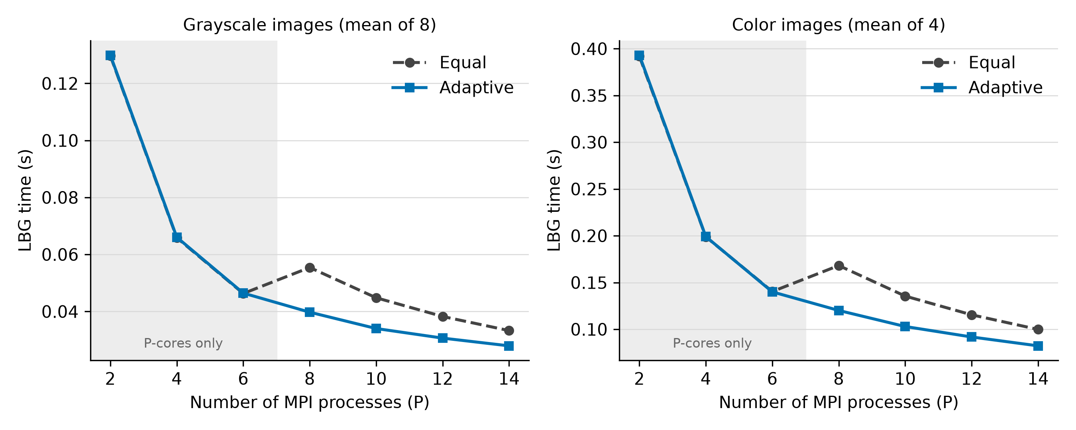
Figure 4.1. LBG time with the Equal and Adaptive strategies (grayscale and color images).
Table 4.13. Adaptive gain over Equal across the twelve images (LBG time and total time).
P | LBG mean gain (%) | Min | Max | Total mean gain (%) | Min | Max | Images with total gain > 1%
2 | -0.2 | -0.4 | 0.1 | -0.4 | -1.1 | 0.0 | 0 of 12
4 | -0.2 | -0.8 | 0.2 | -0.4 | -0.9 | 0.0 | 0 of 12
6 | -0.1 | -1.1 | 1.1 | -0.5 | -1.1 | 0.0 | 0 of 12
8 | 28.4 | 26.1 | 28.9 | 15.2 | 12.5 | 18.3 | 12 of 12
10 | 24.1 | 23.7 | 24.3 | 11.8 | 9.4 | 14.6 | 12 of 12
12 | 20.1 | 15.6 | 20.8 | 8.8 | 6.0 | 12.1 | 12 of 12
14 | 16.6 | 12.2 | 18.0 | 6.8 | 4.0 | 9.6 | 12 of 12

For P ≤ 6, all processes ran on P-cores, and the two strategies gave the same LBG time within -1.1% to +1.1% for every image. The adaptive distribution therefore brought no benefit in this region. The total execution time with the Adaptive strategy was slightly higher on average (by 0.4%, 0.4%, and 0.5% at P = 2, 4, and 6). This difference is of the order of the 1 ms resolution of the total time, and it is consistent with the calibration that is included in the total time; the calibration cost was not measured separately. P = 5 was not measured.
The behavior changed when the processes began to run on E-cores. With the Equal strategy, the LBG time increased from P = 6 to P = 8, from 0.0463 s to 0.0554 s for the grayscale images (19.7%) and from 0.1404 s to 0.1681 s for the color images (19.8%). With the Adaptive strategy, the time continued to decrease. The Adaptive strategy was faster for all twelve images at every P ≥ 8. The mean LBG gain was 28.4% at P = 8 and decreased to 16.6% at P = 14.
Table 4.14 shows whether this gain carried over to the complete program.
Table 4.14. Mean total execution time (s) with the Equal and Adaptive strategies.
P | Grayscale: Equal | Grayscale: Adaptive | Gain (%) | Color: Equal | Color: Adaptive | Gain (%)
2 | 0.193 | 0.194 | -0.5 | 0.530 | 0.532 | -0.2
4 | 0.117 | 0.118 | -0.5 | 0.298 | 0.299 | -0.3
6 | 0.095 | 0.095 | -0.7 | 0.229 | 0.230 | -0.2
8 | 0.105 | 0.090 | 13.8 | 0.261 | 0.214 | 17.9
10 | 0.093 | 0.083 | 10.6 | 0.223 | 0.192 | 14.1
12 | 0.085 | 0.079 | 7.5 | 0.200 | 0.177 | 11.5
14 | 0.080 | 0.075 | 5.5 | 0.181 | 0.164 | 9.4

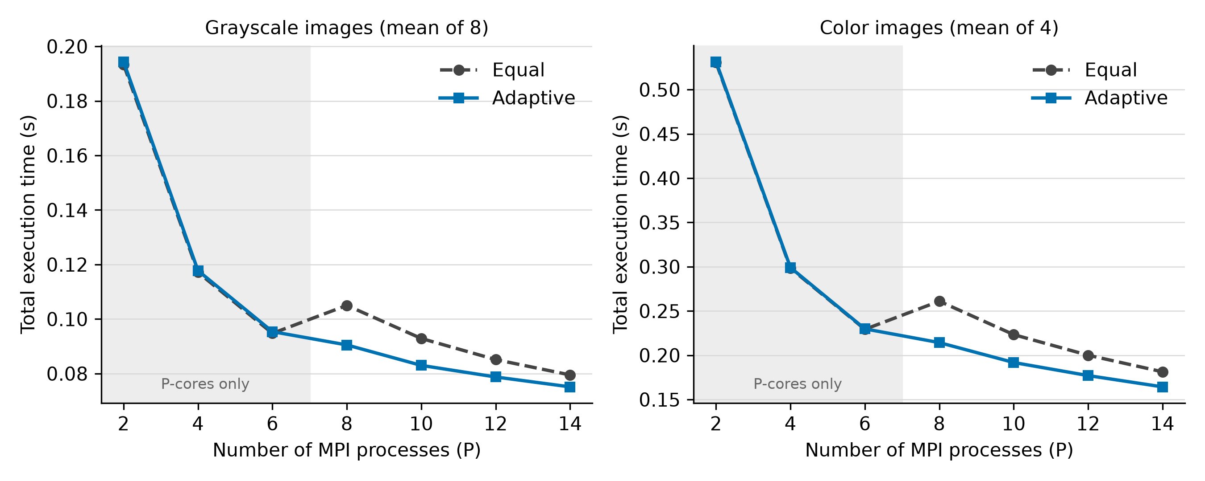
Figure 4.2. Total execution time with the Equal and Adaptive strategies (grayscale and color images).
The Adaptive strategy also reduced the total execution time for all twelve images at every P ≥ 8. The mean gain was 15.2% at P = 8, 11.8% at P = 10, 8.8% at P = 12, and 6.8% at P = 14. The gain was larger for the color images than for the grayscale images (Table 4.14), in line with the larger share of LBG in their sequential time (Section 4.4). The reduction in total time was close to the reduction in LBG time in absolute terms. At P = 8, the mean reduction for the grayscale images was 14.5 ms in total time and 15.7 ms in LBG time. At P = 14, it was 4.4 ms and 5.4 ms. For the color images, the corresponding values were 46.8 ms and 48.0 ms at P = 8, and 17.0 ms and 17.5 ms at P = 14. The difference between the two reductions was 1.2 ms and 1.0 ms for the grayscale images and 1.3 ms and 0.6 ms for the color images at P = 8 and P = 14, which gives an indicative upper bound for the calibration cost, limited by the 1 ms resolution of the total time. The calibration cost was therefore small compared with the time saved by the better workload balance.
A simple capacity model is consistent with this behavior. The calibration measured a throughput of about 275 Mcmp/s for the P-core ranks and about 176.5 Mcmp/s for the E-core ranks, a ratio of r = 0.642. With the Equal strategy, every rank receives N/P vectors, so the slowest (E-core) rank determines the time. With an ideal speed-proportional distribution, the time is proportional to N divided by the sum of the rank speeds. For P > 6, the model gives an adaptive gain of 1 − P·r / (6 + (P − 6)·r). This predicts 29.5%, 25.1%, 21.8%, and 19.3% at P = 8, 10, 12, and 14, against the measured 28.4%, 24.1%, 20.1%, and 16.6%. The model overestimates the gain by 1.0 to 2.7 percentage points, which is expected because it ignores communication and fixed costs. The model also predicts that the Equal strategy becomes about 17% slower from P = 6 to P = 8, whereas about 20% was observed. The value of r was taken from the calibration, and it was not fitted to the timing results.
An earlier measurement session, which recorded only the LBG time, gave mean LBG gains of 28.5%, 24.1%, 20.6%, and 17.7% at P = 8, 10, 12, and 14, which differs from the values above by at most 1.2 percentage points. In 5 image–process combinations (Peppers at P = 8, Chest X-ray at P = 14, Mammogram at P = 14, Lung CT at P = 12, Lung CT at P = 14), the Adaptive LBG time was more than 2 percentage points less favorable than in the earlier session.
These five combinations were measured again, with ten alternated runs each and with the calibrated rank speeds recorded (Table 4.15). The re-measured Adaptive times agreed with the earlier session and not with the main campaign, so the main-campaign values for these cells were probably affected by a transient disturbance that did not recur. The Equal times were practically the same in all three measurements. The calibration does not explain the difference. In the 50 repeated Adaptive runs, one E-core rank was calibrated 4% to 6% below the others in three runs. Only one of these three runs was slower than the median of its cell (by 3.5%), and the slowest run among the remaining ones (10% above its cell median) had normal calibration values. Replacing the five cells by the re-measured values would change the mean LBG gain from 28.4% to 28.6% at P = 8, from 20.1% to 20.6% at P = 12, and from 16.6% to 17.8% at P = 14. The main-campaign values are retained in Tables 4.12 to 4.14 as measured. The re-measured values are given for reference only.
Table 4.15. Re-measurement of the five image–process combinations with the least favorable Adaptive result (LBG time, s).
Image | P | Equal (10 runs) | Adaptive (10 runs) | Gain (%) | Adaptive (main campaign) | Gain (%) | Adaptive (earlier session) | Gain (%)
Lung CT | 12 | 0.0448 | 0.0355 | 20.8 | 0.0378 | 15.6 | 0.0354 | 20.6
Lung CT | 14 | 0.0388 | 0.0318 | 18.0 | 0.0337 | 12.9 | 0.0317 | 18.1
Chest X-ray | 14 | 0.0313 | 0.0256 | 18.2 | 0.0274 | 12.2 | 0.0256 | 17.9
Mammogram | 14 | 0.0278 | 0.0228 | 18.0 | 0.0251 | 14.3 | 0.0227 | 18.1
Peppers | 8 | 0.0625 | 0.0445 | 28.8 | 0.0461 | 26.1 | 0.0446 | 28.8

Optional table (throughput)
Table 4.16 (optional). Mean LBG throughput (million vector assignments per second).
P | Grayscale | Color
Sequential | 9.51 | 10.76
2 | 18.26 | 20.66
4 | 35.68 | 40.61
6 | 51.05 | 57.71
8 | 59.67 | 67.45
10 | 69.57 | 78.64
12 | 77.74 | 88.03
14 | 86.75 | 97.88

Entropy paragraph (for Section 4.3, grayscale images)
Table 4.17 gives the entropy of the VQ index stream of the grayscale images before and after delta coding, together with the average length of the Huffman code that was produced. Delta coding lowered the entropy for every image, from 0.19 bit per index for Lung CT to 2.13 bits per index for Mammogram. The Huffman code length was 0.014 to 0.069 bit above the entropy after delta coding. Compared with a fixed-length index of 6 bits (K = 64), the delta and Huffman stages reduced the size of the index stream by 20.9% for Chest X-ray to 48.6% for Brain MRI. The images had the same order by compression ratio and by the entropy after delta coding: the lower the entropy, the higher the compression ratio. The codebook size and the number of indices were the same for all images. The differences in compression ratio therefore came from the size of the Huffman-coded index stream. The entropy was measured for the grayscale images only, because the color pipeline of the program does not compute it.
Table 4.17. Entropy of the VQ index stream and Huffman code length of the grayscale images (bits per index).
Image | Entropy before delta | Entropy after delta | Reduction by delta | Huffman code length | Saving vs 6-bit indices (%) | CR (×)
Lena | 5.393 | 4.665 | 0.728 | 4.711 | 21.5 | 23.50
Boat | 5.237 | 4.061 | 1.176 | 4.082 | 32.0 | 26.54
Cameraman | 5.165 | 3.682 | 1.483 | 3.703 | 38.3 | 28.88
Peppers | 5.396 | 4.365 | 1.031 | 4.433 | 26.1 | 24.75
Chest X-ray | 5.630 | 4.724 | 0.906 | 4.747 | 20.9 | 23.39
Mammogram | 5.465 | 3.332 | 2.133 | 3.346 | 44.2 | 31.56
Lung CT | 4.581 | 4.394 | 0.187 | 4.463 | 25.6 | 24.63
Brain MRI | 4.084 | 3.018 | 1.066 | 3.084 | 48.6 | 33.49

