Karp–Flatt equation with fraction bars
Picture version (shows in every viewer; copy and paste it as an image):
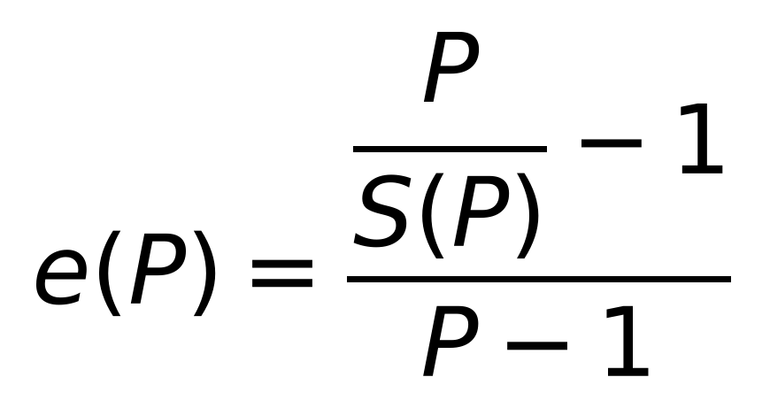
Equivalent form (original Karp–Flatt definition):
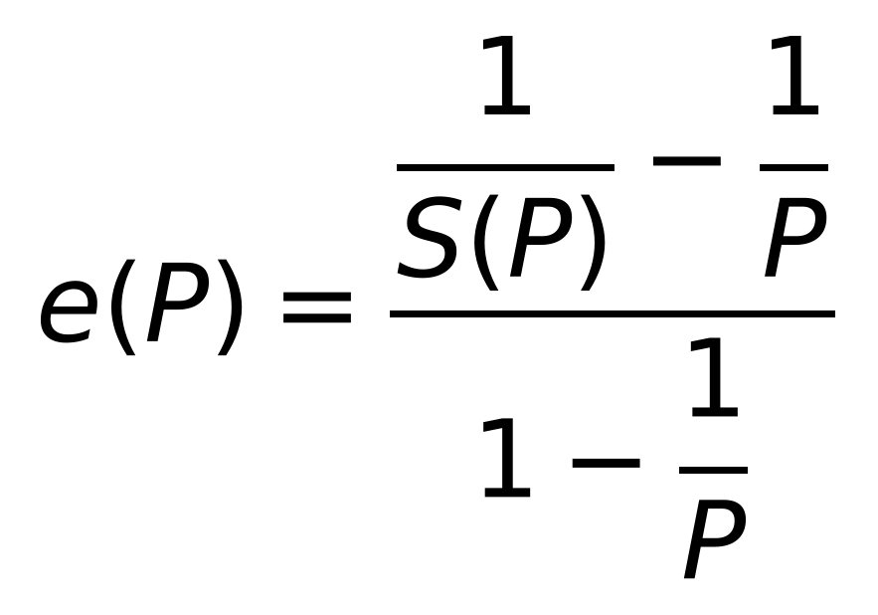
Editable Word equation (select it, copy, and paste into the thesis):
$$e\left(P\right)=\frac{\frac{P}{S\left(P\right)}−1}{P−1}$$
where $S\left(P\right)$ is the speedup obtained with $P$ processes and $e\left(P\right)$ is the experimentally determined serial fraction, $P>1$.
In Word, if you want to type it yourself: Insert → Equation → Fraction (Stacked). In the upper box insert another stacked fraction ($P$ over $S\left(P\right)$) and type −1 after it; in the lower box type P − 1. Then type e(P) = in front of it.

