Business Analytics Report
Realised by : Frini Ibtihel
29 février 2024
London School of Economics

Tables of contents
Summary 2
Introduction 2
Context 2
Market Performance Overview 3
APAC Market Analysis 4
US Market Analysis 7
EU Market Insights 9
LATAM Market Analysis. 10
Canada – Africa – EMEA Market Analysis 12
Conclusion 16

Figure 1: Market performance 3
Figure 2: Dashborad related to the APAC market 4
Figure 3: sales, profit and quantity per category and sub-category 5
Figure 4:Profit, Quantity, and Sales per Region and Category 6
Figure 5: US market analysis 7
Figure 6: MARCH 2019-JULY 2019-NOVEMBER 2021 8
Figure 7: EU market 9
Figure 8: JUNE 2021-MARCH 2021-FEBRUARY 2022 9
Figure 9: PROFIT PER REGION AND CATEGORY 10
Figure 10: LATAM Market 11
Figure 11: Quantity, Profit and Sales per sub-category 11
Figure 12: Sales, profit and Quantity per Segment and Category 12
Figure 13: CANADA-AFRICA-EMEA 13
Figure 14: Quantity and Profit per sub-category 14
Figure 15:Sles and Quantity per Segment and Category 15
Figure 16: Quantity and Profit per sub-category 15
Figure 17: AUGUST 2021-JUNE 2022-SEPTEMBER 2022 16
Figure 18: Quantity and Profit per sub-category 16
Figure 19: Profit and Quantity per Country 17

Word count: 1462

Summary
Given APAC's dominance in profitability, it is critical to keep investing in and improving revenue generating and cost optimization techniques. Regarding LATAM and AFRICA, there is scope for cost reductions despite their low profitability. The strength of LATAM's operating volumes provide a chance to create focused sales strategy. The strong performance sales and quantity performances of EMEA indicate opportunities for revenue growth by concentrating on growing its market share.

Introduction

Data analytics is crucial for preserving a competitive edge in nowadays business environment. Through the utilization of data analytics, organizations can obtain significant insights that facilitate data-driven decision-making, resulting in tangible improvements in operational efficiency.
By analyzing profitability metrics, sales data, and quantities across various product categories and geographic areas, businesses can gain valuable insights into their operations. These insights can then be used to allocate resources more effectively. Consequently, this project serves as an example of how using data analytics to increase operational efficiency can result in significant advantages.

Context

This report provides an analysis of the shipping company; dealing with a plethora of goods that are shipped to various country around the world. The objective is to provide insights for the observed performance and develop recommendations if improvements are required to senior management of the company.

Market Performance Overview
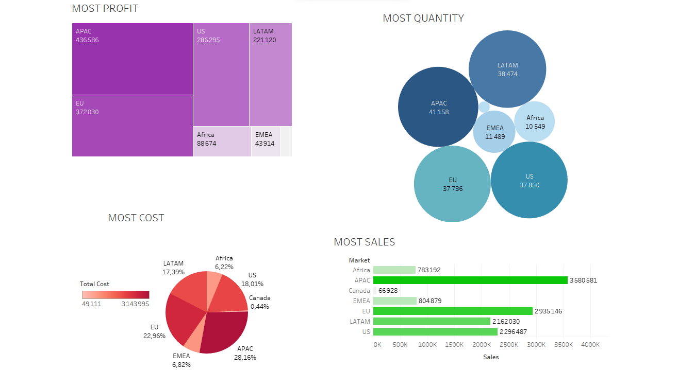
Figure 1: Market performance
The dashboard in figure 1 introduces the market performance metrics, highlighting key variables such as profit, cost, sales, and quantity across different markets. APAC emerges as the leading market. EU secures the second position in profitability, sales, and cost management. Despite ranking lower in quantity metrics, its strong performance in profit and sales demonstrates competitiveness. LATAM stands out for its notable second position in quantity metrics, despite ranking lower in sales, cost, and profit. AFRICA surpasses EMEA in profitability, however, EMEA's higher sales, quantity, and cost metrics suggest a stronger market presence compared to AFRICA. CANADA occupies the last position across all variables, indicating smaller market share.
The remaining parts of this report study each of these markets to shed light into available scopes for improvements.

APAC Market Analysis

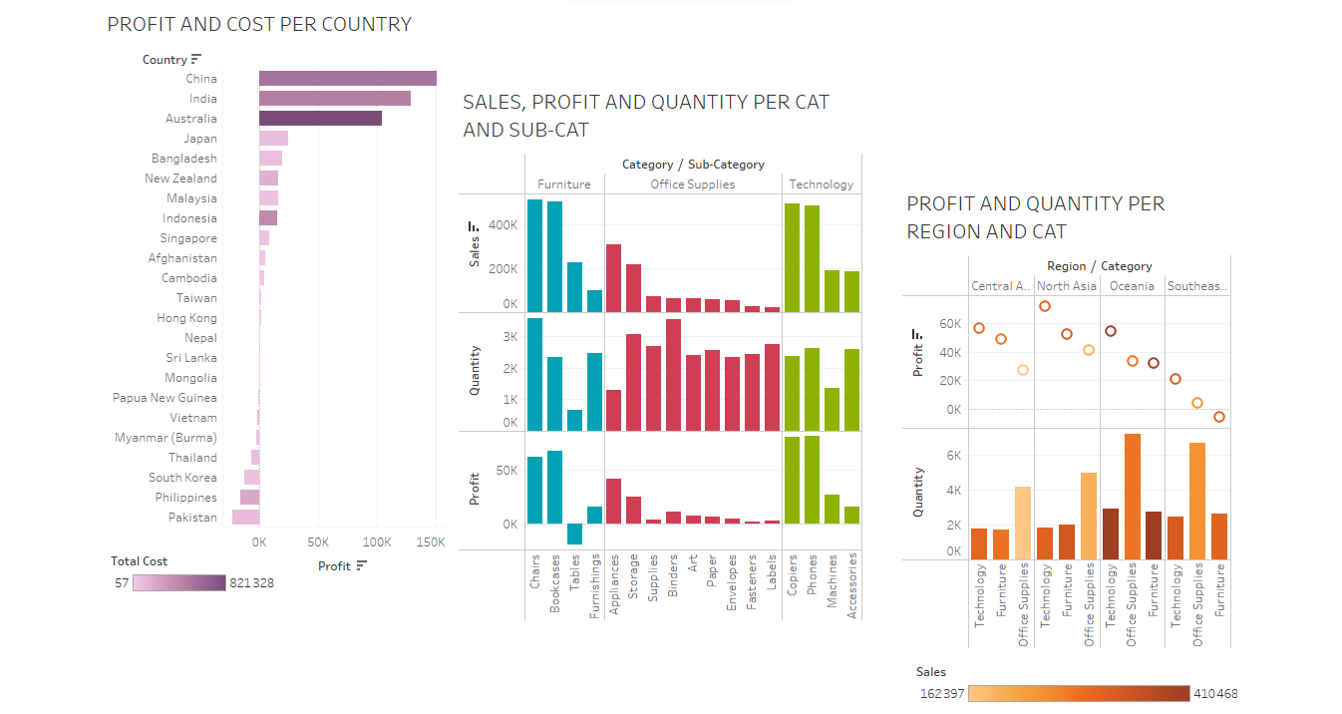
A
Figure 2: Dashborad related to the APAC market
Dashboard of figure 2 analyzes the market performances. Visual A shows the distribution of the realized profits throughout countries along with the implied total cost. We notice that both performances are unequally distributed. While Australia ranks as the most profitable country, it also holds the top spot as the costliest. Additionally, Indonesia's profit ranking contrasts with its cost position, pointing out possible cost-management inefficiencies that need to be addressed.

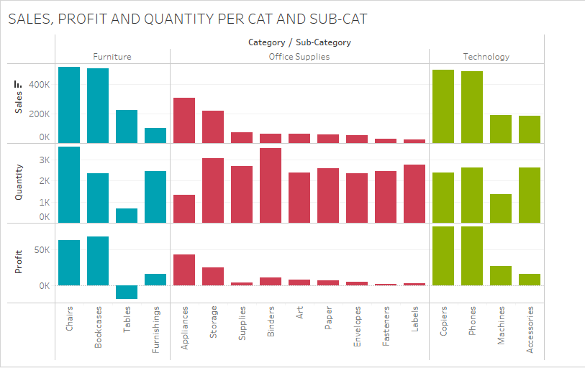
Figure 3: sales, profit and quantity per category and sub-category
Given that sales of bookcases surpass furnishings despite the latter having higher quantity, we might consider reallocating resources. Similarly, for tables, we should focus on enhancing profitability. And since appliances yield the highest sales and profit despite having the least quantity shipped, we should explore opportunities to maximize profitability in this category. As for binders' sales, despite having the highest quantity shipped, it lags behind other categories.
To address this contrast, we should consider strategies such as offering promotions to incentivize purchases. Additionally, since copiers lead in both sales and profit despite lower quantity shipped compared to phones and accessories, we should analyze the factors contributing to their success and replicate strategies that have proven effective.

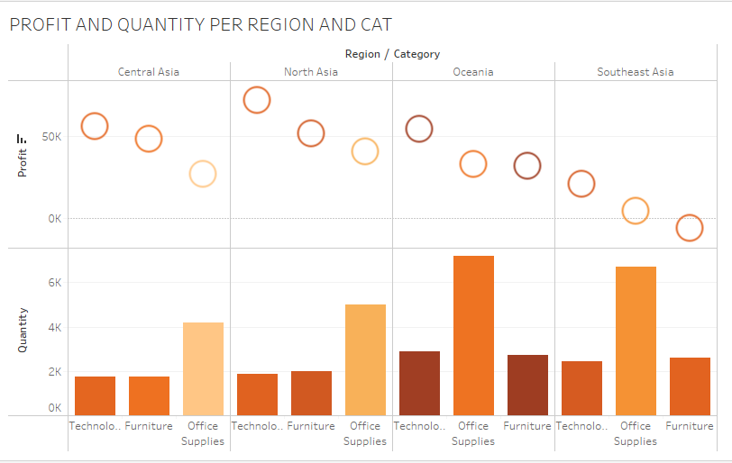
Figure 4:Profit, Quantity, and Sales per Region and Category

Figure 4 establishes the trade between profit, quantity, and sales as well as the market. Concerning Central Asia, given that technology records the lowest quantity shipped but emerges as the most profitable category, we should consider investing in technology products. Though having the highest quantity shipped, office supplies are the least profitable category. Thus, we should evaluate pricing strategies to improve their profitability. This recommendation is also to be extended for Oceania and Southeast Asiaas a similar performance is observed.
Regarding Oceania, despite being the least profitable category with the lowest quantity shipped, furniture has the highest sales so we should focus on enhancing the marketing and sales strategies for furniture products.
As for Southeast Asia, given its lowest profit, we have to conduct an analysis of the market dynamics to assess this issue. Additionally, given the negative profit of furniture, its quantity shipped surpasses technology’s, thus we consider reevaluating the pricing strategies for furniture to improve profitability.

US Market Analysis
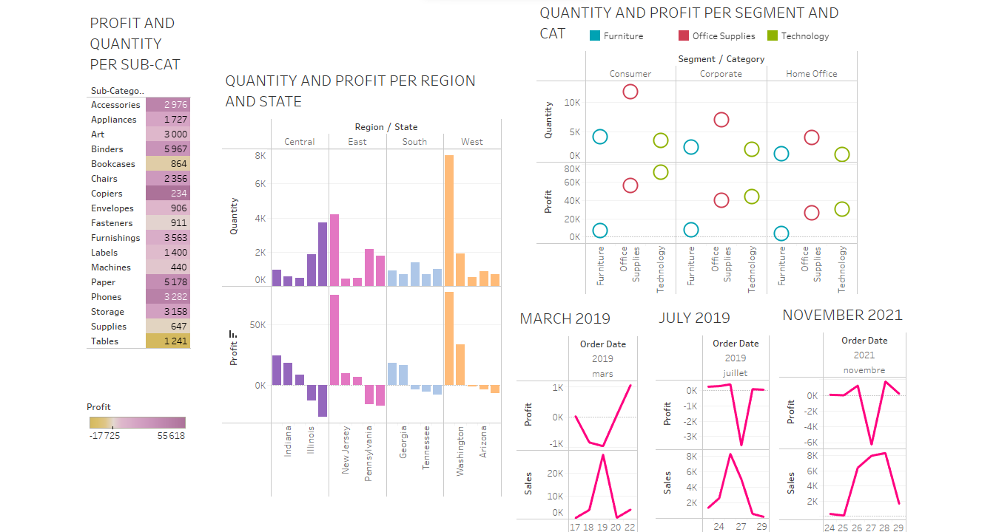
C
B
Figure 5: US market analysis
Figure 5 displays the US market analysis dasgboard. Given that copiers are the most profitable sub-category despite having the lowest quantity, we might consider strategies to capitalize on this profitability. As for binders, which is the most abundant, it’s not the most profitable. Hence, we advocate revising pricing strategies and sales tactics.
Despite having bigger quantities, tables exhibit negative profitability compared to other categories (e.g. machines, supplies, fasteners). Available scope consists in analyzing the contributing factors to the observed underperformance.
Visual B shows that we should allocate resources towards states like Michigan, Indiana, and Virginia, which demonstrate higher profitability despite not having the highest quantities and we might consider implementing strategies to improve profitability in high quantity states like Texas, Illinois, Pennsylvania and Ohio.
We also should investigate the reasons for negative profitability in states like Florida, North Carolina, and Colorado, despite varying quantities.
As for visual C, we should promote technology’s products to maximize profitability despite its lower quantities across segments and to explore product diversification to increase profitability for office supplies given its high quantities.

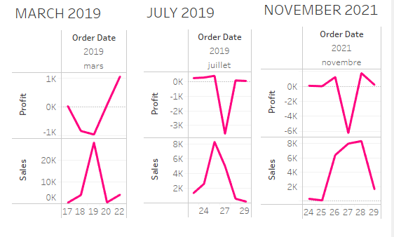
Figure 6: MARCH 2019-JULY 2019-NOVEMBER 2021
As shown in figure 6, profit experiences a surprising decrease when sales suddenly increase during these periods thus we should keep an eye on cost variations to prevent negative impacts on profitability during times of sales growth.

EU Market Insights
Figure 7 deals with EU market. The first visual shows that we should enhance profitability by prioritizing the promotion of bookcases despite their lower quantities, given their high profit. Additionally, we might implement targeted strategies to boost the profitability of art sales. and capitalize on the profitability of storage products by highlighting their benefits thereby maximizing profitability across product categories.

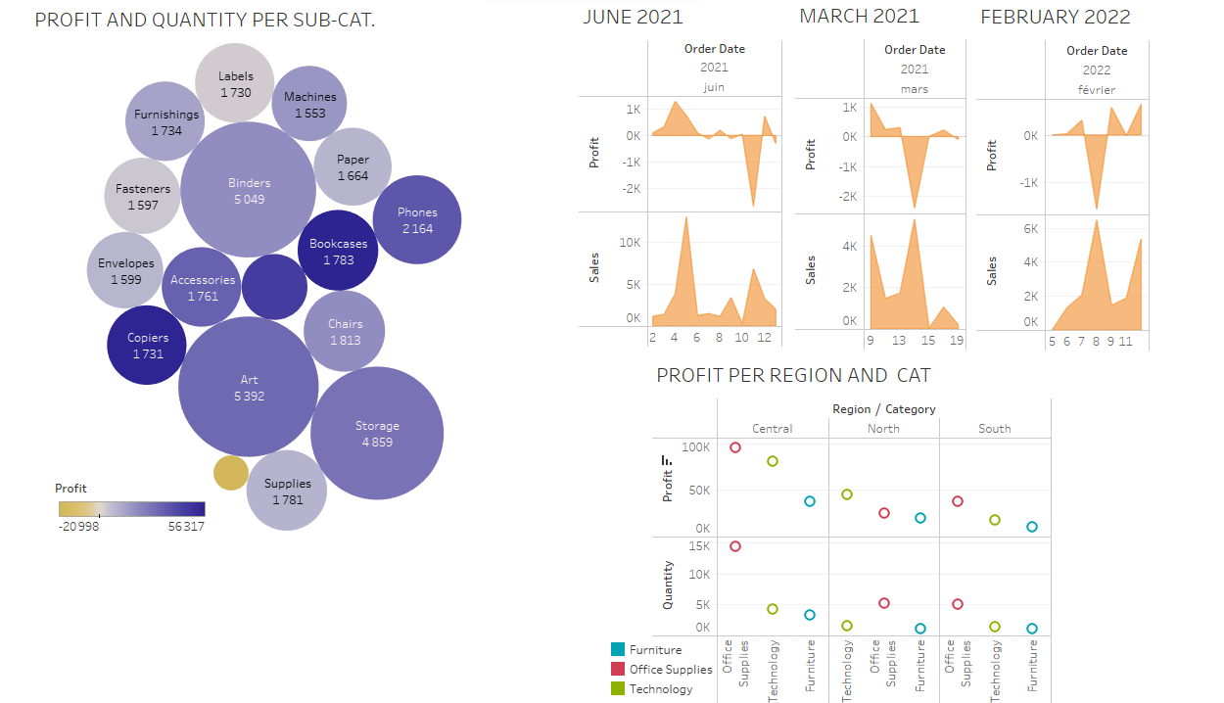
Figure 7: EU market
Figure 8 shows that profit decreases suddenly despite sales increase which implied necessity to adopt procedures to closely track and maintain profitability.

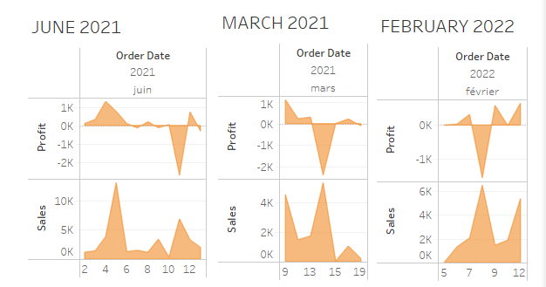
Figure 8: JUNE 2021-MARCH 2021-FEBRUARY 2022

Figure 9 calls for investing resources on maximizing profitability in the technology sector, taking advantage of its potential to outperform furniture in terms of profits. Simultaneously, it pushes us to investigate ways to increase office supply's profitability even when their quantity is increased, to help to maintain their best performance.

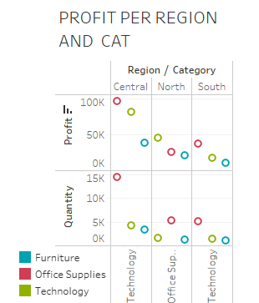
Figure 9: PROFIT PER REGION AND CATEGORY

LATAM Market Analysis
Figure 10 quotes the dashboard related to LATAM market. Visual D forces highlights necessity to address profitability challenges in the least profitable countries such as Honduras, the Dominican Republic, and Brazil, despite their highly shipped quantities.

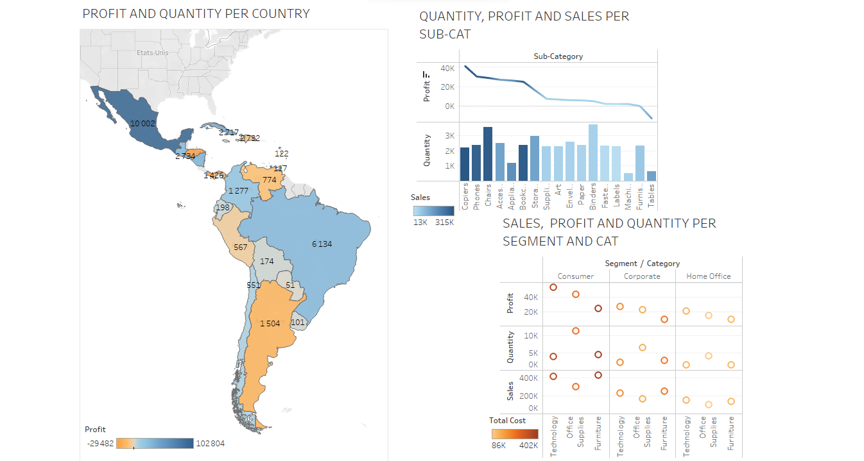
D
Figure 10: LATAM Market

Figure 11 shows that while copiers lead both profitability and sales for reduced quantities, focusing on maintaining their market dominance is crucial. Despite tables being the least profitable, their increased sales indicate the possibility of improving pricing tactics to increase profitability.

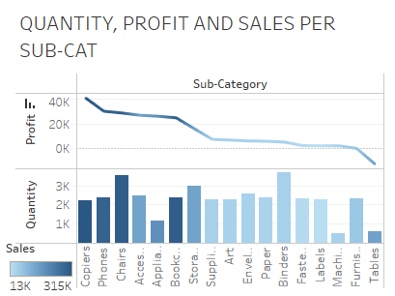
Figure 11: Quantity, Profit and Sales per sub-category

Figure 12 shows that despite furniture having high sales, it's essential to address its profitability challenges by reviewing cost optimization strategies. Additionally, for office supplies, focusing on increasing sales while managing costs can help maximize profitability, given their high quantities and low costs. In the home office segment, highlighting the profitability of technology products, despite lower quantities, and implementing strategies to boost sales and manage costs for office supplies can further increase profitability.

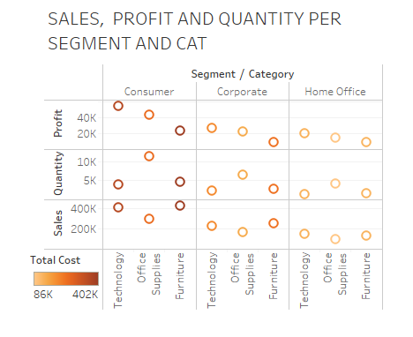
Figure 12: Sales, profit and Quantity per Segment and Category

Canada – Africa – EMEA Market Analysis
Dashboard in figure 12 deals with the Canada, Africa and EMEA markets performances.
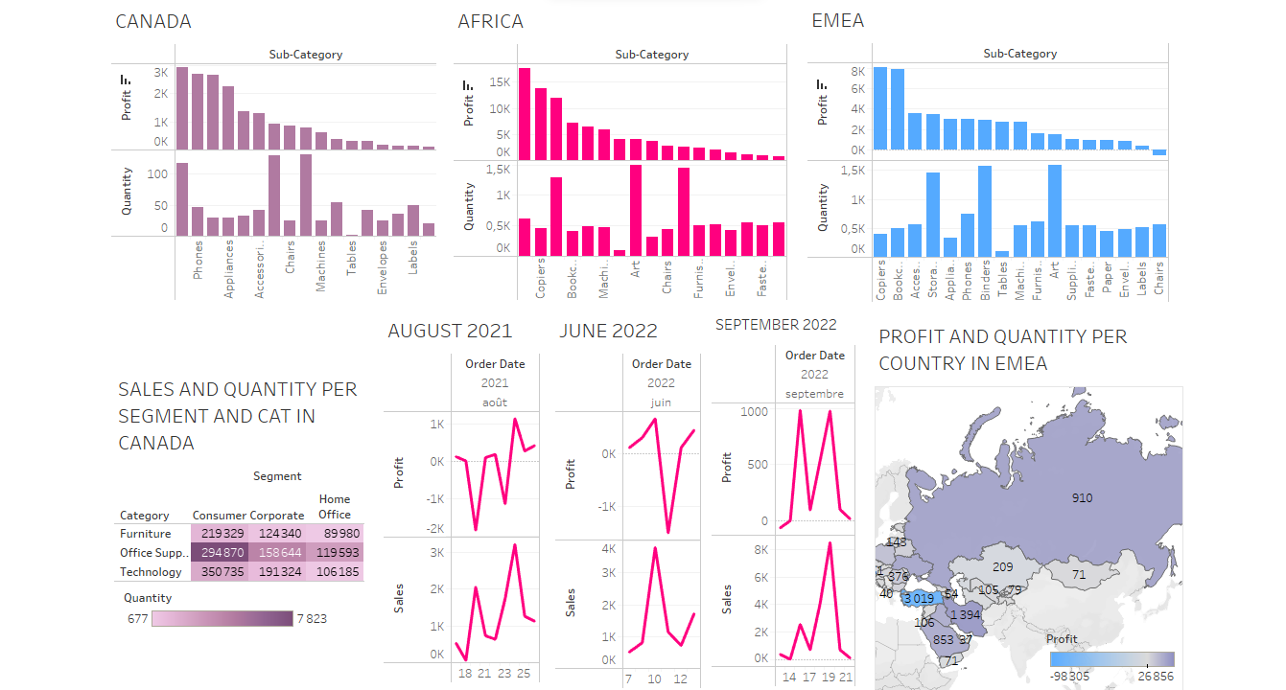
Figure 13: CANADA-AFRICA-EMEA

Figure 14 shows that storage emerges as the most profitable despite not having the highest quantity (binders). Thus, it's recommended to capitalize on this profitability by implementing targeted marketing campaigns.

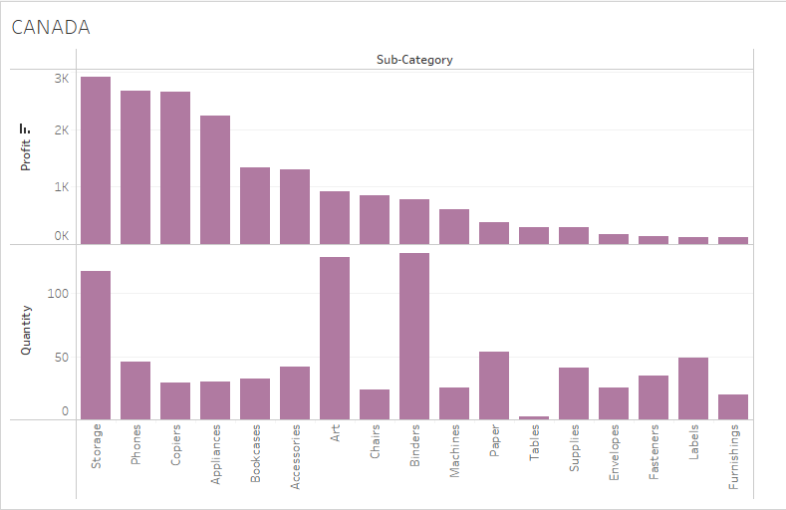
Figure 14: Quantity and Profit per sub-category

The treemap in figure 15 demonstrates that despite having the most sales, technology doesn't have the highest quantity, which belongs to office supplies. Thereby we should concentrate on methods to profit from the increasing demand for technological products.

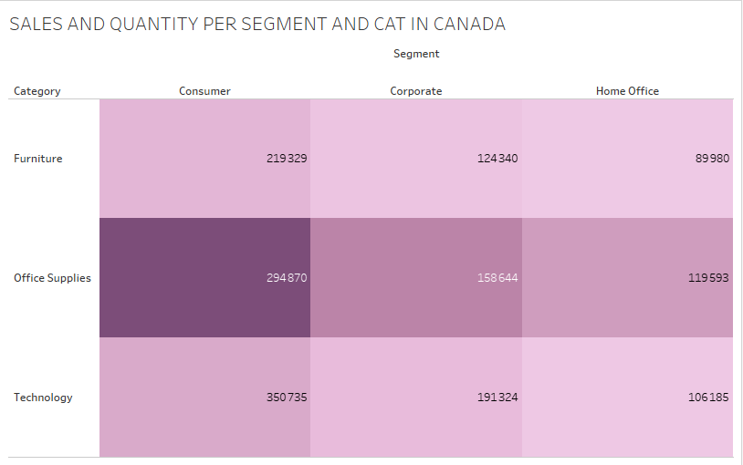
Figure 15:Sles and Quantity per Segment and Category
For Africa market, figure 16 shows that while labels may have higher quantities, we might consider initiatives to enhance their profitability, such as product diversification. Conversely, for tables, despite their lower quantity, we should focus on maximizing profitability through pricing optimization.

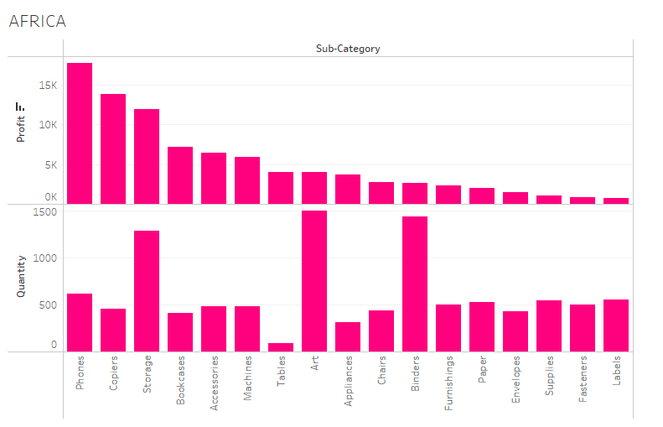
Figure 16: Quantity and Profit per sub-category

Figure 17 clearly forces us to address the observed trend of decreased profitability during periods of increased sales.

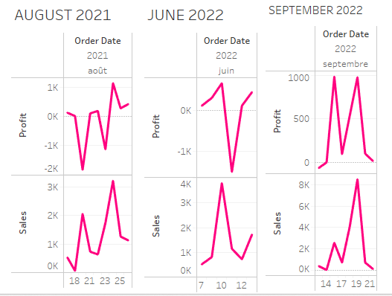
Figure 17: AUGUST 2021-JUNE 2022-SEPTEMBER 2022
On the question of the EMEA market, figure 18 showcases that while copiers have the highest profitability, we should prioritize strategies aimed at elevating their quantities. Meanwhile, for chairs, which exhibit higher quantities, we should focus efforts on enhancing profitability.

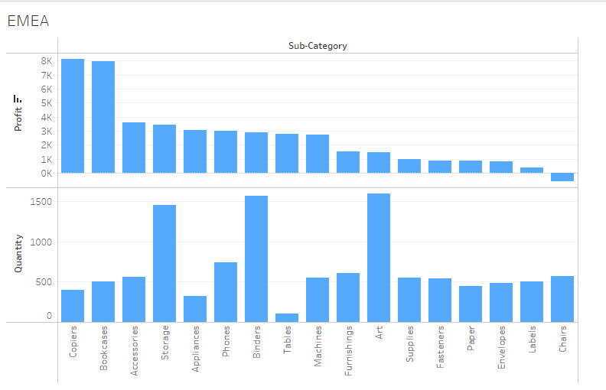
Figure 18: Quantity and Profit per sub-category
As shown in figure 19, Turkey should focus on optimizing cost reduction and operational efficiency despite its high sales volume. Meanwhile, Ukraine should capitalize on its higher profit margins.

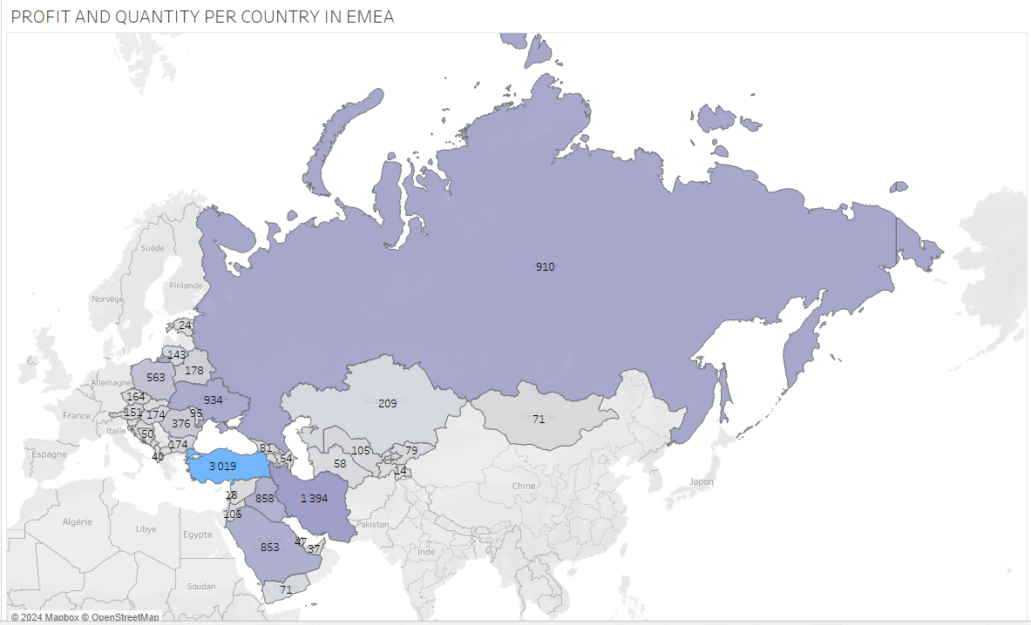
Figure 19: Profit and Quantity per Country

