System Design Document (SDD)
Sovereign Multi-Agent AI Platform for Government of Pakistan

1. System Design Architecture
The System Design Document (SDD) specifies the software microservices architecture, vector storage isolation, routing logic, and technical diagram specifications for the platform.

1.1 Architectural Modules
The system comprises the User Gateway Layer, Central Supervisor Router Engine ('src/central_router.py'), Multi-Tenant Ingestion Pipeline ('src/ingestion_pipeline.py'), and Isolated Spoke Agent RAG Nodes.

Design Diagrams:

01. Architecture Diagram:
Brief Overview:
Demonstrates a high-level overview of how citizen/official requests are routed through the API Gateway and Central Supervisor Router to various sub hubs, isolated spoke agent namespaces and multi-tenant vector databases.
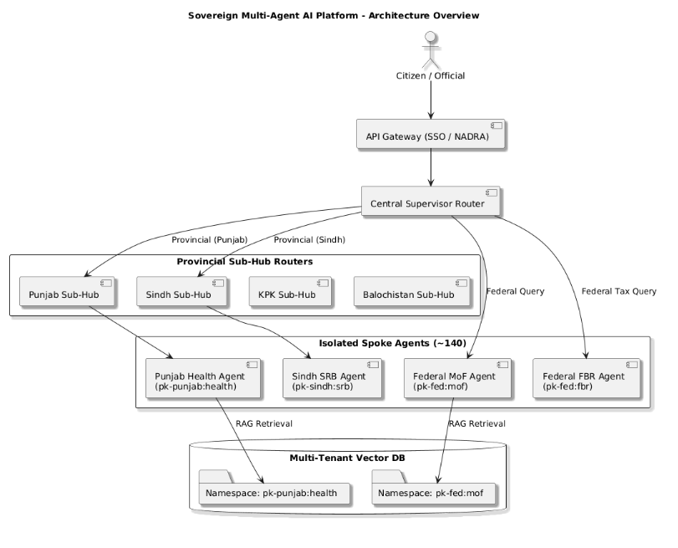
Fig. 1. Architecture Overview

02. ERD Database schema:
Brief Overview:
Shows how the relational database stores information relating to user sessions, query logs, audit logs and isolated vector namespace to relate to document chunks.
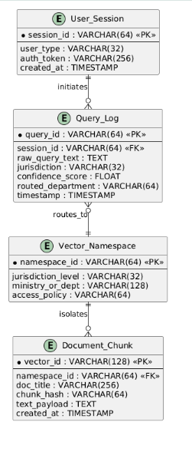
Fig. 2. ERD Database Schema

03. Class Diagram:
Brief Overview:
Shows the object orientated structure of classes, methods and data relating to core system components such as the Central Supervisor Router and Data Ingestion Pipeline.

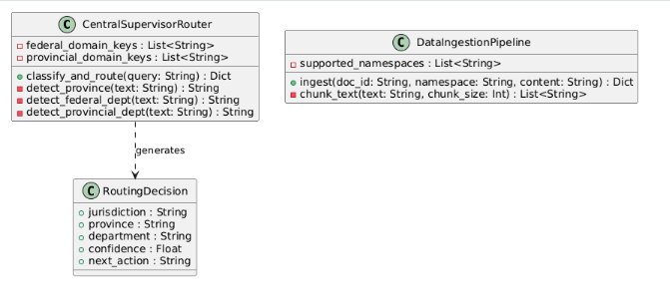
Fig. 3. Class Diagram

04. Sequence Diagram:
Brief Overview:
Shows the step-by-step process of synchronously passing messages between an incoming query, classifying it by jurisdiction, retrieving RAG vectors and providing a verified answer.

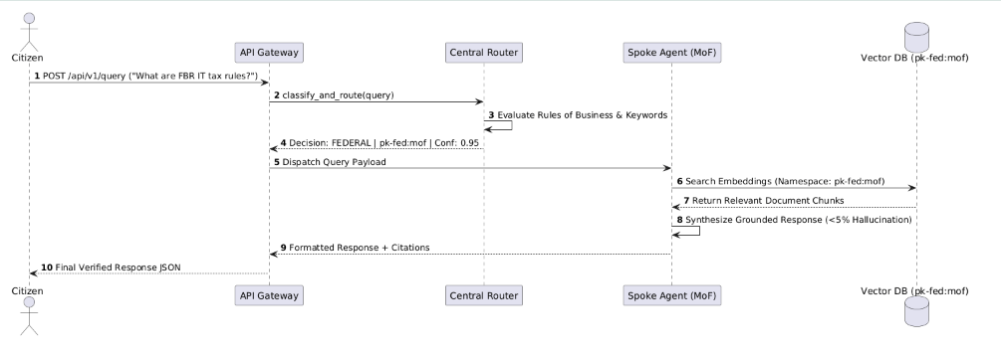
Fig. 4. Sequence Diagram

