Augmentative and Alternative Ways of Communication
for people with reduced or no verbal functional communication

Introduction
- Every patient has his/her own needs and abilities. This varied material has been created for this reason. Health professionals (e.g. nurses, speech-language pathologists) can use it, choose what is more appropriate according to the needs of their patient and even adjust it accordingly.
- Dr. Eliada Pampoulou (Department of Rehabilitation Sciences, The Cyprus University of Technology) coordinated the creation of this material in collaboration with Dr Maria Kyranou (Department of Nursing, The Cyprus University of Technology) and Maria Konstanta, Registered Speech-Language Pathologist.
- The symbols used are the Mulberry Symbols (©Copyright Steve Lee 2020). This work is licensed under the Creative Commons Attribution -ShareAlike 2.0 UK; England & Wales License. Mulberry symbols may be accessed at https://mulberrysymbols.org)

Further support
For further information for the implementation of the following material you can contact Dr Eliada Pampoulou, Lecturer at the Department of Rehabilitation Sciences at The Cyprus University of Technology.
- Telephone Number: +357 25002402
- Email: eliada.pampoulou@cut.ac.cy

Effective communication
A basic requirement for effective communication is to choose a communication code to say yes, no, maybe/I don´t know. The following ways can be used:
- Closing the eyes to say “no” and the opposite to say “yes”.
- Moving the head upwards to say “no” and the opposite to say “yes”.
- Pointing downwards using the thumb to say “no”, the opposite to say “yes” and right-left movement of the whole palm to say “maybe” or “I don´t know”.
- Smiling to say “yes”, the opposite to say “no” and keeping a neutral face expression to say “maybe” or “I don´t know”.
- Using a blank piece of paper where the patient can write down the answer using a pencil.
- Using printed material like the one provided in the following pages.

It is essential to develop a communication code with the patient you support, especially for the vocabulary that is important to him/her. Some “not so helpful” ways of communication include the use of eye contact and nodding/gestures. Here are some ways of communication that can be used by the patient:
- Pointing at the object he/she wants (e.g. a bottle of water)
- Raising his/her leg to ask for a specific need (e.g. to use the toilet)
- Moving his/her fingers to ask for his/her medication.
- Forming a fist and moving it close to the neck to ask for suction.

At the same time the “helpful” ways of communication can be used. But also some additional material might be needed, such as the graphic material presented here. The following pages can be printed and laminated to be used as “communication pages” or as a “communication book”.

For the effective use of the following pages the communication partner has to:
- Each time point to a row and give time to the patient to choose the one he/she wants (this is why you also need to establish beforehand an effective communication code to say “yes/no”)
- When the right row is chosen, the communication partner points to each choice one by one until the patient chooses the target word.

Finally, it is important to follow the following advice:
- Call the patient by his/her name or touch him/her softly on the shoulder/hand so that he/she knows that you wish to communicate with him/her.
- Use simple sentences with few and specific words.
- If the patient cannot answer verbally, use the suggested ways of communication that are mentioned in this presentation.

Yes | I don’t know | No
√ | ? | Χ

Yes | No
I don’t know | Later

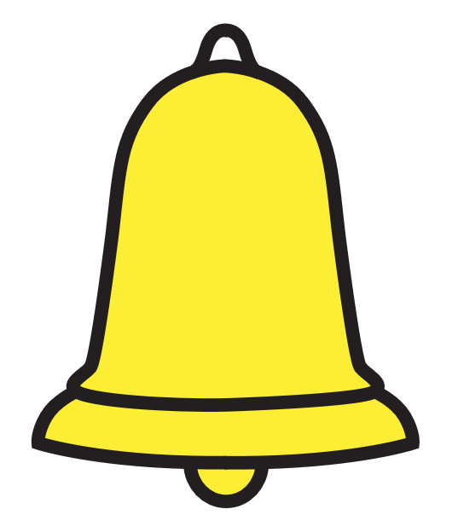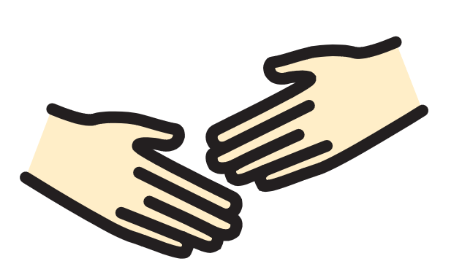 | 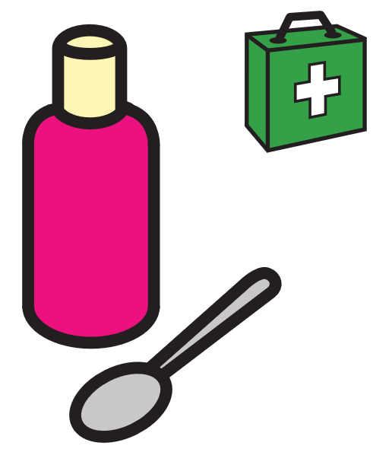 | 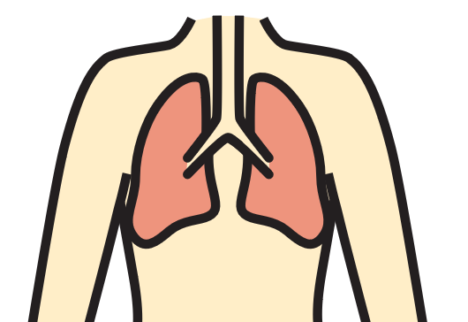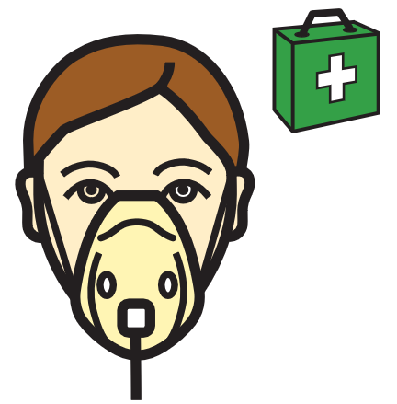 | 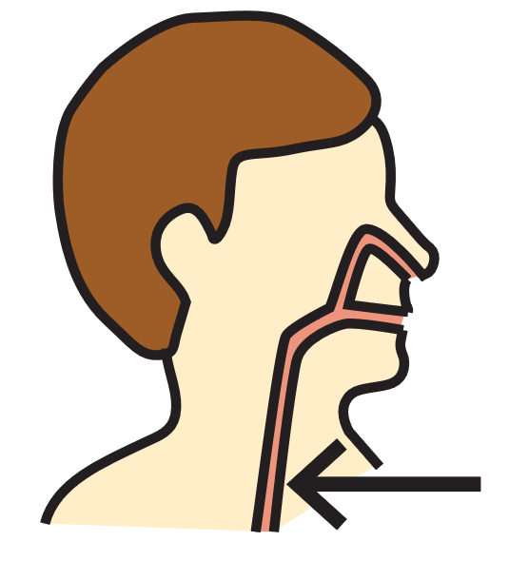
Help | Medicine | Respiratory Problem | Suction
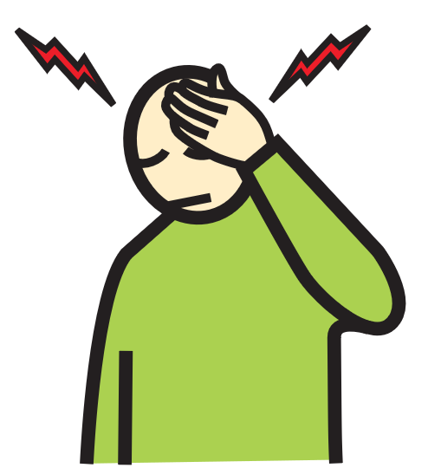 | 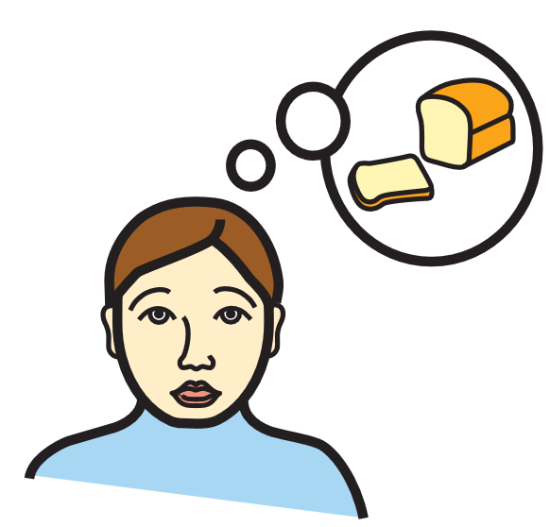 | 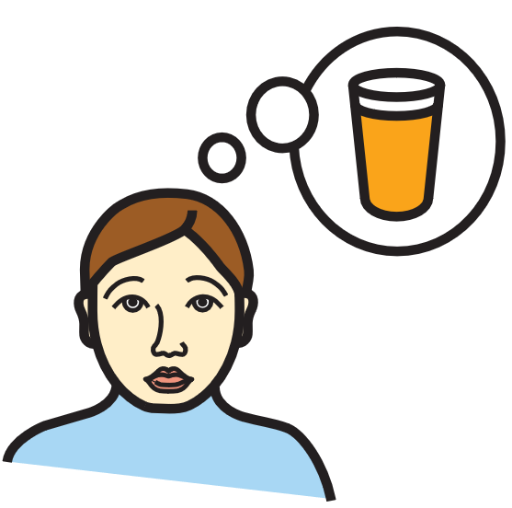 | 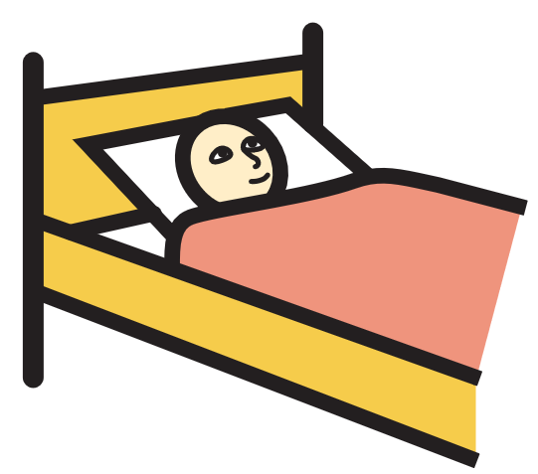
Pain | Hunger | Thirst | Sleep/Insomnia
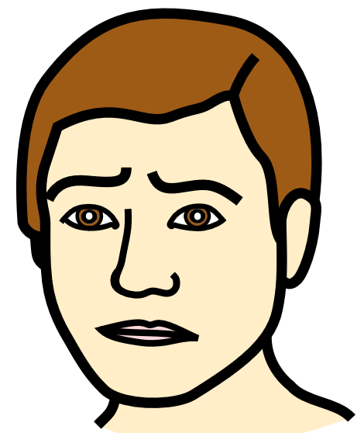 | 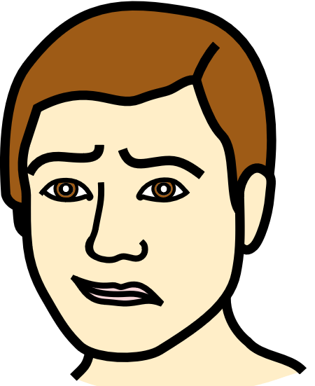 | 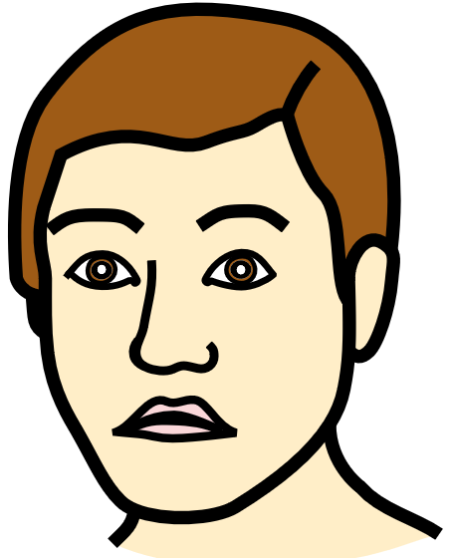 | 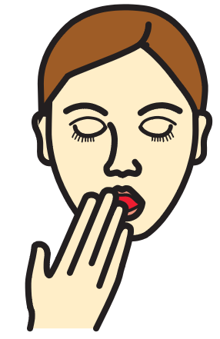
Worried | Desperate | Stress/Fear | Tired
YES | NO | I DON’T KNOW | LATER

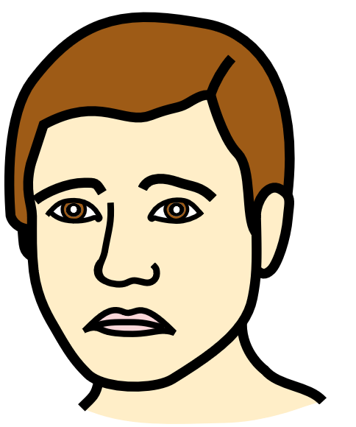 | 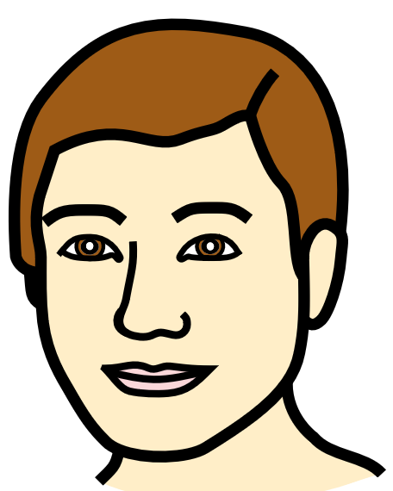 | 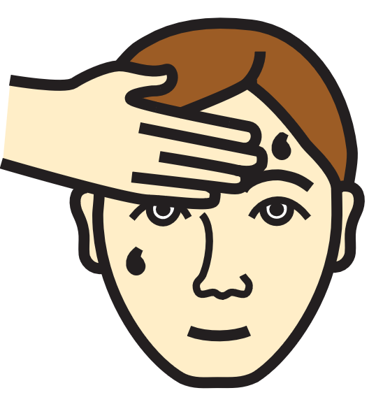 | 
Sad | Calm | Hot | Cold
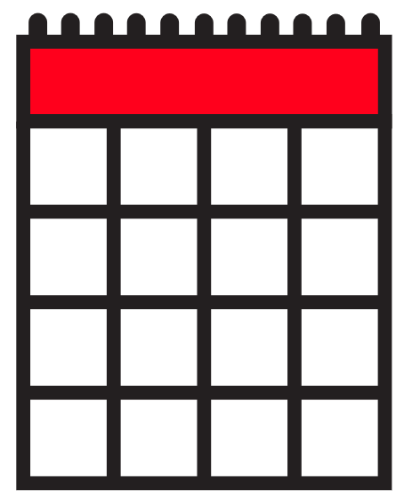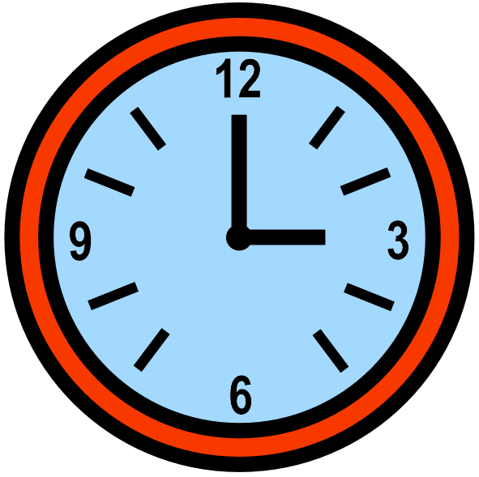 | 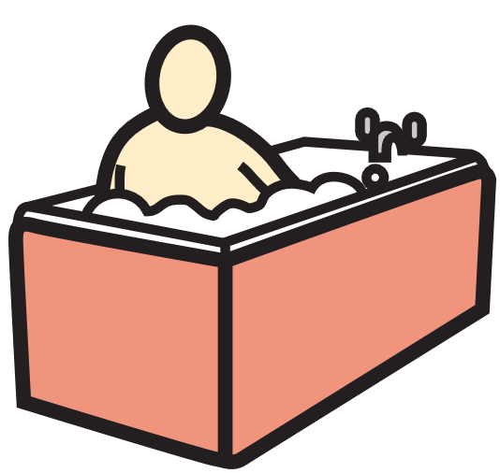 | 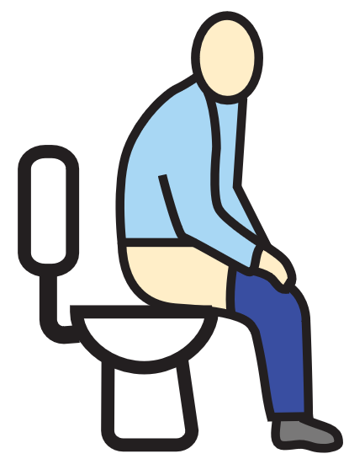 | 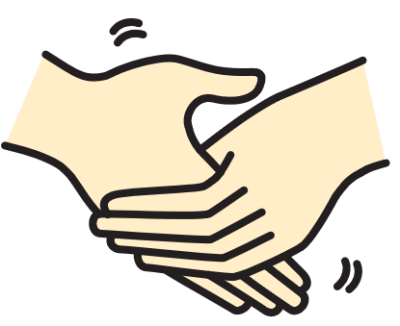
Time/day | Bath | Toilet | Thank you
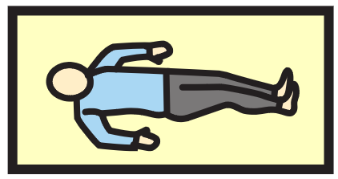 | 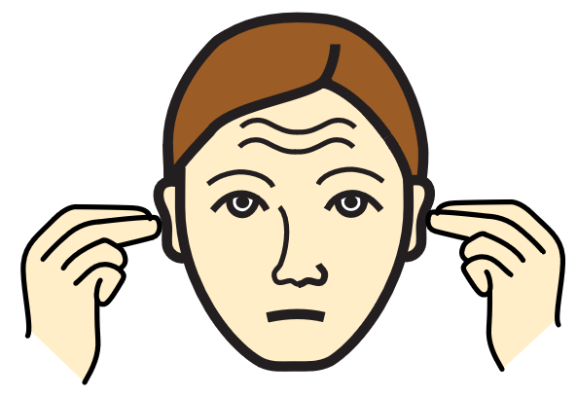 |  | 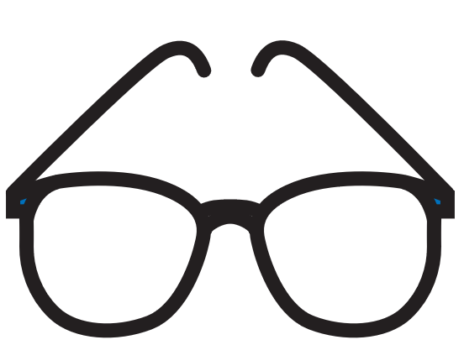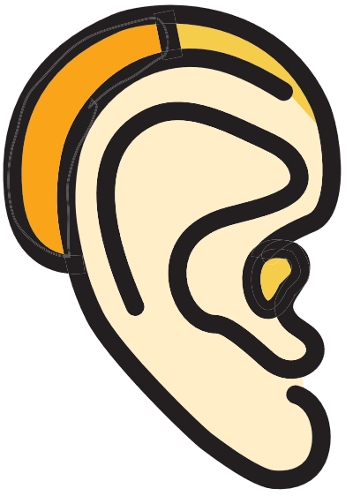
Uncomfortable/Change of places | Noise | Television/Radio | Glasses/Hearing Aid
YES | NO | I DON’T KNOW | LATER

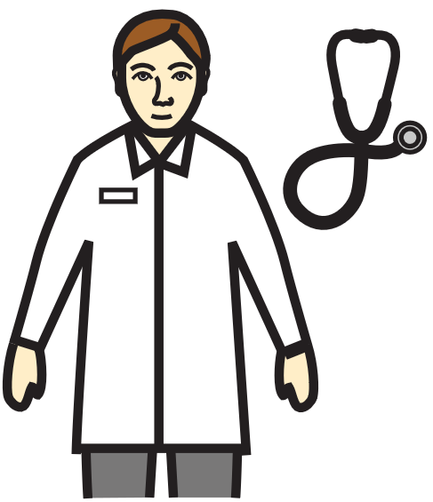 | 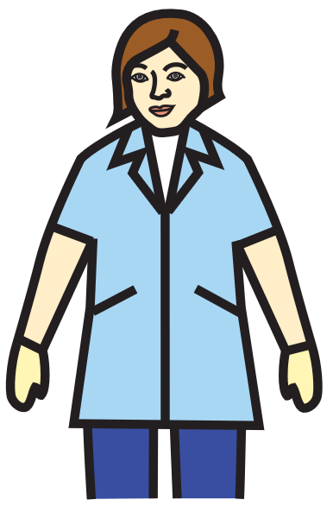 | 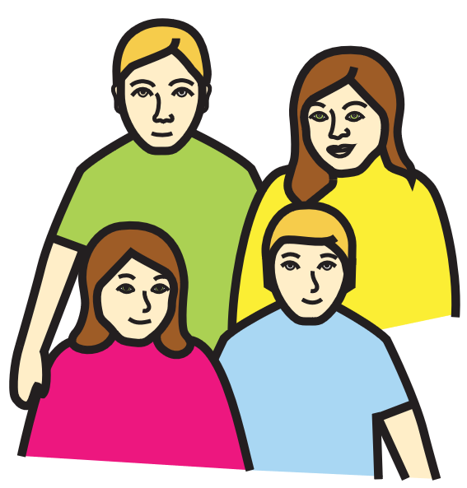 | 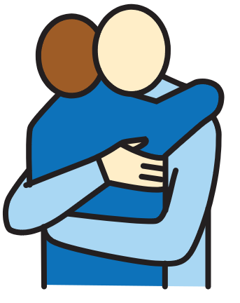
Doctor | Nurse | Family | Friends
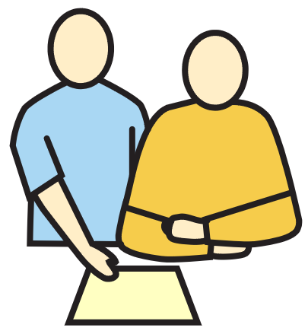 | 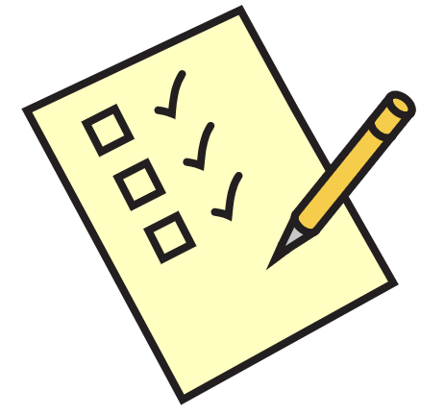 | 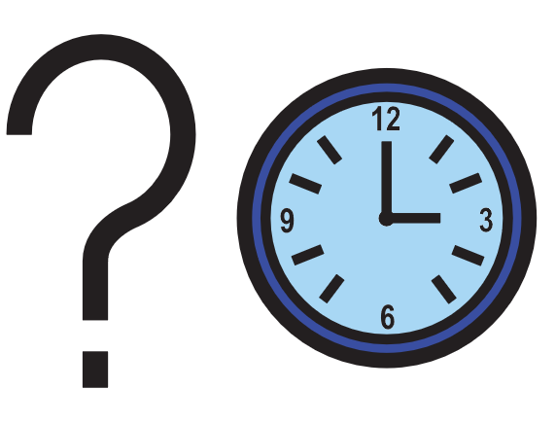 | 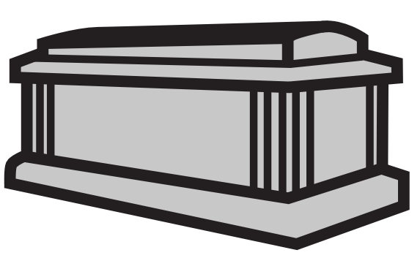
What is my status? | What is my prognosis? | For how long will I be here? | Am I going to die?
 | 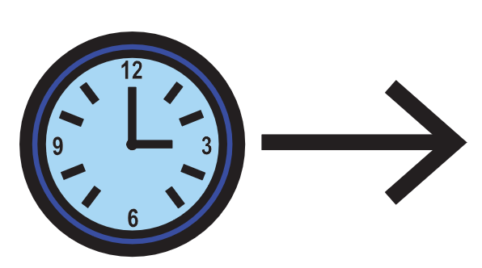
Will this hurt? | What’s going to happen next?
YES | NO | I DON’T KNOW | LATER

Help | Medicine | Respiratory Problem | Suction
Pain | Hunger | Thirst | Sleep/Insomnia
Worried | Desperate | Stress/Fear | Tired
YES | NO | I DON’T KNOW | LATER

Sad | Calm | Hot | Cold
Time/day | Bath | Toilet | Thank you
Uncomfortable/Change of places | Noise | Television/  Radio | Glasses/  Hearing Aid
YES | NO | I DON’T KNOW | LATER

Doctor | Nurse | Family | Friends
What is my status? | What is my prognosis? | For how long will I be here? | Am I going to die?
Will this hurt? | What’s going to happen next?
YES | NO | I DON’T KNOW | LATER

A | B | C | D | E | F | Y
G | H | I | J | K | L | Z
M | N | O | P | Q | R | S
T | U | V | W | X

Table that can be used for the creation of additional material
YES | NO | I DON’T KNOW | LATER

