FYP Checkpoint-2
(Software Design, Prototype/MVP, and Initial Implementation Evidence)

Part A: Software Design Document — FYP-T5
1. Document Control
Field | Details
Project Title | Hybrid Intelligent System for Patient Query Handling and Appointment Management with Guided Patient-to-Department Routing, Urgency-Based Escalation, and Structured Human Handoff Support
Group ID | FYP-2026-G2
Version | 1.0
Date | 05 August 2026
Prepared by | Ibtisam Saleem, Faryal Israr
Supervisor | Dr. Mujeeb ur Rehman Shaikh
Co-Supervisor | Syeda Madeeha Zaidi

2. Purpose and Scope
Purpose: This Software Design Document (SDD) presents the detailed software design of the Hybrid Intelligent System for Patient Query Handling and Appointment Management with Guided Patient-to-Department Routing, Urgency-Based Escalation, and Structured Human Handoff Support. It translates the approved System Requirements Specification (SRS), High-Level Architecture, and Project Plan prepared during Checkpoint-1 into a structured design that supports implementation and testing.
The document defines the system architecture, software modules, database design, API structure, user interface planning, security mechanisms, validation strategies, and design decisions. It serves as the primary technical reference for implementing the Minimum Viable Product (MVP) and provides a clear blueprint for future development phases.
Scope: This version of the Software Design Document covers the core modules planned for the Checkpoint-2 MVP of the proposed system. These include:
- User Registration and Login
- Secure Authentication using JSON Web Token (JWT)
- Role-Based Access Control (Patient, Reception Staff, Department Staff, and Administrator)
- Patient Query Handling Module
- AI-Based Query Classification and Department Routing
- Appointment Management Module
- Patient Dashboard
- Reception Staff Dashboard
- Department Staff Dashboard
- Administrator Dashboard
- Backend API Design
- Database Schema and Relationships
- Security Design, Validation Rules, and Error Handling
The current MVP focuses on establishing a secure backend architecture and demonstrating the core workflow of user authentication and role-based access. Advanced features such as WhatsApp integration, Speech-to-Text, Text-to-Speech, real-time notifications, advanced analytics, and production deployment remain outside the scope of Checkpoint-2 and will be completed in subsequent development phases.
3. Reference Documents

Reference Document | Version / Date | Purpose in Design
Approved Topic Approval Form | Approved Version | Establishes the approved project title, objectives, scope, and baseline for the proposed Hybrid Intelligent System.
System Requirements  Specification (SRS) | Version 1.0 (Checkpoint-1) | Defines the functional requirements, non-functional requirements, actors, use cases, system constraints, and software requirements that guide the detailed software design.
High-Level Architecture and Risk Analysis | Version 1.0 (Checkpoint-1) | Provides the initial layered architecture, technology stack, system components, communication flow, and identified project risks that are refined in this document.
Project Plan | Version 1.0 (Checkpoint-1) | Defines project milestones, implementation schedule, task allocation, ownership, and development roadmap used during the implementation phase.
Supervisor / Checkpoint-1 Feedback | Checkpoint-1 Review | Incorporates recommendations provided by the supervisor regarding system architecture, module organization, documentation quality, implementation priorities, and project scope refinement.

4. Design Goals

Design Goal | Description / How It Will Be Achieved
Modularity | The system is divided into independent modules such as Authentication, Patient Query Processing, Appointment Management, AI Classification, Dashboard Management, and Database Layer. Each module performs a specific responsibility to simplify development and future maintenance.
Maintainability | The application follows a layered architecture using separate folders for routes, controllers, middleware, configuration files, and database operations. This modular structure improves readability, debugging, and future enhancements.
Usability | The system will provide role-based dashboards with simple navigation for Patients, Reception Staff, Department Staff, and Administrators, allowing users to access only the features relevant to their responsibilities.
Security | User authentication is implemented using JSON Web Tokens (JWT), passwords are securely stored using bcrypt hashing, and Role-Based Access Control (RBAC) ensures that users can only access authorized system resources.
Performance | The backend APIs are designed using Express.js with optimized SQL queries to provide fast response times for user authentication, appointment requests, and patient query processing.
Scalability, where applicable | The modular architecture allows future integration of additional features such as WhatsApp integration, Speech-to-Text, Text-to-Speech, real-time notifications, analytics, and cloud deployment without major architectural changes.
Testability | Individual modules such as Registration, Login, Authentication Middleware, Role Authorization, and Appointment APIs can be independently tested using Postman and future automated testing frameworks.

5. System Decomposition

Module /  Component | Purpose | Major  Responsibilities | Related  Requirement(s) | Owner
Authentication & User Management Module | Provides secure user registration, login, authentication, and role-based access control. | Register users, authenticate login credentials, encrypt passwords using bcrypt, generate JWT tokens, verify user sessions, and enforce role-based authorization. | FR-1, FR-2 | Ibtisam Saleem
Patient Query Handling Module | Accepts patient queries or symptom descriptions and prepares them for intelligent processing. | Receive patient input, validate data, perform keyword extraction, categorize queries, and forward them to the routing module. | FR-3, FR-4 | Ibtisam Saleem
Department Recommendation & Routing Module | Determines the most appropriate hospital department using rule-based logic and supports future AI integration. | Analyze patient symptoms, recommend departments, classify urgency levels, and initiate structured human handoff when confidence is low. | FR-5, FR-6, FR-7 | Ibtisam Saleem
Appointment Management Module | Enables patients to book, update, cancel, and view appointments after receiving a department recommendation. | Validate appointment requests, manage schedules, maintain appointment records, and update appointment status. | FR-8, FR-9 | Ibtisam Saleem
Database Management Module | Maintains persistent storage of all application data. | Store users, appointments, patient queries, departments, activity logs, and related system records while maintaining data integrity. | FR-1 to FR-10 | Ibtisam Saleem
Notification & Human Handoff Module | Supports communication with users and escalates uncertain cases to hospital staff. | Generate appointment notifications, assist with routing decisions, and facilitate structured human intervention for unresolved or complex queries. | FR-7, FR-9 | Both Members
Activity Logging & Audit Module | Maintains a record of significant system events. | Log authentication events, appointment activities, patient query processing, administrative actions, and system errors for auditing and troubleshooting. | FR-10 | Ibtisam Saleem

6. Detailed Module Design

Field | Module 1 Details
Module Name | Authentication & User Identity Management Module
Purpose | To provide secure user registration, authentication, and role-based access control for all system users.
Inputs | Full Name, Email Address, Password, Phone Number, User Credentials, JWT Token
Outputs | Successful registration, authenticated user session, JWT access token, authorization response, or validation/error message
Processing Logic | The module validates user input, hashes passwords using bcrypt before storing them in the database, authenticates users during login, generates JSON Web Tokens (JWT), verifies protected requests, and enforces Role-Based Access Control (RBAC) to restrict unauthorized access.
Dependencies | User Database, Authentication Middleware, Role Middleware, JWT Library, bcrypt Library
Related Requirements | FR-1, FR-2
Owner | Ibtisam Saleem

Field | Module 2 Details
Module Name | Patient Query Handling Module
Purpose | To receive, validate, and process patient queries or symptom descriptions before forwarding them for intelligent department recommendation.
Inputs | Patient Query, Symptoms, User Information
Outputs | Validated patient query ready for department recommendation or appropriate validation message
Processing Logic | The module accepts patient-entered symptoms or medical questions, validates mandatory information, performs keyword extraction and preprocessing, and forwards structured input to the Department Recommendation Module for further analysis.
Dependencies | Authentication Module, Database Layer, Department Recommendation Module
Related Requirements | FR-3, FR-4
Owner | Ibtisam Saleem

Field | Module 3 Details
Module Name | Department Recommendation & Intelligent Routing Module
Purpose | To recommend the most appropriate hospital department using rule-based decision logic while supporting future AI-assisted enhancements.
Inputs | Structured Patient Query, Symptoms, Medical Keywords
Outputs | Recommended Department, Urgency Level, Human Handoff Recommendation (if required)
Processing Logic | The module evaluates patient symptoms using predefined medical rules and keyword-based matching to identify the most suitable department. If the system cannot confidently determine a recommendation, the case is escalated through a structured human handoff process. The architecture remains extensible for future AI or NLP integration without major redesign.
Dependencies | Patient Query Module, Database Layer, Appointment Management Module
Related Requirements | FR-5, FR-6, FR-7
Owner | Ibtisam Saleem

Field | Module 4 Details
Module Name | Appointment Scheduling & Management Module
Purpose | To allow patients to schedule, update, cancel, and manage appointments after receiving a department recommendation.
Inputs | Patient ID, Department, Appointment Date, Appointment Time
Outputs | Appointment Confirmation, Appointment Status, Validation or Error Message
Processing Logic | The module validates appointment requests, checks scheduling constraints, stores appointment details in the database, updates appointment status, and allows patients to view or manage their scheduled appointments.
Dependencies | Authentication Module, Department Recommendation Module, Database Layer
Related Requirements | FR-8, FR-9
Owner | Ibtisam Saleem

Field | Module 5 Details
Module Name | Dashboard Management Module
Purpose | To provide customized dashboards for different user roles within the hospital management system.
Inputs | Authenticated User Role, User Information
Outputs | Patient Dashboard, Reception Dashboard, Department Staff Dashboard, Administrator Dashboard
Processing Logic | After successful authentication, the system identifies the user's role and loads the corresponding dashboard with role-specific menus, permissions, and available system functions.
Dependencies | Authentication Module, Database Layer
Related Requirements | FR-2, FR-10
Owner | Faryal Israr
7. Database Design

Table / Entity | Key Attributes | Primary Key | Foreign Keys / Relationships | Important  Constraints / Purpose
Users | user_id, full_name, email, password_hash, phone, role, created_at | user_id | Referenced by Patient Queries, Appointments, and Activity Logs | Email must be unique. Passwords are stored using bcrypt hashing. Role determines system permissions.
Departments | department_id, department_name, description | department_id | Referenced by Patient Queries and Appointments | Stores hospital departments such as Cardiology, Neurology, Orthopedics, Pediatrics, etc.
Patient_Queries | query_id, user_id, symptoms, recommended_department_id, urgency_level, status, created_at | query_id | user_id → Users, recommended_department_id → Departments | Stores patient symptom descriptions and the recommended department generated by the routing module.
Appointments | appointment_id, user_id, department_id, appointment_date, appointment_time, appointment_status | appointment_id | user_id → Users, department_id → Departments | Stores appointment details after a department recommendation. Prevents incomplete appointment records and supports appointment tracking.
Activity_Logs | log_id, user_id, activity_type, activity_description, created_at | log_id | user_id → Users | Maintains an audit trail of important system activities such as login, appointment creation, and patient query submission.

Figure 1: Entity Relationship Diagram (ERD) of the Hybrid Intelligent System for Patient Query Handling and Appointment Management.
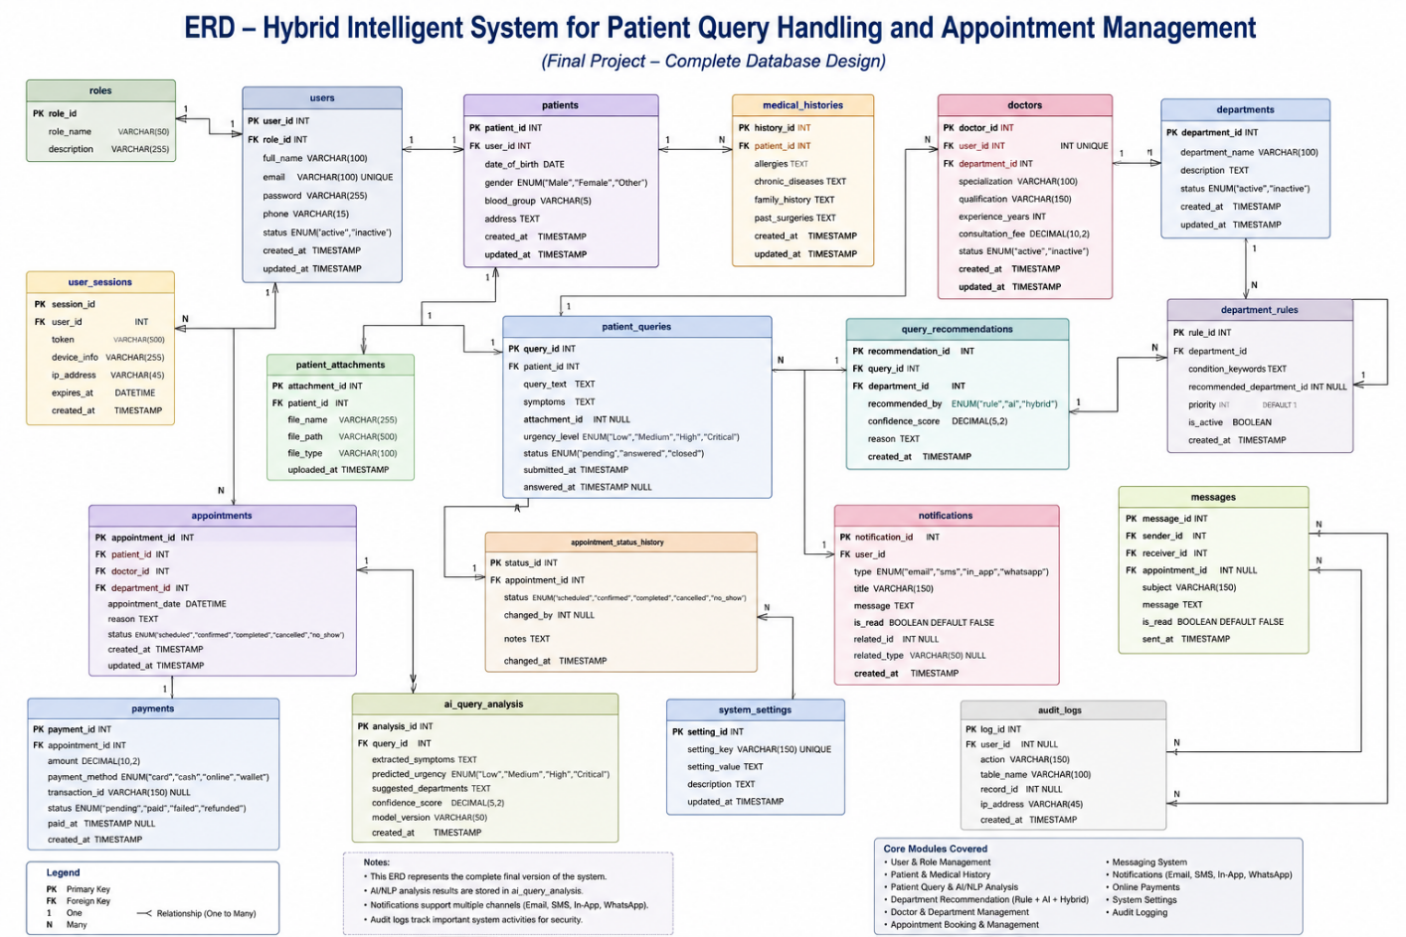
8. UML / System Models

Diagram / Model | Included? | Purpose / Remarks
System Context Diagram | Yes | Illustrates the interaction between external users (Patients, Reception Staff, Department Staff, and Administrators) and the Hybrid Intelligent Hospital System.
Use Case Diagram | Yes | Identifies the major actors of the system and the functional interactions such as registration, login, patient query submission, department recommendation, appointment booking, and dashboard management.
Class Diagram | Yes | Represents the core system classes including User, Department, Patient Query, Appointment, Activity Log, Authentication Service, and Dashboard components along with their relationships.
Sequence Diagram | Yes | Demonstrates the interaction flow during patient query processing, department recommendation, appointment scheduling, and authentication.
Activity Diagram | Yes | Illustrates the complete workflow from user authentication to patient query processing, department recommendation, appointment confirmation, and human handoff where applicable.
Component Diagram | Yes | Shows the interaction between frontend components, backend services, authentication module, routing engine, appointment module, and database.
Deployment Diagram | Yes | Describes the deployment architecture consisting of the client browser, Node.js backend server, and MySQL database server.
Wireframes / UI Flow | Yes | Presents the navigation flow and wireframes for Login, Registration, Patient Dashboard, Reception Dashboard, Department Dashboard, Administrator Dashboard, Patient Query, and Appointment Booking screens.

Figures Included in this Section
- Figure 2: System Context Diagram
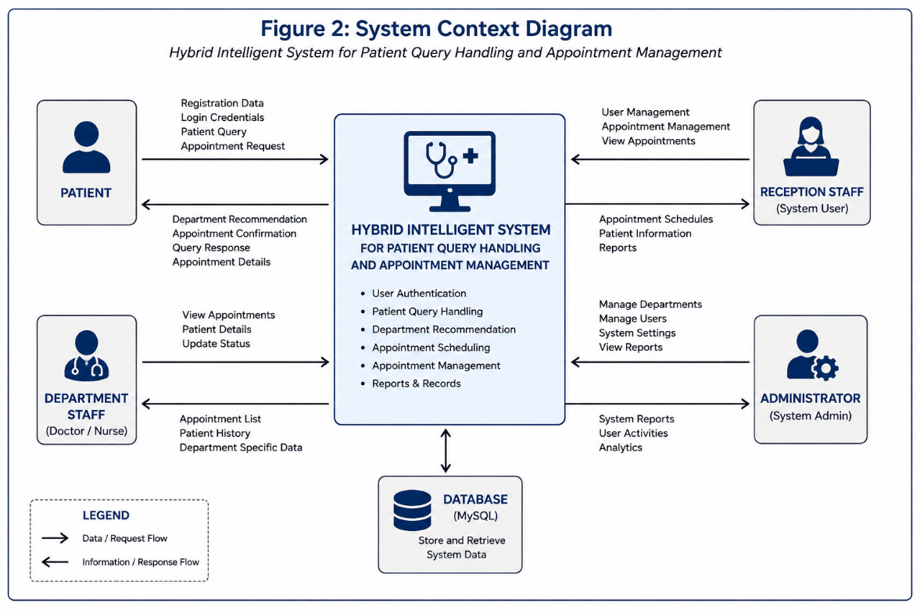
- Figure 3: Use Case Diagram
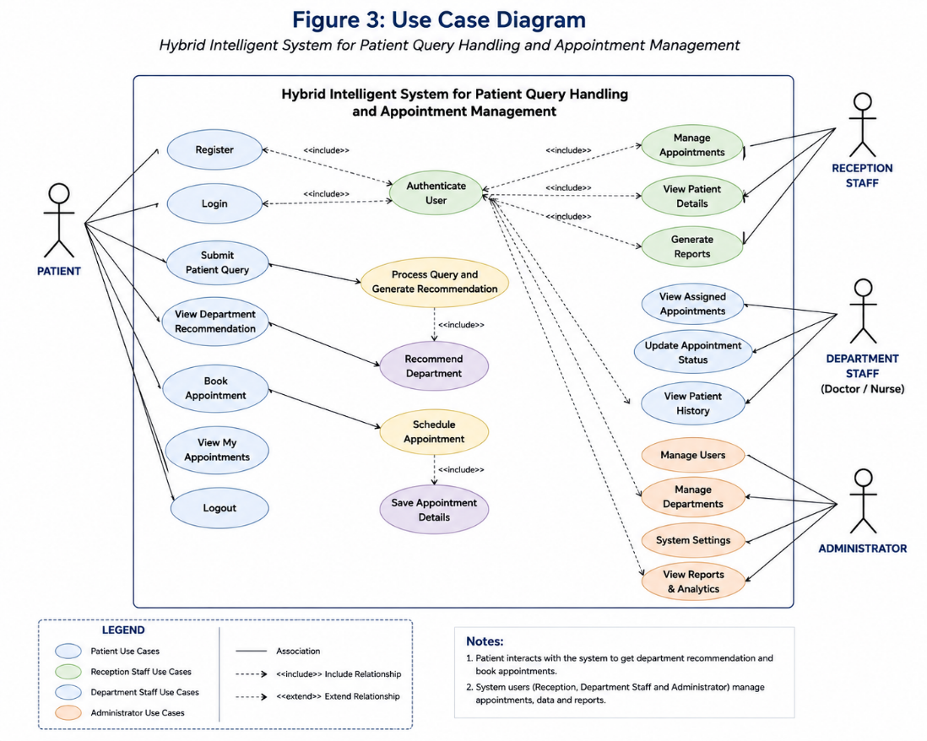

- Figure 4: Class Diagram
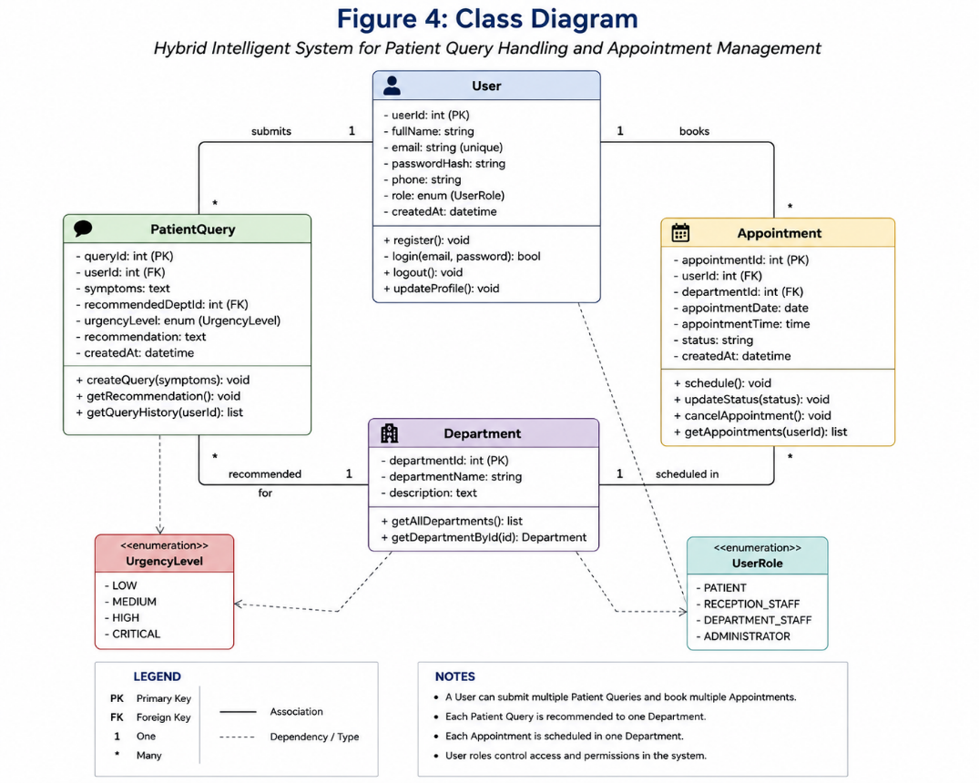
- Figure 5: Sequence Diagram – Patient Query Handling
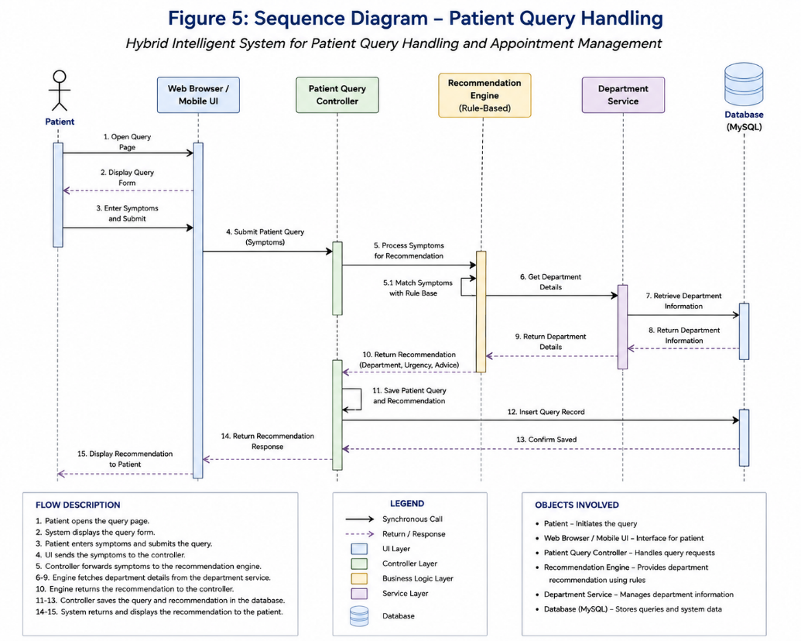

- Figure 6: Sequence Diagram – Appointment Scheduling
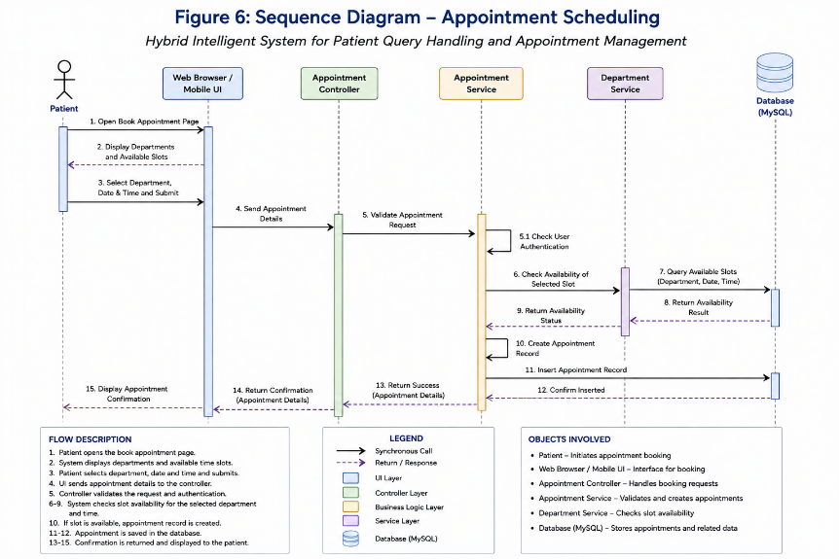
- Figure 7: Activity Diagram – Patient Query and Department Recommendation
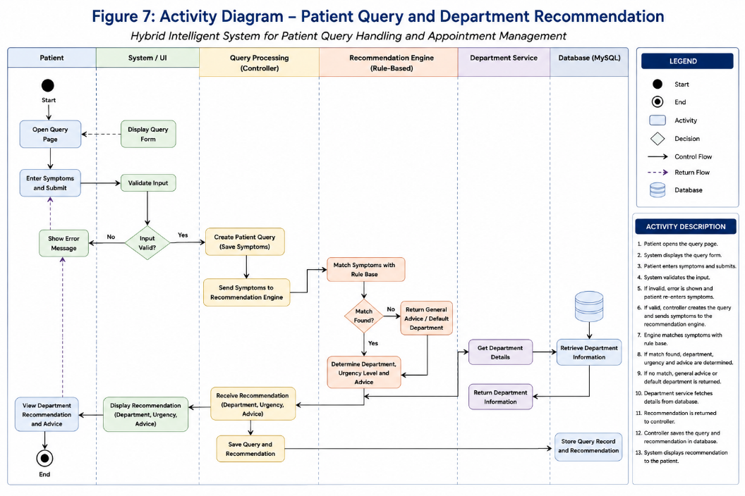

- Figure 8: Component Diagram
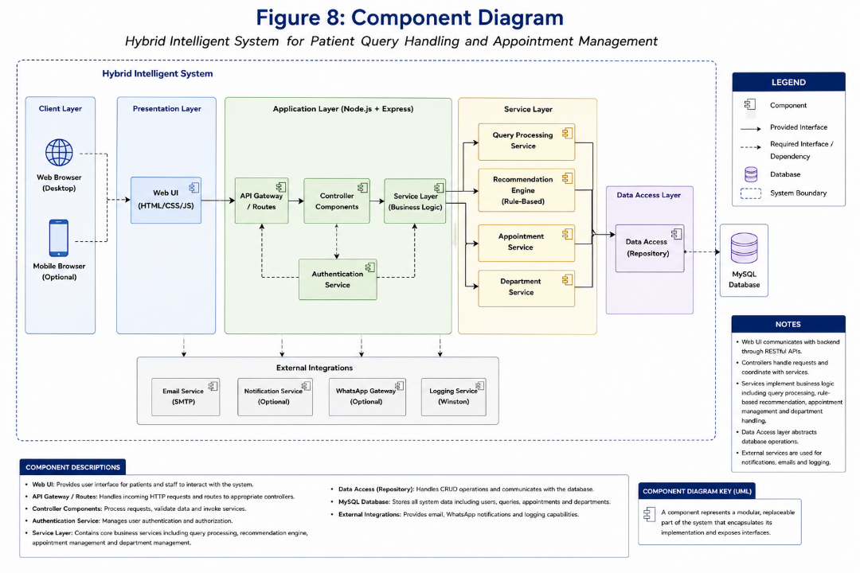
- Figure 9: Deployment Diagram
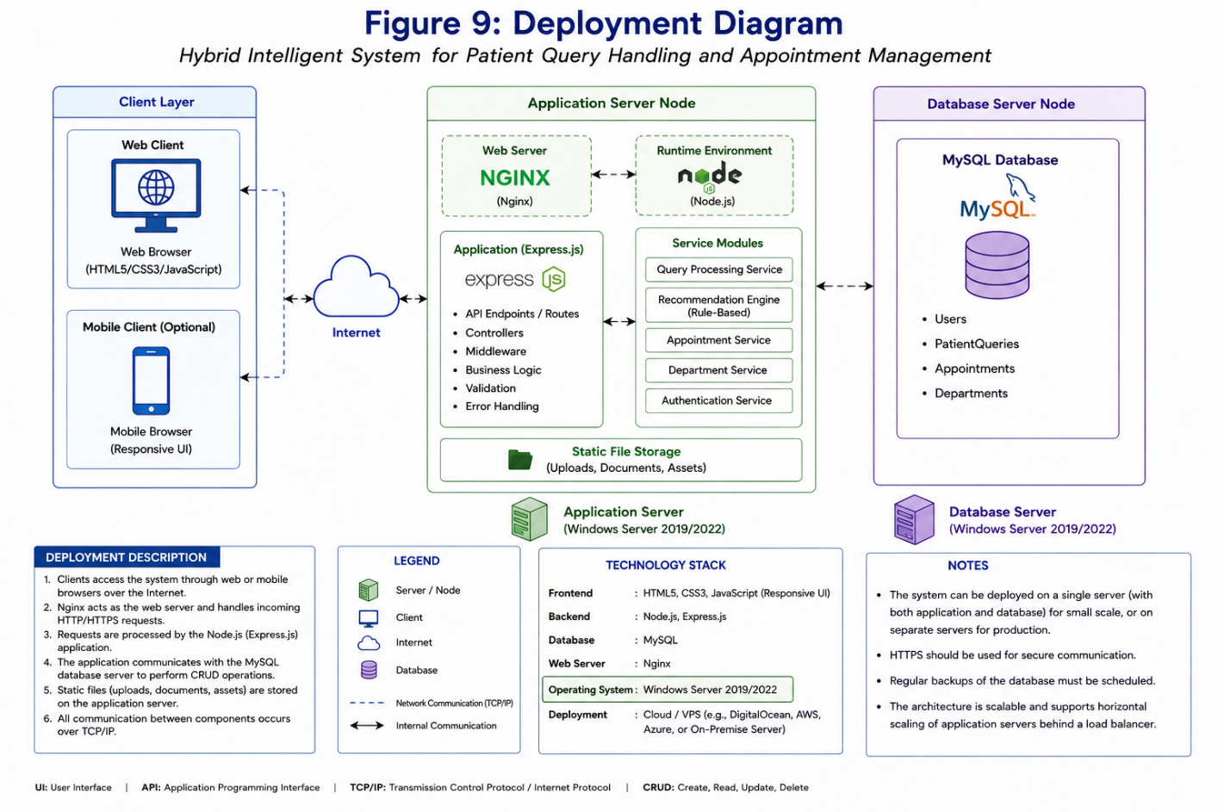

- Figure 10: User Interface Wireframes
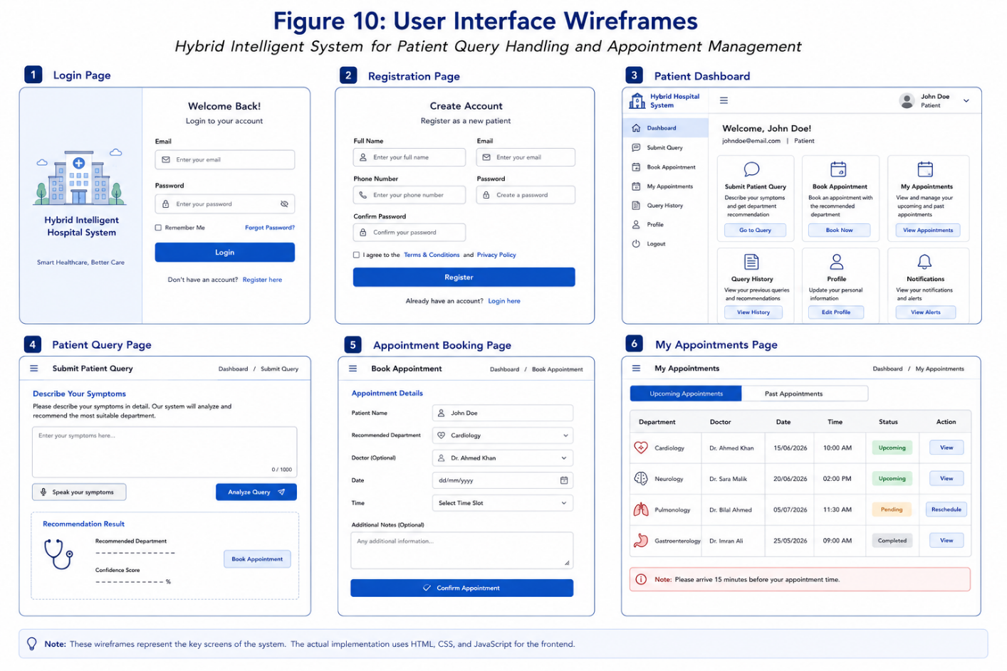

9. API / Interface Design

API / Route / Interface | Method | Input | Output | Authentication Required | Related  Requirement
/api/auth/register | POST | Full Name, Email, Password, Phone Number | User Registration Success / Error Response | No | FR-1
/api/auth/login | POST | Email, Password | JWT Token, User Information, Login Status | No | FR-2
/api/auth/profile | GET | JWT Token | Authenticated User Profile | Yes | FR-2
/api/auth/patient-dashboard | GET | JWT Token | Patient Dashboard Information | Yes (Patient) | FR-2
/api/auth/admin-dashboard | GET | JWT Token | Administrator Dashboard Information | Yes (Administrator) | FR-2
/api/patient/query (Planned) | POST | Patient Symptoms / Query | Recommended Department & Urgency Level | Yes | FR-3, FR-5
/api/appointments/book (Planned) | POST | Patient ID, Department, Appointment Date & Time | Appointment Confirmation | Yes | FR-8
/api/appointments (Planned) | GET | Patient ID | Appointment List | Yes | FR-9

10. User Interface / Navigation Design

Screen / Page | User Role | Purpose | Main Actions | Related  Requirement
Login Page | All Users | Authenticate registered users before granting system access. | Enter email and password, authenticate user, redirect to appropriate dashboard based on role. | FR-2
Registration Page | Patient | Allow new patients to create an account in the system. | Enter personal information, create account, validate input, securely store user details. | FR-1
Patient Dashboard | Patient | Provide access to patient-specific services and information. | Submit patient query, view recommended department, book appointment, view appointment history. | FR-3, FR-8, FR-9
Reception Dashboard | Reception Staff | Manage patient appointments and assist with patient routing. | View appointments, verify patient information, manage appointment records. | FR-9
Department Staff Dashboard | Department Staff | View assigned patient appointments and query information. | Review patient information, update appointment progress, monitor assigned cases. | FR-10
Administrator Dashboard | Administrator | Manage users, departments, and system configuration. | Manage users, departments, monitor activity logs, supervise overall system operations. | FR-10

11. Security Design Considerations

Security Area | Design Control / Decision | Related Module
Authentication | All users must authenticate through secure login before accessing protected system resources. Authentication is implemented using JSON Web Tokens (JWT). | Authentication & User Identity Management Module
Authorization / Role-Based Access Control | User permissions are enforced through Role-Based Access Control (RBAC). Patients, Reception Staff, Department Staff, and Administrators can only access authorized modules. | Authentication & Dashboard Modules
Input Validation | User input is validated at the backend before processing to reduce invalid or malicious requests. Required fields and data formats are verified before database operations. | Authentication, Patient Query, Appointment Modules
Password / Data Protection | User passwords are encrypted using bcrypt before being stored in the database. Plain-text passwords are never stored. | Authentication Module
Session Handling | User authentication sessions are managed using JWT tokens. Protected routes require valid authentication tokens before access is granted. | Authentication Middleware
Error Handling | System-generated errors return controlled messages without exposing internal application details or database information. | All System Modules
Secrets / API Keys, if  applicable | Sensitive configuration values such as database credentials and JWT secret keys are stored using environment variables and are excluded from public repositories. | Configuration Module

12. Error Handling and Validation Design
Error / Validation Case | System Response | User Message / Action | Related Module
Invalid login credentials | Reject login request. | Invalid email or password. Please try again. | Authentication Module
Missing registration fields | Reject registration request until all mandatory fields are completed. | Please complete all required fields. | Authentication Module
Duplicate email address | Prevent duplicate account creation. | Email address already exists. Please use another email. | Authentication Module
Unauthorized access | Deny access to protected resources. | Access denied. Please log in with appropriate credentials. | Authentication & RBAC Module
Invalid or expired JWT token | Reject request and require re-authentication. | Your session has expired. Please log in again. | Authentication Middleware
Invalid patient query | Reject incomplete or invalid patient query. | Please provide sufficient information regarding your symptoms or medical concern. | Patient Query Module
Failed database operation | Roll back transaction and log the error. | Unable to process your request at this time. Please try again later. | Database Management Module

13. Design Decisions and Trade-offs
Design Decision | Reason / Justification | Alternative Considered | Impact
Use Layered Architecture | Separates the application into Presentation, Business Logic, and Database layers, improving maintainability, scalability, and code organization. | Monolithic application structure. | Simplifies development, testing, debugging, and future enhancements.
Use Node.js with Express.js | Express.js provides a lightweight, modular, and efficient framework for developing RESTful APIs required by the system. | Django, Flask, Spring Boot. | Faster backend development with clear route and middleware organization.
Use MySQL as the Database | The project contains structured entities with well-defined relationships such as Users, Departments, Patient Queries, and Appointments. | MongoDB or other NoSQL databases. | Ensures data consistency, integrity, and efficient relational data management.
Use JWT Authentication | JWT enables secure, stateless authentication suitable for REST APIs and simplifies authorization across protected routes. | Session-based authentication. | Improves scalability and simplifies API security implementation.
Use bcrypt for Password Hashing | Protects user passwords by storing only encrypted password hashes instead of plain-text passwords. | Plain-text password storage or custom encryption. | Enhances application security and follows modern authentication practices.
Use Rule-Based Department Recommendation with AI-Ready Architecture | The MVP uses predefined medical rules and keyword matching while keeping the architecture extensible for future AI or NLP integration. | Fully AI-based recommendation engine. | Enables a functional MVP while allowing future intelligent enhancements without architectural redesign.
Implement Role-Based Access Control (RBAC) | Different system users require different permissions and responsibilities. | Single dashboard with unrestricted access. | Improves system security, usability, and administrative control.

14. Traceability to Requirements
Requirement ID | Design Element / Module | Diagram / Model | Verification Method
FR-1 | User Registration Module | Class Diagram, ERD | User Registration Test
FR-2 | Authentication & RBAC Module | Use Case Diagram, Deployment Diagram | Login and Authorization Test
FR-3 | Patient Query Handling Module | Activity Diagram | Patient Query Submission Test
FR-4 | Patient Query Validation | Activity Diagram | Input Validation Test
FR-5 | Department Recommendation Module | Sequence Diagram | Department Recommendation Test
FR-6 | Urgency Classification & Human Handoff | Sequence Diagram | Urgency Classification Test
FR-7 | Human Handoff Module | Activity Diagram | Escalation Workflow Test
FR-8 | Appointment Management Module | ERD, Class Diagram | Appointment Booking Test
FR-9 | Appointment Status Management | Sequence Diagram | Appointment Update Test
FR-10 | Dashboard Management Module | Wireframes, Use Case Diagram | Dashboard Access Test

15. Version / Change Notes

Version | Date | Change Description | Reason | Approved / Reviewed By
1.0 | 04 August 2026 | Initial Software Design Document prepared for Checkpoint-2 based on the approved SRS, High-Level Architecture, and current MVP implementation. | Checkpoint-2 Submission | Dr. Mujeeb ur Rehman Shaikh
1.1 | Future Revision | Updates after supervisor review and additional module implementation. | Future project enhancements and implementation feedback. | Dr. Mujeeb ur Rehman Shaikh

16. Review and Approval

Item | Status / Remarks
Internal Team Review Completed | [ ] Yes [ ] No
Supervisor Remarks
Supervisor Signature
Date

Part B: Updated Architecture
1. Purpose
This section records the architectural refinements made after the completion of Checkpoint-1. The overall layered architecture proposed during Checkpoint-1 remains valid; however, the internal software modules have been refined based on the detailed software design, implementation progress, supervisor feedback, and Minimum Viable Product (MVP) development.
The purpose of this update is to document the evolution of the system architecture from a high-level conceptual design into a more detailed and implementation-oriented structure while maintaining consistency with the approved System Requirements Specification (SRS). The refined architecture clearly separates authentication, patient query processing, intelligent department recommendation, appointment management, dashboard management, and database services to improve modularity, maintainability, scalability, and future extensibility.
2. Architecture Update Summary
Item | Details
Architecture Status | ☑ Minor Refinement
Reason for Update | The architecture was refined to better separate the Authentication, Patient Query Handling, Intelligent Department Recommendation, Appointment Management, Dashboard Management, and Database components after completing the detailed software design and beginning backend implementation.
Affected Layers / Components | Business Logic Layer, API Layer, Security Layer, and Database Layer.
Impact on Technology Stack | No major changes. The selected technology stack remains Node.js, Express.js, MySQL, JWT Authentication, bcrypt Password Hashing, HTML/CSS/JavaScript, and future React.js integration if required.
Impact on Risks / Security | Security has been strengthened through JWT Authentication, Role-Based Access Control (RBAC), bcrypt password hashing, protected API routes, backend input validation, and secure environment variable configuration for sensitive credentials.

3. Updated Architecture Diagram
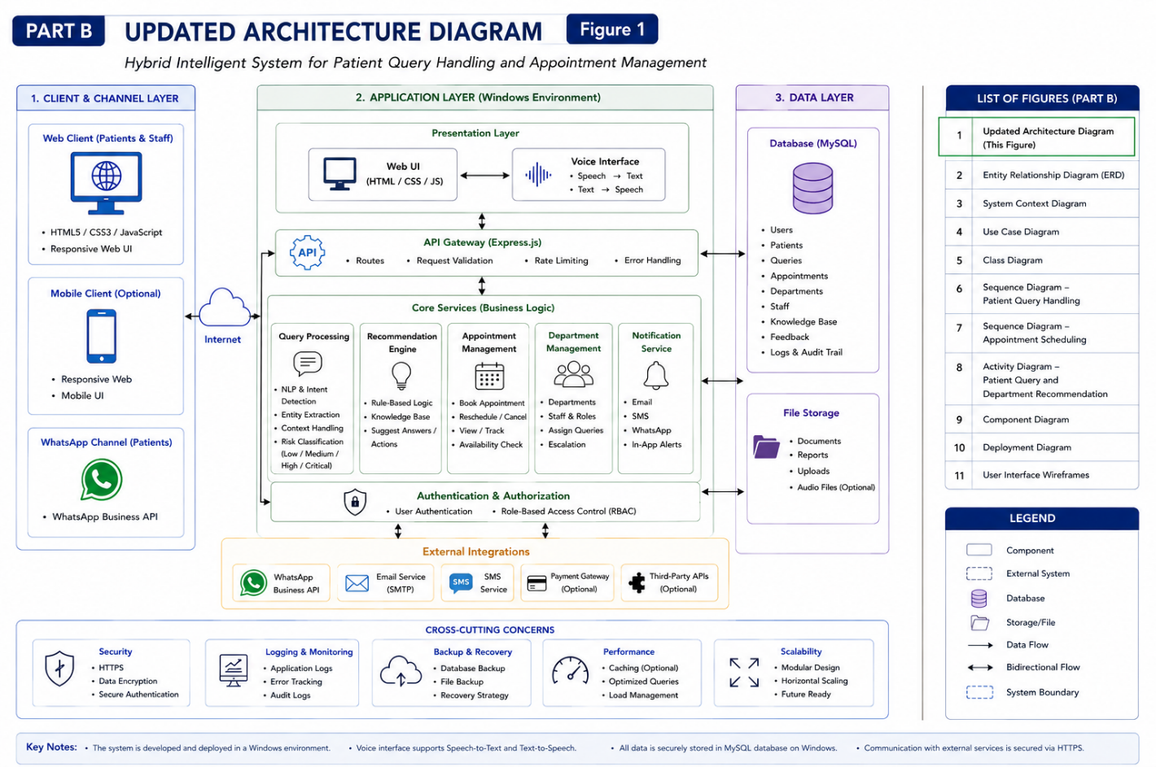
4. Updated Component Mapping

Component | Change / Refinement | Reason | Impact on Design / Implementation
Authentication & User Identity Management Module | Separated into Authentication Controller, JWT Middleware, and Role Authorization Middleware. | Improve security and modularity of user authentication. | Simplifies maintenance and strengthens access control.
Patient Query Handling Module | Refined into a dedicated module responsible for receiving, validating, and preparing patient symptom data before routing. | Improve separation of responsibilities. | Makes the system easier to extend with future AI or NLP capabilities.
Intelligent Department Recommendation Module | Introduced as an independent business logic component responsible for department recommendation and urgency classification. | Centralizes recommendation logic. | Supports future integration of intelligent recommendation algorithms without affecting other modules.
Appointment Scheduling & Management Module | Defined as an independent module connected to the recommendation engine and user management. | Appointment management requires its own validation and business rules. | Simplifies appointment scheduling and future enhancements.
Dashboard Management Module | Dashboard responsibilities separated according to user roles. | Different users require different system functions. | Improves usability, maintainability, and role-based navigation.
Activity Logging Module | Added as a supporting component to record important system events. | Improves traceability and auditing. | Supports monitoring, debugging, and future reporting requirements.

5. Updated Risk / Security Notes

Risk / Security Area | Update | Mitigation / Action
Unauthorized System Access | Security requirements refined during backend implementation. | JWT Authentication, Role-Based Access Control (RBAC), and protected API routes have been implemented.
Password Security | Password storage strategy finalized. | User passwords are encrypted using bcrypt before being stored in the database.
Invalid User Input | Backend validation introduced for user requests. | Required fields and request data are validated before processing or database operations.
Sensitive Configuration Exposure | Sensitive configuration separated from application code. | Database credentials and JWT Secret are stored in environment variables (.env) and excluded from version control.
Incorrect Department Recommendation | Recommendation accuracy depends on predefined rules during the MVP stage. | Structured rule-based decision logic is implemented, with architecture designed for future AI-assisted improvements and human handoff support.
Future Scalability | Additional intelligent services may increase system complexity. | Modular architecture allows independent expansion of recommendation services, notification services, and future intelligent modules without major architectural redesign.

Part C: Prototype / MVP Demonstration — FYP-T6
1. Prototype Scope
The Checkpoint-2 Minimum Viable Product (MVP) demonstrates the foundational backend implementation of the Hybrid Intelligent System for Patient Query Handling and Appointment Management with Guided Patient-to-Department Routing, Urgency-Based Escalation, and Structured Human Handoff Support.
The current prototype focuses on establishing a secure and modular backend architecture by implementing user registration, secure authentication, Role-Based Access Control (RBAC), protected API endpoints, and database integration. These components provide the foundation for the remaining intelligent modules that will be implemented during subsequent development iterations.
The prototype validates the overall system architecture and demonstrates that the core security and user management infrastructure is functional. Planned modules such as Patient Query Handling, Intelligent Department Recommendation, Appointment Scheduling, and Dashboard Interfaces are defined within the software design and are scheduled for implementation in the next development phase.
2. Implemented Requirements

Requirement ID | Feature / Requirement | Implementation Status | Remarks
FR-1 | Patient Registration | Implemented | Secure user registration completed with password hashing.
FR-2 | User Login & Authentication | Implemented | JWT Authentication successfully implemented.
FR-2 | Role-Based Access Control | Implemented | Patient and Administrator authorization verified using middleware.
FR-2 | Protected API Routes | Implemented | Protected routes require valid JWT tokens before access.
FR-3 | Patient Query Submission | Planned | Module designed; implementation scheduled for next development phase.
FR-5 | Department Recommendation | Planned | Rule-based recommendation engine documented but not yet implemented.
FR-6 | Urgency Classification | Planned | Intelligent classification architecture finalized for future implementation.
FR-7 | Human Handoff Support | Planned | Workflow documented; implementation pending.
FR-8 | Appointment Scheduling | Planned | Database and module design completed; implementation pending.
FR-10 | Dashboard Management | Partial | Backend authorization completed; frontend dashboard implementation in progress.

3. Prototype Access / Setup Instructions

Item | Details
Repository Link | https://github.com/ibtisamkhan369-ik/FYP-2026-G2-HybridIntelligentSystemforPatientQueryHandlingAndAppointmentManagement
Branch / Folder | Main Branch / Backend
Local Setup Instructions | 1. Clone the GitHub repository. 2. Open the project in Visual Studio Code. 3. Install Node.js dependencies using npm install. 4. Configure the .env file with database credentials and JWT Secret. 5. Create the MySQL database using the provided SQL script. 6. Start the backend server using npm run dev or nodemon server.js.
Demo URL | Localhost Only
Demo Credentials | Patient Account: (Create during demonstration) Administrator Account: (Future implementation)

4. Evidence of Working Prototype

Evidence Type | Details / Link / Location
Screenshots | /06-Prototype/screenshots/
Demo Video | (Optional — if available)
Test Evidence | Postman API testing screenshots demonstrating Registration, Login, JWT Authentication, Protected Routes, and Role-Based Authorization.
Repository Commit Evidence | GitHub commit history showing backend implementation progress and authentication module development.
Deployment Evidence | Localhost demonstration using Node.js and MySQL.

Screenshots:
- Figure 11: Login
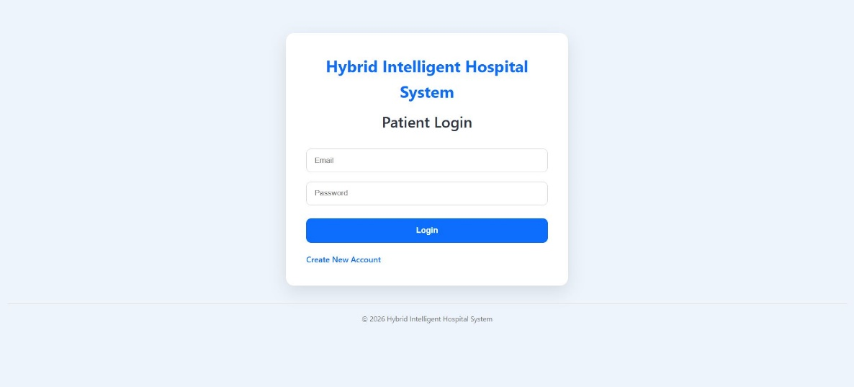

- Figure 12 Registration
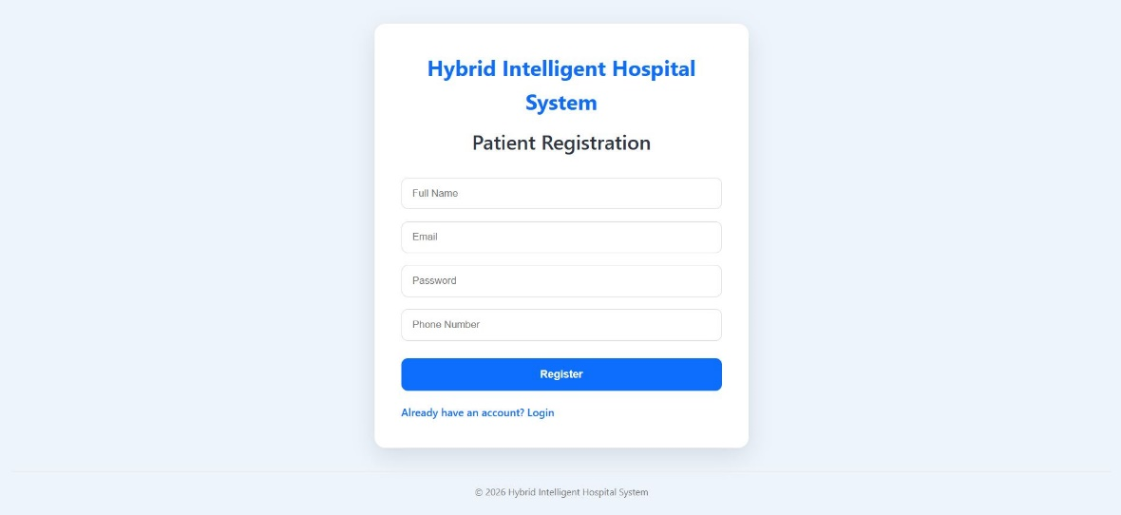
- Figure 13 Dashboard
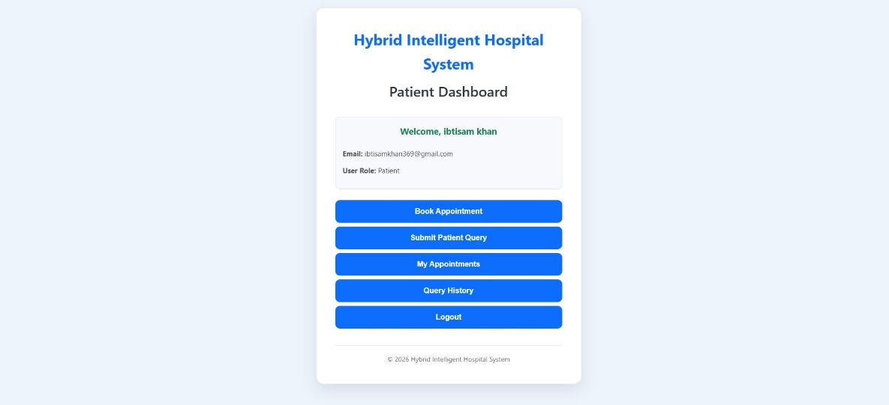

- Figure 14 Patient Query
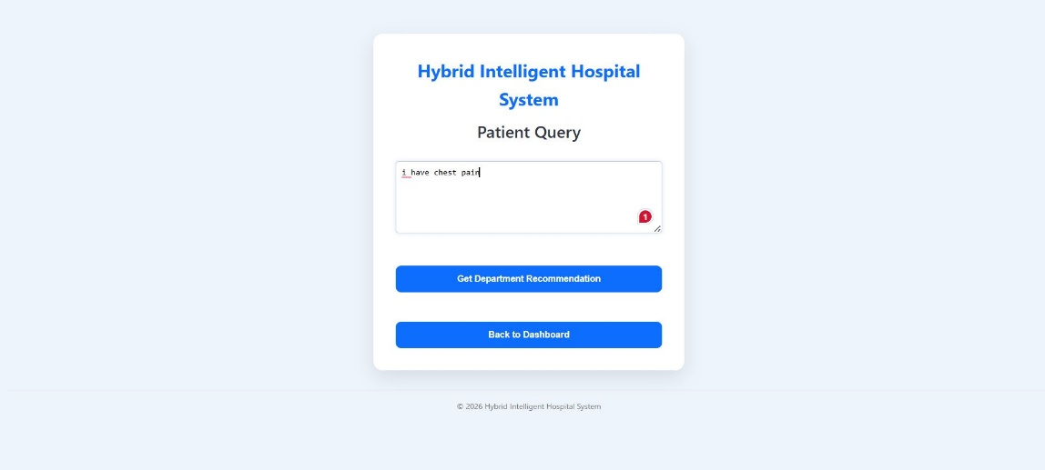

- Figure 15 Department Recommendation
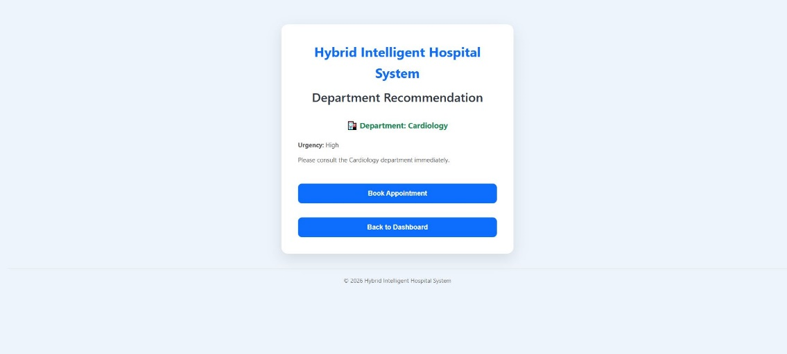
- Figure 16 Appointment Booking
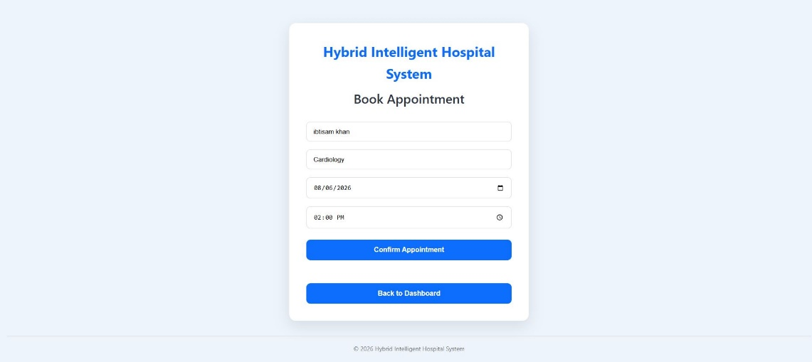

- Figure 17 My Appointments
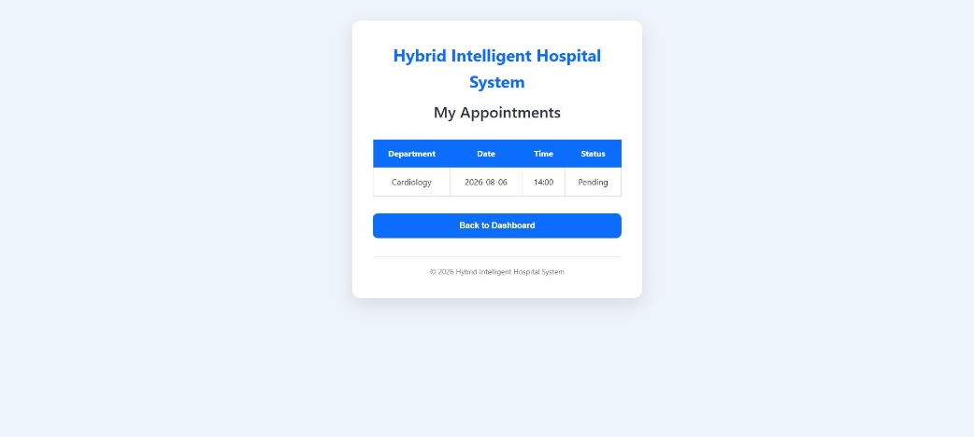

- Figure 18 Database Tables
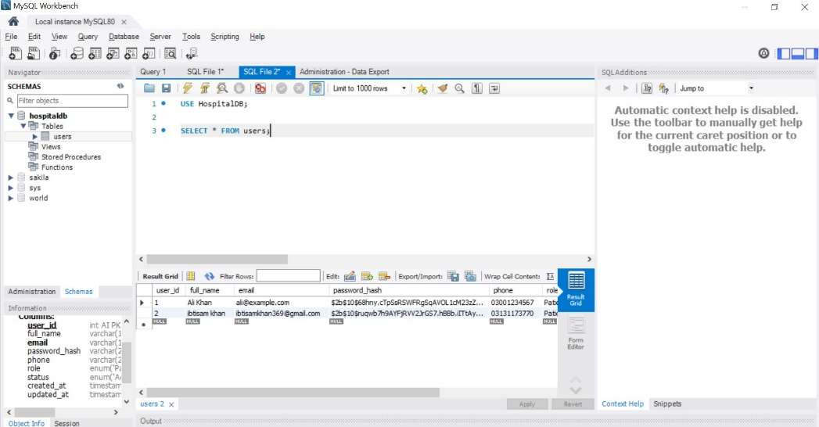
- Figure 19 Register API
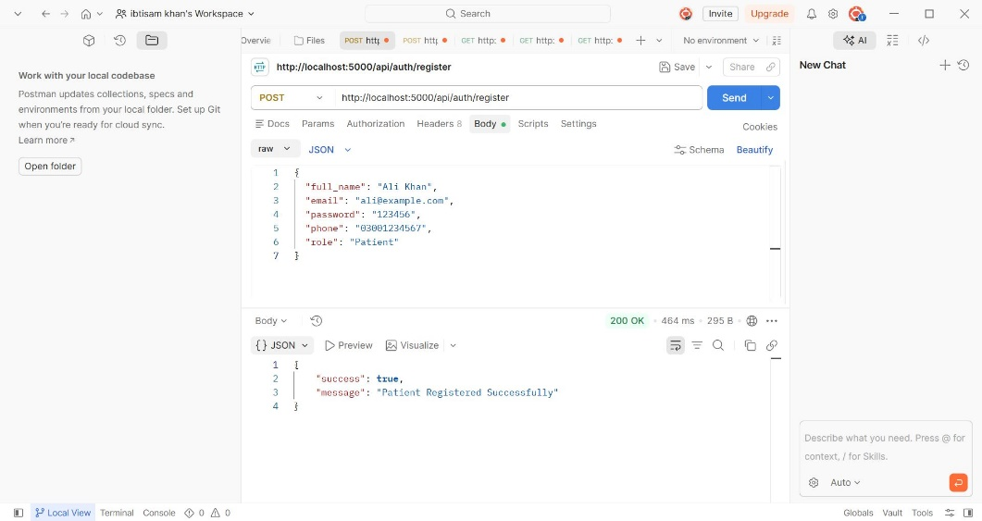

- Figure 20 Login API
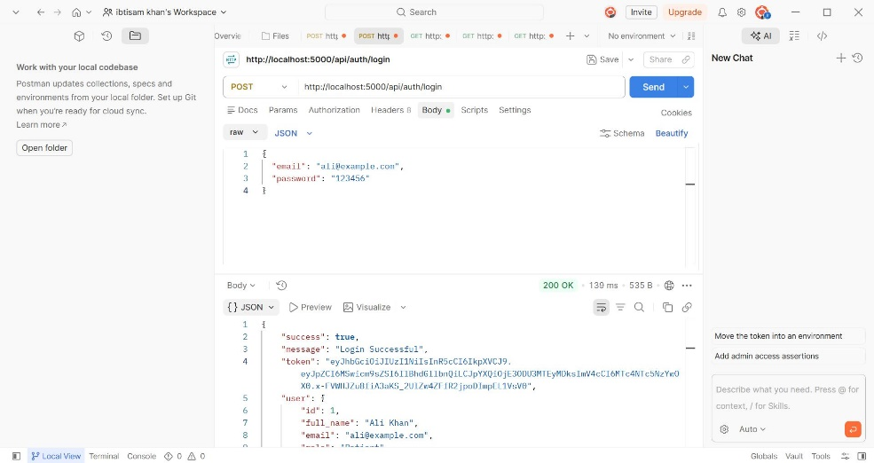

- Figure 21 Protected API
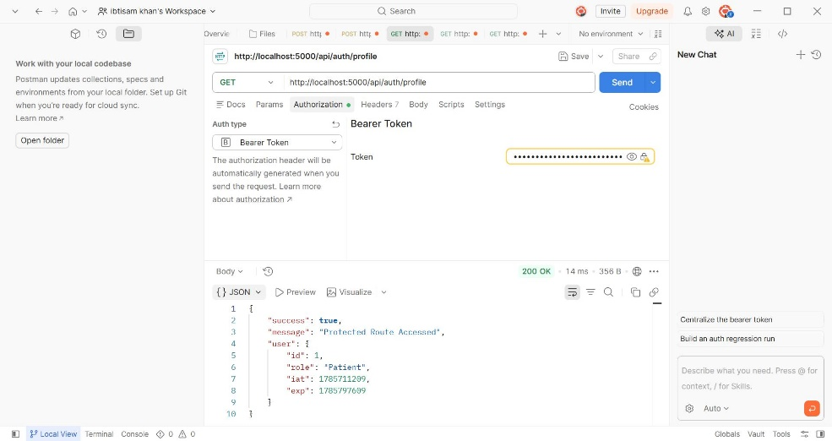
- Figure 22 GitHub Repository
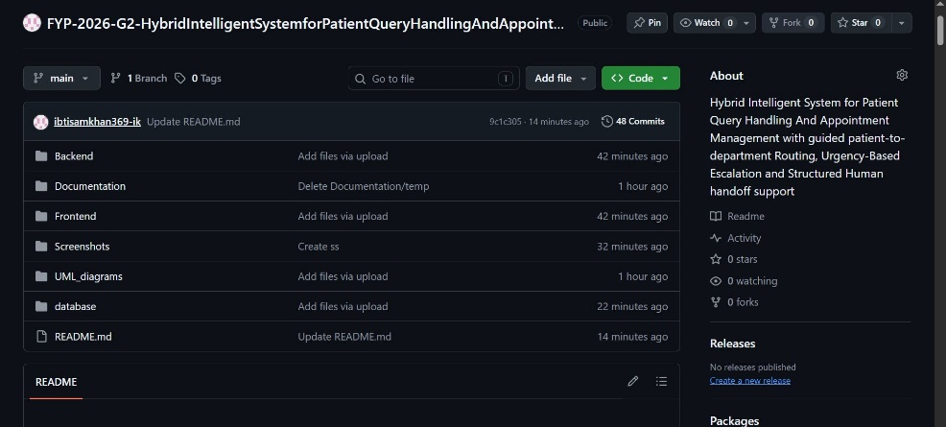

5. Known Limitations
Limitation | Reason | Planned Improvement
Patient Query Processing Module not yet implemented | Development prioritized secure authentication and backend architecture. | Implement during next development iteration.
Intelligent Department Recommendation not yet implemented | Rule-based recommendation engine is currently under development. | Complete recommendation engine and future AI integration.
Appointment Scheduling Module pending | Database and software design completed first. | Implement booking APIs and frontend integration.
Frontend Dashboard under development | Backend implementation prioritized during Checkpoint-2. | Complete dashboards for Patient, Reception Staff, Department Staff, and Administrator.
AI/NLP integration deferred | Intelligent architecture prepared while advanced AI integration remains optional. | Integrate AI-assisted recommendations if required during future development phases.

6. Deployment Details
Item | Details
Deployment Type | Local Prototype
Runtime Environment | Node.js with Express.js
Database Used | MySQL
Dependencies | Express.js, MySQL2, bcrypt, JSON Web Token (JWT), dotenv, Nodemon

7. Supervisor Remarks

Part D: Initial Implementation Evidence Template
1. Sprint / Prototype README Summary — FYP-T7
Field | Details
Project Title | Hybrid Intelligent System for Patient Query Handling and Appointment Management with Guided Patient-to-Department Routing, Urgency-Based Escalation, and Structured Human Handoff Support
Sprint / Prototype Name | Checkpoint-2 MVP Development Sprint
Date | 05 August 2026
GitHub Repository Link | https://github.com/ibtisamkhan369-ik/FYP-2026-G2-HybridIntelligentSystemforPatientQueryHandlingAndAppointmentManagement
Branch / Commit Reference | Main Branch – Checkpoint-2 Implementation
Student Name | Area Covered
Ibtisam Saleem | Backend Development, Database Design, Authentication System, JWT Implementation, Role-Based Access Control, Software Design Documentation
Faryal Israr | Frontend Planning, User Interface Design, Wireframes, Documentation Support, Testing, Dashboard Design
Joint Contribution | System Integration, Documentation Review, GitHub Repository Management, MVP Preparation

2. Implemented Features

Feature | Related Requirement | Implemented By | Repository Location
User Registration | FR-1 | Ibtisam Saleem | /Backend/controllers/authController.js
User Login | FR-2 | Ibtisam Saleem | /Backend/controllers/authController.js
JWT Authentication | FR-2 | Ibtisam Saleem | /Backend/middleware/authMiddleware.js
Role-Based Access Control | FR-2 | Ibtisam Saleem | /Backend/middleware/roleMiddleware.js
Protected API Routes | FR-2 | Ibtisam Saleem | /Backend/routes/authRoutes.js
Database Configuration | FR-1 | Ibtisam Saleem | /Backend/config/db.js
Database Schema | FR-1 | Ibtisam Saleem | /Database/ (or SQL Script Folder)
UI Wireframes | FR-10 | Faryal Israr | /Frontend/Wireframes/ (or documentation folder)
Software Design Documentation | All Requirements | Both | /05-Software-Design/

3. How to Run / Access

Step 1
Clone the GitHub repository.

Step 2
Open the project in Visual Studio Code.

Step 3
Navigate to the Backend folder.
cd Backend

Step 4
Install project dependencies.
npm install

Step 5
Configure the .env file.
Example:
PORT=5000

DB_HOST=localhost
DB_USER=root
DB_PASSWORD=********
DB_NAME=HospitalDB
DB_PORT=3306

JWT_SECRET=your_secret_key

Step 6
Create the MySQL database using the provided SQL script.

Step 7
Start the backend server.
npm run dev
or
nodemon server.js

Step 8
Open Postman and test the REST APIs.
Base URL
http://localhost:5000
4. Test Summary
Test / Scenario | Result | Evidence Location
User Registration | Pass | Postman Screenshot
User Login | Pass | Postman Screenshot
Password Hashing | Pass | MySQL Database Verification
JWT Authentication | Pass | Postman Screenshot
Protected Routes | Pass | Postman Screenshot
Patient Dashboard Authorization | Pass | Postman Screenshot
Administrator Dashboard Authorization | Pass | Postman Screenshot (403 Forbidden)
MySQL Database Connection | Pass | Backend Console Screenshot

5. Pending Issues
Issue | Impact | Planned Action
Patient Query Processing Module pending | Medium | Implement rule-based patient query analysis and validation.
Department Recommendation Engine pending | Medium | Develop intelligent recommendation module using predefined medical rules with future AI extensibility.
Appointment Scheduling Module pending | Medium | Implement backend APIs and frontend integration for appointment management.
Dashboard User Interface pending | Medium | Complete responsive dashboards for all user roles.
Human Handoff Workflow pending | Low | Implement structured escalation workflow for uncertain recommendations.

6. Notes on Ownership
The backend architecture, database connectivity, RESTful APIs, authentication system, JWT implementation, Role-Based Access Control (RBAC), middleware development, database design, and backend documentation were primarily implemented by Ibtisam Saleem.
Frontend planning, user interface design, dashboard layout planning, wireframe preparation, documentation support, and software testing activities were primarily handled by Faryal Israr.
The project was jointly reviewed, integrated, documented, and prepared for the Checkpoint-2 demonstration.
AI tools were used as a documentation and development assistance resource to improve technical writing, software documentation structure, code understanding, debugging guidance, and implementation planning. All architectural decisions, software design, implementation choices, validation, and final project integration were reviewed and verified by the project team.
7. Code Review Checklist — FYP-T8

Checklist Item | Yes | No | Remarks
Naming conventions followed | ☑ | ☐ | Meaningful naming used throughout backend modules.
Code is modular | ☑ | ☐ | Controllers, routes, middleware, configuration, and database logic separated.
Error handling present | ☑ | ☐ | Authentication and API error handling implemented.
No hard-coded secrets | ☑ | ☐ | Sensitive configuration stored in .env file.
Input validation present | ☑ | ☐ | Registration and authentication requests validated before processing.
Logging appropriate | ☑ | ☐ | Basic server logging implemented during backend development.
Comments / documentation adequate | ☑ | ☐ | Code organized with readable structure and documentation.
Edge cases considered | ☑ | ☐ | Invalid login, unauthorized access, duplicate registration, and protected route validation considered.
Dependencies documented | ☑ | ☐ | Required packages documented through package.json and installation instructions.
Security issues reviewed | ☑ | ☐ | JWT, bcrypt, RBAC, protected routes, and environment variables implemented.
Reviewed By |  | Date
Dr. Mujeeb ur Rehman Shaikh |  | 05 August 2026

Final Student Checklist for Checkpoint-2

Checklist Item | Completed?
Software Design Document completed and reviewed | Yes
ERD/database design included | Yes
Relevant UML/system models included | Yes
API/interface design included where applicable | Yes
Updated architecture note/diagram included | Yes
Working prototype/MVP demonstrated | Yes
Prototype README/setup instructions uploaded | Yes
Initial implementation evidence uploaded to GitHub | Yes
Code Review Checklist completed | Yes
Supervisor review completed before submission | Yes

