Лабораторная работа № 4
по дисциплине «Алгоритмы и структуры данных»
Openedu – неделя 4

Подготовил:
студент группы P3217
Бураков Илья Алексеевич

Преподаватели:
Романов Алексей Андреевич
Волчек Дмитрий Геннадьевич

Стек

Условие
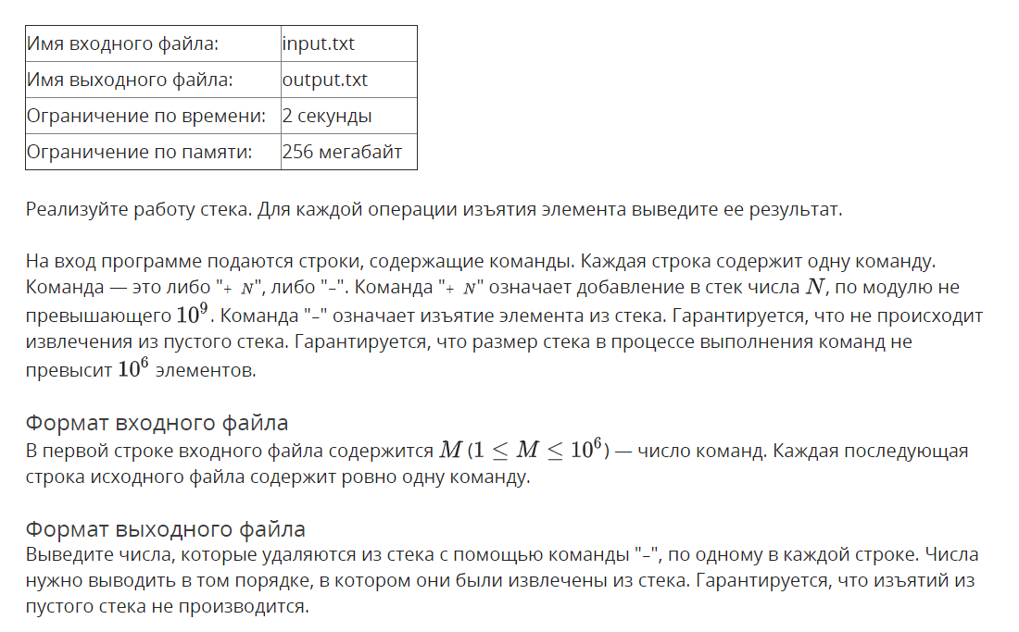
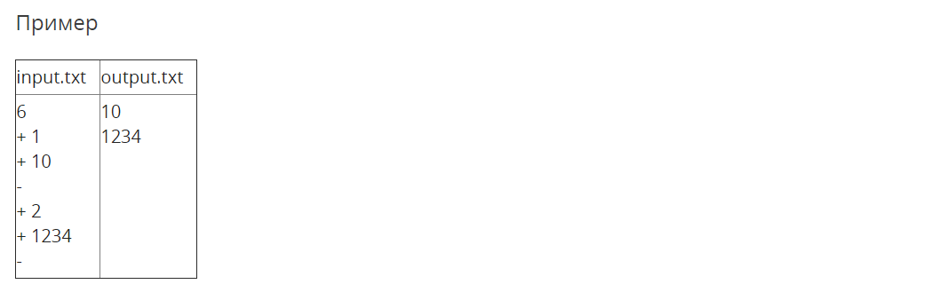

Решение

openedu/week4/lab4_1.cpp

#include "edx-io.hpp"

w

using namespace std;

int main() {

auto stack = new int[1e6];

int n;

io >> n;

for (int i = 0; i < n; i++) {

// read command

char c;

io >> c;

if (c == '+') {

// push

io >> *(stack++);

} else {

// pop

io << *(--stack) << '\n';

}

}

return 0;

}

Результаты
№ теста | Результат | Время, с | Память | Размер входного файла | Размер выходного файла
Max |  | 0.156 | 19202048 | 13389454 | 5693807
1 | OK | 0.000 | 2240512 | 33 | 10
2 | OK | 0.015 | 2228224 | 11 | 3
3 | OK | 0.015 | 2228224 | 19 | 6
4 | OK | 0.000 | 2228224 | 19 | 6
5 | OK | 0.015 | 2228224 | 19 | 6
6 | OK | 0.000 | 2228224 | 96 | 45
7 | OK | 0.015 | 2228224 | 85 | 56
8 | OK | 0.015 | 2228224 | 129 | 11
9 | OK | 0.015 | 2240512 | 131 | 12
10 | OK | 0.000 | 2240512 | 859 | 540
11 | OK | 0.000 | 2244608 | 828 | 573
12 | OK | 0.000 | 2224128 | 1340 | 11
13 | OK | 0.000 | 2224128 | 1325 | 12
14 | OK | 0.000 | 2236416 | 8292 | 5590
15 | OK | 0.000 | 2228224 | 8212 | 5706
16 | OK | 0.015 | 2224128 | 13298 | 111
17 | OK | 0.000 | 2240512 | 13354 | 12
18 | OK | 0.000 | 2228224 | 82372 | 56548
19 | OK | 0.000 | 2240512 | 82000 | 56993
20 | OK | 0.015 | 2281472 | 132796 | 1134
21 | OK | 0.000 | 2265088 | 133914 | 11
22 | OK | 0.031 | 2641920 | 819651 | 569557
23 | OK | 0.015 | 2838528 | 819689 | 569681
24 | OK | 0.015 | 3538944 | 1328670 | 11294
25 | OK | 0.015 | 3547136 | 1338543 | 11
26 | OK | 0.156 | 10014720 | 8196274 | 5693035
27 | OK | 0.140 | 12013568 | 8193816 | 5693807
28 | OK | 0.062 | 19021824 | 13286863 | 112020
29 | OK | 0.062 | 19202048 | 13389454 | 11
30 | OK | 0.046 | 19202048 | 13388564 | 11

Очередь

Условие
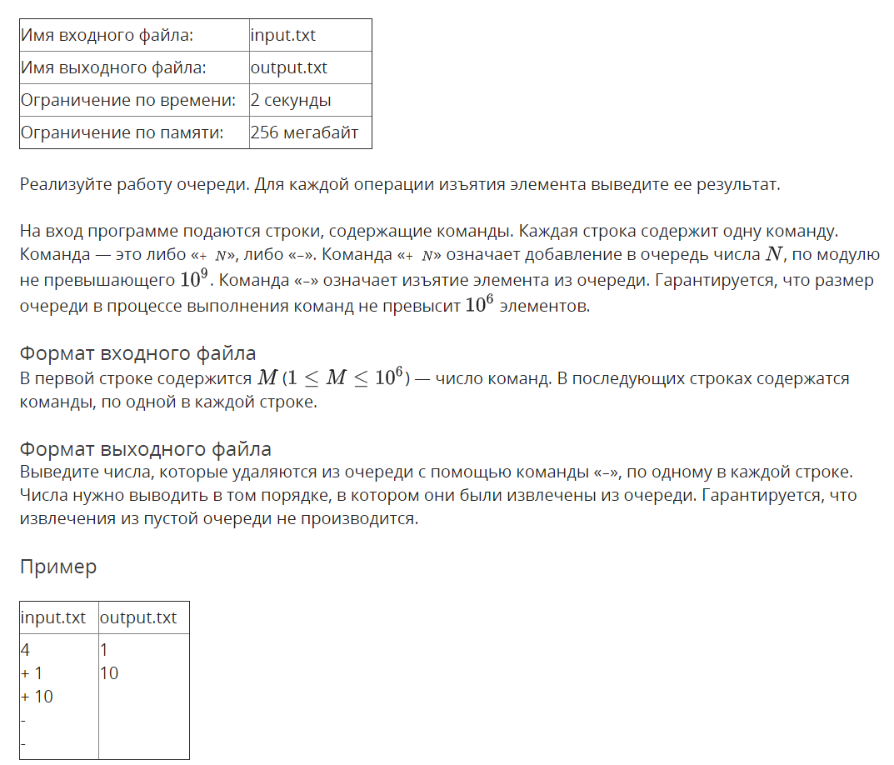

Решение

openedu/week4/lab4_2.cpp

#include "edx-io.hpp"

using namespace std;

#define SIZE 1000000

#define CYCLE_INC(v, sz) (((v) + 1 ) % (sz))

int main() {

auto queue = new int[SIZE];

int head = 0, tail = 0;

int n;

io >> n;

for (int i = 0; i < n; i++) {

// read command

char c;

io >> c;

if (c == '+') {

// push

io >> queue[tail];

tail = CYCLE_INC(tail, SIZE);

} else {

// pop

io << queue[head] << '\n';

head = CYCLE_INC(head, SIZE);

}

}

return 0;

}

Результаты
№ теста | Результат | Время, с | Память | Размер входного файла | Размер выходного файла
Max |  | 0.156 | 19202048 | 13389454 | 5693807
1 | OK | 0.015 | 2240512 | 20 | 7
2 | OK | 0.015 | 2228224 | 11 | 3
3 | OK | 0.000 | 2236416 | 19 | 6
4 | OK | 0.000 | 2228224 | 19 | 6
5 | OK | 0.015 | 2228224 | 96 | 45
6 | OK | 0.000 | 2240512 | 85 | 56
7 | OK | 0.000 | 2228224 | 129 | 12
8 | OK | 0.000 | 2228224 | 131 | 12
9 | OK | 0.000 | 2240512 | 859 | 538
10 | OK | 0.000 | 2232320 | 828 | 573
11 | OK | 0.015 | 2228224 | 1340 | 12
12 | OK | 0.000 | 2228224 | 1325 | 12
13 | OK | 0.015 | 2228224 | 8292 | 5589
14 | OK | 0.015 | 2240512 | 8212 | 5706
15 | OK | 0.000 | 2228224 | 13298 | 115
16 | OK | 0.000 | 2228224 | 13354 | 12
17 | OK | 0.015 | 2260992 | 82372 | 56552
18 | OK | 0.000 | 2244608 | 82000 | 56993
19 | OK | 0.000 | 2265088 | 132796 | 1124
20 | OK | 0.000 | 2256896 | 133914 | 12
21 | OK | 0.031 | 2838528 | 819651 | 569553
22 | OK | 0.015 | 2838528 | 819689 | 569681
23 | OK | 0.015 | 3543040 | 1328670 | 11296
24 | OK | 0.015 | 3551232 | 1338543 | 12
25 | OK | 0.140 | 12013568 | 8196274 | 5693025
26 | OK | 0.156 | 12013568 | 8193816 | 5693807
27 | OK | 0.062 | 19062784 | 13286863 | 112110
28 | OK | 0.062 | 19202048 | 13389454 | 10
29 | OK | 0.046 | 19202048 | 13388564 | 11

Скобочная последовательность

Условие
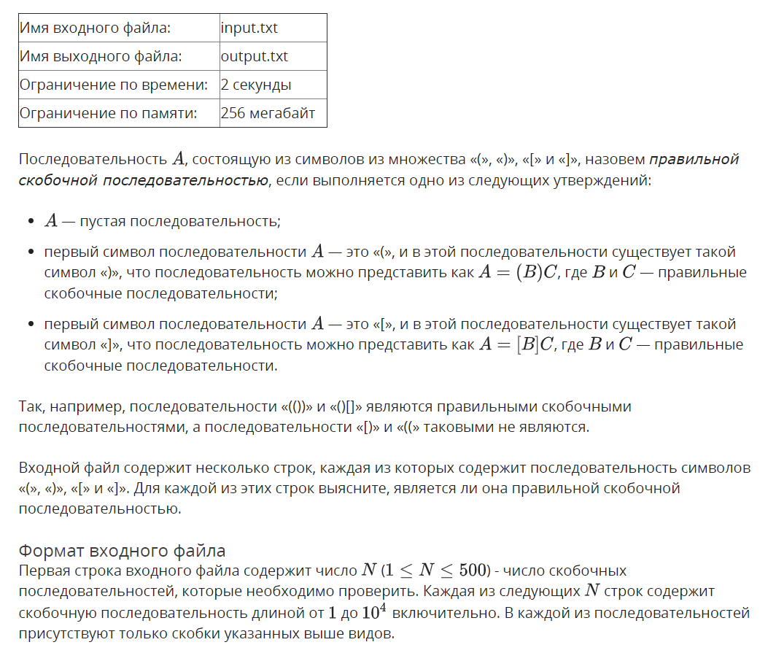
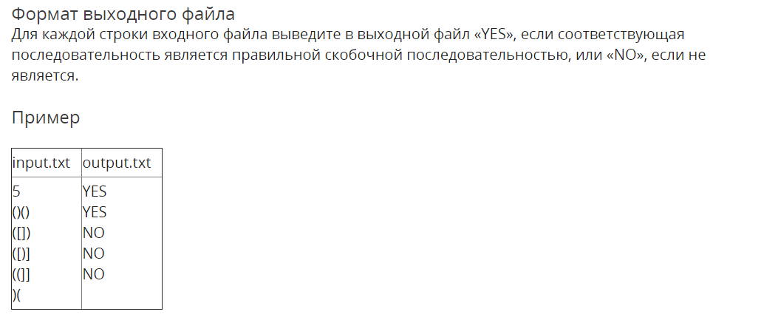

Решение

openedu/week4/lab4_3.cpp

#include "edx-io.hpp"

#include <stack>

#include <string>

using namespace std;

char invert_brace(char brace) {

switch (brace) {

case ')': return '(';

case ']': return '[';

}

}

bool check_braces(string sequence) {

auto st = stack<char>();

for (auto c : sequence) {

if (c == '(' || c == '[') {

st.push(c);

} else {

if (!st.empty() && st.top() == invert_brace(c)) {

st.pop();

} else {

return false;

}

}

}

return st.size() == 0;

}

int main() {

auto stack = new int[1e6];

int n;

io >> n;

for (int i = 0; i < n; i++) {

auto sequence = string();

io >> sequence;

io << (check_braces(sequence) ? "YES" : "NO") << '\n';

}

return 0;

}

Результаты
№ теста | Результат | Время, с | Память | Размер входного файла | Размер выходного файла
Max |  | 0.062 | 7016448 | 5000885 | 2133
1 | OK | 0.000 | 2244608 | 31 | 22
2 | OK | 0.015 | 2232320 | 15 | 16
3 | OK | 0.000 | 2236416 | 68 | 66
4 | OK | 0.000 | 2248704 | 324 | 256
5 | OK | 0.000 | 2236416 | 1541 | 1032
6 | OK | 0.000 | 2248704 | 5880 | 2128
7 | OK | 0.000 | 2236416 | 50867 | 2129
8 | OK | 0.015 | 2326528 | 500879 | 2110
9 | OK | 0.062 | 7016448 | 5000884 | 2120
10 | OK | 0.062 | 7016448 | 5000885 | 2133

Очередь с минимумом

Условие
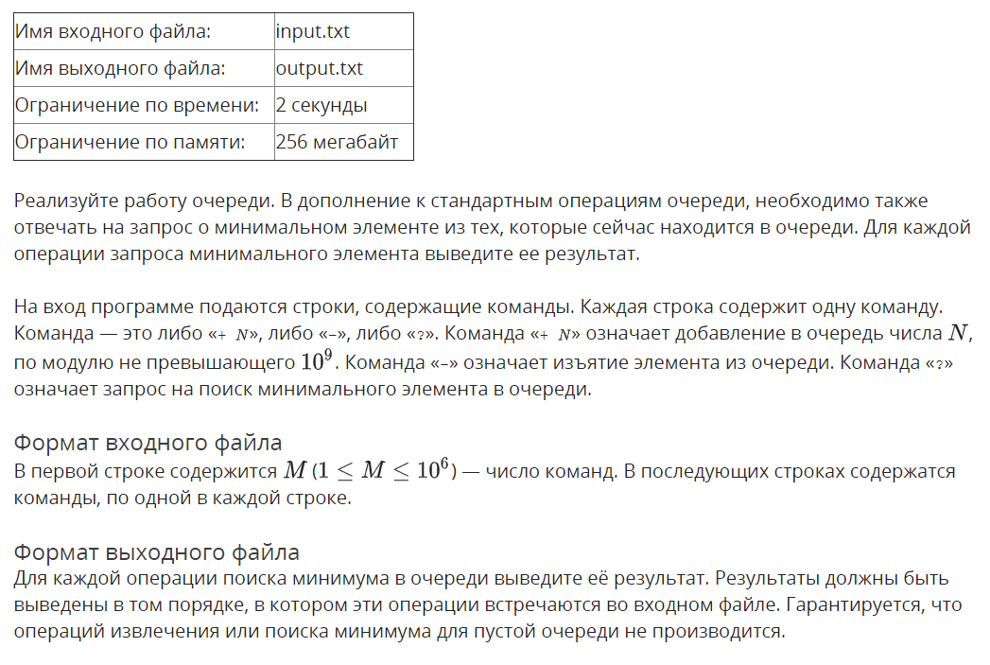
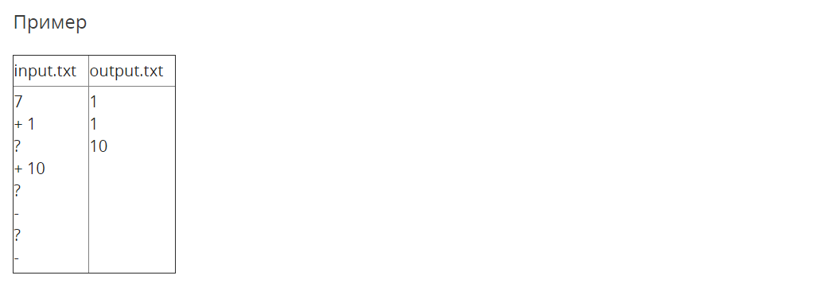

Решение

openedu/week4/lab4_4.cpp

#include "edx-io.hpp"

#include <queue>

#include <set>

#include <algorithm>

using namespace std;

#define SIZE 1000000

#define CYCLE_INC(v, sz) (((v) + 1 ) % (sz))

int main() {

auto queue = new int[SIZE];

int head = 0, tail = 0;

auto pq = multiset<int>();

int n;

io >> n;

for (int i = 0; i < n; i++) {

// read command

char c;

io >> c;

if (c == '+') {

// push

io >> queue[tail];

pq.insert(queue[tail]);

tail = CYCLE_INC(tail, SIZE);

} else if (c == '-') {

// pop

//io << queue[head] << '\n';

pq.erase(pq.find(queue[head]));

head = CYCLE_INC(head, SIZE);

} else {

io << *pq.begin() << '\n';

}

}

return 0;

}

Результаты
№ теста | Результат | Время, с | Память | Размер входного файла | Размер выходного файла
Max |  | 0.968 | 67559424 | 13389342 | 4002151
1 | OK | 0.000 | 2248704 | 29 | 10
2 | OK | 0.000 | 2244608 | 11 | 3
3 | OK | 0.000 | 2232320 | 22 | 6
4 | OK | 0.000 | 2248704 | 22 | 6
5 | OK | 0.000 | 2248704 | 36 | 9
6 | OK | 0.000 | 2236416 | 48 | 12
7 | OK | 0.000 | 2236416 | 76 | 35
8 | OK | 0.015 | 2236416 | 129 | 12
9 | OK | 0.000 | 2236416 | 67 | 48
10 | OK | 0.000 | 2232320 | 44 | 9
11 | OK | 0.000 | 2248704 | 45 | 9
12 | OK | 0.000 | 2236416 | 44 | 9
13 | OK | 0.015 | 2232320 | 45 | 9
14 | OK | 0.000 | 2248704 | 721 | 384
15 | OK | 0.000 | 2248704 | 1340 | 12
16 | OK | 0.000 | 2256896 | 640 | 407
17 | OK | 0.000 | 2244608 | 445 | 90
18 | OK | 0.000 | 2244608 | 456 | 100
19 | OK | 0.000 | 2248704 | 445 | 90
20 | OK | 0.015 | 2248704 | 456 | 100
21 | OK | 0.000 | 2240512 | 6616 | 3812
22 | OK | 0.000 | 2293760 | 13389 | 12
23 | OK | 0.000 | 2269184 | 6461 | 4008
24 | OK | 0.000 | 2269184 | 4896 | 1140
25 | OK | 0.000 | 2281472 | 5007 | 1250
26 | OK | 0.015 | 2269184 | 4896 | 1140
27 | OK | 0.000 | 2265088 | 5007 | 1250
28 | OK | 0.015 | 2265088 | 64907 | 39589
29 | OK | 0.015 | 2555904 | 133814 | 12
30 | OK | 0.000 | 2363392 | 64675 | 39996
31 | OK | 0.015 | 2367488 | 53897 | 13890
32 | OK | 0.000 | 2428928 | 55008 | 15000
33 | OK | 0.000 | 2367488 | 53897 | 13890
34 | OK | 0.000 | 2437120 | 55008 | 15000
35 | OK | 0.015 | 2646016 | 645271 | 404305
36 | OK | 0.062 | 8466432 | 1338956 | 12
37 | OK | 0.031 | 4145152 | 646300 | 400008
38 | OK | 0.031 | 4976640 | 588898 | 163890
39 | OK | 0.031 | 4972544 | 600009 | 175000
40 | OK | 0.031 | 4972544 | 588898 | 163890
41 | OK | 0.031 | 4976640 | 600009 | 175000
42 | OK | 0.203 | 9781248 | 6465010 | 4002151
43 | OK | 0.968 | 67555328 | 13389342 | 12
44 | OK | 0.468 | 23945216 | 6462989 | 4000004
45 | OK | 0.203 | 33193984 | 6388899 | 1888890
46 | OK | 0.218 | 33292288 | 6500010 | 2000000
47 | OK | 0.218 | 33193984 | 6388899 | 1888890
48 | OK | 0.218 | 33292288 | 6500010 | 2000000
49 | OK | 0.968 | 67551232 | 13388086 | 12
50 | OK | 0.015 | 2236416 | 55 | 16
51 | OK | 0.000 | 2248704 | 705 | 225
52 | OK | 0.000 | 2252800 | 6506 | 2000
53 | OK | 0.015 | 2355200 | 65007 | 20000
54 | OK | 0.015 | 3944448 | 650008 | 200000
55 | OK | 0.218 | 22663168 | 6675213 | 2000000
56 | OK | 0.015 | 2252800 | 117 | 12
57 | OK | 0.000 | 2260992 | 1327 | 12
58 | OK | 0.000 | 2289664 | 13417 | 12
59 | OK | 0.015 | 2560000 | 133845 | 12
60 | OK | 0.031 | 8466432 | 1339319 | 12
61 | OK | 0.296 | 67559424 | 13388955 | 12

Quack

Условие
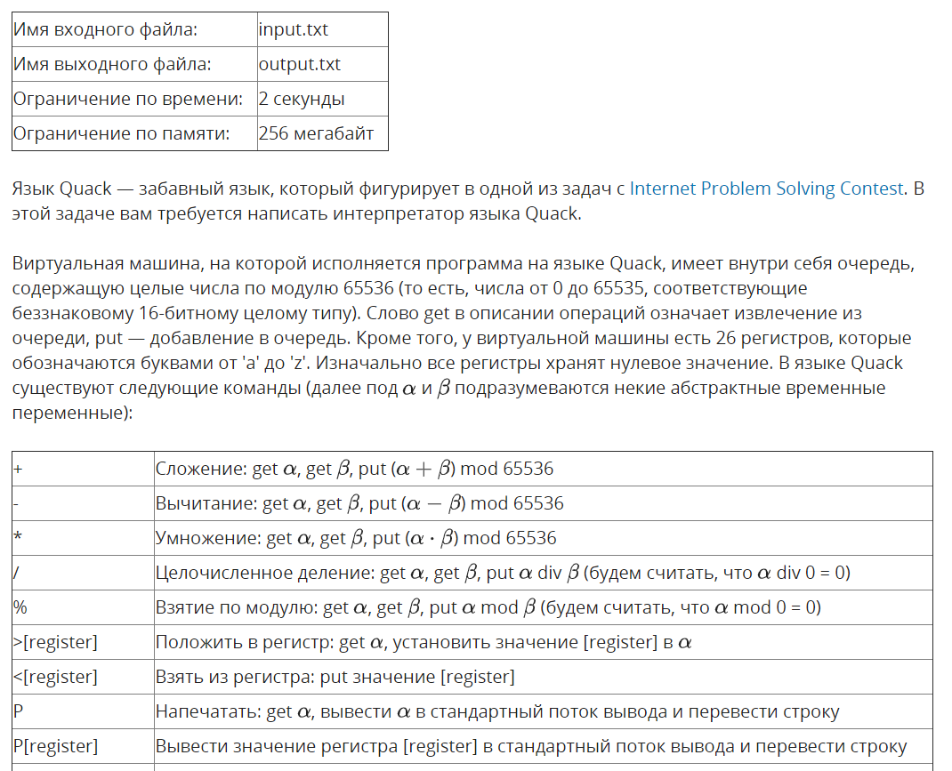
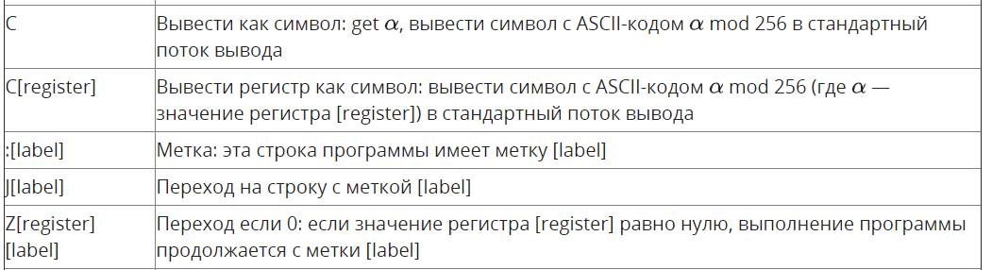
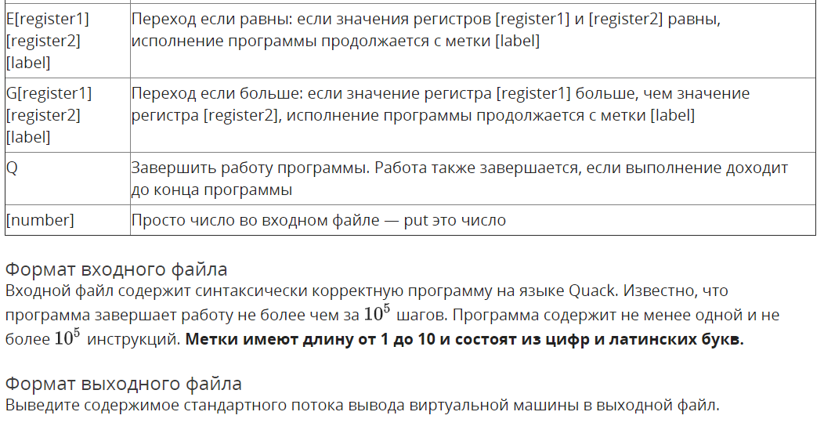
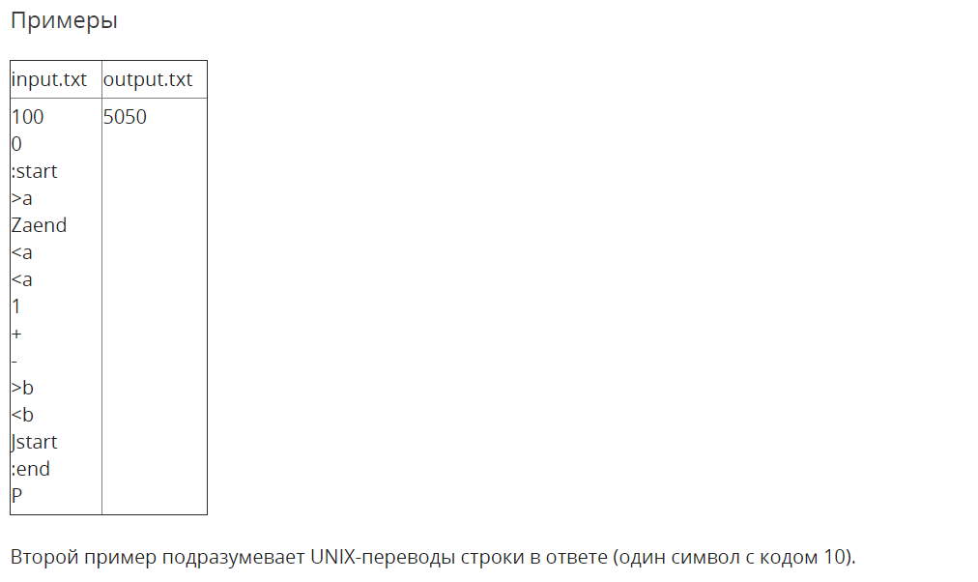

Решение

openedu/week4/lab4_5.cpp

#include "edx-io.hpp"

#include <queue>

#include <vector>

#include <string>

#include <map>

#include <tuple>

#include <fstream>

#include <assert.h>

using namespace std;

typedef uint16_t val_t;

// registers

vector<val_t> reg('z' - 'a' + 1, 0);

// (machine) queue

auto mqueue = queue<val_t>();

// loaded program (instructions reside here)

auto prog = vector<string>(100000);

// instruction pointer (index of "prog")

int ip = 0;

// mapping of labels to their target ip (index of "prog")

auto labels = map<string, int>();

// terminator flag

bool is_terminating = false;

tuple<val_t, val_t> pop_two() {

val_t a = mqueue.front();

mqueue.pop();

val_t b = mqueue.front();

mqueue.pop();

return { a, b };

}

val_t pop_one() {

val_t a = mqueue.front();

mqueue.pop();

return a;

}

#define cmd_reg(pos) (reg[instr[pos] - 'a'])

#define cmd_label_ip(pos) (labels[instr.substr(pos)])

void exec(string instr) {

// if whole instruction is a number

if (find_if(instr.begin(), instr.end(), [](char c) {return !isdigit(c); }) == instr.end()) {

mqueue.push(stoi(instr));

return;

}

// process general instructions

val_t a, b;

switch (instr[0]) {

case '+': {

tie(a, b) = pop_two();

mqueue.push(a + b);

} break;

case '-': {

tie(a, b) = pop_two();

mqueue.push(a - b);

} break;

case '*': {

tie(a, b) = pop_two();

mqueue.push(a * b);

} break;

case '/': {

tie(a, b) = pop_two();

val_t result = (b == 0) ? 0 : a / b;

mqueue.push(result);

} break;

case '%': {

tie(a, b) = pop_two();

val_t result = (b == 0) ? 0 : a % b;

mqueue.push(result);

} break;

case '>': {

cmd_reg(1) = pop_one();

} break;

case '<': {

mqueue.push(cmd_reg(1));

} break;

case 'P': {

val_t printed = (instr.size() == 1) ? pop_one() : cmd_reg(1);

io << printed << '\n';

} break;

case 'C': {

char printed = (instr.size() == 1) ? pop_one() : cmd_reg(1);

io << printed;

} break;

case ':': {

// pass (no need to execute a label definition)

} break;

case 'J': {

ip = cmd_label_ip(1);

} break;

case 'Z': {

if (cmd_reg(1) == 0) {

ip = cmd_label_ip(2);

}

} break;

case 'E': {

if (cmd_reg(1) == cmd_reg(2)) {

ip = cmd_label_ip(3);

}

} break;

case 'G': {

if (cmd_reg(1) > cmd_reg(2)) {

ip = cmd_label_ip(3);

}

} break;

case 'Q': {

is_terminating = true;

} break;

}

}

int main() {

auto cin = ifstream("input.txt");

// load program and mark labels (first pass)

string instr;

int i = 0;

while (cin >> instr) {

if (instr[0] == ':') {

labels[instr.substr(1)] = i + 1;

}

prog[i++] = instr;

}

// i is now size of the program

// start executing it

while (!is_terminating) {

instr = prog[ip++];

exec(instr);

if (ip == i) {

// reached end of program

break;

}

}

cin.close();

return 0;

}

Результаты
№ теста | Результат | Время, с | Память | Размер входного файла | Размер выходного файла
Max |  | 0.093 | 9256960 | 1349803 | 250850
1 | OK | 0.015 | 5120000 | 69 | 6
2 | OK | 0.000 | 5124096 | 232 | 232
3 | OK | 0.015 | 5111808 | 3 | 0
4 | OK | 0.015 | 5124096 | 100 | 19
5 | OK | 0.015 | 5124096 | 56 | 58890
6 | OK | 0.015 | 5120000 | 67 | 30000
7 | OK | 0.015 | 5124096 | 67 | 30000
8 | OK | 0.015 | 5124096 | 55 | 30000
9 | OK | 0.015 | 5124096 | 461 | 62
10 | OK | 0.000 | 5120000 | 11235 | 21
11 | OK | 0.000 | 5120000 | 23748 | 42
12 | OK | 0.015 | 5124096 | 66906 | 9136
13 | OK | 0.015 | 5124096 | 7332 | 993
14 | OK | 0.015 | 5124096 | 4611 | 632
15 | OK | 0.015 | 5124096 | 37968 | 7332
16 | OK | 0.000 | 5124096 | 14 | 3
17 | OK | 0.000 | 5124096 | 70 | 14
18 | OK | 0.015 | 5124096 | 350 | 70
19 | OK | 0.015 | 5124096 | 1750 | 350
20 | OK | 0.000 | 5124096 | 8750 | 1750
21 | OK | 0.015 | 5120000 | 43750 | 8750
22 | OK | 0.031 | 5120000 | 218750 | 43750
23 | OK | 0.015 | 5120000 | 34606 | 4867
24 | OK | 0.046 | 5685248 | 683180 | 7
25 | OK | 0.062 | 5677056 | 683102 | 0
26 | OK | 0.093 | 9256960 | 1349803 | 0
27 | OK | 0.062 | 5120000 | 491572 | 247791
28 | OK | 0.062 | 5124096 | 491488 | 249618
29 | OK | 0.062 | 5124096 | 491600 | 249600
30 | OK | 0.062 | 5124096 | 491502 | 250850
31 | OK | 0.062 | 5124096 | 491416 | 249477
32 | OK | 0.062 | 5124096 | 491520 | 250262
33 | OK | 0.046 | 5124096 | 491317 | 246859
34 | OK | 0.062 | 5120000 | 491514 | 248199
35 | OK | 0.062 | 5120000 | 491557 | 249601

