Лабораторная работа № 10
по дисциплине «Алгоритмы и структуры данных»
Openedu – неделя 10

Подготовил:
студент группы P3217
Бураков Илья Алексеевич

Преподаватели:
Романов Алексей Андреевич
Волчек Дмитрий Геннадьевич

Префикс-функция

Условие
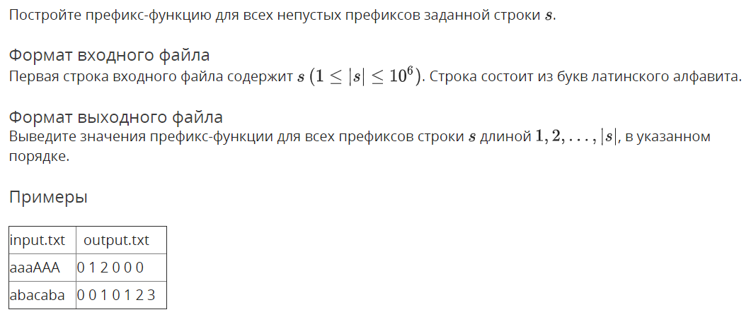

Решение

openedu/week10/lab10_1.cpp

#include "edx-io.hpp"

#include <iostream>

#include <fstream>

#include <vector>

#include <algorithm>

#include <string>

#include <list>

#include <assert.h>

using namespace std;

int main() {

string s;

io >> s;

auto p = vector<int>(s.size());

int j = 0;

for (int i = 1; i < s.size(); i++) {

if (s[i] == s[j]) {

p[i] = ++j;

} else if (j == 0) {

p[i] = 0;

} else {

j = p[j - 1];

i--;

}

}

for (auto e : p) io << e << " ";

return 0;

}

Результаты
№ теста | Результат | Время, с | Память | Размер входного файла | Размер выходного файла
Max |  | 0.234 | 52441088 | 1000002 | 6888889
1 | OK | 0.031 | 10465280 | 8 | 11
2 | OK | 0.015 | 10412032 | 9 | 13
3 | OK | 0.031 | 10592256 | 3 | 1
4 | OK | 0.031 | 10473472 | 4 | 3
5 | OK | 0.031 | 10493952 | 4 | 3
6 | OK | 0.031 | 10428416 | 12 | 19
7 | OK | 0.031 | 10448896 | 12 | 19
8 | OK | 0.062 | 14049280 | 92672 | 185339
9 | OK | 0.046 | 16429056 | 99998 | 588845
10 | OK | 0.046 | 16392192 | 100002 | 561028
11 | OK | 0.062 | 16351232 | 176391 | 352777
12 | OK | 0.062 | 21413888 | 199994 | 1288778
13 | OK | 0.062 | 21258240 | 199992 | 1190916
14 | OK | 0.062 | 16084992 | 172864 | 345723
15 | OK | 0.078 | 24875008 | 300002 | 1988889
16 | OK | 0.093 | 24166400 | 300002 | 1716598
17 | OK | 0.062 | 17178624 | 249367 | 498729
18 | OK | 0.109 | 28073984 | 400002 | 2688854
19 | OK | 0.093 | 27009024 | 399998 | 2333023
20 | OK | 0.078 | 22343680 | 455342 | 910679
21 | OK | 0.109 | 31211520 | 499996 | 3388797
22 | OK | 0.109 | 29626368 | 499998 | 2875815
23 | OK | 0.078 | 23011328 | 505139 | 1010273
24 | OK | 0.156 | 38027264 | 600000 | 4088810
25 | OK | 0.140 | 34594816 | 600002 | 3977734
26 | OK | 0.093 | 23699456 | 539096 | 1078187
27 | OK | 0.203 | 40128512 | 699998 | 4788806
28 | OK | 0.156 | 37699584 | 700002 | 4566499
29 | OK | 0.093 | 22794240 | 492073 | 984141
30 | OK | 0.218 | 41795584 | 799997 | 5488764
31 | OK | 0.156 | 35971072 | 800002 | 3984417
32 | OK | 0.125 | 26619904 | 763540 | 1527075
33 | OK | 0.187 | 44748800 | 899994 | 6188743
34 | OK | 0.187 | 42614784 | 900002 | 5662192
35 | OK | 0.125 | 27447296 | 836144 | 1672283
36 | OK | 0.218 | 52383744 | 1000002 | 6888854
37 | OK | 0.203 | 46895104 | 1000002 | 6555314
38 | OK | 0.187 | 29696000 | 1000002 | 1999999
39 | OK | 0.203 | 52428800 | 1000002 | 6888889
40 | OK | 0.203 | 52441088 | 1000002 | 6888889
41 | OK | 0.218 | 45699072 | 1000002 | 6209772
42 | OK | 0.234 | 52416512 | 1000002 | 6888884
43 | OK | 0.218 | 52412416 | 1000002 | 6888869
44 | OK | 0.203 | 49041408 | 1000002 | 6388894
45 | OK | 0.203 | 52346880 | 1000002 | 6883894

Z-функция

Условие
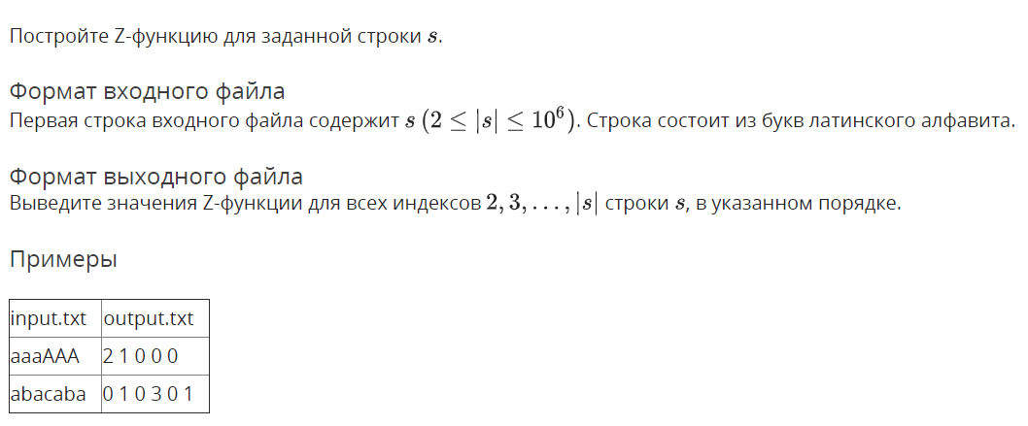

Решение

openedu/week10/lab10_2.cpp

#include "edx-io.hpp"

#include <iostream>

#include <fstream>

#include <vector>

#include <map>

#include <algorithm>

#include <string>

#include <list>

#include <assert.h>

#include <tuple>

using namespace std;

typedef unsigned long long ull;

int main() {

string s;

io >> s;

vector<int> z(1000000);

int l = 0, r = 0;

for (int i = 1; i < s.size(); i++) {

if (i >= r) {

// manually comparing

int j = 0;

while (i + j < s.size() && s[i + j] == s[j]) j++;

// updating z-block

l = i;

r = i + j;

// saving result

z[i] = j;

} else {

// we're inside z-block

if (z[i - l] < r - i) {

// our entire known prefix fits inside z-block, so we've already compared it

z[i] = z[i - l];

} else {

// known prefix outranges z-block, so we get more symbols to manually compare

int j = r - i;

while (i + j < s.size() && s[i + j] == s[j]) j++;

l = i;

r = j + i;

z[i] = j;

}

}

}

for (int i = 1; i < s.size(); i++) {

io << z[i] << " ";

}

return 0;

}

Результаты
№ теста | Результат | Время, с | Память | Размер входного файла | Размер выходного файла
Max |  | 0.250 | 7831552 | 1000002 | 6888888
1 | OK | 0.015 | 5824512 | 8 | 10
2 | OK | 0.000 | 5824512 | 9 | 12
3 | OK | 0.000 | 5824512 | 4 | 2
4 | OK | 0.000 | 5824512 | 4 | 2
5 | OK | 0.000 | 5824512 | 5 | 4
6 | OK | 0.015 | 5824512 | 12 | 18
7 | OK | 0.000 | 5816320 | 12 | 18
8 | OK | 0.031 | 6008832 | 92672 | 185338
9 | OK | 0.031 | 6025216 | 99998 | 264801
10 | OK | 0.015 | 6021120 | 100002 | 272211
11 | OK | 0.031 | 6180864 | 176391 | 352776
12 | OK | 0.046 | 6217728 | 199994 | 474050
13 | OK | 0.046 | 6221824 | 199992 | 456479
14 | OK | 0.046 | 6172672 | 172864 | 345722
15 | OK | 0.062 | 6426624 | 300002 | 1988888
16 | OK | 0.062 | 6426624 | 300002 | 786113
17 | OK | 0.046 | 6316032 | 249367 | 498728
18 | OK | 0.093 | 6623232 | 400002 | 1036108
19 | OK | 0.093 | 6623232 | 399998 | 885168
20 | OK | 0.093 | 6733824 | 455342 | 910678
21 | OK | 0.093 | 6828032 | 499996 | 1217153
22 | OK | 0.109 | 6828032 | 499998 | 1267986
23 | OK | 0.109 | 6836224 | 505139 | 1010272
24 | OK | 0.140 | 7024640 | 600000 | 1406340
25 | OK | 0.125 | 7024640 | 600002 | 1477776
26 | OK | 0.125 | 6897664 | 539096 | 1078186
27 | OK | 0.140 | 7221248 | 699998 | 1682393
28 | OK | 0.140 | 7221248 | 700002 | 1558331
29 | OK | 0.093 | 6811648 | 492073 | 984140
30 | OK | 0.171 | 7417856 | 799997 | 1804662
31 | OK | 0.156 | 7426048 | 800002 | 2196116
32 | OK | 0.156 | 7348224 | 763540 | 1527074
33 | OK | 0.187 | 7622656 | 899994 | 2030971
34 | OK | 0.203 | 7622656 | 900002 | 2765564
35 | OK | 0.171 | 7499776 | 836144 | 1672282
36 | OK | 0.234 | 7827456 | 1000002 | 2611108
37 | OK | 0.203 | 7827456 | 1000002 | 2227775
38 | OK | 0.203 | 7831552 | 1000002 | 1999998
39 | OK | 0.250 | 7831552 | 1000002 | 6888888
40 | OK | 0.234 | 7827456 | 1000002 | 6888888
41 | OK | 0.218 | 7831552 | 1000002 | 2841971
42 | OK | 0.250 | 7831552 | 1000002 | 4444443
43 | OK | 0.218 | 7831552 | 1000002 | 2977776
44 | OK | 0.218 | 7831552 | 1000002 | 2000043
45 | OK | 0.218 | 7831552 | 1000002 | 2004885

Декомпозиция строки

Условие
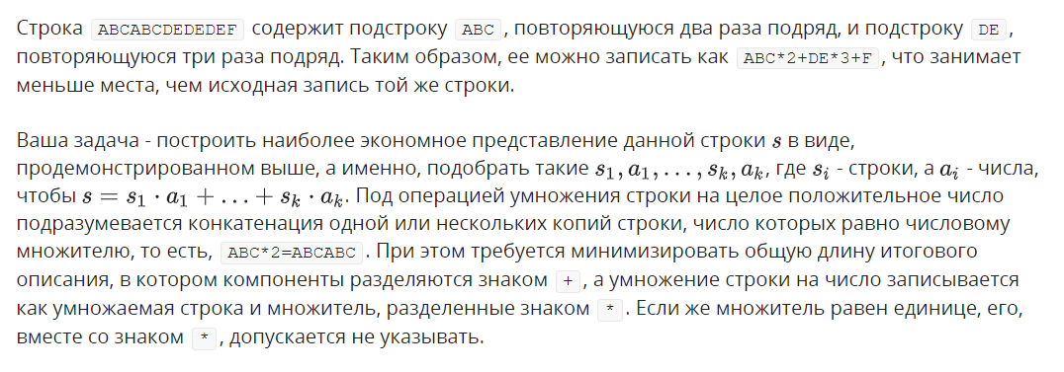
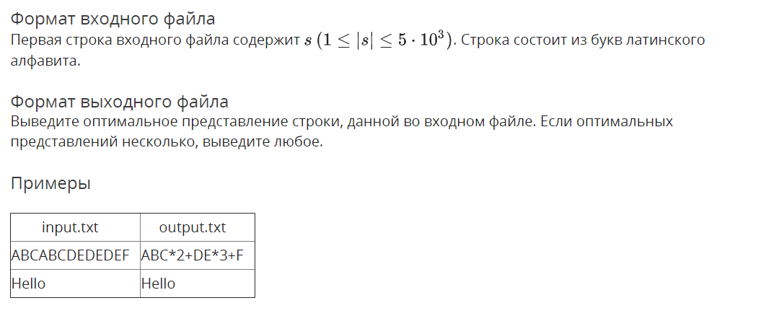

Решение

openedu/week10/lab10_3.cpp

#include "edx-io.hpp"

#include <iostream>

#include <fstream>

#include <vector>

#include <map>

#include <algorithm>

#include <string>

#include <sstream>

#include <list>

#include <assert.h>

#include <tuple>

using namespace std;

typedef unsigned long long ull;

int group_repeats(string s, int cz) {

// determine group length

int l = 2;

while (s.substr(l*cz, cz) == s.substr(0, cz)) l++;

return l;

}

tuple<int, int> calc_z_func(string s, vector<int> &z) {

z[0] = 0;

int l = 0, r = 0;

int maxz = 0;

int maxl = 0;

int cz = 0;

int i;

auto check_candidate = [&i, s, &maxz, &maxl](int candz) {

if (candz == i && candz > maxz) {

// got new candidate - new max z-prefix

int l = group_repeats(s, candz);

// HOW TO OPTIMIZE ???

if (l >= maxl) {

// new candidate is better

maxz = candz;

maxl = l;

}

}

};

auto grab_chars_while_can = [&i, &l, &r, &z, check_candidate, s](int j = 0) {

while (i + j < s.size() && s[i + j] == s[j]) {

j++;

check_candidate(j);

}

// updating z-block

l = i;

r = i + j;

// saving result

z[i] = j;

};

for (i = 1; i < s.size(); i++) {

if (i >= r) {

// manually comparing

grab_chars_while_can();

} else {

// we're inside z-block

if (z[i - l] < r - i) {

// our entire known prefix fits inside z-block, so we've already compared it

z[i] = z[i - l];

} else {

// known prefix outranges z-block, so we get more symbols to manually compare

grab_chars_while_can(r - i);

}

}

check_candidate(z[i]);

}

return make_tuple(maxz, maxl);

}

string get_group_mult_str(pair<string, int> g) {

stringstream result;

result << g.first;

if (g.second != 1) {

result << "*" << g.second;

}

return result.str();

}

string get_group_plain_str(pair<string, int> g) {

stringstream result;

while (g.second--) result << g.first;

return result.str();

}

int main() {

string s;

io >> s;

vector<int> z(s.size());

vector<pair<string, int>> groups;

int l = 0, r = 0;

for (int i = 0; i < s.size();) {

string ss = s.substr(i);

int maxz, maxl;

tie(maxz, maxl) = calc_z_func(ss, z);

if (maxz) {

groups.push_back(make_pair(ss.substr(0, maxz), maxl));

} else {

groups.push_back(make_pair(ss.substr(0, 1), 1));

i++;

}

i += maxz * maxl;

}

// print groups

bool plain = true;

for (int i = 0; i < groups.size(); i++) {

auto g = groups[i];

if (!plain) {

io << "+";

}

string mult = get_group_mult_str(g);

if (mult.size() < g.first.size() * g.second) {

if (i && plain) io << "+";

io << mult;

plain = false;

} else {

string plainstr = get_group_plain_str(g);

io << plainstr;

plain = true;

}

}

return 0;

}

Результаты
№ теста | Результат | Время, с | Память | Размер входного файла | Размер выходного файла
Max |  | 0.250 | 11956224 | 5002 | 5000
1 | OK | 0.031 | 10141696 | 15 | 12
2 | OK | 0.015 | 10125312 | 7 | 5
3 | OK | 0.015 | 10100736 | 3 | 1
4 | OK | 0.015 | 10289152 | 4 | 2
5 | OK | 0.046 | 10092544 | 5 | 3
6 | OK | 0.015 | 10141696 | 6 | 3
7 | OK | 0.031 | 10297344 | 7 | 3
8 | OK | 0.015 | 10121216 | 8 | 3
9 | OK | 0.031 | 10129408 | 9 | 3
10 | OK | 0.015 | 10096640 | 10 | 3
11 | OK | 0.031 | 10149888 | 11 | 3
12 | OK | 0.031 | 10137600 | 12 | 4
13 | OK | 0.031 | 10076160 | 13 | 4
14 | OK | 0.031 | 10088448 | 14 | 4
15 | OK | 0.015 | 10125312 | 4 | 2
16 | OK | 0.031 | 10067968 | 6 | 4
17 | OK | 0.031 | 10113024 | 8 | 4
18 | OK | 0.031 | 10096640 | 10 | 4
19 | OK | 0.031 | 10104832 | 12 | 4
20 | OK | 0.031 | 10039296 | 14 | 4
21 | OK | 0.031 | 10080256 | 16 | 4
22 | OK | 0.031 | 10096640 | 18 | 4
23 | OK | 0.015 | 10088448 | 20 | 4
24 | OK | 0.031 | 10137600 | 22 | 5
25 | OK | 0.031 | 10092544 | 24 | 5
26 | OK | 0.031 | 10080256 | 26 | 5
27 | OK | 0.031 | 10866688 | 450 | 448
28 | OK | 0.031 | 11264000 | 498 | 19
29 | OK | 0.031 | 11272192 | 498 | 56
30 | OK | 0.031 | 11186176 | 817 | 815
31 | OK | 0.046 | 11264000 | 1001 | 13
32 | OK | 0.046 | 11268096 | 1001 | 18
33 | OK | 0.046 | 11198464 | 1452 | 1450
34 | OK | 0.031 | 11255808 | 1502 | 6
35 | OK | 0.046 | 11284480 | 1502 | 73
36 | OK | 0.046 | 11243520 | 1828 | 1826
37 | OK | 0.062 | 11284480 | 1993 | 15
38 | OK | 0.062 | 11288576 | 1991 | 269
39 | OK | 0.046 | 11202560 | 1338 | 1336
40 | OK | 0.078 | 11288576 | 2499 | 15
41 | OK | 0.078 | 11300864 | 2486 | 188
42 | OK | 0.093 | 11243520 | 2402 | 2400
43 | OK | 0.109 | 11350016 | 3002 | 7
44 | OK | 0.109 | 11370496 | 2985 | 66
45 | OK | 0.078 | 11255808 | 2374 | 2372
46 | OK | 0.140 | 11313152 | 3502 | 14
47 | OK | 0.140 | 11296768 | 3500 | 10
48 | OK | 0.093 | 11268096 | 2227 | 2225
49 | OK | 0.156 | 11624448 | 4002 | 12
50 | OK | 0.171 | 11583488 | 4002 | 35
51 | OK | 0.109 | 11259904 | 2921 | 2919
52 | OK | 0.187 | 11763712 | 4502 | 22
53 | OK | 0.203 | 11362304 | 4501 | 86
54 | OK | 0.234 | 11800576 | 4765 | 4763
55 | OK | 0.234 | 11923456 | 5000 | 8
56 | OK | 0.218 | 11542528 | 4988 | 109
57 | OK | 0.250 | 11493376 | 5002 | 5000
58 | OK | 0.234 | 11894784 | 5002 | 6
59 | OK | 0.250 | 11956224 | 5002 | 31
60 | OK | 0.234 | 11513856 | 5002 | 82
61 | OK | 0.218 | 11915264 | 5002 | 7
62 | OK | 0.234 | 11952128 | 5002 | 10
63 | OK | 0.218 | 11943936 | 5002 | 503
64 | OK | 0.234 | 11956224 | 5002 | 54

