Лабораторная работа № 5
по дисциплине «Алгоритмы и структуры данных»
Openedu – неделя 5

Подготовил:
студент группы P3217
Бураков Илья Алексеевич

Преподаватели:
Романов Алексей Андреевич
Волчек Дмитрий Геннадьевич

Куча ли?

Условие
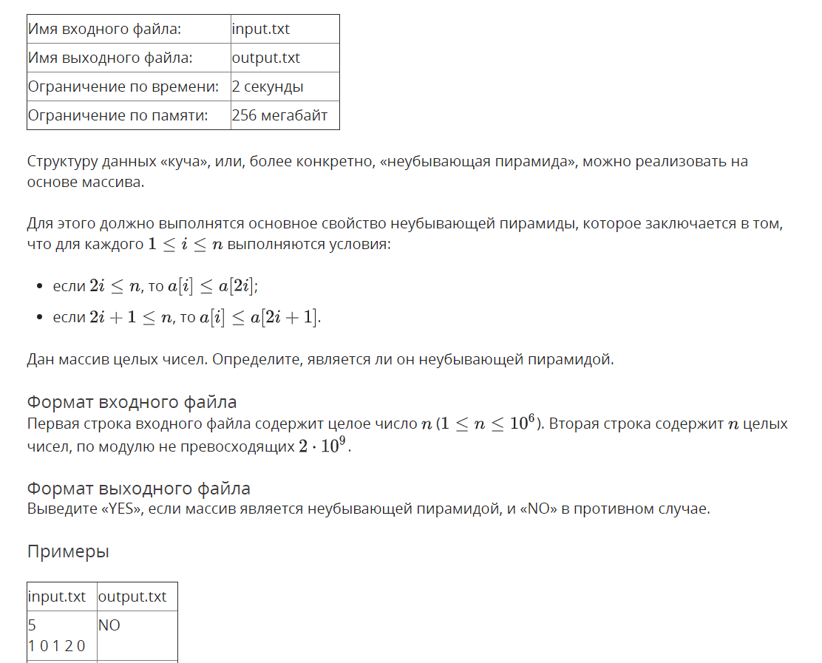

Решение

openedu/week5/lab5_1.cpp

#include "edx-io.hpp"

#include <vector>

#include <string>

using namespace std;

int main() {

int n;

io >> n;

vector<int> arr(n);

for (auto& v : arr) io >> v;

bool result = true;

for (int i = 1; i <= n / 2; i++) {

if (arr[i - 1] > arr[2*i - 1]) {

result = false;

break;

} else if (2 * i + 1 <= n && arr[i - 1] > arr[(2 * i + 1) - 1]) {

result = false;

break;

}

}

io << ((result) ? "YES" : "NO");

return 0;

}

Результаты
№ теста | Результат | Время, с | Память | Размер входного файла | Размер выходного файла
Max |  | 0.046 | 16760832 | 10945420 | 3
1 | OK | 0.000 | 2228224 | 14 | 2
2 | OK | 0.015 | 2228224 | 14 | 3
3 | OK | 0.000 | 2228224 | 1092 | 3
4 | OK | 0.000 | 2240512 | 889 | 3
5 | OK | 0.000 | 2228224 | 1099 | 2
6 | OK | 0.000 | 2240512 | 1100 | 3
7 | OK | 0.000 | 2228224 | 1098 | 3
8 | OK | 0.000 | 2240512 | 1093 | 3
9 | OK | 0.000 | 2228224 | 1105 | 2
10 | OK | 0.000 | 2228224 | 1095 | 2
11 | OK | 0.015 | 2236416 | 10931 | 3
12 | OK | 0.000 | 2248704 | 8837 | 3
13 | OK | 0.000 | 2236416 | 10928 | 2
14 | OK | 0.015 | 2236416 | 10934 | 3
15 | OK | 0.000 | 2236416 | 10989 | 3
16 | OK | 0.000 | 2236416 | 10934 | 3
17 | OK | 0.000 | 2232320 | 10978 | 2
18 | OK | 0.000 | 2236416 | 10960 | 2
19 | OK | 0.015 | 2281472 | 109474 | 3
20 | OK | 0.000 | 2281472 | 89095 | 3
21 | OK | 0.000 | 2277376 | 109362 | 2
22 | OK | 0.000 | 2281472 | 109479 | 3
23 | OK | 0.000 | 2265088 | 109486 | 3
24 | OK | 0.000 | 2269184 | 109443 | 2
25 | OK | 0.000 | 2269184 | 109565 | 2
26 | OK | 0.015 | 2281472 | 109493 | 2
27 | OK | 0.015 | 3313664 | 1094387 | 3
28 | OK | 0.000 | 3104768 | 886879 | 3
29 | OK | 0.015 | 3313664 | 1094726 | 2
30 | OK | 0.000 | 3309568 | 1094117 | 3
31 | OK | 0.000 | 3313664 | 1094308 | 3
32 | OK | 0.015 | 3313664 | 1094215 | 3
33 | OK | 0.000 | 3309568 | 1094084 | 2
34 | OK | 0.015 | 3313664 | 1094403 | 2
35 | OK | 0.046 | 16756736 | 10944156 | 3
36 | OK | 0.046 | 14692352 | 8876466 | 3
37 | OK | 0.046 | 16760832 | 10945179 | 2
38 | OK | 0.046 | 16760832 | 10945420 | 3
39 | OK | 0.046 | 16756736 | 10943533 | 3
40 | OK | 0.046 | 16760832 | 10944594 | 3
41 | OK | 0.046 | 16752640 | 10944330 | 2
42 | OK | 0.046 | 16760832 | 10944738 | 2

Очередь с приоритетами

Условие
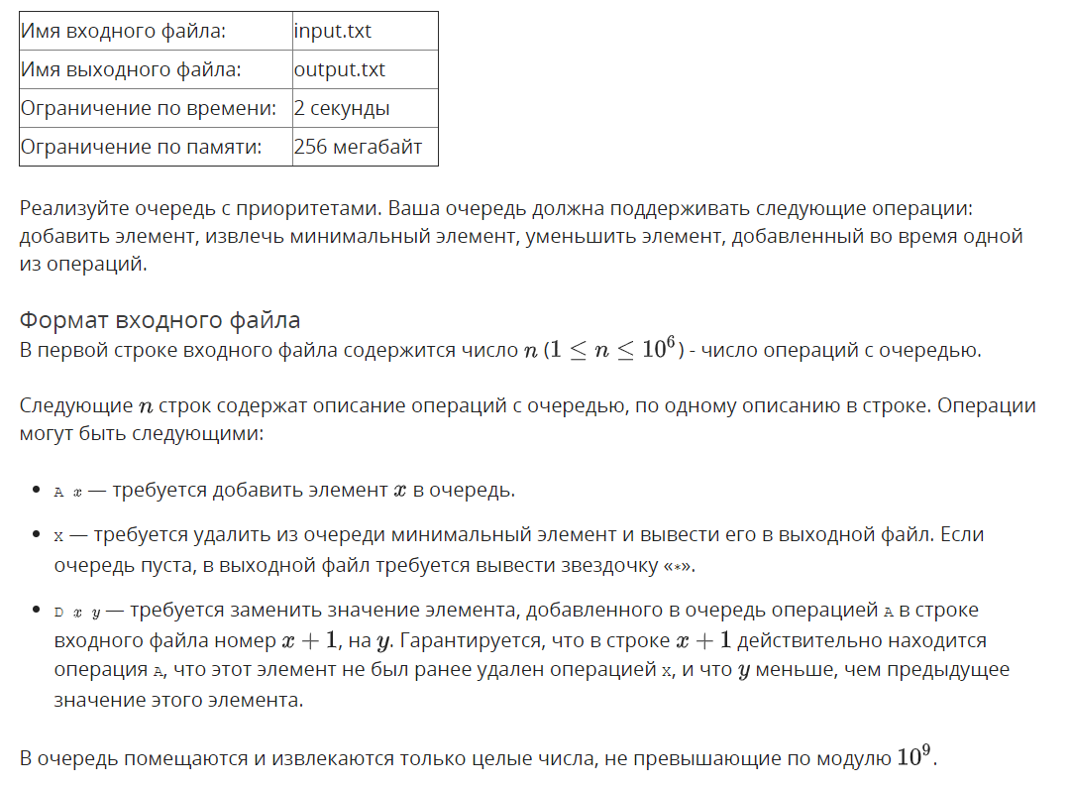
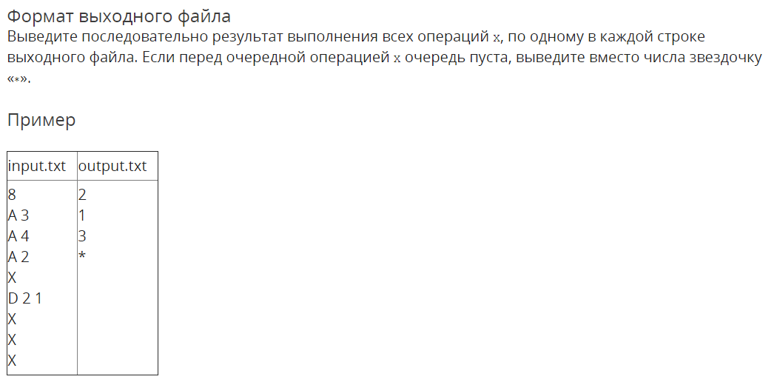

Решение

openedu/week5/lab5_2.cpp

#include "edx-io.hpp"

#include <vector>

#include <string>

using namespace std;

#define MAX_OPS int(1e6)

auto heap = vector<int>();

// arrays for tracking heap elements position by string numbers on which they were added

// need to be able to resolve the link in both directions, so there's two arrays

auto strn_to_loc = new int[1e6 + 1];

auto loc_to_strn = new int[1e6];

#define PARENT(i) (((i) + 1) / 2 - 1)

#define LCHILD(i) (2 * ((i) + 1) - 1)

#define RCHILD(i) (LCHILD(i) + 1)

#define PARENT_EXISTS(i) (i != 0)

#define LCHILD_EXISTS(i) (LCHILD(i) < heap.size())

#define RCHILD_EXISTS(i) (RCHILD(i) < heap.size())

void swap(int a1, int a2) {

int t = heap[a1];

heap[a1] = heap[a2];

heap[a2] = t;

// do position tracking housekeeping as well

// update strn2loc resolver (swap corresponding elements gathered by loc2strn)

int strn1 = loc_to_strn[a1];

int strn2 = loc_to_strn[a2];

t = strn_to_loc[strn1];

strn_to_loc[strn1] = strn_to_loc[strn2];

strn_to_loc[strn2] = t;

// update loc2strn resolver (swap based on just a1 and a2 to be in sync with heap)

t = loc_to_strn[a1];

loc_to_strn[a1] = loc_to_strn[a2];

loc_to_strn[a2] = t;

}

void heapify(int root) {

while (LCHILD_EXISTS(root)) {

int largest_i = root;

if (heap[LCHILD(root)] < heap[largest_i]) {

largest_i = LCHILD(root);

}

if (RCHILD_EXISTS(root) && heap[RCHILD(root)] < heap[largest_i]) {

largest_i = RCHILD(root);

}

if (largest_i == root) {

// done, heap is correct

break;

}

// swap and go deeper

swap(root, largest_i);

root = largest_i;

}

}

void bubble_up(int current) {

// bubble up until new element isn't violating heap condition

while (PARENT_EXISTS(current) && heap[PARENT(current)] > heap[current]) {

swap(PARENT(current), current);

current = PARENT(current);

}

}

void add(int val) {

heap.push_back(val);

bubble_up(heap.size() - 1);

}

int main() {

int ops_size;

io >> ops_size;

heap.reserve(ops_size);

for (int strn = 1; strn <= ops_size; strn++) {

char cmd;

io >> cmd;

switch (cmd) {

case 'A': {

int val;

io >> val;

// register added element to location trackers

strn_to_loc[strn] = heap.size();

loc_to_strn[heap.size()] = strn;

add(val);

} break;

case 'X': {

if (empty(heap)) {

io << "*\n";

} else {

io << heap.front() << "\n";

swap(0, heap.size() - 1);

heap.pop_back();

heapify(0);

}

} break;

case 'D': {

int target_strn, newval;

io >> target_strn >> newval;

int target_index = strn_to_loc[target_strn];

heap[target_index] = newval;

bubble_up(target_index);

} break;

}

}

return 0;

}

Результаты
№ теста | Результат | Время, с | Память | Размер входного файла | Размер выходного файла
Max |  | 0.421 | 22736896 | 12083657 | 5694235
1 | OK | 0.000 | 2232320 | 37 | 12
2 | OK | 0.000 | 2248704 | 6 | 3
3 | OK | 0.000 | 2244608 | 11 | 3
4 | OK | 0.000 | 2244608 | 22 | 4
5 | OK | 0.000 | 2228224 | 19 | 6
6 | OK | 0.000 | 2232320 | 19 | 6
7 | OK | 0.000 | 2244608 | 19 | 6
8 | OK | 0.000 | 2244608 | 48 | 19
9 | OK | 0.000 | 2228224 | 58 | 29
10 | OK | 0.000 | 2232320 | 57 | 28
11 | OK | 0.000 | 2244608 | 48 | 19
12 | OK | 0.000 | 2244608 | 58 | 29
13 | OK | 0.015 | 2244608 | 57 | 28
14 | OK | 0.000 | 2232320 | 828 | 573
15 | OK | 0.000 | 2244608 | 1037 | 369
16 | OK | 0.000 | 2244608 | 828 | 573
17 | OK | 0.015 | 2232320 | 988 | 404
18 | OK | 0.000 | 2248704 | 1082 | 300
19 | OK | 0.000 | 2224128 | 1139 | 240
20 | OK | 0.000 | 2228224 | 930 | 377
21 | OK | 0.015 | 2228224 | 1190 | 280
22 | OK | 0.000 | 2240512 | 8184 | 5678
23 | OK | 0.000 | 2240512 | 10768 | 3637
24 | OK | 0.000 | 2240512 | 8206 | 5700
25 | OK | 0.000 | 2252800 | 9903 | 3928
26 | OK | 0.015 | 2240512 | 10814 | 3000
27 | OK | 0.000 | 2256896 | 11338 | 2400
28 | OK | 0.000 | 2252800 | 11138 | 3582
29 | OK | 0.000 | 2240512 | 10904 | 3851
30 | OK | 0.000 | 2301952 | 81951 | 56944
31 | OK | 0.015 | 2301952 | 110901 | 36274
32 | OK | 0.015 | 2289664 | 81971 | 56964
33 | OK | 0.000 | 2314240 | 99351 | 39719
34 | OK | 0.015 | 2342912 | 107882 | 30000
35 | OK | 0.000 | 2338816 | 113181 | 24000
36 | OK | 0.015 | 2281472 | 112799 | 37474
37 | OK | 0.000 | 2293760 | 114106 | 37576
38 | OK | 0.031 | 3248128 | 819273 | 569265
39 | OK | 0.031 | 3506176 | 1143615 | 361526
40 | OK | 0.031 | 3244032 | 819455 | 569447
41 | OK | 0.031 | 3624960 | 992441 | 396009
42 | OK | 0.031 | 3805184 | 1079125 | 300000
43 | OK | 0.015 | 3923968 | 1131016 | 240000
44 | OK | 0.031 | 3407872 | 1175194 | 377350
45 | OK | 0.015 | 3407872 | 1174192 | 378071
46 | OK | 0.421 | 16015360 | 8194244 | 5694235
47 | OK | 0.312 | 18911232 | 11753433 | 3632457
48 | OK | 0.359 | 16019456 | 8193883 | 5693874
49 | OK | 0.328 | 19755008 | 9926125 | 3963652
50 | OK | 0.312 | 21614592 | 10792079 | 3000000
51 | OK | 0.296 | 22736896 | 11312176 | 2400000
52 | OK | 0.203 | 17903616 | 12078250 | 3794039
53 | OK | 0.203 | 17911808 | 12083657 | 3795822

