Лабораторная работа № 6
по дисциплине «Алгоритмы и структуры данных»
Openedu – неделя 6

Подготовил:
студент группы P3217
Бураков Илья Алексеевич

Преподаватели:
Романов Алексей Андреевич
Волчек Дмитрий Геннадьевич

Двоичный поиск

Условие
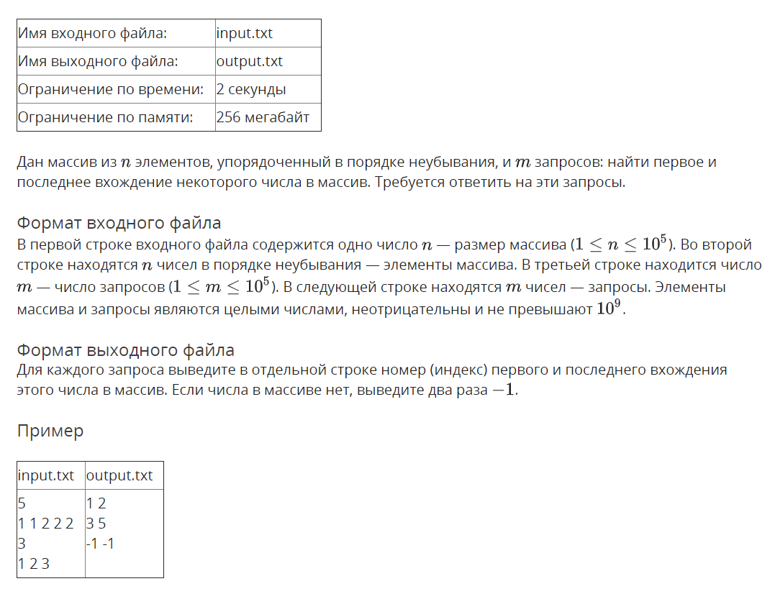

Решение

openedu/week6/lab6_1.cpp

#include "edx-io.hpp"

#include <vector>

#include <string>

using namespace std;

int n;

vector<int> vec;

pair<int, int> bsearch(int e) {

int l = -1,

r = n - 1;

while (r != l + 1) {

int midi = (r + l) / 2;

if (vec[midi] < e) {

l = midi;

} else {

r = midi;

}

}

if (vec[r] != e) {

// +1 will be done later

return make_pair(-2, -2);

}

int leftb = r;

l = -1,

r = n;

while (r != l + 1) {

int midi = (r + l) / 2;

if (vec[midi] <= e) {

l = midi;

} else {

r = midi;

}

}

int rightb = l;

return make_pair(leftb, rightb);

}

int main() {

io >> n;

vec = vector<int>(n);

for (auto &e : vec) io >> e;

int m;

io >> m;

for (int i = 0; i < m; i++) {

int e;

io >> e;

auto result = bsearch(e);

io << result.first + 1 << " " << result.second + 1 << "\n";

}

return 0;

}

Результаты
№ теста | Результат | Время, с | Память | Размер входного файла | Размер выходного файла
Max |  | 0.078 | 4198400 | 1978102 | 1277538
1 | OK | 0.000 | 2240512 | 22 | 17
2 | OK | 0.000 | 2224128 | 20 | 38
3 | OK | 0.000 | 2244608 | 41 | 15
4 | OK | 0.015 | 2224128 | 204081 | 21587
5 | OK | 0.015 | 2392064 | 412716 | 21559
6 | OK | 0.015 | 2396160 | 412714 | 12243
7 | OK | 0.031 | 2531328 | 498728 | 612555
8 | OK | 0.031 | 3043328 | 1008458 | 612906
9 | OK | 0.031 | 3043328 | 1008832 | 341682
10 | OK | 0.046 | 2367488 | 471365 | 861755
11 | OK | 0.046 | 2846720 | 953290 | 859761
12 | OK | 0.046 | 2842624 | 953404 | 548738
13 | OK | 0.000 | 2224128 | 197660 | 51796
14 | OK | 0.015 | 2367488 | 399789 | 51761
15 | OK | 0.015 | 2367488 | 399826 | 29610
16 | OK | 0.062 | 2404352 | 511344 | 947660
17 | OK | 0.062 | 2924544 | 1034328 | 951787
18 | OK | 0.062 | 2928640 | 1034511 | 608920
19 | OK | 0.015 | 2428928 | 384717 | 274370
20 | OK | 0.015 | 2826240 | 777782 | 274601
21 | OK | 0.031 | 2830336 | 778270 | 152655
22 | OK | 0.015 | 2224128 | 219786 | 228823
23 | OK | 0.015 | 2367488 | 444845 | 228627
24 | OK | 0.000 | 2367488 | 444580 | 136297
25 | OK | 0.015 | 2617344 | 452007 | 84006
26 | OK | 0.015 | 3080192 | 914248 | 84077
27 | OK | 0.015 | 3080192 | 914384 | 46178
28 | OK | 0.015 | 2723840 | 534373 | 224808
29 | OK | 0.015 | 3268608 | 1080911 | 225002
30 | OK | 0.015 | 3264512 | 1080929 | 123417
31 | OK | 0.015 | 2650112 | 474858 | 115440
32 | OK | 0.015 | 3137536 | 960744 | 115495
33 | OK | 0.015 | 3137536 | 960330 | 63391
34 | OK | 0.078 | 3198976 | 977910 | 1277538
35 | OK | 0.062 | 4198400 | 1977816 | 1277396
36 | OK | 0.062 | 4198400 | 1978102 | 700050
37 | OK | 0.062 | 3186688 | 966605 | 1000288
38 | OK | 0.062 | 3186688 | 962679 | 1131278
39 | OK | 0.062 | 3223552 | 1000016 | 1200034
40 | OK | 0.078 | 3223552 | 1000016 | 1198665
41 | OK | 0.062 | 3076096 | 858730 | 1199466

Гирлянда

Условие
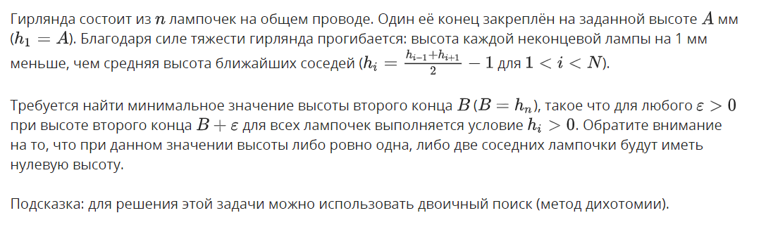
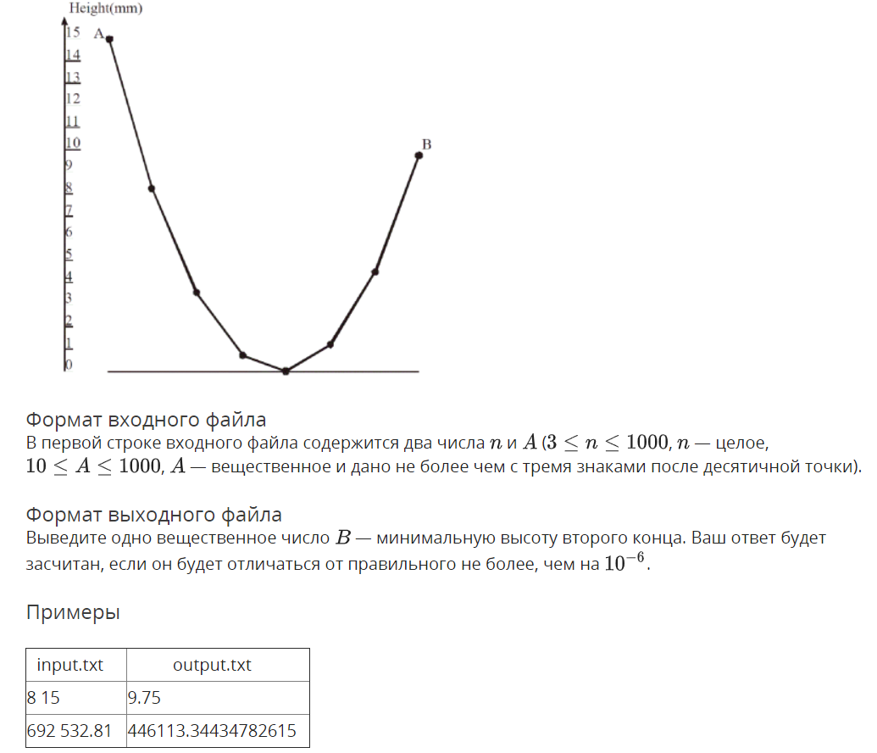

Решение

openedu/week6/lab6_2.cpp

#include "edx-io.hpp"

#include <vector>

#include <string>

using namespace std;

int main() {

int n;

double a;

io >> n >> a;

// lower and upper boundary

double lowerb = 0, upperb = a;

// height of the second lamp

double h2;

// last successful result

double last_result;

while (upperb - lowerb > 1e-10) {

// guessing h2

h2 = (upperb + lowerb) / 2;

// calculating lamp heights

double prev = h2;

double prevprev = a;

double cur;

for (int i = 2; i < n; i++) {

cur = 2 * prev - prevprev + 2;

if (cur < 0) {

// one of the lamps is below zero, invalidating cur, breaking

cur = NAN;

break;

}

prevprev = prev;

prev = cur;

}

// checking if min height is fine

if (!isnan(cur)) {

// still above zero - lowering

upperb = h2;

// cur = last lamp's height

last_result = cur;

} else {

// below zero - raising higher

lowerb = h2;

}

}

io << last_result;

return 0;

}

Результаты
№ теста | Результат | Время, с | Память | Размер входного файла | Размер выходного файла
Max |  | 0.031 | 2285568 | 14 | 22
1 | OK | 0.000 | 2281472 | 9 | 18
2 | OK | 0.015 | 2281472 | 12 | 18
3 | OK | 0.000 | 2269184 | 9 | 22
4 | OK | 0.000 | 2269184 | 11 | 22
5 | OK | 0.015 | 2265088 | 9 | 1
6 | OK | 0.015 | 2269184 | 9 | 1
7 | OK | 0.015 | 2265088 | 14 | 18
8 | OK | 0.015 | 2260992 | 12 | 18
9 | OK | 0.000 | 2269184 | 11 | 18
10 | OK | 0.000 | 2281472 | 13 | 18
11 | OK | 0.000 | 2269184 | 10 | 22
12 | OK | 0.000 | 2269184 | 13 | 18
13 | OK | 0.015 | 2277376 | 10 | 22
14 | OK | 0.000 | 2269184 | 10 | 22
15 | OK | 0.000 | 2281472 | 12 | 18
16 | OK | 0.000 | 2269184 | 9 | 17
17 | OK | 0.000 | 2265088 | 12 | 18
18 | OK | 0.000 | 2269184 | 12 | 18
19 | OK | 0.000 | 2269184 | 12 | 18
20 | OK | 0.000 | 2269184 | 11 | 18
21 | OK | 0.000 | 2269184 | 11 | 18
22 | OK | 0.015 | 2269184 | 11 | 17
23 | OK | 0.015 | 2265088 | 11 | 22
24 | OK | 0.000 | 2277376 | 11 | 18
25 | OK | 0.000 | 2265088 | 12 | 18
26 | OK | 0.000 | 2269184 | 12 | 17
27 | OK | 0.015 | 2269184 | 12 | 18
28 | OK | 0.000 | 2281472 | 12 | 18
29 | OK | 0.000 | 2269184 | 12 | 18
30 | OK | 0.000 | 2285568 | 11 | 22
31 | OK | 0.015 | 2281472 | 12 | 18
32 | OK | 0.000 | 2265088 | 12 | 18
33 | OK | 0.000 | 2265088 | 11 | 22
34 | OK | 0.000 | 2269184 | 12 | 17
35 | OK | 0.000 | 2269184 | 12 | 18
36 | OK | 0.000 | 2281472 | 12 | 18
37 | OK | 0.000 | 2281472 | 12 | 18
38 | OK | 0.000 | 2269184 | 11 | 18
39 | OK | 0.000 | 2281472 | 12 | 18
40 | OK | 0.000 | 2285568 | 12 | 17
41 | OK | 0.000 | 2281472 | 12 | 18
42 | OK | 0.000 | 2277376 | 12 | 18
43 | OK | 0.000 | 2269184 | 11 | 18
44 | OK | 0.015 | 2269184 | 12 | 18
45 | OK | 0.015 | 2269184 | 12 | 18
46 | OK | 0.000 | 2269184 | 11 | 22
47 | OK | 0.000 | 2269184 | 12 | 18
48 | OK | 0.000 | 2281472 | 12 | 18
49 | OK | 0.000 | 2269184 | 11 | 17
50 | OK | 0.000 | 2281472 | 11 | 17
51 | OK | 0.000 | 2281472 | 12 | 18
52 | OK | 0.000 | 2265088 | 12 | 17
53 | OK | 0.000 | 2269184 | 11 | 18
54 | OK | 0.000 | 2269184 | 12 | 18
55 | OK | 0.000 | 2269184 | 12 | 18
56 | OK | 0.000 | 2281472 | 12 | 18
57 | OK | 0.000 | 2269184 | 12 | 18
58 | OK | 0.000 | 2269184 | 12 | 18
59 | OK | 0.000 | 2265088 | 12 | 18
60 | OK | 0.000 | 2269184 | 12 | 18
61 | OK | 0.000 | 2281472 | 12 | 18
62 | OK | 0.015 | 2281472 | 10 | 18
63 | OK | 0.000 | 2269184 | 12 | 18
64 | OK | 0.000 | 2281472 | 11 | 18
65 | OK | 0.000 | 2265088 | 12 | 18
66 | OK | 0.015 | 2269184 | 12 | 18
67 | OK | 0.000 | 2269184 | 10 | 18
68 | OK | 0.031 | 2281472 | 12 | 18
69 | OK | 0.000 | 2281472 | 12 | 17
70 | OK | 0.015 | 2269184 | 12 | 18
71 | OK | 0.015 | 2269184 | 11 | 18
72 | OK | 0.000 | 2281472 | 12 | 18
73 | OK | 0.000 | 2281472 | 12 | 17
74 | OK | 0.000 | 2281472 | 12 | 17
75 | OK | 0.000 | 2281472 | 12 | 18
76 | OK | 0.000 | 2269184 | 12 | 18
77 | OK | 0.000 | 2269184 | 12 | 18
78 | OK | 0.000 | 2281472 | 12 | 18
79 | OK | 0.015 | 2269184 | 12 | 17
80 | OK | 0.015 | 2281472 | 11 | 18
81 | OK | 0.000 | 2269184 | 12 | 18
82 | OK | 0.015 | 2281472 | 12 | 18
83 | OK | 0.000 | 2265088 | 11 | 18
84 | OK | 0.000 | 2281472 | 12 | 18
85 | OK | 0.015 | 2281472 | 11 | 17
86 | OK | 0.015 | 2269184 | 12 | 18
87 | OK | 0.015 | 2281472 | 12 | 18
88 | OK | 0.000 | 2269184 | 11 | 18
89 | OK | 0.015 | 2269184 | 12 | 18
90 | OK | 0.015 | 2265088 | 12 | 18
91 | OK | 0.015 | 2269184 | 12 | 18
92 | OK | 0.031 | 2281472 | 12 | 18
93 | OK | 0.000 | 2269184 | 12 | 18
94 | OK | 0.015 | 2265088 | 12 | 18
95 | OK | 0.000 | 2265088 | 12 | 18
96 | OK | 0.015 | 2269184 | 12 | 17
97 | OK | 0.000 | 2281472 | 12 | 18
98 | OK | 0.000 | 2265088 | 12 | 18
99 | OK | 0.000 | 2269184 | 11 | 18
100 | OK | 0.000 | 2269184 | 11 | 22
101 | OK | 0.015 | 2269184 | 12 | 18
102 | OK | 0.000 | 2269184 | 11 | 18
103 | OK | 0.000 | 2269184 | 12 | 18
104 | OK | 0.000 | 2265088 | 11 | 18
105 | OK | 0.000 | 2281472 | 12 | 18
106 | OK | 0.000 | 2269184 | 11 | 18
107 | OK | 0.000 | 2265088 | 12 | 18
108 | OK | 0.000 | 2269184 | 11 | 18
109 | OK | 0.015 | 2269184 | 12 | 17
110 | OK | 0.000 | 2269184 | 12 | 18
111 | OK | 0.000 | 2260992 | 11 | 18
112 | OK | 0.000 | 2269184 | 12 | 18
113 | OK | 0.015 | 2269184 | 12 | 18
114 | OK | 0.000 | 2269184 | 11 | 18
115 | OK | 0.015 | 2281472 | 12 | 18
116 | OK | 0.015 | 2269184 | 12 | 18
117 | OK | 0.000 | 2265088 | 12 | 18
118 | OK | 0.000 | 2269184 | 12 | 18
119 | OK | 0.000 | 2281472 | 11 | 18
120 | OK | 0.015 | 2265088 | 12 | 18
121 | OK | 0.000 | 2269184 | 12 | 18
122 | OK | 0.000 | 2265088 | 12 | 18
123 | OK | 0.015 | 2281472 | 12 | 18
124 | OK | 0.000 | 2269184 | 12 | 18
125 | OK | 0.000 | 2269184 | 12 | 18
126 | OK | 0.015 | 2265088 | 12 | 18
127 | OK | 0.000 | 2269184 | 12 | 18
128 | OK | 0.000 | 2269184 | 12 | 18
129 | OK | 0.000 | 2269184 | 12 | 18
130 | OK | 0.000 | 2285568 | 12 | 18
131 | OK | 0.000 | 2265088 | 12 | 18
132 | OK | 0.000 | 2269184 | 12 | 17
133 | OK | 0.015 | 2269184 | 12 | 18
134 | OK | 0.000 | 2269184 | 12 | 17
135 | OK | 0.015 | 2269184 | 12 | 18
136 | OK | 0.000 | 2265088 | 12 | 18
137 | OK | 0.000 | 2269184 | 12 | 18
138 | OK | 0.000 | 2269184 | 12 | 18
139 | OK | 0.015 | 2269184 | 12 | 18
140 | OK | 0.000 | 2269184 | 12 | 18
141 | OK | 0.015 | 2269184 | 12 | 18
142 | OK | 0.000 | 2269184 | 12 | 17
143 | OK | 0.015 | 2281472 | 12 | 18
144 | OK | 0.000 | 2269184 | 12 | 18
145 | OK | 0.000 | 2269184 | 12 | 18
146 | OK | 0.000 | 2277376 | 12 | 18
147 | OK | 0.015 | 2269184 | 12 | 18
148 | OK | 0.015 | 2281472 | 12 | 18
149 | OK | 0.015 | 2269184 | 12 | 18
150 | OK | 0.000 | 2269184 | 11 | 18
151 | OK | 0.000 | 2269184 | 12 | 18
152 | OK | 0.015 | 2281472 | 12 | 18
153 | OK | 0.000 | 2269184 | 12 | 18
154 | OK | 0.000 | 2269184 | 12 | 18
155 | OK | 0.000 | 2269184 | 12 | 18
156 | OK | 0.000 | 2281472 | 12 | 18
157 | OK | 0.000 | 2265088 | 12 | 18
158 | OK | 0.015 | 2269184 | 12 | 18
159 | OK | 0.000 | 2281472 | 12 | 18
160 | OK | 0.000 | 2269184 | 12 | 18
161 | OK | 0.000 | 2265088 | 12 | 18
162 | OK | 0.015 | 2265088 | 11 | 18
163 | OK | 0.000 | 2269184 | 11 | 18
164 | OK | 0.015 | 2269184 | 12 | 18
165 | OK | 0.000 | 2269184 | 12 | 18
166 | OK | 0.015 | 2269184 | 12 | 17
167 | OK | 0.000 | 2269184 | 12 | 18
168 | OK | 0.000 | 2269184 | 12 | 18
169 | OK | 0.000 | 2269184 | 12 | 18
170 | OK | 0.000 | 2269184 | 12 | 18
171 | OK | 0.000 | 2269184 | 12 | 18
172 | OK | 0.000 | 2269184 | 12 | 18
173 | OK | 0.000 | 2269184 | 12 | 18
174 | OK | 0.000 | 2281472 | 12 | 18
175 | OK | 0.000 | 2269184 | 12 | 18
176 | OK | 0.015 | 2269184 | 12 | 18
177 | OK | 0.000 | 2281472 | 12 | 17
178 | OK | 0.015 | 2269184 | 12 | 18
179 | OK | 0.000 | 2281472 | 12 | 18
180 | OK | 0.015 | 2269184 | 12 | 18
181 | OK | 0.015 | 2269184 | 12 | 18
182 | OK | 0.000 | 2265088 | 12 | 17
183 | OK | 0.015 | 2265088 | 12 | 17
184 | OK | 0.000 | 2281472 | 12 | 18
185 | OK | 0.015 | 2269184 | 12 | 18
186 | OK | 0.000 | 2281472 | 11 | 18
187 | OK | 0.000 | 2281472 | 12 | 18
188 | OK | 0.000 | 2269184 | 9 | 22
189 | OK | 0.000 | 2269184 | 11 | 18
190 | OK | 0.000 | 2269184 | 12 | 18
191 | OK | 0.015 | 2269184 | 12 | 18
192 | OK | 0.000 | 2277376 | 12 | 18
193 | OK | 0.015 | 2269184 | 12 | 18
194 | OK | 0.000 | 2285568 | 12 | 18
195 | OK | 0.000 | 2269184 | 12 | 18
196 | OK | 0.000 | 2269184 | 12 | 18
197 | OK | 0.015 | 2265088 | 12 | 18
198 | OK | 0.000 | 2281472 | 12 | 18
199 | OK | 0.015 | 2269184 | 12 | 18
200 | OK | 0.000 | 2269184 | 11 | 18
201 | OK | 0.000 | 2281472 | 12 | 18
202 | OK | 0.031 | 2269184 | 12 | 18
203 | OK | 0.031 | 2269184 | 12 | 17
204 | OK | 0.015 | 2269184 | 12 | 18
205 | OK | 0.000 | 2265088 | 12 | 18
206 | OK | 0.000 | 2269184 | 12 | 18
207 | OK | 0.000 | 2269184 | 12 | 18
208 | OK | 0.000 | 2269184 | 11 | 18
209 | OK | 0.031 | 2269184 | 12 | 18
210 | OK | 0.000 | 2269184 | 11 | 18
211 | OK | 0.000 | 2269184 | 11 | 18
212 | OK | 0.000 | 2281472 | 11 | 18
213 | OK | 0.000 | 2265088 | 10 | 18
214 | OK | 0.015 | 2269184 | 12 | 18
215 | OK | 0.000 | 2269184 | 12 | 18
216 | OK | 0.031 | 2281472 | 12 | 18
217 | OK | 0.000 | 2269184 | 12 | 18
218 | OK | 0.000 | 2269184 | 11 | 16
219 | OK | 0.000 | 2269184 | 12 | 18
220 | OK | 0.015 | 2269184 | 11 | 18
221 | OK | 0.015 | 2277376 | 12 | 18
222 | OK | 0.000 | 2269184 | 12 | 18
223 | OK | 0.015 | 2265088 | 11 | 18
224 | OK | 0.015 | 2269184 | 11 | 17
225 | OK | 0.000 | 2269184 | 12 | 18
226 | OK | 0.000 | 2269184 | 12 | 18
227 | OK | 0.000 | 2269184 | 12 | 18
228 | OK | 0.015 | 2269184 | 12 | 18
229 | OK | 0.000 | 2269184 | 12 | 18
230 | OK | 0.000 | 2269184 | 12 | 18
231 | OK | 0.000 | 2265088 | 12 | 18
232 | OK | 0.015 | 2269184 | 12 | 18
233 | OK | 0.015 | 2269184 | 12 | 18
234 | OK | 0.000 | 2265088 | 12 | 18
235 | OK | 0.015 | 2269184 | 12 | 18
236 | OK | 0.000 | 2269184 | 11 | 18
237 | OK | 0.000 | 2269184 | 11 | 18
238 | OK | 0.000 | 2269184 | 11 | 18
239 | OK | 0.000 | 2265088 | 12 | 18
240 | OK | 0.015 | 2269184 | 12 | 18
241 | OK | 0.015 | 2269184 | 12 | 18
242 | OK | 0.000 | 2269184 | 12 | 18
243 | OK | 0.015 | 2281472 | 12 | 18
244 | OK | 0.000 | 2269184 | 12 | 18
245 | OK | 0.000 | 2269184 | 12 | 18
246 | OK | 0.015 | 2269184 | 10 | 22
247 | OK | 0.015 | 2269184 | 11 | 18
248 | OK | 0.000 | 2265088 | 12 | 18
249 | OK | 0.015 | 2281472 | 12 | 18
250 | OK | 0.000 | 2281472 | 12 | 18

Высота дерева

Условие
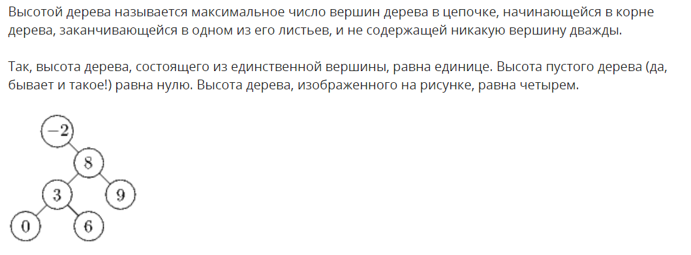

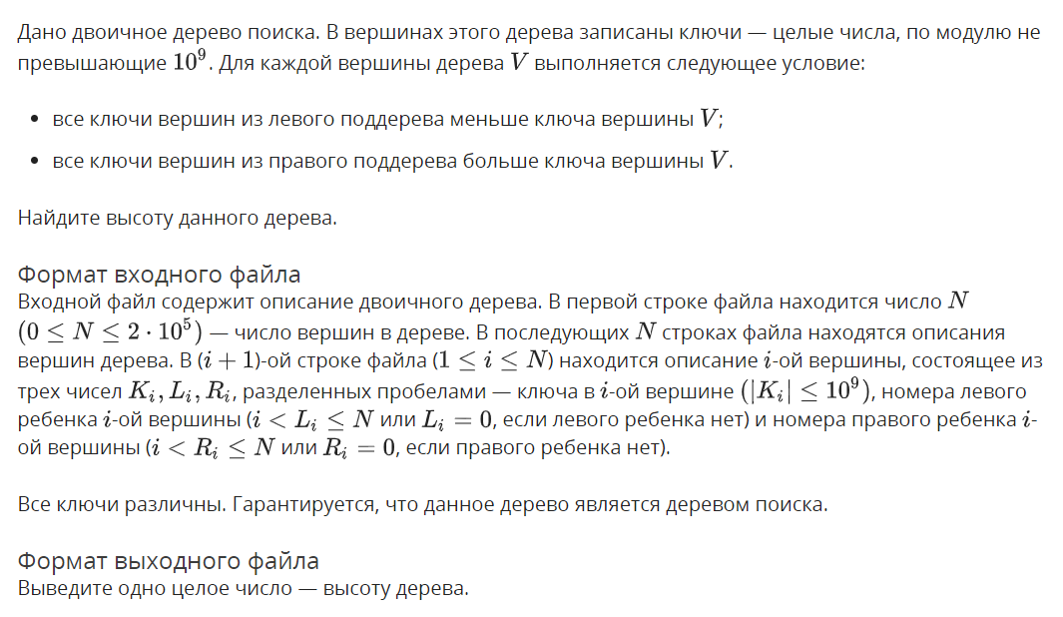
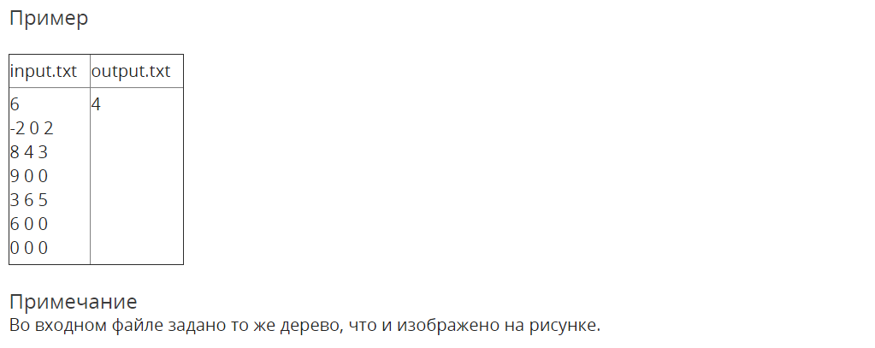

Решение

openedu/week6/lab6_3.cpp

#include "edx-io.hpp"

#include <vector>

#include <algorithm>

using namespace std;

struct NodeDescription {

int k;

int ln;

int rn;

};

vector<NodeDescription> descriptions;

struct Node {

int k;

Node* l;

Node* r;

static Node* createFromDescription(NodeDescription &descr) {

auto n = new Node();

n->k = descr.k;

n->l = descr.ln ? createFromDescription(descriptions[descr.ln - 1]) : nullptr;

n->r = descr.rn ? createFromDescription(descriptions[descr.rn - 1]) : nullptr;

return n;

}

};

int find_depth(Node* tree) {

if (tree == nullptr) {

return 0;

}

return max(find_depth(tree->l), find_depth(tree->r)) + 1;

}

int main() {

int n;

io >> n;

if (n == 0) {

io << 0;

return 0;

}

descriptions = vector<NodeDescription>(n);

for (auto &e : descriptions) {

e = NodeDescription();

io >> e.k >> e.ln >> e.rn;

}

Node* tree = Node::createFromDescription(descriptions[0]);

io << find_depth(tree);

return 0;

}

Результаты
№ теста | Результат | Время, с | Память | Размер входного файла | Размер выходного файла
Max |  | 0.062 | 24301568 | 3989144 | 6
1 | OK | 0.000 | 2220032 | 46 | 1
2 | OK | 0.000 | 2224128 | 3 | 1
3 | OK | 0.015 | 2224128 | 11 | 1
4 | OK | 0.000 | 2224128 | 18 | 1
5 | OK | 0.015 | 2220032 | 103 | 1
6 | OK | 0.000 | 2220032 | 76 | 2
7 | OK | 0.000 | 2224128 | 155 | 2
8 | OK | 0.015 | 2236416 | 163 | 2
9 | OK | 0.015 | 2224128 | 57 | 1
10 | OK | 0.000 | 2236416 | 161 | 1
11 | OK | 0.000 | 2240512 | 2099 | 1
12 | OK | 0.000 | 2232320 | 1197 | 3
13 | OK | 0.000 | 2244608 | 2073 | 3
14 | OK | 0.000 | 2228224 | 2139 | 3
15 | OK | 0.000 | 2232320 | 686 | 1
16 | OK | 0.015 | 2244608 | 2128 | 2
17 | OK | 0.000 | 2244608 | 8777 | 1
18 | OK | 0.000 | 2306048 | 10426 | 3
19 | OK | 0.015 | 2301952 | 16336 | 3
20 | OK | 0.000 | 2306048 | 16835 | 3
21 | OK | 0.000 | 2232320 | 3520 | 1
22 | OK | 0.000 | 2277376 | 16969 | 2
23 | OK | 0.000 | 2334720 | 36534 | 2
24 | OK | 0.000 | 2527232 | 38820 | 4
25 | OK | 0.000 | 2527232 | 55707 | 4
26 | OK | 0.000 | 2527232 | 57235 | 4
27 | OK | 0.000 | 2248704 | 7784 | 2
28 | OK | 0.000 | 2400256 | 56607 | 2
29 | OK | 0.000 | 2506752 | 149518 | 2
30 | OK | 0.000 | 3039232 | 117171 | 4
31 | OK | 0.015 | 3026944 | 164193 | 4
32 | OK | 0.000 | 3026944 | 168789 | 4
33 | OK | 0.015 | 2314240 | 29385 | 2
34 | OK | 0.015 | 2596864 | 171161 | 2
35 | OK | 0.015 | 3960832 | 624213 | 2
36 | OK | 0.031 | 5472256 | 489475 | 5
37 | OK | 0.015 | 5619712 | 637029 | 5
38 | OK | 0.015 | 5636096 | 654072 | 5
39 | OK | 0.000 | 2347008 | 62037 | 2
40 | OK | 0.015 | 4018176 | 666913 | 2
41 | OK | 0.031 | 6041600 | 1259549 | 2
42 | OK | 0.031 | 14553088 | 1788745 | 6
43 | OK | 0.031 | 15015936 | 2254723 | 6
44 | OK | 0.031 | 15077376 | 2313971 | 6
45 | OK | 0.015 | 2531328 | 152298 | 2
46 | OK | 0.015 | 9404416 | 2306482 | 2
47 | OK | 0.015 | 10231808 | 2561292 | 2
48 | OK | 0.046 | 23490560 | 3177798 | 6
49 | OK | 0.062 | 24203264 | 3888903 | 6
50 | OK | 0.062 | 24301568 | 3989144 | 6
51 | OK | 0.000 | 2670592 | 200543 | 2
52 | OK | 0.046 | 14675968 | 3953465 | 2

Удаление поддеревьев

Условие
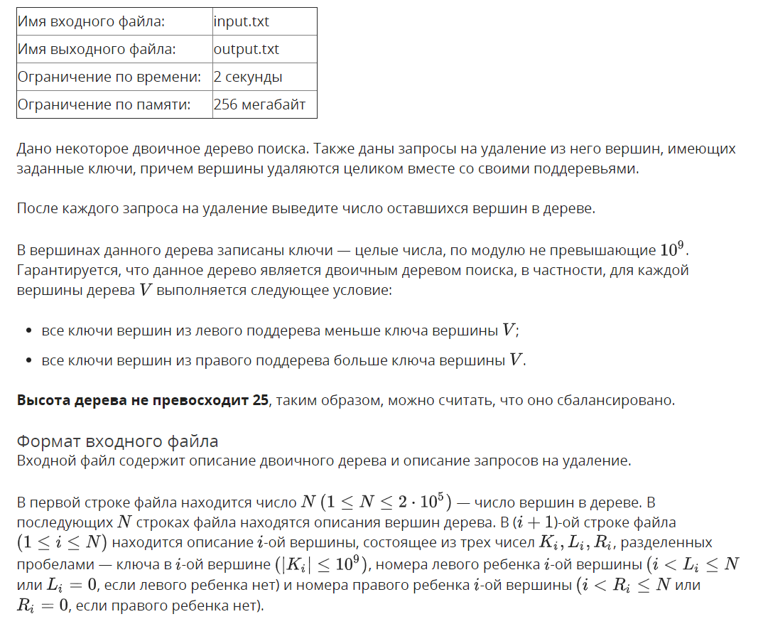
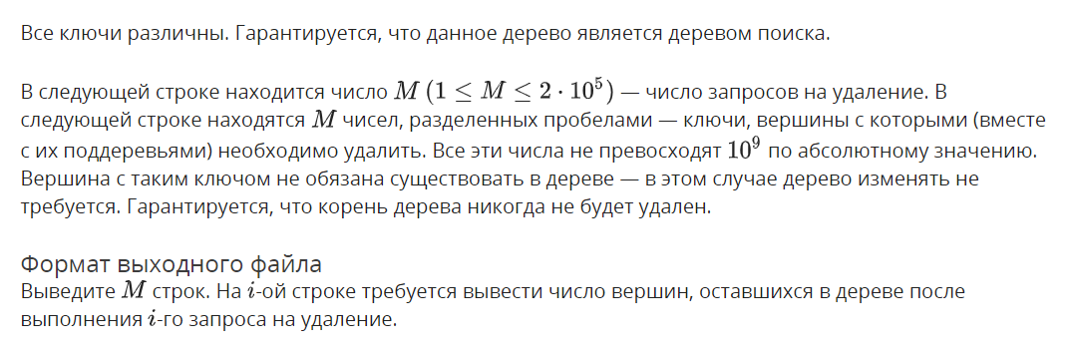
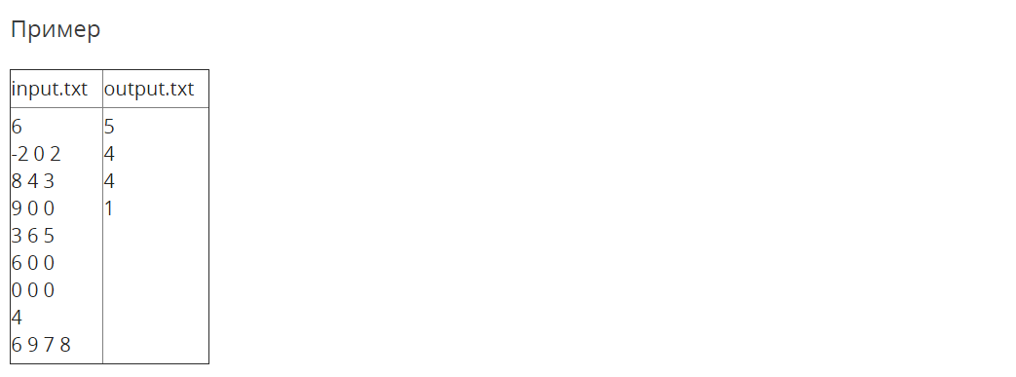

Решение

openedu/week6/lab6_4.cpp

#include "edx-io.hpp"

#include <vector>

#include <algorithm>

using namespace std;

struct NodeDescription {

int k;

int ln;

int rn;

};

vector<NodeDescription> descriptions;

struct Node {

int k;

Node* parent;

Node* l = nullptr;

Node* r = nullptr;

int getSize() {

return (size == -1) ? recalculateSize() : size;

}

int recalculateSize() {

int lsize = l ? l->getSize() : 0;

int rsize = r ? r->getSize() : 0;

size = lsize + rsize + 1;

return size;

}

static Node* createFromDescription(NodeDescription &descr) {

auto n = new Node();

n->k = descr.k;

if (descr.ln) {

n->l = createFromDescription(descriptions[descr.ln - 1]);

n->l->parent = n;

}

if (descr.rn) {

n->r = createFromDescription(descriptions[descr.rn - 1]);

n->r->parent = n;

}

return n;

}

private:

int size = -1;

};

void dropNode(Node* tree, int key) {

if (key < tree->k) {

if (tree->l) dropNode(tree->l, key);

} else if (key > tree->k) {

if (tree->r) dropNode(tree->r, key);

} else {

// screw memory management! nogc!

if (tree->parent->l == tree) {

tree->parent->l = nullptr;

} else {

tree->parent->r = nullptr;

}

// but efficient size calculation management is important

do {

tree = tree->parent;

tree->recalculateSize();

} while (tree->parent);

}

}

int main() {

int n;

io >> n;

descriptions = vector<NodeDescription>(n);

for (auto &e : descriptions) {

e = NodeDescription();

io >> e.k >> e.ln >> e.rn;

}

Node* tree = Node::createFromDescription(descriptions[0]);

int kn;

io >> kn;

for (int i = 0; i < kn; i++) {

int key;

io >> key;

dropNode(tree, key);

io << tree->getSize() << "\n";

}

return 0;

}

Результаты
№ теста | Результат | Время, с | Память | Размер входного файла | Размер выходного файла
Max |  | 0.109 | 19943424 | 6029382 | 1077960
1 | OK | 0.000 | 2236416 | 58 | 12
2 | OK | 0.000 | 2224128 | 27 | 12
3 | OK | 0.000 | 2224128 | 34 | 15
4 | OK | 0.000 | 2220032 | 211 | 30
5 | OK | 0.000 | 2220032 | 246 | 30
6 | OK | 0.000 | 2232320 | 3437 | 457
7 | OK | 0.000 | 2224128 | 3363 | 483
8 | OK | 0.000 | 2273280 | 18842 | 4247
9 | OK | 0.015 | 2285568 | 25683 | 3739
10 | OK | 0.000 | 2359296 | 69351 | 14791
11 | OK | 0.015 | 2437120 | 88936 | 11629
12 | OK | 0.000 | 2650112 | 244892 | 40297
13 | OK | 0.015 | 2727936 | 255614 | 37596
14 | OK | 0.031 | 4796416 | 978616 | 141281
15 | OK | 0.031 | 4890624 | 992647 | 137802
16 | OK | 0.062 | 8306688 | 2488583 | 634135
17 | OK | 0.062 | 12435456 | 3489729 | 483105
18 | OK | 0.109 | 14438400 | 4639039 | 1077960
19 | OK | 0.109 | 19832832 | 6007604 | 931260
20 | OK | 0.093 | 19943424 | 6029382 | 916969

