Лабораторная работа № 7
по дисциплине «Алгоритмы и структуры данных»
Openedu – неделя 7

Подготовил:
студент группы P3217
Бураков Илья Алексеевич

Преподаватели:
Романов Алексей Андреевич
Волчек Дмитрий Геннадьевич

Проверка сбалансированности

Условие
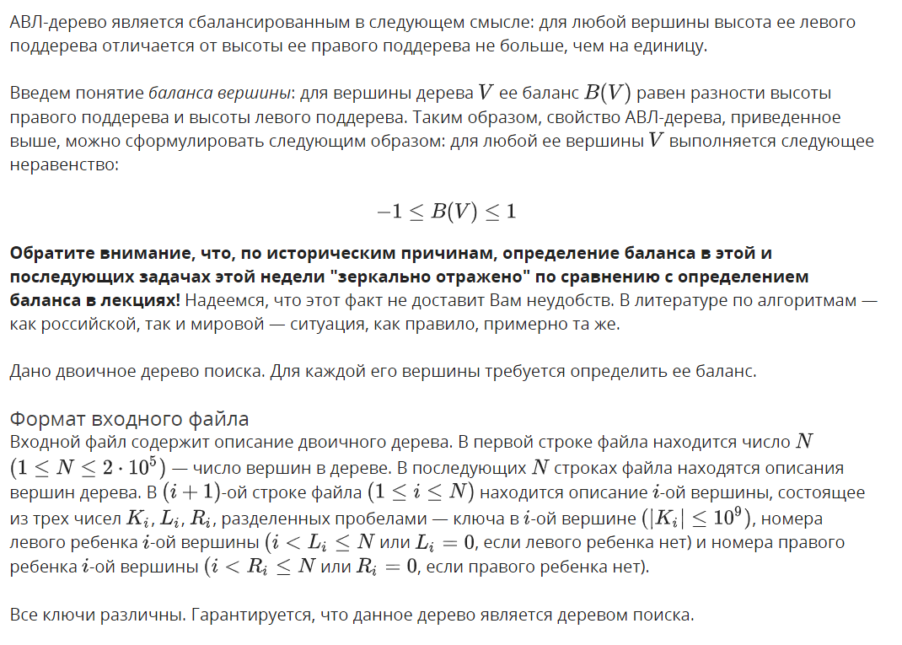
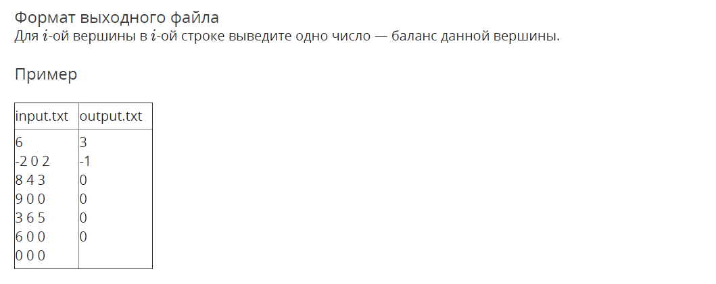

Решение

openedu/week7/lab7_1.cpp

#include "edx-io.hpp"

#include <iostream>

#include <fstream>

#include <vector>

#include <algorithm>

#include <string>

#include <list>

#include <assert.h>

#include <tuple>

using namespace std;

typedef int32_t balance_t;

struct Node {

int key;

balance_t balance = 0;

int height = 1;

Node* parent = nullptr;

Node* left = nullptr;

Node* right = nullptr;

balance_t get_left_balance() { return (left) ? left->balance : -1; };

balance_t get_right_balance() { return (right) ? right->balance : -1; };

int get_left_height() { return (left) ? left->height : -1; };

int get_right_height() { return (right) ? right->height : -1; };

};

struct NodeDescr {

int k;

int li;

int ri;

// remember balance just for this task

balance_t balance_result;

};

Node* build_tree(vector<NodeDescr> &input, int root_index = 0) {

// root node description

NodeDescr& rd = input[root_index];

// create new node

Node* tree = new Node();

tree->key = rd.k;

// recursively build left and right subtrees if needed

if (rd.li) {

tree->left = build_tree(input, rd.li - 1);

tree->left->parent = tree;

}

if (rd.ri) {

tree->right = build_tree(input, rd.ri - 1);

tree->right->parent = tree;

}

// calculate height and balance

tree->height = max(tree->get_right_height(), tree->get_left_height()) + 1;

tree->balance = tree->get_right_height() - tree->get_left_height();

// remember balance just for this task

rd.balance_result = tree->balance;

return tree;

}

Node* find_node(Node* tree, int key) {

if (tree == nullptr) {

return nullptr;

} else if (key == tree->key) {

return tree;

} else if (key < tree->key) {

return find_node(tree->left, key);

} else {

return find_node(tree->right, key);

}

}

int main() {

int n;

io >> n;

vector<NodeDescr> input(n);

for (auto& descr : input) {

io >> descr.k >> descr.li >> descr.ri;

}

auto tree = build_tree(input);

for (auto& descr : input) {

io << descr.balance_result << "\n";

}

return 0;

}

Результаты
№ теста | Результат | Время, с | Память | Размер входного файла | Размер выходного файла
Max |  | 0.125 | 28200960 | 3986010 | 1688889
1 | OK | 0.015 | 2220032 | 46 | 19
2 | OK | 0.000 | 2224128 | 10 | 3
3 | OK | 0.000 | 2220032 | 17 | 6
4 | OK | 0.000 | 2224128 | 17 | 7
5 | OK | 0.000 | 2224128 | 24 | 9
6 | OK | 0.000 | 2232320 | 24 | 10
7 | OK | 0.000 | 2220032 | 24 | 9
8 | OK | 0.000 | 2220032 | 24 | 10
9 | OK | 0.015 | 2224128 | 24 | 11
10 | OK | 0.015 | 2228224 | 31 | 12
11 | OK | 0.015 | 2236416 | 31 | 13
12 | OK | 0.000 | 2240512 | 31 | 12
13 | OK | 0.000 | 2224128 | 31 | 13
14 | OK | 0.015 | 2224128 | 31 | 14
15 | OK | 0.000 | 2224128 | 31 | 12
16 | OK | 0.015 | 2220032 | 31 | 13
17 | OK | 0.000 | 2224128 | 31 | 13
18 | OK | 0.000 | 2232320 | 31 | 14
19 | OK | 0.000 | 2236416 | 31 | 13
20 | OK | 0.015 | 2236416 | 31 | 14
21 | OK | 0.031 | 2224128 | 31 | 13
22 | OK | 0.015 | 2224128 | 31 | 14
23 | OK | 0.015 | 2240512 | 31 | 15
24 | OK | 0.000 | 2236416 | 38 | 15
25 | OK | 0.015 | 2240512 | 38 | 16
26 | OK | 0.000 | 2236416 | 38 | 15
27 | OK | 0.015 | 2240512 | 38 | 16
28 | OK | 0.000 | 2236416 | 38 | 17
29 | OK | 0.000 | 2224128 | 38 | 15
30 | OK | 0.000 | 2240512 | 38 | 16
31 | OK | 0.000 | 2236416 | 38 | 16
32 | OK | 0.046 | 2236416 | 38 | 17
33 | OK | 0.015 | 2236416 | 38 | 16
34 | OK | 0.000 | 2224128 | 38 | 17
35 | OK | 0.000 | 2236416 | 38 | 16
36 | OK | 0.015 | 2232320 | 38 | 17
37 | OK | 0.000 | 2224128 | 38 | 18
38 | OK | 0.015 | 2224128 | 38 | 15
39 | OK | 0.000 | 2236416 | 38 | 16
40 | OK | 0.000 | 2240512 | 38 | 15
41 | OK | 0.015 | 2240512 | 38 | 16
42 | OK | 0.000 | 2224128 | 38 | 17
43 | OK | 0.000 | 2236416 | 38 | 15
44 | OK | 0.000 | 2220032 | 38 | 16
45 | OK | 0.000 | 2236416 | 38 | 16
46 | OK | 0.015 | 2236416 | 38 | 17
47 | OK | 0.015 | 2224128 | 38 | 16
48 | OK | 0.000 | 2232320 | 38 | 17
49 | OK | 0.015 | 2236416 | 38 | 16
50 | OK | 0.000 | 2228224 | 38 | 17
51 | OK | 0.000 | 2220032 | 38 | 18
52 | OK | 0.000 | 2224128 | 38 | 16
53 | OK | 0.000 | 2240512 | 38 | 17
54 | OK | 0.000 | 2236416 | 38 | 16
55 | OK | 0.000 | 2236416 | 38 | 17
56 | OK | 0.000 | 2236416 | 38 | 18
57 | OK | 0.000 | 2236416 | 38 | 16
58 | OK | 0.000 | 2220032 | 38 | 17
59 | OK | 0.000 | 2224128 | 38 | 17
60 | OK | 0.015 | 2240512 | 38 | 18
61 | OK | 0.000 | 2224128 | 38 | 17
62 | OK | 0.000 | 2232320 | 38 | 18
63 | OK | 0.000 | 2236416 | 38 | 17
64 | OK | 0.000 | 2220032 | 38 | 18
65 | OK | 0.000 | 2236416 | 38 | 19
66 | OK | 0.000 | 2236416 | 45 | 18
67 | OK | 0.000 | 2240512 | 45 | 19
68 | OK | 0.000 | 2224128 | 45 | 18
69 | OK | 0.015 | 2224128 | 45 | 19
70 | OK | 0.000 | 2236416 | 45 | 20
71 | OK | 0.000 | 2220032 | 45 | 18
72 | OK | 0.000 | 2224128 | 45 | 19
73 | OK | 0.015 | 2220032 | 45 | 19
74 | OK | 0.000 | 2220032 | 45 | 20
75 | OK | 0.015 | 2220032 | 45 | 19
76 | OK | 0.000 | 2240512 | 45 | 20
77 | OK | 0.000 | 2224128 | 45 | 19
78 | OK | 0.015 | 2236416 | 45 | 20
79 | OK | 0.015 | 2220032 | 45 | 21
80 | OK | 0.000 | 2240512 | 45 | 18
81 | OK | 0.000 | 2224128 | 45 | 19
82 | OK | 0.000 | 2224128 | 45 | 18
83 | OK | 0.015 | 2224128 | 45 | 19
84 | OK | 0.000 | 2220032 | 45 | 20
85 | OK | 0.000 | 2220032 | 45 | 18
86 | OK | 0.000 | 2236416 | 45 | 19
87 | OK | 0.015 | 2224128 | 45 | 19
88 | OK | 0.000 | 2224128 | 45 | 20
89 | OK | 0.000 | 2224128 | 45 | 19
90 | OK | 0.000 | 2220032 | 45 | 20
91 | OK | 0.000 | 2224128 | 45 | 19
92 | OK | 0.000 | 2236416 | 45 | 20
93 | OK | 0.015 | 2232320 | 45 | 21
94 | OK | 0.000 | 2228224 | 45 | 19
95 | OK | 0.000 | 2236416 | 45 | 20
96 | OK | 0.015 | 2236416 | 45 | 19
97 | OK | 0.000 | 2220032 | 45 | 20
98 | OK | 0.000 | 2224128 | 45 | 21
99 | OK | 0.015 | 2244608 | 45 | 19
100 | OK | 0.000 | 2236416 | 45 | 20
101 | OK | 0.015 | 2220032 | 45 | 20
102 | OK | 0.000 | 2232320 | 45 | 21
103 | OK | 0.000 | 2224128 | 45 | 20
104 | OK | 0.000 | 2224128 | 45 | 21
105 | OK | 0.000 | 2236416 | 45 | 20
106 | OK | 0.000 | 2224128 | 45 | 21
107 | OK | 0.000 | 2220032 | 45 | 22
108 | OK | 0.000 | 2224128 | 45 | 18
109 | OK | 0.000 | 2240512 | 45 | 19
110 | OK | 0.000 | 2236416 | 45 | 18
111 | OK | 0.000 | 2236416 | 45 | 19
112 | OK | 0.000 | 2224128 | 45 | 20
113 | OK | 0.000 | 2224128 | 45 | 18
114 | OK | 0.015 | 2224128 | 45 | 19
115 | OK | 0.000 | 2236416 | 45 | 19
116 | OK | 0.000 | 2224128 | 45 | 20
117 | OK | 0.015 | 2224128 | 45 | 19
118 | OK | 0.015 | 2220032 | 45 | 20
119 | OK | 0.000 | 2224128 | 45 | 19
120 | OK | 0.000 | 2236416 | 45 | 20
121 | OK | 0.000 | 2220032 | 45 | 21
122 | OK | 0.000 | 2224128 | 45 | 18
123 | OK | 0.000 | 2224128 | 45 | 19
124 | OK | 0.000 | 2220032 | 45 | 18
125 | OK | 0.000 | 2236416 | 45 | 19
126 | OK | 0.000 | 2236416 | 45 | 20
127 | OK | 0.015 | 2224128 | 45 | 19
128 | OK | 0.015 | 2224128 | 45 | 20
129 | OK | 0.000 | 2236416 | 45 | 19
130 | OK | 0.000 | 2228224 | 45 | 20
131 | OK | 0.000 | 2224128 | 45 | 21
132 | OK | 0.000 | 2220032 | 45 | 19
133 | OK | 0.015 | 2224128 | 45 | 20
134 | OK | 0.000 | 2224128 | 45 | 20
135 | OK | 0.000 | 2236416 | 45 | 21
136 | OK | 0.000 | 2220032 | 45 | 18
137 | OK | 0.000 | 2220032 | 45 | 19
138 | OK | 0.000 | 2224128 | 45 | 20
139 | OK | 0.000 | 2224128 | 45 | 21
140 | OK | 0.015 | 2228224 | 45 | 21
141 | OK | 0.000 | 2236416 | 45 | 22
142 | OK | 0.015 | 2236416 | 45 | 19
143 | OK | 0.015 | 2224128 | 45 | 20
144 | OK | 0.015 | 2224128 | 45 | 19
145 | OK | 0.000 | 2224128 | 45 | 20
146 | OK | 0.015 | 2236416 | 45 | 21
147 | OK | 0.000 | 2220032 | 45 | 19
148 | OK | 0.000 | 2236416 | 45 | 20
149 | OK | 0.000 | 2232320 | 45 | 20
150 | OK | 0.000 | 2228224 | 45 | 21
151 | OK | 0.000 | 2236416 | 45 | 20
152 | OK | 0.015 | 2236416 | 45 | 21
153 | OK | 0.000 | 2224128 | 45 | 20
154 | OK | 0.000 | 2220032 | 45 | 21
155 | OK | 0.000 | 2236416 | 45 | 22
156 | OK | 0.000 | 2224128 | 45 | 19
157 | OK | 0.000 | 2224128 | 45 | 20
158 | OK | 0.015 | 2236416 | 45 | 19
159 | OK | 0.000 | 2240512 | 45 | 20
160 | OK | 0.015 | 2240512 | 45 | 21
161 | OK | 0.000 | 2236416 | 45 | 19
162 | OK | 0.000 | 2236416 | 45 | 20
163 | OK | 0.000 | 2224128 | 45 | 20
164 | OK | 0.000 | 2240512 | 45 | 21
165 | OK | 0.015 | 2224128 | 45 | 20
166 | OK | 0.000 | 2236416 | 45 | 21
167 | OK | 0.000 | 2224128 | 45 | 20
168 | OK | 0.015 | 2224128 | 45 | 21
169 | OK | 0.015 | 2236416 | 45 | 22
170 | OK | 0.000 | 2240512 | 45 | 19
171 | OK | 0.000 | 2236416 | 45 | 20
172 | OK | 0.000 | 2236416 | 45 | 19
173 | OK | 0.015 | 2224128 | 45 | 20
174 | OK | 0.015 | 2236416 | 45 | 21
175 | OK | 0.000 | 2224128 | 45 | 19
176 | OK | 0.000 | 2224128 | 45 | 20
177 | OK | 0.000 | 2224128 | 45 | 20
178 | OK | 0.000 | 2224128 | 45 | 21
179 | OK | 0.000 | 2236416 | 45 | 20
180 | OK | 0.000 | 2240512 | 45 | 21
181 | OK | 0.000 | 2240512 | 45 | 20
182 | OK | 0.015 | 2224128 | 45 | 21
183 | OK | 0.000 | 2224128 | 45 | 22
184 | OK | 0.015 | 2236416 | 45 | 20
185 | OK | 0.000 | 2240512 | 45 | 21
186 | OK | 0.015 | 2224128 | 45 | 20
187 | OK | 0.000 | 2236416 | 45 | 21
188 | OK | 0.000 | 2220032 | 45 | 22
189 | OK | 0.000 | 2236416 | 45 | 20
190 | OK | 0.000 | 2236416 | 45 | 21
191 | OK | 0.000 | 2224128 | 45 | 21
192 | OK | 0.000 | 2228224 | 45 | 22
193 | OK | 0.000 | 2224128 | 45 | 21
194 | OK | 0.000 | 2224128 | 45 | 22
195 | OK | 0.015 | 2236416 | 45 | 21
196 | OK | 0.000 | 2224128 | 45 | 22
197 | OK | 0.015 | 2224128 | 45 | 23
198 | OK | 0.000 | 2224128 | 221 | 55
199 | OK | 0.015 | 2224128 | 220 | 59
200 | OK | 0.000 | 2236416 | 220 | 46
201 | OK | 0.000 | 2236416 | 223 | 48
202 | OK | 0.000 | 2240512 | 226 | 45
203 | OK | 0.000 | 2232320 | 1786 | 502
204 | OK | 0.000 | 2240512 | 1785 | 555
205 | OK | 0.000 | 2232320 | 1785 | 445
206 | OK | 0.000 | 2244608 | 1845 | 365
207 | OK | 0.015 | 2232320 | 1847 | 363
208 | OK | 0.000 | 2277376 | 9555 | 3006
209 | OK | 0.000 | 2297856 | 9554 | 3297
210 | OK | 0.000 | 2277376 | 9554 | 2730
211 | OK | 0.000 | 2273280 | 9303 | 1888
212 | OK | 0.000 | 2265088 | 9984 | 1877
213 | OK | 0.000 | 2461696 | 37691 | 12907
214 | OK | 0.000 | 2465792 | 37690 | 13974
215 | OK | 0.000 | 2482176 | 37690 | 11820
216 | OK | 0.015 | 2387968 | 39602 | 7150
217 | OK | 0.000 | 2371584 | 38744 | 7125
218 | OK | 0.000 | 3268608 | 178903 | 63876
219 | OK | 0.000 | 3264512 | 178902 | 68889
220 | OK | 0.015 | 3264512 | 178902 | 58890
221 | OK | 0.015 | 2789376 | 185712 | 33049
222 | OK | 0.015 | 2797568 | 180580 | 33013
223 | OK | 0.046 | 14761984 | 1853240 | 724890
224 | OK | 0.046 | 14761984 | 1853239 | 773873
225 | OK | 0.046 | 14761984 | 1853239 | 675751
226 | OK | 0.031 | 10063872 | 1855624 | 324156
227 | OK | 0.046 | 10063872 | 1856715 | 324455
228 | OK | 0.093 | 25477120 | 3473125 | 1412256
229 | OK | 0.093 | 25477120 | 3473124 | 1501788
230 | OK | 0.109 | 25477120 | 3473124 | 1322578
231 | OK | 0.078 | 17014784 | 3603994 | 592172
232 | OK | 0.078 | 17059840 | 3646224 | 592525
233 | OK | 0.125 | 28196864 | 3888905 | 1589032
234 | OK | 0.109 | 28200960 | 3888904 | 1688889
235 | OK | 0.109 | 28200960 | 3888904 | 1488890
236 | OK | 0.078 | 18608128 | 3890628 | 661024
237 | OK | 0.093 | 18706432 | 3986010 | 661067

Делаю я левый поворот…

Условие
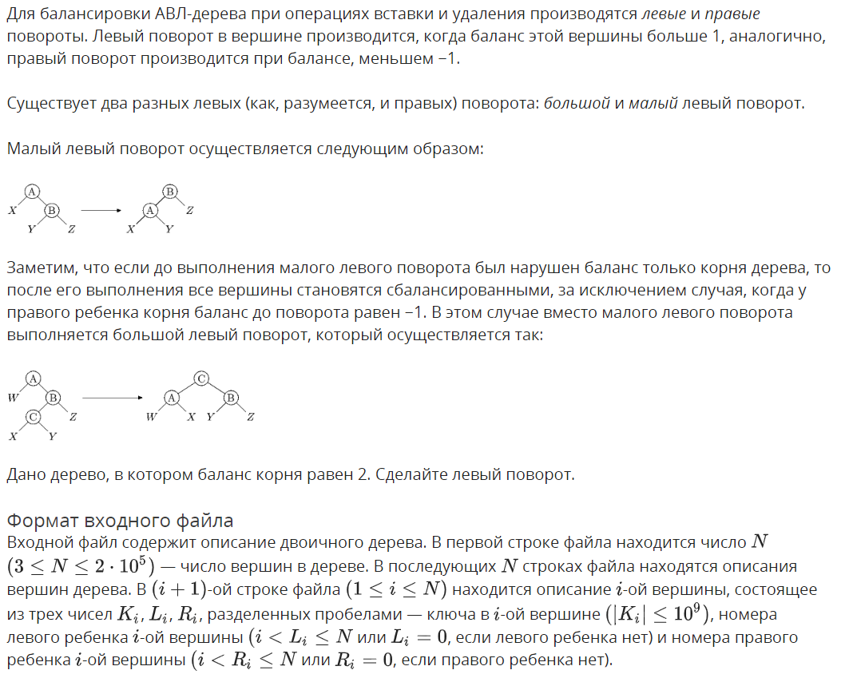
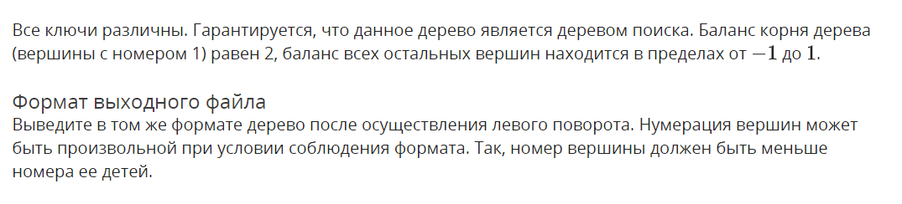
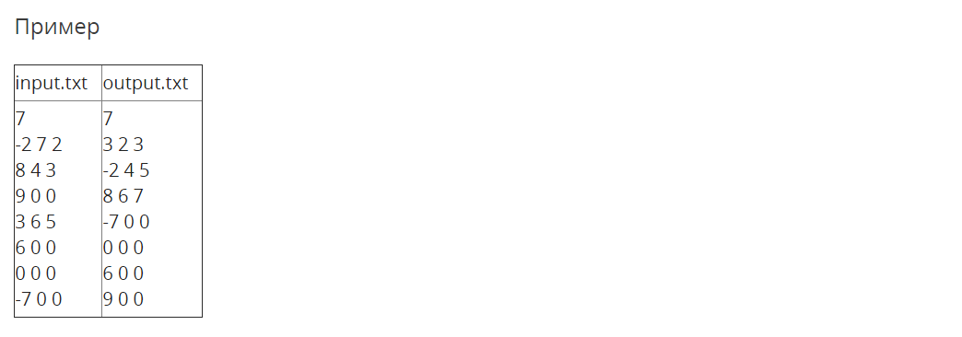

Решение

openedu/week7/lab7_2.cpp

#include "edx-io.hpp"

#include <iostream>

#include <fstream>

#include <vector>

#include <algorithm>

#include <string>

#include <list>

#include <assert.h>

#include <tuple>

using namespace std;

typedef int32_t balance_t;

struct Node {

int key;

balance_t balance = 0;

int height = 1;

Node* parent = nullptr;

Node* left = nullptr;

Node* right = nullptr;

// dirty hack

int latest_population_descr_index;

balance_t get_left_balance() { return (left) ? left->balance : -1; };

balance_t get_right_balance() { return (right) ? right->balance : -1; };

int get_left_height() { return (left) ? left->height : -1; };

int get_right_height() { return (right) ? right->height : -1; };

void replace_child(Node* from, Node* to) {

if (left == from) {

left = to;

} else {

assert(right == from);

right = to;

}

to->parent = this;

from->parent = nullptr;

}

};

struct NodeDescription {

int k;

int li = 0;

int ri = 0;

};

struct TreeDescription {

vector<NodeDescription> descriptions;

TreeDescription() {}

TreeDescription(int size) : descriptions(size) {}

NodeDescription& description_for_index(int index) {

return descriptions[index];

}

void populate_from_tree(Node* tree) {

// children set later

descriptions.push_back(NodeDescription{ tree->key });

// dirty hack for setting children!

int current_index = descriptions.size() - 1;

tree->latest_population_descr_index = current_index;

// setting children of previously added things

if (tree->parent) {

if (tree->parent->left == tree) {

descriptions[tree->parent->latest_population_descr_index].li = current_index + 1;

} else {

assert(tree->parent->right == tree);

descriptions[tree->parent->latest_population_descr_index].ri = current_index + 1;

}

}

// recursively populate from subtrees

if (tree->left) {

populate_from_tree(tree->left);

}

if (tree->right) {

populate_from_tree(tree->right);

}

}

};

Node* build_tree(TreeDescription &input, int root_index = 0) {

// root node description

auto& rd = input.description_for_index(root_index);

// create new node

Node* tree = new Node();

tree->key = rd.k;

// recursively build left and right subtrees if needed

if (rd.li) {

tree->left = build_tree(input, rd.li - 1);

tree->left->parent = tree;

}

if (rd.ri) {

tree->right = build_tree(input, rd.ri - 1);

tree->right->parent = tree;

}

// calculate height and balance

tree->height = max(tree->get_right_height(), tree->get_left_height()) + 1;

tree->balance = tree->get_right_height() - tree->get_left_height();

return tree;

}

Node*& find_node(Node*& tree, int key) {

if (tree == nullptr) {

return tree;

} else if (key == tree->key) {

return tree;

} else if (key < tree->key) {

return find_node(tree->left, key);

} else {

return find_node(tree->right, key);

}

}

void rotate_l(Node*& tree) {

assert(tree->right != nullptr);

Node* a = tree;

Node* b = a->right;

Node* x = a->left;

Node* y = b->left;

Node* z = b->right;

if (a->parent) {

a->parent->replace_child(a, b);

} else {

b->parent = nullptr;

}

b->left = a;

a->parent = b;

a->right = y;

if (y) {

y->parent = a;

}

tree = b;

}

void rotate_r(Node*& tree) {

assert(tree->left != nullptr);

Node* a = tree;

Node* b = a->left;

Node* x = a->right;

Node* y = b->right;

Node* z = b->left;

if (a->parent) {

a->parent->replace_child(a, b);

} else {

b->parent = nullptr;

}

b->right = a;

a->parent = b;

a->left = y;

if (y) {

y->parent = a;

}

tree = b;

}

void rotate_lr(Node*& tree) {

// большой правый

rotate_l(tree->left);

rotate_r(tree);

}

void rotate_rl(Node*& tree) {

// большой левый

rotate_r(tree->right);

rotate_l(tree);

}

int main() {

int n;

io >> n;

TreeDescription input(n);

for (auto& descr : input.descriptions) {

io >> descr.k >> descr.li >> descr.ri;

}

auto tree = build_tree(input);

if (tree->right->balance == -1) {

rotate_rl(tree);

} else {

rotate_l(tree);

}

TreeDescription output;

output.populate_from_tree(tree);

io << n << "\n";

for (auto& descr : output.descriptions) {

io << descr.k << " " << descr.li << " " << descr.ri << "\n";

}

return 0;

}

Результаты
№ теста | Результат | Время, с | Память | Размер входного файла | Размер выходного файла
Max |  | 0.203 | 24616960 | 3986416 | 3986416
1 | OK | 0.000 | 2252800 | 54 | 54
2 | OK | 0.015 | 2248704 | 24 | 24
3 | OK | 0.000 | 2265088 | 24 | 24
4 | OK | 0.015 | 2252800 | 31 | 31
5 | OK | 0.000 | 2252800 | 45 | 45
6 | OK | 0.000 | 2248704 | 45 | 45
7 | OK | 0.015 | 2265088 | 45 | 45
8 | OK | 0.000 | 2265088 | 45 | 45
9 | OK | 0.000 | 2252800 | 52 | 52
10 | OK | 0.015 | 2248704 | 52 | 52
11 | OK | 0.000 | 2252800 | 52 | 52
12 | OK | 0.000 | 2256896 | 52 | 52
13 | OK | 0.015 | 2252800 | 52 | 52
14 | OK | 0.000 | 2252800 | 52 | 52
15 | OK | 0.000 | 2252800 | 59 | 59
16 | OK | 0.000 | 2248704 | 59 | 59
17 | OK | 0.000 | 2248704 | 59 | 59
18 | OK | 0.000 | 2252800 | 59 | 59
19 | OK | 0.015 | 2260992 | 66 | 66
20 | OK | 0.000 | 2260992 | 75 | 75
21 | OK | 0.015 | 2277376 | 75 | 75
22 | OK | 0.000 | 2256896 | 75 | 75
23 | OK | 0.015 | 2265088 | 75 | 75
24 | OK | 0.000 | 2260992 | 75 | 75
25 | OK | 0.015 | 2277376 | 75 | 75
26 | OK | 0.000 | 2260992 | 75 | 75
27 | OK | 0.000 | 2260992 | 75 | 75
28 | OK | 0.000 | 2277376 | 75 | 75
29 | OK | 0.000 | 2260992 | 75 | 75
30 | OK | 0.015 | 2256896 | 75 | 75
31 | OK | 0.000 | 2269184 | 75 | 75
32 | OK | 0.000 | 2260992 | 75 | 75
33 | OK | 0.000 | 2273280 | 75 | 75
34 | OK | 0.000 | 2265088 | 75 | 75
35 | OK | 0.000 | 2260992 | 75 | 75
36 | OK | 0.015 | 2260992 | 75 | 75
37 | OK | 0.015 | 2277376 | 75 | 75
38 | OK | 0.000 | 2260992 | 75 | 75
39 | OK | 0.000 | 2256896 | 75 | 75
40 | OK | 0.015 | 2256896 | 75 | 75
41 | OK | 0.000 | 2273280 | 75 | 75
42 | OK | 0.000 | 2269184 | 75 | 75
43 | OK | 0.000 | 2273280 | 75 | 75
44 | OK | 0.015 | 2260992 | 75 | 75
45 | OK | 0.015 | 2277376 | 75 | 75
46 | OK | 0.000 | 2256896 | 75 | 75
47 | OK | 0.015 | 2260992 | 75 | 75
48 | OK | 0.000 | 2260992 | 75 | 75
49 | OK | 0.000 | 2260992 | 75 | 75
50 | OK | 0.000 | 2256896 | 75 | 75
51 | OK | 0.000 | 2260992 | 75 | 75
52 | OK | 0.000 | 2260992 | 84 | 84
53 | OK | 0.000 | 2269184 | 84 | 84
54 | OK | 0.015 | 2260992 | 84 | 84
55 | OK | 0.000 | 2265088 | 84 | 84
56 | OK | 0.000 | 2256896 | 84 | 84
57 | OK | 0.015 | 2260992 | 84 | 84
58 | OK | 0.000 | 2277376 | 84 | 84
59 | OK | 0.000 | 2260992 | 84 | 84
60 | OK | 0.000 | 2273280 | 84 | 84
61 | OK | 0.000 | 2273280 | 84 | 84
62 | OK | 0.015 | 2260992 | 84 | 84
63 | OK | 0.000 | 2273280 | 84 | 84
64 | OK | 0.000 | 2260992 | 84 | 84
65 | OK | 0.000 | 2265088 | 84 | 84
66 | OK | 0.000 | 2260992 | 84 | 84
67 | OK | 0.000 | 2277376 | 84 | 84
68 | OK | 0.000 | 2256896 | 84 | 84
69 | OK | 0.000 | 2260992 | 84 | 84
70 | OK | 0.000 | 2273280 | 84 | 84
71 | OK | 0.000 | 2273280 | 84 | 84
72 | OK | 0.000 | 2260992 | 84 | 84
73 | OK | 0.000 | 2273280 | 84 | 84
74 | OK | 0.000 | 2273280 | 84 | 84
75 | OK | 0.000 | 2265088 | 84 | 84
76 | OK | 0.015 | 2277376 | 84 | 84
77 | OK | 0.015 | 2260992 | 84 | 84
78 | OK | 0.000 | 2260992 | 84 | 84
79 | OK | 0.015 | 2260992 | 84 | 84
80 | OK | 0.000 | 2256896 | 84 | 84
81 | OK | 0.015 | 2260992 | 84 | 84
82 | OK | 0.000 | 2260992 | 84 | 84
83 | OK | 0.000 | 2256896 | 84 | 84
84 | OK | 0.000 | 2260992 | 84 | 84
85 | OK | 0.015 | 2265088 | 84 | 84
86 | OK | 0.000 | 2260992 | 84 | 84
87 | OK | 0.031 | 2256896 | 84 | 84
88 | OK | 0.000 | 2260992 | 84 | 84
89 | OK | 0.015 | 2273280 | 84 | 84
90 | OK | 0.000 | 2256896 | 84 | 84
91 | OK | 0.000 | 2256896 | 84 | 84
92 | OK | 0.000 | 2277376 | 84 | 84
93 | OK | 0.000 | 2260992 | 84 | 84
94 | OK | 0.015 | 2273280 | 84 | 84
95 | OK | 0.015 | 2265088 | 84 | 84
96 | OK | 0.015 | 2273280 | 84 | 84
97 | OK | 0.000 | 2260992 | 84 | 84
98 | OK | 0.000 | 2260992 | 84 | 84
99 | OK | 0.000 | 2260992 | 84 | 84
100 | OK | 0.015 | 2260992 | 84 | 84
101 | OK | 0.000 | 2260992 | 84 | 84
102 | OK | 0.000 | 2256896 | 84 | 84
103 | OK | 0.000 | 2260992 | 84 | 84
104 | OK | 0.015 | 2260992 | 84 | 84
105 | OK | 0.015 | 2260992 | 84 | 84
106 | OK | 0.015 | 2260992 | 84 | 84
107 | OK | 0.015 | 2260992 | 84 | 84
108 | OK | 0.000 | 2260992 | 84 | 84
109 | OK | 0.000 | 2260992 | 84 | 84
110 | OK | 0.000 | 2273280 | 84 | 84
111 | OK | 0.000 | 2273280 | 84 | 84
112 | OK | 0.000 | 2260992 | 84 | 84
113 | OK | 0.015 | 2260992 | 84 | 84
114 | OK | 0.015 | 2273280 | 84 | 84
115 | OK | 0.000 | 2260992 | 84 | 84
116 | OK | 0.015 | 2265088 | 84 | 84
117 | OK | 0.015 | 2260992 | 84 | 84
118 | OK | 0.000 | 2260992 | 84 | 84
119 | OK | 0.000 | 2273280 | 84 | 84
120 | OK | 0.015 | 2273280 | 84 | 84
121 | OK | 0.015 | 2273280 | 84 | 84
122 | OK | 0.015 | 2277376 | 84 | 84
123 | OK | 0.015 | 2260992 | 84 | 84
124 | OK | 0.015 | 2260992 | 84 | 84
125 | OK | 0.000 | 2256896 | 84 | 84
126 | OK | 0.000 | 2260992 | 84 | 84
127 | OK | 0.015 | 2273280 | 84 | 84
128 | OK | 0.015 | 2260992 | 84 | 84
129 | OK | 0.000 | 2273280 | 84 | 84
130 | OK | 0.000 | 2260992 | 84 | 84
131 | OK | 0.000 | 2260992 | 84 | 84
132 | OK | 0.000 | 2273280 | 93 | 93
133 | OK | 0.000 | 2273280 | 93 | 93
134 | OK | 0.000 | 2260992 | 93 | 93
135 | OK | 0.015 | 2265088 | 93 | 93
136 | OK | 0.000 | 2273280 | 93 | 93
137 | OK | 0.000 | 2273280 | 93 | 93
138 | OK | 0.000 | 2260992 | 93 | 93
139 | OK | 0.000 | 2260992 | 93 | 93
140 | OK | 0.000 | 2260992 | 93 | 93
141 | OK | 0.015 | 2260992 | 93 | 93
142 | OK | 0.031 | 2273280 | 93 | 93
143 | OK | 0.000 | 2260992 | 93 | 93
144 | OK | 0.015 | 2260992 | 93 | 93
145 | OK | 0.000 | 2265088 | 93 | 93
146 | OK | 0.015 | 2273280 | 93 | 93
147 | OK | 0.015 | 2260992 | 93 | 93
148 | OK | 0.015 | 2273280 | 93 | 93
149 | OK | 0.015 | 2260992 | 93 | 93
150 | OK | 0.000 | 2260992 | 93 | 93
151 | OK | 0.000 | 2260992 | 93 | 93
152 | OK | 0.000 | 2260992 | 93 | 93
153 | OK | 0.000 | 2260992 | 93 | 93
154 | OK | 0.015 | 2260992 | 93 | 93
155 | OK | 0.000 | 2277376 | 93 | 93
156 | OK | 0.000 | 2260992 | 93 | 93
157 | OK | 0.000 | 2260992 | 93 | 93
158 | OK | 0.000 | 2260992 | 93 | 93
159 | OK | 0.015 | 2273280 | 93 | 93
160 | OK | 0.000 | 2260992 | 93 | 93
161 | OK | 0.000 | 2256896 | 93 | 93
162 | OK | 0.000 | 2273280 | 93 | 93
163 | OK | 0.000 | 2260992 | 93 | 93
164 | OK | 0.000 | 2260992 | 93 | 93
165 | OK | 0.015 | 2252800 | 93 | 93
166 | OK | 0.015 | 2265088 | 93 | 93
167 | OK | 0.015 | 2281472 | 93 | 93
168 | OK | 0.000 | 2260992 | 93 | 93
169 | OK | 0.000 | 2269184 | 93 | 93
170 | OK | 0.000 | 2260992 | 93 | 93
171 | OK | 0.000 | 2260992 | 93 | 93
172 | OK | 0.031 | 2269184 | 93 | 93
173 | OK | 0.015 | 2260992 | 93 | 93
174 | OK | 0.000 | 2260992 | 93 | 93
175 | OK | 0.000 | 2273280 | 93 | 93
176 | OK | 0.000 | 2265088 | 93 | 93
177 | OK | 0.015 | 2260992 | 93 | 93
178 | OK | 0.000 | 2260992 | 93 | 93
179 | OK | 0.000 | 2256896 | 93 | 93
180 | OK | 0.015 | 2256896 | 93 | 93
181 | OK | 0.015 | 2260992 | 93 | 93
182 | OK | 0.000 | 2260992 | 93 | 93
183 | OK | 0.015 | 2260992 | 93 | 93
184 | OK | 0.015 | 2260992 | 93 | 93
185 | OK | 0.000 | 2256896 | 93 | 93
186 | OK | 0.000 | 2265088 | 93 | 93
187 | OK | 0.015 | 2256896 | 93 | 93
188 | OK | 0.015 | 2260992 | 93 | 93
189 | OK | 0.015 | 2260992 | 93 | 93
190 | OK | 0.000 | 2260992 | 93 | 93
191 | OK | 0.000 | 2260992 | 93 | 93
192 | OK | 0.015 | 2260992 | 93 | 93
193 | OK | 0.000 | 2256896 | 93 | 93
194 | OK | 0.015 | 2273280 | 93 | 93
195 | OK | 0.015 | 2269184 | 93 | 93
196 | OK | 0.000 | 2265088 | 93 | 93
197 | OK | 0.000 | 2260992 | 93 | 93
198 | OK | 0.015 | 2260992 | 93 | 93
199 | OK | 0.015 | 2260992 | 93 | 93
200 | OK | 0.000 | 2260992 | 93 | 93
201 | OK | 0.000 | 2256896 | 93 | 93
202 | OK | 0.000 | 2273280 | 93 | 93
203 | OK | 0.000 | 2273280 | 93 | 93
204 | OK | 0.015 | 2260992 | 93 | 93
205 | OK | 0.000 | 2273280 | 93 | 93
206 | OK | 0.000 | 2265088 | 93 | 93
207 | OK | 0.000 | 2260992 | 93 | 93
208 | OK | 0.031 | 2260992 | 93 | 93
209 | OK | 0.000 | 2260992 | 93 | 93
210 | OK | 0.015 | 2273280 | 93 | 93
211 | OK | 0.015 | 2260992 | 93 | 93
212 | OK | 0.015 | 2273280 | 93 | 93
213 | OK | 0.000 | 2273280 | 93 | 93
214 | OK | 0.000 | 2273280 | 93 | 93
215 | OK | 0.015 | 2273280 | 93 | 93
216 | OK | 0.000 | 2265088 | 93 | 93
217 | OK | 0.000 | 2273280 | 93 | 93
218 | OK | 0.000 | 2260992 | 93 | 93
219 | OK | 0.000 | 2260992 | 93 | 93
220 | OK | 0.000 | 2273280 | 93 | 93
221 | OK | 0.000 | 2260992 | 93 | 93
222 | OK | 0.015 | 2256896 | 93 | 93
223 | OK | 0.000 | 2260992 | 93 | 93
224 | OK | 0.000 | 2260992 | 93 | 93
225 | OK | 0.015 | 2260992 | 93 | 93
226 | OK | 0.000 | 2265088 | 93 | 93
227 | OK | 0.015 | 2256896 | 93 | 93
228 | OK | 0.015 | 2256896 | 93 | 93
229 | OK | 0.000 | 2260992 | 93 | 93
230 | OK | 0.000 | 2260992 | 93 | 93
231 | OK | 0.000 | 2260992 | 93 | 93
232 | OK | 0.000 | 2273280 | 93 | 93
233 | OK | 0.000 | 2256896 | 93 | 93
234 | OK | 0.000 | 2260992 | 93 | 93
235 | OK | 0.015 | 2256896 | 93 | 93
236 | OK | 0.000 | 2277376 | 93 | 93
237 | OK | 0.000 | 2260992 | 93 | 93
238 | OK | 0.000 | 2260992 | 93 | 93
239 | OK | 0.000 | 2269184 | 93 | 93
240 | OK | 0.015 | 2260992 | 93 | 93
241 | OK | 0.015 | 2260992 | 93 | 93
242 | OK | 0.000 | 2252800 | 93 | 93
243 | OK | 0.015 | 2260992 | 93 | 93
244 | OK | 0.000 | 2260992 | 93 | 93
245 | OK | 0.000 | 2260992 | 93 | 93
246 | OK | 0.000 | 2273280 | 93 | 93
247 | OK | 0.000 | 2260992 | 93 | 93
248 | OK | 0.000 | 2256896 | 93 | 93
249 | OK | 0.000 | 2260992 | 93 | 93
250 | OK | 0.000 | 2260992 | 93 | 93
251 | OK | 0.000 | 2273280 | 93 | 93
252 | OK | 0.000 | 2273280 | 220 | 220
253 | OK | 0.000 | 2269184 | 1798 | 1798
254 | OK | 0.015 | 2265088 | 1842 | 1842
255 | OK | 0.000 | 2338816 | 9606 | 9606
256 | OK | 0.000 | 2318336 | 9569 | 9569
257 | OK | 0.015 | 2318336 | 9662 | 9662
258 | OK | 0.015 | 2318336 | 9777 | 9777
259 | OK | 0.000 | 2433024 | 37717 | 37717
260 | OK | 0.000 | 2433024 | 37874 | 37874
261 | OK | 0.000 | 2441216 | 39268 | 39268
262 | OK | 0.015 | 2433024 | 39470 | 39470
263 | OK | 0.015 | 3096576 | 181024 | 181024
264 | OK | 0.015 | 3092480 | 183405 | 183405
265 | OK | 0.015 | 3096576 | 180784 | 180784
266 | OK | 0.015 | 3096576 | 183152 | 183152
267 | OK | 0.015 | 3096576 | 181246 | 181246
268 | OK | 0.015 | 3096576 | 180886 | 180886
269 | OK | 0.093 | 13688832 | 1843051 | 1843051
270 | OK | 0.093 | 13737984 | 1888721 | 1888721
271 | OK | 0.093 | 13475840 | 1866794 | 1866794
272 | OK | 0.093 | 13746176 | 1898864 | 1898864
273 | OK | 0.093 | 13754368 | 1908693 | 1908693
274 | OK | 0.093 | 13729792 | 1881384 | 1881384
275 | OK | 0.171 | 22421504 | 3526463 | 3526463
276 | OK | 0.171 | 22458368 | 3559824 | 3559824
277 | OK | 0.171 | 22495232 | 3598289 | 3598289
278 | OK | 0.171 | 22482944 | 3590402 | 3590402
279 | OK | 0.156 | 22466560 | 3567894 | 3567894
280 | OK | 0.171 | 22462464 | 3566660 | 3566660
281 | OK | 0.171 | 22384640 | 3487414 | 3487414
282 | OK | 0.171 | 24502272 | 3874088 | 3874088
283 | OK | 0.203 | 24608768 | 3978208 | 3978208
284 | OK | 0.187 | 24588288 | 3957801 | 3957801
285 | OK | 0.187 | 24608768 | 3978349 | 3978349
286 | OK | 0.187 | 24616960 | 3986416 | 3986416
287 | OK | 0.187 | 24559616 | 3933437 | 3933437
288 | OK | 0.187 | 24555520 | 3926735 | 3926735

Вставка в АВЛ-дерево

Условие
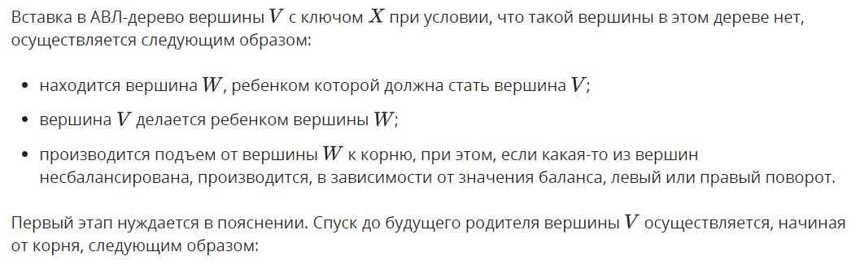
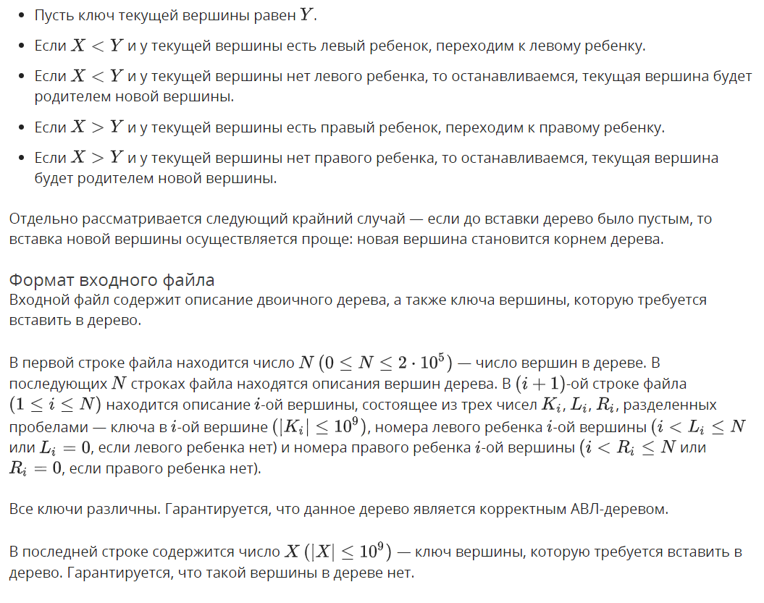
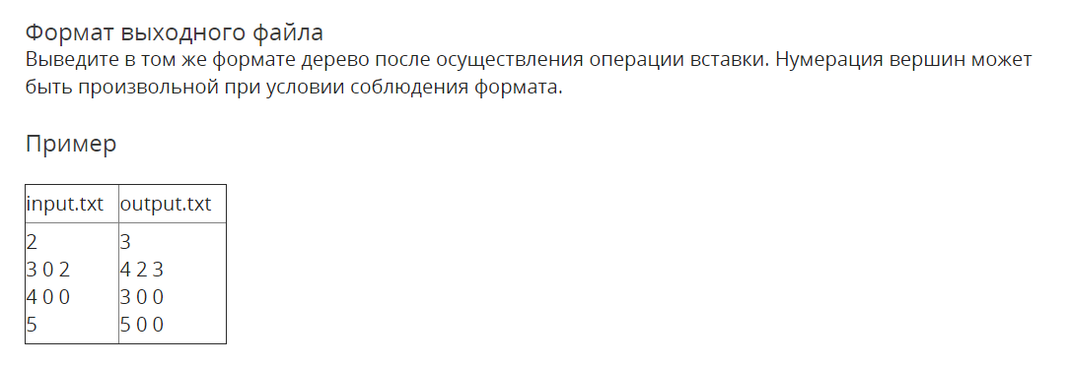

Решение

openedu/week7/lab7_3.cpp

#include "edx-io.hpp"

#include <iostream>

#include <fstream>

#include <vector>

#include <algorithm>

#include <string>

#include <list>

#include <assert.h>

#include <tuple>

using namespace std;

typedef int32_t balance_t;

struct Node {

int key;

balance_t balance = 0;

int height = 1;

Node* parent = nullptr;

Node* left = nullptr;

Node* right = nullptr;

// dirty hack

size_t latest_population_descr_index;

Node(int key) : key(key) {}

balance_t get_left_balance() { return (left) ? left->balance : -1; };

balance_t get_right_balance() { return (right) ? right->balance : -1; };

int get_left_height() { return (left) ? left->height : 0; };

int get_right_height() { return (right) ? right->height : 0; };

void replace_child(Node* from, Node* to) {

if (left == from) {

left = to;

} else {

assert(right == from);

right = to;

}

if (to) {

to->parent = this;

}

from->parent = nullptr;

}

void subtree_change_height(Node* from, int dh = 1) {

if (left == from) {

balance -= dh;

} else {

assert(right == from);

balance += dh;

}

height += dh;

}

void recalc_structure(int trust_deep = 3) {

if (trust_deep) {

if (left) left->recalc_structure(trust_deep - 1);

if (right) right->recalc_structure(trust_deep - 1);

height = max(get_right_height(), get_left_height()) + 1;

balance = get_right_height() - get_left_height();

}

}

};

struct NodeDescription {

int k;

int li = 0;

int ri = 0;

};

struct TreeDescription {

vector<NodeDescription> descriptions;

TreeDescription() {}

TreeDescription(int size) : descriptions(size) {}

NodeDescription& description_for_index(size_t index) {

return descriptions[index];

}

void populate_from_tree(Node* tree) {

// children set later

descriptions.push_back(NodeDescription{ tree->key });

// dirty hack for setting children!

size_t current_index = descriptions.size() - 1;

tree->latest_population_descr_index = current_index;

// setting children of previously added things

if (tree->parent) {

if (tree->parent->left == tree) {

descriptions[tree->parent->latest_population_descr_index].li = current_index + 1;

} else {

assert(tree->parent->right == tree);

descriptions[tree->parent->latest_population_descr_index].ri = current_index + 1;

}

}

// recursively populate from subtrees

if (tree->left) {

populate_from_tree(tree->left);

}

if (tree->right) {

populate_from_tree(tree->right);

}

}

};

Node* build_tree(TreeDescription &input, size_t root_index = 0) {

// root node description

auto& rd = input.description_for_index(root_index);

// create new node

Node* tree = new Node(rd.k);

// recursively build left and right subtrees if needed

if (rd.li) {

tree->left = build_tree(input, rd.li - 1);

tree->left->parent = tree;

}

if (rd.ri) {

tree->right = build_tree(input, rd.ri - 1);

tree->right->parent = tree;

}

// calculate height and balance

tree->height = max(tree->get_right_height(), tree->get_left_height()) + 1;

tree->balance = tree->get_right_height() - tree->get_left_height();

return tree;

}

Node*& find_node(Node*& tree, int key) {

if (tree == nullptr) {

return tree;

} else if (key == tree->key) {

return tree;

} else if (key < tree->key) {

return find_node(tree->left, key);

} else {

return find_node(tree->right, key);

}

}

void rotate_l(Node*& tree) {

// малый левый

assert(tree->right != nullptr);

Node* a = tree;

Node* b = a->right;

Node* x = a->left;

Node* y = b->left;

Node* z = b->right;

if (a->parent) {

a->parent->replace_child(a, b);

} else {

b->parent = nullptr;

}

b->left = a;

a->parent = b;

a->right = y;

if (y) {

y->parent = a;

}

tree = b;

tree->recalc_structure();

}

void rotate_r(Node*& tree) {

// малый правый

assert(tree->left != nullptr);

Node* a = tree;

Node* b = a->left;

Node* x = a->right;

Node* y = b->right;

Node* z = b->left;

if (a->parent) {

a->parent->replace_child(a, b);

} else {

b->parent = nullptr;

}

b->right = a;

a->parent = b;

a->left = y;

if (y) {

y->parent = a;

}

tree = b;

tree->recalc_structure();

}

void rotate_lr(Node*& tree) {

// большой правый

rotate_l(tree->left);

rotate_r(tree);

}

void rotate_rl(Node*& tree) {

// большой левый

rotate_r(tree->right);

rotate_l(tree);

}

void balance_tree(Node*& tree) {

if (tree->balance == 2) {

if (tree->right->balance == -1) {

rotate_rl(tree);

} else {

rotate_l(tree);

}

} else if (tree->balance == -2) {

if (tree->left->balance == 1) {

rotate_lr(tree);

} else {

rotate_r(tree);

}

}

}

bool insert_to_tree(Node*& tree, Node* node) {

if (tree == nullptr) {

tree = node;

return true;

}

bool balancing_done = false;

// digging into the tree to find a right place for a node

if (node->key == tree->key) {

// assert(false && "key already in tree");

return true;

} else if (node->key < tree->key) {

if (tree->left) {

balancing_done = insert_to_tree(tree->left, node);

} else {

tree->left = node;

node->parent = tree;

tree->subtree_change_height(node, 1);

}

} else {

if (tree->right) {

balancing_done = insert_to_tree(tree->right, node);

} else {

tree->right = node;

node->parent = tree;

tree->subtree_change_height(node, 1);

}

}

// balancing on our way back if needed

balance_tree(tree);

// recalculate balances due to height change

// if node has a parent and subtree's height was increased (balance != 0)

if (tree->parent && tree->balance != 0 && !balancing_done) {

tree->parent->subtree_change_height(tree, 1);

return false;

}

return true;

}

void delete_node_simple(Node*& tree) {

if (tree->left == nullptr && tree->right == nullptr) {

if (tree->parent) {

tree->parent->subtree_change_height(tree, -1);

// tree->parent->replace_child(tree, nullptr);

}

delete tree;

tree = nullptr;

} else if (tree->left == nullptr || tree->right == nullptr) {

Node* saved = (tree->right) ? tree->right : tree->left;

if (tree->parent) {

tree->parent->subtree_change_height(tree, -1);

// tree->parent->replace_child(tree, saved);

}

saved->parent = tree->parent;

delete tree;

tree = saved;

} else {

assert(false && "not a simple node to delete!");

}

}

bool delete_from_tree(Node*& tree, int key, Node* target = nullptr) {

if (tree == nullptr) {

return true;

}

if (!tree->parent && !tree->left && !tree->right) {

if (key == tree->key) {

delete_node_simple(tree);

return false;

} else {

// assert(false && "key not in a tree!");

return true;

}

}

bool balancing_done = false;

if (!target) {

// digging into the tree

if (key == tree->key) {

if (!tree->left && !tree->right) {

delete_node_simple(tree);

return false;

} else if (!tree->left) {

delete_node_simple(tree);

return false;

} else {

balancing_done = delete_from_tree(tree->left, key, tree);

}

} else if (key < tree->key) {

balancing_done = delete_from_tree(tree->left, key);

} else {

assert(key > tree->key);

balancing_done = delete_from_tree(tree->right, key);

}

} else {

if (tree->right) {

balancing_done = delete_from_tree(tree->right, key, target);

} else {

// found prev

target->key = tree->key;

delete_node_simple(tree);

return false;

}

}

// balancing on our way back if needed

balance_tree(tree);

// recalculate balances due to height change

// if node has a parent and subtree's height was DECREASED (balance == 0)

if (tree->parent && tree->balance == 0 && !balancing_done) {

tree->parent->subtree_change_height(tree, -1);

return false;

}

return true;

}

int main() {

int n;

io >> n;

TreeDescription input(n);

for (auto& descr : input.descriptions) {

io >> descr.k >> descr.li >> descr.ri;

}

Node* tree = nullptr;

if (n) {

tree = build_tree(input);

}

int k;

io >> k;

insert_to_tree(tree, new Node(k));

TreeDescription output;

output.populate_from_tree(tree);

io << output.descriptions.size() << "\n";

for (auto& descr : output.descriptions) {

io << descr.k << " " << descr.li << " " << descr.ri << "\n";

}

return 0;

}

Результаты
№ теста | Результат | Время, с | Память | Размер входного файла | Размер выходного файла
Max |  | 0.203 | 24645632 | 4011957 | 4011966
1 | OK | 0.015 | 2269184 | 20 | 24
2 | OK | 0.000 | 2269184 | 6 | 10
3 | OK | 0.000 | 2256896 | 14 | 18
4 | OK | 0.015 | 2260992 | 13 | 17
5 | OK | 0.000 | 2269184 | 21 | 25
6 | OK | 0.000 | 2269184 | 20 | 24
7 | OK | 0.000 | 2269184 | 20 | 24
8 | OK | 0.000 | 2269184 | 21 | 25
9 | OK | 0.015 | 2269184 | 20 | 24
10 | OK | 0.015 | 2269184 | 20 | 24
11 | OK | 0.015 | 2277376 | 28 | 32
12 | OK | 0.000 | 2269184 | 27 | 31
13 | OK | 0.015 | 2256896 | 27 | 31
14 | OK | 0.000 | 2281472 | 27 | 31
15 | OK | 0.000 | 2269184 | 35 | 39
16 | OK | 0.000 | 2269184 | 34 | 38
17 | OK | 0.000 | 2269184 | 34 | 38
18 | OK | 0.000 | 2269184 | 34 | 38
19 | OK | 0.015 | 2269184 | 34 | 38
20 | OK | 0.015 | 2281472 | 35 | 39
21 | OK | 0.000 | 2260992 | 34 | 38
22 | OK | 0.000 | 2256896 | 34 | 38
23 | OK | 0.000 | 2269184 | 34 | 38
24 | OK | 0.015 | 2269184 | 34 | 38
25 | OK | 0.000 | 2265088 | 35 | 39
26 | OK | 0.015 | 2281472 | 34 | 38
27 | OK | 0.000 | 2269184 | 34 | 38
28 | OK | 0.031 | 2277376 | 34 | 38
29 | OK | 0.015 | 2260992 | 34 | 38
30 | OK | 0.015 | 2269184 | 35 | 39
31 | OK | 0.000 | 2260992 | 34 | 38
32 | OK | 0.000 | 2256896 | 34 | 38
33 | OK | 0.000 | 2265088 | 34 | 38
34 | OK | 0.015 | 2269184 | 34 | 38
35 | OK | 0.015 | 2269184 | 42 | 46
36 | OK | 0.000 | 2269184 | 41 | 45
37 | OK | 0.000 | 2269184 | 41 | 45
38 | OK | 0.000 | 2281472 | 41 | 45
39 | OK | 0.015 | 2269184 | 41 | 45
40 | OK | 0.015 | 2269184 | 41 | 45
41 | OK | 0.000 | 2256896 | 42 | 46
42 | OK | 0.015 | 2256896 | 41 | 45
43 | OK | 0.015 | 2269184 | 41 | 45
44 | OK | 0.000 | 2269184 | 41 | 45
45 | OK | 0.000 | 2269184 | 41 | 45
46 | OK | 0.000 | 2285568 | 41 | 45
47 | OK | 0.000 | 2281472 | 42 | 46
48 | OK | 0.015 | 2269184 | 41 | 45
49 | OK | 0.000 | 2269184 | 41 | 45
50 | OK | 0.000 | 2281472 | 41 | 45
51 | OK | 0.015 | 2277376 | 41 | 45
52 | OK | 0.015 | 2256896 | 41 | 45
53 | OK | 0.000 | 2269184 | 42 | 46
54 | OK | 0.000 | 2265088 | 41 | 45
55 | OK | 0.000 | 2269184 | 41 | 45
56 | OK | 0.000 | 2269184 | 41 | 45
57 | OK | 0.000 | 2281472 | 41 | 45
58 | OK | 0.000 | 2281472 | 41 | 45
59 | OK | 0.000 | 2269184 | 42 | 46
60 | OK | 0.000 | 2281472 | 41 | 45
61 | OK | 0.000 | 2260992 | 41 | 45
62 | OK | 0.015 | 2269184 | 41 | 45
63 | OK | 0.015 | 2269184 | 41 | 45
64 | OK | 0.000 | 2269184 | 41 | 45
65 | OK | 0.015 | 2281472 | 42 | 46
66 | OK | 0.000 | 2269184 | 41 | 45
67 | OK | 0.000 | 2281472 | 41 | 45
68 | OK | 0.000 | 2269184 | 41 | 45
69 | OK | 0.000 | 2269184 | 41 | 45
70 | OK | 0.015 | 2281472 | 41 | 45
71 | OK | 0.000 | 2256896 | 50 | 54
72 | OK | 0.000 | 2269184 | 49 | 53
73 | OK | 0.000 | 2281472 | 49 | 53
74 | OK | 0.000 | 2252800 | 49 | 53
75 | OK | 0.000 | 2285568 | 49 | 53
76 | OK | 0.000 | 2265088 | 49 | 53
77 | OK | 0.000 | 2265088 | 50 | 54
78 | OK | 0.015 | 2277376 | 50 | 54
79 | OK | 0.000 | 2281472 | 49 | 53
80 | OK | 0.000 | 2269184 | 49 | 53
81 | OK | 0.000 | 2273280 | 49 | 53
82 | OK | 0.000 | 2269184 | 49 | 53
83 | OK | 0.000 | 2281472 | 49 | 53
84 | OK | 0.000 | 2252800 | 50 | 54
85 | OK | 0.015 | 2269184 | 50 | 54
86 | OK | 0.000 | 2269184 | 49 | 53
87 | OK | 0.000 | 2269184 | 49 | 53
88 | OK | 0.000 | 2265088 | 49 | 53
89 | OK | 0.000 | 2269184 | 49 | 53
90 | OK | 0.000 | 2269184 | 49 | 53
91 | OK | 0.000 | 2269184 | 50 | 54
92 | OK | 0.000 | 2256896 | 50 | 54
93 | OK | 0.015 | 2269184 | 49 | 53
94 | OK | 0.000 | 2252800 | 49 | 53
95 | OK | 0.000 | 2269184 | 49 | 53
96 | OK | 0.000 | 2281472 | 49 | 53
97 | OK | 0.000 | 2281472 | 49 | 53
98 | OK | 0.000 | 2269184 | 50 | 54
99 | OK | 0.015 | 2281472 | 58 | 62
100 | OK | 0.000 | 2269184 | 57 | 61
101 | OK | 0.015 | 2269184 | 57 | 61
102 | OK | 0.000 | 2260992 | 57 | 61
103 | OK | 0.000 | 2269184 | 57 | 61
104 | OK | 0.015 | 2256896 | 57 | 61
105 | OK | 0.015 | 2265088 | 58 | 62
106 | OK | 0.015 | 2281472 | 58 | 62
107 | OK | 0.015 | 2281472 | 58 | 62
108 | OK | 0.000 | 2265088 | 57 | 61
109 | OK | 0.000 | 2269184 | 57 | 61
110 | OK | 0.015 | 2277376 | 57 | 61
111 | OK | 0.000 | 2281472 | 57 | 61
112 | OK | 0.015 | 2265088 | 57 | 61
113 | OK | 0.000 | 2273280 | 58 | 62
114 | OK | 0.000 | 2269184 | 58 | 62
115 | OK | 0.000 | 2256896 | 58 | 62
116 | OK | 0.015 | 2281472 | 57 | 61
117 | OK | 0.000 | 2269184 | 57 | 61
118 | OK | 0.015 | 2269184 | 57 | 61
119 | OK | 0.015 | 2269184 | 57 | 61
120 | OK | 0.000 | 2277376 | 57 | 61
121 | OK | 0.000 | 2281472 | 58 | 62
122 | OK | 0.015 | 2265088 | 58 | 62
123 | OK | 0.000 | 2269184 | 58 | 62
124 | OK | 0.000 | 2256896 | 57 | 61
125 | OK | 0.000 | 2273280 | 57 | 61
126 | OK | 0.031 | 2269184 | 57 | 61
127 | OK | 0.031 | 2269184 | 57 | 61
128 | OK | 0.015 | 2265088 | 57 | 61
129 | OK | 0.000 | 2281472 | 58 | 62
130 | OK | 0.000 | 2269184 | 58 | 62
131 | OK | 0.000 | 2269184 | 58 | 62
132 | OK | 0.031 | 2269184 | 57 | 61
133 | OK | 0.000 | 2256896 | 57 | 61
134 | OK | 0.015 | 2260992 | 57 | 61
135 | OK | 0.015 | 2269184 | 57 | 61
136 | OK | 0.000 | 2265088 | 57 | 61
137 | OK | 0.000 | 2269184 | 58 | 62
138 | OK | 0.015 | 2281472 | 58 | 62
139 | OK | 0.000 | 2281472 | 58 | 62
140 | OK | 0.015 | 2281472 | 57 | 61
141 | OK | 0.015 | 2281472 | 57 | 61
142 | OK | 0.000 | 2269184 | 57 | 61
143 | OK | 0.000 | 2252800 | 57 | 61
144 | OK | 0.000 | 2273280 | 57 | 61
145 | OK | 0.000 | 2269184 | 58 | 62
146 | OK | 0.000 | 2269184 | 58 | 62
147 | OK | 0.000 | 2281472 | 58 | 62
148 | OK | 0.015 | 2265088 | 57 | 61
149 | OK | 0.000 | 2281472 | 57 | 61
150 | OK | 0.000 | 2269184 | 57 | 61
151 | OK | 0.000 | 2265088 | 57 | 61
152 | OK | 0.000 | 2285568 | 57 | 61
153 | OK | 0.015 | 2260992 | 58 | 62
154 | OK | 0.000 | 2256896 | 58 | 62
155 | OK | 0.000 | 2269184 | 58 | 62
156 | OK | 0.000 | 2277376 | 57 | 61
157 | OK | 0.000 | 2269184 | 57 | 61
158 | OK | 0.000 | 2265088 | 57 | 61
159 | OK | 0.000 | 2269184 | 57 | 61
160 | OK | 0.000 | 2269184 | 57 | 61
161 | OK | 0.000 | 2269184 | 58 | 62
162 | OK | 0.015 | 2265088 | 58 | 62
163 | OK | 0.000 | 2273280 | 58 | 62
164 | OK | 0.000 | 2252800 | 57 | 61
165 | OK | 0.015 | 2269184 | 57 | 61
166 | OK | 0.000 | 2269184 | 57 | 61
167 | OK | 0.000 | 2269184 | 57 | 61
168 | OK | 0.000 | 2269184 | 57 | 61
169 | OK | 0.015 | 2269184 | 58 | 62
170 | OK | 0.000 | 2281472 | 58 | 62
171 | OK | 0.000 | 2281472 | 58 | 62
172 | OK | 0.000 | 2269184 | 57 | 61
173 | OK | 0.015 | 2260992 | 57 | 61
174 | OK | 0.000 | 2256896 | 57 | 61
175 | OK | 0.000 | 2281472 | 57 | 61
176 | OK | 0.000 | 2281472 | 57 | 61
177 | OK | 0.015 | 2269184 | 58 | 62
178 | OK | 0.000 | 2277376 | 58 | 62
179 | OK | 0.000 | 2281472 | 58 | 62
180 | OK | 0.000 | 2269184 | 57 | 61
181 | OK | 0.015 | 2269184 | 57 | 61
182 | OK | 0.015 | 2269184 | 57 | 61
183 | OK | 0.015 | 2269184 | 57 | 61
184 | OK | 0.015 | 2256896 | 57 | 61
185 | OK | 0.015 | 2281472 | 58 | 62
186 | OK | 0.000 | 2269184 | 58 | 62
187 | OK | 0.000 | 2269184 | 58 | 62
188 | OK | 0.015 | 2265088 | 57 | 61
189 | OK | 0.000 | 2281472 | 57 | 61
190 | OK | 0.015 | 2269184 | 57 | 61
191 | OK | 0.000 | 2265088 | 57 | 61
192 | OK | 0.015 | 2281472 | 57 | 61
193 | OK | 0.015 | 2256896 | 58 | 62
194 | OK | 0.000 | 2273280 | 58 | 62
195 | OK | 0.000 | 2265088 | 58 | 62
196 | OK | 0.000 | 2269184 | 57 | 61
197 | OK | 0.000 | 2265088 | 57 | 61
198 | OK | 0.015 | 2281472 | 57 | 61
199 | OK | 0.000 | 2281472 | 57 | 61
200 | OK | 0.000 | 2281472 | 57 | 61
201 | OK | 0.015 | 2269184 | 58 | 62
202 | OK | 0.000 | 2265088 | 58 | 62
203 | OK | 0.015 | 2277376 | 58 | 62
204 | OK | 0.000 | 2256896 | 57 | 61
205 | OK | 0.015 | 2277376 | 57 | 61
206 | OK | 0.000 | 2269184 | 57 | 61
207 | OK | 0.015 | 2281472 | 57 | 61
208 | OK | 0.015 | 2269184 | 57 | 61
209 | OK | 0.015 | 2269184 | 58 | 62
210 | OK | 0.000 | 2269184 | 58 | 62
211 | OK | 0.000 | 2281472 | 58 | 62
212 | OK | 0.015 | 2269184 | 57 | 61
213 | OK | 0.015 | 2273280 | 57 | 61
214 | OK | 0.000 | 2256896 | 57 | 61
215 | OK | 0.000 | 2269184 | 57 | 61
216 | OK | 0.015 | 2281472 | 57 | 61
217 | OK | 0.000 | 2269184 | 58 | 62
218 | OK | 0.015 | 2269184 | 58 | 62
219 | OK | 0.000 | 2269184 | 58 | 62
220 | OK | 0.015 | 2265088 | 57 | 61
221 | OK | 0.000 | 2269184 | 57 | 61
222 | OK | 0.000 | 2269184 | 57 | 61
223 | OK | 0.000 | 2269184 | 57 | 61
224 | OK | 0.000 | 2269184 | 57 | 61
225 | OK | 0.000 | 2269184 | 58 | 62
226 | OK | 0.000 | 2265088 | 58 | 62
227 | OK | 0.000 | 2269184 | 58 | 62
228 | OK | 0.000 | 2281472 | 57 | 61
229 | OK | 0.000 | 2281472 | 57 | 61
230 | OK | 0.000 | 2281472 | 57 | 61
231 | OK | 0.000 | 2269184 | 57 | 61
232 | OK | 0.000 | 2269184 | 57 | 61
233 | OK | 0.000 | 2260992 | 58 | 62
234 | OK | 0.000 | 2252800 | 58 | 62
235 | OK | 0.000 | 2265088 | 240 | 245
236 | OK | 0.000 | 2277376 | 243 | 248
237 | OK | 0.015 | 2285568 | 1835 | 1841
238 | OK | 0.000 | 2285568 | 1815 | 1821
239 | OK | 0.015 | 2285568 | 1834 | 1840
240 | OK | 0.015 | 2334720 | 9951 | 9957
241 | OK | 0.015 | 2338816 | 9831 | 9837
242 | OK | 0.000 | 2330624 | 9854 | 9860
243 | OK | 0.015 | 2441216 | 38301 | 38308
244 | OK | 0.000 | 2433024 | 37664 | 37671
245 | OK | 0.000 | 2449408 | 39108 | 39115
246 | OK | 0.000 | 2449408 | 39190 | 39197
247 | OK | 0.015 | 3100672 | 183695 | 183703
248 | OK | 0.015 | 3100672 | 184258 | 184266
249 | OK | 0.015 | 3104768 | 185065 | 185073
250 | OK | 0.031 | 3104768 | 185428 | 185436
251 | OK | 0.031 | 3104768 | 185741 | 185749
252 | OK | 0.093 | 13754368 | 1900094 | 1900102
253 | OK | 0.093 | 13709312 | 1860225 | 1860233
254 | OK | 0.093 | 13746176 | 1899455 | 1899463
255 | OK | 0.078 | 13717504 | 1861088 | 1861096
256 | OK | 0.093 | 13795328 | 1942127 | 1942135
257 | OK | 0.093 | 13783040 | 1930200 | 1930208
258 | OK | 0.125 | 13717504 | 1861244 | 1861252
259 | OK | 0.171 | 22417408 | 3510448 | 3510457
260 | OK | 0.171 | 22556672 | 3650901 | 3650910
261 | OK | 0.171 | 22458368 | 3552374 | 3552383
262 | OK | 0.156 | 22335488 | 3435983 | 3435992
263 | OK | 0.171 | 22466560 | 3562689 | 3562698
264 | OK | 0.156 | 22417408 | 3521159 | 3521168
265 | OK | 0.171 | 22433792 | 3539149 | 3539158
266 | OK | 0.187 | 24621056 | 3985264 | 3985273
267 | OK | 0.187 | 24506368 | 3866892 | 3866901
268 | OK | 0.187 | 24580096 | 3942753 | 3942762
269 | OK | 0.187 | 24461312 | 3824263 | 3824272
270 | OK | 0.187 | 24645632 | 4011957 | 4011966
271 | OK | 0.187 | 24592384 | 3955420 | 3955429
272 | OK | 0.187 | 24584192 | 3946583 | 3946592
273 | OK | 0.203 | 24539136 | 3891536 | 3891545

Удаление из АВЛ-дерева

Условие
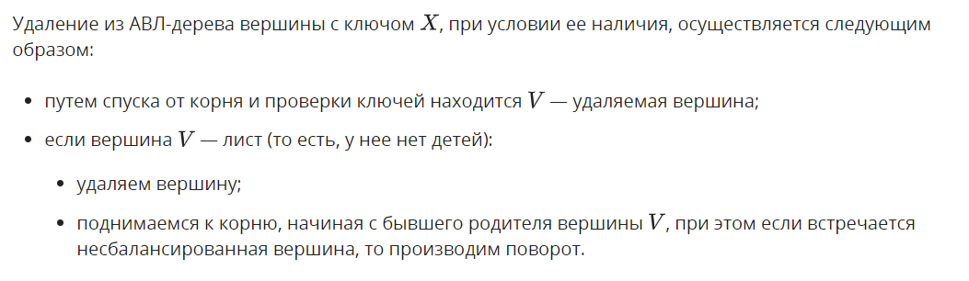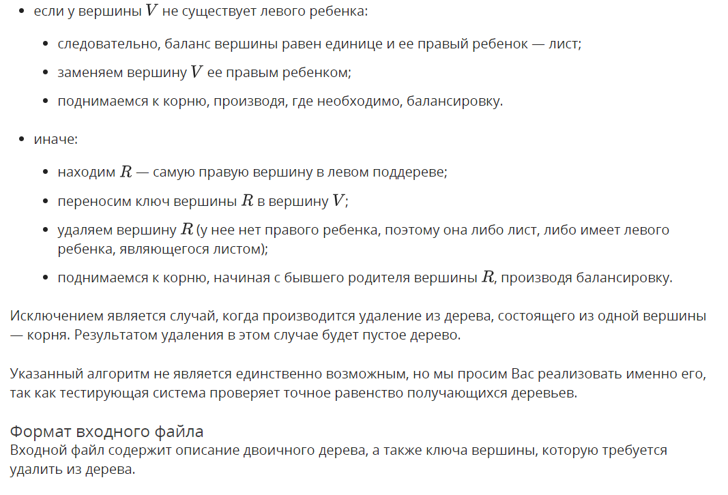
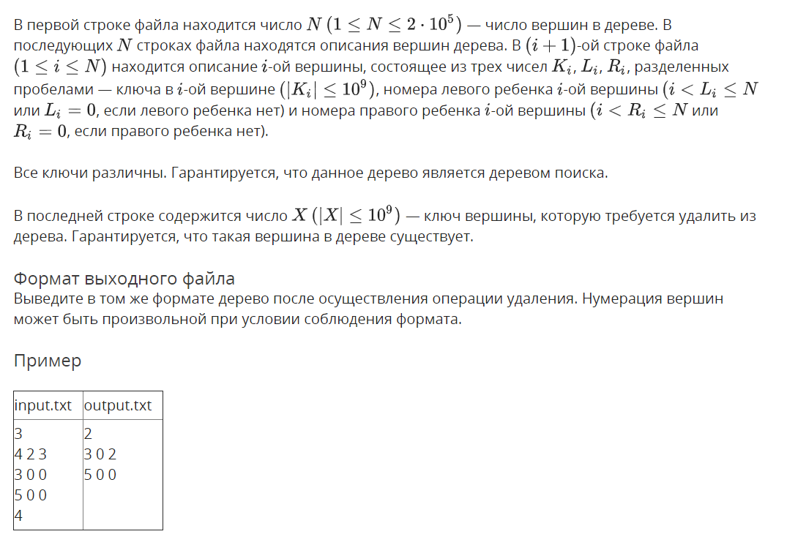

Решение

openedu/week7/lab7_4.cpp

#include "edx-io.hpp"

#include <iostream>

#include <fstream>

#include <vector>

#include <algorithm>

#include <string>

#include <list>

#include <assert.h>

#include <tuple>

using namespace std;

typedef int32_t balance_t;

struct Node {

int key;

balance_t balance = 0;

int height = 1;

Node* parent = nullptr;

Node* left = nullptr;

Node* right = nullptr;

// dirty hack

size_t latest_population_descr_index;

Node(int key) : key(key) {}

balance_t get_left_balance() { return (left) ? left->balance : -1; };

balance_t get_right_balance() { return (right) ? right->balance : -1; };

int get_left_height() { return (left) ? left->height : 0; };

int get_right_height() { return (right) ? right->height : 0; };

void replace_child(Node* from, Node* to) {

if (left == from) {

left = to;

} else {

assert(right == from);

right = to;

}

if (to) {

to->parent = this;

}

from->parent = nullptr;

}

void subtree_change_height(Node* from, int dh = 1) {

if (left == from) {

balance -= dh;

} else {

assert(right == from);

balance += dh;

}

height += dh;

}

void recalc_structure(int trust_deep = 3) {

if (trust_deep) {

if (left) left->recalc_structure(trust_deep - 1);

if (right) right->recalc_structure(trust_deep - 1);

height = max(get_right_height(), get_left_height()) + 1;

balance = get_right_height() - get_left_height();

}

}

};

struct NodeDescription {

int k;

int li = 0;

int ri = 0;

};

struct TreeDescription {

vector<NodeDescription> descriptions;

TreeDescription() {}

TreeDescription(int size) : descriptions(size) {}

NodeDescription& description_for_index(size_t index) {

return descriptions[index];

}

void populate_from_tree(Node* tree) {

// children set later

descriptions.push_back(NodeDescription{ tree->key });

// dirty hack for setting children!

size_t current_index = descriptions.size() - 1;

tree->latest_population_descr_index = current_index;

// setting children of previously added things

if (tree->parent) {

if (tree->parent->left == tree) {

descriptions[tree->parent->latest_population_descr_index].li = current_index + 1;

} else {

assert(tree->parent->right == tree);

descriptions[tree->parent->latest_population_descr_index].ri = current_index + 1;

}

}

// recursively populate from subtrees

if (tree->left) {

populate_from_tree(tree->left);

}

if (tree->right) {

populate_from_tree(tree->right);

}

}

};

Node* build_tree(TreeDescription &input, size_t root_index = 0) {

// root node description

auto& rd = input.description_for_index(root_index);

// create new node

Node* tree = new Node(rd.k);

// recursively build left and right subtrees if needed

if (rd.li) {

tree->left = build_tree(input, rd.li - 1);

tree->left->parent = tree;

}

if (rd.ri) {

tree->right = build_tree(input, rd.ri - 1);

tree->right->parent = tree;

}

// calculate height and balance

tree->height = max(tree->get_right_height(), tree->get_left_height()) + 1;

tree->balance = tree->get_right_height() - tree->get_left_height();

return tree;

}

Node*& find_node(Node*& tree, int key) {

if (tree == nullptr) {

return tree;

} else if (key == tree->key) {

return tree;

} else if (key < tree->key) {

return find_node(tree->left, key);

} else {

return find_node(tree->right, key);

}

}

void rotate_l(Node*& tree) {

// малый левый

assert(tree->right != nullptr);

Node* a = tree;

Node* b = a->right;

Node* x = a->left;

Node* y = b->left;

Node* z = b->right;

if (a->parent) {

a->parent->replace_child(a, b);

} else {

b->parent = nullptr;

}

b->left = a;

a->parent = b;

a->right = y;

if (y) {

y->parent = a;

}

tree = b;

tree->recalc_structure();

}

void rotate_r(Node*& tree) {

// малый правый

assert(tree->left != nullptr);

Node* a = tree;

Node* b = a->left;

Node* x = a->right;

Node* y = b->right;

Node* z = b->left;

if (a->parent) {

a->parent->replace_child(a, b);

} else {

b->parent = nullptr;

}

b->right = a;

a->parent = b;

a->left = y;

if (y) {

y->parent = a;

}

tree = b;

tree->recalc_structure();

}

void rotate_lr(Node*& tree) {

// большой правый

rotate_l(tree->left);

rotate_r(tree);

}

void rotate_rl(Node*& tree) {

// большой левый

rotate_r(tree->right);

rotate_l(tree);

}

void balance_tree(Node*& tree) {

if (tree->balance == 2) {

if (tree->right->balance == -1) {

rotate_rl(tree);

} else {

rotate_l(tree);

}

} else if (tree->balance == -2) {

if (tree->left->balance == 1) {

rotate_lr(tree);

} else {

rotate_r(tree);

}

}

}

bool insert_to_tree(Node*& tree, Node* node) {

if (tree == nullptr) {

tree = node;

return true;

}

bool balancing_done = false;

// digging into the tree to find a right place for a node

if (node->key == tree->key) {

// assert(false && "key already in tree");

return true;

} else if (node->key < tree->key) {

if (tree->left) {

balancing_done = insert_to_tree(tree->left, node);

} else {

tree->left = node;

node->parent = tree;

tree->subtree_change_height(node, 1);

}

} else {

if (tree->right) {

balancing_done = insert_to_tree(tree->right, node);

} else {

tree->right = node;

node->parent = tree;

tree->subtree_change_height(node, 1);

}

}

// balancing on our way back if needed

balance_tree(tree);

// recalculate balances due to height change

// if node has a parent and subtree's height was increased (balance != 0)

if (tree->parent && tree->balance != 0 && !balancing_done) {

tree->parent->subtree_change_height(tree, 1);

return false;

}

return true;

}

void delete_node_simple(Node*& tree) {

if (tree->left == nullptr && tree->right == nullptr) {

if (tree->parent) {

tree->parent->subtree_change_height(tree, -1);

// tree->parent->replace_child(tree, nullptr);

}

delete tree;

tree = nullptr;

} else if (tree->left == nullptr || tree->right == nullptr) {

Node* saved = (tree->right) ? tree->right : tree->left;

if (tree->parent) {

tree->parent->subtree_change_height(tree, -1);

// tree->parent->replace_child(tree, saved);

}

saved->parent = tree->parent;

delete tree;

tree = saved;

} else {

assert(false && "not a simple node to delete!");

}

}

bool delete_from_tree(Node*& tree, int key, Node* target = nullptr) {

if (tree == nullptr) {

return true;

}

if (!tree->parent && !tree->left && !tree->right) {

if (key == tree->key) {

delete_node_simple(tree);

return false;

} else {

// assert(false && "key not in a tree!");

return true;

}

}

bool balancing_done = false;

if (!target) {

// digging into the tree

if (key == tree->key) {

if (!tree->left && !tree->right) {

delete_node_simple(tree);

return false;

} else if (!tree->left) {

delete_node_simple(tree);

return false;

} else {

balancing_done = delete_from_tree(tree->left, key, tree);

}

} else if (key < tree->key) {

balancing_done = delete_from_tree(tree->left, key);

} else {

assert(key > tree->key);

balancing_done = delete_from_tree(tree->right, key);

}

} else {

if (tree->right) {

balancing_done = delete_from_tree(tree->right, key, target);

} else {

// found prev

target->key = tree->key;

delete_node_simple(tree);

return false;

}

}

// balancing on our way back if needed

balance_tree(tree);

// recalculate balances due to height change

// if node has a parent and subtree's height was DECREASED (balance == 0)

if (tree->parent && tree->balance == 0 && !balancing_done) {

tree->parent->subtree_change_height(tree, -1);

return false;

}

return true;

}

int main() {

int n;

io >> n;

TreeDescription input(n);

for (auto& descr : input.descriptions) {

io >> descr.k >> descr.li >> descr.ri;

}

Node* tree = nullptr;

if (n) {

tree = build_tree(input);

}

int k;

io >> k;

delete_from_tree(tree, k);

if (tree == nullptr) {

io << "0";

return 0;

}

TreeDescription output;

output.populate_from_tree(tree);

io << output.descriptions.size() << "\n";

for (auto& descr : output.descriptions) {

io << descr.k << " " << descr.li << " " << descr.ri << "\n";

}

return 0;

}

Результаты
№ теста | Результат | Время, с | Память | Размер входного файла | Размер выходного файла
Max |  | 0.218 | 24723456 | 4077288 | 4077255
1 | OK | 0.000 | 2277376 | 27 | 17
2 | OK | 0.015 | 2269184 | 13 | 1
3 | OK | 0.000 | 2256896 | 20 | 10
4 | OK | 0.015 | 2269184 | 20 | 10
5 | OK | 0.015 | 2281472 | 20 | 10
6 | OK | 0.000 | 2269184 | 20 | 10
7 | OK | 0.015 | 2269184 | 27 | 17
8 | OK | 0.000 | 2269184 | 27 | 17
9 | OK | 0.000 | 2277376 | 27 | 17
10 | OK | 0.015 | 2260992 | 34 | 24
11 | OK | 0.015 | 2265088 | 34 | 24
12 | OK | 0.000 | 2269184 | 34 | 24
13 | OK | 0.000 | 2265088 | 34 | 24
14 | OK | 0.015 | 2269184 | 34 | 24
15 | OK | 0.000 | 2269184 | 34 | 24
16 | OK | 0.000 | 2269184 | 34 | 24
17 | OK | 0.000 | 2269184 | 34 | 24
18 | OK | 0.015 | 2285568 | 34 | 24
19 | OK | 0.000 | 2281472 | 34 | 24
20 | OK | 0.000 | 2260992 | 34 | 24
21 | OK | 0.000 | 2269184 | 34 | 24
22 | OK | 0.000 | 2252800 | 34 | 24
23 | OK | 0.000 | 2265088 | 34 | 24
24 | OK | 0.000 | 2269184 | 34 | 24
25 | OK | 0.015 | 2269184 | 34 | 24
26 | OK | 0.000 | 2269184 | 41 | 31
27 | OK | 0.000 | 2265088 | 41 | 31
28 | OK | 0.015 | 2269184 | 41 | 31
29 | OK | 0.000 | 2273280 | 41 | 31
30 | OK | 0.000 | 2269184 | 41 | 31
31 | OK | 0.000 | 2281472 | 41 | 31
32 | OK | 0.000 | 2256896 | 41 | 31
33 | OK | 0.000 | 2281472 | 41 | 31
34 | OK | 0.015 | 2260992 | 41 | 31
35 | OK | 0.000 | 2265088 | 41 | 31
36 | OK | 0.000 | 2269184 | 41 | 31
37 | OK | 0.015 | 2265088 | 41 | 31
38 | OK | 0.015 | 2260992 | 41 | 31
39 | OK | 0.000 | 2269184 | 41 | 31
40 | OK | 0.000 | 2281472 | 41 | 31
41 | OK | 0.000 | 2256896 | 41 | 31
42 | OK | 0.000 | 2269184 | 41 | 31
43 | OK | 0.000 | 2269184 | 41 | 31
44 | OK | 0.015 | 2269184 | 41 | 31
45 | OK | 0.000 | 2285568 | 41 | 31
46 | OK | 0.000 | 2269184 | 41 | 31
47 | OK | 0.000 | 2269184 | 41 | 31
48 | OK | 0.000 | 2260992 | 41 | 31
49 | OK | 0.000 | 2265088 | 41 | 31
50 | OK | 0.015 | 2269184 | 41 | 31
51 | OK | 0.000 | 2252800 | 41 | 31
52 | OK | 0.015 | 2265088 | 41 | 31
53 | OK | 0.000 | 2269184 | 41 | 31
54 | OK | 0.031 | 2281472 | 41 | 31
55 | OK | 0.031 | 2269184 | 41 | 31
56 | OK | 0.000 | 2265088 | 48 | 38
57 | OK | 0.000 | 2269184 | 48 | 38
58 | OK | 0.000 | 2269184 | 48 | 38
59 | OK | 0.000 | 2269184 | 48 | 38
60 | OK | 0.015 | 2269184 | 48 | 38
61 | OK | 0.000 | 2256896 | 48 | 38
62 | OK | 0.000 | 2281472 | 48 | 38
63 | OK | 0.000 | 2281472 | 48 | 38
64 | OK | 0.015 | 2269184 | 48 | 38
65 | OK | 0.000 | 2269184 | 48 | 38
66 | OK | 0.000 | 2269184 | 48 | 38
67 | OK | 0.015 | 2281472 | 48 | 38
68 | OK | 0.000 | 2260992 | 48 | 38
69 | OK | 0.015 | 2269184 | 48 | 38
70 | OK | 0.000 | 2265088 | 48 | 38
71 | OK | 0.015 | 2252800 | 48 | 38
72 | OK | 0.015 | 2281472 | 48 | 38
73 | OK | 0.000 | 2281472 | 48 | 38
74 | OK | 0.000 | 2269184 | 48 | 38
75 | OK | 0.000 | 2269184 | 48 | 38
76 | OK | 0.000 | 2269184 | 48 | 38
77 | OK | 0.015 | 2269184 | 48 | 38
78 | OK | 0.000 | 2260992 | 48 | 38
79 | OK | 0.000 | 2269184 | 48 | 38
80 | OK | 0.000 | 2269184 | 55 | 45
81 | OK | 0.031 | 2269184 | 55 | 45
82 | OK | 0.015 | 2269184 | 55 | 45
83 | OK | 0.000 | 2265088 | 55 | 45
84 | OK | 0.000 | 2269184 | 55 | 45
85 | OK | 0.000 | 2269184 | 55 | 45
86 | OK | 0.015 | 2265088 | 55 | 45
87 | OK | 0.015 | 2281472 | 55 | 45
88 | OK | 0.015 | 2260992 | 55 | 45
89 | OK | 0.000 | 2269184 | 55 | 45
90 | OK | 0.000 | 2277376 | 55 | 45
91 | OK | 0.031 | 2256896 | 55 | 45
92 | OK | 0.015 | 2277376 | 55 | 45
93 | OK | 0.000 | 2265088 | 55 | 45
94 | OK | 0.015 | 2281472 | 55 | 45
95 | OK | 0.000 | 2281472 | 55 | 45
96 | OK | 0.000 | 2269184 | 55 | 45
97 | OK | 0.000 | 2269184 | 55 | 45
98 | OK | 0.015 | 2273280 | 55 | 45
99 | OK | 0.015 | 2269184 | 55 | 45
100 | OK | 0.015 | 2265088 | 55 | 45
101 | OK | 0.000 | 2256896 | 55 | 45
102 | OK | 0.000 | 2269184 | 55 | 45
103 | OK | 0.000 | 2281472 | 55 | 45
104 | OK | 0.000 | 2269184 | 55 | 45
105 | OK | 0.000 | 2281472 | 55 | 45
106 | OK | 0.000 | 2281472 | 55 | 45
107 | OK | 0.000 | 2281472 | 55 | 45
108 | OK | 0.000 | 2273280 | 55 | 45
109 | OK | 0.000 | 2265088 | 55 | 45
110 | OK | 0.000 | 2269184 | 55 | 45
111 | OK | 0.015 | 2269184 | 55 | 45
112 | OK | 0.000 | 2269184 | 55 | 45
113 | OK | 0.000 | 2265088 | 55 | 45
114 | OK | 0.000 | 2265088 | 55 | 45
115 | OK | 0.015 | 2281472 | 55 | 45
116 | OK | 0.000 | 2265088 | 55 | 45
117 | OK | 0.015 | 2269184 | 55 | 45
118 | OK | 0.015 | 2273280 | 55 | 45
119 | OK | 0.015 | 2265088 | 55 | 45
120 | OK | 0.015 | 2269184 | 55 | 45
121 | OK | 0.000 | 2269184 | 55 | 45
122 | OK | 0.000 | 2269184 | 55 | 45
123 | OK | 0.015 | 2269184 | 55 | 45
124 | OK | 0.000 | 2269184 | 55 | 45
125 | OK | 0.000 | 2269184 | 55 | 45
126 | OK | 0.015 | 2269184 | 55 | 45
127 | OK | 0.000 | 2269184 | 55 | 45
128 | OK | 0.000 | 2273280 | 55 | 45
129 | OK | 0.015 | 2265088 | 55 | 45
130 | OK | 0.000 | 2252800 | 55 | 45
131 | OK | 0.000 | 2269184 | 55 | 45
132 | OK | 0.000 | 2269184 | 55 | 45
133 | OK | 0.015 | 2281472 | 55 | 45
134 | OK | 0.015 | 2269184 | 55 | 45
135 | OK | 0.000 | 2269184 | 55 | 45
136 | OK | 0.000 | 2285568 | 55 | 45
137 | OK | 0.000 | 2265088 | 55 | 45
138 | OK | 0.015 | 2260992 | 55 | 45
139 | OK | 0.000 | 2269184 | 55 | 45
140 | OK | 0.000 | 2256896 | 55 | 45
141 | OK | 0.000 | 2281472 | 55 | 45
142 | OK | 0.015 | 2281472 | 55 | 45
143 | OK | 0.000 | 2281472 | 55 | 45
144 | OK | 0.015 | 2265088 | 55 | 45
145 | OK | 0.000 | 2265088 | 55 | 45
146 | OK | 0.000 | 2269184 | 55 | 45
147 | OK | 0.000 | 2269184 | 55 | 45
148 | OK | 0.000 | 2260992 | 55 | 45
149 | OK | 0.000 | 2269184 | 55 | 45
150 | OK | 0.015 | 2273280 | 55 | 45
151 | OK | 0.000 | 2269184 | 55 | 45
152 | OK | 0.000 | 2269184 | 55 | 45
153 | OK | 0.000 | 2269184 | 55 | 45
154 | OK | 0.015 | 2269184 | 55 | 45
155 | OK | 0.000 | 2269184 | 55 | 45
156 | OK | 0.000 | 2265088 | 55 | 45
157 | OK | 0.000 | 2285568 | 55 | 45
158 | OK | 0.000 | 2256896 | 55 | 45
159 | OK | 0.000 | 2269184 | 55 | 45
160 | OK | 0.000 | 2269184 | 55 | 45
161 | OK | 0.000 | 2281472 | 55 | 45
162 | OK | 0.000 | 2269184 | 55 | 45
163 | OK | 0.015 | 2265088 | 55 | 45
164 | OK | 0.000 | 2269184 | 55 | 45
165 | OK | 0.000 | 2265088 | 55 | 45
166 | OK | 0.015 | 2269184 | 55 | 45
167 | OK | 0.000 | 2269184 | 55 | 45
168 | OK | 0.000 | 2260992 | 55 | 45
169 | OK | 0.015 | 2269184 | 55 | 45
170 | OK | 0.000 | 2252800 | 55 | 45
171 | OK | 0.015 | 2269184 | 55 | 45
172 | OK | 0.000 | 2269184 | 55 | 45
173 | OK | 0.000 | 2269184 | 55 | 45
174 | OK | 0.000 | 2269184 | 55 | 45
175 | OK | 0.000 | 2269184 | 55 | 45
176 | OK | 0.000 | 2269184 | 55 | 45
177 | OK | 0.000 | 2269184 | 55 | 45
178 | OK | 0.000 | 2277376 | 55 | 45
179 | OK | 0.000 | 2269184 | 55 | 45
180 | OK | 0.000 | 2256896 | 55 | 45
181 | OK | 0.000 | 2269184 | 55 | 45
182 | OK | 0.000 | 2281472 | 55 | 45
183 | OK | 0.000 | 2269184 | 55 | 45
184 | OK | 0.000 | 2260992 | 55 | 45
185 | OK | 0.000 | 2269184 | 55 | 45
186 | OK | 0.000 | 2281472 | 55 | 45
187 | OK | 0.000 | 2269184 | 55 | 45
188 | OK | 0.000 | 2273280 | 55 | 45
189 | OK | 0.000 | 2277376 | 55 | 45
190 | OK | 0.000 | 2269184 | 55 | 45
191 | OK | 0.000 | 2265088 | 55 | 45
192 | OK | 0.000 | 2281472 | 55 | 45
193 | OK | 0.000 | 2269184 | 55 | 45
194 | OK | 0.015 | 2269184 | 55 | 45
195 | OK | 0.000 | 2277376 | 55 | 45
196 | OK | 0.000 | 2269184 | 55 | 45
197 | OK | 0.000 | 2269184 | 55 | 45
198 | OK | 0.000 | 2260992 | 55 | 45
199 | OK | 0.015 | 2273280 | 239 | 210
200 | OK | 0.000 | 2277376 | 235 | 208
201 | OK | 0.015 | 2301952 | 1797 | 1769
202 | OK | 0.000 | 2285568 | 1809 | 1781
203 | OK | 0.015 | 2285568 | 1831 | 1803
204 | OK | 0.015 | 2338816 | 9625 | 9597
205 | OK | 0.000 | 2342912 | 10026 | 9996
206 | OK | 0.000 | 2355200 | 9672 | 9642
207 | OK | 0.000 | 2453504 | 39459 | 39428
208 | OK | 0.015 | 2441216 | 39672 | 39641
209 | OK | 0.000 | 2465792 | 38780 | 38749
210 | OK | 0.000 | 2441216 | 38392 | 38361
211 | OK | 0.000 | 3104768 | 179425 | 179394
212 | OK | 0.015 | 3108864 | 182878 | 182845
213 | OK | 0.015 | 3125248 | 185986 | 185953
214 | OK | 0.000 | 3112960 | 186275 | 186244
215 | OK | 0.015 | 3104768 | 179082 | 179051
216 | OK | 0.078 | 13774848 | 1912349 | 1912319
217 | OK | 0.093 | 13729792 | 1864033 | 1864003
218 | OK | 0.093 | 13770752 | 1913940 | 1913908
219 | OK | 0.078 | 13742080 | 1879988 | 1879958
220 | OK | 0.093 | 13742080 | 1887512 | 1887482
221 | OK | 0.093 | 13795328 | 1932558 | 1932526
222 | OK | 0.078 | 13737984 | 1875036 | 1875006
223 | OK | 0.203 | 22511616 | 3597394 | 3597361
224 | OK | 0.171 | 22482944 | 3569973 | 3569940
225 | OK | 0.171 | 22425600 | 3512224 | 3512193
226 | OK | 0.171 | 22536192 | 3624329 | 3624296
227 | OK | 0.156 | 22437888 | 3523352 | 3523321
228 | OK | 0.171 | 22544384 | 3638077 | 3638044
229 | OK | 0.156 | 22425600 | 3512844 | 3512813
230 | OK | 0.187 | 24637440 | 4001320 | 4001287
231 | OK | 0.171 | 24600576 | 3954282 | 3954249
232 | OK | 0.187 | 24555520 | 3907814 | 3907783
233 | OK | 0.187 | 24637440 | 3983014 | 3982983
234 | OK | 0.187 | 24674304 | 4029895 | 4029862
235 | OK | 0.218 | 24690688 | 4046188 | 4046157
236 | OK | 0.187 | 24723456 | 4077288 | 4077255
237 | OK | 0.187 | 24547328 | 3902092 | 3902061

Упорядоченное множество на АВЛ-дереве

Условие
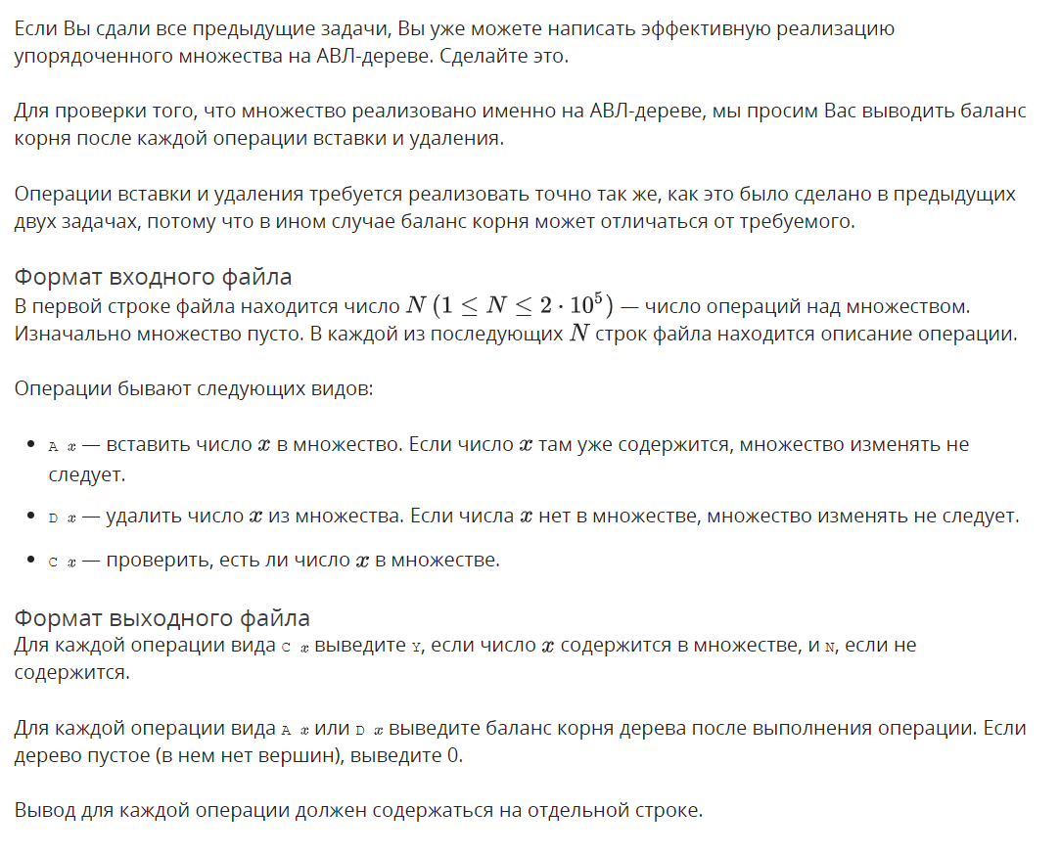
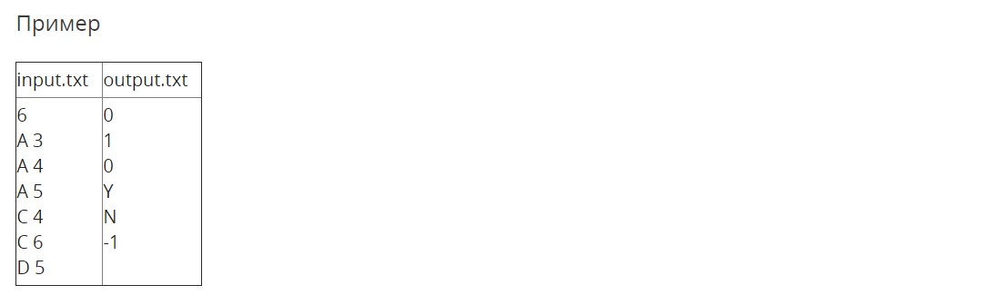

Решение

openedu/week7/lab7_5.cpp

#include "edx-io.hpp"

#include <iostream>

#include <fstream>

#include <vector>

#include <algorithm>

#include <string>

#include <list>

#include <assert.h>

#include <tuple>

using namespace std;

typedef int32_t balance_t;

struct Node {

int key;

balance_t balance = 0;

int height = 1;

Node* parent = nullptr;

Node* left = nullptr;

Node* right = nullptr;

// dirty hack

size_t latest_population_descr_index;

Node(int key) : key(key) {}

balance_t get_left_balance() { return (left) ? left->balance : -1; };

balance_t get_right_balance() { return (right) ? right->balance : -1; };

int get_left_height() { return (left) ? left->height : 0; };

int get_right_height() { return (right) ? right->height : 0; };

void replace_child(Node* from, Node* to) {

if (left == from) {

left = to;

} else {

assert(right == from);

right = to;

}

if (to) {

to->parent = this;

}

from->parent = nullptr;

}

void subtree_change_height(Node* from, int dh = 1) {

if (left == from) {

balance -= dh;

} else {

assert(right == from);

balance += dh;

}

height += dh;

}

void recalc_structure(int trust_deep = 30) {

if (trust_deep) {

if (left) left->recalc_structure(trust_deep - 1);

if (right) right->recalc_structure(trust_deep - 1);

height = max(get_right_height(), get_left_height()) + 1;

balance = get_right_height() - get_left_height();

}

}

};

struct NodeDescription {

int k;

int li = 0;

int ri = 0;

};

struct TreeDescription {

vector<NodeDescription> descriptions;

TreeDescription() {}

TreeDescription(int size) : descriptions(size) {}

NodeDescription& description_for_index(size_t index) {

return descriptions[index];

}

void populate_from_tree(Node* tree) {

// children set later

descriptions.push_back(NodeDescription{ tree->key });

// dirty hack for setting children!

size_t current_index = descriptions.size() - 1;

tree->latest_population_descr_index = current_index;

// setting children of previously added things

if (tree->parent) {

if (tree->parent->left == tree) {

descriptions[tree->parent->latest_population_descr_index].li = current_index + 1;

} else {

assert(tree->parent->right == tree);

descriptions[tree->parent->latest_population_descr_index].ri = current_index + 1;

}

}

// recursively populate from subtrees

if (tree->left) {

populate_from_tree(tree->left);

}

if (tree->right) {

populate_from_tree(tree->right);

}

}

};

Node* build_tree(TreeDescription &input, size_t root_index = 0) {

// root node description

auto& rd = input.description_for_index(root_index);

// create new node

Node* tree = new Node(rd.k);

// recursively build left and right subtrees if needed

if (rd.li) {

tree->left = build_tree(input, rd.li - 1);

tree->left->parent = tree;

}

if (rd.ri) {

tree->right = build_tree(input, rd.ri - 1);

tree->right->parent = tree;

}

// calculate height and balance

tree->height = max(tree->get_right_height(), tree->get_left_height()) + 1;

tree->balance = tree->get_right_height() - tree->get_left_height();

return tree;

}

Node*& find_node(Node*& tree, int key) {

if (tree == nullptr) {

return tree;

} else if (key == tree->key) {

return tree;

} else if (key < tree->key) {

return find_node(tree->left, key);

} else {

return find_node(tree->right, key);

}

}

void rotate_l(Node*& tree) {

// малый левый

assert(tree->right != nullptr);

Node* a = tree;

Node* b = a->right;

Node* x = a->left;

Node* y = b->left;

Node* z = b->right;

if (a->parent) {

a->parent->replace_child(a, b);

} else {

b->parent = nullptr;

}

b->left = a;

a->parent = b;

a->right = y;

if (y) {

y->parent = a;

}

tree = b;

tree->recalc_structure();

}

void rotate_r(Node*& tree) {

// малый правый

assert(tree->left != nullptr);

Node* a = tree;

Node* b = a->left;

Node* x = a->right;

Node* y = b->right;

Node* z = b->left;

if (a->parent) {

a->parent->replace_child(a, b);

} else {

b->parent = nullptr;

}

b->right = a;

a->parent = b;

a->left = y;

if (y) {

y->parent = a;

}

tree = b;

tree->recalc_structure();

}

void rotate_lr(Node*& tree) {

// большой правый

rotate_l(tree->left);

rotate_r(tree);

}

void rotate_rl(Node*& tree) {

// большой левый

rotate_r(tree->right);

rotate_l(tree);

}

void balance_tree(Node*& tree) {

if (tree->balance == 2) {

if (tree->right->balance == -1) {

rotate_rl(tree);

} else {

rotate_l(tree);

}

} else if (tree->balance == -2) {

if (tree->left->balance == 1) {

rotate_lr(tree);

} else {

rotate_r(tree);

}

}

}

bool insert_to_tree(Node*& tree, Node* node) {

if (tree == nullptr) {

tree = node;

return true;

}

bool balancing_done = false;

// digging into the tree to find a right place for a node

if (node->key == tree->key) {

// assert(false && "key already in tree");

return true;

} else if (node->key < tree->key) {

if (tree->left) {

balancing_done = insert_to_tree(tree->left, node);

} else {

tree->left = node;

node->parent = tree;

tree->subtree_change_height(node, 1);

}

} else {

if (tree->right) {

balancing_done = insert_to_tree(tree->right, node);

} else {

tree->right = node;

node->parent = tree;

tree->subtree_change_height(node, 1);

}

}

// balancing on our way back if needed

balance_tree(tree);

// recalculate balances due to height change

// if node has a parent and subtree's height was increased (balance != 0)

if (tree->parent && tree->balance != 0 && !balancing_done) {

tree->parent->subtree_change_height(tree, 1);

return false;

}

return true;

}

void delete_node_simple(Node*& tree) {

if (tree->left == nullptr && tree->right == nullptr) {

if (tree->parent) {

tree->parent->subtree_change_height(tree, -1);

// tree->parent->replace_child(tree, nullptr);

}

delete tree;

tree = nullptr;

} else if (tree->left == nullptr || tree->right == nullptr) {

Node* saved = (tree->right) ? tree->right : tree->left;

if (tree->parent) {

tree->parent->subtree_change_height(tree, -1);

// tree->parent->replace_child(tree, saved);

}

saved->parent = tree->parent;

delete tree;

tree = saved;

} else {

assert(false && "not a simple node to delete!");

}

}

bool delete_from_tree(Node*& tree, int key, Node* target = nullptr) {

if (tree == nullptr) {

return true;

}

if (!tree->parent && !tree->left && !tree->right) {

if (key == tree->key) {

delete_node_simple(tree);

return false;

} else {

// assert(false && "key not in a tree!");

return true;

}

}

bool balancing_done = false;

if (!target) {

// digging into the tree

if (key == tree->key) {

if (!tree->left && !tree->right) {

delete_node_simple(tree);

return false;

} else if (!tree->left) {

delete_node_simple(tree);

return false;

} else {

balancing_done = delete_from_tree(tree->left, key, tree);

}

} else if (key < tree->key) {

balancing_done = delete_from_tree(tree->left, key);

} else {

assert(key > tree->key);

balancing_done = delete_from_tree(tree->right, key);

}

} else {

if (tree->right) {

balancing_done = delete_from_tree(tree->right, key, target);

} else {

// found prev

target->key = tree->key;

delete_node_simple(tree);

return false;

}

}

// balancing on our way back if needed

balance_tree(tree);

// recalculate balances due to height change

// if node has a parent and subtree's height was DECREASED (balance == 0)

if (tree->parent && tree->balance == 0 && !balancing_done) {

tree->parent->subtree_change_height(tree, -1);

return false;

}

return true;

}

int main() {

int n;

io >> n;

Node* tree = nullptr;

char c;

int arg;

while (n--) {

io >> c >> arg;

switch (c) {

case 'A': {

insert_to_tree(tree, new Node(arg));

io << ((tree) ? tree->balance : 0);

} break;

case 'D': {

delete_from_tree(tree, arg);

io << ((tree) ? tree->balance : 0);

} break;

case 'C': {

io << ((find_node(tree, arg)) ? 'Y' : 'N');

} break;

}

io << '\n';

}

return 0;

}

Результаты
№ теста | Результат | Время, с | Память | Размер входного файла | Размер выходного файла
Max |  | 0.187 | 17522688 | 2678110 | 731071
1 | OK | 0.000 | 2256896 | 33 | 19
2 | OK | 0.000 | 2256896 | 114 | 66
3 | OK | 0.000 | 2256896 | 154 | 90
4 | OK | 0.000 | 2244608 | 154 | 91
5 | OK | 0.000 | 2256896 | 154 | 90
6 | OK | 0.000 | 2252800 | 154 | 95
7 | OK | 0.015 | 2252800 | 154 | 91
8 | OK | 0.015 | 2277376 | 154 | 94
9 | OK | 0.000 | 2244608 | 154 | 95
10 | OK | 0.000 | 2252800 | 154 | 90
11 | OK | 0.000 | 2248704 | 154 | 90
12 | OK | 0.015 | 2256896 | 154 | 90
13 | OK | 0.015 | 2256896 | 154 | 95
14 | OK | 0.000 | 2256896 | 154 | 97
15 | OK | 0.015 | 2277376 | 154 | 94
16 | OK | 0.015 | 2269184 | 154 | 93
17 | OK | 0.000 | 2256896 | 154 | 90
18 | OK | 0.000 | 2256896 | 154 | 90
19 | OK | 0.000 | 2269184 | 154 | 98
20 | OK | 0.015 | 2256896 | 154 | 93
21 | OK | 0.000 | 2260992 | 154 | 92
22 | OK | 0.000 | 2269184 | 154 | 98
23 | OK | 0.031 | 5079040 | 1000008 | 616458
24 | OK | 0.046 | 5079040 | 1000008 | 622272
25 | OK | 0.031 | 5152768 | 1000008 | 625335
26 | OK | 0.031 | 5079040 | 1000008 | 628546
27 | OK | 0.046 | 5079040 | 1000008 | 631472
28 | OK | 0.046 | 5079040 | 1000008 | 632217
29 | OK | 0.046 | 5074944 | 1000008 | 631772
30 | OK | 0.031 | 5079040 | 1000008 | 631071
31 | OK | 0.046 | 5074944 | 1000008 | 630132
32 | OK | 0.046 | 5169152 | 1017957 | 630451
33 | OK | 0.062 | 5079040 | 1000008 | 616595
34 | OK | 0.046 | 5079040 | 1000008 | 622199
35 | OK | 0.046 | 5079040 | 1000008 | 625057
36 | OK | 0.046 | 5079040 | 1000008 | 628040
37 | OK | 0.046 | 5079040 | 1000008 | 631495
38 | OK | 0.046 | 5079040 | 1000008 | 632086
39 | OK | 0.046 | 5079040 | 1000008 | 631753
40 | OK | 0.046 | 5074944 | 1000008 | 630849
41 | OK | 0.046 | 5074944 | 1000008 | 630110
42 | OK | 0.046 | 5095424 | 1018151 | 630800
43 | OK | 0.000 | 2281472 | 756 | 369
44 | OK | 0.000 | 2285568 | 758 | 432
45 | OK | 0.000 | 2265088 | 1659 | 408
46 | OK | 0.000 | 2269184 | 723 | 383
47 | OK | 0.000 | 2281472 | 723 | 385
48 | OK | 0.000 | 2265088 | 723 | 415
49 | OK | 0.000 | 2256896 | 723 | 415
50 | OK | 0.000 | 2281472 | 1668 | 377
51 | OK | 0.000 | 2277376 | 1660 | 396
52 | OK | 0.000 | 2326528 | 5348 | 2337
53 | OK | 0.015 | 2326528 | 5350 | 2848
54 | OK | 0.015 | 2338816 | 10439 | 2648
55 | OK | 0.015 | 2285568 | 5238 | 2343
56 | OK | 0.015 | 2285568 | 5238 | 2465
57 | OK | 0.000 | 2285568 | 5238 | 2719
58 | OK | 0.000 | 2297856 | 5238 | 2719
59 | OK | 0.000 | 2273280 | 10450 | 2421
60 | OK | 0.000 | 2293760 | 10439 | 2405
61 | OK | 0.000 | 2600960 | 32784 | 12708
62 | OK | 0.015 | 2600960 | 32787 | 14896
63 | OK | 0.000 | 2592768 | 56716 | 12715
64 | OK | 0.015 | 2359296 | 31674 | 12778
65 | OK | 0.000 | 2322432 | 31674 | 13220
66 | OK | 0.000 | 2318336 | 31674 | 14383
67 | OK | 0.000 | 2359296 | 31674 | 14825
68 | OK | 0.000 | 2318336 | 56748 | 13671
69 | OK | 0.000 | 2367488 | 56716 | 13193
70 | OK | 0.015 | 3616768 | 162462 | 57855
71 | OK | 0.046 | 3637248 | 162466 | 68948
72 | OK | 0.015 | 3629056 | 258205 | 71756
73 | OK | 0.015 | 2609152 | 152067 | 59306
74 | OK | 0.015 | 2646016 | 152067 | 59903
75 | OK | 0.015 | 2646016 | 152067 | 66900
76 | OK | 0.015 | 2613248 | 152067 | 67497
77 | OK | 0.015 | 2777088 | 258312 | 70001
78 | OK | 0.015 | 2732032 | 258332 | 58111
79 | OK | 0.062 | 8609792 | 811002 | 274035
80 | OK | 0.062 | 8613888 | 811006 | 332612
81 | OK | 0.078 | 9027584 | 1222794 | 299942
82 | OK | 0.046 | 5287936 | 799892 | 286940
83 | OK | 0.046 | 5316608 | 799892 | 282227
84 | OK | 0.062 | 5320704 | 799892 | 324420
85 | OK | 0.062 | 5287936 | 799892 | 319707
86 | OK | 0.062 | 6053888 | 1222871 | 284516
87 | OK | 0.046 | 5103616 | 1223246 | 288111
88 | OK | 0.156 | 16736256 | 1888898 | 600000
89 | OK | 0.156 | 16732160 | 1888903 | 731071
90 | OK | 0.187 | 17522688 | 2677526 | 600067
91 | OK | 0.125 | 9334784 | 1777788 | 601696
92 | OK | 0.125 | 9367552 | 1777788 | 632768
93 | OK | 0.125 | 9359360 | 1777788 | 698302
94 | OK | 0.125 | 9326592 | 1777788 | 698303
95 | OK | 0.156 | 11026432 | 2678110 | 611713
96 | OK | 0.109 | 8863744 | 2677266 | 600286

