Лабораторная работа № 8
по дисциплине «Алгоритмы и структуры данных»
Openedu – неделя 8

Подготовил:
студент группы P3217
Бураков Илья Алексеевич

Преподаватели:
Романов Алексей Андреевич
Волчек Дмитрий Геннадьевич

Множество

Условие
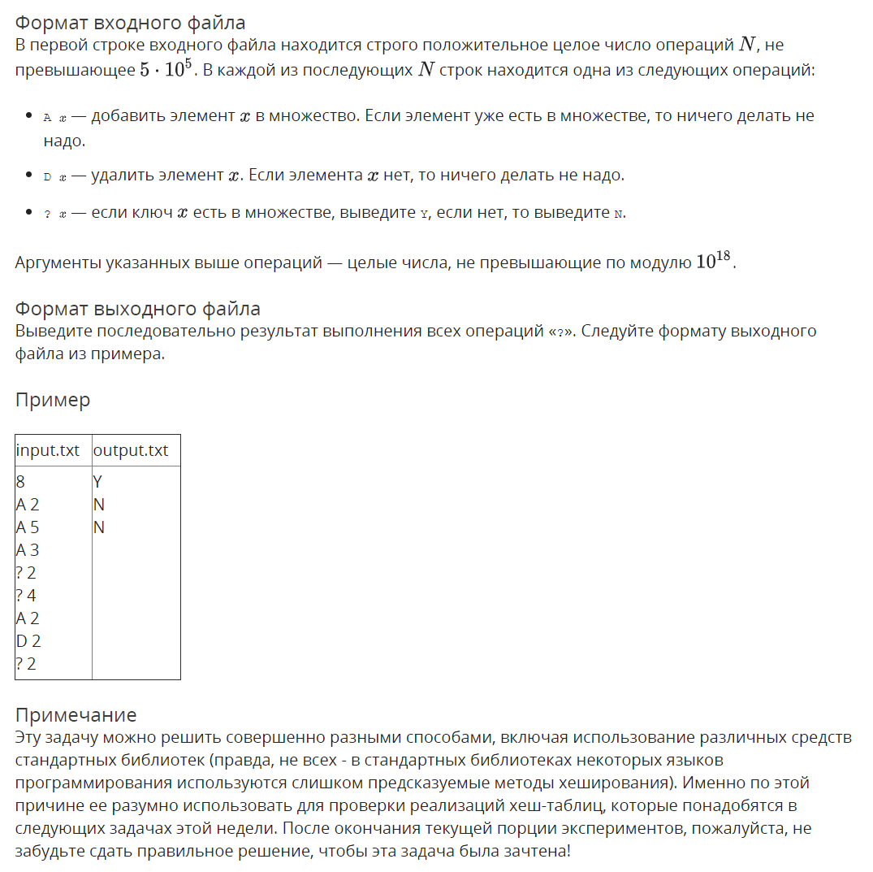

Решение

openedu/week8/lab8_1.cpp

#include "edx-io.hpp"

#include <vector>

#include <algorithm>

#include <forward_list>

using namespace std;

#define HASHTABLE_SIZE 909151

unsigned int h(long long x) {

x = ((x >> 16) ^ x) * 0x45d9f3b;

x = ((x >> 16) ^ x) * 0x45d9f3b;

x = (x >> 16) ^ x;

return x % HASHTABLE_SIZE;

}

int main() {

int n;

io >> n;

auto hashmap = new forward_list<long long>[HASHTABLE_SIZE];

for (int i = 0; i < n; i++) {

char c;

long long arg;

io >> c >> arg;

switch (c) {

case 'A': {

hashmap[h(arg)].remove(arg);

hashmap[h(arg)].push_front(arg);

} break;

case 'D': {

hashmap[h(arg)].remove(arg);

} break;

case '?': {

auto list = hashmap[h(arg)];

io << (find(list.begin(), list.end(), arg) != list.end() ? "Y" : "N") << "\n";

} break;

}

}

return 0;

}

Результаты
№ теста | Результат | Время, с | Память | Размер входного файла | Размер выходного файла
Max |  | 0.187 | 34676736 | 11189636 | 501237
1 | OK | 0.015 | 9506816 | 43 | 9
2 | OK | 0.015 | 9506816 | 8 | 3
3 | OK | 0.015 | 9506816 | 51 | 12
4 | OK | 0.015 | 9510912 | 542 | 99
5 | OK | 0.015 | 9519104 | 618 | 54
6 | OK | 0.015 | 9502720 | 5451 | 1038
7 | OK | 0.015 | 9523200 | 6436 | 957
8 | OK | 0.000 | 9519104 | 13382 | 957
9 | OK | 0.015 | 9523200 | 22394 | 981
10 | OK | 0.015 | 9531392 | 7030 | 465
11 | OK | 0.015 | 9527296 | 7020 | 411
12 | OK | 0.015 | 9510912 | 63829 | 10002
13 | OK | 0.015 | 9682944 | 80339 | 4947
14 | OK | 0.015 | 9674752 | 80203 | 5034
15 | OK | 0.031 | 9633792 | 545113 | 100323
16 | OK | 0.031 | 9736192 | 639485 | 99282
17 | OK | 0.031 | 9895936 | 738870 | 99558
18 | OK | 0.031 | 11546624 | 1338668 | 99636
19 | OK | 0.046 | 12451840 | 2237627 | 99540
20 | OK | 0.031 | 11673600 | 903052 | 50202
21 | OK | 0.031 | 11673600 | 902843 | 49536
22 | OK | 0.093 | 11812864 | 2725205 | 501237
23 | OK | 0.093 | 12292096 | 3196877 | 499713
24 | OK | 0.109 | 12865536 | 3694712 | 501051
25 | OK | 0.125 | 21237760 | 6694340 | 500355
26 | OK | 0.140 | 25731072 | 11189636 | 500040
27 | OK | 0.171 | 22106112 | 4902931 | 249012
28 | OK | 0.171 | 22102016 | 4902757 | 250305
29 | OK | 0.171 | 31494144 | 9687139 | 300000
30 | OK | 0.171 | 31490048 | 9687570 | 300000
31 | OK | 0.156 | 29806592 | 8000008 | 300000
32 | OK | 0.187 | 34676736 | 11000008 | 150000

Прошитый ассоциативный массив

Условие
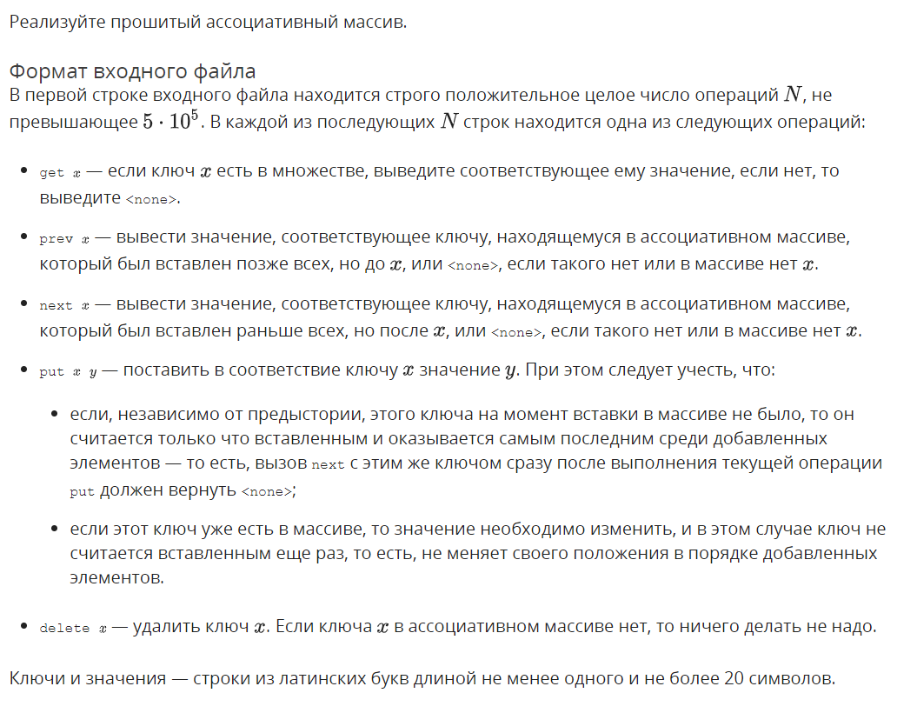
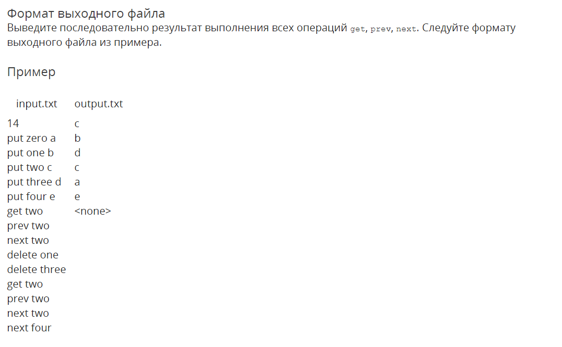

Решение

openedu/week8/lab8_2.cpp

#include "edx-io.hpp"

#include <vector>

#include <algorithm>

#include <string>

#include <list>

using namespace std;

#define HASHTABLE_SIZE 800000

struct Entry {

string key;

string val;

list<Entry*>::iterator orderlink;

Entry(string newkey, string newval) {

key = newkey;

val = newval;

}

};

void main() {

int n;

io >> n;

auto hashmap = new list<Entry>[HASHTABLE_SIZE];

auto orderlist = list<Entry*>();

for (int i = 0; i < n; i++) {

string cmd, key, val;

io >> cmd >> key;

auto &list = hashmap[hash<string>{}(key) % HASHTABLE_SIZE];

auto result = find_if(list.begin(), list.end(), [key](const Entry& e) {return e.key == key; });

if (cmd == "put") {

io >> val;

if (result == list.end()) {

list.push_front(Entry(key, val));

orderlist.push_front(&list.front());

list.front().orderlink = orderlist.begin();

} else {

result->val = val;

}

} else if (cmd == "delete") {

if (result != list.end()) {

orderlist.erase(result->orderlink);

list.erase(result);

}

} else if (cmd == "get") {

io << (result != list.end() ? result->val : "<none>") << "\n";

} else if (cmd == "next") {

io << ((result != list.end() && result->orderlink != orderlist.begin()) ? (*prev(result->orderlink))->val : "<none>") << "\n";

} else if (cmd == "prev") {

io << ((result != list.end() && next(result->orderlink) != orderlist.end()) ? (*next(result->orderlink))->val : "<none>") << "\n";

}

}

}

Результаты
№ теста | Результат | Время, с | Память | Размер входного файла | Размер выходного файла
Max |  | 0.859 | 227897344 | 23499808 | 10303658
1 | OK | 0.109 | 92213248 | 158 | 26
2 | OK | 0.109 | 92213248 | 12 | 8
3 | OK | 0.109 | 92213248 | 25 | 5
4 | OK | 0.093 | 92209152 | 25 | 8
5 | OK | 0.109 | 92213248 | 82 | 20
6 | OK | 0.109 | 92209152 | 1200 | 504
7 | OK | 0.109 | 92225536 | 1562 | 564
8 | OK | 0.109 | 92213248 | 12204 | 4617
9 | OK | 0.093 | 92217344 | 12058 | 4340
10 | OK | 0.125 | 92749824 | 960183 | 395964
11 | OK | 0.140 | 93106176 | 1318345 | 765350
12 | OK | 0.140 | 93216768 | 1420595 | 880052
13 | OK | 0.140 | 92868608 | 1079934 | 395020
14 | OK | 0.125 | 92639232 | 840022 | 332970
15 | OK | 0.140 | 93020160 | 1223121 | 889998
16 | OK | 0.187 | 99450880 | 3120970 | 486100
17 | OK | 0.203 | 99459072 | 3123298 | 486652
18 | OK | 0.203 | 99524608 | 3122193 | 479024
19 | OK | 0.125 | 92696576 | 900630 | 420456
20 | OK | 0.187 | 99450880 | 3121195 | 486718
21 | OK | 0.218 | 113725440 | 4199992 | 8
22 | OK | 0.218 | 113623040 | 4099993 | 8
23 | OK | 0.218 | 113524736 | 3999994 | 8
24 | OK | 0.218 | 113426432 | 3899995 | 8
25 | OK | 0.218 | 113324032 | 3799996 | 8
26 | OK | 0.203 | 113225728 | 3699997 | 8
27 | OK | 0.218 | 113127424 | 3599998 | 8
28 | OK | 0.203 | 113029120 | 3499999 | 8
29 | OK | 0.218 | 112930816 | 3400000 | 8
30 | OK | 0.203 | 112824320 | 3300001 | 8
31 | OK | 0.234 | 97189888 | 5399043 | 1973124
32 | OK | 0.234 | 95993856 | 4200443 | 1669405
33 | OK | 0.296 | 97898496 | 6099290 | 4429770
34 | OK | 0.546 | 128020480 | 15598672 | 2589784
35 | OK | 0.531 | 127737856 | 15589269 | 2586758
36 | OK | 0.531 | 130023424 | 15603830 | 2398360
37 | OK | 0.234 | 96292864 | 4499616 | 2110630
38 | OK | 0.546 | 128028672 | 15603381 | 2583188
39 | OK | 0.687 | 201281536 | 20999992 | 8
40 | OK | 0.671 | 200781824 | 20499993 | 8
41 | OK | 0.687 | 200282112 | 19999994 | 8
42 | OK | 0.687 | 199778304 | 19499995 | 8
43 | OK | 0.703 | 199278592 | 18999996 | 8
44 | OK | 0.703 | 198778880 | 18499997 | 8
45 | OK | 0.687 | 198279168 | 17999998 | 8
46 | OK | 0.671 | 197779456 | 17499999 | 8
47 | OK | 0.687 | 197279744 | 17000000 | 8
48 | OK | 0.687 | 196780032 | 16500001 | 8
49 | OK | 0.859 | 166625280 | 18500008 | 5499986
50 | OK | 0.843 | 227897344 | 23499808 | 220
51 | OK | 0.453 | 105299968 | 13500208 | 10303658
52 | OK | 0.828 | 129847296 | 15500008 | 8799944
53 | OK | 0.843 | 203411456 | 21500008 | 2200000
54 | OK | 0.828 | 166625280 | 18500008 | 5500000
55 | OK | 0.859 | 227897344 | 23499808 | 220
56 | OK | 0.500 | 105295872 | 13500208 | 10300130
57 | OK | 0.859 | 129847296 | 15500008 | 8799958
58 | OK | 0.843 | 203407360 | 21500008 | 2200000

Почти интерактивная хеш-таблица

Условие
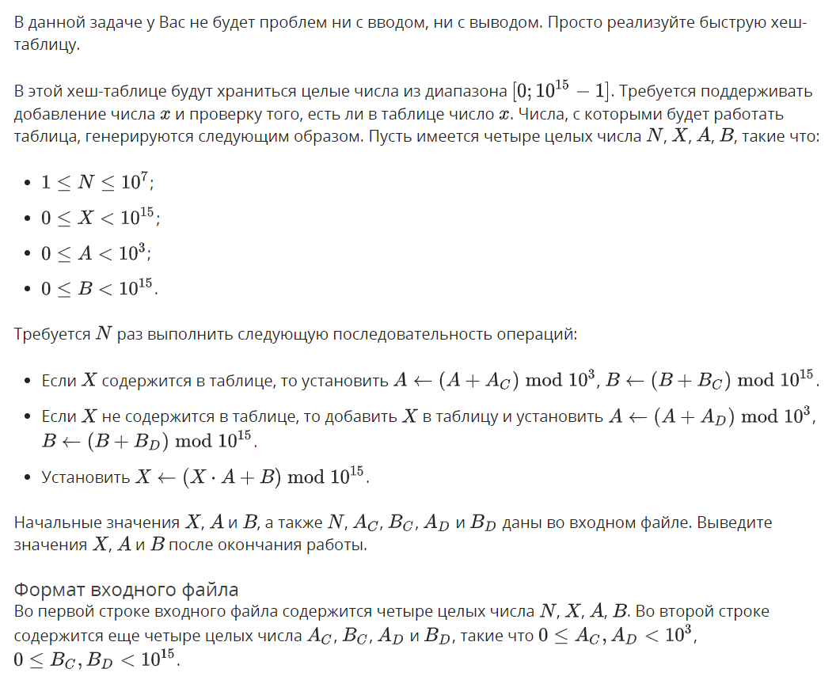
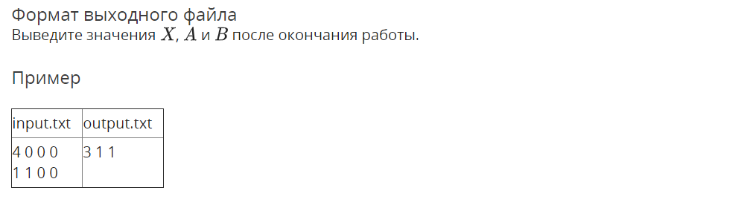

Решение

openedu/week8/lab8_3.cpp

#include "edx-io.hpp"

#include <vector>

#include <algorithm>

#include <string>

#include <forward_list>

using namespace std;

#define HASHTABLE_SIZE 800000

typedef unsigned long long ull;

auto HASHMAP = new vector<ull>[HASHTABLE_SIZE];

ull h(ull x) {

x = ((x >> 16) ^ x) * 0x45d9f3b;

x = ((x >> 16) ^ x) * 0x45d9f3b;

x = (x >> 16) ^ x;

return x % HASHTABLE_SIZE;

}

bool add_if_not_in_hashmap(ull x) {

auto& list = HASHMAP[h(x)];

if (find(list.begin(), list.end(), x) != list.end()) {

// already found

return false;

} else {

list.push_back(x);

return true;

}

}

#define E3 1000

#define E15 1000000000000000

void main() {

long long N, X, A, B, Ac, Bc, Ad, Bd;

io >> N >> X >> A >> B >> Ac >> Bc >> Ad >> Bd;

for (int i = 0; i < N; i++) {

if (add_if_not_in_hashmap(X)) {

A = (A + Ad) % E3;

B = (B + Bd) % E15;

} else {

A = (A + Ac) % E3;

B = (B + Bc) % E15;

}

X = (X * A + B) % E15;

}

io << X << " " << A << " " << B << "\n";

}

Результаты
№ теста | Результат | Время, с | Память | Размер входного файла | Размер выходного файла
Max |  | 4.000 | 176107520 | 87 | 37
1 | OK | 0.015 | 21438464 | 18 | 7
2 | OK | 0.031 | 21438464 | 19 | 7
3 | OK | 0.046 | 21434368 | 21 | 7
4 | OK | 0.015 | 21438464 | 21 | 7
5 | OK | 0.015 | 21434368 | 21 | 7
6 | OK | 0.015 | 21454848 | 21 | 15
7 | OK | 0.015 | 21442560 | 21 | 7
8 | OK | 0.015 | 21446656 | 21 | 9
9 | OK | 0.031 | 21442560 | 21 | 9
10 | OK | 0.031 | 21463040 | 30 | 28
11 | OK | 0.015 | 21463040 | 30 | 28
12 | OK | 0.015 | 21454848 | 35 | 35
13 | OK | 0.015 | 21458944 | 47 | 32
14 | OK | 0.015 | 21454848 | 63 | 35
15 | OK | 0.015 | 21458944 | 81 | 37
16 | OK | 0.015 | 21463040 | 82 | 37
17 | OK | 0.015 | 21434368 | 23 | 7
18 | OK | 0.015 | 21434368 | 23 | 7
19 | OK | 0.015 | 21434368 | 23 | 7
20 | OK | 0.031 | 23117824 | 23 | 21
21 | OK | 0.015 | 21442560 | 23 | 7
22 | OK | 0.015 | 21446656 | 23 | 9
23 | OK | 0.015 | 21446656 | 23 | 9
24 | OK | 0.046 | 23130112 | 32 | 30
25 | OK | 0.031 | 23126016 | 32 | 30
26 | OK | 0.031 | 23130112 | 37 | 35
27 | OK | 0.046 | 23134208 | 51 | 35
28 | OK | 0.031 | 23121920 | 64 | 34
29 | OK | 0.031 | 23121920 | 84 | 37
30 | OK | 0.046 | 23117824 | 84 | 36
31 | OK | 0.046 | 21434368 | 24 | 7
32 | OK | 0.046 | 21434368 | 24 | 7
33 | OK | 0.046 | 21438464 | 24 | 7
34 | OK | 0.312 | 36139008 | 24 | 24
35 | OK | 0.046 | 21442560 | 24 | 7
36 | OK | 0.062 | 21442560 | 24 | 9
37 | OK | 0.046 | 21446656 | 24 | 9
38 | OK | 0.328 | 36110336 | 33 | 16
39 | OK | 0.328 | 36114432 | 33 | 30
40 | OK | 0.343 | 36134912 | 38 | 35
41 | OK | 0.328 | 36143104 | 52 | 35
42 | OK | 0.343 | 36200448 | 66 | 35
43 | OK | 0.328 | 36114432 | 84 | 37
44 | OK | 0.343 | 36139008 | 85 | 37
45 | OK | 0.312 | 21422080 | 25 | 7
46 | OK | 0.312 | 21438464 | 25 | 7
47 | OK | 0.312 | 21434368 | 25 | 7
48 | OK | 3.843 | 174858240 | 25 | 27
49 | OK | 0.296 | 21442560 | 25 | 7
50 | OK | 0.312 | 21442560 | 25 | 9
51 | OK | 0.312 | 21438464 | 25 | 9
52 | OK | 1.968 | 36110336 | 34 | 16
53 | OK | 3.890 | 175190016 | 34 | 30
54 | OK | 3.953 | 176107520 | 39 | 35
55 | OK | 3.953 | 174637056 | 51 | 35
56 | OK | 3.953 | 174338048 | 67 | 35
57 | OK | 3.984 | 175140864 | 87 | 37
58 | OK | 4.000 | 174944256 | 87 | 37
59 | OK | 4.000 | 175235072 | 87 | 35
60 | OK | 3.968 | 174563328 | 86 | 37
61 | OK | 3.968 | 174424064 | 87 | 37
62 | OK | 3.968 | 174665728 | 86 | 37
63 | OK | 4.000 | 175329280 | 86 | 37
64 | OK | 3.968 | 173940736 | 86 | 37
65 | OK | 3.968 | 175345664 | 87 | 37
66 | OK | 3.968 | 175616000 | 85 | 35
67 | OK | 3.968 | 174804992 | 85 | 36
68 | OK | 3.984 | 174964736 | 87 | 36

