Лабораторная работа № 9
по дисциплине «Алгоритмы и структуры данных»
Openedu – неделя 9

Подготовил:
студент группы P3217
Бураков Илья Алексеевич

Преподаватели:
Романов Алексей Андреевич
Волчек Дмитрий Геннадьевич

Наивный поиск подстроки в строке

Условие
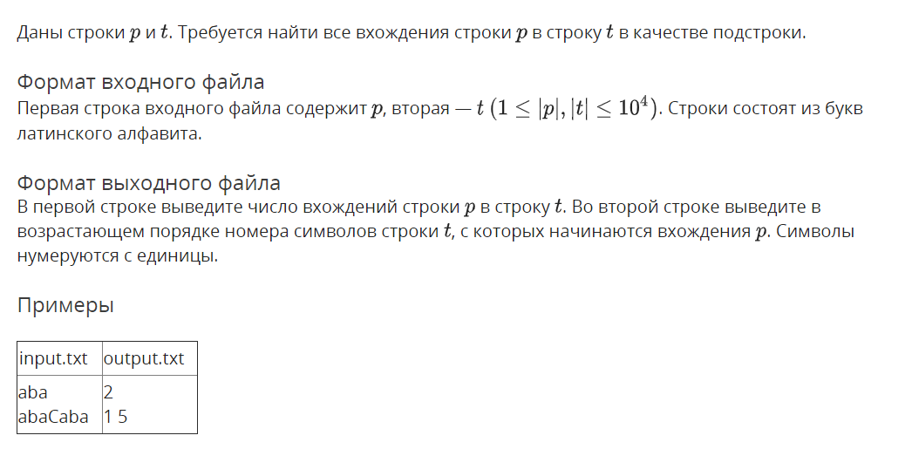

Решение

openedu/week9/lab9_1.cpp

#include "edx-io.hpp"

#include <vector>

#include <algorithm>

#include <string>

#include <list>

#include <assert.h>

using namespace std;

void main() {

string substr, s;

io >> substr >> s;

auto result = vector<int>();

result.reserve(10000);

for (int i = 0; i <= long long(s.size() - substr.size()); i++) {

int si = 0;

while (s[i + si] == substr[si]) {

si++;

if (si == substr.size()) {

result.push_back(i);

break;

}

}

}

io << result.size() << "\n";

for (auto e : result) io << e + 1 << " ";

}

Результаты
№ теста | Результат | Время, с | Память | Размер входного файла | Размер выходного файла
Max |  | 0.062 | 2281472 | 20003 | 48890
1 | OK | 0.015 | 2240512 | 14 | 7
2 | OK | 0.000 | 2252800 | 6 | 5
3 | OK | 0.000 | 2240512 | 6 | 3
4 | OK | 0.000 | 2240512 | 7 | 7
5 | OK | 0.015 | 2240512 | 7 | 3
6 | OK | 0.000 | 2256896 | 9 | 7
7 | OK | 0.000 | 2240512 | 10 | 5
8 | OK | 0.000 | 2236416 | 3004 | 3
9 | OK | 0.000 | 2240512 | 3028 | 7
10 | OK | 0.000 | 2236416 | 2656 | 429
11 | OK | 0.000 | 2244608 | 2005 | 8895
12 | OK | 0.000 | 2252800 | 4003 | 7
13 | OK | 0.000 | 2232320 | 3004 | 3
14 | OK | 0.000 | 2232320 | 2252 | 1850
15 | OK | 0.000 | 2236416 | 2021 | 186
16 | OK | 0.000 | 2240512 | 2008 | 8884
17 | OK | 0.000 | 2236416 | 3004 | 3904
18 | OK | 0.015 | 2252800 | 2670 | 3
19 | OK | 0.000 | 2252800 | 3028 | 7
20 | OK | 0.000 | 2240512 | 2404 | 691
21 | OK | 0.000 | 2240512 | 2005 | 8899
22 | OK | 0.000 | 2236416 | 4003 | 7
23 | OK | 0.015 | 2232320 | 2670 | 3
24 | OK | 0.000 | 2236416 | 2252 | 1886
25 | OK | 0.000 | 2236416 | 2022 | 190
26 | OK | 0.015 | 2240512 | 2008 | 8884
27 | OK | 0.000 | 2236416 | 3004 | 3904
28 | OK | 0.015 | 2232320 | 5337 | 3
29 | OK | 0.000 | 2240512 | 5028 | 8
30 | OK | 0.000 | 2236416 | 4372 | 648
31 | OK | 0.000 | 2256896 | 4005 | 18899
32 | OK | 0.015 | 2248704 | 8003 | 7
33 | OK | 0.015 | 2236416 | 5337 | 3
34 | OK | 0.000 | 2232320 | 4804 | 3480
35 | OK | 0.000 | 2236416 | 4015 | 789
36 | OK | 0.015 | 2260992 | 4008 | 18864
37 | OK | 0.015 | 2248704 | 6004 | 8904
38 | OK | 0.015 | 2236416 | 5337 | 3
39 | OK | 0.015 | 2248704 | 5028 | 8
40 | OK | 0.000 | 2244608 | 4477 | 786
41 | OK | 0.015 | 2252800 | 4005 | 18894
42 | OK | 0.000 | 2252800 | 8003 | 7
43 | OK | 0.015 | 2244608 | 5337 | 3
44 | OK | 0.000 | 2248704 | 4572 | 3974
45 | OK | 0.000 | 2236416 | 4015 | 397
46 | OK | 0.015 | 2248704 | 4008 | 18884
47 | OK | 0.015 | 2248704 | 6004 | 8904
48 | OK | 0.015 | 2244608 | 9004 | 3
49 | OK | 0.000 | 2240512 | 7028 | 13
50 | OK | 0.000 | 2240512 | 7179 | 660
51 | OK | 0.015 | 2265088 | 6005 | 28899
52 | OK | 0.000 | 2244608 | 12003 | 7
53 | OK | 0.015 | 2240512 | 8004 | 3
54 | OK | 0.015 | 2260992 | 6752 | 5678
55 | OK | 0.000 | 2260992 | 6015 | 1204
56 | OK | 0.000 | 2265088 | 6008 | 28884
57 | OK | 0.015 | 2252800 | 9004 | 13904
58 | OK | 0.015 | 2244608 | 9004 | 3
59 | OK | 0.000 | 2240512 | 7028 | 8
60 | OK | 0.000 | 2236416 | 6470 | 506
61 | OK | 0.000 | 2260992 | 6005 | 28899
62 | OK | 0.000 | 2240512 | 12003 | 7
63 | OK | 0.015 | 2244608 | 8004 | 3
64 | OK | 0.000 | 2260992 | 8004 | 4480
65 | OK | 0.000 | 2244608 | 6016 | 608
66 | OK | 0.015 | 2269184 | 6008 | 28884
67 | OK | 0.015 | 2252800 | 9004 | 13904
68 | OK | 0.015 | 2244608 | 12004 | 3
69 | OK | 0.000 | 2248704 | 9028 | 13
70 | OK | 0.000 | 2244608 | 9920 | 439
71 | OK | 0.015 | 2273280 | 8005 | 38899
72 | OK | 0.000 | 2224128 | 16003 | 7
73 | OK | 0.031 | 2244608 | 12004 | 3
74 | OK | 0.000 | 2248704 | 8728 | 8376
75 | OK | 0.000 | 2248704 | 8017 | 1623
76 | OK | 0.015 | 2277376 | 8008 | 38844
77 | OK | 0.046 | 2244608 | 12004 | 18904
78 | OK | 0.015 | 2256896 | 12004 | 3
79 | OK | 0.015 | 2252800 | 9028 | 17
80 | OK | 0.000 | 2256896 | 10660 | 350
81 | OK | 0.000 | 2281472 | 8005 | 38899
82 | OK | 0.015 | 2236416 | 16003 | 7
83 | OK | 0.031 | 2240512 | 10670 | 3
84 | OK | 0.015 | 2248704 | 10004 | 6769
85 | OK | 0.015 | 2248704 | 8022 | 812
86 | OK | 0.000 | 2273280 | 8008 | 38884
87 | OK | 0.031 | 2269184 | 12004 | 18904
88 | OK | 0.031 | 2244608 | 15004 | 3
89 | OK | 0.000 | 2236416 | 11028 | 17
90 | OK | 0.015 | 2236416 | 10925 | 665
91 | OK | 0.015 | 2228224 | 10005 | 48885
92 | OK | 0.031 | 2228224 | 20003 | 7
93 | OK | 0.046 | 2232320 | 13337 | 3
94 | OK | 0.015 | 2228224 | 12504 | 8256
95 | OK | 0.000 | 2232320 | 10020 | 1022
96 | OK | 0.015 | 2228224 | 10008 | 48884
97 | OK | 0.062 | 2232320 | 15004 | 23904
98 | OK | 0.031 | 2236416 | 15004 | 3
99 | OK | 0.015 | 2228224 | 11028 | 17
100 | OK | 0.000 | 2236416 | 11004 | 498
101 | OK | 0.015 | 2232320 | 10005 | 48890
102 | OK | 0.000 | 2236416 | 20003 | 7
103 | OK | 0.046 | 2248704 | 13337 | 3
104 | OK | 0.015 | 2232320 | 10912 | 10926
105 | OK | 0.000 | 2232320 | 10015 | 2042
106 | OK | 0.015 | 2244608 | 10008 | 48884
107 | OK | 0.062 | 2232320 | 15004 | 23904

Карта

Условие
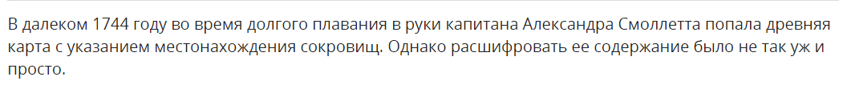
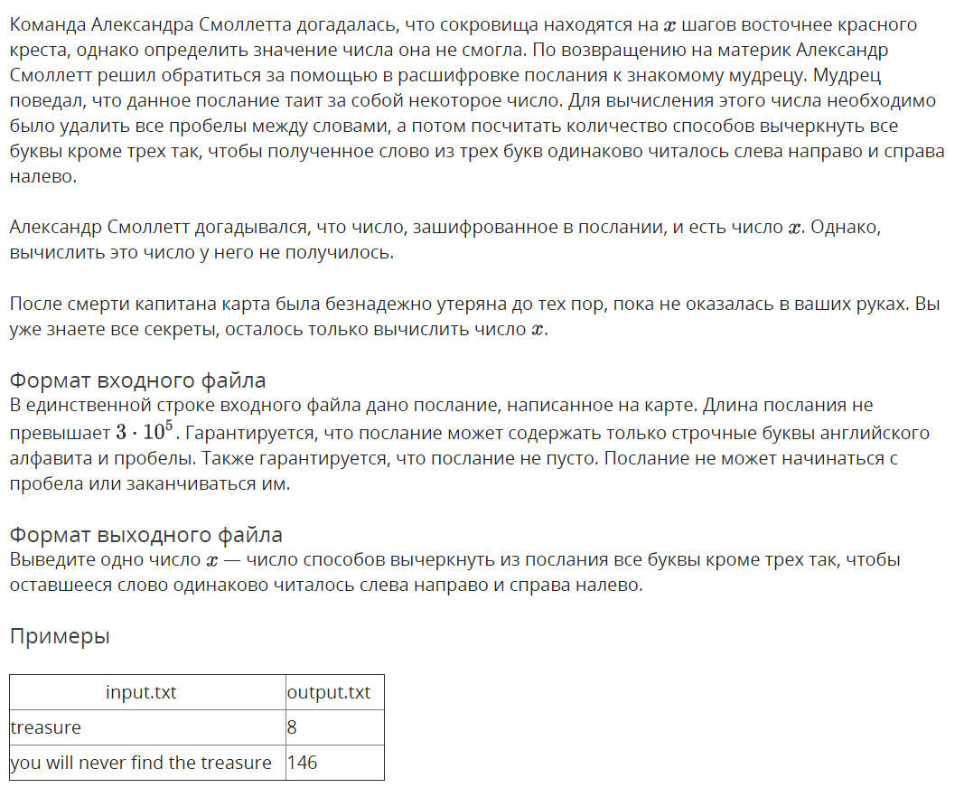

Решение

openedu/week9/lab9_2.cpp

#include "edx-io.hpp"

#include <iostream>

#include <fstream>

#include <vector>

#include <map>

#include <algorithm>

#include <string>

#include <list>

#include <assert.h>

#include <tuple>

using namespace std;

typedef unsigned long long ull;

struct CharEntry {

ull left, right;

CharEntry(ull left = 0, ull right = 0) : left(left), right(right) {}

};

int main() {

ifstream fin("input.txt");

string s;

char c;

while (fin >> c) {

if (c != ' ') {

s.push_back(c);

}

}

// counting chars

map<char, CharEntry*> right, left;

for (auto cc : s) {

auto ce = right.find(cc);

if (ce != right.end()) {

ce->second->right++;

} else {

right[cc]= new CharEntry(0, 1);

}

}

ull output = 0;

c = s[0];

auto ce = right[c];

left[c] = ce;

ce->left++;

ce->right--;

for (auto cc : s.substr(1)) {

auto ce = right[cc];

ce->right--;

for (auto le : left) {

output += le.second->left * le.second->right;

}

ce->left++;

left[cc] = ce;

}

io << output;

return 0;

}

Результаты
№ теста | Результат | Время, с | Память | Размер входного файла | Размер выходного файла
Max |  | 0.140 | 2768896 | 300002 | 16
1 | OK | 0.000 | 2342912 | 10 | 1
2 | OK | 0.000 | 2338816 | 34 | 3
3 | OK | 0.000 | 2338816 | 5 | 1
4 | OK | 0.000 | 2338816 | 6 | 1
5 | OK | 0.000 | 2338816 | 7 | 1
6 | OK | 0.000 | 2322432 | 9 | 2
7 | OK | 0.000 | 2338816 | 7 | 1
8 | OK | 0.000 | 2338816 | 7 | 1
9 | OK | 0.000 | 2318336 | 13 | 2
10 | OK | 0.000 | 2334720 | 202 | 6
11 | OK | 0.000 | 2338816 | 202 | 6
12 | OK | 0.015 | 2351104 | 202 | 6
13 | OK | 0.000 | 2338816 | 202 | 6
14 | OK | 0.000 | 2351104 | 202 | 5
15 | OK | 0.000 | 2363392 | 202 | 5
16 | OK | 0.015 | 2338816 | 202 | 5
17 | OK | 0.000 | 2338816 | 202 | 7
18 | OK | 0.015 | 2347008 | 5002 | 11
19 | OK | 0.000 | 2347008 | 5002 | 11
20 | OK | 0.000 | 2330624 | 5002 | 11
21 | OK | 0.000 | 2347008 | 5002 | 11
22 | OK | 0.015 | 2347008 | 5002 | 11
23 | OK | 0.000 | 2347008 | 5002 | 11
24 | OK | 0.000 | 2363392 | 5002 | 11
25 | OK | 0.000 | 2355200 | 5002 | 11
26 | OK | 0.000 | 2334720 | 5002 | 11
27 | OK | 0.000 | 2359296 | 5002 | 11
28 | OK | 0.015 | 2371584 | 5002 | 9
29 | OK | 0.000 | 2338816 | 5002 | 9
30 | OK | 0.000 | 2355200 | 5002 | 9
31 | OK | 0.000 | 2355200 | 5002 | 9
32 | OK | 0.015 | 2359296 | 5002 | 9
33 | OK | 0.062 | 2760704 | 300002 | 16
34 | OK | 0.062 | 2760704 | 300002 | 16
35 | OK | 0.046 | 2605056 | 300002 | 16
36 | OK | 0.046 | 2760704 | 300002 | 16
37 | OK | 0.062 | 2748416 | 300002 | 16
38 | OK | 0.062 | 2748416 | 300002 | 16
39 | OK | 0.140 | 2768896 | 300002 | 15
40 | OK | 0.140 | 2768896 | 300002 | 15
41 | OK | 0.125 | 2768896 | 300002 | 15
42 | OK | 0.140 | 2768896 | 300002 | 15
43 | OK | 0.140 | 2764800 | 300002 | 15
44 | OK | 0.125 | 2609152 | 300002 | 15
45 | OK | 0.109 | 2764800 | 300002 | 15
46 | OK | 0.125 | 2752512 | 300002 | 15
47 | OK | 0.140 | 2764800 | 300002 | 15
48 | OK | 0.125 | 2756608 | 300002 | 15
49 | OK | 0.125 | 2768896 | 300002 | 15
50 | OK | 0.125 | 2768896 | 300002 | 15
51 | OK | 0.125 | 2768896 | 300002 | 15
52 | OK | 0.125 | 2768896 | 300002 | 15

