Лабораторная работа № 3
по дисциплине «Алгоритмы и структуры данных»
Openedu – неделя 3

Подготовил:
студент группы P3217
Бураков Илья Алексеевич

Преподаватели:
Романов Алексей Андреевич
Волчек Дмитрий Геннадьевич

Сортировка целых чисел

Условие
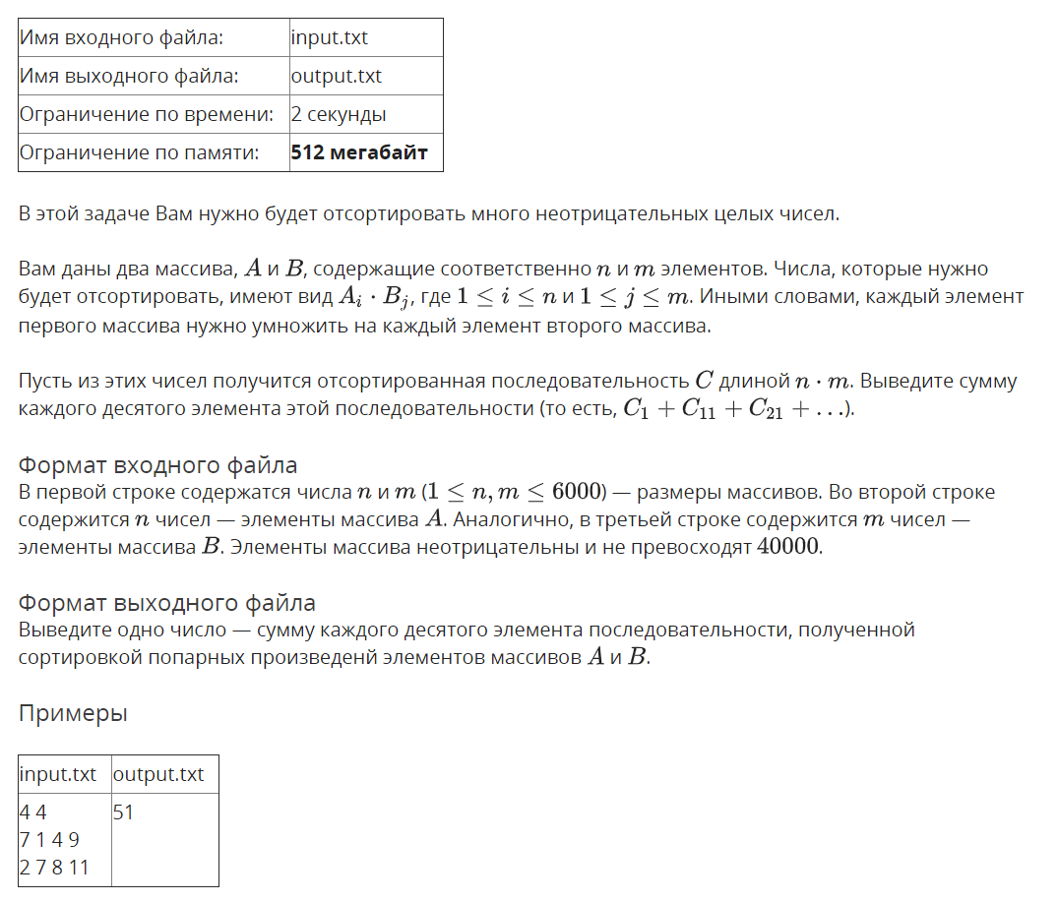

Решение

openedu/week3/lab3_1.cpp

#include "edx-io.hpp"

#include <vector>

#include <string>

#include <algorithm>

using namespace std;

int n, m;

# define KTH_BYTE(k, val) ((val) >> 8 * k) & 0xFF

int main() {

// read array sizes

io >> n >> m;

// read arrays

auto a = vector<int>(n);

auto b = vector<int>(m);

for (auto &e : a) io >> e;

for (auto &e : b) io >> e;

// compose array to sort

// STL vectors result in TLE! how's that possible

auto c = new int[n * m];

int max_val = 0;

int next;

for (int i = 0; i < n; i++){

for (int j = 0; j < m; j++) {

next = a[i] * b[j];

c[i*m + j] = next;

if (next > max_val) {

max_val = next;

}

}

}

// i - radix sort phase

auto result = new int[n * m];

auto counts = new int[256];

for (int byte_n = 0; (1LL << (byte_n * 8)) <= max_val; byte_n++) {

memset(counts, 0, 256 * sizeof(int));

// do element counting

for (int i = 0; i < n * m; i++) {

counts[KTH_BYTE(byte_n, c[i])]++;

}

// calculate prepending elements count for each element

for (int i = 1; i < 256; i++) {

counts[i] += counts[i - 1];

}

// assembling sorted array

for (int i = n * m - 1; i >= 0; i--) {

// calculate result position and set c[i] to it

result[--counts[KTH_BYTE(byte_n, c[i])]] = c[i];

}

memcpy(c, result, sizeof(int) * n * m);

}

// print order that we've got

long long sum = 0;

for (int i = 0; i < n * m; i += 10) {

sum += c[i];

}

io << sum;

return 0;

}

Результаты
№ теста | Результат | Время, с | Память | Размер входного файла | Размер выходного файла
Max |  | 1.859 | 289931264 | 68699 | 16
1 | OK | 0.000 | 2224128 | 24 | 2
2 | OK | 0.000 | 2224128 | 34 | 1
3 | OK | 0.015 | 2224128 | 38 | 2
4 | OK | 0.000 | 2236416 | 106 | 10
5 | OK | 0.000 | 2224128 | 234 | 11
6 | OK | 0.000 | 2240512 | 698 | 11
7 | OK | 0.000 | 2228224 | 705 | 12
8 | OK | 0.000 | 2236416 | 586 | 12
9 | OK | 0.000 | 2220032 | 34325 | 12
10 | OK | 0.000 | 2285568 | 5769 | 12
11 | OK | 0.000 | 2285568 | 3498 | 12
12 | OK | 0.000 | 2220032 | 924 | 12
13 | OK | 0.000 | 2269184 | 3494 | 12
14 | OK | 0.000 | 2269184 | 5772 | 12
15 | OK | 0.000 | 2220032 | 34449 | 12
16 | OK | 0.000 | 2351104 | 34368 | 13
17 | OK | 0.000 | 2293760 | 4006 | 13
18 | OK | 0.015 | 2314240 | 2886 | 13
19 | OK | 0.015 | 2293760 | 4009 | 13
20 | OK | 0.000 | 2347008 | 34361 | 13
21 | OK | 0.031 | 6668288 | 34966 | 14
22 | OK | 0.031 | 6623232 | 9167 | 14
23 | OK | 0.031 | 6619136 | 9162 | 14
24 | OK | 0.031 | 6668288 | 34917 | 14
25 | OK | 0.296 | 49881088 | 39991 | 15
26 | OK | 0.296 | 51863552 | 28668 | 15
27 | OK | 0.296 | 49881088 | 40034 | 15
28 | OK | 0.906 | 145903616 | 51489 | 15
29 | OK | 0.875 | 145903616 | 51525 | 15
30 | OK | 1.859 | 289931264 | 68655 | 16
31 | OK | 1.718 | 289931264 | 68625 | 16
32 | OK | 1.718 | 289931264 | 68699 | 16

Цифровая сортировка

Условие
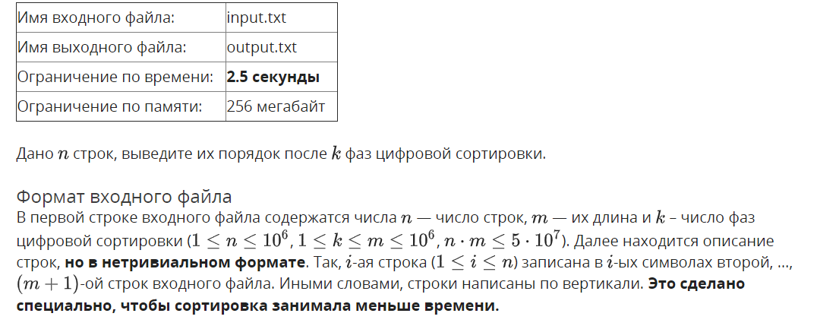
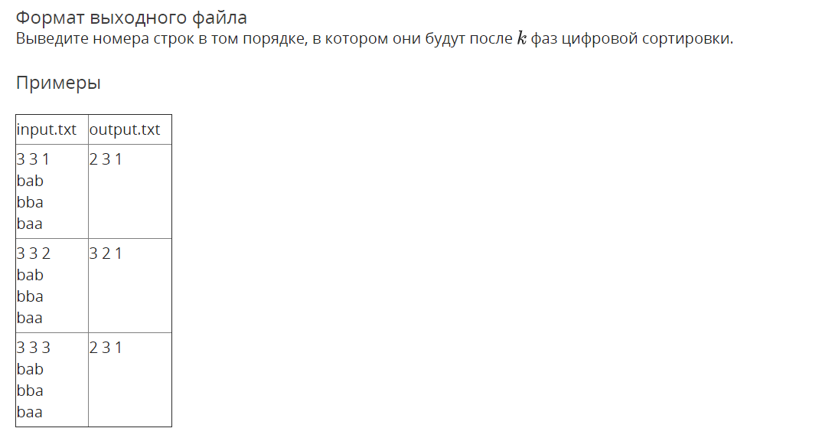

Решение

openedu/week3/lab3_2.cpp

#include "edx-io.hpp"

#include <vector>

#include <string>

#include <algorithm>

using namespace std;

int n, m, k;

vector<pair<char, int>> counting_sort(vector<pair<char, int>> &vec) {

// indices 97 - 122 (26 letters), shift = 97

auto counts = vector<int>(26, 0);

// do element counting

for (auto e : vec) {

counts[e.first - 'a']++;

}

// calculate prepending elements count for each element

for (int i = 1; i < counts.size(); i++) {

counts[i] += counts[i - 1];

}

// assembling sorted array

vector<pair<char, int>> result(vec.size());

for (int i = vec.size() - 1; i >= 0; i--) {

int result_position = --counts[vec[i].first - 'a'];

result[result_position] = vec[i];

}

return result;

}

int main() {

// read main input values

io >> n >> m >> k;

// read and store all m input strings in memory because they're in invalid order!

auto read_chars = vector<string>(m);

for (auto &str: read_chars) {

// read n chars - i-th chars of n strings

io >> str;

}

// will be sorted vector of pairs: strings' ith characters (i = 0..m-1) and their initial indices

auto sorted = vector<pair<char, int>>(n);

for (int i = 0; i < n; i++) {

// '-' is temporary: will be replaced by real char from input

sorted[i] = make_pair('-', i);

}

// i - radix sort phase

for (int i = 0; i < k; i++) {

// put read chars in appropriate order to "sorted" vec

for (int j = 0; j < n; j++) {

sorted[j].first = read_chars.back()[sorted[j].second];

}

read_chars.pop_back();

// stable counting sort by i-th chars

sorted = counting_sort(sorted);

}

// print order that we've got

for (auto p : sorted) {

io << p.second + 1 << ' ';

}

return 0;

}

Результаты
№ теста | Результат | Время, с | Память | Размер входного файла | Размер выходного файла
Max |  | 1.406 | 166260736 | 52000020 | 6888896
1 | OK | 0.015 | 2248704 | 22 | 6
2 | OK | 0.000 | 2248704 | 22 | 6
3 | OK | 0.015 | 2236416 | 22 | 6
4 | OK | 0.000 | 2236416 | 10 | 2
5 | OK | 0.000 | 2232320 | 11 | 4
6 | OK | 0.000 | 2248704 | 130 | 21
7 | OK | 0.015 | 2228224 | 129 | 21
8 | OK | 0.000 | 2236416 | 129 | 21
9 | OK | 0.000 | 2236416 | 129 | 21
10 | OK | 0.015 | 2236416 | 129 | 21
11 | OK | 0.000 | 2248704 | 230 | 51
12 | OK | 0.000 | 2236416 | 229 | 51
13 | OK | 0.000 | 2232320 | 229 | 51
14 | OK | 0.015 | 2236416 | 229 | 51
15 | OK | 0.000 | 2236416 | 229 | 51
16 | OK | 0.000 | 2236416 | 450 | 51
17 | OK | 0.000 | 2252800 | 449 | 51
18 | OK | 0.000 | 2232320 | 450 | 51
19 | OK | 0.000 | 2236416 | 449 | 51
20 | OK | 0.000 | 2248704 | 449 | 51
21 | OK | 0.000 | 2240512 | 530 | 141
22 | OK | 0.015 | 2260992 | 529 | 141
23 | OK | 0.000 | 2256896 | 529 | 141
24 | OK | 0.015 | 2240512 | 529 | 141
25 | OK | 0.000 | 2256896 | 529 | 141
26 | OK | 0.000 | 2244608 | 1212 | 21
27 | OK | 0.000 | 2236416 | 1210 | 21
28 | OK | 0.000 | 2236416 | 1211 | 21
29 | OK | 0.000 | 2236416 | 1211 | 21
30 | OK | 0.000 | 2256896 | 1211 | 21
31 | OK | 0.000 | 2232320 | 2031 | 692
32 | OK | 0.015 | 2240512 | 2030 | 692
33 | OK | 0.000 | 2236416 | 2030 | 692
34 | OK | 0.015 | 2236416 | 2030 | 692
35 | OK | 0.015 | 2248704 | 2030 | 692
36 | OK | 0.015 | 2248704 | 2610 | 141
37 | OK | 0.000 | 2248704 | 2609 | 141
38 | OK | 0.000 | 2260992 | 2610 | 141
39 | OK | 0.000 | 2260992 | 2610 | 141
40 | OK | 0.000 | 2248704 | 2609 | 141
41 | OK | 0.000 | 2256896 | 4051 | 692
42 | OK | 0.000 | 2260992 | 4050 | 692
43 | OK | 0.000 | 2240512 | 4051 | 692
44 | OK | 0.015 | 2244608 | 4051 | 692
45 | OK | 0.015 | 2256896 | 4051 | 692
46 | OK | 0.015 | 2252800 | 6012 | 21
47 | OK | 0.000 | 2252800 | 6010 | 21
48 | OK | 0.000 | 2265088 | 6012 | 21
49 | OK | 0.000 | 2252800 | 6012 | 21
50 | OK | 0.000 | 2252800 | 6010 | 21
51 | OK | 0.000 | 2269184 | 10213 | 292
52 | OK | 0.000 | 2260992 | 10211 | 292
53 | OK | 0.000 | 2252800 | 10212 | 292
54 | OK | 0.015 | 2260992 | 10212 | 292
55 | OK | 0.000 | 2273280 | 10212 | 292
56 | OK | 0.000 | 2277376 | 20052 | 3893
57 | OK | 0.015 | 2273280 | 20051 | 3893
58 | OK | 0.000 | 2285568 | 20052 | 3893
59 | OK | 0.000 | 2289664 | 20052 | 3893
60 | OK | 0.015 | 2293760 | 20051 | 3893
61 | OK | 0.000 | 2318336 | 26012 | 141
62 | OK | 0.000 | 2318336 | 26010 | 141
63 | OK | 0.000 | 2318336 | 26012 | 141
64 | OK | 0.000 | 2314240 | 26011 | 141
65 | OK | 0.000 | 2334720 | 26012 | 141
66 | OK | 0.000 | 2285568 | 40413 | 692
67 | OK | 0.000 | 2310144 | 40411 | 692
68 | OK | 0.000 | 2289664 | 40413 | 692
69 | OK | 0.000 | 2293760 | 40412 | 692
70 | OK | 0.000 | 2289664 | 40413 | 692
71 | OK | 0.000 | 2318336 | 52014 | 141
72 | OK | 0.000 | 2318336 | 52011 | 141
73 | OK | 0.015 | 2322432 | 52013 | 141
74 | OK | 0.015 | 2318336 | 52013 | 141
75 | OK | 0.000 | 2330624 | 52013 | 141
76 | OK | 0.000 | 2355200 | 102015 | 292
77 | OK | 0.000 | 2355200 | 102012 | 292
78 | OK | 0.000 | 2367488 | 102014 | 292
79 | OK | 0.000 | 2351104 | 102014 | 292
80 | OK | 0.000 | 2363392 | 102014 | 292
81 | OK | 0.000 | 2543616 | 200033 | 108894
82 | OK | 0.015 | 2551808 | 200032 | 108894
83 | OK | 0.015 | 2543616 | 200032 | 108894
84 | OK | 0.000 | 2547712 | 200032 | 108894
85 | OK | 0.015 | 2543616 | 200032 | 108894
86 | OK | 0.015 | 2445312 | 250112 | 23893
87 | OK | 0.000 | 2461696 | 250111 | 23893
88 | OK | 0.015 | 2457600 | 250112 | 23893
89 | OK | 0.015 | 2441216 | 250111 | 23893
90 | OK | 0.015 | 2457600 | 250112 | 23893
91 | OK | 0.015 | 2940928 | 400053 | 108894
92 | OK | 0.000 | 2945024 | 400052 | 108894
93 | OK | 0.015 | 2945024 | 400053 | 108894
94 | OK | 0.000 | 2945024 | 400053 | 108894
95 | OK | 0.015 | 2945024 | 400053 | 108894
96 | OK | 0.000 | 2891776 | 501014 | 3893
97 | OK | 0.000 | 2891776 | 501012 | 3893
98 | OK | 0.015 | 2891776 | 501014 | 3893
99 | OK | 0.000 | 2891776 | 501014 | 3893
100 | OK | 0.000 | 2891776 | 501013 | 3893
101 | OK | 0.031 | 3985408 | 1000414 | 23893
102 | OK | 0.000 | 3985408 | 1000412 | 23893
103 | OK | 0.015 | 3993600 | 1000414 | 23893
104 | OK | 0.015 | 3981312 | 1000413 | 23893
105 | OK | 0.015 | 3989504 | 1000414 | 23893
106 | OK | 0.093 | 10629120 | 2400018 | 21
107 | OK | 0.000 | 10625024 | 2400013 | 21
108 | OK | 0.093 | 10633216 | 2400018 | 21
109 | OK | 0.078 | 10633216 | 2400018 | 21
110 | OK | 0.093 | 10629120 | 2400018 | 21
111 | OK | 0.062 | 7639040 | 2500113 | 288894
112 | OK | 0.031 | 7639040 | 2500112 | 288894
113 | OK | 0.062 | 7639040 | 2500113 | 288894
114 | OK | 0.031 | 7639040 | 2500112 | 288894
115 | OK | 0.046 | 7634944 | 2500113 | 288894
116 | OK | 0.046 | 10326016 | 4004016 | 8893
117 | OK | 0.015 | 10334208 | 4004013 | 8893
118 | OK | 0.062 | 10326016 | 4004016 | 8893
119 | OK | 0.031 | 10330112 | 4004015 | 8893
120 | OK | 0.062 | 10330112 | 4004016 | 8893
121 | OK | 0.093 | 12652544 | 5000215 | 288894
122 | OK | 0.031 | 12652544 | 5000213 | 288894
123 | OK | 0.109 | 12652544 | 5000214 | 288894
124 | OK | 0.062 | 12652544 | 5000214 | 288894
125 | OK | 0.093 | 12652544 | 5000214 | 288894
126 | OK | 0.203 | 23457792 | 10000216 | 588895
127 | OK | 0.046 | 23453696 | 10000214 | 588895
128 | OK | 0.203 | 23457792 | 10000215 | 588895
129 | OK | 0.062 | 23457792 | 10000215 | 588895
130 | OK | 0.078 | 23457792 | 10000215 | 588895
131 | OK | 0.421 | 45064192 | 20000216 | 1288895
132 | OK | 0.078 | 45064192 | 20000214 | 1288895
133 | OK | 0.390 | 45064192 | 20000215 | 1288895
134 | OK | 0.281 | 45064192 | 20000215 | 1288895
135 | OK | 0.312 | 45064192 | 20000215 | 1288895
136 | OK | 0.406 | 52699136 | 25001015 | 288894
137 | OK | 0.078 | 52707328 | 25001013 | 288894
138 | OK | 0.390 | 52695040 | 25001015 | 288894
139 | OK | 0.250 | 52699136 | 25001015 | 288894
140 | OK | 0.187 | 52699136 | 25001015 | 288894
141 | OK | 0.578 | 84078592 | 26000018 | 141
142 | OK | 0.156 | 84070400 | 26000013 | 141
143 | OK | 0.609 | 84078592 | 26000018 | 141
144 | OK | 0.562 | 84078592 | 26000018 | 141
145 | OK | 0.421 | 84078592 | 26000018 | 141
146 | OK | 0.359 | 55164928 | 25100017 | 1892
147 | OK | 0.062 | 55099392 | 25100013 | 1892
148 | OK | 0.359 | 55164928 | 25100017 | 1892
149 | OK | 0.234 | 55164928 | 25100017 | 1892
150 | OK | 0.125 | 55164928 | 25100016 | 1892
151 | OK | 0.343 | 53051392 | 25010016 | 23893
152 | OK | 0.046 | 53055488 | 25010013 | 23893
153 | OK | 0.359 | 53051392 | 25010016 | 23893
154 | OK | 0.093 | 53055488 | 25010015 | 23893
155 | OK | 0.312 | 53051392 | 25010016 | 23893
156 | OK | 0.640 | 59867136 | 25000114 | 3388895
157 | OK | 0.156 | 59863040 | 25000113 | 3388895
158 | OK | 0.609 | 59867136 | 25000114 | 3388895
159 | OK | 0.296 | 59867136 | 25000114 | 3388895
160 | OK | 0.171 | 59867136 | 25000113 | 3388895
161 | OK | 0.546 | 84254720 | 40040018 | 8893
162 | OK | 0.078 | 84258816 | 40040014 | 8893
163 | OK | 0.546 | 84254720 | 40040018 | 8893
164 | OK | 0.265 | 84254720 | 40040017 | 8893
165 | OK | 0.437 | 84267008 | 40040018 | 8893
166 | OK | 0.640 | 93782016 | 40400019 | 692
167 | OK | 0.125 | 93761536 | 40400014 | 692
168 | OK | 0.671 | 93782016 | 40400019 | 692
169 | OK | 0.312 | 93782016 | 40400018 | 692
170 | OK | 0.140 | 93761536 | 40400016 | 692
171 | OK | 0.562 | 82370560 | 40004017 | 108894
172 | OK | 0.093 | 82370560 | 40004014 | 108894
173 | OK | 0.578 | 82370560 | 40004017 | 108894
174 | OK | 0.265 | 82366464 | 40004016 | 108894
175 | OK | 0.359 | 82370560 | 40004017 | 108894
176 | OK | 0.812 | 85082112 | 40000416 | 1288895
177 | OK | 0.125 | 85082112 | 40000414 | 1288895
178 | OK | 0.890 | 85082112 | 40000416 | 1288895
179 | OK | 0.218 | 85082112 | 40000415 | 1288895
180 | OK | 0.140 | 85082112 | 40000414 | 1288895
181 | OK | 0.921 | 133156864 | 51000019 | 292
182 | OK | 0.218 | 133152768 | 51000014 | 292
183 | OK | 0.953 | 133156864 | 51000019 | 292
184 | OK | 0.265 | 133160960 | 51000018 | 292
185 | OK | 0.703 | 133156864 | 51000019 | 292
186 | OK | 0.703 | 105156608 | 50100018 | 3893
187 | OK | 0.125 | 105050112 | 50100014 | 3893
188 | OK | 0.687 | 105156608 | 50100018 | 3893
189 | OK | 0.265 | 105156608 | 50100018 | 3893
190 | OK | 0.437 | 105156608 | 50100018 | 3893
191 | OK | 1.406 | 117891072 | 50000115 | 6888896
192 | OK | 0.312 | 117891072 | 50000114 | 6888896
193 | OK | 1.328 | 117891072 | 50000115 | 6888896
194 | OK | 0.890 | 117891072 | 50000115 | 6888896
195 | OK | 1.187 | 117891072 | 50000115 | 6888896
196 | OK | 0.750 | 108507136 | 50200019 | 1892
197 | OK | 0.125 | 108445696 | 50200014 | 1892
198 | OK | 0.734 | 108503040 | 50200018 | 1892
199 | OK | 0.453 | 108507136 | 50200018 | 1892
200 | OK | 0.578 | 108507136 | 50200018 | 1892
201 | OK | 0.828 | 103518208 | 50001016 | 588895
202 | OK | 0.109 | 103530496 | 50001014 | 588895
203 | OK | 0.828 | 103518208 | 50001016 | 588895
204 | OK | 0.531 | 103518208 | 50001016 | 588895
205 | OK | 0.187 | 103518208 | 50001015 | 588895
206 | OK | 0.765 | 102756352 | 50002017 | 288894
207 | OK | 0.109 | 102764544 | 50002014 | 288894
208 | OK | 0.734 | 102756352 | 50002016 | 288894
209 | OK | 0.437 | 102756352 | 50002016 | 288894
210 | OK | 0.734 | 102756352 | 50002016 | 288894
211 | OK | 1.156 | 109879296 | 50000216 | 3388895
212 | OK | 0.187 | 109879296 | 50000214 | 3388895
213 | OK | 1.140 | 109879296 | 50000215 | 3388895
214 | OK | 0.968 | 109879296 | 50000215 | 3388895
215 | OK | 0.750 | 109879296 | 50000215 | 3388895
216 | OK | 1.203 | 166256640 | 52000020 | 141
217 | OK | 0.296 | 166252544 | 52000014 | 141
218 | OK | 1.234 | 166256640 | 52000019 | 141
219 | OK | 1.078 | 166248448 | 52000019 | 141
220 | OK | 0.343 | 166260736 | 52000018 | 141
221 | OK | 0.703 | 103845888 | 50010017 | 48894
222 | OK | 0.109 | 103854080 | 50010014 | 48894
223 | OK | 0.718 | 103849984 | 50010017 | 48894
224 | OK | 0.296 | 103849984 | 50010017 | 48894
225 | OK | 0.250 | 103845888 | 50010017 | 48894
226 | OK | 0.687 | 103981056 | 50020018 | 23893
227 | OK | 0.109 | 103948288 | 50020014 | 23893
228 | OK | 0.671 | 103981056 | 50020017 | 23893
229 | OK | 0.609 | 103989248 | 50020017 | 23893
230 | OK | 0.609 | 103989248 | 50020017 | 23893

