Лабораторная работа № 1

по дисциплине «Алгоритмы и структуры данных»

Openedu – неделя 1

Подготовил:

студент группы P3217

Бураков Илья Алексеевич

Преподаватели:

Романов Алексей Андреевич

Волчек Дмитрий Геннадьевич

# Задача «a+b»

## Условие

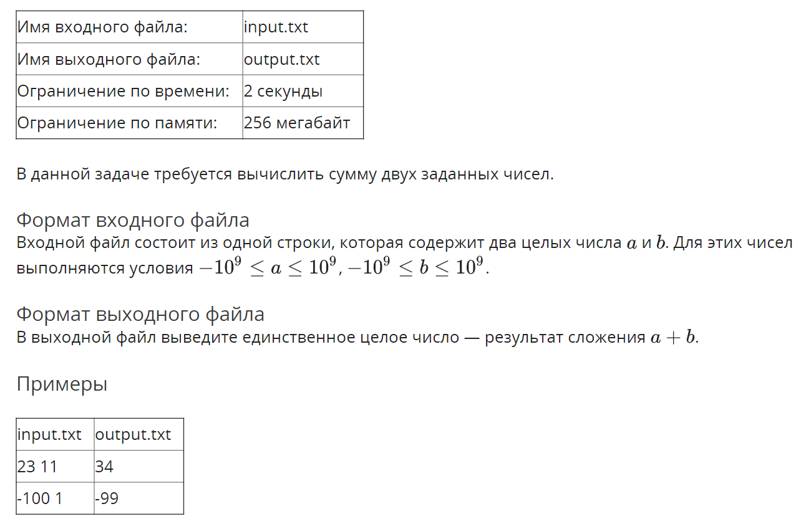

## Решение

openedu/week1/lab1_1.py

from edx_io import edx_io

# testing official course io wrapper for Python

with edx_io() as io:

io.writeln(io.next_int() + io.next_int())

## Результаты

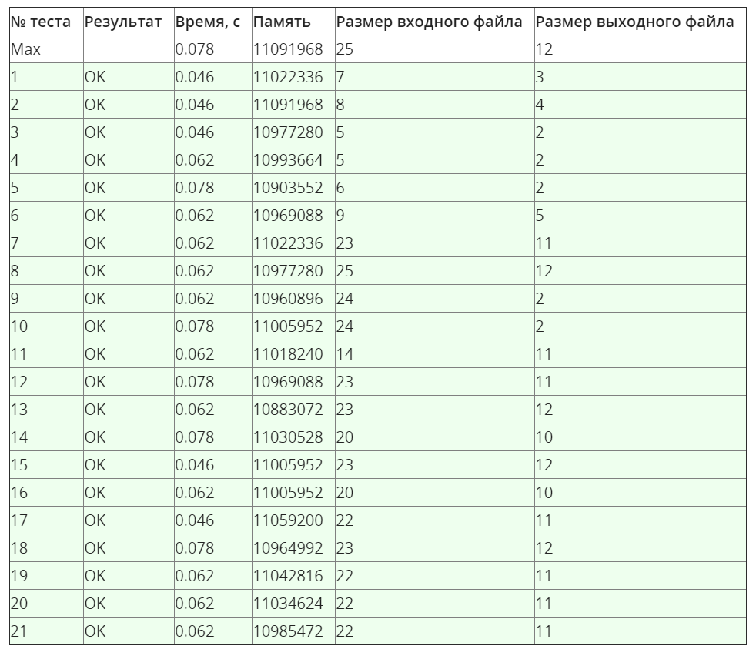



# Задача «a+b^2»

## Условие

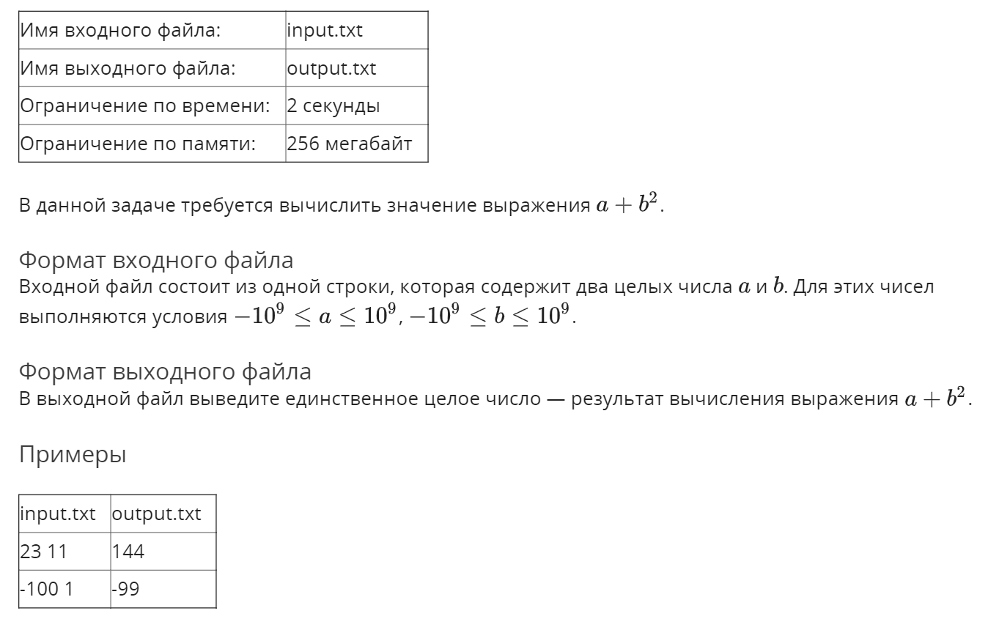

## Решение

openedu/week1/lab1_2.py

from edx_io import edx_io

with edx_io() as io:

io.writeln(io.next_int() + io.next_int() ** 2)

## Результаты

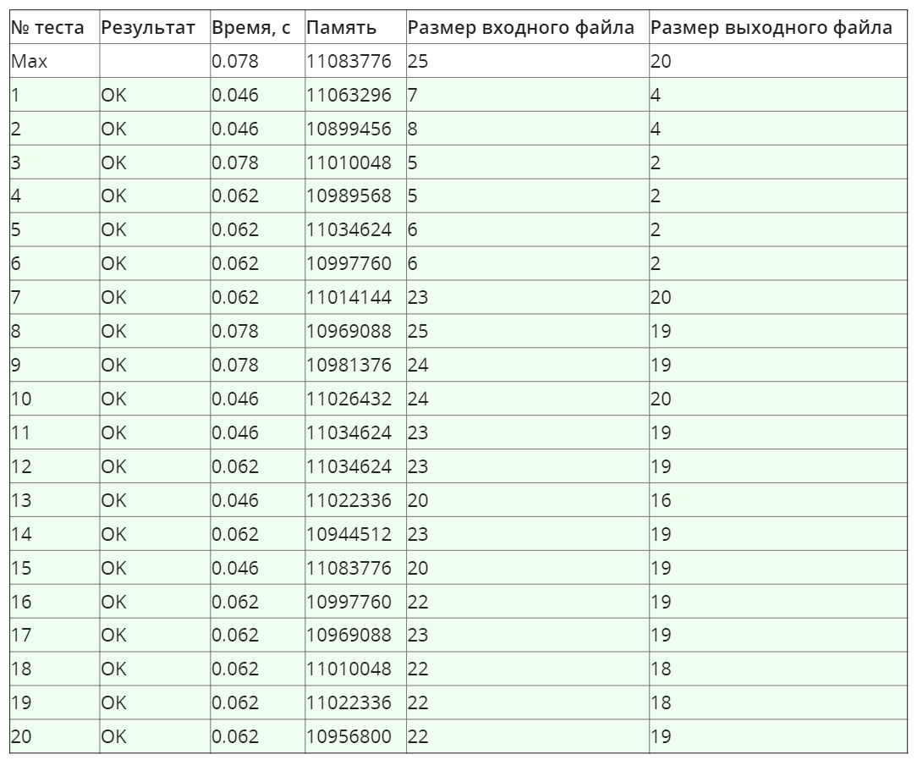

## Сортировка вставками

## Условие

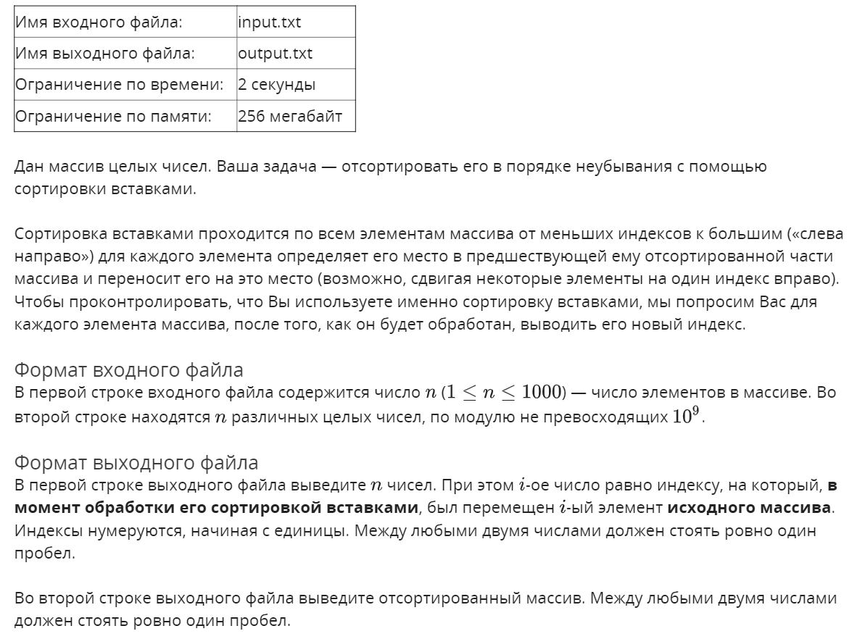

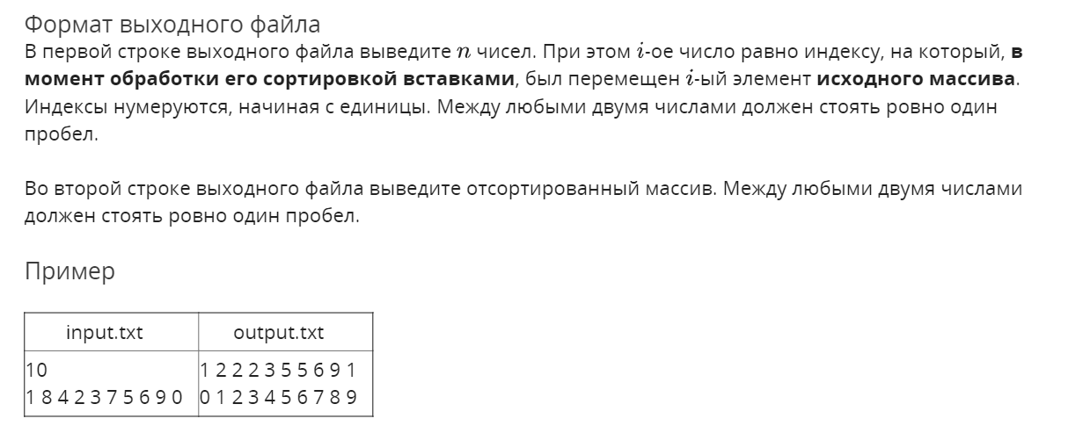

## Решение

openedu/week1/lab1_3.py

from edx_io import edx_io

with edx_io() as io:

# read input

n = io.next_int()

arr = [io.next_int() for i in range(n)]

# list for saving intermediate indices

indices = []

# perform soring

for i in range(n):

for j in range(i - 1, -1, -1):

if arr[j] > arr[j+1]:

# if the order is wrong, swap 'em all!

arr[j], arr[j+1] = arr[j+1], arr[j]

else:

# else remember the index or the inserted element, as requested

# need j+1, indexing from 1

indices.append(j + 2)

# and go for inserting the next element

break

else:

# if we reached the beginning, put 1 as index

indices.append(1)

# write results

io.writeln(indices)

io.writeln(arr)

## Результаты

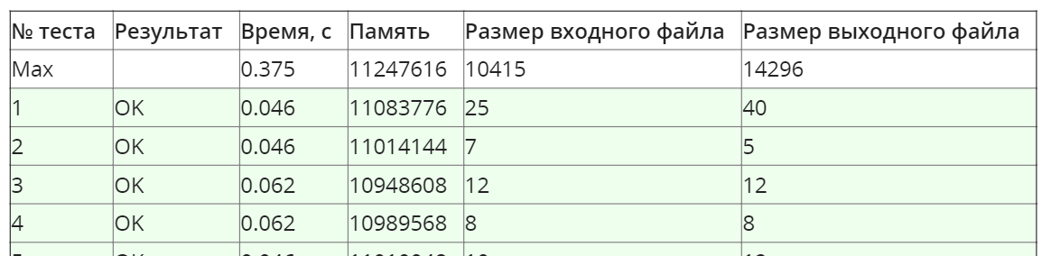

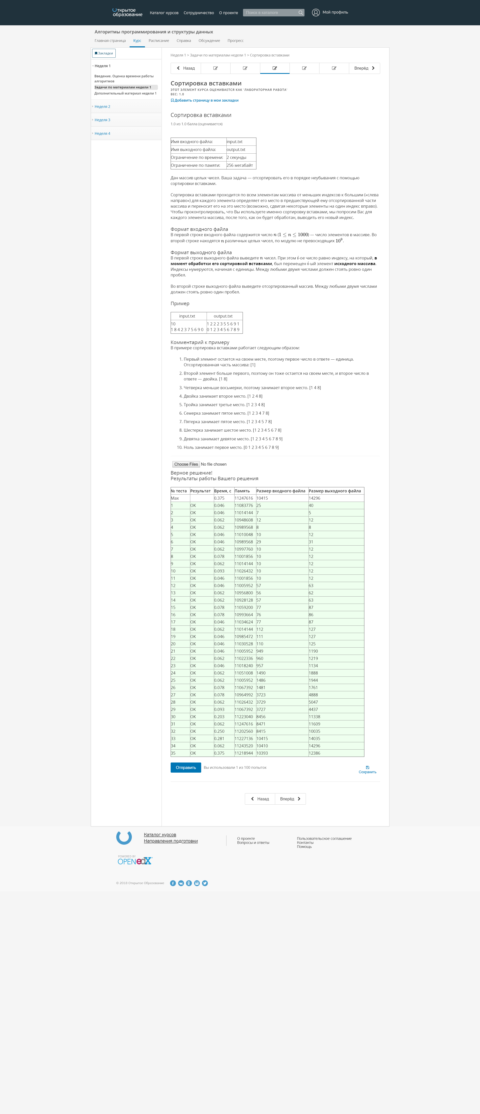

## Знакомство с жителями Сортлэнда

## Условие

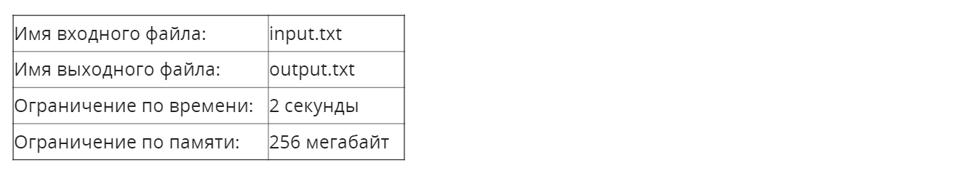

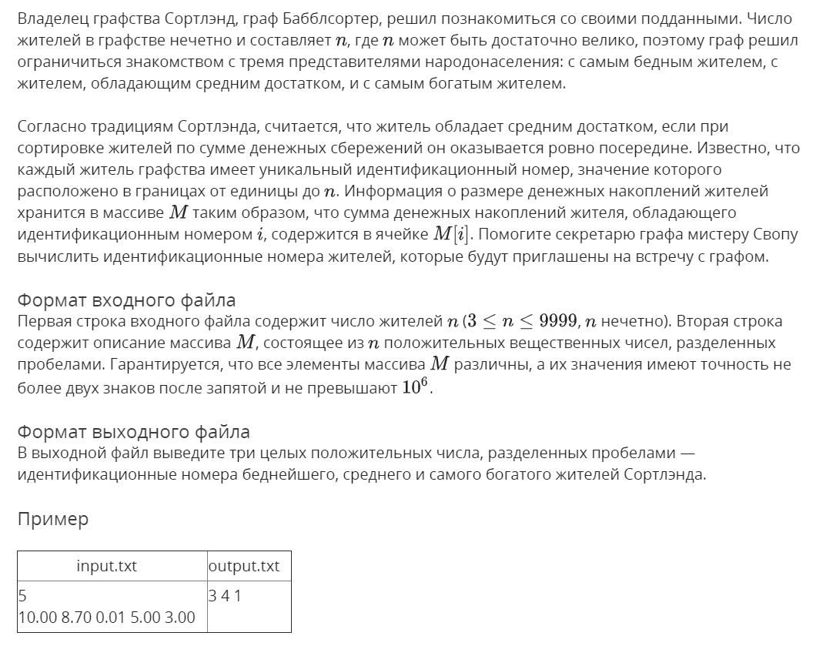

## Решение

openedu/week1/lab1_4.py

from edx_io import edx_io

with edx_io() as io:

# read input

n = io.next_int()

incomes = [(io.next_float(), i + 1) for i in range(n)]

# perform sorting

# I tried Insertion Sort, even with Cython optimizations - time limit exceeded :(

# bad time or variable limits, imo

# thus using stable O(nlogn) sort here, they deserve it

incomes.sort()

# write results

io.writeln((incomes[0][1], incomes[n // 2][1], incomes[-1][1]))

## Результаты

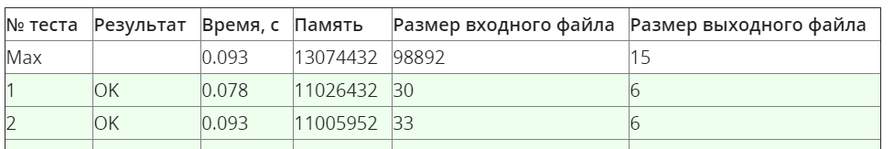

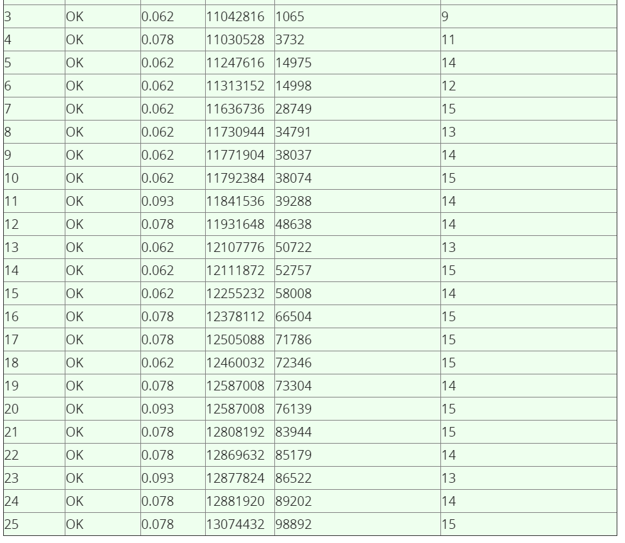

## Секретарь Своп

## Условие

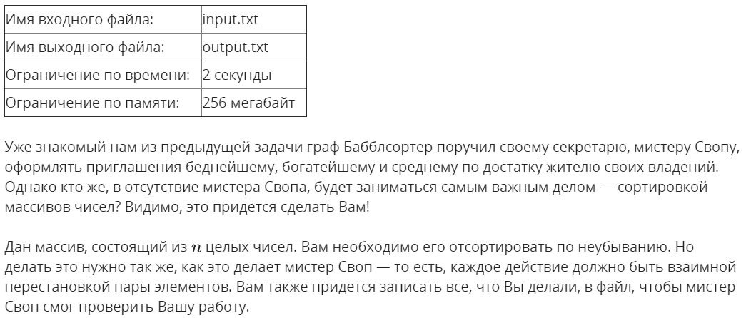

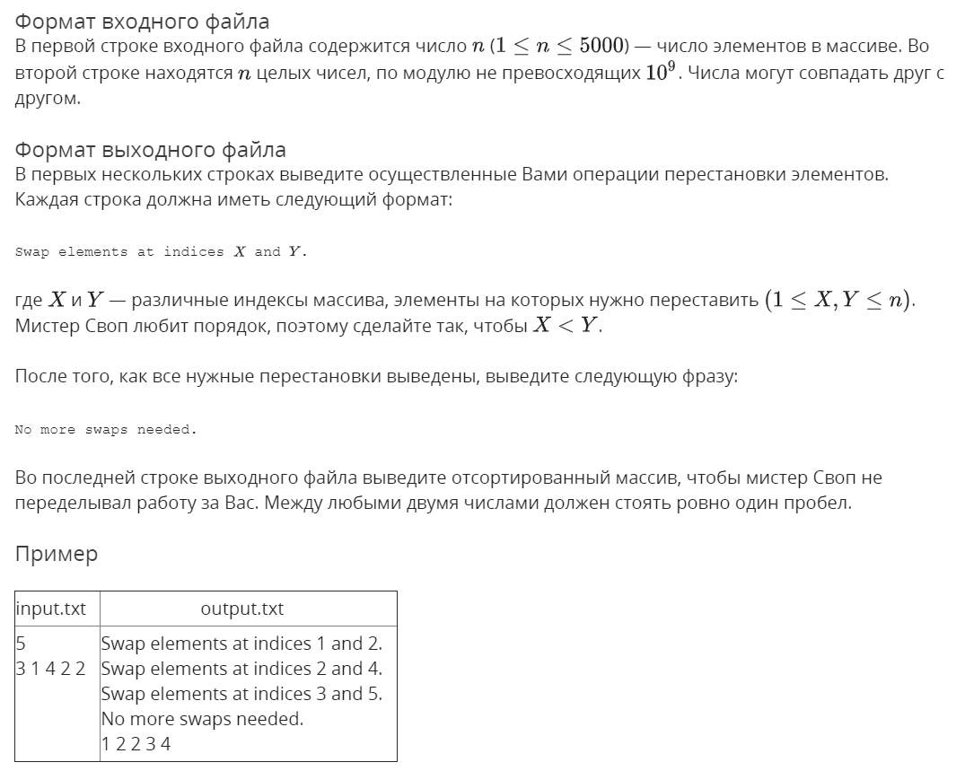

## Решение

openedu/week1/lab1_5.py

from edx_io import edx_io

with edx_io() as io:

# read input

n = io.next_int()

incomes = [io.next_int() for i in range(n)]

# perform sorting swaps not to bloat io (selection sort)

for i in range(n - 1):

# find min value and its index

mi = incomes.index(min(incomes[i:]), i)

# swap current and min

if mi != i:

incomes[mi], incomes[i] = incomes[i], incomes[mi]

io.writeln(f"Swap elements at indices {i + 1} and {mi + 1}.")

# write results

io.writeln("No more swaps needed.")

io.writeln(incomes)

## Результаты

