1. 1
2. 0

1 0 0 1

1 0 0 1

0 0 1 1

Truth Table

|  |  |  |  |  |  |  |
| --- | --- | --- | --- | --- | --- | --- |
| C1 prev | C2 prev | C3 prev | M | C1 | C2 | C3 |
| 0 | 0 | 0 | 0 | 1 | 1 | 1 |
| 0 | 0 | 0 | 1 | 0 | 0 | 1 |
| 0 | 0 | 1 | 0 | 0 | 0 | 0 |
| 0 | 0 | 1 | 1 | 0 | 1 | 0 |
| 0 | 1 | 0 | 0 | 0 | 0 | 1 |
| 0 | 1 | 0 | 1 | 0 | 1 | 1 |
| 0 | 1 | 1 | 0 | 0 | 1 | 0 |
| 0 | 1 | 1 | 1 | 1 | 0 | 0 |
| 1 | 0 | 0 | 0 | 0 | 1 | 1 |
| 1 | 0 | 0 | 1 | 1 | 0 | 1 |
| 1 | 0 | 1 | 0 | 1 | 0 | 0 |
| 1 | 0 | 1 | 1 | 1 | 1 | 0 |
| 1 | 1 | 0 | 0 | 1 | 0 | 1 |
| 1 | 1 | 0 | 1 | 1 | 1 | 1 |
| 1 | 1 | 1 | 0 | 1 | 1 | 0 |
| 1 | 1 | 1 | 1 | 0 | 0 | 0 |

K-Map for C1

|  |  |  |  |  |
| --- | --- | --- | --- | --- |
| C3M \ C1C2 | 00 | 01 | 11 | 10 |
| 00 | 1 | 0 | 1 | 0 |
| 01 | 0 | 0 | 1 | 1 |
| 11 | 0 | 1 | 0 | 1 |
| 10 | 0 | 0 | 1 | 1 |

K-Map for C2

|  |  |  |  |  |
| --- | --- | --- | --- | --- |
| C3M \ C1C2 | 00 | 01 | 11 | 10 |
| 00 | 1 | 0 | 0 | 1 |
| 01 | 0 | 1 | 1 | 0 |
| 11 | 1 | 0 | 0 | 1 |
| 10 | 0 | 1 | 1 | 0 |

K-Map for C3

|  |  |  |  |  |
| --- | --- | --- | --- | --- |
| C3M \ C1C2 | 00 | 01 | 11 | 10 |
| 00 | 1 | 1 | 1 | 1 |
| 01 | 1 | 1 | 1 | 1 |
| 11 | 0 | 0 | 0 | 0 |
| 10 | 0 | 0 | 0 | 0 |

DC1 = C1’C2’C3’M’ + C1’C2C3M + C1C2C3’ + C1C2’M + C1C3M’

DC2 = C2’ C3’M’ + C2 C3’M + C2’ C3M + C2C3M’

DC3 = C3’

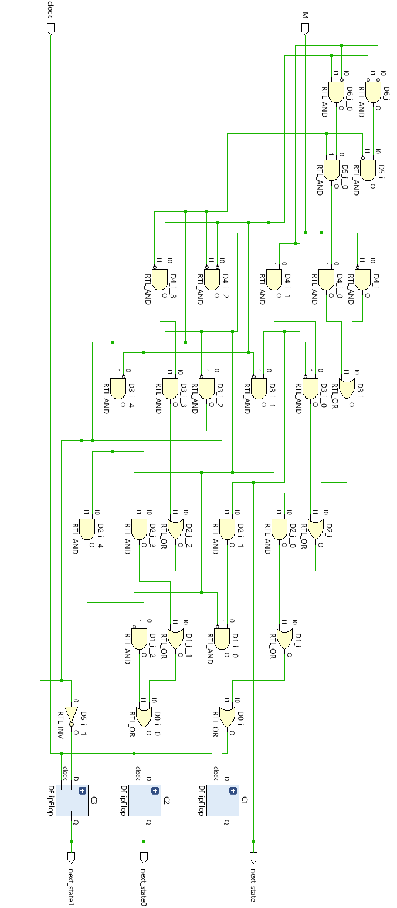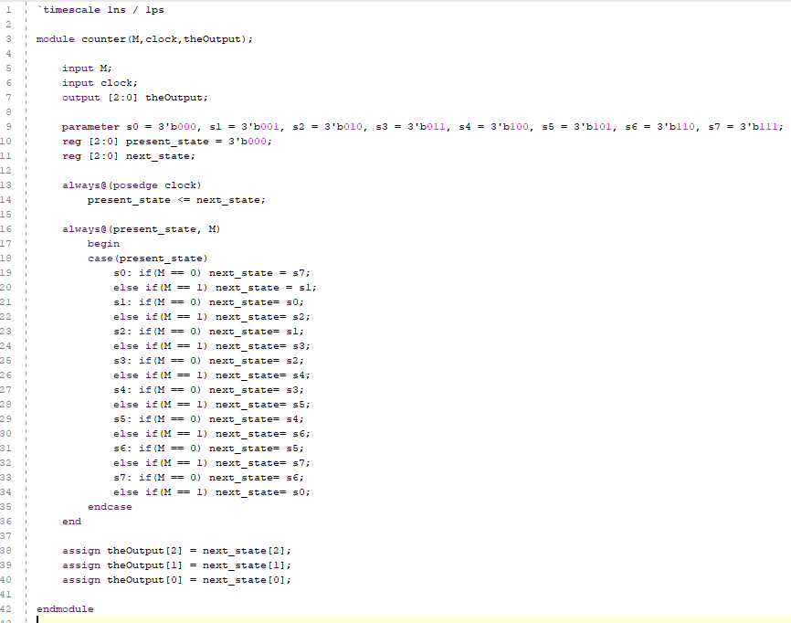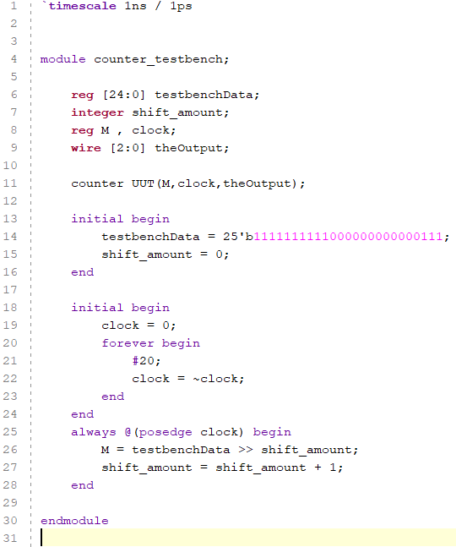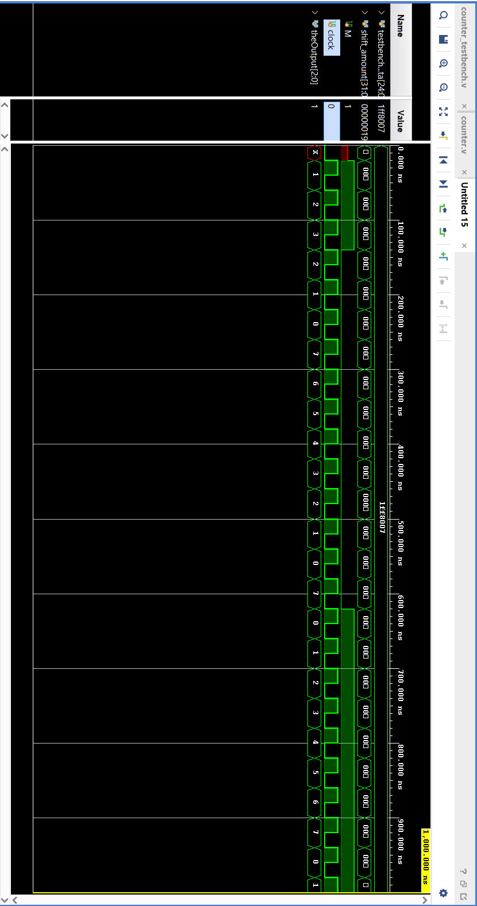

İbrahim Burak Tanrıkulu 21827852

Şerife Ebru Yardım 21785784

BBM 233 Lab Experiment 5