**Homework I**

**Spss Analysis of Frequency Tables, Related Graphs and Descriptive Statistics with Comments**

İbrahim Burak Tanrıkulu 21827852 V101(CX)

**The data is about weekly studying hours of randomly selected 50 students from Faculty of Engineering.**

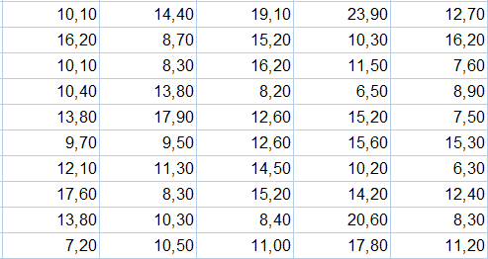 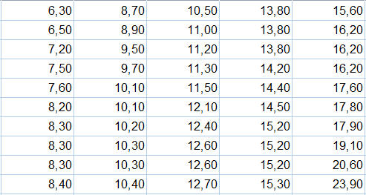

Given data Sorted given data

Data type of this data is Quantitative ( Continuous ) data and scale of it is “interval”.

Minimum value of this data is “6,30” and maximum value of this data is “23,90”.

**Frequency Table**

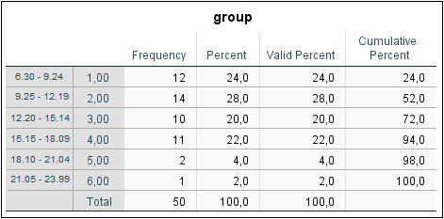

Highest frequency is 14 with %28 percentage that means most of the students study 9,25 – 12,19 hours.

Lowest frequency is 1 with %2 percentage that means just one student studies more than 21 hours.

Students rarely ( %6 ) study more than 18 hours.

**Graphs**

**Histogram**

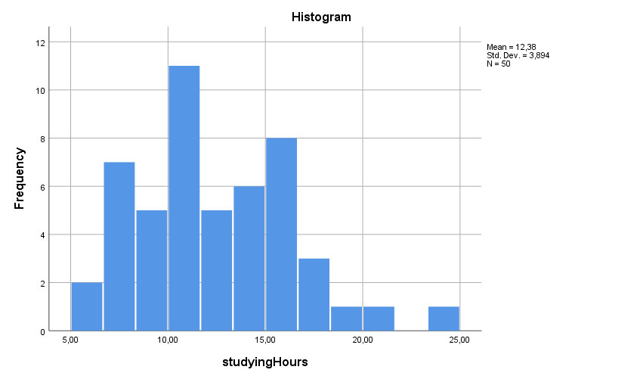

**Boxplot**

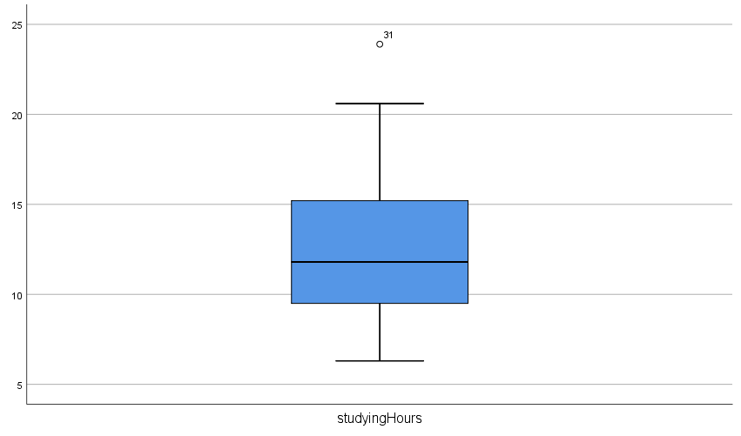

**studyingHours Stem-and-Leaf Plot**

Frequency Stem & Leaf

14,00 0 . 66777888888899

22,00 1 . 0000000111122222333444

12,00 1 . 555556667779

1,00 2 . 0

1,00 Extremes (>=24)

Stem width: 10,00

Each leaf: 1 case(s)

Most of the values in range of 10,0 – 10,5.

|  |  |  |
| --- | --- | --- |
| **Statistics** | | |
| studyingHours | | |
| N | Valid | 50 |
| Missing | 0 |
| Mean | | 12,3840 |
| Median | | 11,8000 |
| Mode | | 8,30a |
| Std. Deviation | | 3,89449 |
| Variance | | 15,167 |
| Skewness | | ,660 |
| Std. Error of Skewness | | ,337 |
| Kurtosis | | ,231 |
| Std. Error of Kurtosis | | ,662 |
| Minimum | | 6,30 |
| Maximum | | 23,90 |
| Percentiles | 25 | 9,3500 |
| 50 | 11,8000 |
| 75 | 15,2000 |
| a. Multiple modes exist. The smallest value is shown | | |

**Comments of Graph Shape:**

In this table, mean > median.

So, This table is “right-skewed” and asymetric.

Values in this table, morstly gathered from left side

and it reached peak at 10 - 11 hours. Graph is unimodal.

Kurtosis coefficient > 0. So, graph is leptokurtic.

There is one value outside of whiskers. So, there is an outlier

in this graph and it is “23.90” (max value).

In stem-and-leaf plot, we see most of the values in 10,0 – 10,5

In boxplot, we see that median is not in the middle of the box.

It is lower than middle. So, our graph is positive skewed.

**Other Comments**

Variance is low. So data values are near from mean.

Q1:

%25 of values are smaller than 9.35 and

%75 of values are larger than 9.35.

Q2:

%50 of values are smaller than 11.80 and

%50 of values are larger than 11.80.

Q3:

%75 of values are smaller than 15.20 and

%25 of values are larger than 15.20.

In the graph there are 4 modes with frequency of 3 : 8,30 – 13,80 – 15,20 – 16,20 .