**Homework II**

**Confidence Intervals and Hypothesis Tests**

İbrahim Burak Tanrıkulu 21827852 V101(CX)

**Part 1:**

In 1897, legislature was introduced in Indiana which would make 3.2 the official value of pi for the State.

a) Test whether the claim is true, by using the data given in the excel file “pi_data-05” at significance level 0.05.

b) Estimate 95% confidence interval of pi value.

Following table shows 25 random values are generated by using a code for pi:

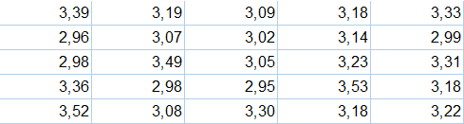Let’s create Hypothesis:

H0 : μ = 3.20

H1 : μ ≠ 3.20

Variance is unknown and n<30. So we will use One Sample T test

Outputs of SPSS:

|  |  |  |  |  |
| --- | --- | --- | --- | --- |
| **One-Sample Statistics** | | | | |
|  | N | Mean | Std. Deviation | Std. Error Mean |
| PiData | 25 | 3,1888 | ,17777 | ,03555 |

|  |  |  |  |  |  |  |
| --- | --- | --- | --- | --- | --- | --- |
| **One-Sample Test** | | | | | | |
|  | Test Value = 3.20 | | | | | |
| t | df | Sig. (2-tailed) | Mean Difference | 95% Confidence Interval of the Difference | |
| Lower | Upper |
| PiData | -,315 | 24 | ,755 | -,01120 | -,0846 | ,0622 |

Test statistic’s value *t* = -0,315 and critical value is *t0.025,24* = 2,064. │-0,315│ < 2,064.

Also p value = 0,755 is greater than α = 0,05. So H0 cannot be rejected.

Confidence interval is P(3,1154 ≤ μ ≤ 3,2622) = 0,95 . This interval includes μ1 – μ2 = 0.

Claim is true at the significance level of α=0,05 with %95 confidence interval.

We can say that official value of pi is 3,2 .

**Part 2:**

In automobile manufacture, the manager claims that new engines release less carbon dioxide in air than standard engines. For this aim, 10 standard engines and 10 new engines have been controlled and their carbon emissions values are given in excel file “engine_data-05”.

a) Test whether the claim is true at significance level 0.05.

b) Estimate 95% confidence interval of the difference between the standard and new engines carbon emissions means.

Following table shows 10 standard engines’s and 10 new engines’s carbon emissions values.

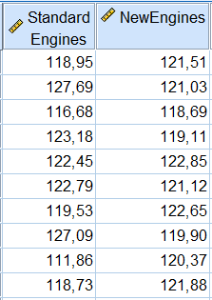

Let’s create Hypothesis:

H0 : μ1 > μ2

H1 : μ1 ≤ μ2

Before testing these hypothesis, we need decide σ12 = σ22 or not.

H0 : σ12 = σ22

H1 : σ12 ≠ σ22

Variances are unknown and n<30. So we will use Independent Samples T test.

Outputs of SPSS:

|  |  |  |  |  |  |
| --- | --- | --- | --- | --- | --- |
| **Group Statistics** | | | | | |
|  | Type | N | Mean | Std. Deviation | Std. Error Mean |
| Engine | Standard | 10 | 120,8950 | 4,77855 | 1,51111 |
| New | 10 | 120,9110 | 1,39963 | ,44260 |

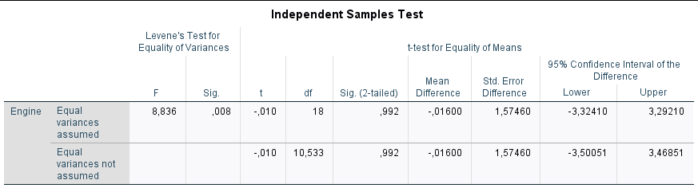

We will decide these variances is equal or not with Levene’s Test.

As we can see in the table; Levene’s test’s significance value p = 0,008 < α = 0,05 .

As a result H0 : σ12 = σ22 is rejected. We can say that variances are different.

Since σ12 ≠ σ22 , for the hypothesis we use second line of the independent samples test table.

Test statistic’s value *t* = -0,010 and critical value ≈ 2,210. │-0,010│ < 2,210

Also p value p = 0,992 > α = 0,05. So H0 is cannot be rejected.

Confidence interval (-3,50051; 3,46851) includes μ1 – μ2 = 0. H0 cannot be rejected.

Claim is true at the significance level of α=0,05 with %95 confidence interval.

We can say that new engines release less carbon dioxide in air than standard engines.