EXERCISES FOR SECTION 2 AND SECTION 3

1. A digital scale is used that provides weights to the nearest gram. This scale rounds the weights to the nearest integer.

a) What is the sample space for this experiment?

Let A denote the event that a weight exceeds 11 grams, let B denote the event that a weight is less than or equal to 15 grams, and let C denote the event that a weight is greater than or equal to 8 grams and less than 12 grams.

b)  c)  d) 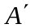 e)  f) 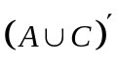 g) 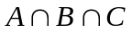 h) 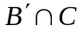
i) 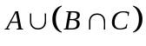

Solution:

a) 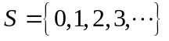 b)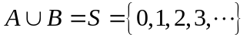 c) 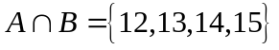
d) 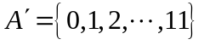 e)  f) 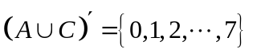
g) 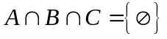 h) 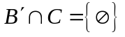 i) 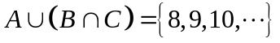

2. The rise time of a reactor is measured in minutes (and fractions of minutes). Let the sample space be positive, real numbers. Define the events A and B as follows:

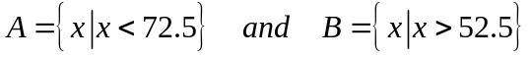

Describe each of the following events:

a) b) 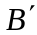 c) d)

Solution:

a) 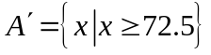 b) 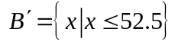 c) 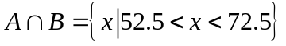
d) 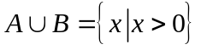

3. Orders for a computer are summarized by the optional features that are requested as follows:

 | proportion of orders
no optional feature | 0.3
one optional feature | 0.5
more than one optional feature | 0.2

- What is the probability that an order requests at least one optional feature?
- What is the probability that an order does not request more than one optional feature?

Solution:
a)

b)
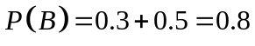

4. Disk of polycarbonate plastic from a supplier are analyzed for scratch and shock resistance. The results from 100 disks are summarized as follows:

 |  | shock resistance
 |  | high | low
scratch  resistance | high | 70 | 9
scratch  resistance | low | 16 | 5

Let A denote the event that a disk has high shock resistance, and let B denote the event that a disk has high scratch resistance. If a disk is selected at random, determine the following probabilities.

a) 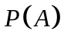 b) 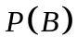 c) 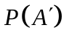 d) 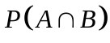 e) 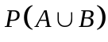 f) 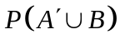 g) 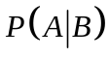
h) 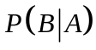

Solution:

a) 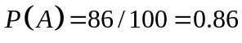 b) 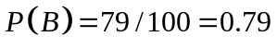 c) 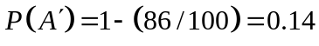
d) 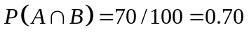
e)

f) 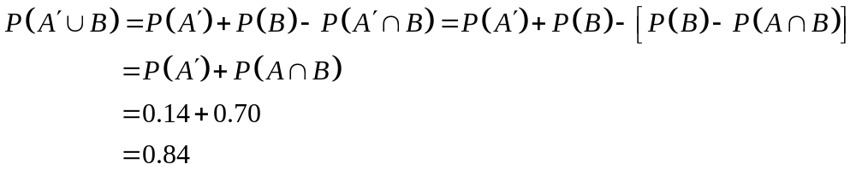

g) 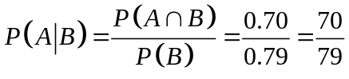
h) 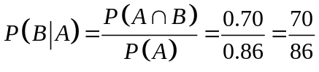

5. If 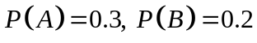 and 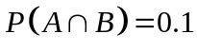, determine the following probabilities:

a) b) c) 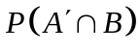 d) 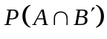 e) 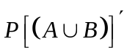 f)

Solution:

a) 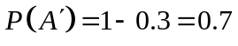 b)
c)
d)
e) 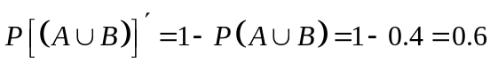 (from part b)
f) 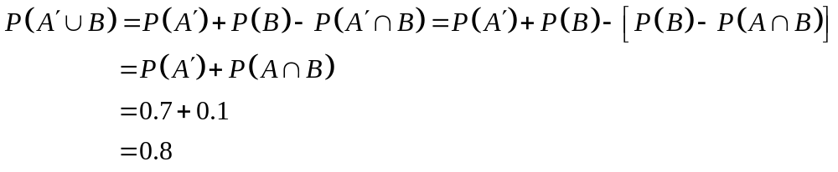

6. The analysis of shafts (mil, dingil, aks) for a compressor (sıkıştırıcı) is summarized by conformance to specifications:

 |  | roundness conforms
 |  | yes | no
surface finish | yes | 345 | 5
conforms | no | 12 | 8

Solution:

- If we know that a shaft conforms to roundness requirements, what is the probability that it conforms to surface finish requirements?

- If we know that a shaft does not conform to roundness requirements, what is the probability that it conforms to surface finish requirements?

Solution:

a) 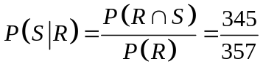 b) 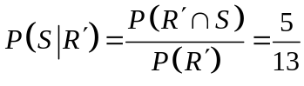

7. Suppose that 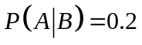, 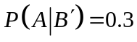, and 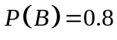. What is ?

Solution:

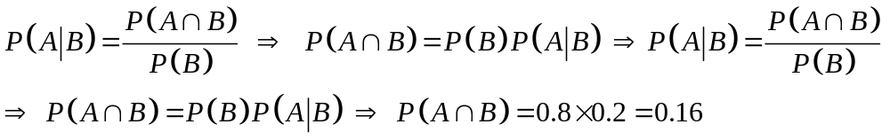

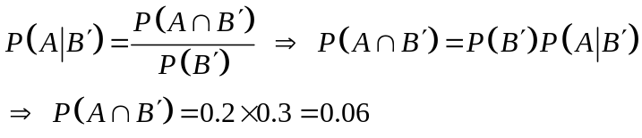

8. Suppose 2% of cotton fabric rolls and 3% of nylon fabric rolls contain flaws (kusur). Of the rolls used by a manufacturer, 70 % are cotton and 30 % are nylon. What is the probability that a randomly selected roll used by the manufacturer contains flaws?

Solution:

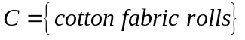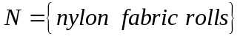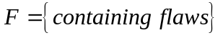

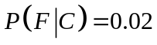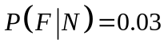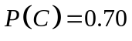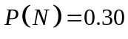

9. If 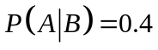, and 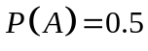 are the events A and B independent?

Solution:

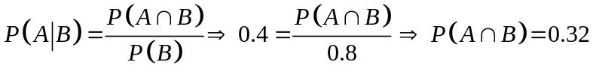

If only if 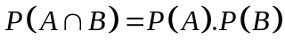 then A and B are independent events.

So that 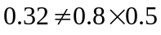 then A and B are not independent events.

10. Because a new medical procedure has been shown to be effective in the early detection of an illness, a medical screening of the population is proposed. The probability that the test correctly identifies someone with the illness as positive is 0.99, and the probability that the test correctly identifies someone without the illness as negative is 0.95. The incidence (raslantı, etki alanı) of the illness in the general population is 0.0001. You take the test, and the result is positive. What is the probability that you have the illness?

Solution:

Let D denote the event that you have the illness, and let S the event that the test signals positive. The probability requested can be denoted as 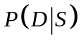. The probability that the test correctly signals someone without the illness as negative is 0.95. Consequently, the probability of a positive test without the illness is 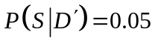. From Bayes’ Theorem,

Surprisingly, even though the test is effective, in the sense that 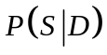 is high and 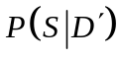 is low, because the incidence of the illness in the general population is low, the chances are quite small that you actually have the disease even if the test is positive.

