Pacman:

Getting Started:
Just double-click on the pacman.jar file, and enjoy! It's that simple!
Once you're on the main menu, either choose Start Game or Watch Demo to do either of those 2 actions, and if you wish to leave, just choose quit.

Controls:
Menu:
Move with the arrow keys, and hit Enter to choose options.
Game:
Press W to move forward, S to move back, and A or D to strafe.
Move the mouse to look around.
Highscore Submission:
Just type letters, and they'll show up! And press Enter to submit!

Gameplay:
You are Pacman. You are stuck in this maze, haunted by 4 angry ghosts. You goal is simple: Fight your way through the levels, and survive as long as possible, while getting as many points as possible.

Objects:
Pellets:

Pick these up and get 10 points!

Energizer:

When you eat these, you become mighty and powerul, and can even defeat the ghosts... for a while. But be careful that you're not in danger when it runs out!

Bonuses:

Pick these up, and get a lot of points!

Ghosts:
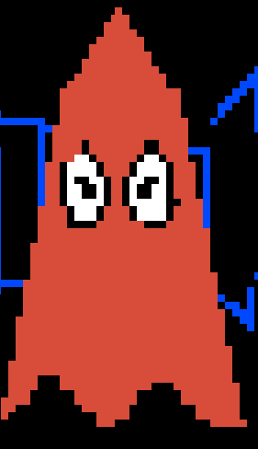
These angry ghosts will try to kill you, so watch out for them!

The HUD:
At the bottom right of your screen is the mini-map. It shows you the area around you. But it doesn't display the ghosts, so watch out!
And at the bottom left, it shows your score and your lives. When you run out of lives, it's game over, so be careful!

Game End:
When the game ends, you'll get the opportunity to input your initials, and submit them to the global highscore boards. Then, you'll see the highscores from around the world, and you'll be returned to the main menu.

