# News article

The news article[1] “*Vegetarian women more likely to break hips - study*” was published on BBC News on 11 August 2022. Unfortunately, the author of the article is not mentioned.

link: <https://www.bbc.com/news/uk-england-leeds-62504018> (28/01/2023)

The news article is based on the research paper[2] “*Risk of hip fracture in meat‑eaters, pescatarians, and vegetarians: results from the UK Women’s Cohort Study*” by James Webster, Darren C. Greenwood and Janet E. Cade from August 2022. The paper was published on BMC Medicine.

link: <https://doi.org/10.1186/s12916-022-02468-0> (28/01/2023)

# Variables and Research question

How is the hip fracture risk in occasional meat-eaters, pescatarians, and vegetarians compared to regular meat-eaters for women in the United Kingdom? (Webster et al. 2022: 1)

In the paper, the authors pose the question whether plant-based diets have effects on the risk of hip fractures. They compare a plant-based diet group (occasional meat-eaters, pescatarians, vegetarians) to a diet group of regular meat-eaters as reference. The dependent variable is the risk of a hip fracture. For the risk factor, the authors used data from the Hospital Episode Statistics. The explanatory variable are the types of diets. They gained data from a questionnaire from the World Cancer Research Fund (WCRF). The sample are women aged 35 to 69 years in the UK. About 26,000 individuals took part.

The main message of the article is that vegetarian women experience a higher risk of breaking hips in later life compared to non-vegetarian women. Compared to meat-eaters, vegetarians are facing a third higher risk of hip fractures. Among the group of vegetarians, 3% suffered a hip break.

# Economic and Econometric model

The economic model according to the article would look like this:

The article only features vegetarians and meat-eaters as groups. As nothing is reported about vegans and those only eating fish, we would suppose that these diets are included in the other groups. If only two groups are analysed, a dummy variable for diet could be included (). There is a variable for the age of the person.

When looking at the paper, the authors used a cox proportional hazard regression for their study. As the cases are only women, a dummy variable for sex does not have to be included. The diet variables are a group dummy, which take the value if a certain diet describes the individual’s diet (if not the value is ). The model is controlled for other variables. Among them are age, ethnicity, socio-economic status, number of children, physical activity, BMI, and nutritional supplement use. Beside the control variables, the economic model above would not change.

Note that the reference is the group of meat-eating women. Should we include a beta for meat-eaters in the model? The econometric model in linear form according to the paper is:

We did not add all control variables individually in the econometric model above. We quote those which we found the most important. Other control variables are noted as “”. Moreover, the author used a cox proportional hazard regression which we have not covered in the course. With some research we observed that such a model is used in biostatistics.

# Claiming (Causal) Relationship in News article

The headline of the article claims a clear relationship of hip breaks and a vegetarian diet. The wording in the text of the article is somewhat more cautious. The author of the article summarises the paper and assumes that vegetarians have a lack of nutrients which have effects on the bone and muscle health. This then leads more likely to a hip fracture. Webster et al. are cited several times in the article. They point to other factors that could have an explanatory influence on the dependent variable. For example, how healthy a person’s lifestyle is, or weather body weight has an impact on breaks as well. To sum up, the article claims a causal relationship between a vegetarian diet and hip fracture risk to some extent. Nevertheless, the author states that other factors could also play a role.

# Claiming (Causal) Relationship in Original paper

When describing the findings of the study, the authors of the paper assume a correlation between vegetarian diets and hip fractures. “Vegetarians but not occasional meat-eaters or pescatarians were at higher risk of hip fracture than regular meat-eaters in this cohort of UK women.” (Webster et al. 2022: 6) Moreover, the paper refers to findings that a lower body mass index (BMI) is not associated with a higher risk of having a hip fracture between the groups. “There was no clear evidence of effect modification by BMI across diet groups.” (Webster et al. 2022: 6) However, the group including vegetarians had a lower mean BMI than the other groups according to the paper. That could partly explain the higher risk of hip fracturs of vegetarian women (Webster et al. 2022: 7).

The interpretation of the results in the paper rather indicates a correlation of the two variables (type of diet, hip fracture risk). Causality only to some extent.

The second possible reason given for the findings is the lack of important nutrients that vegetarians tend to have due to their diet. Other studies are cited which indicate that a lack of these nutrients may cause a higher risk of hip fractures (Webster et al. 2022: 7).

# Reasons for Not Causal Relationship

Webster et al. controlled for several other factors which influence the hip fracture risk for women. In our point of view, no variables added to the model are irrelevant. Especially the inclusion of the number of children is plausible as it could explain the higher risk. But it would be absurd to assume that only vegetarian women give birth to (more) children (than meat-eating women). Nevertheless, the authors primarily associate the type of diet with the risk of hip fracture.

A vegetarian diet is associated with a general healthy lifestyle. Women take more care of their health which includes a balanced diet, regular physical activity, sufficient sleep as well as avoiding unhealthy habits like smoking or drinking alcohol. When doing sports on a regular basis, the risk of experience fractures in general is higher than women who do not engage in physical activity. The amount of physical activity in each group might be an overly underestimated factor.

Omitted variables include the bone health and genetics of the individual. As these variables are not included but could explain the relationship, the assumption that a vegetarian diet causes hip fractures is not causal.

Another problem is that in the study only women were considered who have a residence in the United Kingdom. It would be interesting to investigate vegetarian men compared to meat-eating men. To find international evidence, it would be advisable to extend the sample to other countries on several continents. Moreover, the time period is quite small to make general assumption. The paper states that vegetarian women experience hip fractures more often in later life. However, when these women were young, it was not common to eat meat regularly, as it was quite expensive. But as this is only one aspect, it is also possible that other conditions during this lifetime could trigger a hip fracture in later life.

There could also be a reverse causality. It suggests that women which experience a hip fracture decide to eat a vegetarian diet. A hip fracture may make women rethink their lifestyle and eating habits. This may lead them to switch to a plant-based diet.

# Working with the Data

Unfortunately, we have not been granted access to the UK Women's Cohort Questionnaire Data dataset by the Consumer Data Research Centre (CDRC).

link: <https://data.cdrc.ac.uk/dataset/uk-womens-cohort-questionnaire-data>

# References

BBC News (11 August 2022). *Vegetarian women more likely to break hips – study*. Published on BBC News. link: <https://www.bbc.com/news/uk-england-leeds-62504018> (28/01/2023).

Webster, J., Greenwood, D.C. & Cade, J.E (2022). *Risk of hip fracture in meat-eaters, pescatarians, and vegetarians: results from the UK Women’s Cohort Study*. BMC Med 20, 275.

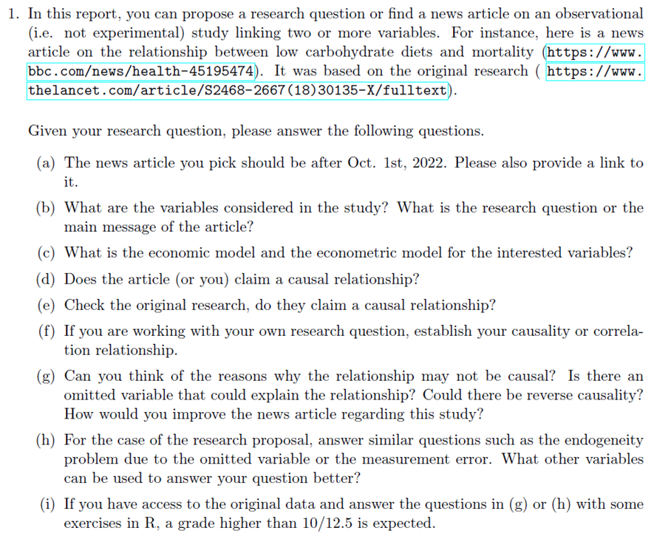

1. When referring to the news article by BBC News, we use the term “article”.
2. When referring to the research paper by Webster et al. 2022, we use the term “paper”.