Contents

Conclusions 1

Limitations 5

Other outcomes 6

# Conclusions

1. **Given the provided data, what are three conclusions we can draw about Kickstarter campaigns?**

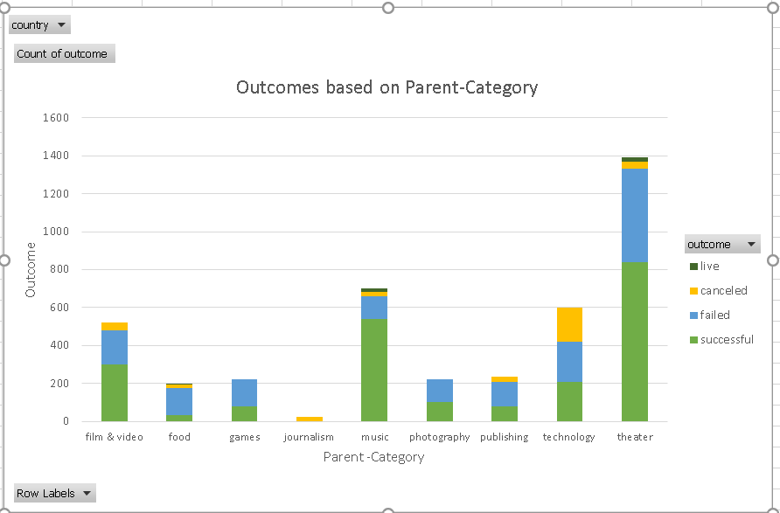

Fig - 1

* 1. Analysis between Parent Category and Outcome (Fig 1), indicates that 53% of projects launched are successful of which Music (77%) and Theater (60.2%) seems to be most likely to succeed. On the contrary Food and Journalism seem to be least successful projects.
  2. Further only the Music and Theater Parent categories had live projects at the time of data snapshot.
  3. **Hypothesis** – **Pursue** Parent Categories like -Music and Theater for most likely successful outcomes and **avoid** from Food and Journalism.

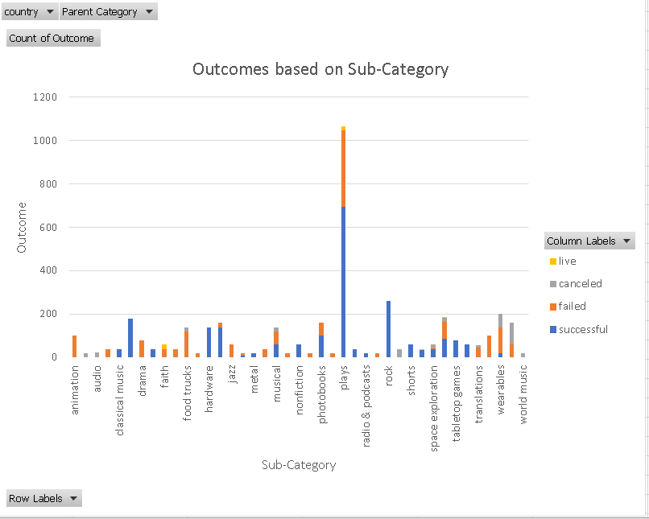

Fig - 2

1. Analysis of Sub Category and Outcome (Fig - 2), indicates that subcategories like Classical Music, Documentary, Electronic Music, Hardware, Metal no fiction, Pop, Radio Podcasts, Table top Games, Television have a 100% successful outcomes. While all animation, drama, faith, mobile games, places, video games related projects have failed.
2. **Hypothesis** – **Pursue** Classical Music, Documentary, Electronic Music, Hardware, Metal no fiction, Pop, Radio Podcasts, Table top Games, Television. **Avoid** animation, drama, faith, mobile games, places, video
3. It is worth mentioning that due to lack of additional data on background / attributes of investors (like their age, income, background etc), we are unable to draw more detailed correlations to what else may influence subcategory outcomes

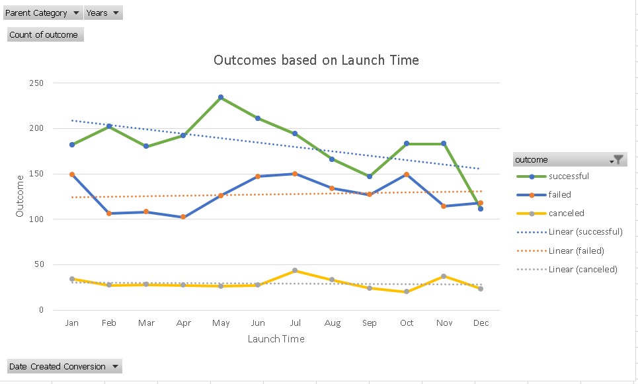

Fig - 3

1. Analysis of Outcomes and Launch time, indicates a cyclical / seasonal trends for successful & failed outcomes related to time of the year. There is uptick of successful projects during start of financial year; a decline heading into the Tax season; an uptick post tax season; a multi month decline as we head into the summer holiday period; a drop as we head into Thanksgiving and Christmas time (probably due to lack of additional disposable income to invest)
2. **Hypothesis 1–** There is increased likelihood of projects turning out to be successful if launched in start of year (January), after Quarter 1 to mid Quarter 2, after summer holiday season (from Sept to Thanksgiving)
3. **Hypothesis 2–** Even though we see cyclical trends across the year, overall there’s a negative linear relation between Outcomes with Launched date as we progress from the beginning to the end of the year for successful projects. A slight positive relation for failed projects and almost steady relation for canceled projects. This information also corroborating the **hypothesis 1** that projects launched in the beginning of the year are more likely to succeed.

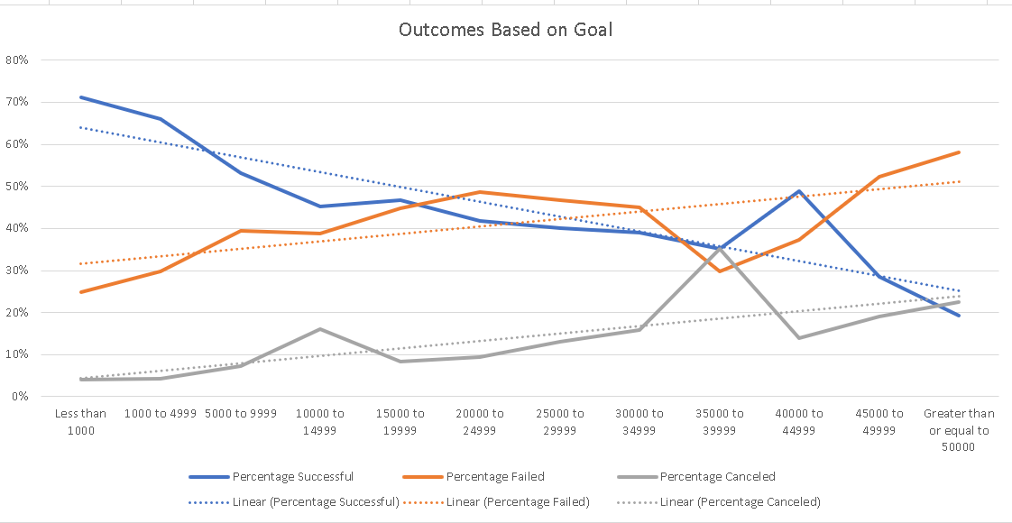

Fig - 4

* 1. Analysis of Goal and outcomes (Fig 4) indicates lower budget projects are more successful with the trend line showing negative linear relation mostly as the Goal amount increases. There is a 71% success rate for projects < 1000K amount even though there’s a spike for 40K to 45K worth projects with a success rate of 49%.
  2. **Hypothesis**: There’s a likelihood of projects becoming successful for lower cost projects <1000. This also might indicate the state of economy of that location or financial conditions of the people who are pledging. More investigation can be done once data related to people are available to do more correlation and causation effects etc.

# Limitations

1. **What are some limitations of this dataset?**
   1. Based on the background provided, more than 300,000 projects have been launched on Kickstarter but only 1/3 of the total projects had successful outcome which is just 33%. But the sample data is showing a success percentage of almost 50% (2185 out of 4114). This sample data is less than 2% of the total data size and may not be a correct representation of the actual data/trend. Also seem like sample data has bias towards art related projects like music, plays. Ideal would have been having at least 60 to 70% as the sample data to learn more accurate correlation of Outcomes with other variables in the data so that a trend and outcome can be predicted for future projects.
   2. Lack of information on data about people who have pledged like their age group, average income, demographics, geographic locations etc as that would have helped to understand if there was any bias on the categories they have pledged.

# Other outcomes

1. **What are some other possible tables and/or graphs that we could create?**
   1. We can plot a graph of the categories and sub-categories on the x-axis with outcomes as independent variable. (See below)

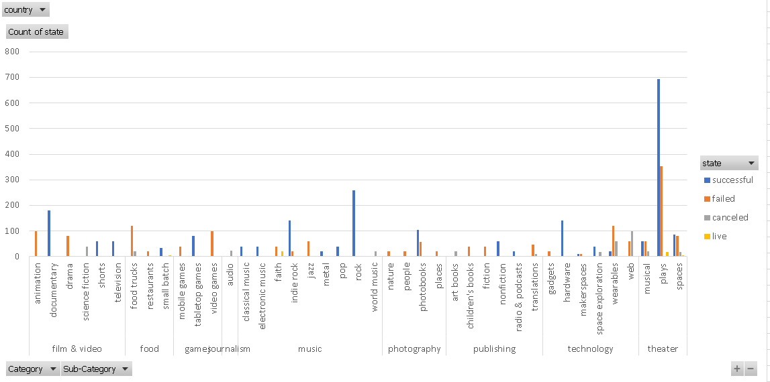

* 1. As the dependent variable (outcome/state) and independent variables ( Category/Sub-Category) are of categorical and in text format, they need be converted to numbers (0 or 1) in categorical coding format to perform regression analysis.
  2. We may try to see any relation between staff picked projects with various outcomes or countries with outcomes also. Based on the below table, there’s 87% probability of success for staff picked projects versus non staff picked.(47%).

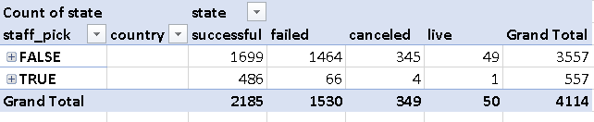

* 1. A relation can be looked between country Vs outcomes to understand how different countries are responding to crowdfunding projects.

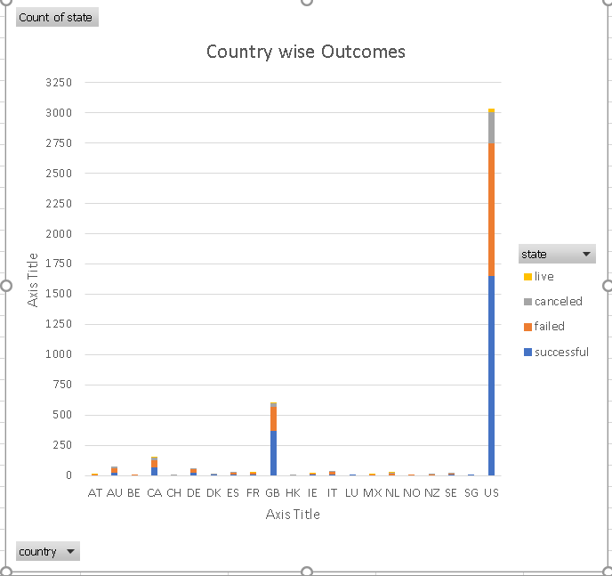

* 1. In conclusion, there could be many other cause and effects that could be investigated with more available data.

**===========================================**