|  |  |
| --- | --- |
| Creator: | OBR TEAM HS23-24 |
| Date: | 08/01/2024 |
| Last Update: | 18/01/2024 |
| Modified by: | OBR TEAM HS23-24 |

**OBR - HEIDI**

**PROJECT DESCRIPTION**

The primary goal of the Optical Braille Recognition (OBR) project is to streamline the scanning experience for individuals with visual impairments. The challenge lies in the wear and tear of Braille materials, making books and texts unreadable over time due to repetitive use. Additionally, there are analog Braille books that have not been digitized, posing an accessibility barrier for the visually impaired.

The proposed solution involves the development of a system capable of accurately recognizing Braille characters and texts, converting them into digital encoding encompassing both digital Braille and Latin characters. This system should possess the capability to read texts in various languages, allowing users to make corrections in the event of recognition errors for a more accurate and user-friendly experience.

**HOW TO USE IT**

* Pre-requirements
  + Connection of the scanner with the PC, and plugged
  + CZUR Windows App installation (<https://www.czur.com/support/et18pro>)
  + AngelinaReader GitHub repository installed

(<https://github.com/IlyaOvodov/AngelinaReader>)

* + Follow the Installation steps in the README.md file
    - Python installation
    - Install required packages
    - Set scanner environment
* Start the PC
  + Sign in with the scanning user
  + Launch the scanner App, CZUR Scanner
* To automate the application setup (CZUR) and conversion process with angelina reader, follow the steps mentioned in the following link and execute the script: <https://github.com/ic21b031/obr-scanner.git>

Language and other settings can be adapted

* Turn on the Scanner
  + 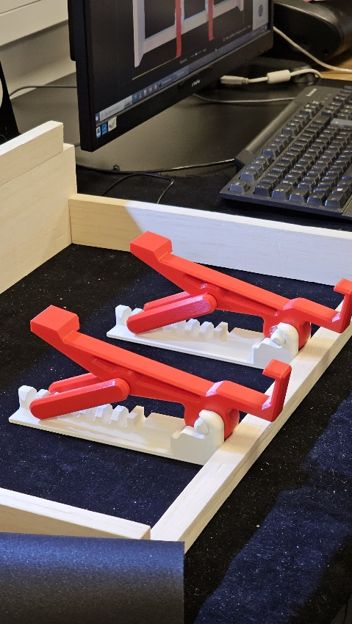

Figure : Slope stands

* + Switch in the back
  + Turn on the top light (button in the base)
  + Turn on the middle light (touch-button in the back of the lamp)
* Allocate the frame properly, so it falls in the middle of the image scanned
  + Further explanation can be found in Frame.docx file
* For better results, position the support to incline the document (Second position, see Figure 2: Slope stands)
* Allocate on top the book/paper (see Figure 1: Book placement)

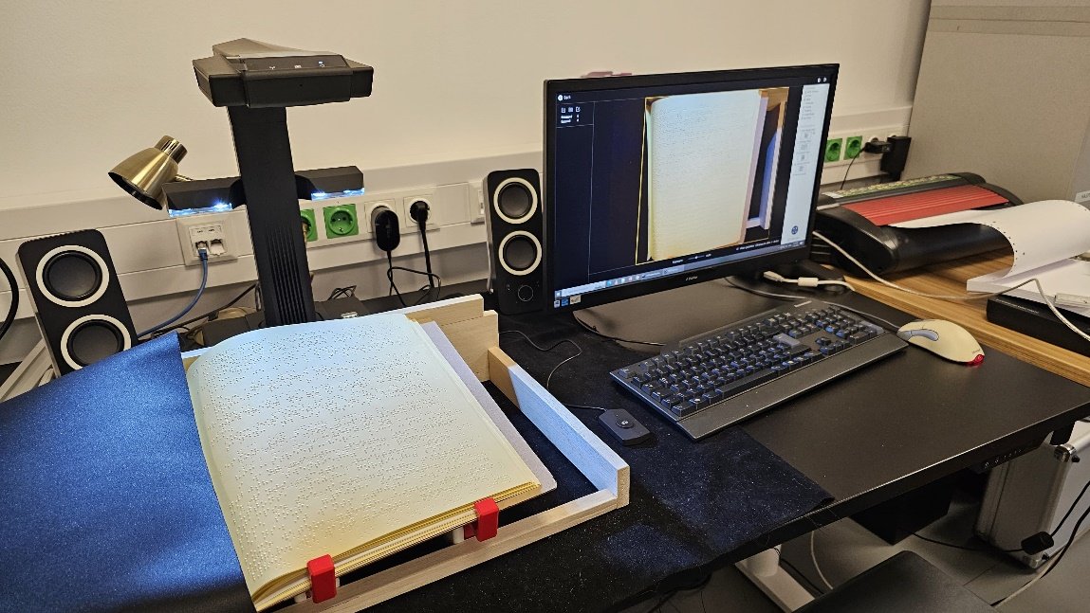

Figure : Book placement

* Optionally, cover the part you do not want to scan with the black cloth
* Scan
  + Set the filter to 'no filter' for better results.
* The output documents are created in the given output path
  + .brl - braille file
  + .jpg - image scanned with the letters on top
  + .txt - contains the translated text