|  |  |
| --- | --- |
| Creator: | OBR TEAM HS23-24 |
| Date: | 08/01/2024 |
| Last Update: | 18/01/2024 |
| Modified by: | OBR TEAM HS23-24 |

Frame

One of the main goals of this project is to make things easier for our HEIDI. That's why we have designed a frame with the exact measurements of the edges of the scanner's camera. This way, our HEIDI will be able to know at all times where it will be able to place its books and if the size is right.

* **Methodology**

Before designing the frame, several factors must be taken into account. First of all, the scanner camera had an initial height of 31cm. But after a series of tests scanning different books we came to the conclusion that it was best to increase this height by placing a 6 cm base as there are very large books that do not fit in the camera. With this the final height of the scanner is 37cm and the width of what the camera scans is 49cm. On the other hand, we have to take into account that we are using a tilting piece. This makes the book slightly higher and reduces the perspective of the book in the camera.

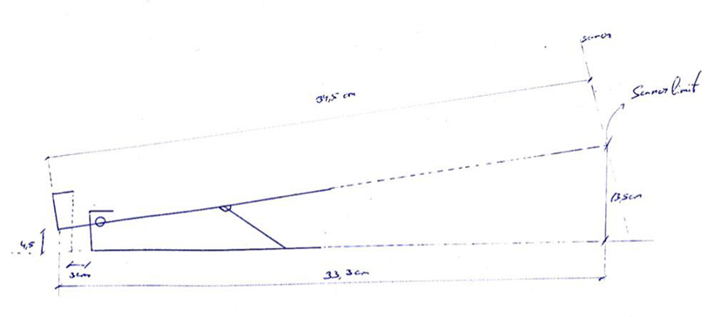

Figure 1. Sketch of the tilt piece.

In figure 1 we see that the stand makes the book approximately 4.5cm higher. On the other hand, we see that the book to be scanned must have a maximum height of 34.5cm. Due to the inclination, the length of the frame should not be the same length as the length of the book, but should be shorter. This can be calculated using the Pythagorean Theorem, as shown in figure 2. The height from the base to the limit of the scanner is 13.5cm. Therefore, when designing the frame, it should be taken into account that this side should be >13.5cm. The same goes for the laterals because the lowest part of the book will be 4,5cm. Finally we see that between the start of the book and the base of the tilt piece there is a distance of 3cm. The frame will hold the base of the piece so the length will have a distance of approximately 30cm.

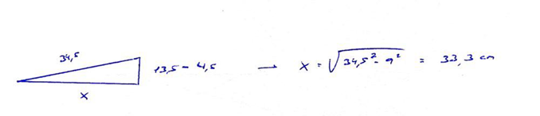

Figure 2. Calculation of frame length using the Pythagorean Theorem.

Once the measurements were taken, it was concluded that the frame should have a rectangular shape with each side having a different height depending on its position. For this purpose, it was decided to use balsa wood as the main material. This type of wood is perfect for the realisation of architectural models due to its low weight. Each piece of the frame will be measured with a meter, cut with a cutter and glued with a glue gun.

* **Design**

In order to carry out the design, a programme called Solid Edge was used. This programme is perfect for creating 3D parts and designing plans.

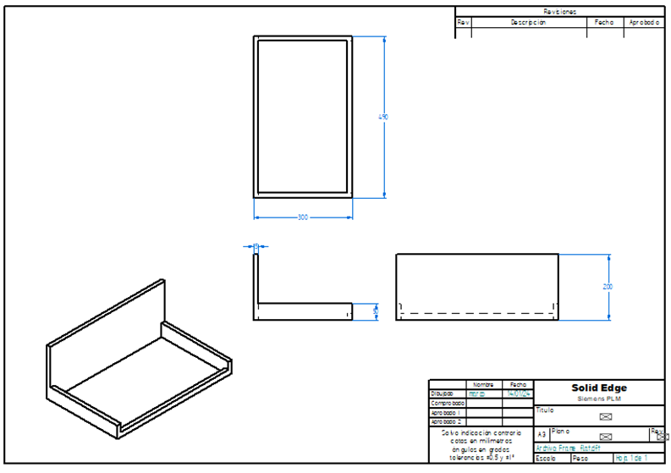

Figure 3. Different perspectives with their frame measurements.

Figure 3 shows the different perspectives (elevation, plan and profile) of the frame already designed with their corresponding measurements in mm and figure 4 shows the frame designed in 3D.

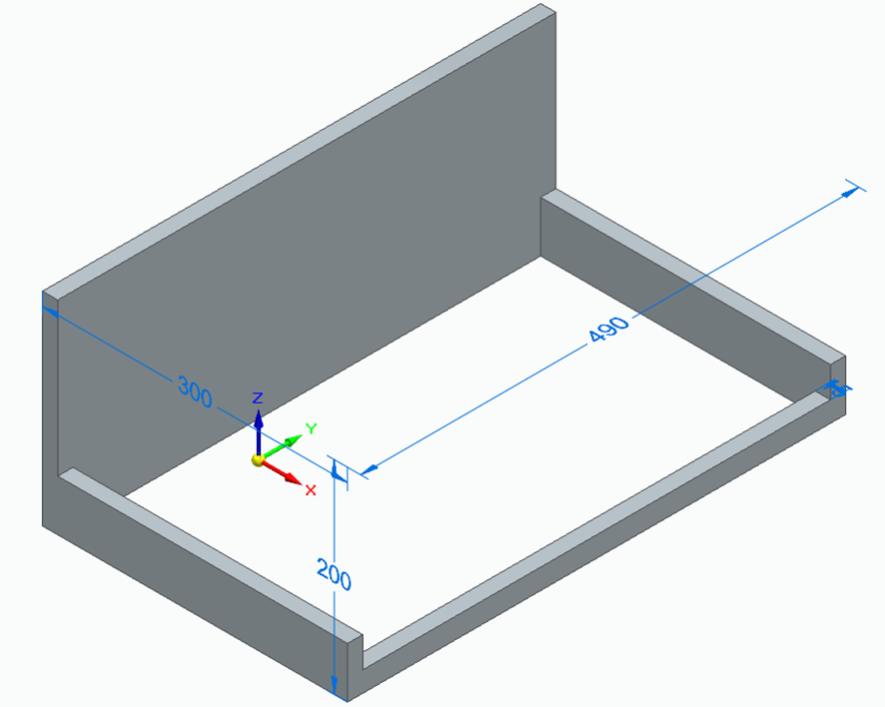

Figure 4. 3D design of the frame.

With this image we can see more clearly what is the aim of the final result.

* **Manufacturing**

Two 100x10x1,5cm balsa wood boards were used to make the frame. These were cut to size with the cutter according to where they should be placed in the frame, as shown in figure 5.

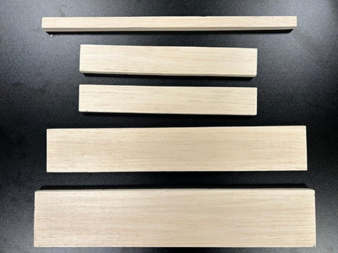

Figure 5. Customised frame parts.

Once it was checked that the pieces fitted as they should, they were glued using the glue gun already present in the laboratory. The final result is shown in figure 6.

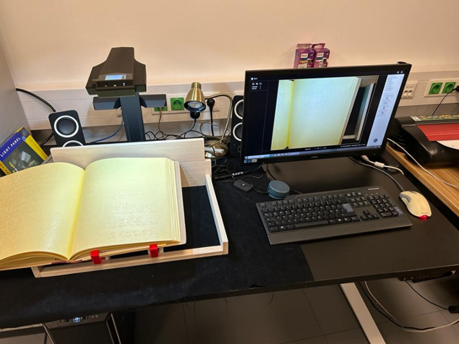

Figure 6. Final test with a book.