Who we are

IC5Team consists of a group of 5 researchers who have a common interest in Geoinformation, new technologies and their interconnection. Each of the 5 researchers has a different background from geography, topography to biology, and where formed in different universities through Europe.

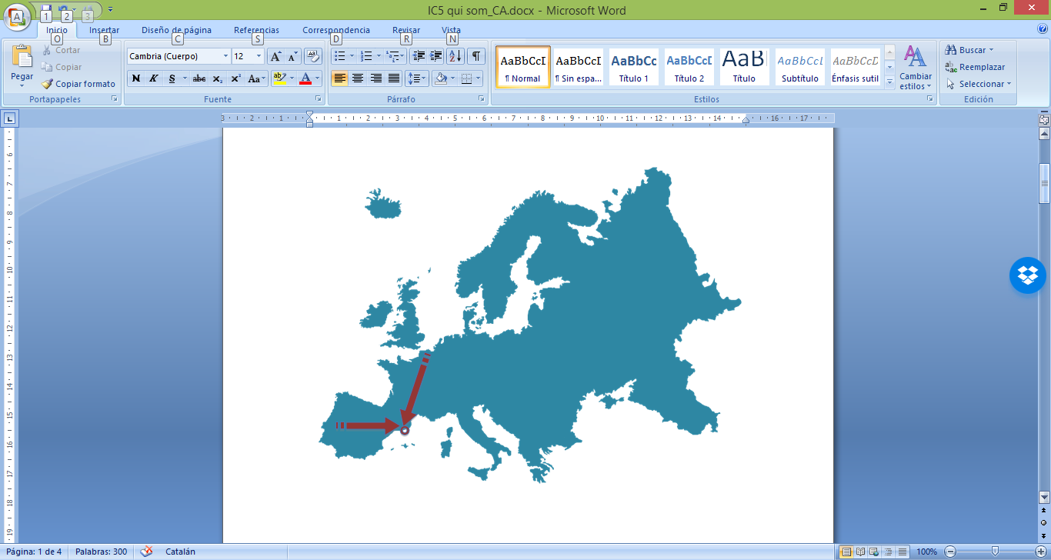

The IC5Team members have developed their careers in different environments such as activity within private companies, research groups working in public administration or the world of entrepreneurship. This is a key value of our team because it allows us to know how Geoinformation affects each of the above cited areas.

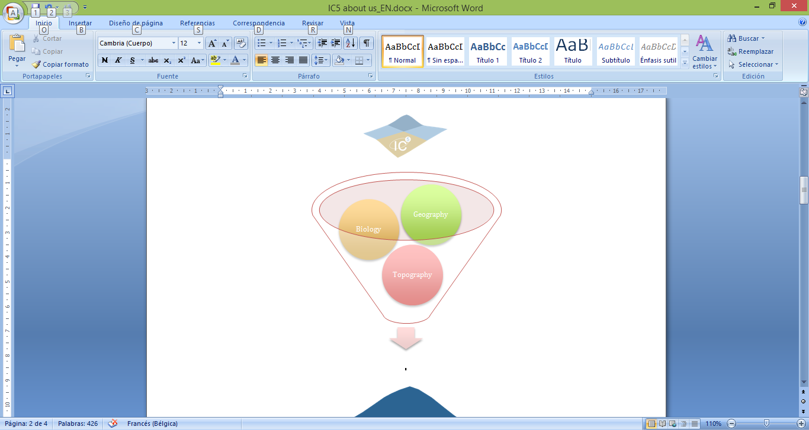

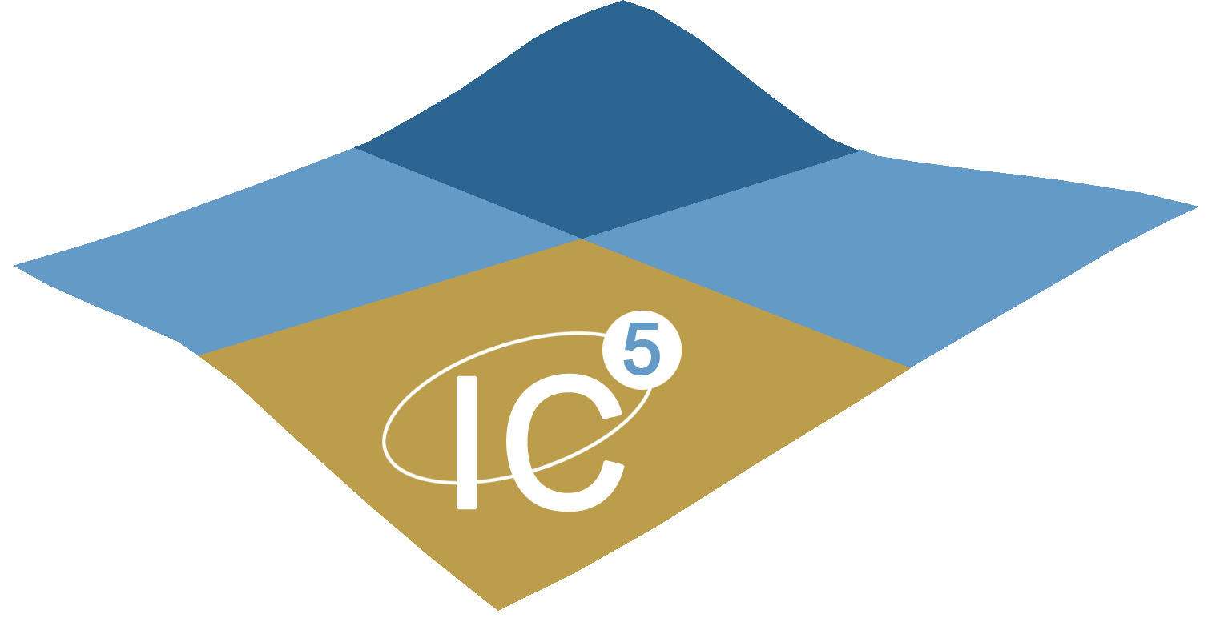

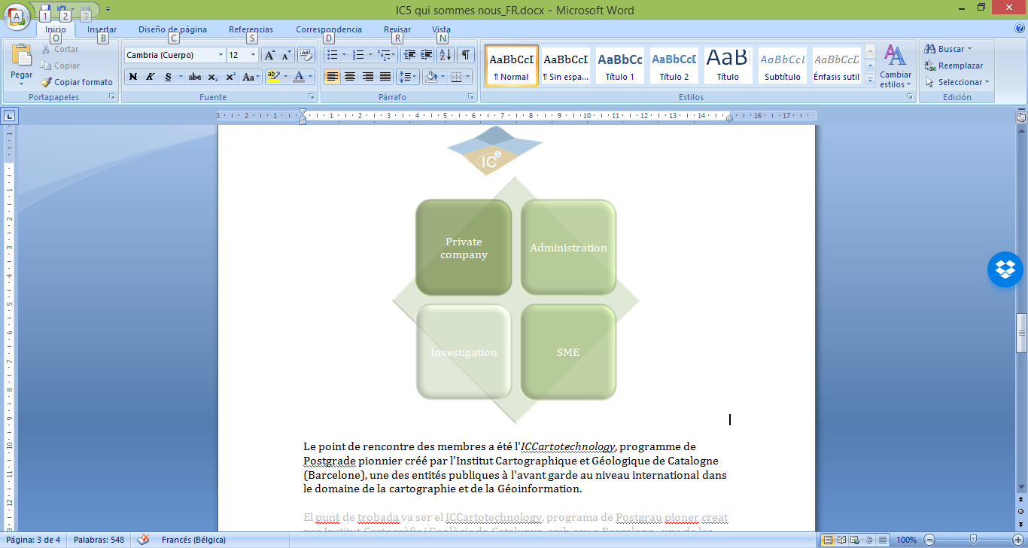

The meeting point of the team members has been the *ICCartotechnology* course, pioneer postgraduate program created by the Cartographic and Geologic Institute of Catalonia (based in Barcelona), one of the entities with more experience and international precursor in the world of cartography and Geoinformation.

In this program, professors, specialists and researchers from around the world taught their skills and knowledge of the different processes and disciplines of modern cartography.

It is in this scenario that IC5Team was borned.

Members of IC5Team:

|  |  |
| --- | --- |
| Ms. Anna Tarda | Cartographer. Remote Sensing expert |
| Ms. Ariadna Just | Geomatic engineer. LiDAR expert |
| Ms. Blanca Botey | Biologist. Geoinformation and GIS expert |
| Mr. Martí Pizarro | Geomatic engineer. CEO at TOP20 company |
| Mr. Thomas Cernocky | Geographer. GIS expert |

Our vision

Our multidisciplinary team thinks that the information is more and more present in the society and acquires a decisive role in decision-making and management in both economic and social aspects.

Nowadays we are facing a new paradigm, in which the WHAT, WHO and HOW, but also the WHERE - as spatial localization in an increasingly globalized world-, can make smarter and appropriate answers for more intelligent and complex and society.

Our mission

We want to put Geoinformation tools at the service Society tools that, when applied to real cases, enable to contribute to knowledge and added value.