DHCP : Configure DHCP Server

 |  | Configure DHCP ( Dynamic Host Configuration Protocol ) Server to assign IP addresses to client hosts in local network.
[1] |  | Install and Configure DHCP. On this example, it shows only for IPv4 configuration.

[root@dlp ~]#
dnf -y install dhcp-server
[root@dlp ~]#
vi /etc/dhcp/dhcpd.conf
# create new

# specify domain name
option domain-name "srv.world";
# specify DNS server's hostname or IP address
option domain-name-servers dlp.srv.world;
# default lease time
default-lease-time 600;
# max lease time
max-lease-time 7200;
# this DHCP server to be declared valid
authoritative;
# specify network address and subnetmask

subnet 10.0.0.0 netmask 255.255.255.0 {
# specify the range of lease IP address
range dynamic-bootp 10.0.0.200 10.0.0.254;
# specify broadcast address
option broadcast-address 10.0.0.255;
# specify gateway
option routers 10.0.0.1;
}

[root@dlp ~]#
systemctl enable --now dhcpd

[2] | If Firewalld is running, allow DHCP service. DHCP Server uses [67/UDP].

[root@dlp ~]#
firewall-cmd --add-service=dhcp
success
[root@dlp ~]#
firewall-cmd --runtime-to-permanent
success

[3] | It's possible to see leased IP address in the file below from DHCP Server to DHCP Clients.

[root@dlp ~]#
ll /var/lib/dhcpd

total 4
-rw-r--r--. 1 dhcpd dhcpd 0 Aug 10 05:14 dhcpd6.leases
-rw-r--r--. 1 dhcpd dhcpd 617 Jan 11 10:50 dhcpd.leases
-rw-r--r--. 1 dhcpd dhcpd 0 Aug 10 05:14 dhcpd.leases~

[root@dlp ~]#
cat /var/lib/dhcpd/dhcpd.leases

# The format of this file is documented in the dhcpd.leases(5) manual page.
# This lease file was written by isc-dhcp-4.4.2b1

# authoring-byte-order entry is generated, DO NOT DELETE
authoring-byte-order little-endian;

server-duid "\000\001\000\001)o\235\357RT\000\337\207\255";

lease 10.0.0.233 {
starts 2 2022/01/11 01:50:28;
ends 2 2022/01/11 02:00:28;
cltt 2 2022/01/11 01:50:28;
binding state active;
next binding state free;
rewind binding state free;
hardware ethernet 00:0c:29:f3:7b:12;
uid "\001\000\014)\363{\022";
set vendor-class-identifier = "MSFT 5.0";
client-hostname "RX-78";
}
.....
.....

DHCP : Configure DHCP Client : CentOS2022/01/11

 | Configure DHCP Client to get IP address from DHCP Server in local network.
[1] | For CentOS Clients, Configure like follows. (Replace [enp1s0] to your own device name)

[root@client ~]#
nmcli connection modify enp1s0 ipv4.method auto
[root@client ~]#
nmcli connection down enp1s0; nmcli connection up enp1s0

DHCP : Configure DHCP Client : Windows

Configure DHCP Client on Windows computer. This example is based on Windows 11.

[2] | Right-click the start button and open the [Network connection], and then click the [Properties].

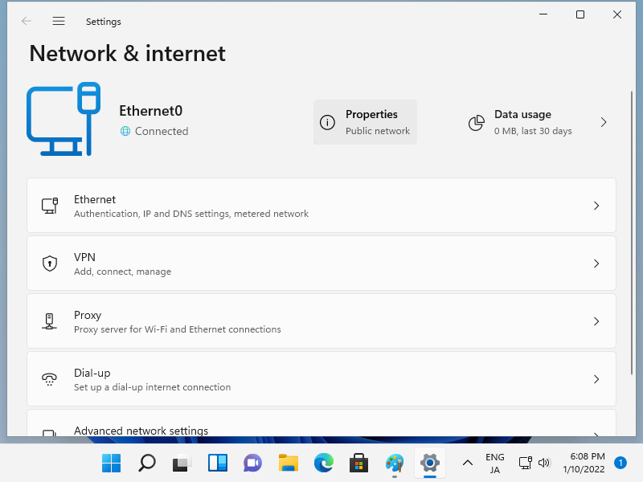

[3] | That's OK if [IP assignment] is [DHCP]. If not, click the [Edit] button.

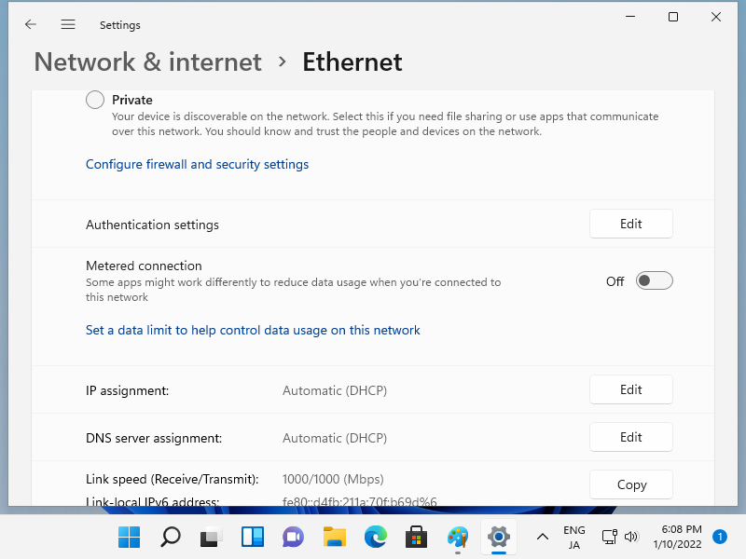

If clicked [Edit] button on previous section, following window is shown. Select [Automatic (DHCP)] and save.

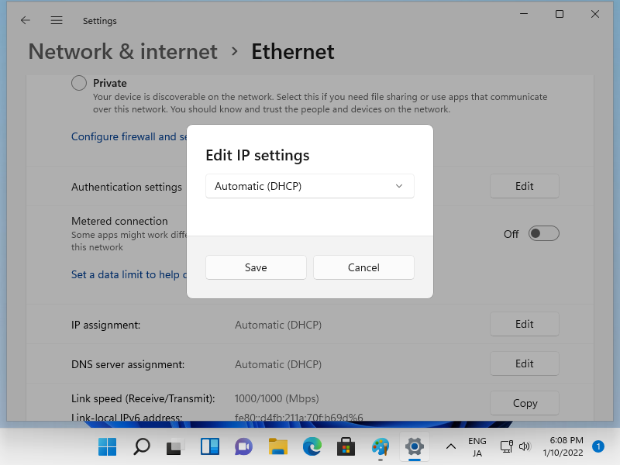

[5] | Confirm the Network connection status, that's OK if IP is assigned.

