**安得良師千萬個，大庇天下學生盡歡顏！**

**華粵學院網上教育暨籌款專項**

一. 誠邀有志參與粵語或正體中文教學的人士齊來報名作網上義務教師，未有教學經驗的也歡迎報名接受教學訓練。請於美東時間7月11日零時零分前把上課報名表電郵至[teach@icacnpo.com](mailto:teach@icacnpo.com).

報名表連結：

<https://docs.google.com/forms/d/1AYHC5GB6pC_qAwAELMPf-jJ6a0GYVh2rzQvGiTawiC4/edit>

二。學院邀請有志學習粵語或正體中文人士，不分國籍﹑語言﹑年紀﹑宗教﹑地區，只要能以英文﹑粵語﹑或國語上課，由小孩至成人，由初學發音﹑矯正懶音﹑日常會話到詩﹑歌﹑粵曲賞析等，參與免費網上學習。任何人士均歡迎填妥以下表格，由華粵學院配對適合教師。第一階段為七至八月，現定四堂。課程﹑材料或老師均由學院安排，不得異議。上課時間盡量配合學生，惟學生選了時間而未能參與則作棄權論。這是一項為華粵學院籌款項目，每名參與學生（或家長）需要籌得100元美金贊助額或以上，而每名贊助捐款者最少每次捐10元，學生或家長需確保於截止時間前完成以下各項：

(1)於美東時間7月1日零時零分前把上課報名表電郵至[teach@icacnpo.com](mailto:teach@icacnpo.com)

報名表連結：<https://docs.google.com/forms/d/1bPf9Gw8mzonaHww-D6vYHTjTNaWXflqk-0d710VVuAA/edit>

(2)於美東時間7月11日零時零分前把已籌足款項的籌款表連同捐款紀錄電郵至[teach@icacnpo.com](mailto:teach@icacnpo.com)

三. 華粵學院為美國註冊非營利組織，已獲批美國國稅局501(c)3免稅資格，二零二二年一月一日起生效 (EIN : 87-4042015），歡迎大眾慷慨解囊，任何時候都可用以下方式捐助學院：

（1） Zelle電子銀行轉帳 :電郵:[icac.npo@gmail.com](mailto:icac.npo@gmail.com)或掃以下二維碼

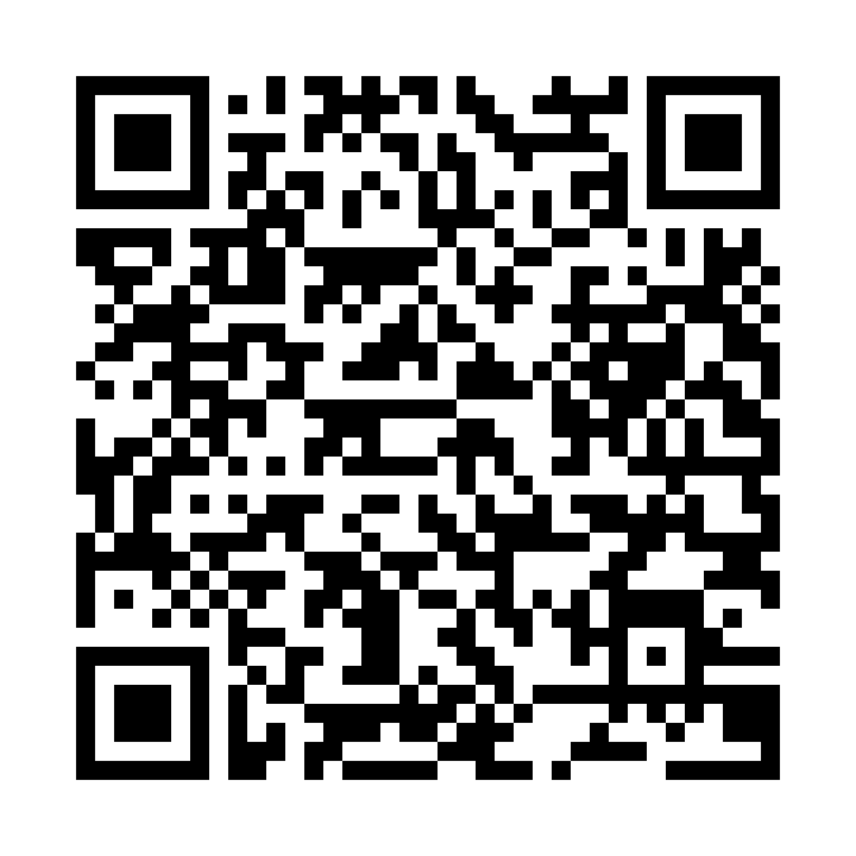

（2） Paypal付款: 按入以下連結或掃以下二維碼

<https://www.paypal.com/donate/?hosted_button_id=WVY87RKX8EWH2>



（3） 支票付款：

郵寄支票地址： PNC bank, 2992 S Main St, Ann Arbor, MI 48103

支票抬頭請付： Institute Of Chinese And Cantonese NPO

**How can we gather thousands of great teachers to joyously shelter students worldwide!**

**Online Educational Fundraising Event.**

1. The ICAC cordially invites those who are inspired to teach Cantonese or Traditional Chinese to join our online pro bono teaching. People without teaching experience are also welcome as training will be provided. Please submit your application by 00:00 Eastern Time on July 11th, 2022 to [teach@icacnpo.com](mailto:teach@icacnpo.com).

Teacher applicat ion form:

<https://docs.google.com/forms/d/1AYHC5GB6pC_qAwAELMPf-jJ6a0GYVh2rzQvGiTawiC4/edit>

2. The Institute invites those who are interested in learning Cantonese or Traditional Chinese to attend online classes for free. Regardless of nationality, language, age, religion, region, participants can be children or adults as long as one can communicate in English, Cantonese or Mandarin in class. The scope of learning ranges from elementary level of pronunciation, lazy tone correction, daily conversation to appreciation of poems, songs and Cantonese opera.

When an application form is received, the Institute will match student to teacher. The schedule is four classes in Phase 1 held in July – August. Syllabus, materials and teachers will be assigned by the Institute. No alternative arrangement will be entertained. Classes will be scheduled to meet student’s need to the best ability. If a student misses a class, no makeup class will be scheduled.

This is also a fundraising event for ICAC. Every student (or their parents) is required to raise USD 100 from their sponsors to participate in the event. Each donation of a sponsor should be no less than USD 10. Student or parent/guardian should ensure to complete the following items before the deadline:

(1)Submit your application to [teach@icacnpo.com](mailto:teach@icacnpo.com) by 00:00 Eastern Time on July 11th, 2022.

Student application form:<https://docs.google.com/forms/d/1bPf9Gw8mzonaHww-D6vYHTjTNaWXflqk-0d710VVuAA/edit>

(2)Raise the required funds and submit the totally $100 donation record to [teach@icacnpo.com](mailto:teach@icacnpo.com) by 00:00 Eastern Time on July 11th, 2022.

3. The ICAC is a non-profit organization registered in the United States. Exempt from Federal income tax under section 501(c)(3) of the Inland Revenue Code has been obtained effective on January 1, 2022 (EIN: 87-4042015). We always welcome any donations through the following means:

（1） By Zelle:

Choose email:[icac.npo@gmail.com](mailto:icac.npo@gmail.com). Or scan QR code



（2） By Paypal:

Please click the following link Or scan QR code

<https://www.paypal.com/donate/?hosted_button_id=WVY87RKX8EWH2>



（3） By sending check:

Please send your check to:

PNC bank, 2992 S Main St, Ann Arbor, MI 48103

Payable to: Institute Of Chinese And Cantonese NPO