The metabolic cost of the febrile host across the priority Candida
Results
Dissolved-oxygen respirometry was used to fit thermal performance curves for four Candida auris clades (I-IV; three isolates each) and C. parapsilosis (three isolates), across 22-44 °C (12 temperatures). Growth was modelled with a Sharpe-Schoolfield function and per-cell respiration with a Boltzmann-Arrhenius function, both fitted hierarchically (isolates nested within clades) in a Bayesian framework. Unless stated, values are posterior medians with 95% credible intervals (CrI).

Methods (summary)
O₂ concentration was recorded continuously with PreSens SensorDish readers across the temperature series (22-44 °C, 12 temperatures; one plate per group × temperature, three isolates × five replicate wells). Specific growth rate and per-cell respiration rate were recovered simultaneously from each O₂ time series using the mechanistic oxygen-dynamics model of Cakin et al. (2026), which couples exponential population growth with biomass-proportional oxygen consumption, O₂(t) = O_{2,0} + (K/r)(1 − e^{rt}), where r is the specific growth rate and K the volumetric O₂ consumption rate at the window start. Per-cell respiration, carbon-use efficiency and derived quantities were computed as in that study.
Units. The oxygen-dynamics model recovers the specific growth rate r (h⁻¹) from the exponential term. A per-cell carbon assimilation flux was then formed as G = r q, where q is the per-cell carbon quota (a temperature-independent constant per taxon); the per-cell respiratory carbon flux R was obtained from the volumetric O₂ consumption rate divided by the biomass integral, converted to carbon. G and R are therefore both per-cell carbon fluxes (fg C cell⁻¹ h⁻¹), and carbon-use efficiency CUE = G/(G + R) is the dimensionless ratio of these two matched quantities. Because q is independent of temperature, the growth activation energy E_{G} equals the activation energy of r (q shifts the intercept, not the Boltzmann slope) and is directly comparable to the respiration activation energy E_{R}. Growth thermal performance curves (Fig. 1a) and E_{G} thus derive from a rate constant; the r-to-carbon conversion enters only where CUE and downstream ratios are formed.

Growth and respiration decouple, placing the carbon-economy optimum below body temperature
Growth rate rose with temperature to a clade-level optimum near 33-36 °C and then declined, following the expected unimodal thermal performance curve (Fig. 1a). Per-cell respiration showed no such turnover: it increased monotonically across the entire measured range, and leave-one-out cross-validation favoured the monotonic Arrhenius model over a unimodal Sharpe-Schoolfield alternative (Fig. 1b). Growth and respiration are therefore governed by different thermal sensitivities.
This difference is quantified by the activation energies (Fig. 1c). In every taxon, the activation energy of growth exceeded that of respiration: E_{G} ranged 0.81-1.14 eV and E_{R} 0.30-0.52 eV, with the growth-respiration difference credibly greater than zero in all five taxa (0.39-0.73 eV; 95% CrI excluding zero throughout). Growth is thus roughly twice as temperature-sensitive as respiration.
Because respiration continues to rise while growth saturates and falls, carbon-use efficiency (CUE = G/(G+R)) is itself a unimodal function of temperature that peaks early and then collapses (Fig. 1d). The temperature of this economic optimum, T_{opt}(CUE) lay below human body temperature in every taxon: 31.3-34.1 °C, with posterior probability P(T_{opt}(CUE) < 37 °C) ≥ 0.999 for all five (Fig. 1e). The economic optimum sat 1.0-2.6 °C below the growth optimum and 2.9-5.7 °C below 37 °C. The mammalian host temperature therefore lies beyond the point at which warming still improves the carbon economy of any species tested.
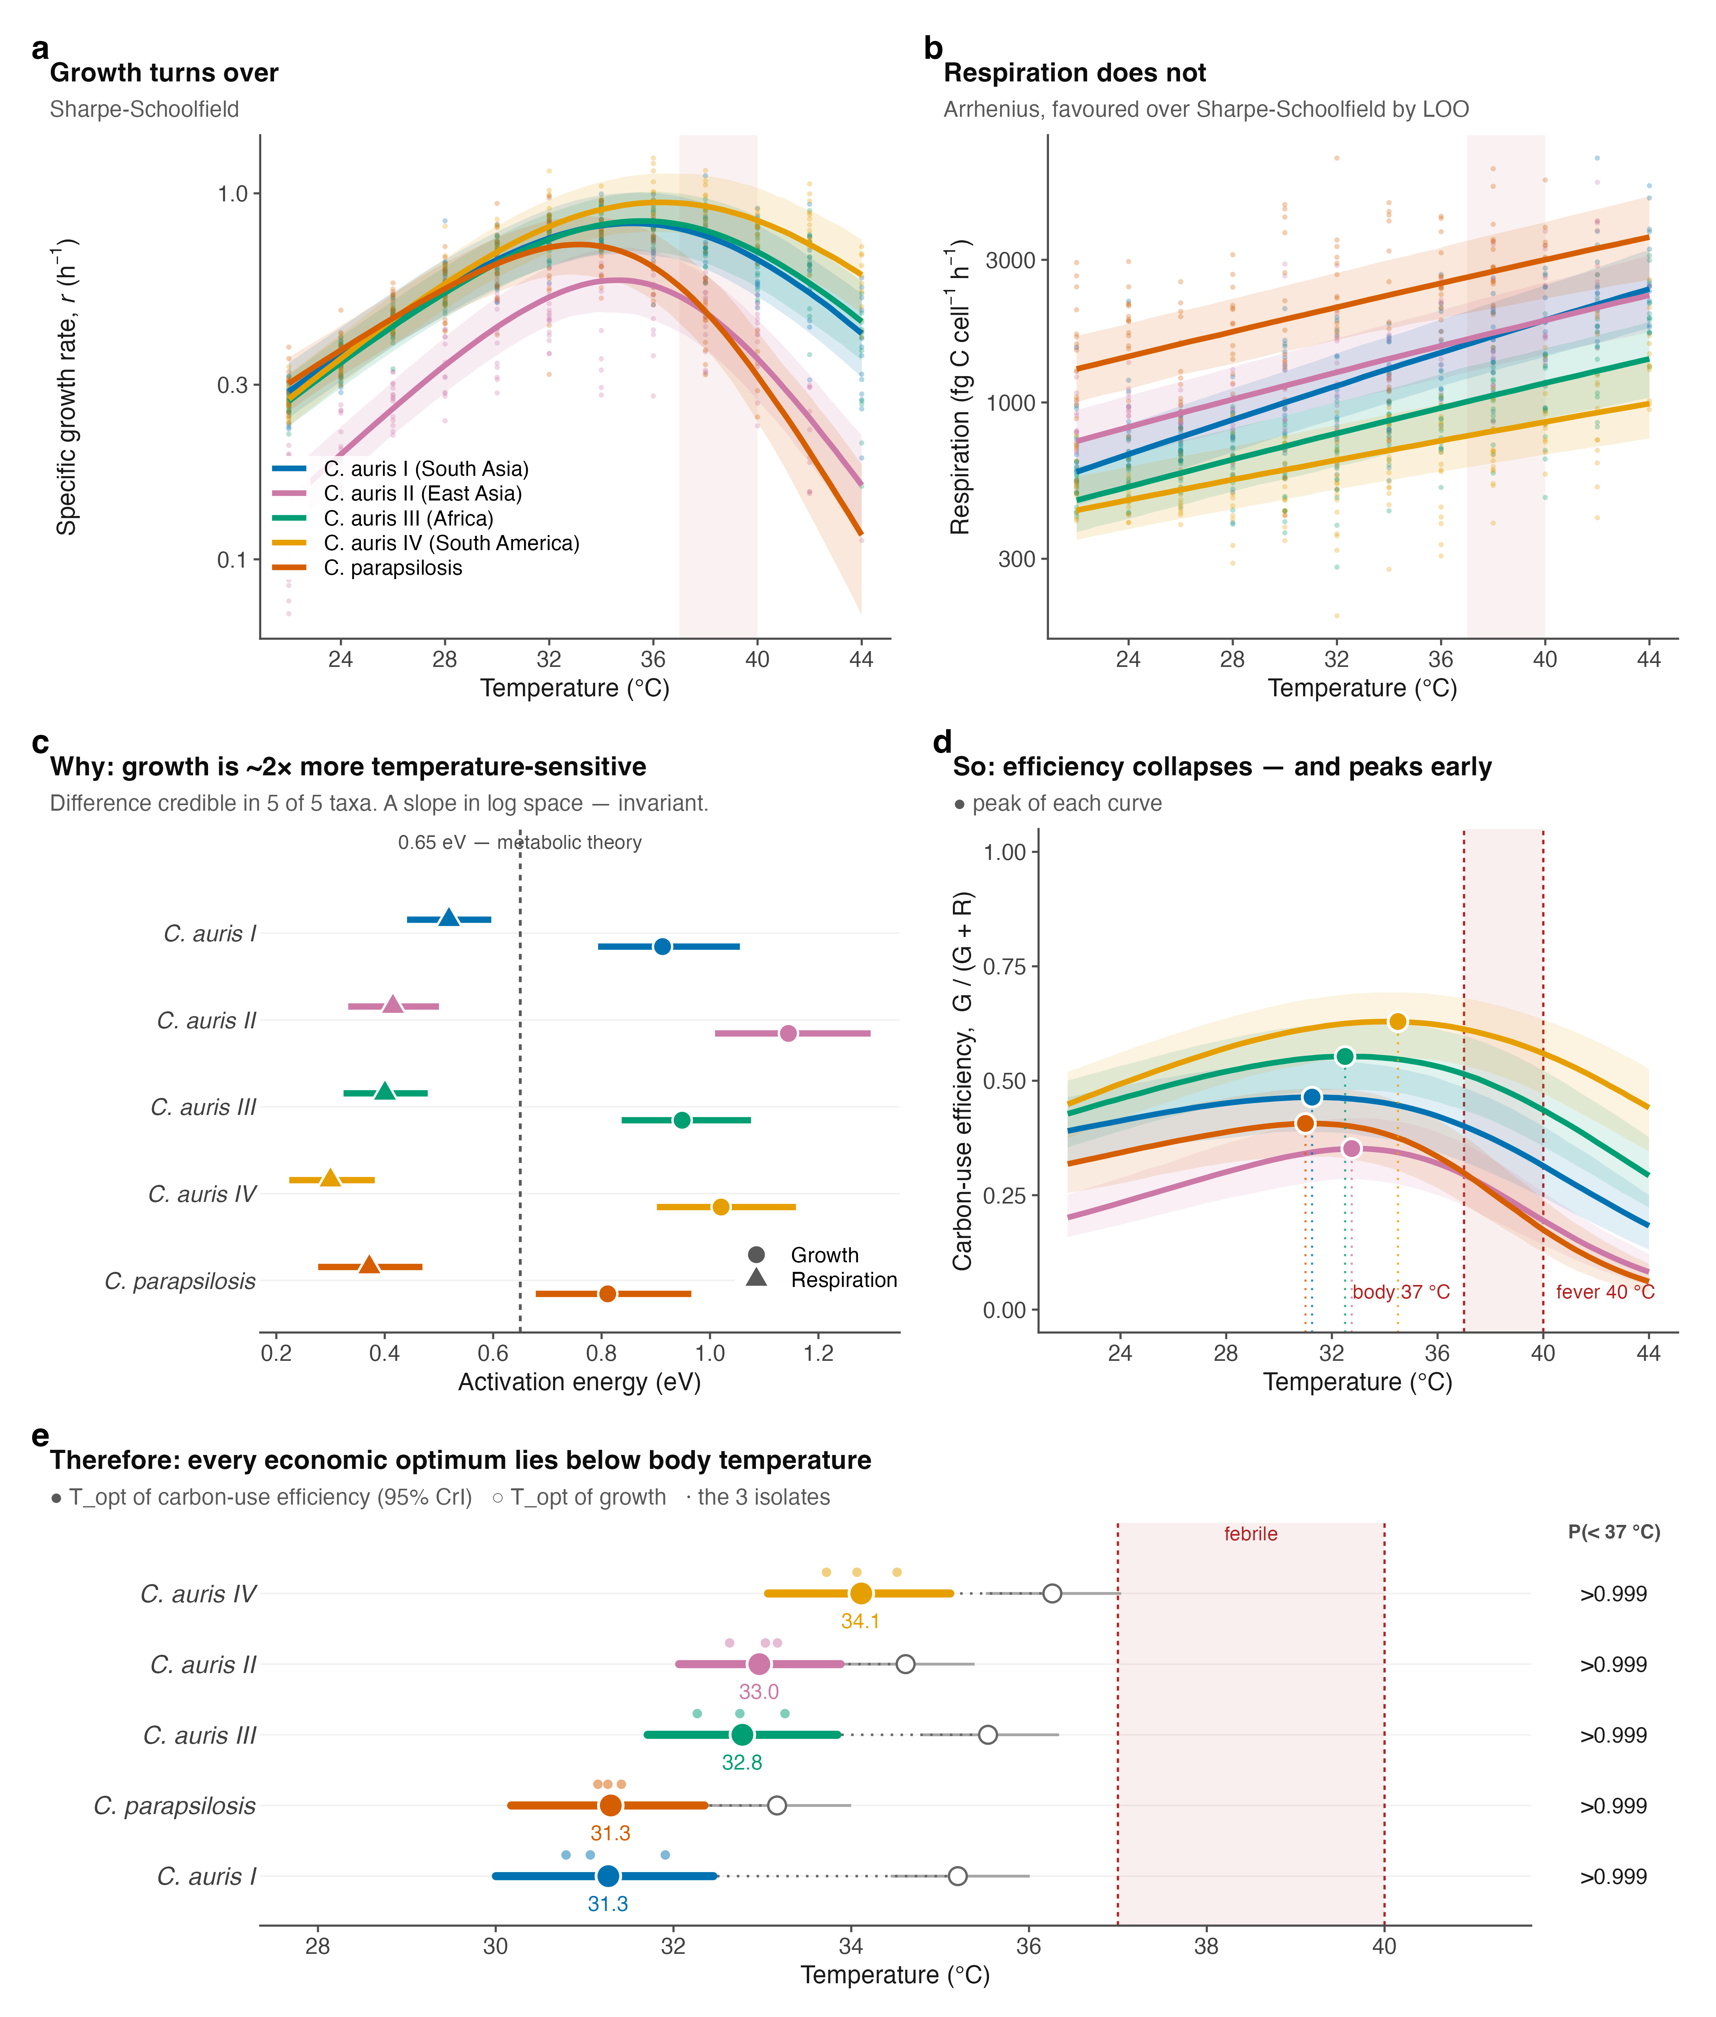
Figure 1. Growth and respiration decouple with temperature, placing every carbon-economy optimum below body temperature. (a) Specific growth rate r (h⁻¹) and (b) per-cell respiration carbon flux (fg C cell⁻¹ h⁻¹) versus temperature (points, isolate-level observations; lines, clade-level posterior medians; bands, 95% CrI). Growth turns over; respiration does not (Arrhenius favoured over Sharpe-Schoolfield by leave-one-out cross-validation). (c) Activation energies of growth (circles) and respiration (triangles); dashed line, the 0.65 eV metabolic-theory value. Growth is credibly more temperature-sensitive than respiration in all five taxa. (d) Carbon-use efficiency, CUE = G/(G+R), collapses with warming and peaks early; filled points mark each curve’s peak. (e) Thermal optimum of CUE (filled points, 95% CrI; open points, growth optimum; small points, isolates), with the posterior probability that it lies below 37 °C. Shaded band, 37 to 40 °C (body to fever).

A febrile host imposes a quantifiable, taxon-specific carbon tax
Because the economic optimum lies below 37 °C, every taxon operates at a carbon penalty in the host. We express this as the relative respiratory cost, i.e. respiration per unit growth relative to each taxon’s own cheapest temperature (Fig. 2a). At 40 °C (fever), this cost reached 1.34× for C. auris Clade IV but 3.22× for C. parapsilosis.
The three-degree step from body temperature (37 °C) to fever (40 °C) captures the clinical penalty most directly (Fig. 2c). Over this interval C. parapsilosis retained only 57% of its 37 °C growth rate (0.57, 95% CrI 0.49-0.65) while its respiratory cost per unit growth rose 2.00× (1.76-2.32). The C. auris clades were far less affected: Clade IV retained 89% of growth (0.89, 0.86-0.93) at a cost increase of only 1.25× (1.19-1.31), with Clades I-III intermediate (growth retained 0.67-0.84; cost 1.37×-1.72×). Fever thus suppresses growth without suppressing respiration, and it does so most severely in C. parapsilosis.
A warmer environmental optimum predicts a lower cost of fever. Across the five taxa, the environmental growth optimum was strongly and negatively associated with the metabolic cost of fever: the more thermotolerant a taxon, the less a fever cost it (Fig. 2b). Computed as a posterior distribution over Spearman’s ρ (propagating parameter uncertainty rather than treating the five taxon medians as fixed), the correlation was ρ = −0.90 (95% CrI −1.00 to −0.30; P(ρ < 0) = 0.996). C. parapsilosis occupied the cool-optimum, expensive-fever extreme and C. auris Clade IV the warm-optimum, cheap-fever extreme. This links adaptation to a warm environment with tolerance of the febrile host as facets of a single thermal trait, consistent with the hypothesis that environmental thermal selection underlies fungal thermotolerance to the mammalian host. We note that T_{opt} and fever cost are partly geometrically coupled through the growth curve; however, respiration (E_{R}) is an independent parameter that could have broken the relationship and did not. The correlation rests on only five taxa; it is therefore reported as suggestive and will be tested directly with additional species.
Clade-level differences within C. auris. Pairwise comparison of the fever cost resolved 8 of 10 taxon contrasts (95% CrI excluding a ratio of 1; Fig. 2d). All four C. auris clades credibly paid less at fever than C. parapsilosis (cost ratios 0.42-0.70), and Clade IV was credibly the cheapest of all clades. Only two contrasts, Clade I versus Clade II (0.85, 0.68-1.05) and Clade I versus Clade III (1.18, 0.99-1.41), could not be separated at three isolates per clade.
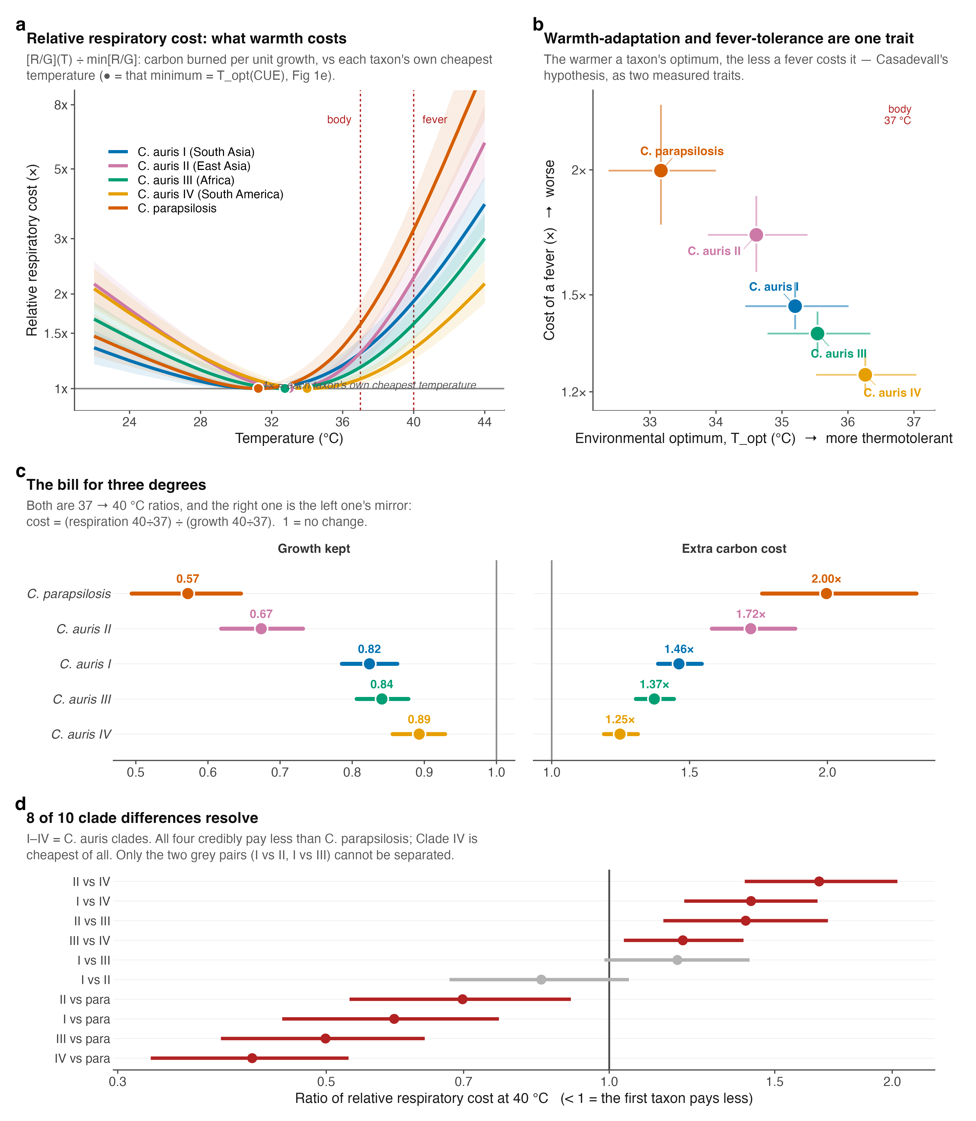
Figure 2. The metabolic cost of a fever, and its relationship to environmental thermotolerance. (a) Relative respiratory cost (respiration per unit growth, relative to each taxon’s own cheapest temperature) versus temperature; filled points mark each minimum, which coincides with T_{opt}(CUE) in Fig. 1e. Dashed lines, body (37 °C) and fever (40 °C). (b) Environmental growth optimum versus the cost of a fever ([R/G] at 40 °C ÷ at 37 °C), five taxa (points, 95% CrI); the warmer a taxon’s optimum, the lower its fever cost (posterior Spearman ρ = −0.90). (c) The 37→40 °C bill: growth retained (growth at 40 °C ÷ at 37 °C, left) and the accompanying increase in respiratory cost per unit growth (right); points, posterior medians; bars, 95% CrI; 1 = no change. (d) Pairwise ratios of fever cost (I-IV, C. auris clades). Red, 95% CrI excludes 1; grey, unresolved.

Reference
Cakin I, Millington R, Pawar S, Buckling A, Smirnoff N, Padfield D, Duffy J, Yvon-Durocher G. A novel method to simultaneously estimate bacterial respiration and growth from oxygen dynamics. ISME Communications 2026;6(1):ycag024. https://doi.org/10.1093/ismeco/ycag024

