The metabolic cost of the febrile host across the priority Candida
Results
Dissolved-oxygen respirometry was used to fit thermal performance curves for four Candida auris clades (I-IV; three isolates each) and C. parapsilosis (three isolates), across 22-44 °C (12 temperatures). Growth was modelled with a Sharpe-Schoolfield function and per-cell respiration with a Boltzmann-Arrhenius function, both fitted hierarchically (isolates nested within clades) in a Bayesian framework. Unless stated, values are posterior medians with 95% credible intervals (CrI).

Methods (summary)
O₂ concentration was recorded continuously with PreSens SensorDish readers across the temperature series (22-44 °C, 12 temperatures; three isolates × five replicates per temperature). Specific growth rate and per-cell respiration rate were recovered simultaneously from each O₂ time series using the mechanistic oxygen-dynamics model of Cakin et al. (2026), which couples exponential population growth with biomass-proportional oxygen consumption, O₂(t) = O_{2,0} + (K/r)(1 − e^{rt}), where r is the specific growth rate and K the volumetric O₂ consumption rate at the window start. Per-cell respiration, carbon-use efficiency and derived quantities were computed as in that study.
Units. The oxygen-dynamics model recovers the specific growth rate r (h⁻¹) from the exponential term. A per-cell carbon assimilation flux was then formed as G = r q, where q is the per-cell carbon quota (a temperature-independent constant per taxon); the per-cell respiratory carbon flux R was obtained from the volumetric O₂ consumption rate divided by the biomass integral, converted to carbon. G and R are therefore both per-cell carbon fluxes (fg C cell⁻¹ h⁻¹), and carbon-use efficiency CUE = G/(G + R) is the dimensionless ratio of these two matched quantities. Because q is independent of temperature, the growth activation energy E_{G} equals the activation energy of r (q shifts the intercept, not the Boltzmann slope) and is directly comparable to the respiration activation energy E_{R}. Growth thermal performance curves (Fig. 1a) and E_{G} thus derive from a rate constant; the r-to-carbon conversion enters only where CUE and downstream ratios are formed.

Growth and respiration decouple, placing the carbon-economy optimum below body temperature
Growth rate rose with temperature to a clade-level optimum near 33-36 °C and then declined, following the expected unimodal thermal performance curve (Fig. 1a). Per-cell respiration showed no such turnover: it increased monotonically across the entire measured range, and leave-one-out cross-validation favoured the monotonic Arrhenius model over a unimodal Sharpe-Schoolfield alternative (Fig. 1b). Growth and respiration are therefore governed by different thermal sensitivities.
This difference is quantified by the activation energies (Fig. 1c). In every taxon, the activation energy of growth exceeded that of respiration: E_{G} ranged 0.83-1.14 eV and E_{R} 0.30-0.52 eV, with the growth-respiration difference credibly greater than zero in all five taxa (0.39-0.73 eV; 95% CrI excluding zero throughout). Growth is thus roughly twice as temperature-sensitive as respiration.
Because respiration continues to rise while growth saturates and falls, carbon-use efficiency (CUE = G/(G+R)) is itself a unimodal function of temperature that peaks early and then collapses (Fig. 1d). The temperature of this economic optimum, T_{opt}(CUE) lay below human body temperature in every taxon: 31.3-34.1 °C, with posterior probability P(T_{opt}(CUE) < 37 °C) ≥ 0.999 for all five (Fig. 1e). The economic optimum sat 1.6-3.9 °C below the growth optimum and 2.9-5.7 °C below 37 °C. The mammalian host temperature therefore lies beyond the point at which warming still improves the carbon economy of any species tested.
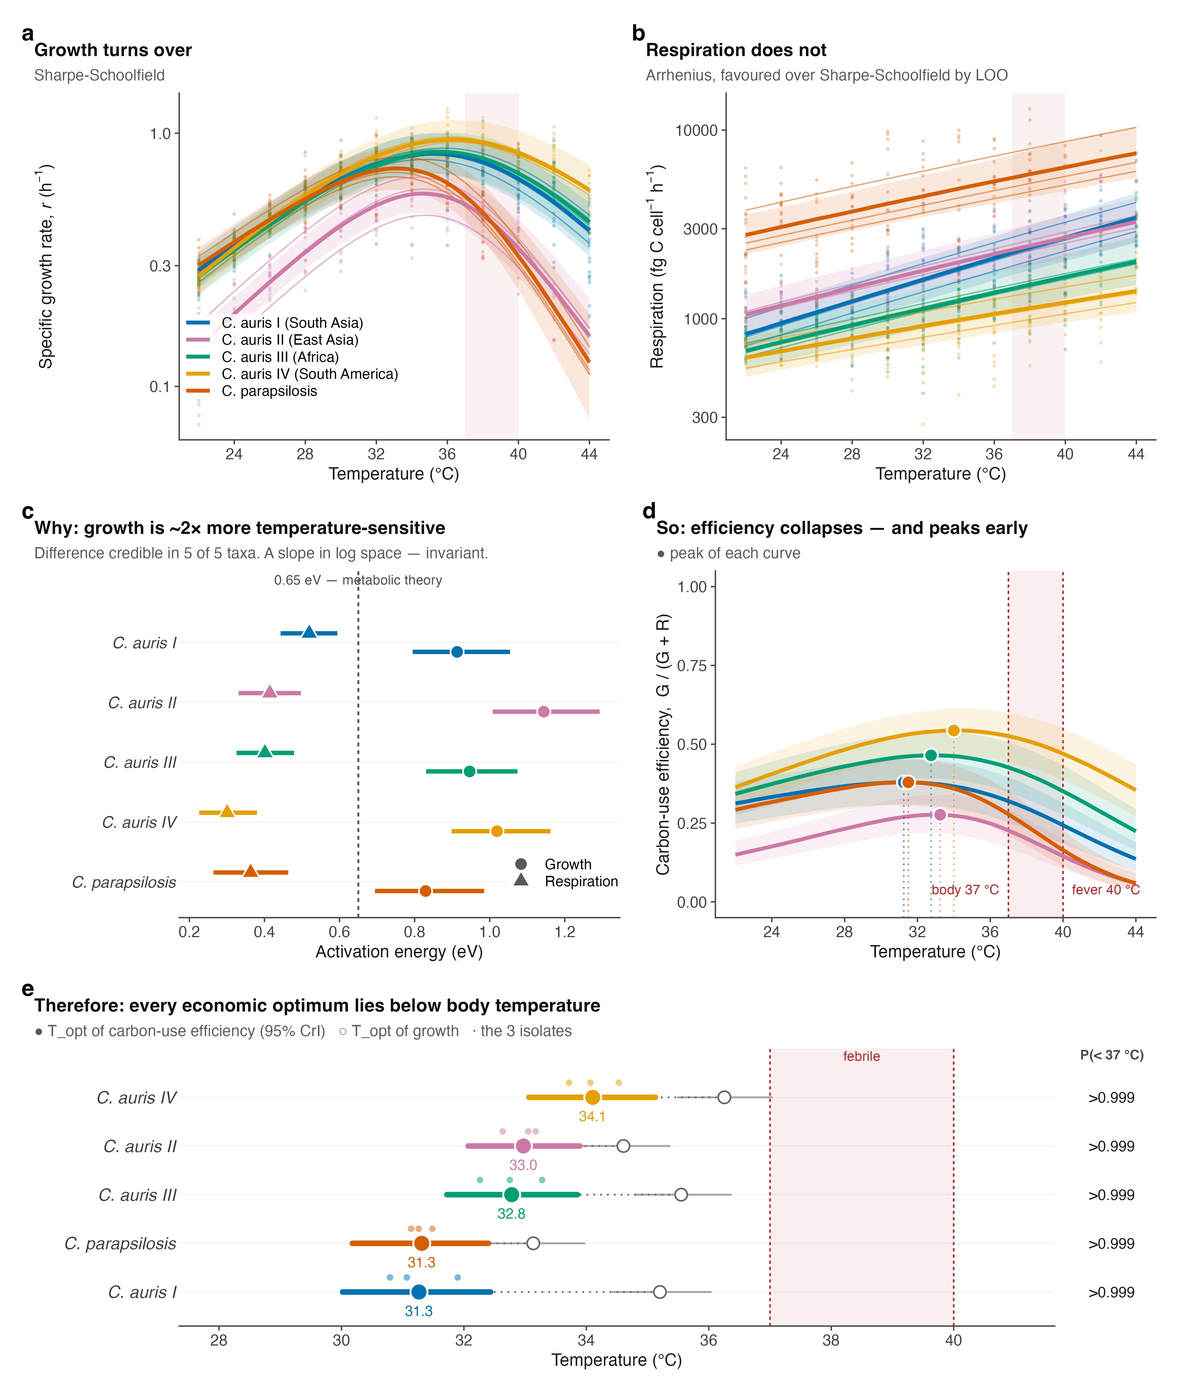
Figure 1. Growth and respiration decouple with temperature, placing every carbon-economy optimum below body temperature. (a) Specific growth rate r (h⁻¹) and (b) per-cell respiration carbon flux (fg C cell⁻¹ h⁻¹) versus temperature (points, isolate-level observations; thin lines, per-isolate fits; bold lines, clade-level posterior medians; bands, 95% CrI). Growth turns over; respiration does not (Arrhenius favoured over Sharpe-Schoolfield by leave-one-out cross-validation). (c) Activation energies of growth (circles) and respiration (triangles); dashed line, the 0.65 eV metabolic-theory value. Growth is credibly more temperature-sensitive than respiration in all five taxa. (d) Carbon-use efficiency, CUE = G/(G+R), collapses with warming and peaks early; filled points mark each curve’s peak. (e) Thermal optimum of CUE (filled points, 95% CrI; open points, growth optimum; small points, isolates), with the posterior probability that it lies below 37 °C. Shaded band, 37 to 40 °C (body to fever).
A febrile host imposes a quantifiable, taxon-specific carbon tax

Because the economic optimum lies below 37 °C, every taxon operates at a carbon penalty in the host. We express this as the relative respiratory cost, i.e. respiration per unit growth relative to each taxon’s own cheapest temperature (Fig. 2a). At 40 °C (fever), this cost reached 1.34× for C. auris Clade IV but 3.13× for C. parapsilosis.
The three-degree step from body temperature (37 °C) to fever (40 °C) captures the clinical penalty most directly (Fig. 2c). Over this interval C. parapsilosis retained only 58% of its 37 °C growth rate (0.58, 95% CrI 0.50-0.67) while its respiratory cost per unit growth rose 1.96× (1.71-2.31). The C. auris clades were far less affected: Clade IV retained 89% of growth (0.89, 0.85-0.93) at a cost increase of only 1.25× (1.19-1.31), with Clades I-III intermediate (growth retained 0.67-0.84; cost 1.37×-1.73×). Fever thus suppresses growth without suppressing respiration, and it does so most severely in C. parapsilosis.
A warmer environmental optimum predicts a lower cost of fever. Across the five taxa, the environmental growth optimum was strongly and negatively associated with the metabolic cost of fever: the more thermotolerant a taxon, the less a fever cost it (Fig. 2b). Computed as a posterior distribution over Spearman’s ρ (propagating parameter uncertainty rather than treating the five taxon medians as fixed), the correlation was ρ = −0.90 (95% CrI −1.00 to −0.30; P(ρ < 0) = 0.996). C. parapsilosis occupied the cool-optimum, expensive-fever extreme and C. auris Clade IV the warm-optimum, cheap-fever extreme. This links adaptation to a warm environment with tolerance of the febrile host as facets of a single thermal trait, consistent with the hypothesis that environmental thermal selection underlies fungal thermotolerance to the mammalian host. We note that T_{opt} and fever cost are partly geometrically coupled through the growth curve; however, respiration (E_{R}) is an independent parameter that could have broken the relationship and did not. The correlation rests on only five taxa; it is therefore reported as suggestive and will be tested directly with additional species.
Clade-level differences within C. auris. Pairwise comparison of the fever cost resolved 8 of 10 taxon contrasts (95% CrI excluding a ratio of 1; Fig. 2d). All four C. auris clades credibly paid less at fever than C. parapsilosis (cost ratios 0.43-0.72), and Clade IV was credibly the cheapest of all clades. Only two contrasts, Clade I versus Clade II (0.85, 0.68-1.04) and Clade I versus Clade III (1.18, 0.98-1.42), could not be separated at three isolates per clade.
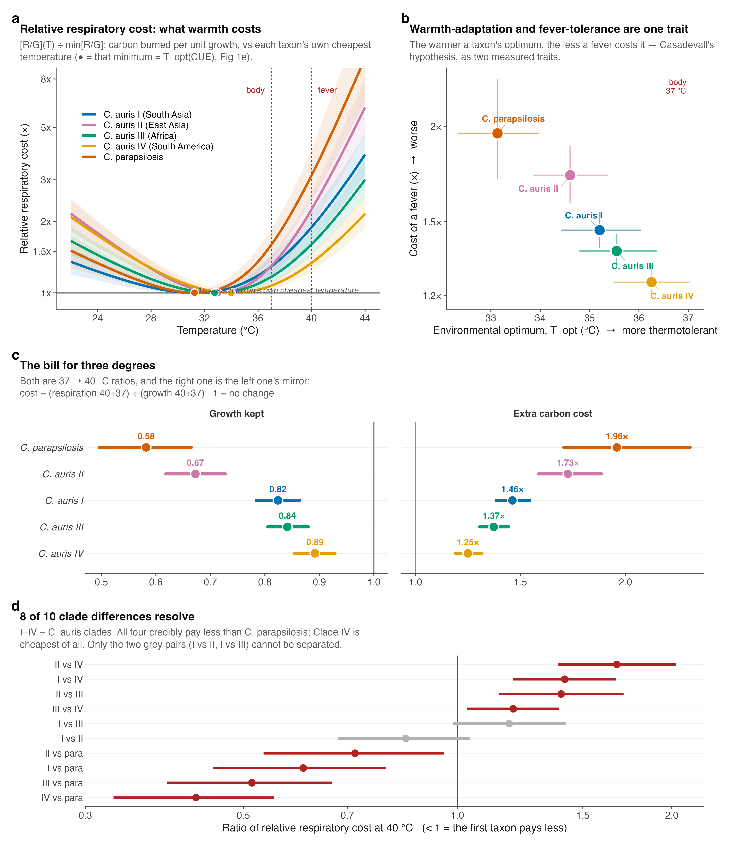

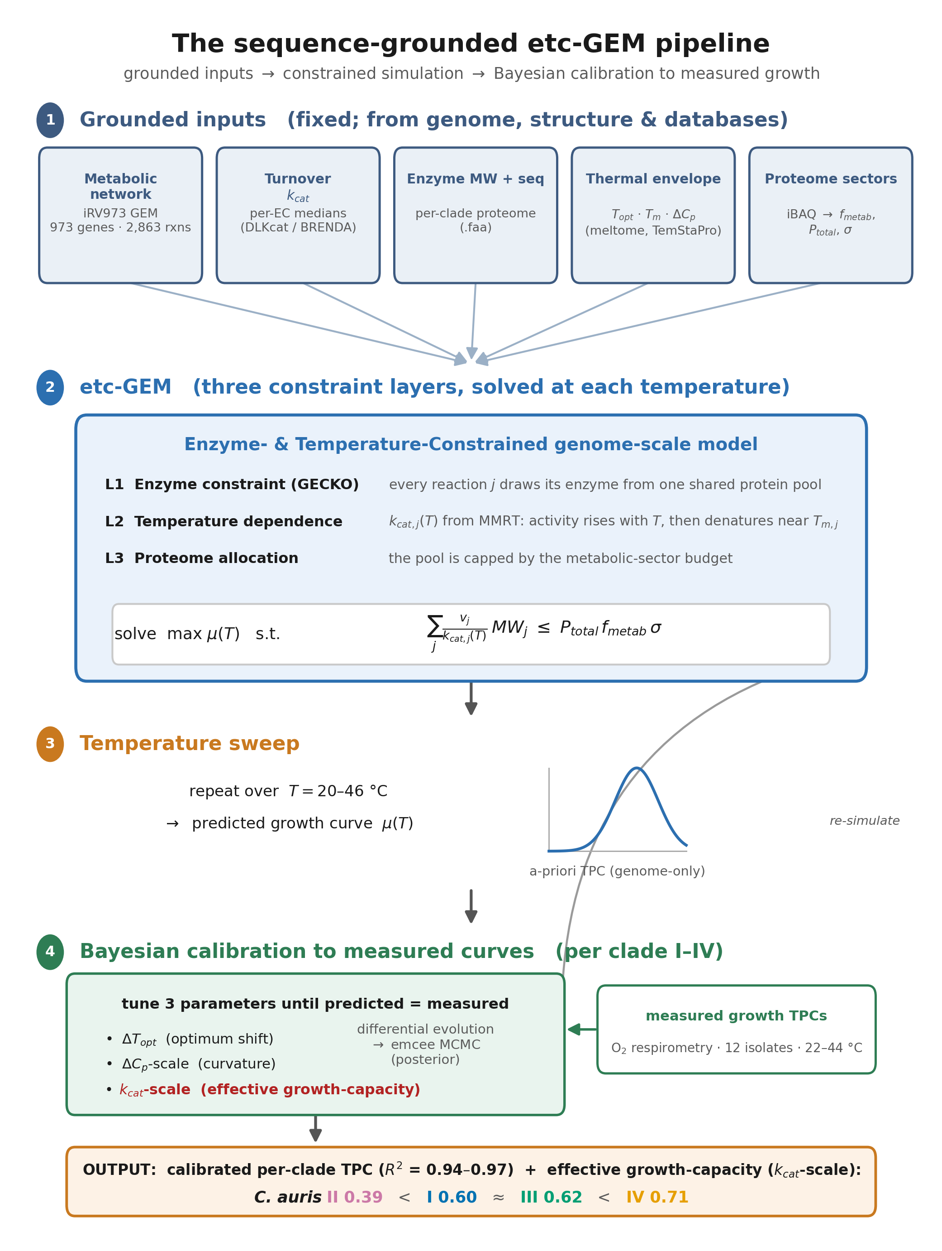
Figure 4. The sequence-grounded etc-GEM pipeline. Fixed, genome-derived inputs (the iRV973 metabolic network; per-reaction turnover kcat from EC/DLKcat; enzyme molecular weights and per-clade sequences; per-enzyme thermal parameters Topt, Tm and ΔCp; and proteome-sector fractions) feed an enzyme- and temperature-constrained genome-scale model that, at each temperature, maximises growth subject to a shared enzyme budget. Three parameters (ΔTopt, ΔCp-scale, and effective-capacity kcat-scale) are then calibrated by differential evolution and MCMC to each clade's measured growth curve. Because the genome is >99% identical across clades, only the effective growth-capacity axis differs, giving the per-clade values in Figure 3.
The four clades are near-identical at the enzyme level: median whole-proteome amino-acid identity was 99.4-100% across clades I-IV (reciprocal best-hit alignment of the four reference proteomes). Consequently the genome-derived model predicts a single, essentially identical thermal curve for all four clades, whereas the measured clades differ roughly two-fold in peak growth (Fig. 3b). Sequence variation therefore cannot account for the clade differences.
The difference resides instead in an effective growth-capacity axis (kcat-scale), an effective flux-generating capacity per unit modelled metabolic proteome that lumps enzyme abundance, active fraction, substrate saturation, maintenance and respiratory coupling (Fig. 3c). It is a single proteome-wide capacity scaling, not a change in the individual database-derived kcat values, which are shared across the near-identical clades. Its posterior ordered with thermotolerance (Clade II lowest at 0.39, Clades I and III intermediate at 0.60 and 0.62, Clade IV highest at 0.71), and of the three calibration parameters it was the only one that separated the clades (5 of 6 pairwise contrasts with non-overlapping 95% CrI, versus 1 of 6 for the optimum shift and 0 of 6 for curvature; Supplementary Fig. 1b).
The effective capacity axis covaries with measured respiratory economics. The growth-fitted effective-capacity scalar covaried across the twelve isolates with independently measured, respiration-containing outcomes. It was negatively associated with the cost of a fever (r = -0.86, 95% CI -0.96 to -0.76): the higher a clade's capacity, the cheaper its fever (Fig. 3d). It was likewise negatively associated with per-cell respiration at the growth optimum (r = -0.64), so that higher-capacity clades sustain growth while respiring less carbon (Fig. 3e). These cross-phenotype associations indicate that the scalar captures a reproducible physiological axis extending beyond peak-growth amplitude, but they do not constitute independent mechanistic validation of enzyme abundance. The fever tax is itself derived from measured growth and respiration through carbon-use efficiency, so it is not a fully independent target; and a flux-variability analysis showed that oxygen consumption at fixed optimal growth is not uniquely determined by the growth-calibrated model, so the model's respiration is an objective-selected flux solution rather than a unique prediction. Growth-only fits of alternative capacity, maintenance and uptake constraints each reproduced the clade growth ranking but none recovered the observed ranking in respiratory cost, and Clade II combined the lowest growth with the highest respiratory cost. We therefore read the fitted parameter as an effective growth-capacity axis that does not by itself distinguish reduced enzyme deployment from a coupling or maintenance component. Capacity behaved as a clade-level trait, with 90% of its variance between clades (ICC₁ = 0.90; ANOVA F₃,₈ = 27.7, P = 1.4×10⁻⁴; Supplementary Fig. 1a). The capacity-versus-peak-growth relationship, by contrast, is a self-consistency check rather than independent evidence, because capacity is itself the fitted height term (Supplementary Fig. 2).
Because the clades are near-identical in coding sequence, the capacity differences cannot be encoded there. A direct transcriptional test did not, however, localise them to bulk mRNA: in the only public clade-resolved RNA-seq at a controlled condition (Clade I versus Clade II, 37 °C; GEO GSE165762), the model's 928 central-metabolic enzyme genes were not coordinately lower in the low-capacity clade (median log₂ fold-change -0.005 versus +0.031 for the genome background; Wilcoxon P = 0.93; Supplementary Fig. 1d). Because that analysis is compositional (standard library-size-normalised RNA-seq, a single Clade II isolate, one 37 °C snapshot), it rules out a relative down-allocation of metabolic transcripts, not lower absolute output. The causal layer is therefore non-coding, regulatory, post-transcriptional, post-translational, or bioenergetic, and remains undetermined among these; distinguishing them will require a model-identifiability analysis (profiling capacity against maintenance, uptake and respiratory coupling) together with absolute, spike-in-calibrated proteomics, which partitions but does not fully close these branches.
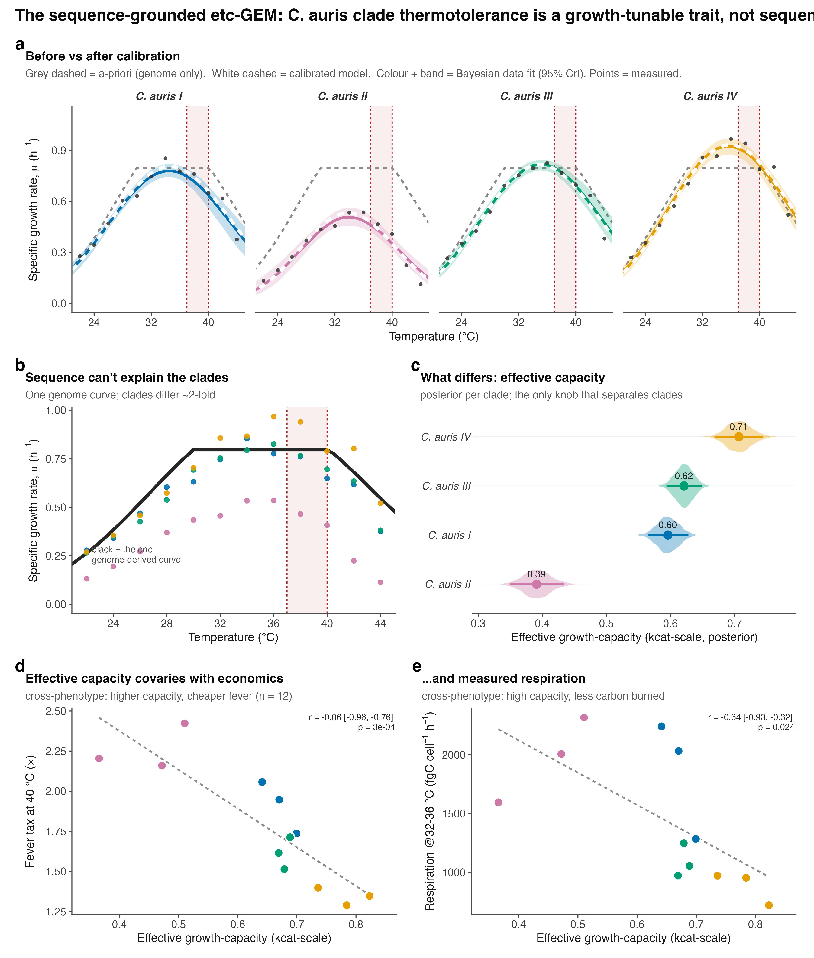
Figure 3. Clade thermotolerance is a growth-tunable trait, not sequence. (a) Per-clade calibration of the sequence-grounded etc-GEM: grey dashed, genome-only (a-priori) prediction; white dashed, calibrated model; colour and band, Bayesian data fit (95% CrI); points, measured. (b) The genome yields one curve for all clades (black), yet the measured clades differ ~2-fold. (c) Posterior of the effective growth-capacity parameter (kcat-scale) per clade; the only calibration parameter that separates the clades. (d) Effective growth-capacity versus the measured fever tax at 40 °C and (e) versus per-cell respiration at 32-36 °C (points, twelve isolates coloured by clade). The scalar was fitted to growth only; d-e are cross-phenotype associations, not independent mechanistic validation, because the fever tax derives from measured growth and respiration and the model's respiration at fixed growth is not uniquely determined (see text). They replace the earlier capacity-versus-growth panel, which was a self-consistency check (Supplementary Fig. 2).

Supplementary figures
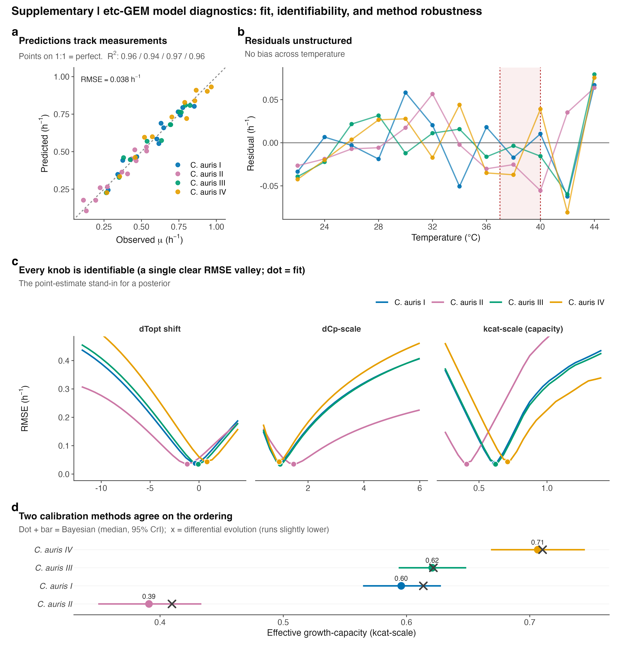
Supplementary Figure 1. The effective growth-capacity axis is a real, clade-level, non-coding, non-transcriptional trait. (a) Capacity across the twelve isolates by clade (bars, clade means); 90% of the variance lies between clades (ICC₁ = 0.90). (b) Number of clade pairs resolved (non-overlapping 95% CrI) by each calibration parameter; only the effective growth-capacity parameter (kcat-scale) separates the clades. (c) Median whole-proteome amino-acid identity of each clade to Clade I (diamond reciprocal best-hit); coding sequence is >99% identical. (d) Distribution of Clade I-versus-II log₂ fold-change for the model's 928 metabolic-enzyme genes (red) against the genome background (grey), from GEO GSE165762; the metabolic set is not coordinately shifted (Wilcoxon P = 0.93).
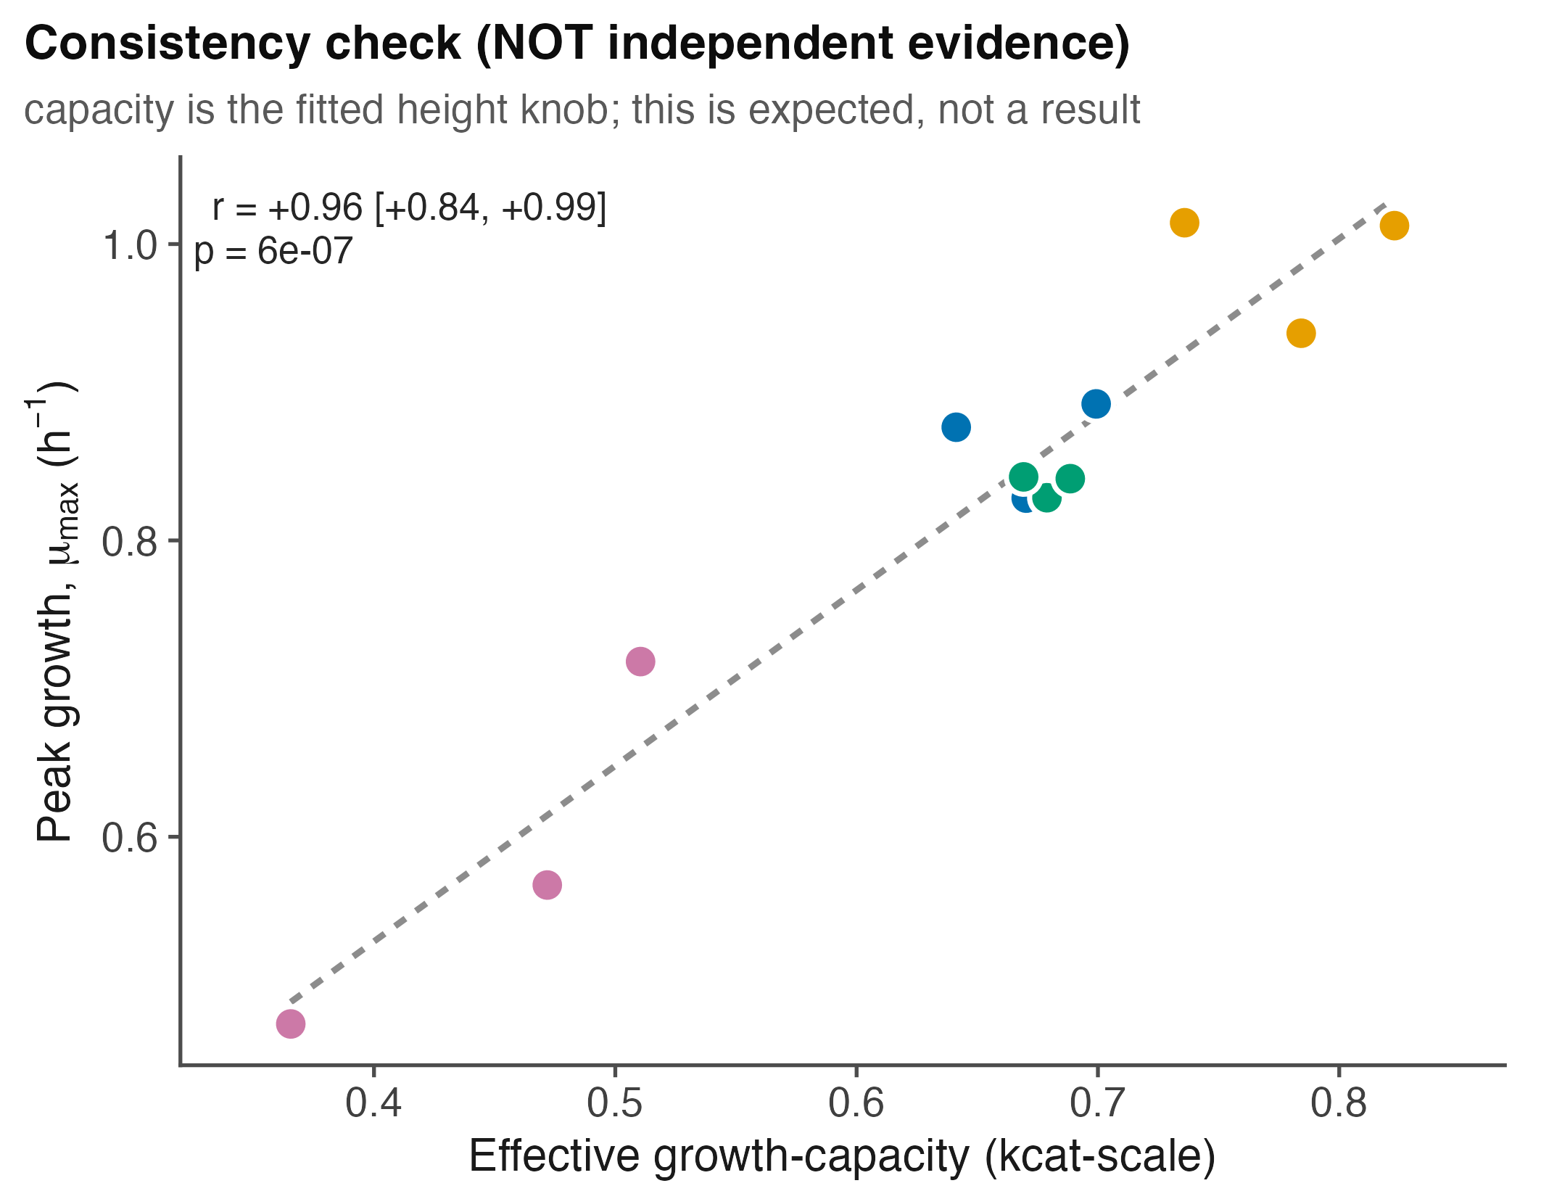
Supplementary Figure 2. Self-consistency check. Effective growth-capacity (the fitted curve-height parameter) versus measured peak growth across the twelve isolates (r = 0.96). Because capacity scales curve height by construction, this relationship is expected and is shown as a consistency check, not as independent evidence; the out-of-sample tests are in Fig. 3d-e.

Reference
Cakin I, Millington R, Pawar S, Buckling A, Smirnoff N, Padfield D, Duffy J, Yvon-Durocher G. A novel method to simultaneously estimate bacterial respiration and growth from oxygen dynamics. ISME Communications 2026;6(1):ycag024. https://doi.org/10.1093/ismeco/ycag024

