Supra-optimal temperature antagonises prothioconazole action in Zymoseptoria tritici through convergent thermal and chemical stress responses
Ilgaz Cakin
Helen Fones
Nicholas Smirnoff
Samraat Pawar
Angus Buckling
Daniel Padfield
Gabriel Yvon-Durocher
Abstract
Fungicide sensitivity is typically measured at a single laboratory temperature, yet plant pathogens experience fluctuating thermal conditions that are shifting under climate change. Combining temperature-resolved dose–response physiology, RNA-seq and targeted respiratory inhibition, we show that temperature reshapes the action of the azole fungicide prothioconazole in the wheat pathogen Zymoseptoria tritici. Across seven temperatures and a full dose range, prothioconazole imposed an energetically costly stress state rather than simply arresting growth: it suppressed growth while increasing biomass-specific respiration, reducing estimated carbon-use efficiency by roughly two-thirds. The temperature–fungicide interaction reversed across the thermal optimum, shifting from synergy below it to antagonism above it, with EC₅₀ increasing an estimated ~4.5-fold from 15 to 27 °C. Transcriptomics provided a molecular basis for this pattern: the fungicide remodelled approximately 2,000 genes at cool and near-optimal temperatures, repressing ribosomal and respiratory-chain genes while strongly inducing the non-phosphorylating alternative oxidase (AOX), but this response contracted nearly ten-fold at 27 °C, where heat alone had already engaged many of the same programmes. To ask whether AOX contributes to performance rather than merely marking the stress state, we inhibited it pharmacologically with salicylhydroxamic acid across a dose series at 15 and 27 °C. Growth was unaffected at 15 °C but fell steeply with dose at 27 °C, a difference between temperatures of −0.024 h⁻¹ per tenfold increase in inhibitor concentration (Welch’s t on culture-level slopes, P = 0.020), indicating that the alternative respiratory route carries a measurable share of growth specifically under supra-optimal heat. Together, these results identify thermal physiology as a determinant of fungicide potency and support incorporating temperature dependence into fungicide sensitivity testing and disease-control models as cropping environments become warmer and more thermally variable.

Introduction
Fungal pathogens are among the most serious threats to global food security, destroying enough produce annually to feed hundreds of millions of people and placing persistent pressure on the small arsenal of chemistries available to control them (Fisher et al. 2018; Steinberg and Gurr 2020). Few systems illustrate this dependence better than Septoria tritici blotch (STB), caused by the ascomycete Zymoseptoria tritici, one of the most damaging diseases of wheat in temperate Europe. The fungus enters through stomata and grows symptomlessly in the leaf apoplast for one to two weeks before switching to a destructive necrotrophic phase; this long latent period makes chemical control largely prophylactic and spray timing unforgiving (Steinberg 2015). Yield losses range from 5 to 20% even in well-managed crops and can approach half of the yield of susceptible cultivars in conducive seasons. Keeping the disease in check absorbs a large share of European fungicide expenditure, with annual costs to growers measured in hundreds of millions of euros (Fones and Gurr 2015; Torriani et al. 2015). Control rests disproportionately on the azoles, sterol demethylation inhibitors that block the cytochrome P450 sterol 14α-demethylase CYP51 thereby depleting ergosterol, the principal sterol of its membranes, and disrupting membrane sterol composition (Cools and Fraaije 2013). Prothioconazole, a triazolinthione whose binding to Z. tritici CYP51 is mechanistically distinct from that of older triazoles (Parker et al. 2011), remains one of the most widely used molecules in European wheat. Yet the durability of this chemistry is eroding: decades of intense use have driven the sequential accumulation of CYP51 alterations, enhanced efflux and target overexpression, and field performance of the azole class has declined measurably across Europe (Cools and Fraaije 2013; Jørgensen et al. 2022). With registration pipelines narrowing and resistance advancing, understanding the conditions under which existing fungicides work well or badly has become as important as discovering new ones (Steinberg and Gurr 2020).
One of those conditions is temperature. Climate warming is redistributing crop pathogens polewards, altering infection risk, and reshaping the geography of disease pressure on the crops that feed most of humanity (Bebber et al. 2013; Chaloner et al. 2021). The consequences of warming for the pathogens themselves have received sustained attention, and Z. tritici is known to harbour heritable variation in thermal sensitivity within and among populations (Lendenmann et al. 2016). The consequences of warming for chemical control have not. Sensitivity is characterised almost exclusively in standardised assays at a single, near-optimal laboratory temperature, even though field populations experience fluctuating thermal regimes that are shifting and broadening under climate change. A recent synthesis concluded that the influence of temperature on fungicide effectiveness is among the most neglected dimensions of climate-change impacts on crop protection, with the available evidence scattered, largely phenomenological, and rarely mechanistic (Juroszek et al. 2022). Fungicide dose recommendations, resistance-monitoring assays and regulatory efficacy testing are all implicitly premised on a temperature-invariant relationship between dose and effect. If that premise fails, then both the efficacy and the resistance-selection consequences of a given spray programme become functions of the weather.
Thermal physiology offers a quantitative framework for asking how it fails. The performance of ectothermic organisms follows unimodal thermal performance curves whose rising limbs, optima and collapse above the optimum are well described by thermodynamic models of enzyme kinetics and inactivation (Schoolfield et al. 1981; Angilletta 2009). The metabolic theory of ecology describes the Arrhenius-like temperature scaling of metabolic rates and supplies a common currency, the activation energy, for comparing fluxes within one organism (Gillooly et al. 2001; Brown et al. 2004). Growth and respiration need not share the same temperature dependence, and whenever respiration is activated more steeply than growth, carbon-use efficiency (CUE), the fraction of assimilated carbon converted into biomass rather than respired, must decline with warming, with consequences for microbial carbon budgets (Manzoni et al. 2012; Smith et al. 2019). For a pathogen under chemical attack, this framework makes the physiological context of drug exposure explicit: a cell near its thermal optimum, growing rapidly, is a different target from a cell at the edge of its niche whose energy budget is already strained.
How toxicant effects combine with thermal stress is a long-standing question in ecotoxicology, where interactions between chemicals and natural stressors are known to range from antagonism to strong synergy, with temperature among the most powerful modulators (Holmstrup et al. 2010; Noyes et al. 2009; Verheyen and Stoks 2023). Null models such as Bliss independence provide the formal reference against which such interactions can be classified (Bliss 1939). Yet in plant pathology this framework has rarely been deployed, and almost never together with the physiological and molecular measurements needed to explain the interactions it detects. Several features of Z. tritici physiology provide plausible mechanisms for such interactions. Azole action is embedded in wider cell physiology: inhibition of ergosterol synthesis perturbs membrane composition with consequences that reach nutrient uptake, redox balance and respiration (Parker et al. 2014), and the target enzyme itself is not thermally neutral, with Z. tritici CYP51 showing temperature-sensitive catalytic activity in vitro (Price et al. 2015), a direct point of contact between the thermal and chemical axes of this study. Azole exposure elicits well-characterised transcriptional responses spanning the ergosterol pathway, efflux transporters and detoxification systems, and the fungus possesses an alternative oxidase (AOX), a cyanide-resistant terminal oxidase that sustains respiratory electron flow when the cytochrome pathway is compromised and that already underlies reduced sensitivity to complex III inhibitors in this species (Joseph-Horne et al. 2001; Miguez et al. 2004). Whether such respiratory flexibility shapes the temperature dependence of azole action is unknown.
Here we combine factorial physiology, transcriptomics and targeted respiratory inhibition to dissect how temperature and prothioconazole interact in Z. tritici. We measured biomass-specific growth, respiration and CUE across seven temperatures spanning the species’ thermal niche and eight fungicide doses, fitted the resulting thermal performance and dose-response surfaces within a Bayesian framework, and tested the combined action of the two stressors against Bliss independence. We profiled the transcriptome across the temperature by fungicide factorial to identify the molecular strategies underlying the physiological responses. Finally, we tested the contribution of the alternative oxidase directly, by inhibiting it pharmacologically across a dose series at a cool and a supra-optimal temperature. We show that prothioconazole potency is strongly temperature-dependent and that the interaction reverses across the thermal optimum, from synergy in the cool range to antagonism under supra-optimal heat. We show that the transcriptional response to the drug converges on the response to warming itself and is strongly attenuated where heat has already engaged the same programmes. Finally, we show that blocking the alternative oxidase costs the fungus growth at supra-optimal temperature but not in the cool range, identifying respiratory rerouting as a functional component of the heat-engaged state and not only a transcriptional marker of it. Together these results argue that chemical control of crop disease cannot be understood, or optimised, independently of the thermal physiology of its target.

Results

Prothioconazole suppresses growth but elevates respiration, collapsing carbon-use efficiency
We fitted Sharpe–Schoolfield thermal performance curves to biomass-corrected growth and respiration rates of Z. tritici, both derived from the same dissolved-oxygen time series rather than measured independently (Methods), across seven temperatures (15–28 °C) and eight prothioconazole doses (0–4 mg L⁻¹) (Fig. 1A–D; fit diagnostics in Fig. S1, posterior predictive checks in Fig. S2). Prothioconazole progressively lowered the baseline metabolic rate for growth: ln(B₀) declined from −2.95 in the control to −3.93 at 4 mg L⁻¹, a near three-fold reduction, with the posterior probability of a negative shift exceeding 0.99 at all doses ≥ 0.5 mg L⁻¹ (Fig. 1A,B). Other thermal-performance parameters showed no detectable treatment-dependent shifts, indicating that the drug reduced metabolic capacity without reshaping the thermal response.
Respiration moved in the opposite direction: baseline ln(B₀) increased from −2.79 to −2.29 (P(positive) > 0.98 for doses ≥ 0.5 mg L⁻¹; Fig. 1C,D), i.e. treated cells respired more per unit biomass even as they grew less. The consequence is a sharp loss of efficiency: modelling estimated carbon-use efficiency (CUE; derived from the fitted rates and a common cell-carbon conversion, Methods) as a Boltzmann–Arrhenius function with a shared thermal sensitivity (E = −0.40) and dose-specific intercepts, the intercept α fell from −0.86 (control) to −1.87 (4 mg L⁻¹), a roughly two-thirds reduction in predicted CUE, while the thermal sensitivity was unchanged (Fig. 1E,F). Consistent with this decline, respiration was more thermally sensitive than growth at every dose (activation energies 0.67–0.88 eV versus 0.33–0.62 eV; across-dose contrast ΔĒ_a = 0.34 eV, 95% CrI 0.21–0.48; Fig. 1G), and the size of this gap matches the magnitude of the CUE thermal sensitivity re-estimated on the log scale (|E_CUE| = 0.37, 95% CrI 0.26–0.49) — an internal consistency of the fitted rates rather than an independent test, since growth, respiration and CUE all derive from the same oxygen trajectories. No systematic dose dependence of either activation energy was resolved (all dose-versus-control contrasts crossed zero). Together, these data indicate that prothioconazole does not simply arrest growth; it induces a metabolically costly state characterised by elevated biomass-specific respiration and reduced conversion of assimilated carbon into biomass.
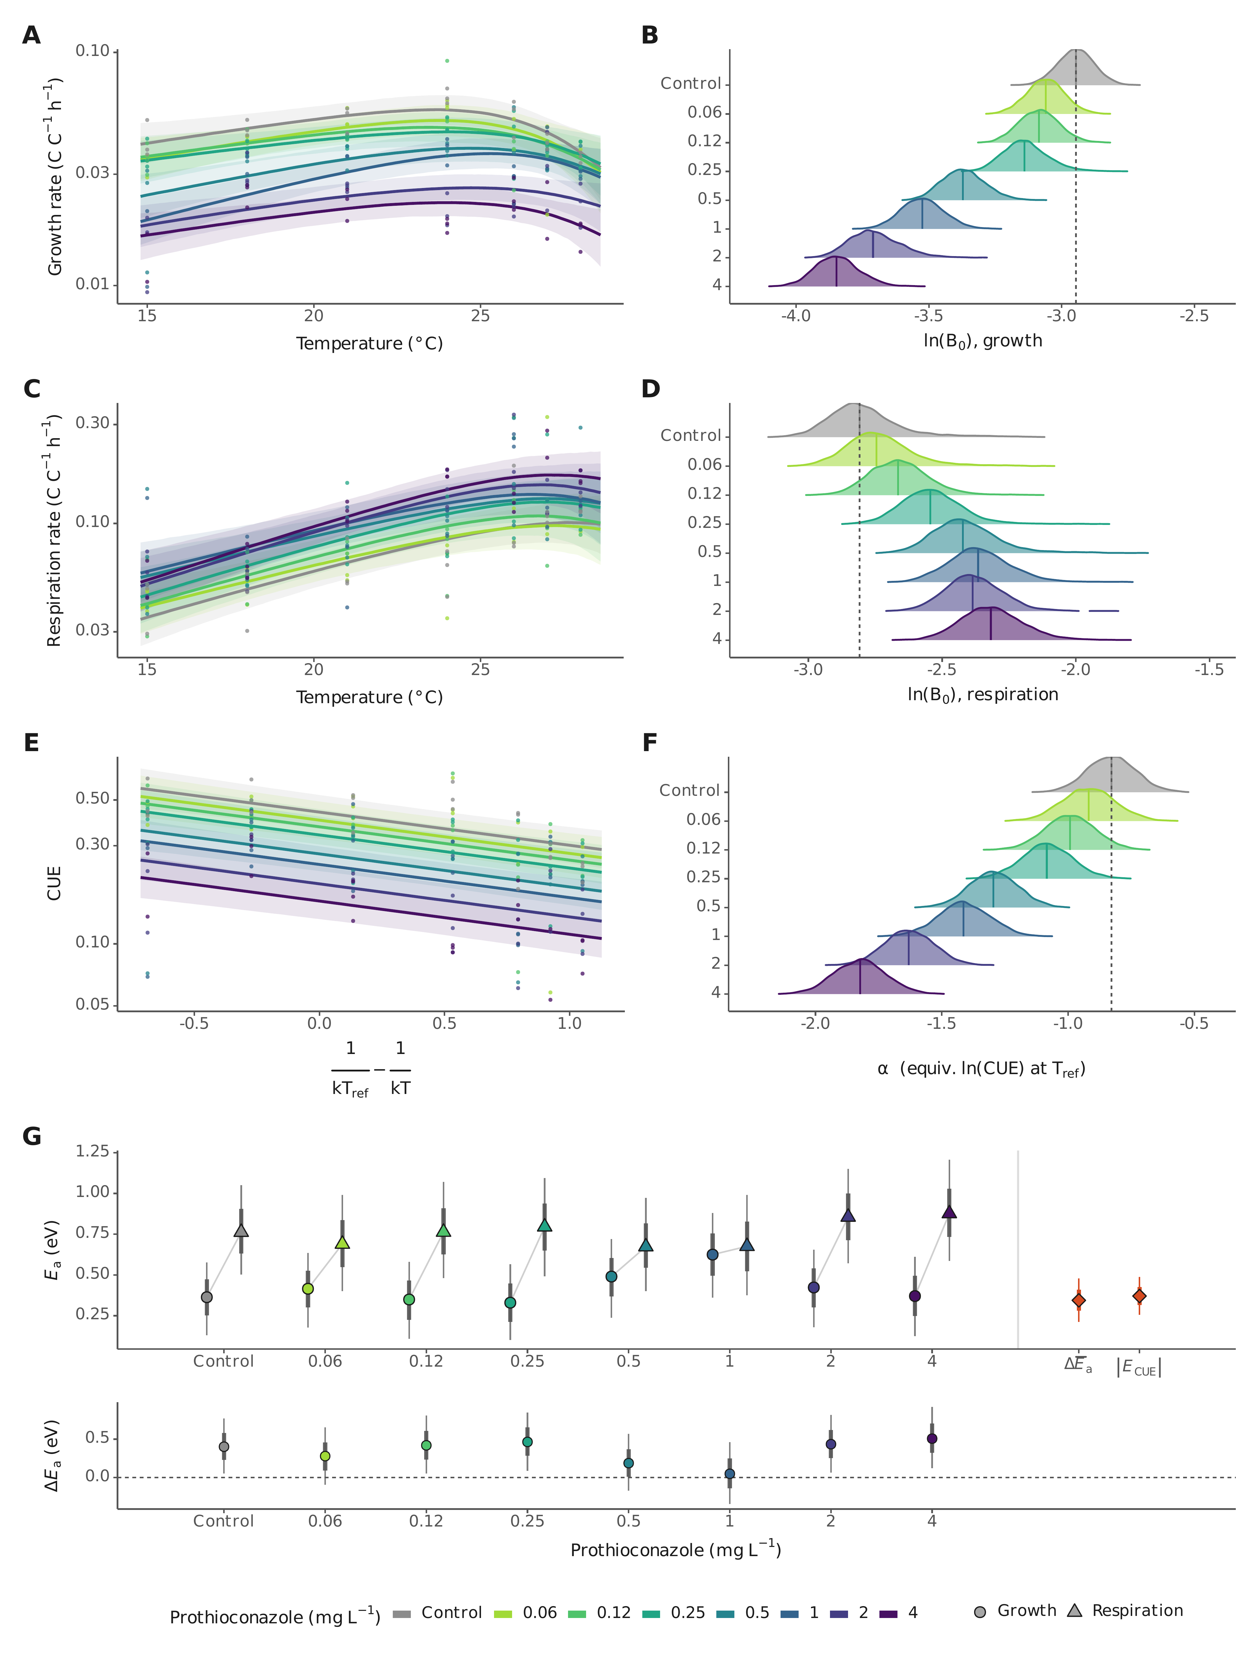
Figure 1. Prothioconazole suppresses growth but increases respiration, collapsing carbon-use efficiency across the thermal range of Zymoseptoria tritici. (A) Sharpe–Schoolfield thermal performance curves for biomass-corrected growth rate across seven temperatures (15–28 °C) and eight prothioconazole doses (0–4 mg L⁻¹). Lines show posterior medians and ribbons 95% credible intervals; colours encode dose (grey, solvent control; viridis ramp, increasing dose). (B) Posterior distributions of the dose-specific baseline growth parameter ln(B₀), showing progressive suppression of growth capacity with increasing concentration. (C) Sharpe–Schoolfield thermal performance curves for biomass-corrected respiration rate. (D) Posterior distributions of dose-specific ln(B₀) for respiration, showing increased biomass-specific respiration under prothioconazole. (E) Carbon-use efficiency (CUE = P/(P + R)) modelled as a Boltzmann–Arrhenius function of temperature with a shared thermal sensitivity and dose-specific intercepts; lines show posterior medians per dose and ribbons 95% credible intervals. (F) Posterior distributions of the dose-specific CUE intercept α, showing a progressive downward shift with increasing concentration. (G) Dose-specific activation energies from the Sharpe–Schoolfield fits: paired posterior medians and 95% credible intervals for growth and respiration at each dose (within-dose pairs connected), with the across-dose summary at right — the mean respiration–growth contrast ΔĒ_a = 0.34 eV (95% CrI 0.21–0.48) alongside the CUE thermal sensitivity re-estimated on the log scale (|E_CUE| = 0.37, 95% CrI 0.26–0.49). The agreement of these two quantities is a cross-model consistency check, not an independent test, as all rates derive from the same oxygen trajectories. Bottom strip: the within-dose difference ΔE_a = E_a,resp − E_a,growth with 95% CrI (dashed line, zero); respiration was more temperature-sensitive than growth at every dose (posterior probability 0.60–1.00 across doses; ≥ 0.93 at six of eight), and no systematic dose dependence of either activation energy was resolved. Raw-data fit diagnostics are in Fig. S1 and posterior predictive checks in Fig. S2.

Fungicide potency is temperature-dependent, switching from synergy to antagonism across the thermal optimum
Hill dose–response modelling revealed that fungicide potency depends strongly on temperature (Fig. 2A,B; per-temperature fits in Fig. S3; model-form sensitivity in Methods). The half-maximal effective concentration (EC₅₀) for growth was lowest, i.e. the fungus was most sensitive, at 15 °C (1.12 mg L⁻¹, pEC₅₀ = 5.49) and highest at 27 °C (5.00 mg L⁻¹, pEC₅₀ = 4.82; this fitted value lies beyond the maximum tested dose of 4 mg L⁻¹ and is therefore an extrapolation — the posterior probability that the true EC₅₀ exceeds the tested range is 0.84 at 27 °C (95% CrI 3.2–11.2 mg L⁻¹), against 0.32 at 18 °C; Fig. S9B), an estimated ~4.5-fold loss of potency at supra-optimal temperature. At 18 and 27 °C the tested concentrations did not reduce growth below half the dose-zero control (minimum relative growth 0.53 at both), so the EC₅₀ estimates at these two temperatures are extrapolations of the Hill form rather than interpolations of the measured range, and their credible intervals are correspondingly wide. Respiration responded to dose in the opposite direction, increasing log-linearly with concentration; the effect was largest at the 24 °C optimum (+27.9% per mg L⁻¹, 95% CrI 15.4–42.4; the largest of the seven temperatures in 86% of posterior draws), and the 95% credible interval excluded zero at 15, 21 and 24 °C only (Fig. 2C; per-temperature fits with data in Fig. S3).
To test formally whether temperature and fungicide interact, we adapted Bliss independence to treat thermal deviation and fungicide exposure as two stressors, referenced to the thermal optimum (T_opt = 24 °C, the temperature of highest baseline growth), which served as the zero-deviation thermal reference (Fig. 2D,E). Below the optimum, the interaction was synergistic: at 15 °C the Bliss deviation was negative across low-to-intermediate doses, with the strongest synergy at 0.12 mg L⁻¹ (Δ = −0.096; P(synergy) = 1.0), and the pooled cool region (15–19 °C) showed a negative median deviation (−0.099). Above the optimum it reversed to antagonism, strongest at 27 °C (Δ = +0.27 at 2 mg L⁻¹; P(antagonism) > 0.999; pooled hot region 25–28 °C median +0.097). This synergy-to-antagonism reversal was robust to the choice of reference temperature (re-referencing to 21 °C left the synergistic and antagonistic calls unchanged; Fig. S9C). Relative to the Bliss expectation, cool temperatures therefore enhance the growth-suppressive effect of prothioconazole, whereas supra-optimal heat weakens it.
Because the Bliss analysis requires both a reference temperature and a multiplicative null, the interaction was also assessed independently of that formulation. Log growth rate across all 156 replicate-level observations was modelled with penalised regression splines as a separable surface, $logg=f(T)+h(c)$, in which temperature and dose act independently, and compared with an otherwise identical surface containing an additional pure-interaction tensor term, $+ ti(T,c)$ (Methods). The interaction term was strongly supported (effective degrees of freedom 5.50, F = 4.62, P = 1.1 × 10⁻⁴; ΔAIC = 22.1) and improved out-of-sample prediction under exact leave-one-out cross-validation, in which both models were refitted once per held-out observation (paired difference in squared prediction error 0.0082, 95% CI 0.0019–0.0144, P = 0.011). Given no reference temperature and no multiplicative structure, the fitted surface nonetheless recovers the reversal: at the higher concentrations the interaction residual is negative at 15 °C, indicating growth lower than a non-interacting surface predicts, and positive at 27–28 °C, passing through zero in the intermediate range (Fig. S11). Two bounds apply. Support depends in part on the dimension of the spline basis, being weakest where the temperature basis is too coarse to represent a sign reversal at all (Table S1), and pointwise credible intervals on the residual surface include zero almost everywhere, so the evidence lies in the global model comparison and out-of-sample performance rather than at individual points of the surface. Within those bounds, the temperature × fungicide interaction is supported independently of the Bliss reference temperature and of the multiplicative null.
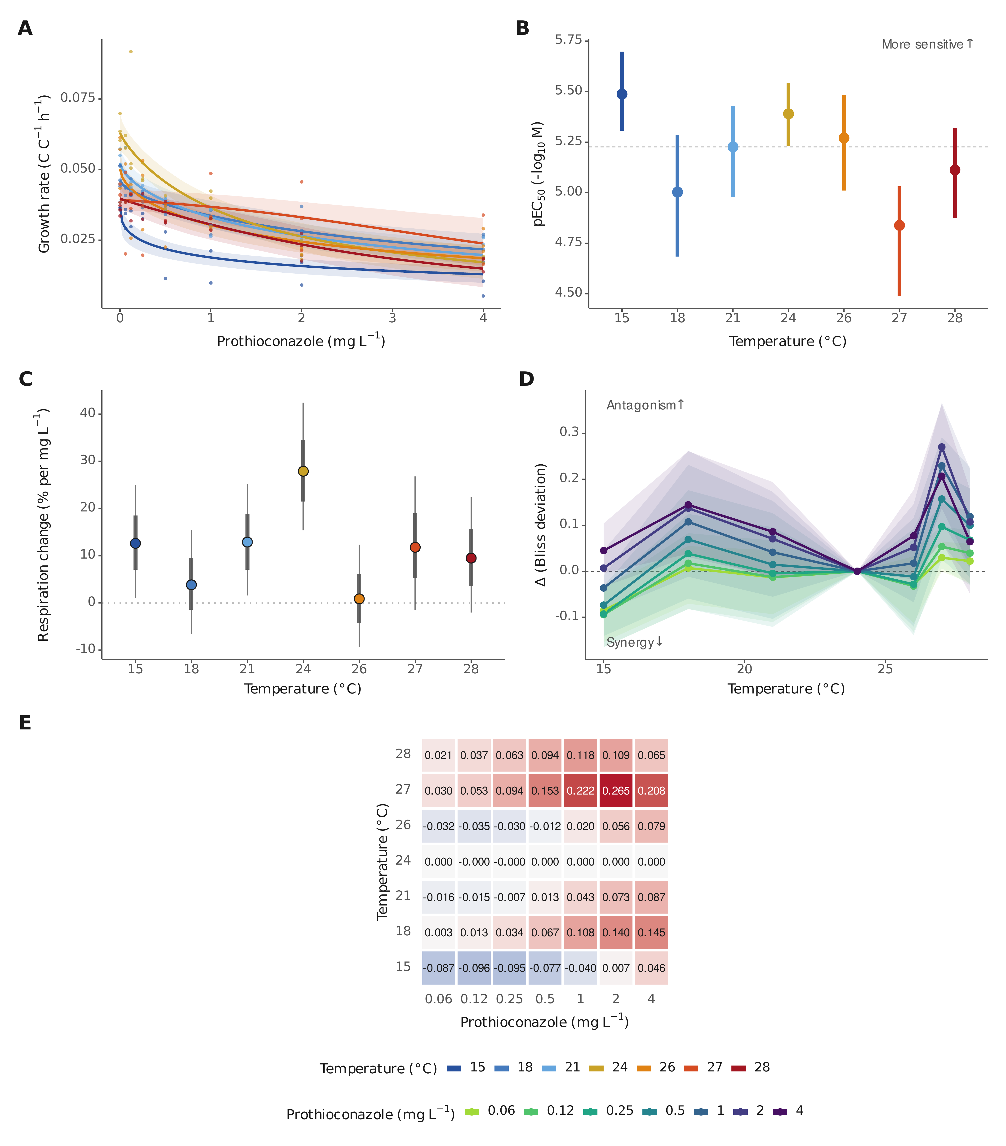
Figure 2. Fungicide potency is temperature-dependent and the temperature × fungicide interaction reverses across the thermal optimum. (A) Hill dose–response curves for growth at each temperature (posterior medians with 95% credible ribbons; colours encode temperature from cool blue to hot red; per-temperature panels with data in Fig. S3). (B) Temperature-specific potency (pEC₅₀, the negative log₁₀ EC₅₀ in mol L⁻¹): the fungus is most sensitive at 15 °C and least sensitive at 27 °C (the 18 and 27 °C estimates are extrapolations beyond the tested dose range; see text and Fig. S9B). (C) The prothioconazole effect on respiration, expressed as the percentage change per mg L⁻¹ from the log-linear model (posterior medians with 95% and 66% credible intervals). The effect is largest at the 24 °C optimum (+27.9% per mg L⁻¹, 95% CrI 15.4–42.4; the largest of the seven temperatures in 86% of posterior draws) and the 95% CrI excludes zero at 15, 21 and 24 °C only; the underlying per-temperature fits with data are in Fig. S3. (D) Bliss deviation Δ versus temperature for each concentration (posterior medians, 95% credible ribbons; dashed line, Bliss independence Δ = 0; the 24 °C thermal optimum is the zero-deviation reference). Negative Δ indicates synergy, positive Δ antagonism. (E) Heatmap of posterior mean Δ for each temperature × concentration combination, showing synergy at cool and antagonism at supra-optimal temperatures. Robustness to the reference choice and dose range is shown in Fig. S9.

Prothioconazole triggers a temperature-dependent transcriptional response
To resolve the mechanism, we sequenced the transcriptomes of six treatment groups (15, 21 and 27 °C, each at 0 and 2 mg L⁻¹ prothioconazole; 7–8 replicate cultures per group), bracketing the thermal optimum and sampling the synergistic (15 °C) and antagonistic (27 °C) regions of the interaction. Principal-component analysis cleanly separated samples by temperature (PC1, 36% of variance) and by fungicide (PC2, 23%), showing that both factors strongly structure transcriptomic variation (Fig. 3A).
The prothioconazole response was large and strongly temperature-dependent. The drug significantly altered 1,922 genes at 15 °C and 2,194 at 21 °C (adjusted P < 0.05, |log₂FC| ≥ 1), but only 182 at 27 °C, an approximately ten-fold contraction (Fig. 3B). A formal interaction test confirmed this temperature dependence gene by gene: 2,409 genes responded to the drug differently across temperatures (likelihood-ratio test, adjusted P < 0.05), and among interaction genes contrasting 27 °C with 15 °C, 97% showed attenuation rather than amplification of the drug response. At the pathway level the interaction was likewise dominated by attenuation at 27 °C: repression of the gene-expression machinery weakened (ribosome interaction NES +3.44, FDR < 10⁻⁴; spliceosome +2.72; RNA polymerase +2.38) and induction of xenobiotic/P450 detoxification also weakened (NES −2.3 and −2.1), whereas ABC-efflux induction showed no significant interaction — the component of the drug response that persists at supra-optimal temperature (Fig. S14). At the sample level, the ribosomal-module response to the drug was 0.87 ± 0.38 log₂ units weaker at 27 °C than at 15 °C (temperature × drug interaction F(2,39) = 12.3, P = 7.3 × 10⁻⁵; robust to leaving out any single sample, maximum P = 2.7 × 10⁻⁴). At the cool and near-optimal temperatures the cell mounted a clear xenobiotic-defence programme: ATP-binding-cassette efflux pumps were strongly induced (CDR1, +4.0 log₂FC; SNQ2) together with glutathione-S-transferases, whereas the drug target itself was barely affected, with CYP51/ERG11 not significantly induced at any temperature and the ergosterol pathway only mildly perturbed (Fig. S4). The magnitude of the transcriptome-wide drug response, quantified per gene, likewise contracted with warming (median |log₂FC| of drug-responsive genes falling by roughly a third at 27 °C relative to 15 °C; Fig. S5). Excluding the lowest-depth libraries did not alter these conclusions (per-gene log₂FC correlation with the full data ≥ 0.97; Methods).
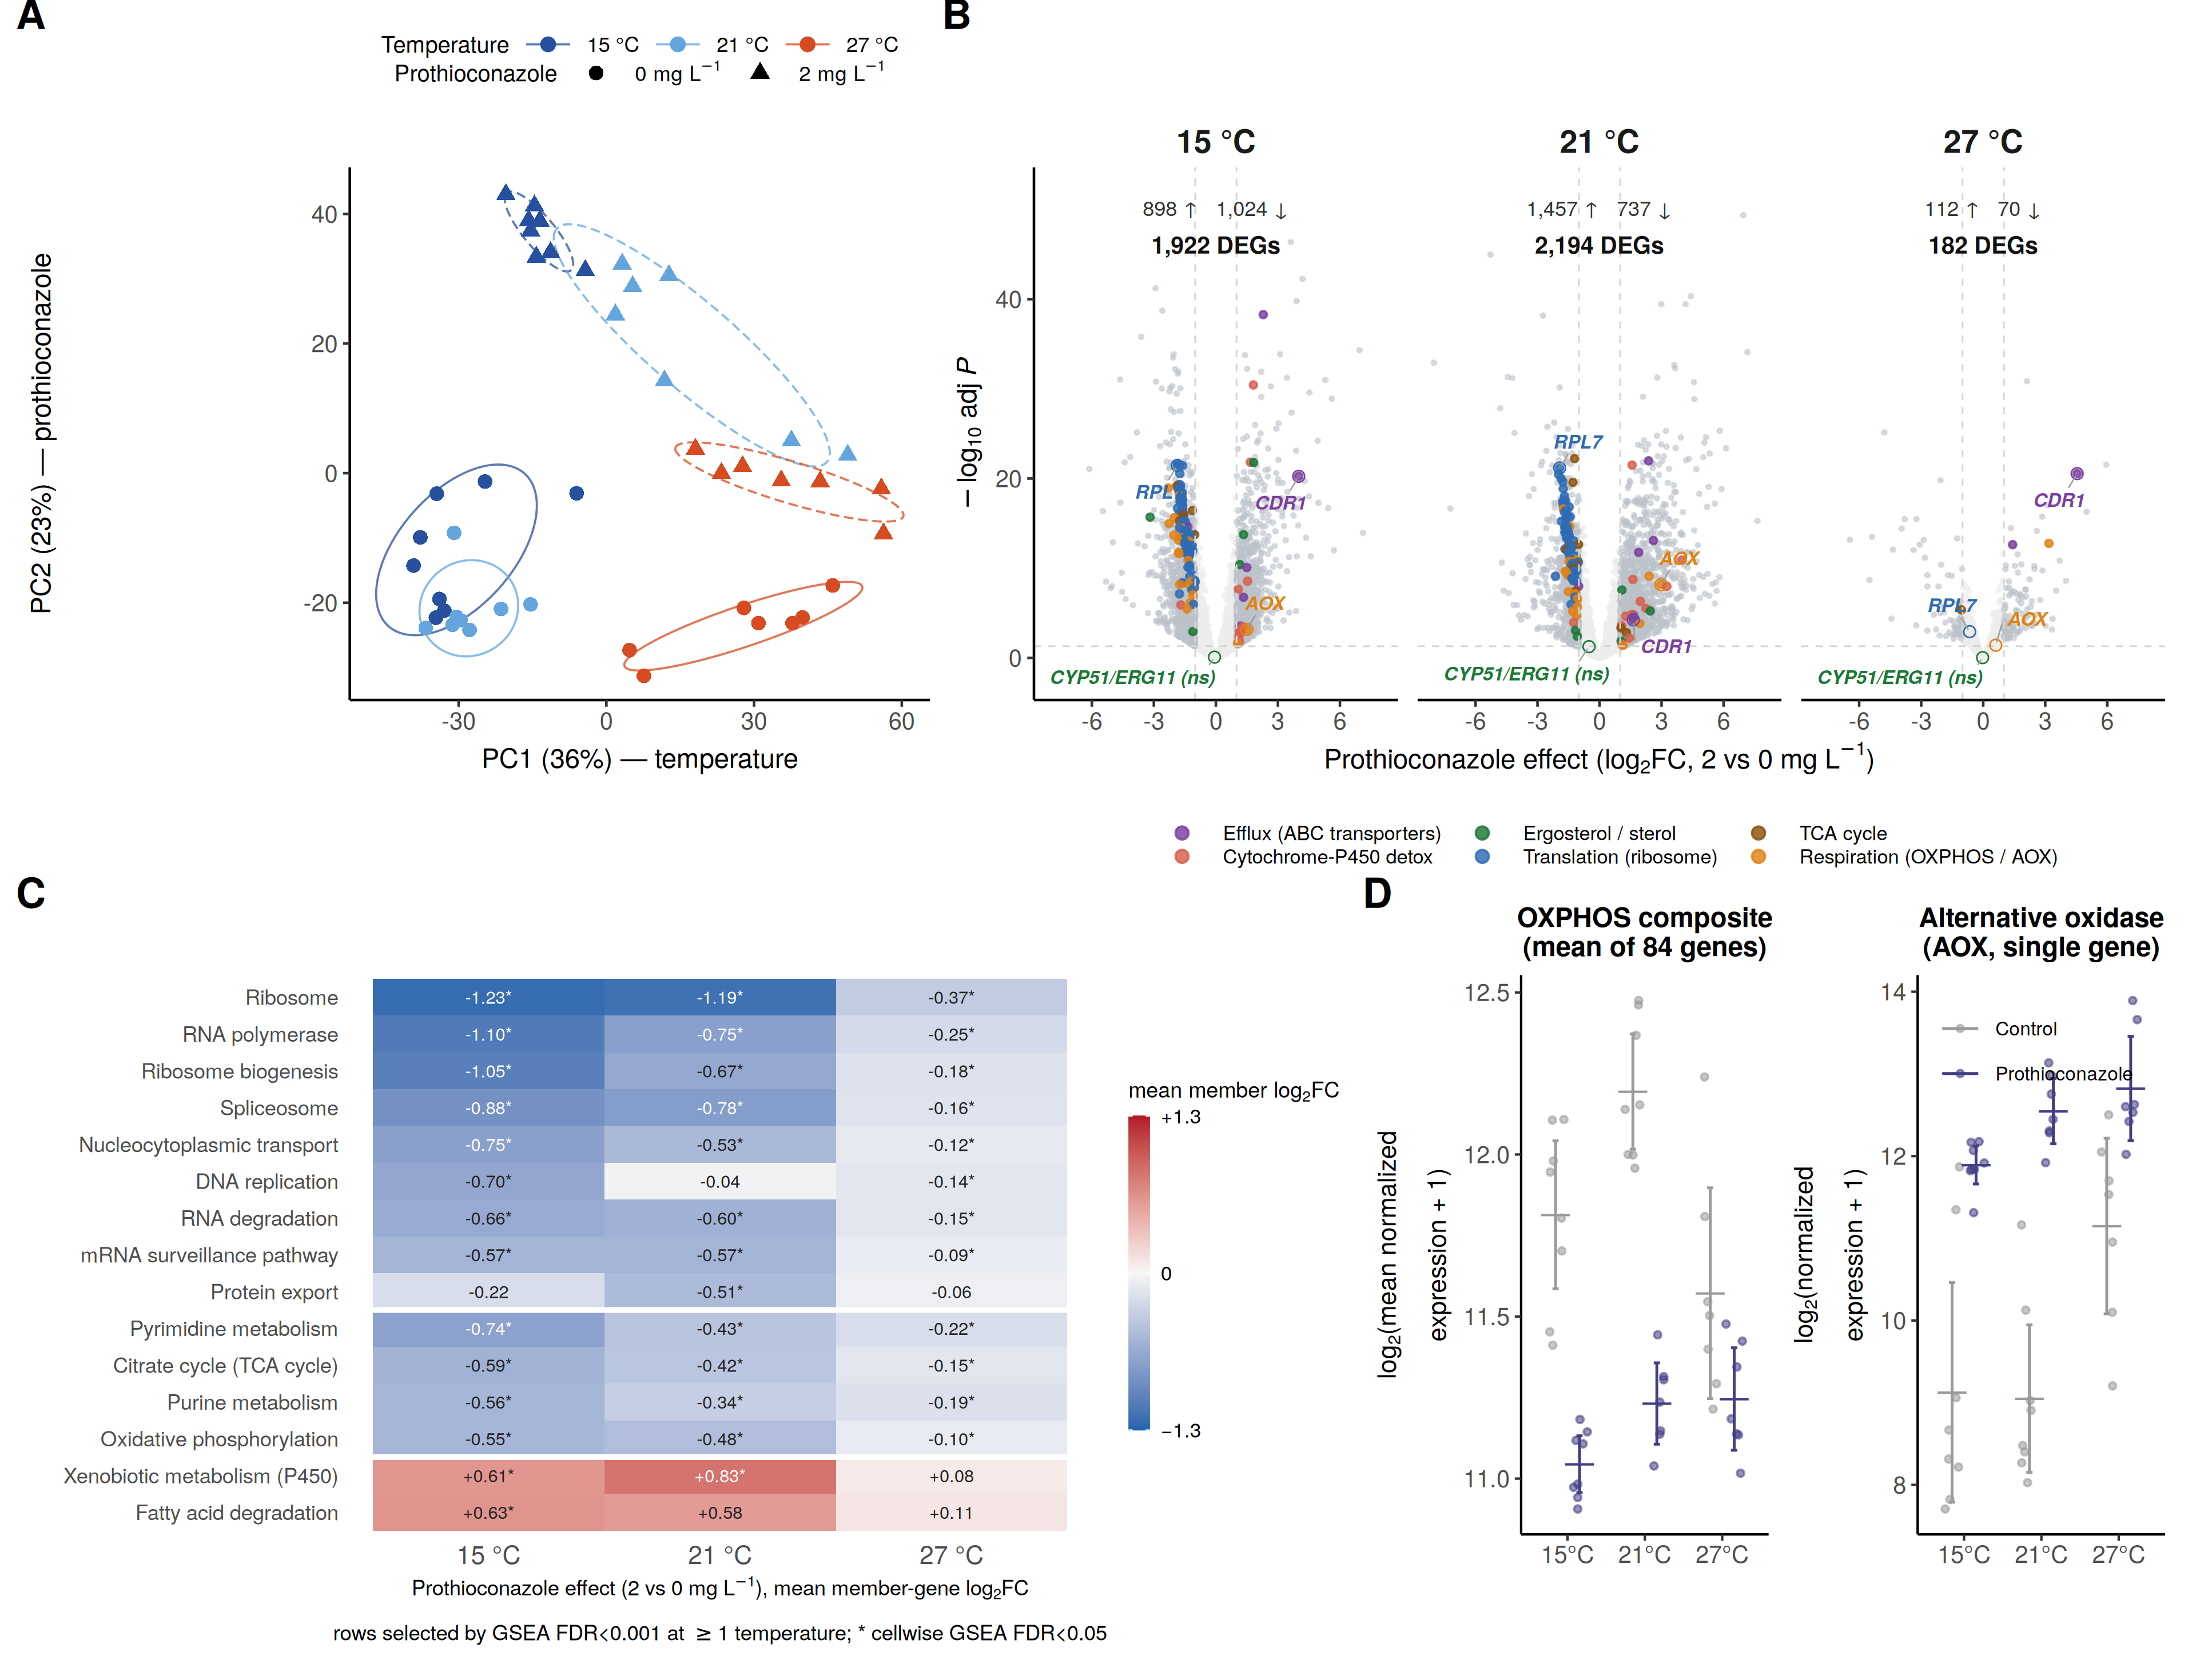
Figure 3. Prothioconazole engages a temperature-dependent transcriptional programme. (A) Principal-component analysis of all RNA-seq samples (top 500 variable genes; n = 7–8 per group). Points are coloured by temperature and shaped by prothioconazole dose (circles, 0; triangles, 2 mg L⁻¹), with outline ellipses per group. (B) Volcano plots of the prothioconazole effect (log₂FC, 2 versus 0 mg L⁻¹) at 15, 21 and 27 °C, with the number of genes passing adjusted P < 0.05 and |log₂FC| ≥ 1 tallied per panel (↑ up, ↓ down). Selected KEGG categories are coloured (legend). A fixed set of mechanistically central genes — the azole target CYP51/ERG11, the alternative oxidase AOX, the efflux transporter CDR1 and the ribosomal protein RPL7 — is labelled in every panel irrespective of significance (ringed points; “ns”, not significant). CYP51/ERG11 is not significantly changed at any temperature (adjusted P = 0.83, 0.056 and 0.94 at 15, 21 and 27 °C). (C) KEGG pathway heatmap (gene-set enrichment analysis; pathways at FDR < 0.001 in at least one temperature), grouped into gene-expression machinery, energy and nucleotide metabolism, and xenobiotic/lipid-catabolism blocks (white separators); cell colour and value are the mean member-gene log₂FC (not the enrichment score) and an asterisk marks GSEA FDR < 0.05 for that cell. (D) Classical respiration (oxidative phosphorylation, OXPHOS) versus alternative oxidase (AOX) expression in control and treated cultures on a log₂(normalized count + 1) scale; points are individual samples, bars group means with 95% confidence intervals across biological samples (n = 7–8). The ergosterol pathway in detail is in Fig. S4; effect-size attenuation at 27 °C in Fig. S5; the full pathway landscape and gene-level view in Figs S6 and S7.

Ribosome repression and respiratory rerouting link the transcriptome to reduced growth, elevated respiration and declining CUE
Data-driven pathway analysis (gene-set enrichment over a restricted KEGG universe; Fig. 3C, full pathway landscape in Fig. S6, gene-level view in Fig. S7) tied the transcriptome directly to the physiology. The dominant signal was repression of the growth machinery: ribosomal-protein and ribosome-biogenesis genes were strongly down-regulated (mean member log₂FC −1.23 and −1.05 at 15 °C), consistent with the drug-induced reduction in growth in Fig. 1A,B.
The apparent respiratory paradox, increased respiration despite repression of the canonical respiratory chain, was accompanied by opposing regulation of two terminal pathways. The classical, ATP-coupled respiratory chain (oxidative phosphorylation, TCA cycle) was repressed by the drug (mean log₂FC −0.55 and −0.59), yet the non-phosphorylating alternative oxidase (AOX) was strongly induced (Fig. 3C,D). AOX consumes oxygen without conserving energy as ATP; its induction therefore provides a plausible mechanism by which oxygen consumption could increase (Fig. 1C,D) while less carbon is retained as biomass (lower CUE; Fig. 1E,F), a route tested directly by inhibitor perturbation below. In absolute terms, AOX expression increased with both temperature and prothioconazole; however, because AOX was already elevated at 27 °C, the incremental fold-change induced by the drug was reduced, consistent with the marked attenuation of the overall response. This apparent attenuation of AOX induction at 27 °C was not, however, individually resolved (temperature × drug interaction P = 0.052); it is the contraction of the drug response at the module and transcriptome level that is statistically established. Consistent with broader metabolic reorganisation, fatty-acid biosynthesis, β-oxidation and peroxisomal genes were concomitantly up-regulated, alongside an oxidative-stress (glutathione/antioxidant) response. Notably, the drug-target pathway itself was only mildly perturbed and CYP51 was not transcriptionally up-regulated, indicating no evidence, under these conditions, for the transcriptional target-overexpression compensation seen in some resistant field strains.

Temperature alone reshapes the transcriptome in two regimes
To separate the drug response from the cell’s intrinsic thermal response, we examined temperature alone in untreated controls (Fig. 4). Warming from 15 to 21 °C, toward the thermal optimum, changed remarkably little (49 genes), whereas warming to the supra-optimal 27 °C elicited a genome-wide response of roughly 1,400 genes (Fig. 4A). At the pathway level this response fell into two regimes (Fig. 4B): from 15 to 21 °C oxidative phosphorylation, the proteasome and translation were mildly induced, consistent with ramping toward maximal growth, whereas from 21 to 27 °C the entire gene-expression machinery (ribosome, ribosome biogenesis, RNA polymerase, spliceosome) was strongly repressed, consistent with a supra-optimal heat-stress response. Classical respiration peaked near the optimum and declined at 27 °C, while the alternative oxidase was strongly induced at 27 °C (Fig. 4C), a temperature-driven shift toward non-phosphorylating respiration that mirrors the drug-induced shift in Fig. 3D. Notably, this supra-optimal response was dominated by translational shutdown rather than a classical heat-shock or chaperone induction. In contrast to this shared repression, CDR1 responded in opposite directions to the two stressors — induced by prothioconazole (Fig. 3) but repressed by warming (Fig. 4) — indicating that the drug–heat convergence documented below is a programme-level phenomenon rather than gene-by-gene identity.
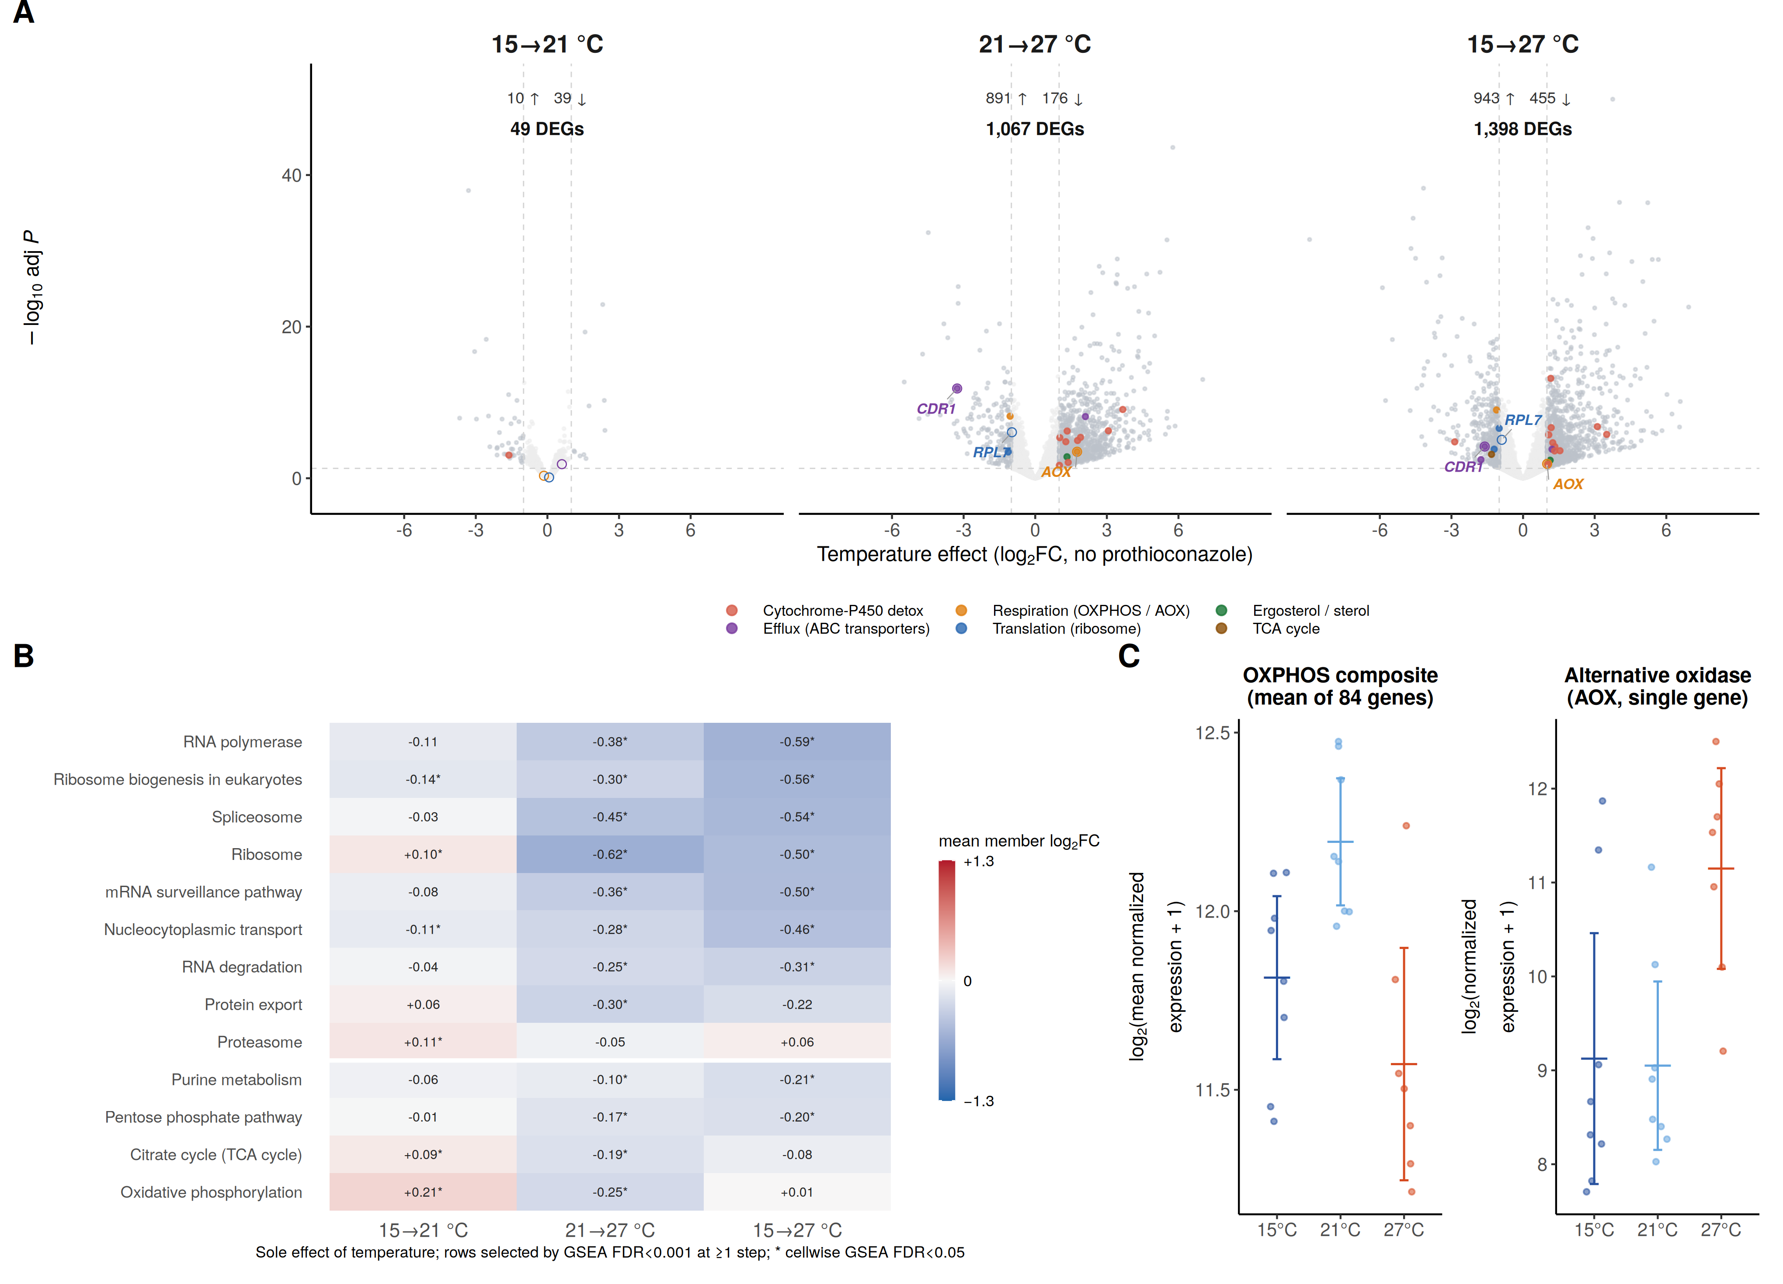
Figure 4. Temperature alone reshapes the transcriptome in two regimes — limited toward the thermal optimum and extensive above it. All panels use control (no-prothioconazole) samples. (A) Volcano plots of the pure thermal response for the three warming steps (15→21, 21→27 and 15→27 °C), with significant genes tallied and a fixed gene set (AOX, CDR1, RPL7) marked as in Fig. 3B; in the 15→21 °C panel the fixed-set points are ringed but unlabelled because none passes significance in this limited step. The transcriptome barely changes from 15 to 21 °C (49 genes) and then mounts a genome-wide response beyond the thermal optimum. (B) KEGG pathway GSEA heatmap (pathways at FDR < 0.001 in at least one step), sharing the ±1.3 colour scale with Fig. 3C and with rows ordered by the 15→27 °C effect; cell colour and value are the mean member-gene log₂FC and an asterisk marks GSEA FDR < 0.05 for that cell. Translation, respiration and proteasome pathways are mildly induced toward the optimum, whereas the gene-expression machinery is strongly repressed at 27 °C. (C) Classical respiration (OXPHOS) and alternative oxidase (AOX) expression across temperature on a log₂(normalized count + 1) scale; points are individual samples, bars group means with 95% confidence intervals (n = 7–8).

Prothioconazole and temperature converge on shared programmes that track whole-organism physiology
Because temperature and prothioconazole each remodel overlapping parts of metabolism, we compared their transcriptional programmes directly. At the pathway level the drug response (pooled over the engaged 15 and 21 °C) and the warming response (27 versus 15 °C) were strongly and positively correlated (Pearson r = 0.66, descriptive; Fig. 5A): the same growth and energy programmes (ribosome, oxidative phosphorylation, TCA cycle, proteasome) were repressed by both perturbations, with ABC-transporter efflux the sole drug-specific exception. This convergence was itself temperature-dependent (Fig. 5B): the gene-level alignment between the drug effect and the warming programme was steep when the drug was applied at 15 °C (slope 0.41) and 21 °C (slope 0.64) but essentially vanished at 27 °C (slope 0.04; gene-level concordance in Fig. S8).
These transcriptional programmes descriptively tracked whole-organism physiology. Across the six condition means, the ribosome module score was strongly correlated with growth rate (Pearson r = +0.93, descriptive, n = 6; Fig. 5C), and expression of the single alternative-oxidase gene covaried inversely with carbon-use efficiency (r = −0.98; leave-one-out range −0.99 to −0.98; Fig. S13). This identifies AOX induction as a marker of the low-CUE state but does not establish that AOX activity caused the decline in CUE, a point taken up with the inhibitor experiment below.
Drug-induced repression of the ribosomal regulon was strongly temperature-dependent (sample-level interaction above), such that at 27 °C — where heat alone had already down-shifted the translational machinery (Fig. 4) — the drug removed substantially less residual ribosomal expression. These observations are consistent with a translation-capacity hypothesis for the loss of potency at supra-optimal temperature, in which the drug’s growth effect is limited by how much translational capacity remains to be repressed; testing this causally requires perturbation experiments. As a complementary, direction-level view of the same convergence, projecting the untreated 27 °C transcriptome onto the fixed drug-response direction indicated a displacement of the control state toward the drug-responsive state (cos = 0.45, ≈ 20% of the total heat shift; sample bootstrap 95% CI 0.27–0.56; robust to removing the top 1–5% of contributing genes, cos 0.44–0.41; Methods). This displacement was directionally consistent but did not exceed a correlation-preserving sample-label permutation null at α = 0.05 (P = 0.096) and is reported descriptively. Together these results provide a mechanistic hypothesis for the Bliss interaction (Fig. 2D,E): because prothioconazole and temperature converge on the same machinery, their effects compound below the thermal optimum, whereas at supra-optimal temperature heat has already repressed that machinery, leaving little for the fungicide to act upon.
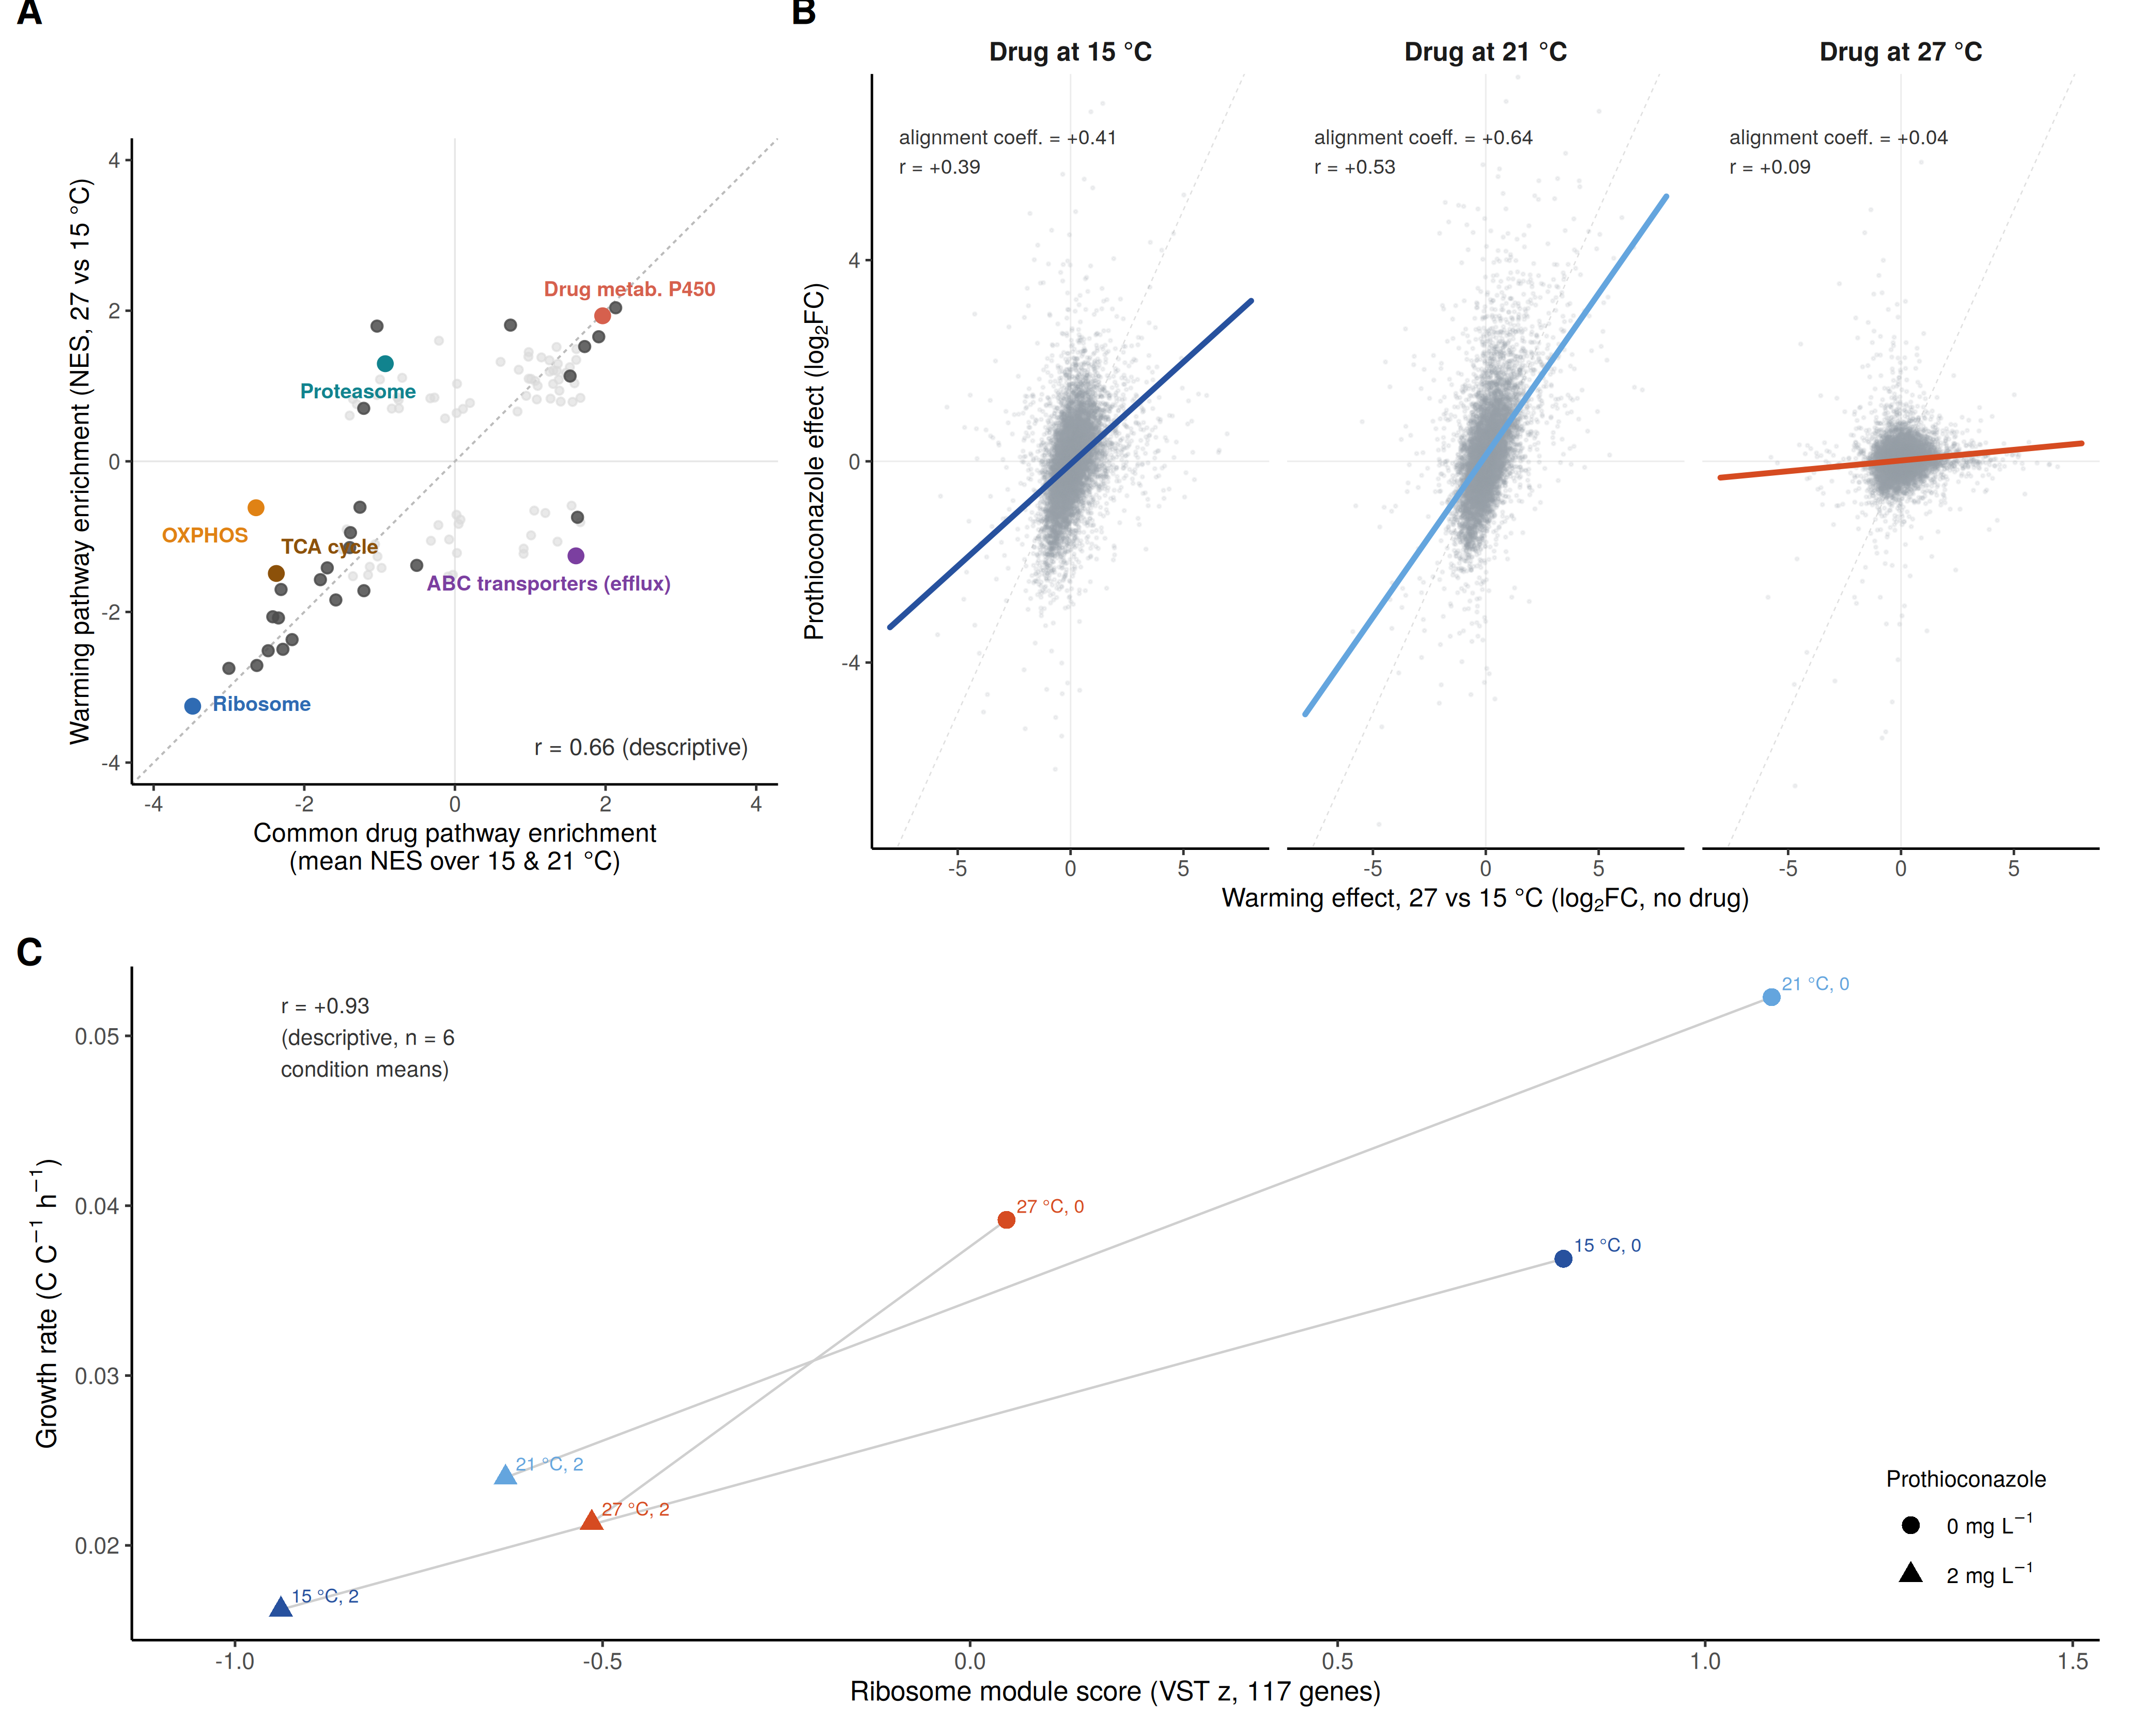
Figure 5. Prothioconazole and temperature converge on shared programmes that track whole-organism physiology. (A) Pathway-level convergence: each point is a KEGG pathway, plotted by the mean of its separately estimated normalized enrichment scores (NES) for the drug response at the two engaged temperatures (15 and 21 °C) versus the warming response (27 versus 15 °C, no drug). Most of the significantly enriched pathways fall in the lower-left quadrant (68% of the 28 pathways significant in at least one contrast at FDR < 0.05, against 32% of all 105 tested; both perturbations repress the same growth and energy programmes; Pearson r = 0.66, descriptive); ABC-transporter efflux is the drug-specific exception. Per-temperature versions give r = 0.57 (15 °C) and 0.68 (21 °C). (B) Gene-level alignment coefficients: within each facet, each gene’s drug log₂FC at the indicated temperature is regressed on its warming log₂FC (27 versus 15 °C, no drug) across the 8,137 genes tested in all contrasts (grey identity line). The alignment is steep at 15 °C (slope 0.41) and 21 °C (0.64) and essentially flat at 27 °C (0.04); gene-level concordance is shown in Fig. S8. (C) Ribosome module score versus growth rate across the six condition means (descriptive, n = 6; Pearson r = +0.93); connectors join the 0 and 2 mg L⁻¹ conditions at each temperature. Points are coloured by temperature and shaped by dose. The AOX–CUE relationship is in Fig. S13; extended module–trait correlations are in Fig. S10.

Inhibiting the alternative oxidase suppresses growth at supra-optimal but not at cool temperature
The transcriptional data identify AOX as a marker of the low-CUE state, but they cannot say whether the enzyme contributes to performance or merely accompanies it. If AOX carries an appreciable share of respiratory electron flow specifically at supra-optimal temperature, then removing that branch should cost the cell growth at 27 °C and little or nothing at 15 °C. SHAM is not selective for the alternative oxidase, so this is a test of the prediction rather than of AOX alone; we return to that below. We tested this directly with salicylhydroxamic acid (SHAM), the standard pharmacological inhibitor of alternative oxidase, applied as a five-point dose series (0.0125–0.2 mM) to three independent cultures at each of 15 and 27 °C, with growth rates estimated from dissolved oxygen using the same model and fitting procedure as throughout (Fig. 6A; Methods).
The two temperatures responded in opposite directions (Fig. 6B). Within each culture we regressed growth rate on log₁₀ SHAM concentration and treated the three resulting slopes as replicates, so that the comparison is made at the level of the biological replicate rather than the well. At 15 °C the slope was slightly positive and not distinguishable from zero (mean +0.0043 h⁻¹ per tenfold increase in dose, n = 3 cultures, P = 0.077); no negative dose response was detected at 15 °C over the range tested. At 27 °C every culture declined, and steeply (mean −0.0195 h⁻¹ per tenfold, P = 0.041), with growth at the highest retained dose falling to roughly one third of the untreated rate. The difference between temperatures was −0.0238 h⁻¹ per tenfold, with a 95% confidence interval of −0.0396 to −0.0080 that excludes zero across its whole width (Welch’s t on the six culture-level slopes, P = 0.020; Fig. 6C). The unequal-variance test is required because the slope variance at 27 °C exceeded that at 15 °C by an order of magnitude. That excess variance is not a property of one plate: the solvent controls scatter far more at 27 °C than at 15 °C on the SHAM plate (coefficient of variation 37% against 1%) and independently on the n-propyl gallate plate (58% against 5%), so supra-optimal cultures are genuinely more variable between biological replicates.
Because estimated rates depend on the interval of the oxygen trace over which the model is fitted, the analysis was repeated under seven alternative rules, four fixed absolute windows and three anchored to fixed fractions of each trace’s oxygen drawdown; the 27 °C slope was steeper than the 15 °C slope under every one of them, with the temperature difference ranging from −0.011 to −0.023 h⁻¹ per tenfold against −0.0238 for the hand-selected windows reported above (Fig. S12). The highest dose tested (0.35 mM) was excluded because at 27 °C two of three wells consumed too little oxygen for a rate to be identifiable at all; the exclusion is made on estimability grounds and is conservative, since those wells lie in the direction of the reported effect. A planned specificity check with a second, chemically unrelated alternative-oxidase inhibitor did not resolve the question. The complementary experiment with n-propyl gallate (nPG; maximum concentration 0.1 mM, set by the solubility of the ethanol master stock) yielded an imprecise temperature contrast in growth-rate dose-response slopes (27 °C minus 15 °C: +0.0009 h⁻¹ per tenfold concentration increase; 95% CI −0.0452 to +0.0470; two-sided Welch’s t test, P = 0.96), compatible with both zero and the estimated SHAM contrast and therefore inconclusive regarding temperature-dependent inhibitor sensitivity (Fig. S15). No consistent dose response was present at either temperature: the cultures disagreed in sign at both, and at each temperature the mean slope was set by a single divergent culture, excluding which leaves +0.00006 h⁻¹ per tenfold at 15 °C and +0.0031 at 27 °C. This contrasts with SHAM, where all three cultures declined at 27 °C and none did at 15 °C. Because target engagement was not measured for either compound, the two concentration ranges cannot be equated as degrees of AOX inhibition. Four features of the design bound the inference. The two temperatures were run as separate plates in dedicated incubators, so temperature is confounded with plate and run; dose is assigned to plate column, so a within-plate positional gradient would enter the dose axis, although the solvent controls argue against one, scattering as much when column is held fixed (nPG plate) as when it varies (SHAM plate). SHAM is not selective for the alternative oxidase. And no fungicide was present in either inhibitor experiment, so they speak to the contribution of the alternative route to growth under supra-optimal heat, not to its mediation of the drug–temperature interaction.
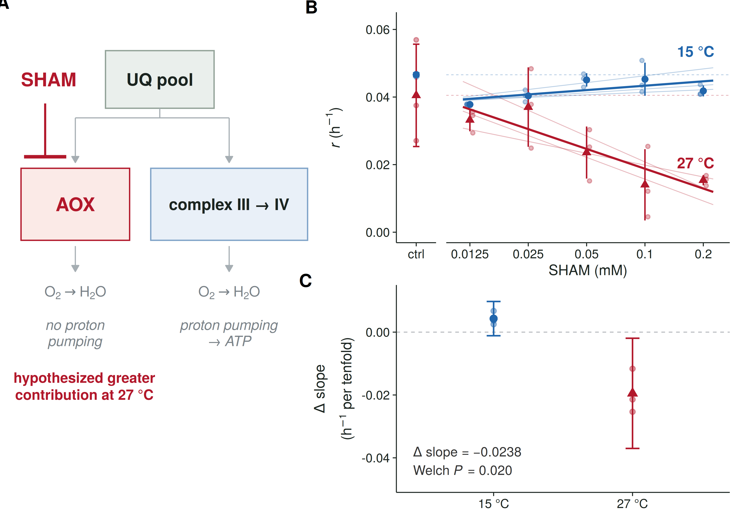
Figure 6. SHAM suppresses growth at supra-optimal but not at cool temperature. (A) The pharmacological logic. The ubiquinone pool is oxidised either by the alternative oxidase, which is non-phosphorylating, or by the cytochrome route through complexes III and IV, which pumps protons and yields ATP; both branches reduce oxygen to water. SHAM inhibits the alternative branch, which the transcriptional and physiological data implicate as engaged at 27 °C; SHAM also inhibits peroxidases and lipoxygenases, so the schematic shows the hypothesis under test rather than an established route. (B) Growth rate against SHAM concentration at 15 °C (blue circles) and 27 °C (red triangles). Faint points are the three independent cultures and thin lines their within-culture regressions; symbols and bars are the mean ± s.d. across cultures and thick lines the mean of the three culture-level slopes. Dashed horizontal lines mark the solvent-control mean at each temperature, shown separately at left (ctrl). n = 3 cultures per dose per temperature. (C) The per-culture slope of growth rate on log₁₀ SHAM concentration at each temperature (faint points, individual cultures; symbol and bar, mean and 95% confidence interval; dashed line, no dose effect). The slope is not distinguishable from zero at 15 °C and is negative at 27 °C, a difference of −0.0238 h⁻¹ per tenfold (Welch’s t, P = 0.020). Robustness to the choice of fitting interval is in Fig. S12, the second inhibitor in Fig. S15, and per-curve fits with their selected intervals in Table S2.

Discussion
Combining quantitative physiology, transcriptomics and targeted respiratory inhibition, we show that temperature is not a passive backdrop to fungicide action in Z. tritici but an active determinant of it. Prothioconazole drives cells into a costly, energetically inefficient stress state (repression of growth-associated programmes, reduced canonical respiratory investment, induction of the alternative oxidase, and metabolic reorganisation consistent with increased maintenance and storage allocation) that provides a coherent account of reduced growth, elevated respiration and reduced carbon-use efficiency. An overlapping programme is engaged by supra-optimal temperature, and where heat has already activated it, prothioconazole produces a reduced incremental effect. This offers a coherent molecular account of the temperature-dependent efficacy seen physiologically: synergy under cool conditions and antagonism under supra-optimal heat. Critically, inhibiting the alternative oxidase pharmacologically cost the fungus growth at supra-optimal temperature but not in the cool range, showing that the respiratory route engaged in the heat-associated state is not merely a transcriptional marker of it, but carries a measurable share of performance in exactly the thermal regime where the interaction reverses.
A central feature of this response is the alternative oxidase. AOX is a cyanide-resistant, non-phosphorylating terminal oxidase widely implicated in fungal stress tolerance (Joseph-Horne et al. 2001). It is also an established modulator of fungicide sensitivity: by bypassing the cytochrome bc1 complex, AOX can sustain respiration when quinone-outside inhibitor (QoI/strobilurin) fungicides inhibit the canonical chain, including in Z. tritici (Wood and Hollomon 2003; Miguez et al. 2004). Our results extend the relevance of AOX beyond respiratory-targeting fungicides by showing strong AOX induction during exposure to an azole that acts primarily on sterol biosynthesis. This induction could reconcile the otherwise paradoxical pairing of increased respiration with decreased growth and CUE: oxygen consumption can increase through a non-phosphorylating route without a corresponding increase in biomass production. Pharmacological inhibition puts this on a causal footing at one end of the thermal range. SHAM had no measurable effect on growth at 15 °C at any dose up to 0.2 mM, but suppressed growth steeply, and in every culture, at 27 °C: the temperature at which AOX transcript abundance is highest and the physiology least efficient. The reading we favour is that in the cool range the cytochrome route carries essentially all respiratory flux, so removing the alternative branch costs nothing, whereas at supra-optimal temperature an appreciable share of flux passes through AOX and its removal is paid for in growth. This is a functional result rather than a transcriptional correlation, and it is the one direct intervention in the study, but its limits are substantial. The SHAM response is consistent with an AOX contribution to growth at supra-optimal temperature, yet it does not establish AOX dependence, because SHAM also inhibits other enzymes including peroxidases and lipoxygenases; the complementary n-propyl gallate experiment was inconclusive at the precision achieved and did not resolve that specificity limitation. Temperature was confounded with plate and run, and neither inhibitor experiment contained prothioconazole, so together they do not establish that AOX mediates temperature-dependent azole antagonism. That both prothioconazole and heat induce AOX suggests that it forms part of a broader stress programme and may contribute to cross-protection, whereby prior exposure to one stress alters tolerance to another (Berry and Gasch 2008). A cell already shifted toward this state under heat stress may experience a smaller incremental metabolic impact when exposed to prothioconazole; the drug–warming overlap is, moreover, transcriptome-wide, with AOX itself contributing only ~0.1% of the shared-programme convergence signal (Methods), so AOX is best read as one functional component of a much broader shared response rather than its sole mediator. The decisive next experiment is the same inhibitor series run in the presence of prothioconazole across the thermal range: if AOX activity is what blunts the drug at 27 °C, then blocking it should restore potency there and leave it unchanged at 15 °C.
Why should a sterol-synthesis inhibitor and heat converge on the same programme at all? One plausible point of mechanistic contact is the membrane itself. Membrane fluidity is a primary temperature sensor in fungi, coupled to the heat-stress regulatory circuitry (Leach and Cowen 2014), and azole inhibition of ergosterol synthesis perturbs exactly the membrane composition on which that sensing depends. Azole-induced disruption of ergosterol synthesis and sterol composition may therefore be read by the cell, in part, as a thermal signal, recruiting the overlapping stress physiology we observe. Consistent with this, the supra-optimal response in our data was dominated by repression of the translational apparatus rather than by the classical chaperone induction that typifies acute heat shock in fungi (Bakar et al. 2020; Neves-da-Rocha et al. 2023), suggesting a physiological state distinct from a canonical acute heat-shock response and, given the multi-day exposure, consistent with longer-term physiological rebalancing, the kind of state a slow-acting fungicide is likely to encounter in the field.
What then explains the temperature dependence of potency itself? The measured CYP51-axis quantities do not: CYP51 and CPR transcript abundance, predicted CYP51 turnover and efflux-transporter expression all declined or remained flat with warming, individually and in combination predicting stable or increased, rather than decreased, potency (Supplementary sign audit). The loss of potency is therefore not a simple target-abundance or efflux phenomenon, and the transcriptional convergence documented in Figures 3–5 supplies the most parsimonious account available from these data: where heat has already repressed the growth and energy programmes on which the drug acts, less remains for the drug to repress. Consistent with this partition, the enhanced sensitivity at 15 °C and the antagonism at 27 °C fall at opposite ends of the same convergence gradient (Fig. 5B). Separating this from a temperature-dependent change in the catalytic safety margin around CYP51, or in intracellular drug exposure, will require direct measurement of sterol flux and of intracellular prothioconazole rather than inference from the dose–response surface.
The applied implication is clear. Prothioconazole potency against Z. tritici declined approximately 4.5-fold from 15 °C to 27 °C, and the transcriptional response to prothioconazole was strongly attenuated at 27 °C. Because fungicide sensitivity is routinely assayed at a single near-optimal temperature, standard testing may overestimate activity whenever infections or treated populations experience supra-optimal temperatures. As cropping climates warm and pathogen distributions shift polewards (Bebber et al. 2013), this temperature dependence could become increasingly relevant to field efficacy. Both thermal regimes identified here fall within the range that European wheat crops experience during the fungicide-application window, so the sign of the interaction is not fixed across the conditions under which chemical control is actually applied. Temperature-resolved efficacy testing, and disease models that treat fungicide performance as temperature-dependent, are therefore warranted. The antagonism we observe is not explained by CYP51 transcriptional up-regulation, suggesting an environmentally mediated route to reduced control that conventional resistance monitoring could miss: this loss of potency is distinct from heritable resistance, yet single-temperature sensitivity assays could confound or overlook the distinction. Resistance to single-site fungicides, including azoles, has repeatedly evolved in Z. tritici and remains central to resistance management (Lucas et al. 2015), and shifting azole sensitivity has already been linked to reduced field performance across Europe (Jørgensen et al. 2022); our results add an orthogonal environmental axis of variation in efficacy that can arise without detectable target-overexpression compensation.
Several limitations temper these conclusions. The transcriptome–physiology link is correlative; further functional tests (sterol profiling, efflux assays, and AOX perturbation in the presence of the fungicide) are needed to establish causality. Consistent with this, a ribosome-expression model calibrated on the untreated conditions alone did not quantitatively predict growth under the drug (overpredicting it at 15 °C), so translational capacity indexes, but does not by itself quantitatively determine, the growth response. The RNA-seq sampled a single dose at three temperatures, and a fraction of the prothioconazole-responsive genes are uncharacterised Z. tritici genes whose roles remain unknown and provide candidates for follow-up. RNA yield varied among treatments, but normalisation and sensitivity analyses indicated that this did not drive the main conclusions. The inhibitor experiment carries its own constraints. SHAM is not selective for the alternative oxidase, so the growth cost at 27 °C is attributable to that branch only in so far as no comparably heat-dependent secondary target is involved. The two temperatures were run as separate plates in separate incubators, so a run effect cannot be formally excluded, although a run effect reproducing a dose-dependent decline in all three cultures at one temperature and not the other would be unusual. The effect was measured with no fungicide present, so it establishes a contribution of the alternative route to growth under heat rather than a role in the drug interaction itself. With three cultures per temperature the slopes are imprecisely estimated, so the magnitude of the difference should be treated as provisional, even though its direction was reproduced under every fitting rule tested; the fitting-rule analysis addresses sensitivity to interval selection, not independent replication of the temperature manipulation. Because each temperature was run as a single plate, the three cultures replicate the biological response within a run rather than replicating the temperature treatment itself, and a plate-specific distortion of the dose response would not be separable from a temperature effect; establishing the contrast causally would require independent runs with temperature assignments crossed between incubators and dose positions balanced. Two design constraints also warrant note: each temperature was maintained in a dedicated incubator, so temperature and incubator effects cannot be formally separated (the smooth, unimodal response across seven temperatures and the concordance of physiology, transcriptomics and modelling argue against a simple incubator artefact, but do not exclude it), and because cultures were harvested at a comparable physiological stage rather than a fixed clock time, elapsed culture age co-varied with temperature. Intracellular prothioconazole and its desthio metabolite were not quantified, so temperature-dependent changes in uptake, metabolism or effective intracellular exposure cannot be separated from changes in cellular sensitivity. Finally, results from a single isolate under controlled conditions require validation across genetic backgrounds and in planta, where host physiology, fluctuating temperature and the latent phase of infection may modulate the interaction.

Conclusion
Integrating physiology, transcriptomics and targeted respiratory inhibition provides a mechanistic framework linking cellular energy metabolism, thermal physiology and temperature-dependent fungicide action. Prothioconazole induces an energetically inefficient stress state, marked by induction of the alternative oxidase, that overlaps the cell’s own response to supra-optimal heat; where heat has already engaged much of that programme, the incremental response to the fungicide is strongly attenuated. Two links in this chain are supported quantitatively: expression of the alternative oxidase tracks the loss of carbon-use efficiency across conditions, and inhibiting the enzyme costs the fungus growth at supra-optimal temperature while costing it nothing in the cool range, so that route is functionally engaged where the interaction reverses. Together, these results show that fungicide potency depends on the thermal physiological state of the pathogen, and they support incorporating temperature dependence into sensitivity assays, dose models and resistance monitoring as cropping climates become warmer and more thermally variable.

Materials and Methods
Strain and culture
Zymoseptoria tritici isolate IPO323 (reference genome IPO323, assembly MG2 (Goodwin et al. 2011)) was cultured in yeast malt sucrose (YMS) medium (4 g L⁻¹ yeast extract, 4 g L⁻¹ malt extract, 4 g L⁻¹ sucrose) following Kellner et al. (2014). Precultures were inoculated from frozen stock into liquid YMS and grown for 4 days at 21 °C with shaking at 200 rpm, then passed through a 100 µm cell strainer to remove hyphal clumps; the resulting cell suspension was used to inoculate the growth and respiration assays, which were run in the same medium at the assayed temperatures. Prothioconazole (PESTANAL analytical standard; Sigma-Aldrich) was dissolved in dimethyl sulfoxide (DMSO) and diluted into YMS immediately before each assay; all treatments, including the no-fungicide solvent controls, contained the same final DMSO concentration (0.4%, v/v). The eight nominal concentrations were 0 (solvent control), 0.06, 0.12, 0.25, 0.5, 1, 2 and 4 mg L⁻¹.
Growth and respiration assays
Dissolved oxygen is the directly measured quantity throughout; specific growth and respiration rates are estimates derived from a mechanistic model fitted to the oxygen trajectories, not independent respirometry. Growth and respiration were derived from dissolved-oxygen consumption time series recorded for each temperature × dose × replicate across seven temperatures (15, 18, 21, 24, 26, 27 and 28 °C) and eight prothioconazole concentrations (0–4 mg L⁻¹). Dissolved oxygen was measured with SensorDish® readers (PreSens Precision Sensing GmbH, Regensburg, Germany), which monitor up to 24 vials per plate noninvasively through optical sensor spots containing a fluorescent dye whose quenching by oxygen reports the oxygen partial pressure. Readers were factory-calibrated, and before each run a two-point calibration against 0% and air-saturated oxygen was performed following the manufacturer’s protocol. All liquid handling was carried out aseptically in a laminar-flow hood using sterile, manufacturer-supplied vials. Up to three replicate 5 ml vials per temperature × dose combination were inoculated from a single common culture batch (replicate vials, not independent biological cultures) at OD₆₀₀ = 0.0005 (approximately 1 × 10⁷ cells L⁻¹, confirmed by haemocytometer counts), filled to slight convexity to eliminate headspace, and sealed with gas-tight caps. Sealed vials were placed on the readers in temperature-controlled incubators held at each set point, allowed ~45 min for the optical signal and baseline to stabilise, after which dissolved oxygen was logged at 1-min intervals over multi-day runs until oxygen was substantially depleted. All seven temperatures were assayed in parallel on the same day from a single common culture batch, each in a separate temperature-controlled incubator with its SensorDish reader linked to a shared acquisition unit; temperature and incubator are therefore confounded in this design.
Growth and respiration rates were estimated from each dissolved-oxygen time series using the mechanistic oxygen-consumption model of Cakin et al. (2026), which couples exponential population growth with biomass-proportional oxygen uptake. Assuming exponential growth with specific growth rate $r$,
$$N(t)=N_{0} e^{rt},$$
and oxygen uptake proportional to biomass with per-cell respiration $R$,
$$\frac{dO_{2}}{dt}=−R N(t),$$
integration gives
$$O_{2}(t)=O_{2,0}−\frac{R N_{0}}{r}\left(e^{rt}−1\right).$$
Each trace was smoothed with a cubic spline to locate the onset of sustained oxygen decline, trimmed to the interval of approximately exponential growth, re-zeroed, and normalised to a reference oxygen level defined as the mean of its first three retained points; the normalised model
$$O(t)=O_{0}+\frac{k}{r}\left(1−e^{rt}\right),$$
in which $k$ is the initial fractional oxygen-decline rate, was then fitted to each replicate by bounded nonlinear least squares (nlsLM, minpack.lm). The specific growth rate r and the decline rate k were estimated per replicate, and per-cell respiration was recovered by combining k with the reference oxygen level and the initial cell density (N₀); N₀ was reconstructed from the inoculation density (Ninoc, from haemocytometer counts) and the measured delay $Δt$ between inoculation and the start of the fitted window, $N_{0}=N_{inoc} e^{rΔt}$. In total, 168 vials were set up (seven temperatures × eight doses × three vials), of which 165 returned an oxygen trace; no trace was recorded for three vials (one each at 15 °C and 1 mg L⁻¹, 27 °C and 1 mg L⁻¹, and 27 °C and 4 mg L⁻¹), which are absent from the instrument export. A trace was retained when the oxygen model converged on the selected fit window and yielded positive growth and respiration estimates; fit windows and sample exclusions were set with an interactive trim-selection tool applied before treatment-level analysis, and fit quality (RMSE, R², parameter-boundary flags) was recorded as diagnostics (supp_tpc_fit_quality.csv in the deposited analysis repository) rather than applied as an automatic cutoff. All 165 recorded traces met the retention criterion and a further 9 were excluded at trim selection, leaving 156 traces (45 of the 56 temperature × dose groups with three vials, 10 with two and 1 with one) for all downstream analyses.
Rates were placed on a common carbon basis using the cell-geometry and carbon-density assumptions of the same framework (cell dimensions 2.5 × 70 µm; carbon density 100 fg µm⁻³; 1:1 O₂:C molar ratio, respiratory quotient 1) and biomass-corrected, and carbon-use efficiency (CUE) was computed as carbon-based production divided by the sum of production and respiration, $CUE=P/(P+R)$. The assumed cell size (2.5 × 70 µm) reflects the elongated conidial morphology reported for Z. tritici (yeast-like blastospores in liquid culture may be smaller) and lies within the published range for Z. tritici (1.7–3.4 × 39–86 µm) (Quaedvlieg et al. 2011); under the assumption of a common cell-carbon conversion across treatments (a single value is applied to every sample), the qualitative dose-dependent decline in CUE is robust to the absolute cell-carbon value, although systematic changes in cell size or carbon content with temperature or dose would affect it. CUE is therefore interpreted as relative, dose-dependent change rather than absolute efficiency.
Thermal performance, dose–response and CUE modelling
All rate models were fitted in a Bayesian framework with brms (Bürkner 2017) (Stan; 4 chains, 4,000 iterations, 2,000 warmup). Biomass-corrected growth and respiration thermal performance curves were fitted with the Sharpe–Schoolfield model (Schoolfield et al. 1981); baseline rate ln(B₀), activation energy E, deactivation energy Eₕ and the high-temperature inactivation parameter Tₕ were estimated per dose; the thermal optimum was derived from the fitted parameters rather than estimated directly (Tₕ, the temperature at which inactivation halves the rate, is related to but distinct from the optimum). Dose–response of growth was modelled with a hierarchical Hill function across temperatures,
$$r(c)=\frac{r_{0}}{1+{\left(c/{EC}_{50}\right)}^{n}},$$
with baseline rate $r_{0}$, half-maximal concentration ${EC}_{50}$ and Hill coefficient $n$ estimated per temperature, yielding temperature-specific EC₅₀; potency is also reported as pEC₅₀, the negative base-10 logarithm of the EC₅₀ expressed in mol L⁻¹ (converted from mg L⁻¹ using the prothioconazole molar mass of 344.26 g mol⁻¹); respiration dose–response was modelled by log-linear regression, and the dose effect is reported as the percentage change per mg L⁻¹, 100 × (exp(β_T) − 1), from the temperature-specific posterior slopes. Because the fitted EC₅₀ exceeds the tested dose range at some temperatures, the posterior probability P(EC₅₀ > 4 mg L⁻¹) was computed per temperature from the Hill posterior draws as an explicit extrapolation diagnostic. The anomalously flat respiration dose response at 26 °C was checked by an observation-level jackknife of the ordinary-least-squares slope (no sign changes across all 23 single-observation deletions; maximum leverage 0.27), so it is not driven by a single influential vial. Carbon-use efficiency was modelled as a Boltzmann–Arrhenius function with a shared thermal sensitivity E and dose-specific intercepts. All rate models used a Gaussian likelihood with weakly informative priors. For the Sharpe–Schoolfield model the activation energy was given $E∼N(0.65,0.35)$ eV (bounded 0–3), the deactivation energy $E_{h}∼N(4,1.5)$ eV and the inactivation parameter $T_{h}∼N(\text{data-driven mean},3)$ K; the Arrhenius and CUE models used intercepts $α∼N(0,5)$ and a residual standard deviation $∼Exponential(1)$; and the Hill dose–response model used $r_{0}∼N(0.04,0.02)$, ${EC}_{50}∼Lognormal(0,1)$ and Hill coefficient $n∼N(1.5,1)$ (all lower-bounded at 0), with a random intercept on r₀ for replicate series within temperature (grouping factor: temperature × replicate index, 21 levels, each collecting the dose observations of one replicate series). Replicate vials were the unit of replication, and a sensitivity analysis adding a per-condition (temperature × dose) random intercept left the conclusions unchanged. Models were sampled with 4 chains of 4,000 iterations (2,000 warmup; adapt_delta 0.95, max_treedepth 12–15); convergence was assessed from the R-hat statistic and effective sample sizes, and model adequacy from posterior predictive checks (Fig. S2; empirical 95% predictive coverage 0.93–0.97 across all model classes). Sensitivity of the dose–response conclusions to model form was assessed by refitting the growth dose–response under alternative parameterisations (shared Hill coefficient across temperatures; shared EC₅₀ across temperatures) and comparing them by approximate leave-one-out cross-validation (Vehtari et al. 2017); the full temperature-specific Hill model was preferred, and temperature-specific fungicide effects reported in the text derive from it rather than from cross-temperature Sharpe–Schoolfield smoothing.
Temperature × fungicide interaction (Bliss independence)
Synergy/antagonism was assessed by adapting Bliss independence to treat thermal deviation from the reference temperature and fungicide exposure as two stressors (temperature is not a second toxicant in the conventional Bliss sense; the operational definitions follow). The thermal optimum Topt (temperature of highest posterior-median baseline growth, r₀) served as the zero-deviation thermal reference. On each posterior draw we computed the temperature-only, fungicide-only and observed combined effects, all expressed relative to growth at the thermal optimum,
$$f_{T}(T)=\frac{r(T,0)}{r(T_{opt},0)}, f_{F}(c)=\frac{r(T_{opt},c)}{r(T_{opt},0)}, f_{obs}(T,c)=\frac{r(T,c)}{r(T_{opt},0)},$$
and the Bliss deviation
$$Δ=f_{obs}−f_{T} f_{F},$$
with $Δ<0$ indicating synergy and $Δ>0$ antagonism. Robustness to the reference choice was confirmed by re-running with 21 °C as reference.
Reference-free test of the interaction
Because the Bliss formulation depends on both a reference temperature and a multiplicative null, the interaction was tested again with neither. Log growth rate was modelled by generalised additive models (mgcv) fitted by restricted maximum likelihood (Wood 2011) to all 156 replicate-level observations, with dose entered as $\log_{10}(c+0.03)$ so that the solvent control is retained on the log scale. The separable (“no interaction”) null,
$$logg=f(T)+h(c)+ε,$$
was compared with a model adding a pure-interaction tensor-product term built from the same marginal bases,
$$logg=f(T)+h(c)+ti(T,c)+ε,$$
where $f$ and $h$ are penalised thin-plate regression splines (basis dimensions 6 and 5) and $ti$ is a low-rank tensor-product interaction (Wood 2006) with the marginal main effects removed, so that a null $ti$ term corresponds exactly to separability. The two models were compared by (i) exact leave-one-out cross-validation, refitting both models $n=156$ times and comparing the paired difference in squared prediction error by a two-sided t test, (ii) AIC, and (iii) the approximate significance of the $ti$ term. Because the tensor basis dimension is a user choice, the comparison was repeated across basis dimensions from $3×3$ to $5×4$ (Table S1). The interaction was favoured at every setting, but the strength of support increased with the dimension of the temperature basis, which at three basis functions leaves the interaction too few degrees of freedom to represent a sign reversal across the thermal optimum; correspondingly, the exact leave-one-out advantage was significant at the reported $5×4$ basis (P = 0.011) and directional but not significant at a coarser $4×3$ basis (paired difference 0.0033, 95% CI −0.0010 to 0.0075, P = 0.131). The interaction residual surface $F(T,c)−[f(T)+h(c)]$ and its 95% intervals were obtained by drawing 4,000 samples from the multivariate normal posterior of each model’s coefficients and differencing the two linear predictors on a temperature × dose grid (Fig. S11).
RNA-seq, quantification and differential expression
Cells for RNA were harvested individually from each PreSens vial in late exponential phase, immediately before its dissolved-oxygen signal reached the minimum, so that cultures were compared at a broadly comparable physiological stage rather than at an identical clock time. Cultures were not held under anoxia; based on real-time oxygen trajectories, elapsed time to harvest varied with temperature, from approximately 45–50 h at 27 °C to 60–65 h at 15 °C. Total RNA was extracted with the QIAGEN AllPrep Bacterial/Fungal DNA/RNA/Protein Kit. For the transcriptomics experiment, a master culture stock was prepared and distributed into 7–8 PreSens vials per treatment group; each RNA-seq replicate was one such separately incubated vial, harvested and extracted individually. These vials were dedicated to the transcriptomics experiment and, as in the physiology assays, represent replicate vials drawn from a common inoculum rather than independent culture batches. RNA from six treatment groups (15/21/27 °C × 0/2 mg L⁻¹; 7–8 replicate cultures per group, each an independently incubated vial drawn from a common inoculum) was prepared into strand-specific, poly(A)-enriched mRNA sequencing libraries by the Exeter Sequencing Service and sequenced as paired-end 150 bp reads (2 × 150 bp) on an Illumina NovaSeq X (run 20260619_LH00682_0123); the reverse-stranded library type (ISR) was confirmed by Salmon automatic library-type detection, yielding a median of 22.8 million read pairs per sample (range 13.0–33.7 million).
Final library fragment-size distribution was verified on an Agilent TapeStation (D1000 ScreenTape), each library showing the expected single peak at approximately 285 bp. Quality control used FastQC (v0.12.1), FastQ Screen (v0.16.0) and MultiQC (v1.35).
Reads were quantified against the Z. tritici IPO323 (MG2) transcriptome (Ensembl Fungi) with Salmon (v2.1.2; selective alignment, –gcBias –seqBias) (Patro et al. 2017) and imported to gene level with tximport (Soneson et al. 2015). Differential expression used DESeq2 (Love et al. 2014) with temperature and prothioconazole as categorical factors (releveled to 15 °C and 0 mg L⁻¹ as references) and the design ~ temperature + prothioconazole + temperature:prothioconazole; pairwise contrasts (2 vs 0 mg L⁻¹ within each temperature; temperatures within each dose) used an equivalent combined-group model with ashr log₂FC shrinkage. The temperature × prothioconazole interaction was tested with a likelihood-ratio test comparing the full model against the reduced model ~ temperature + prothioconazole. Genes were retained if they had ≥10 counts in ≥7 samples; differential expression was called at adjusted P < 0.05 and |log₂FC| ≥ 1. Conclusions were confirmed to be robust to exclusion of the lowest-depth libraries (refitting after dropping the single weakest library (21_0_R2, ~13.0 M read pairs), then the three weakest (21_0_R2, 27_0_R4 and 15_2_R3); per-gene log₂FC correlation with the full data ≥ 0.97). DESeq2 Cook’s-distance diagnostics flagged no sample as influential (maximum per-sample fraction of flagged genes 2 × 10⁻⁴).
Functional annotation and module analysis
Pathway-level responses were quantified by gene-set enrichment analysis (GSEA; gseapy prerank (Fang et al. 2023), genes ranked by the DESeq2 Wald statistic) over a restricted KEGG universe (metabolism and genetic-information-processing pathways, excluding global maps and disease pathways). Pathways were retained at Benjamini–Hochberg FDR < 0.001 in at least one condition and displayed as the mean log₂FC of their member genes; the normalized enrichment score (NES) was used for cross-condition comparison. Gene-to-pathway assignments derived from functional annotation of the IPO323 proteome with eggNOG-mapper v2 (Cantalapiedra et al. 2021) (KEGG orthology and pathway memberships); alternative oxidase, ABC-transporter and ergosterol genes were additionally verified against KEGG and UniProt annotation. To link transcriptome to physiology, functional module scores were computed per condition as the mean variance-stabilised z-score over member genes and correlated with condition-level growth, respiration and CUE (Pearson and Spearman). These correlations are computed across the six condition-level means and are reported as descriptive associations, not as independent predictive relationships. For the pathway-level convergence analysis (Fig. 5A), the drug response was summarised per pathway as the mean of the 15 °C and 21 °C normalized enrichment scores (significance taken as the smaller of the two FDRs) and compared with the warming NES (27 versus 15 °C, controls). Gene-level alignment slopes (Fig. 5B) are ordinary least-squares regressions of each gene’s drug log₂FC at a given temperature on its warming log₂FC (27 versus 15 °C, controls), fitted across all genes shared between contrasts. Because the warming and drug contrasts share control samples at 15 and 27 °C but not at 21 °C, shared-control noise could in principle inflate the 15 °C slope and deflate the 27 °C slope. This was tested by recomputing the slopes with the control replicates at each temperature randomly split into disjoint subsets used for the warming and drug contrasts (200 splits, variance-stabilised group means): the median slopes were 0.38 at 15 °C, 0.60 at 21 °C and 0.08 at 27 °C, and the 15 °C slope exceeded the 27 °C slope in 100% of splits, so the attenuation at 27 °C is not an artefact of shared controls.
The temperature dependence of the module-level drug response was tested at the sample level: per-sample module scores (mean log₂(normalized count + 1) over member genes; ribosome module = the 117 genes of the KEGG ribosome pathway, map03010, matching the module used in Fig. 5C) were fitted by ordinary least squares with temperature, dose and their interaction as categorical factors, the interaction assessed by an F-test against the additive model (F(2,39) for 45 samples in six groups), and the 27 °C-versus-15 °C attenuation reported as the planned contrast (drug effect at 27 °C) − (drug effect at 15 °C) with its 95% confidence interval. Leave-one-sample-out refits confirmed that no single sample drives the ribosome-module interaction (all P ≤ 2.7 × 10⁻⁴). The same pathway universe was used for an interaction-level GSEA, ranking genes by the Wald statistic of the DESeq2 27 °C × prothioconazole interaction contrast (gseapy prerank, seed 42); 26 pathways reached FDR < 0.05 (Fig. S14).
For the state-projection analysis, a fixed drug-response direction was defined on log₂(normalized count + 1) group means as the renormalised sum of the unit-normalised mean drug shifts at 15 and 21 °C (the two temperatures at which the drug response is fully engaged), and the untreated warming shift (27 versus 15 °C control means) was projected onto it. Alignment is reported as the cosine between the two vectors (cos = 0.45; cos², the shared-variance fraction, ≈ 0.20). Uncertainty was assessed by bootstrap resampling of samples within each condition (500 resamples; 95% CI 0.27–0.56) and significance by a sample-label permutation null that shuffles which control samples are labelled 15 versus 27 °C while preserving group sizes and the gene–gene correlation structure (1,000 permutations; P = 0.096); the analysis is accordingly reported as descriptive. The cosine was robust to removing the top 1% or 5% of genes by |loading| (cos 0.44 and 0.41), and per-gene contributions to the projection (the product of drug-direction loading and warming-shift component) attribute only ~0.1% of the convergence signal to AOX itself.
Alternative-oxidase inhibition
The contribution of the alternative oxidase to growth was tested pharmacologically with salicylhydroxamic acid (SHAM), prepared as a 250 mM master stock in absolute ethanol and diluted in ethanol to working stocks at 500× the intended final dose, so that 10 µL added to each 5 mL vial gave final concentrations of 0.0125, 0.025, 0.05, 0.1, 0.2 and 0.35 mM at a constant 0.2% (v/v) ethanol in every vial, solvent controls included. Three independent cultures were grown as described above, harvested in exponential phase, adjusted to a common starting density and dispensed into PreSens SensorDish vials; one plate was run per temperature (15 and 27 °C), with cultures assigned to rows and doses to columns. Dissolved oxygen was logged for 68.6 h and growth rates were estimated with the same oxygen-consumption model, fitting-interval selection and quality criteria used throughout. The 0.35 mM dose was excluded from analysis because at 27 °C two of the three wells consumed too little oxygen for the model to return an identifiable rate; this exclusion is made on estimability grounds and is conservative with respect to the contrast reported, since the excluded wells lie in the direction of the reported effect.
Because dose varies within culture, the dose response was analysed at the level of the biological replicate. Within each culture the estimated growth rate was regressed on log₁₀ SHAM concentration across the five retained doses, and the three resulting slopes were treated as independent observations at each temperature; a one-sample t test against zero was used within each temperature, and the two temperatures were compared with Welch’s unequal-variance t test on the six culture-level slopes. The unequal-variance form is required because the variance of the slopes at 27 °C exceeded that at 15 °C by an order of magnitude. Sensitivity to the choice of fitting interval was assessed by repeating the whole analysis under seven alternative window rules: four fixed absolute windows and three anchored to fixed fractions of each trace’s oxygen drawdown (Fig. S12). A parallel plate set was run with n-propyl gallate (0.0125 to 0.1 mM in ethanol), an alternative-oxidase inhibitor of a different chemotype, over a dose range reaching only 0.1 mM; those traces have not been through the same manual fitting-interval selection and are not reported here. Two features of the design constrain interpretation and are carried into the Discussion: each temperature was run as a single plate in a dedicated incubator, so temperature is confounded with plate and run, and SHAM is not selective for the alternative oxidase.
Data and code availability
Raw sequencing reads are available at the European Nucleotide Archive under project accession PRJEB123587 (to be released on publication). Analysis code (physiology, transcriptomics and inhibitor pipelines), processed data, the per-well oxygen-model fits with their selected fitting intervals, and the scripts regenerating every main and supplementary figure are available at https://github.com/icakin/zt-temperature-prothioconazole and permanently archived at Zenodo (doi:10.5281/zenodo.21861072).

Acknowledgements
We are grateful to the staff of the Living Systems Institute for their help and support, to Dr Graham Thomas (Department of Biosciences, University of Exeter), and to the Exeter Sequencing Service for library preparation and sequencing. This work was supported by UK Research and Innovation (UKRI) under research grant NE/Y000889/1.

Author contributions
Ilgaz Cakin: conceptualisation, methodology, software, validation, investigation, formal analysis, resources, data curation, writing (original draft). Helen Fones: conceptualisation, resources, supervision. Nicholas Smirnoff: conceptualisation, resources, supervision, funding acquisition. Samraat Pawar: conceptualisation, resources, supervision, funding acquisition. Angus Buckling: conceptualisation, resources, supervision, funding acquisition. Daniel Padfield: conceptualisation, resources, supervision, funding acquisition. Gabriel Yvon-Durocher: conceptualisation, methodology, software, validation, resources, writing (review and editing), supervision, funding acquisition.

References
Angilletta, M. J. 2009. Thermal Adaptation: A Theoretical and Empirical Synthesis.
Bakar, N. A., S. A. Karsani, and S. A. Alias. 2020. “Fungal Survival Under Temperature Stress: A Proteomic Perspective.” PeerJ 8: e10423. https://doi.org/10.7717/peerj.10423.
Bebber, D. P., M. A. T. Ramotowski, and S. J. Gurr. 2013. “Crop Pests and Pathogens Move Polewards in a Warming World.” Nature Climate Change 3: 985–88. https://doi.org/10.1038/nclimate1990.
Berry, D. B., and A. P. Gasch. 2008. “Stress-Activated Genomic Expression Changes Serve a Preparative Role for Impending Stress in Yeast.” Molecular Biology of the Cell 19: 4580–87. https://doi.org/10.1091/mbc.e07-07-0680.
Bliss, C. I. 1939. “The Toxicity of Poisons Applied Jointly.” Annals of Applied Biology 26: 585–615. https://doi.org/10.1111/j.1744-7348.1939.tb06990.x.
Brown, J. H., J. F. Gillooly, A. P. Allen, V. M. Savage, and G. B. West. 2004. “Toward a Metabolic Theory of Ecology.” Ecology 85: 1771–89. https://doi.org/10.1890/03-9000.
Bürkner, P.-C. 2017. “Brms: An r Package for Bayesian Multilevel Models Using Stan.” Journal of Statistical Software 80(1): 1–28. https://doi.org/10.18637/jss.v080.i01.
Cakin, I., R. Millington, S. Pawar, et al. 2026. “A Novel Method to Simultaneously Estimate Bacterial Respiration and Growth from Oxygen Dynamics.” ISME Communications 6(1): ycag024. https://doi.org/10.1093/ismeco/ycag024.
Cantalapiedra, C. P., A. Hernández-Plaza, I. Letunic, P. Bork, and J. Huerta-Cepas. 2021. “eggNOG-Mapper V2: Functional Annotation, Orthology Assignments, and Domain Prediction at the Metagenomic Scale.” Molecular Biology and Evolution 38(12): 5825–29. https://doi.org/10.1093/molbev/msab293.
Chaloner, T. M., S. J. Gurr, and D. P. Bebber. 2021. “Plant Pathogen Infection Risk Tracks Global Crop Yields Under Climate Change.” Nature Climate Change 11: 710–15. https://doi.org/10.1038/s41558-021-01104-8.
Cools, H. J., and B. A. Fraaije. 2013. “Update on Mechanisms of Azole Resistance in Mycosphaerella Graminicola and Implications for Future Control.” Pest Management Science 69: 150–55. https://doi.org/10.1002/ps.3348.
Fang, Z., X. Liu, and G. Peltz. 2023. “GSEApy: A Comprehensive Package for Performing Gene Set Enrichment Analysis in Python.” Bioinformatics 39(1): btac757. https://doi.org/10.1093/bioinformatics/btac757.
Fisher, M. C., N. J. Hawkins, D. Sanglard, and S. J. Gurr. 2018. “Worldwide Emergence of Resistance to Antifungal Drugs Challenges Human Health and Food Security.” Science 360: 739–42. https://doi.org/10.1126/science.aap7999.
Fones, H., and S. Gurr. 2015. “The Impact of Septoria Tritici Blotch Disease on Wheat: An EU Perspective.” Fungal Genetics and Biology 79: 3–7. https://doi.org/10.1016/j.fgb.2015.04.004.
Gillooly, J. F., J. H. Brown, G. B. West, V. M. Savage, and E. L. Charnov. 2001. “Effects of Size and Temperature on Metabolic Rate.” Science 293: 2248–51. https://doi.org/10.1126/science.1061967.
Goodwin, S. B. et al. 2011. “Finished Genome of the Fungal Wheat Pathogen Mycosphaerella Graminicola Reveals Dispensome Structure, Chromosome Plasticity, and Stealth Pathogenesis.” PLoS Genetics 7(6): e1002070. https://doi.org/10.1371/journal.pgen.1002070.
Holmstrup, M. et al. 2010. “Interactions Between Effects of Environmental Chemicals and Natural Stressors: A Review.” Science of the Total Environment 408: 3746–62. https://doi.org/10.1016/j.scitotenv.2009.10.067.
Jørgensen, L. N. et al. 2022. “Shifting Sensitivity of Septoria Tritici Blotch Compromises Field Performance and Yield of Main Fungicides in Europe.” Frontiers in Plant Science 13: 1060428. https://doi.org/10.3389/fpls.2022.1060428.
Joseph-Horne, T., D. W. Hollomon, and P. M. Wood. 2001. “Fungal Respiration: A Fusion of Standard and Alternative Components.” Biochimica Et Biophysica Acta 1504: 179–95. https://doi.org/10.1016/S0005-2728(00)00251-6.
Juroszek, P., M. Laborde, B. Kleinhenz, M. Mellenthin, P. Racca, and H. Sierotzki. 2022. “A Review on the Potential Effects of Temperature on Fungicide Effectiveness.” Plant Pathology 71: 775–84. https://doi.org/10.1111/ppa.13531.
Kellner, R., A. Bhattacharyya, S. Poppe, T. Y. Hsu, R. B. Brem, and E. H. Stukenbrock. 2014. “Expression Profiling of the Wheat Pathogen Zymoseptoria Tritici Reveals Genomic Patterns of Transcription and Host-Specific Regulatory Programs.” Genome Biology and Evolution 6(6): 1353–65. https://doi.org/10.1093/gbe/evu101.
Leach, M. D., and L. E. Cowen. 2014. “Membrane Fluidity and Temperature Sensing Are Coupled via Circuitry Comprised of Ole1, Rsp5, and Hsf1 in Candida Albicans.” Eukaryotic Cell 13(8): 1077–84. https://doi.org/10.1128/EC.00138-14.
Lendenmann, M. H., D. Croll, J. Palma-Guerrero, E. L. Stewart, and B. A. McDonald. 2016. “QTL Mapping of Temperature Sensitivity Reveals Candidate Genes for Thermal Adaptation and Growth Morphology in the Plant Pathogenic Fungus Zymoseptoria Tritici.” Heredity 116: 384–94. https://doi.org/10.1038/hdy.2015.111.
Love, M. I., W. Huber, and S. Anders. 2014. “Moderated Estimation of Fold Change and Dispersion for RNA-Seq Data with DESeq2.” Genome Biology 15(12): 550. https://doi.org/10.1186/s13059-014-0550-8.
Lucas, J. A., N. J. Hawkins, and B. A. Fraaije. 2015. “The Evolution of Fungicide Resistance.” Advances in Applied Microbiology 90: 29–92. https://doi.org/10.1016/bs.aambs.2014.09.001.
Manzoni, S., P. Taylor, A. Richter, A. Porporato, and G. I. Ågren. 2012. “Environmental and Stoichiometric Controls on Microbial Carbon-Use Efficiency in Soils.” New Phytologist 196: 79–91. https://doi.org/10.1111/j.1469-8137.2012.04225.x.
Miguez, M., C. Reeve, P. M. Wood, and D. W. Hollomon. 2004. “Alternative Oxidase Reduces the Sensitivity of Mycosphaerella Graminicola to QoI Fungicides.” Pest Management Science 60: 3–7. https://doi.org/10.1002/ps.837.
Neves-da-Rocha, J. et al. 2023. “Insights and Perspectives on the Role of Proteostasis and Heat Shock Proteins in Fungal Infections.” Microorganisms 11(8): 1878. https://doi.org/10.3390/microorganisms11081878.
Noyes, P. D. et al. 2009. “The Toxicology of Climate Change: Environmental Contaminants in a Warming World.” Environment International 35: 971–86. https://doi.org/10.1016/j.envint.2009.02.006.
Parker, J. E. et al. 2011. “Mechanism of Binding of Prothioconazole to Mycosphaerella Graminicola CYP51 Differs from That of Other Azole Antifungals.” Applied and Environmental Microbiology 77: 1460–65. https://doi.org/10.1128/AEM.01332-10.
Parker, J. E., A. G. S. Warrilow, C. L. Price, J. G. L. Mullins, D. E. Kelly, and S. L. Kelly. 2014. “Resistance to Antifungals That Target CYP51.” Journal of Chemical Biology 7: 143–61. https://doi.org/10.1007/s12154-014-0121-1.
Patro, R., G. Duggal, M. I. Love, R. A. Irizarry, and C. Kingsford. 2017. “Salmon Provides Fast and Bias-Aware Quantification of Transcript Expression.” Nature Methods 14(4): 417–19. https://doi.org/10.1038/nmeth.4197.
Price, C. L., A. G. S. Warrilow, J. E. Parker, et al. 2015. “Novel Substrate Specificity and Temperature-Sensitive Activity of Mycosphaerella Graminicola CYP51 Supported by the Native NADPH Cytochrome P450 Reductase.” Applied and Environmental Microbiology 81: 3379–86. https://doi.org/10.1128/AEM.03965-14.
Quaedvlieg, W. et al. 2011. “Zymoseptoria Gen. Nov.: A New Genus to Accommodate Septoria-Like Species Occurring on Graminicolous Hosts.” Persoonia 26: 57–69. https://doi.org/10.3767/003158511X571841.
Schoolfield, R. M., P. J. H. Sharpe, and C. E. Magnuson. 1981. “Non-Linear Regression of Biological Temperature-Dependent Rate Models Based on Absolute Reaction-Rate Theory.” Journal of Theoretical Biology 88: 719–31. https://doi.org/10.1016/0022-5193(81)90246-0.
Smith, T. P., T. J. H. Thomas, B. García-Carreras, et al. 2019. “Community-Level Respiration of Prokaryotic Microbes May Rise with Global Warming.” Nature Communications 10: 5124. https://doi.org/10.1038/s41467-019-13109-1.
Soneson, C., M. I. Love, and M. D. Robinson. 2015. “Differential Analyses for RNA-Seq: Transcript-Level Estimates Improve Gene-Level Inferences.” F1000Research 4: 1521. https://doi.org/10.12688/f1000research.7563.1.
Steinberg, G. 2015. “Cell Biology of Zymoseptoria Tritici: Pathogen Cell Organization and Wheat Infection.” Fungal Genetics and Biology 79: 17–23. https://doi.org/10.1016/j.fgb.2015.04.002.
Steinberg, G., and S. J. Gurr. 2020. “Fungi, Fungicide Discovery and Global Food Security.” Fungal Genetics and Biology 144: 103476. https://doi.org/10.1016/j.fgb.2020.103476.
Torriani, S. F. F., J. P. E. Melichar, C. Mills, N. Pain, H. Sierotzki, and M. Courbot. 2015. “Zymoseptoria Tritici: A Major Threat to Wheat Production, Integrated Approaches to Control.” Fungal Genetics and Biology 79: 8–12. https://doi.org/10.1016/j.fgb.2015.04.010.
Vehtari, A., A. Gelman, and J. Gabry. 2017. “Practical Bayesian Model Evaluation Using Leave-One-Out Cross-Validation and WAIC.” Statistics and Computing 27: 1413–32. https://doi.org/10.1007/s11222-016-9696-4.
Verheyen, J., and R. Stoks. 2023. “Thermal Performance Curves in a Polluted World: Too Cold and Too Hot Temperatures Synergistically Increase Pesticide Toxicity.” Environmental Science & Technology 57(8): 3270–79. https://doi.org/10.1021/acs.est.2c07567.
Wood, P. M., and D. W. Hollomon. 2003. “A Critical Evaluation of the Role of Alternative Oxidase in the Performance of Strobilurin and Related Fungicides Acting at the Qo Site of Complex III.” Pest Management Science 59: 499–511. https://doi.org/10.1002/ps.655.
Wood, S. N. 2006. “Low-Rank Scale-Invariant Tensor Product Smooths for Generalized Additive Mixed Models.” Biometrics 62(4): 1025–36. https://doi.org/10.1111/j.1541-0420.2006.00574.x.
Wood, S. N. 2011. “Fast Stable Restricted Maximum Likelihood and Marginal Likelihood Estimation of Semiparametric Generalized Linear Models.” Journal of the Royal Statistical Society: Series B (Statistical Methodology) 73(1): 3–36. https://doi.org/10.1111/j.1467-9868.2010.00749.x.

Supplementary Materials
Supplementary Figures S1–S14 and Supplementary Table S1 are provided in the separate Supplementary Materials document.

