END-TO-END AZURE DATA ENGINEERING PROJECT
Building a Bronze → Silver → Gold Medallion Pipeline
Azure Data Lake Storage · Azure Data Factory · Databricks · Synapse Analytics · Power BI
By
Akanbi Abdullahi
🥉 BRONZE — Raw ingestion into the data lake
🥈 SILVER — Cleaning & transformation with Databricks
🥇 GOLD — Curated views served through Synapse & Power BI

Project Overview
This guide documents, step by step, how to build a complete data engineering pipeline on Azure using the medallion architecture. Raw data is ingested from a GitHub-hosted dataset, cleaned and transformed, then served as curated views ready for reporting in Power BI.
The pipeline is organised into three layers:
- Bronze — raw data is ingested from source and landed in the data lake untouched.
- Silver — data is cleaned and transformed using Databricks, then written back to the lake.
- Gold — curated views and external tables are created in Synapse Analytics and connected to Power BI for reporting.

Architecture at a Glance
Stage | Tool | What happens
Bronze | Azure Data Factory | Pipeline copies raw CSV files from a GitHub repo into the bronze container
Silver | Azure Databricks | Notebook reads bronze data, cleans/transforms it, writes Parquet to the silver container
Gold | Synapse Analytics + Power BI | Serverless SQL views/external tables expose curated data to Power BI

Prerequisites
- An active Azure subscription
- The source dataset uploaded to a GitHub repository
- Power BI Desktop installed
- Basic familiarity with SQL and Python/PySpark

PHASE 1 OF 3
Bronze Layer — Ingest with Azure Data Factory

In this phase you'll provision a data lake, then build an Azure Data Factory (ADF) pipeline that pulls every file from a GitHub-hosted dataset and lands it in the bronze container — without having to configure each file by hand.

1.1 Create the Storage Account and Containers
- Create your resource group and choose a storage account name.
- Create the storage account, then open Storage Browser → Blob Containers.
- Add three containers: bronze, silver, and gold.
- When creating the storage account, tick the hierarchical namespace option so the account behaves as a Data Lake (ADLS Gen2) rather than plain blob storage.
TIP
Enabling the hierarchical namespace is what turns a standard storage account into a Data Lake Gen2 account — it can't easily be turned on after the fact, so set it at creation time.

1.2 Create Azure Data Factory
Azure Data Factory is where you'll build the pipelines that handle ingestion and, later, orchestration.
- From the Azure portal, create a new Data Factory resource.
- Once deployed, open it and launch the ADF Studio.

1.3 Create a Linked Service (Connection to GitHub)
A linked service tells ADF how to connect to a data source — in this case, raw files hosted on GitHub.
- In ADF Studio, click the Manage icon on the left-hand navigation.
- Click New, then search for and select HTTP as the connection type.
- Give the linked service a descriptive name.
- Under Connect via integration runtime, use AutoResolveIntegrationRuntime. First-time users may be prompted to download a runtime locally — follow the prompt if so.
- In the Base URL field, enter your GitHub raw content root: https://raw.githubusercontent.com
- Set Authentication type to Anonymous, click Test Connection, and once you see a green success message, click OK.
TIP

1.4 Build the Ingestion Pipeline
- Go to Author, click the + icon, and choose Pipeline.
- Give the pipeline a name.
- From the activities pane, open Move & Transform and drag a Copy Data activity onto the canvas.
A Copy Data activity needs two things configured: a source (where the data lives) and a sink (where the data goes).

Configure the Source
- On the Source tab, click New, and select HTTP as the type, with Delimited Text as the file format.
- Name the dataset and select the linked service you created in step 1.3 (test the connection and click OK if creating a new one).
- You'll see a field for Relative URL — leave this blank for now.
- Rather than hardcoding a relative URL for every file, make it dynamic: open the dataset's Advanced section, click inside the Relative URL field, then click Add dynamic content.
- Click the + next to Parameters to create a new parameter (e.g. p_rel_url) and save it.
- Back in the Pipeline Expression Builder, click the new parameter — it inserts an expression like @dataset().p_rel_url. That's your dynamic source configured.

Configure the Sink
- On the Copy activity, open the Sink tab, click +, and select Azure Data Lake Storage — the account with your bronze/silver/gold containers.
- Choose Delimited Text as the format.
- Name the dataset and select the linked service for your storage account.
- Instead of hardcoding a path, make the file system, directory, and file name dynamic in the same way: open Advanced → Open this dataset, and add dynamic content.
- Set the file system to bronze, then create two more parameters — one for the directory (e.g. p_sink_folder) and one for the file name (e.g. p_sink_file).

1.5 Loop Through All Datasets
Rather than repeating the Copy Data configuration for every file, a ForEach loop iterates through a list of files and drives the same Copy activity for each one.
- Search the activities pane for ForEach and drag it onto the canvas. In its Settings, set it to Sequential.
- Drag a Lookup activity onto the canvas — this will read the list of files to copy.
- In the bronze container, create a folder to hold pipeline parameters, then create a JSON file listing every dataset to ingest, for example:
[
{
"p_rel_url": "<dataset_url_from_git>/Product_Categories.csv",
"p_sink_folder": "Product_Categories",
"p_sink_file": "Product_Categories.csv"
},
...
]
IMPORTANT
The dataset_url_from_git is the normal GitHub file URL (the one you see when browsing the file in the repo) — not the raw URL used for the linked service's base URL. Add one object per dataset, separated by commas, and save the file as JSON (e.g. git.json) in the parameters folder you just created.
- On the Lookup activity, point Settings at the new JSON file, and uncheck First row only so it returns every entry.
- Temporarily deactivate the ForEach and Copy Data activities (General tab) so only Lookup runs, then click Debug to test it.
- If it succeeds, hover over the output and click the output icon — you'll see a "Value" array; this is the variable ADF created to hold the list of files.
- Reactivate the other two activities, then connect the Lookup activity's success (green) output to the ForEach activity.
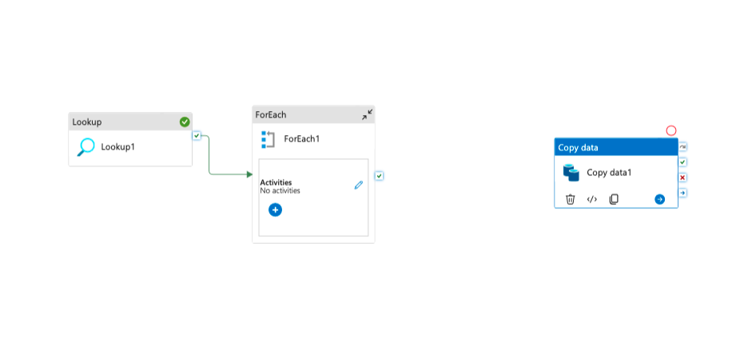
Figure 1 — Lookup activity connected to the ForEach loop on the pipeline canvas.
- Move the Copy Data activity inside the ForEach loop so every iteration of the loop runs a copy.
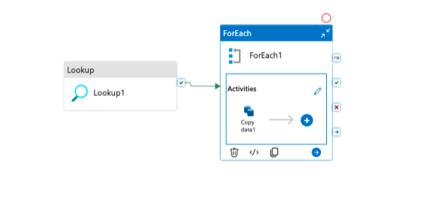
Figure 2 — Copy Data activity nested inside the ForEach1 loop.
With Copy Data inside the loop, every file in the lookup's output will be copied automatically — one iteration per dataset.
- Open the ForEach loop and click into the Copy Data activity to fill in the dynamic source and sink values.
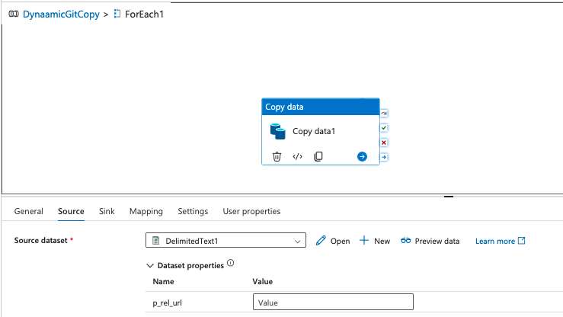  Figure 3 — Source settings for the Copy activity. | 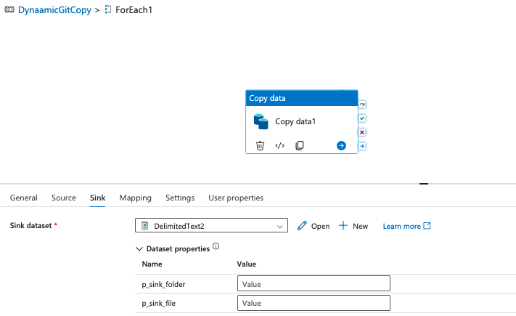  Figure 4 — Sink settings for the Copy activity.
- On the source, add dynamic content, choose Activity Outputs → ForEach, which inserts @item(), then append the parameter name from your JSON file, e.g.:
@item().p_sink_folder
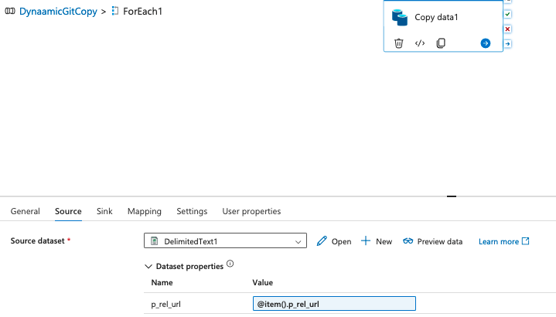  Figure 5 — Building the dynamic source expression. | 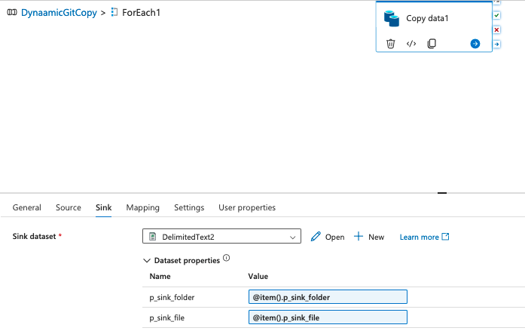  Figure 6 — Building the dynamic sink expression.
- On the ForEach activity's Settings → Items field, add dynamic content, select Activity Outputs → Lookup1, and append .value to reference the full list:
@activity('Lookup1').output.value
- Click Debug to run the full pipeline. Once every Copy Data iteration shows green, your dataset has landed in the bronze layer.
✓ Bronze layer complete

PHASE 2 OF 3
Silver Layer — Transform with Databricks

With raw files sitting in bronze, the next phase uses Databricks to read, clean, and transform the data, then write the results to the silver container as Parquet.

2.1 Create the Databricks Workspace
- From the Azure portal, create a Databricks resource and launch the workspace.
- Create a compute cluster (any size suitable for your dataset).
- Create a notebook and start the compute.

2.2 Register an App for Secure Storage Access
Databricks authenticates to the storage account using a Microsoft Entra ID (Azure AD) app registration — a service principal with scoped permissions.
- Go to All Resources and open Microsoft Entra ID.
- Go to App Registrations → New Registration and give it a name.
- Once created, note the Application (client) ID and Directory (tenant) ID — you'll need both shortly.
- In the same app registration, go to Certificates & Secrets, create a new client secret, and copy the secret value immediately (it's only shown once).

2.3 Grant the App Access to Storage
- Go to your storage account → Access Control (IAM) → Add role assignment.
- Search for and select Storage Blob Data Contributor.
- Assign access to User, group, or service principal, then select the app you just registered.
- Review and create the role assignment.

2.4 Connect the Notebook to Storage
With the app registered and granted access, connect the Databricks notebook to the storage account using OAuth. Store the client secret in a Databricks secret scope rather than pasting it directly into the notebook.
from pyspark.sql.functions import *
from pyspark.sql.types import *

service_credential = dbutils.secrets.get(
scope="<secret-scope>", key="<service-credential-key>"
)

spark.conf.set("fs.azure.account.auth.type.<storage-account>.dfs.core.windows.net", "OAuth")
spark.conf.set(
"fs.azure.account.oauth.provider.type.<storage-account>.dfs.core.windows.net",
"org.apache.hadoop.fs.azurebfs.oauth2.ClientCredsTokenProvider"
)
spark.conf.set(
"fs.azure.account.oauth2.client.id.<storage-account>.dfs.core.windows.net",
"<application-id>"
)
spark.conf.set(
"fs.azure.account.oauth2.client.secret.<storage-account>.dfs.core.windows.net",
service_credential
)
spark.conf.set(
"fs.azure.account.oauth2.client.endpoint.<storage-account>.dfs.core.windows.net",
"https://login.microsoftonline.com/<directory-id>/oauth2/token"
)
Replace the placeholders with your own values:
- <secret-scope> — the Databricks secret scope name
- <service-credential-key> — the name of the key containing the client secret
- <storage-account> — your Azure storage account name
- <application-id> — the Application (client) ID from your Entra ID app
- <directory-id> — the Directory (tenant) ID from your Entra ID app
REFERENCE
For the full reference on connecting Databricks to Azure storage, see learn.microsoft.com/en-us/azure/databricks/connect/storage/azure-storage.

2.5 Ingest and Transform the Data
Read a bronze file into a DataFrame:
df_cal = spark.read.format('csv') \
.option("header", True) \
.option("inferSchema", True) \
.load('abfss://bronze@storageName.dfs.core.windows.net/AdventureWorks_Calendar')
Apply whatever cleaning and transformation logic the dataset needs, then write the result back to the silver container as Parquet:
df_ret.write.format('parquet') \
.mode('append') \
.option('path', 'abfss://silver@awstoragedatalakedulla.dfs.core.windows.net/AdventureWorks_Returns') \
.save()
Repeat the read-transform-write pattern for each dataset that needs to move from bronze to silver.
✓ Silver layer complete

PHASE 3 OF 3
Gold Layer — Serve with Synapse & Power BI

The final phase creates a serverless SQL layer over the silver data using Synapse Analytics, exposes it as curated gold views and external tables, then connects Power BI for reporting.

3.1 Create the Synapse Workspace
- Create a Synapse Analytics workspace from the Azure portal.
- Grant the workspace's managed identity a role on the storage account: go to the storage account → Access Control (IAM) → Add role assignment → select Managed Identity → choose your Synapse workspace as the member.
- Open Synapse Studio, go to Develop, and create a New SQL Script.

3.2 Create a Serverless SQL Database
- Click Data → SQL Database. You'll be offered two options: Serverless or Dedicated.
- Choose Serverless and create a new database.
- In the "Use database" dropdown, select the database you just created.
Serverless SQL pools let you query files directly in the data lake using OPENROWSET() — this is the abstraction layer between the SQL views and the underlying Parquet files.
- Add another role assignment on the storage account, this time selecting your own user email, so you can query the data interactively.

3.3 Create the Gold Schema and Views
Create a dedicated schema to hold the curated gold objects:
CREATE SCHEMA gold
Create one view per table, pointing OPENROWSET() at the matching folder in the silver container. To find each dataset's URL: open the silver container, click the ⋮ menu next to the dataset, and select Properties — the URL is listed there.
CREATE VIEW gold.calendar
AS
SELECT
*
FROM
OPENROWSET(
BULK 'https://dullastorage.blob.core.windows.net/silver/AdventureWorks_Calendar/',
FORMAT = 'PARQUET'
) AS QUERY1
Repeat this pattern to create a view for every dataset in silver.

3.4 Create External Data Sources and File Format
Because the lake holds a mix of formats (Parquet, CSV, JSON), an external data source and file format need to be defined, backed by a database-scoped credential, before external tables can be created.
CREATE MASTER KEY ENCRYPTION BY PASSWORD = 'password'
REFERENCE
For the full reference on scoped credentials, see learn.microsoft.com/en-us/sql/t-sql/statements/create-database-scoped-credential-transact-sql.
CREATE DATABASE SCOPED CREDENTIAL cred_name
WITH
IDENTITY = 'Managed Identity'

CREATE EXTERNAL DATA SOURCE source_silver
WITH (
LOCATION = 'https://awstoragedatalakedulla.blob.core.windows.net/silver',
CREDENTIAL = cred_name
)

CREATE EXTERNAL DATA SOURCE source_gold
WITH (
LOCATION = 'https://awstoragedatalakedulla.blob.core.windows.net/gold',
CREDENTIAL = cred_name
)
Next, define the external file format:
REFERENCE
For the full reference on external file formats, see learn.microsoft.com/en-us/sql/t-sql/statements/create-external-file-format-transact-sql.
CREATE EXTERNAL FILE FORMAT format_parquet
WITH (
FORMAT_TYPE = PARQUET,
DATA_COMPRESSION = 'org.apache.hadoop.io.compress.SnappyCodec'
)

3.5 Create External Tables
With the data source, credential, and file format in place, materialise the gold views as external tables using CREATE EXTERNAL TABLE AS SELECT (CETAS). This writes the query results into the gold container as physical Parquet files.
CREATE EXTERNAL TABLE gold.extsales
WITH (
LOCATION = 'extsales',
DATA_SOURCE = source_gold,
FILE_FORMAT = format_parquet
) AS
SELECT * FROM gold.sales
Repeat for each gold view that should be persisted as an external table.

3.6 Connect Power BI
- Open Power BI Desktop → Get Data → Azure → Azure Synapse Analytics SQL.
- In Synapse Studio, copy the workspace's Serverless SQL endpoint.
- Paste the endpoint into Power BI and connect.
- When prompted, enter the username and password created with the Synapse workspace. (The password can be reset from the Synapse workspace settings if forgotten.)
✓ Gold layer complete — pipeline connected end to end

Summary
This project moved a raw dataset all the way from a public GitHub repository to reporting-ready views in Power BI, using the medallion architecture as the guiding structure:
- Bronze: Azure Data Factory dynamically ingested every file in the source repo using parameterised datasets and a ForEach/Lookup loop.
- Silver: Databricks authenticated to the lake via a Microsoft Entra ID app registration, then cleaned and transformed the data into Parquet.
- Gold: Synapse serverless SQL exposed the silver data as views, and CETAS materialised curated external tables consumed directly by Power BI.

Together, these three phases form a repeatable, parameter-driven pipeline: adding a new dataset only requires a new entry in the ingestion JSON file and a corresponding view/table in Synapse — no rebuilding the pipeline itself.

