<https://reactjs.org/> - library

Εισαγωγή – Ιστορική αναδρομή (Javascript framework)

----

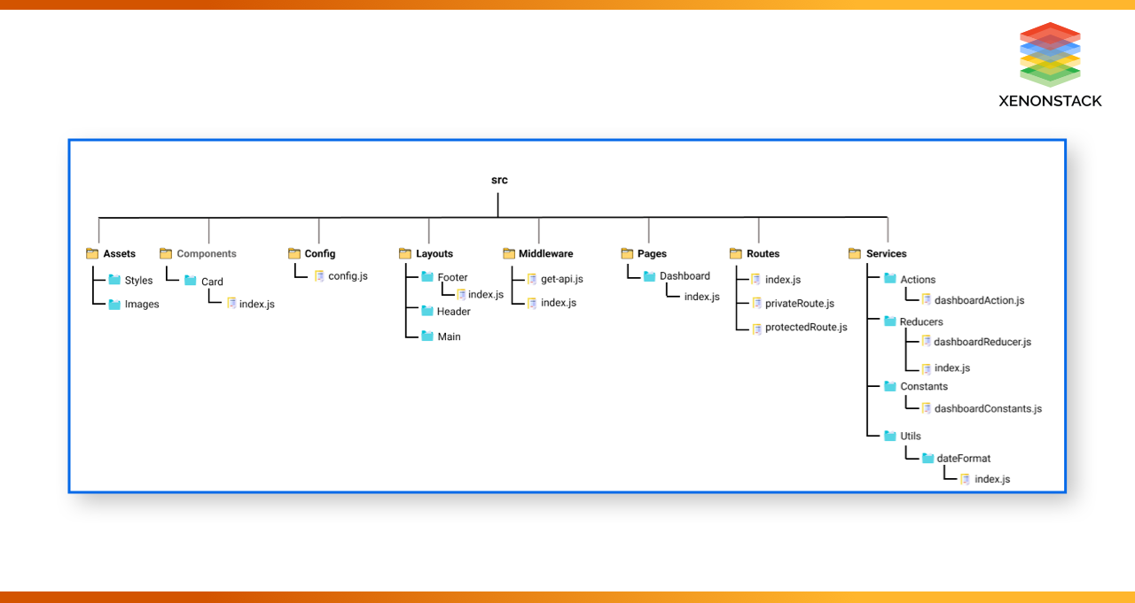

Πλεονεκτήματα / Μειονεκτήματα

Configure the environment

Your first hello world in react.

Παραδείγματα εφαρμογών στην React:

<https://github.com/ahfarmer/calculator>

<https://ahfarmer.github.io/calculator/>

Η βιβλιοθήκη React μπορεί να αναγνωρίσει μια εξωτερική καθορισμένη λειτουργία δηλώνοντας την με κεφαλαία γράμματα, στο παράδειγμα μας έχουμε:

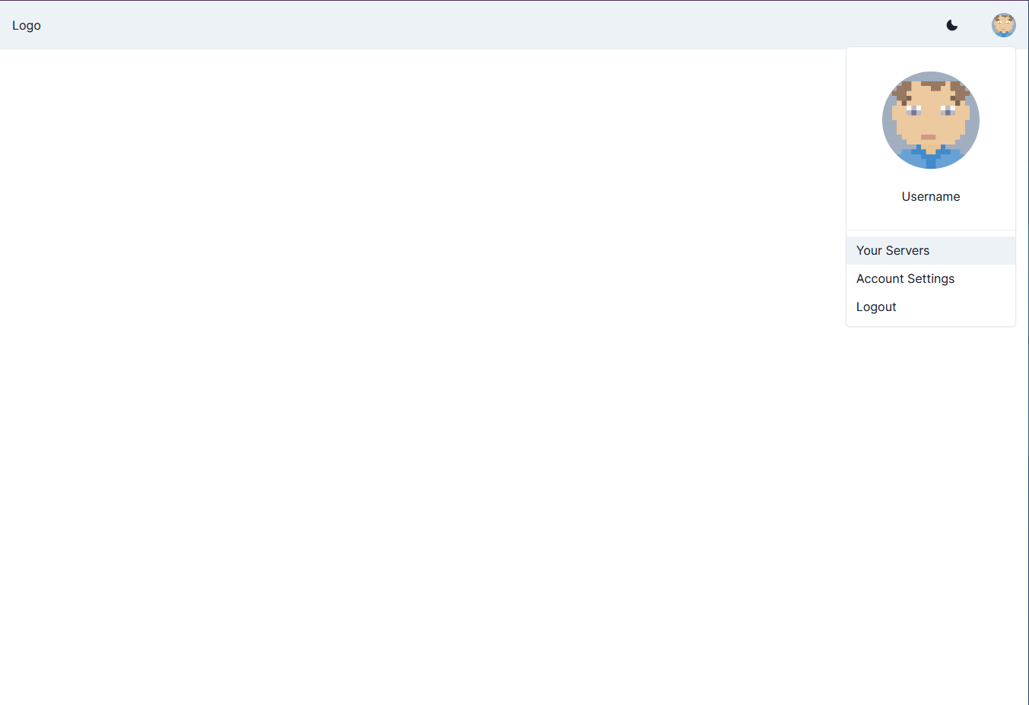

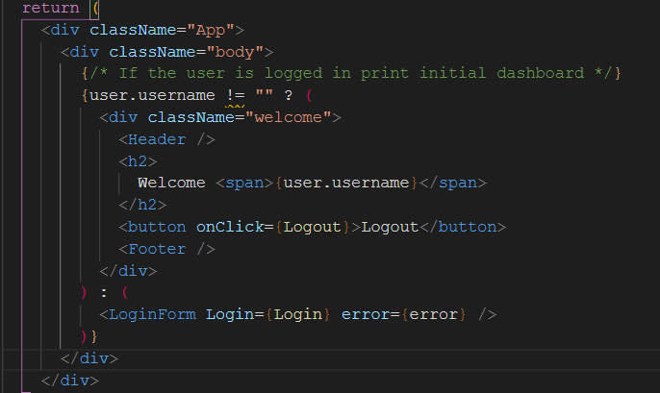

FTP Client – (** drag&drop **)

LOGIN to FTP

User + password

* Upload file to FTP server
* Download file to FTP server
* **List server FTP server files**

npm install react-dnd react-dnd-html5-backend

**import axios from 'axios';**

<https://www.geeksforgeeks.org/file-uploading-in-react-js/>

<https://medium.com/stackfame/get-list-of-all-files-in-a-directory-in-node-js-befd31677ec5>

<https://expressjs.com/>

npm install ftp-srv –save

server.js

import express from ‘’

/ Quick start

const FtpSrv = require('ftp-srv');

const ftpServer = new FtpSrv({ options ... });

ftpServer.on('login', (data, resolve, reject) => { ... });

...

ftpServer.listen()

.then(() => { ... });

Set-up server -> []

Login && Upload – [Cristian]

Download &&

Creating a react app using a pre-defined template

npx create-react-app my-app --template [template-name]

Outside of react but useful for any react developer

**npx create-react-app my-app --template @chakra-ui/typescripts**

<https://thewebdev.info/2021/05/24/how-to-download-file-in-react-js/>

npm i sass

SaSS instead of css