**Panikos Christou – Cristian Ionut Canciu**

**ΕΠΛ 434 –Λογικός Προγραμματισμός και Τεχνητή Νοημοσύνη  
Άσκηση Γοργία – Μέρος 3 Food Method picker**

Table of Contents

A) General description: 2

B) Language of Options, and Environment/Sensory information 3

Options 3

Environment/Sensory information: 3

Defeasible: 3

C) Scenarios: 4

Panikos 4

Cristian 4

D)Architecture 5

E)Manual 6

1. General description:  
   We have 2 students who have different ways of getting their foods.

Panikos Prefers it in this order:

1. Delivery
2. Takeaway
3. Cook

Cristian Prefers it in this order:

1. Cook
2. Takeaway
3. Delivery

Firstly, there is a chance the restaurant does noDelivery or noTakeaway, moreover there is a chance we can’t cook (noCook) each contradicting all their respective options.  
Secondly, we can be in moodToCook so we cook despite for example preferring delivery .  
Thirdly, we can haveHw so we prefer delivery/takeaway depending on the User because University work is more important that time to cook.

Fourthly, there is a chance we have easyHw so we prefer to do what we wanted in the beginning and pretty much cancels the havehw part.  
Lastly, if all options are contradicted, then we are left with no option than to cook with anything we have.

# B) Language of Options, and Environment/Sensory information

Options:

* delivery(Method)
* takeAway(Method)
* cook(Method)

## Environment/Sensory information:

* noCook/0
* noDelivery/0
* noTakeaway/0
* noOptions/0 //If all above are true then we are forced to cook
* moodToCook/0
* haveHw/0
* easyHw/0

## Defeasible:

* prefersTakeaway #For Cristian who prefers takeaway than delivery //always true
* prefersDelivery #For Panikos when he prefers delivery than takeway //always true

# C) Scenarios:

### Panikos

1. } , delivery(method)> # we prefer delivery always
2. noDelivery} , takeAway(method)> # we prefer takeaway after delivery is unavailable
3. moodToCook}, cook(method)> # we prefer to cook
4. haveHw}, delivery(method)> # we prefer delivery than takeAway (Cristian does not)
5. haveHw,easyHw}, delivery (method)> # we can still cook, but prefer delivery (Cristian does not)
6. moodToCook, haveHw , easyHw }, cook(method)> # we can do anything so we prefer to cook
7. moodToCook, noCook}, delivery(method)> # we cannot cook so we go with delivery
8. haveHw, noDelivery}, takeAway(method)> # we cant delivey like above so takeaway instead
9. haveHw,easyHw, noDelivery, noTakeaway}, cook(method)> # we cook even if last resort
10. moodToCook, haveHw , easyHw, noCook }, delivery(method)> # we delivery because we cant cook
11. haveHw , noCook, noDelivery, noTakeaway}, cook(method) # we have no options so we are left to cook despite everything else.

### Cristian

1. } , cook(method)> # we prefer cooking always
2. noCook} , takeAway(method)> # we prefer takeaway after cooking is unavailable
3. moodToCook}, cook(method)> # we prefer to cook
4. haveHw}, takeAway(method)> # we prefer takeAway than delivery (Panikos does not)
5. haveHw,easyHw}, cook(method)> # we can still cook,so we do (Panikos does not)
6. moodToCook, haveHw , easyHw }, cook(method)> # we can do anything so we prefer to cook anyways
7. moodToCook, noCook}, takeAway(method)> # we cannot cook so we go with takeaway
8. haveHw, noTakeaway}, delivey(method)> # we can’t takeaway like we like so we delivery instead
9. haveHw, easyHw, noDelivery, noTakeaway}, cook(method)> # we cook because nothing else is allowed
10. moodToCook, haveHw , easyHw, noCook }, takeAway(method)> # we takeaway because we cant cook like we like
11. haveHw , noCook, noDelivery, noTakeaway}, cook(method) # we have no options so we are left to cook despite everything else.

# D) Architecture

<http://cproject.in.cs.ucy.ac.cy/EPL434/Group1/source/application/php/index.php?>

Api.php

index.php

LinkGorgiaswithPHP.php

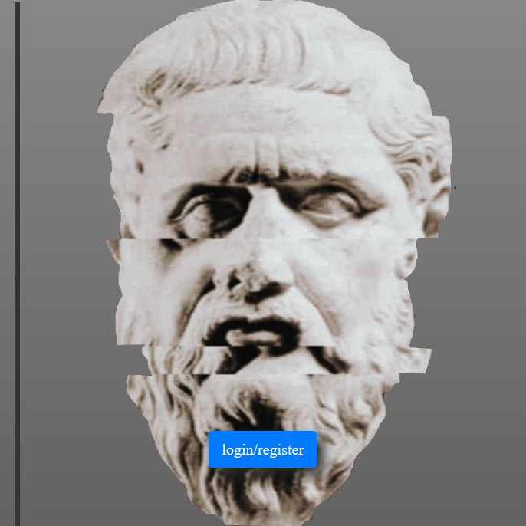

**https://aiasvm1.amcl.tuc.gr:8085/**



Username + Password

Authentication

ASK GORGIAS

Certified User



GORGIAS ANSWERS

PHP SERVICE RUNNING

# E) Manual

To use our tool, you firstly need to be connected to the ucy vpn.

Then you need to type on your URL bar on a browser

“ <http://cproject.in.cs.ucy.ac.cy/EPL434/Group1/source/application/php/index.php?> ”  
From here you will see our site:

From here we see a slider that turns from green to red Choosing which User preference you like.



Then you have the a few switches for what Environment/Sensory information you want active on the query:

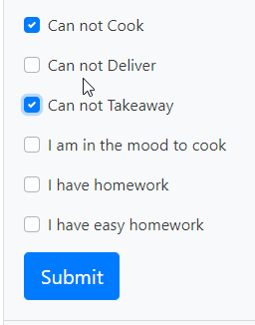  
  
Lastly, after you have selected which Environment/Sensory information you want active. Click submit and below you will get an response from Gorgias Cloud API with a result and an explanation.

