Applied GPU Programming, HW1
Assignment Group 40: Yuanyu Zhang, Hongen Wang, Xinyang Li
All runs used Google Colab with a Tesla T4 (compute capability 7.5).

Question 3

Question 3.1: Troubleshooting and 24-qubit run
No troubleshooting was needed. The build commands from the assignment worked as given with the compute capability set to 75, and the benchmark ran on the GPU backend.
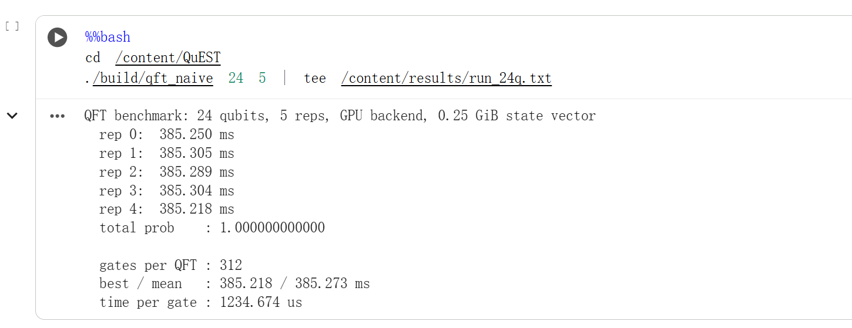
Figure 3.1: Output of the 24-qubit QFT benchmark.

Question 3.2: Memory at 28 qubits
Quantity | Value | How obtained
GPU memory (whole device) | 4203 MiB | nvidia-smi, memory.used, polled during the run
GPU memory (this process) | 4200 MiB | nvidia-smi, used_memory per process
Process resident memory | 179 MiB | /usr/bin/time -v and VmHWM in /proc/PID/status
System memory in use | 1308 MiB before, 1515 MiB peak | free -m

The run uses about 4.1 GiB of GPU memory. Almost all of it is the state vector, 2^28 amplitudes x 16 bytes = 4096 MiB. System memory use is small, about 180 MiB for the process.

Question 3.3: Top three kernels at 24 qubits
Profile: nsys profile --trace=cuda,osrt --stats=true -o qft_24q ./build/qft_naive 24 5.
Rank | Kernel | Total (ms) | Time (%) | Instances | Avg (ms)
1 | kernel_statevec_anyCtrlOneTargDiagMatr_sub<1> | 1874.1 | 80.8 | 1656 | 1.132
2 | kernel_statevec_anyCtrlOneTargDenseMatr_subA<0> | 332.7 | 14.3 | 144 | 2.311
3 | kernel_statevec_anyCtrlSwap_subA<0> | 96.4 | 4.2 | 72 | 1.338

The run has one warm-up and five timed QFTs, so each gate runs six times.

Question 3.4: Kernels and quantum gates
Kernel | Gate | Per QFT (24 qubits)
kernel_statevec_anyCtrlOneTargDiagMatr_sub | applyTwoQubitPhaseShift | 276
kernel_statevec_anyCtrlOneTargDenseMatr_subA | applyHadamard | 24
kernel_statevec_anyCtrlSwap_subA | applySwap | 12

The phase gate is applied as a one-control, one-target diagonal matrix, the Hadamard as a dense 2x2 matrix, and the swap through localiser_statevec_anyCtrlSwap. The kernels are in quest/src/gpu/gpu_kernels.cuh. Six runs times 276, 24 and 12 gives the instance counts in 3.3. The phase kernel dominates the total because it runs 276 times per QFT.

Question 3.5: CUDA API calls on the CPU thread
A single CPU thread launches the kernels with cudaLaunchKernel, once per gate (312 per QFT). All 312 launches finish within 7.6 ms. The GPU needs 385 ms, so the CPU then waits in cudaDeviceSynchronize, which syncQuESTEnv calls.

Question 3.6: 16 and 28 qubits
Qubits | QFT time, best / mean (ms) | Typical kernel (phase / Hadamard / swap)
16 | 1.732 / 1.800 | 9.4 us / 18.5 us / 5.4 us
24 | 384.96 / 385.00 | 1.13 ms / 2.31 ms / 1.18 ms
28 | 8187.2 / 8193.6 | 18.0 ms / 36.9 ms / 18.6 ms

Kernel time scales with the state vector from 24 to 28 qubits (16 times larger, 16 times slower). At 16 qubits the kernels last only microseconds, similar to the launch cost (about 5 us), and the GPU is idle for about 15 % of a QFT.
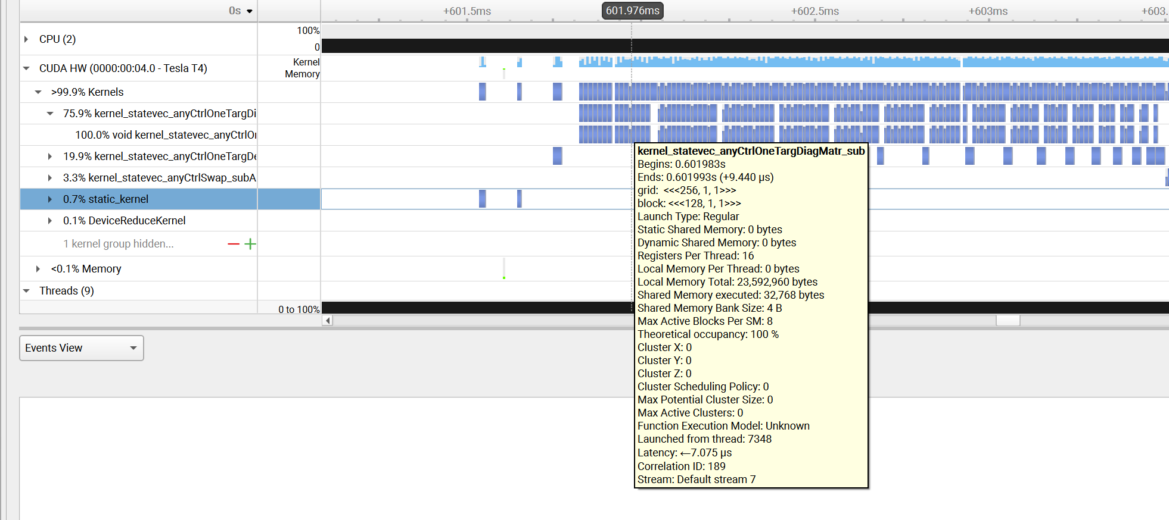
Figure 3.2: Nsight Systems timeline at 16 qubits. The tooltip shows one phase kernel (kernel_statevec_anyCtrlOneTargDiagMatr_sub) lasting 9.44 µs.
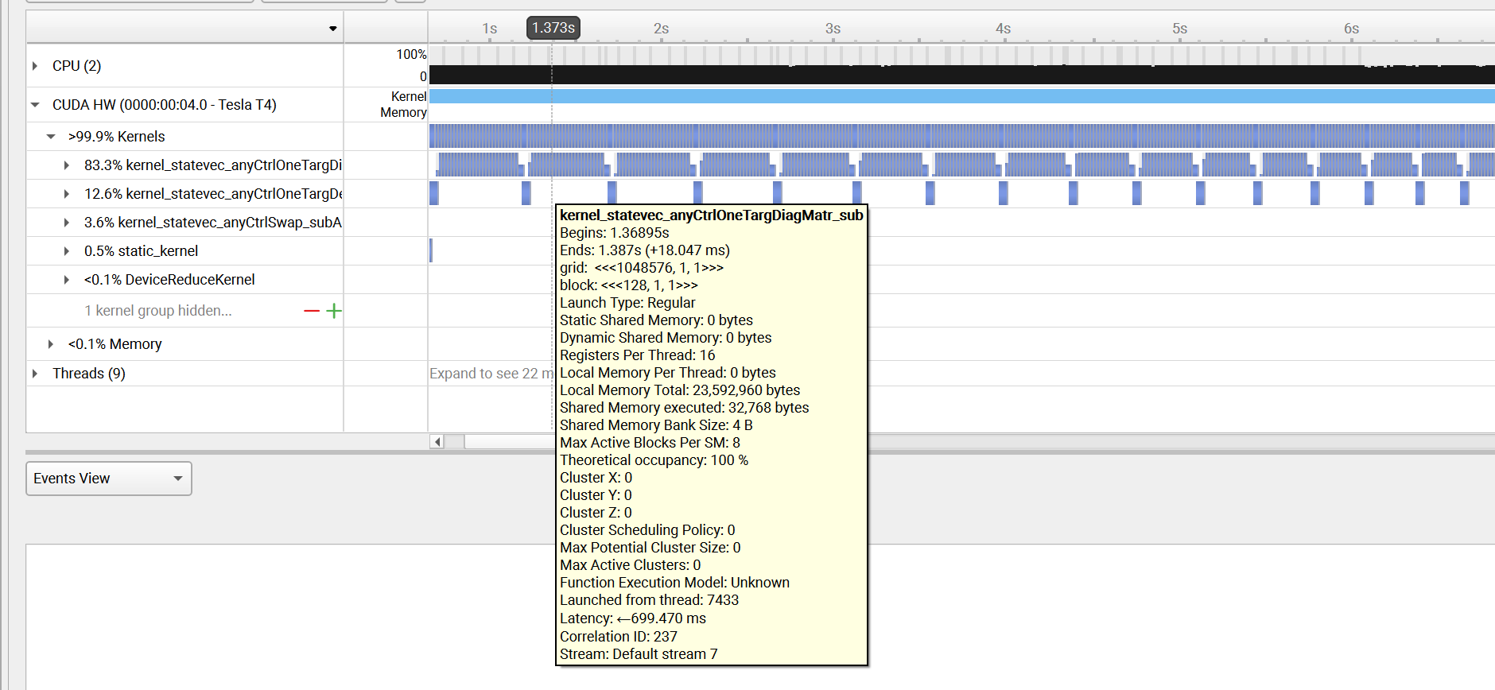
Figure 3.3: Nsight Systems timeline at 28 qubits. The tooltip shows the same phase kernel lasting 18.05 ms.

