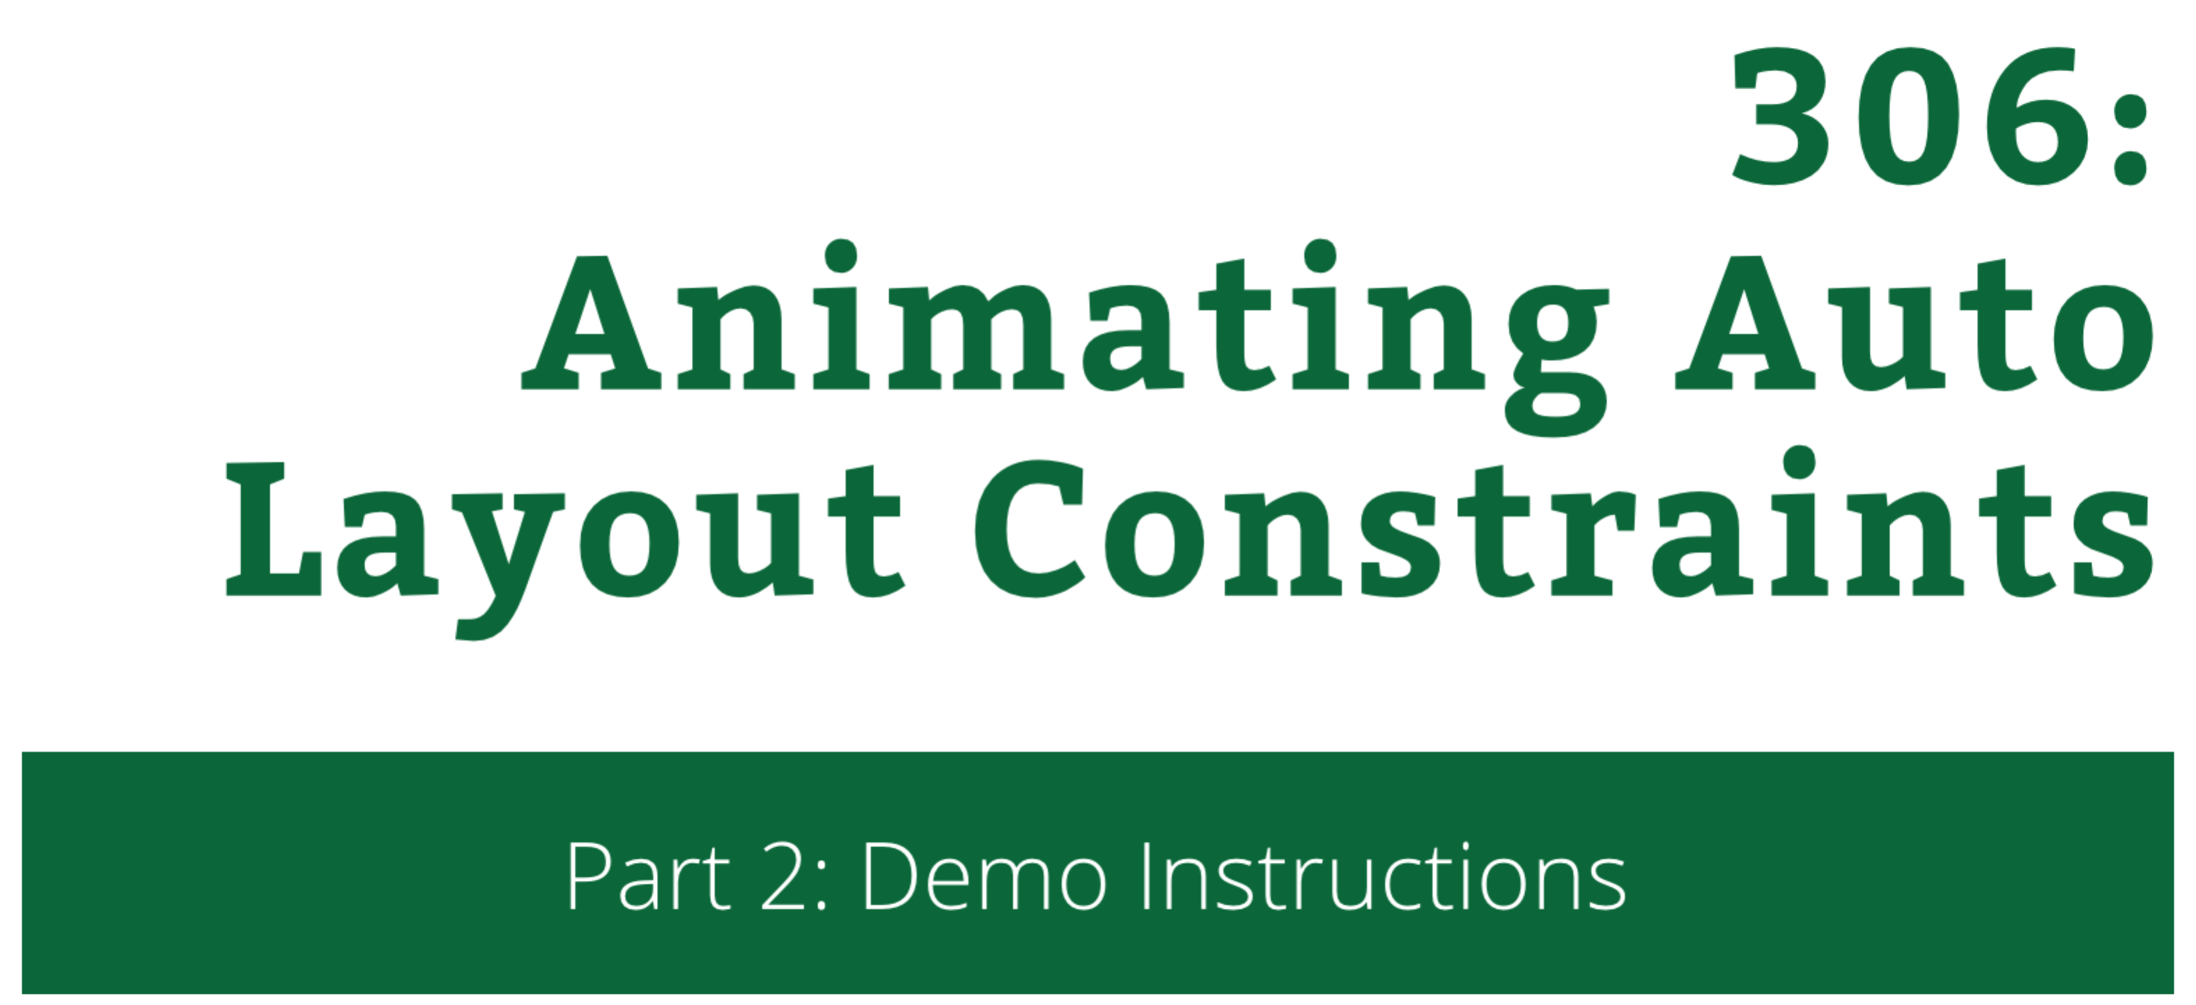

306: Animating Auto Layout Constraints

Part 2: Demo Instructions

Copyright © 2014 Razeware LLC.

All rights reserved. No part of this book or corresponding materials (such as text, images, or source code) may be reproduced or distributed by any means without prior written per- mission of the copyright owner.

This book and all corresponding materials (such as source code) are provided on an "as is" basis, without warranty of any kind, express or implied, including but not limited to the warranties of merchantability, fitness for a particular purpose, and noninfringement. In no event shall the authors or copyright holders be liable for any claim, damages or other liability, whether in action of contract, tort or otherwise, arising from, out of or in connec- tion with the software or the use or other dealings in the software.

All trademarks and registered trademarks appearing in this book are the property of their respective owners.

# Basic Animations

In this demo you will add some basic auto layout constraints animations to the starter project.

The steps here will be explained in the demo, but here are the raw steps in case you miss a step or get stuck.

## Step 1: Find & Replace Constraints

In **ViewController.swift**, add in adjustHeights(...):

for constraint in viewToSelect.superview!.constraints() as [NSLayoutConstraint] {

if contains(views, constraint.firstItem as UIView) &&

constraint.firstAttribute == .Height {

println("height constraint found")

}

}

Add after the println():

viewToSelect.superview!.removeConstraint(constraint)

Add the code to calculate the multiplier:

var multiplier: CGFloat = 0.34

if shouldSelect {

multiplier = (viewToSelect == constraint.firstItem as UIView) ? 0.55 : 0.23

}

Finally add the new constraint to replace the old one:

let newConstraint = NSLayoutConstraint(

item: constraint.firstItem,

attribute: .Height,

relatedBy: .Equal,

toItem: (constraint.firstItem as UIView).superview!,

attribute: .Height,

multiplier: multiplier,

constant: 0.0)

viewToSelect.superview!.addConstraint(newConstraint)

## Step 2: Add animations

At the bottom of toggleView(...) add:

UIView.animateWithDuration(1.0, delay: 0.00, usingSpringWithDamping: 0.4, initialSpringVelocity: 1.0, options: .CurveEaseIn | .AllowUserInteraction | .BeginFromCurrentState, animations: {

self.view.layoutIfNeeded()

}, completion: nil)

## Step 3: Reading Animations

In viewDidLoad() replace:

Selector("toggleView:")

with:

Selector("toggleSpeaking:")

Add the new tap handler:

func toggleSpeaking(tap: UITapGestureRecognizer) {

toggleView(tap)

let isSelected = (selectedView==tap.view!)

}

Append to the new method:

UIView.animateWithDuration(1.0, delay: 0.00, usingSpringWithDamping: 0.4, initialSpringVelocity: 10.0, options: .CurveEaseIn, animations: {

self.changeDetailsTo(isSelected ? kSelectedDetailsText : kDeselectedDetailsText)

self.view.layoutIfNeeded()

}, completion: nil)

This will spawn an error because changeDetailsTo(...) is still not implemented – add it to the class:

func changeDetailsTo(text: String) {

speakingDetails.text = text

}

Add inside the method the code to move the text out of the screen:

for constraint in speakingDetails.superview!.constraints() as [NSLayoutConstraint] {

if constraint.firstItem as UIView == speakingDetails &&   
 constraint.firstAttribute == .Leading {

constraint.constant = -view.frame.size.width/2

speakingView.layoutIfNeeded()

break

}

}

And insert the code to animate the text back to its original location just before break:

constraint.constant = 0.0

UIView.animateWithDuration(0.5, delay: 0.1, options: .CurveEaseOut, animations: {

self.speakingView.layoutIfNeeded()

}, completion: nil)

## Step 4: Deselect views

When you click not on the same view but on another – the old text stays in the Speaking strip. Append a “deselect” handler to the toggleSpeaking(...) method:

deselectCurrentView = {

self.changeDetailsTo(kDeselectedDetailsText)

}

Now call the “deselect” handler before you select any new views. In toggleView(...) insert the following code before assigning value to selectedView:

if !wasSelected {

UIView.animateWithDuration(1.0, delay: 0.00, usingSpringWithDamping: 0.4, initialSpringVelocity: 10.0, options: .CurveEaseIn | .AllowUserInteraction | .BeginFromCurrentState, animations: {

self.deselectCurrentView?()  
 self.deselectCurrentView = nil

self.view.layoutIfNeeded()

}, completion: nil)

}

## Conclusion

Congrats, at this time you should have the basic animations complete, and learned a lot about Auto Layout along the way! You are ready to move on to the lab.