**MONARCH ACADEMY CURRICULUM MAPPING PROJECT**

Front page: Monarch Butterfly on green screen; title “Monarch Academy” subtitle “Expeditions Curriculum Map”; extremely simple layout on right with link buttons for :

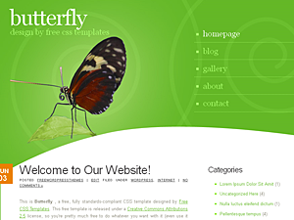

1. **MONARCH EL** (brief summary of EL & Monarch)

2. **PURPOSE** (Why is a curriculum map important to us: Purpose for curriculum mapping project: increase collaboration, close “holes” in instruction, tool for dynamic/working document to be changed over time, cohesion and “flow” between grade levels, systematic increases of complexity from grade to grade, even/thorough coverage of common core standards & big ideas over a student’s 9 years at Monarch, increased accountability for skills & standards, building meaningful connections across grade levels, communication among all stakeholders, pacing & planning, focused reflection, documentation of el process, locates gaps repetitions and areas of improvement, tool for teachers, etc.)

3. **HOW TO USE THE CURRICULUM MAP TOOL** Tutorial videos to teach teachers how to effectively use the tools including **inputting a lesson, inputting expedition overview info, easily adding common core standards, using the blooms taxonomy tool, etc.**

4. **CURRICULUM MAP** (when you click here, it should take you to a page where you can see a chart of all of the grades & their expedition titles for the year…when you click on an expedition title, it will link you to the expedition details page- example:)

|  |  |  |  |
| --- | --- | --- | --- |
| **Grade** | **Fall Expedition** | **Winter Interim** | **Spring expedition** |
| K | Expedition | Expedition | Expedition |
| 1 | Expedition | Expedition | Expedition |
| 2 | Expedition | Expedition | Expedition |
| 3 | Expedition | Expedition | Expedition |
| 4 | Expedition | Expedition | Expedition |
| 5 | Expedition | Expedition | Expedition |
| 6 | Expedition | Expedition | Expedition |
| 7 | Expedition | Expedition | Expedition |
| 8 | Expedition | Expedition | Expedition |

5. **TOOLBOX** including **planning calendar** (way to recreate the “post-it method” that second grade used to include all components of literacy, math, etc. so “real planning” could begin from the map), **blooms LT tool, descriptions of big ideas** (sci/soc), **easy access to common core** (maybe a way to easily add these to document?), **EL tools like the list of products ideas, Product backmapping tool** (like mind mapping?), **ideas menu** including 1. Activities (initiatves, warmups, energizers, dividers, etc.), 2. Greetings, 3. Debriefing, Links to resources? (elschools.org, etc.)

6. **REPORTS** : -searchable by grade level, subject/key word, big ideas, specific standard, -meta-analysis tools: example, A report showing the balance of ss/science big ideas across the 9 grade levels might show a chart with grade levels down the side and the big ideas across the top (the program should generate a one page chart showing a “check” in areas that are covered -ex. Grade 2, interdependence) This style, but with big ideas instead of subjects:

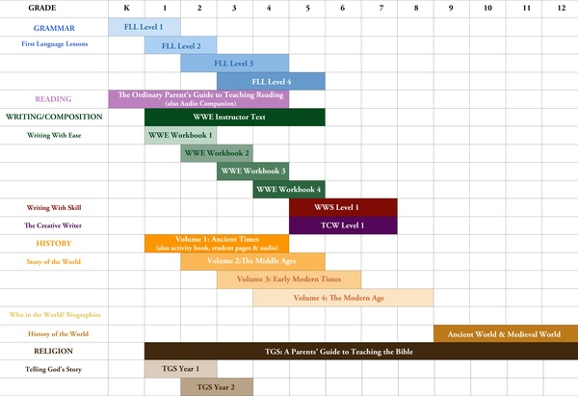

7. **ARCHIVE**

-ability to save maps yearly so we can change them each year but have an archive of those changes?

*When you click on each expedition (from chart under curriculum map link), you’d open the following Expedition overview:*

**Expedition Overview**

|  |  |  |
| --- | --- | --- |
| **Grade Level** | Kindergarten  *\*drop down menu*  First  Second  Third  Fourth  Fifth  Sixth  Seventh  Eighth | |
| **Expedition Title** | __________________________________________________ | |
| **Time Frame** | First Six Weeks  *\*drop down menu*  Fall Expedition  Winter Interim  Spring Expedition | |
| **Last Updated** | ___/___ /_____ | |
| **Expedition Summary** | __________________________________________________ | |
| **Essential/Guiding Questions** | __________________________________________________ | |
| **Science Enduring Understandings/ Big Ideas** | Systems  *\*drop down menu*  Structure & Function  Constancy & Change  Interdependence  Models  Scale | |
| **Social Studies Enduring Understandings/ Big Ideas** | Geographic Relationships *\*drop down menu*  Evolution of Governance  The Challenge of Progress  Universals of Culture  Sources of Conflict  Historical Inquiry | |
| **Kickoff/ Hook** | ______________________________ *capability to upload pics & video examples | |
| **Case Studies** | Case Study #1 | Title/Concept: ______________________________  Content: _____________________________________  Project(s): ___________________________________ *capability to upload pics & video examples |
| Case Study #2 | Title/Concept: ______________________________  Content: _____________________________________  Project(s): ___________________________________ *capability to upload pics & video examples |
| Case Study #3 | Title/Concept: ______________________________  Content: _____________________________________  Project(s): ___________________________________ *capability to upload pics & video examples |
| Case Study #4 | Title/Concept: ______________________________  Content: _____________________________________  Project(s): ___________________________________ *capability to upload pics & video examples |
| **Field Work** | _____________________________________ *capability to upload pics & video examples | |
| **Experts** | _____________________________________ *capability to upload pics & video examples | |
| **Service Learning** | _____________________________________ *capability to upload pics & video examples | |
| **Final Product** | Summary: _____________________________________ *capability to upload pics & video examples Authentic Audience: _____________________________________ | |
| **Culmination/ “Wingspan”** | _____________________________________ *capability to upload pics & video examples | |
| **Notes** | __________________________________ *capability to upload pics & video examples | |

**Specific Content & Skills being Assessed**

|  |  |  |  |  |  |  |
| --- | --- | --- | --- | --- | --- | --- |
| **Content Area** | ***Common Core Standards*** | ***Long Term Learning Targets*** | ***Supporting Learning Targets*** | ***Assessments***  ***O=of learning***  ***F=for learning*** | ***Resources, Materials, Activities*** | ***Modifications & Accommodations*** |
| **Language Arts** | ___________ *Is there an *easy way to grab common core standards so this could be as simple as a drop down menu?* | ___________  * *automatically bullets these with a bulls eye target*  *\*Is there a way to easily link the Blooms taxonomy tool to this section for higher caliber verb choice?* | ___________  * *automatically bullets these with a bulls eye target*  *\*Is there a way to easily link the Blooms taxonomy tool to this section for higher caliber verb choice?* | ___________  * *with feature to add rubrics*  *Maybe a feature to separate the “of” and “for” learning assessments visually (by color or a symbol, etc.) | ___________  *\* with feature to add student work samples, web links & actual master documents that teachers can store and come back to map to use*  *LINK TO “ADD LESSON PLAN” | ___________  *\*with capability to add work samples, links & masters* |
| **Mathematics** | ___________ | ___________ | ___________ | ___________ | ___________ | ___________ |
| **Science** | ___________ | ___________ | ___________ | ___________ | ___________ | ___________ |
| **Social Studies** | ___________ | ___________ | ___________ | ___________ | ___________ | ___________ |
| **Cultural Arts** | ___________ | ___________ | ___________ | ___________ | ___________ | ___________ |
| **Other** | ___________ | ___________ | ___________ | ___________ | ___________ | ___________ |

-Expedition Overviews should be formatted so that they are easily printable

-Is there a way to link specific instructional lesson plans that teachers create to the overview (maybe through the “resources, materials, activities” column of the specific content chart)? Or would it be clearer to keep lesson planning separate with the planning calendar tool?