Game plot
ONE NIGHTS AT COFFEES
Red Text -> excluded
1 nights->2endings(bad,good)
#Night1->Night2->Night3->Some scary strange shit->Ending
#3-4 customers every night
#News before start of the night(via newspaper for originality)->Radio/TV
Customers:
1)Lady with dog(just irritated, gonna shout in the end, smt lik
2) Office worker
3)Kid
5)Tired programmer lol(he can speak with 01010 code)
6)Final client?
(Depends on what did Meryem draw)
Antagonist:
#Monster? Maniac? Huge cup of coffee?
No separate antagonist
Synopsis:
Main character is a boy, student in his 20ish.
Introduction:
Mother left->MC should find a job
Frame1:letter
Frame2:Café space

Letter from mum:
“Hello sweetie!
Your mum is sooooo tired from her ordinary life. Whole my life was just work-home-work cycle, and I am sure you understand how hard that is So, I decided to try something new and find some happiness in my life. You remember Jack, right? We are going on a world trip together. I don’t think I’ll be coming back soon, so this flat is yours now! (don’t forget to pay rent).
Take care! I’ll send you a souvenir!
P.S. I left some money for you. Have fun;)
XOXO,
Mom”
MC: She left… And its only 50$
MC: I need to find a job

Coffee part:
1)Customer 1
NPC: One coffee! And I need it fast! Oh wait, who are you? I haven’t seen you here before. Whatever, just bring me my coffee, I am in a hurry. And don’t add anything which I can be allergic to!
MC: But how can I know/…
NPC: Fast! Didn’t you hear me? Don’t talk to me, just give me what I asked for!
MC*cooking*
MC: Here you go!
NPC:*sips*
NPC: WHAT DID YOU ADD HERE? I AM ALLERGIC TO CAFFEINEE!1
NPC: *dies*
MC: oh no.
MC: Did I just kill my first customer?
MC: What should I do? (light blinking? Can be added to scary moments)
Radio/TV: Hey you! Listen closely. You should do what I say if you wanna live.
Radio/TV: She was not a human being. And no one among your customers is gonna be a human.
Radio/TV: You must not show them that you know it or they are gonna kill you. You need to serve them as normal customers and pretend everything is fine. Finish the shift and do whatever they ask you. You can leave when you see first sunlight. Try to stay alive and don’t show your fear. Good luck! Next customer is here…

2)Customer 2
NPC: Good evening! Can I get a Cappuccino? Thank you!
MC: Yeah.., sure!
MC:”this client looks pretty normal. I guess it was just my hallucination”
NPC: Oh, and can you add some worms in it?
MC: What.. But we don’t have any.//
NPC: Over there! I see the jar.
MC:*cooking*
MC: Here you go.
NPC: Thank yo!
NPC: *eat the paper cup instantly*
NPC: *leaving*
MC: “It is just my nightmare. I am gonna act like nothing is happening”

3)Customer 3
NPC: Hi, human! I lost my mum. Can you help me to find her? She feels scent of blood. Can I order a blood, so she can find me?
NPC: Oh, right, it’s a coffee shop. Can you just add blood in my coffee? Add some of yours please!
MC: Yes, sure!
MC : *cooking* (I am thinking of making mc cut himself for this psrt and adding coffee in it)
MC: Here you go!
*mother is coming*, light blinking (she should look like a demon or something)
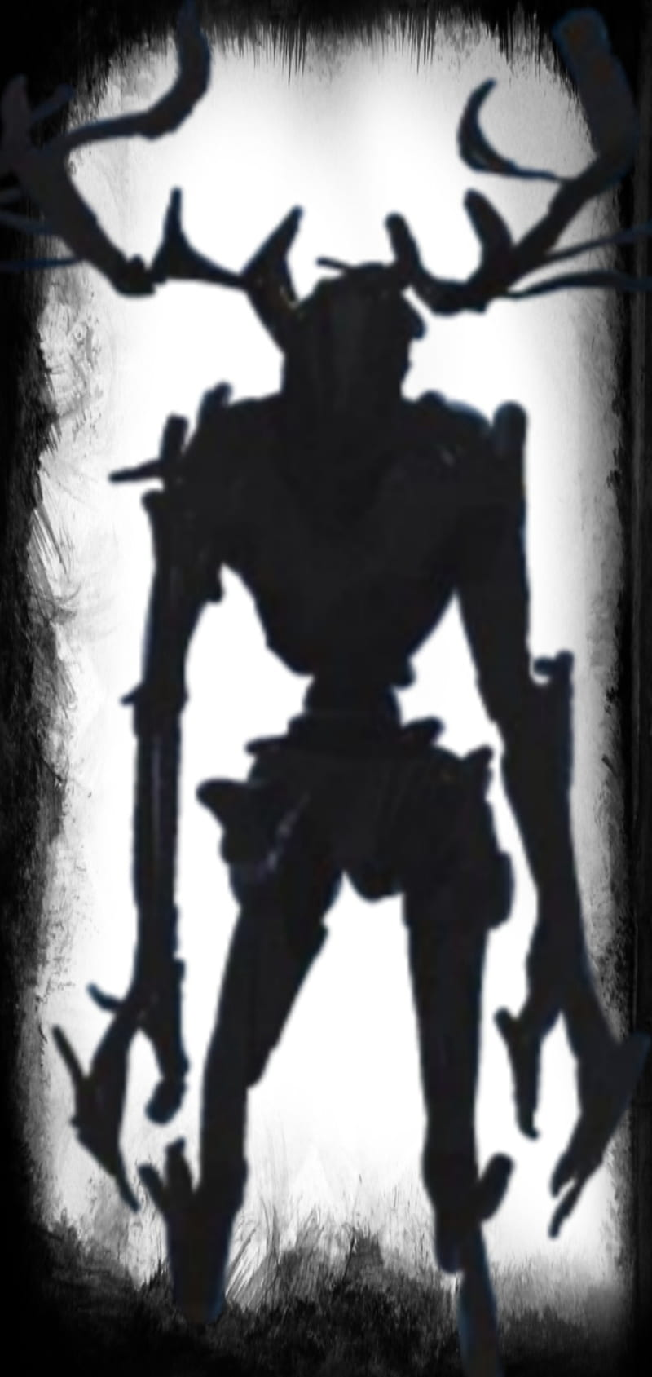
NPC: Oh, hi mum.
4)Customer 5
NPC: 010100101001010.
MC:?
NPC: Oh sorry. I haven’t slept in a week. Need to finish one project till tomorrow morning. I work so much, sometimes I think I am not a human anymore, I am just a 01010010101010.
NPC: Nevermind. Can I get 00110011 00100000 01100011 01101111 01100110 01100110 01100101 01100101(3 coffee) with 01101110 01101111 00100000 01110011 01110101 01100111 01100001 01110010 (no sugar). Fast please. -- ( words converted into binary code)—
MC: sure.
MC:*cooking*
MC: Here you go!
NPC: 01011001 01101111 01110101 00100000 01100001 01110010 01100101 00100000 01100111 01101111 01101110 01101110 01100001 00100000 01100100 01101001 01100101 00100000 01101001 01101110 00100000 01100001 01100111 01101111 01101110 01111001 00101110 00100000 01011001 01101111 01110101 01110010 00100000 01110011 01101111 01110101 01101100 00100000 01110111 01101001 01101100 01101100 00100000 01100111 01101111 00100000 01110100 01101111 00100000 01101000 01100101 01101100 01101100 00101110 00100000 01011001 01101111 01110101 00100000 01100001 01110010 01100101 00100000 01100100 01101111 01101111 01101101 01100101 01100100 00101110 00100000 01011001 01101111 01110101 00100000 01110111 01101001 01101100 01101100 00100000 01100100 01101001 01100101 00100000 01100010 01100101 01100110 01101111 01110010 01100101 00100000 01110011 01110101 01101110 00100000 01110010 01101001 01110011 01100101 01110011 00101110 (You are gonna die in agony. Your soul will go to hell. You are doomed. You will die before sun rises.)—
NPC: Thank you! Have a great night! :)
MC: “That was strange”
5)The last customer
NPC(Woman in a long dress with long messy hair; we can’t see her face but blood is leaking from her mouth(idk, maybe I should change this part)): Hi, sweetie~~ I am soooo thirsty, I could even drink someone’s blood right now. Can’t wait any longer~~ Bring me coffee with milk fast or I can’t guarantee your safety~~
*mc has 40s to do the final order*->If the time is up, we have a bad ending
SUNRISE->normal customer for the ending

Ending:
NPC: Good morning! Do you have coffee here?
MC: Actually, we don’t.
MC: And I don’t work here.
-~The End~-

