ICAT Web Service Tutorial

- Import the WSDL file to generate the client stubs.
  - Alpha release user location
    - https://volga.dl.ac.uk:8181/ICATService/ICAT?wsdl
  - This contains all the available methods in one WSDL file

- The import needs to be done with the wsimport utility
  - https://jax-ws.dev.java.net/jax-ws-ea3/docs/wsimport.html
  - Please use Netbeans 6.1, which does the importing for you.

- Download the keystore containing volga’s glassfish’s public key
  - The administrator responsible for the glassfish installation will be able to provide you with the public key.

- Set the java environment variables below for your java installation:
  - -Djavax.net.ssl.trustStore=location of downloaded keystore
  - -Djavax.net.ssl.trustStorePassword=changeit

- Log on to the system with your federal username and password with something like this: (They are encrypted)
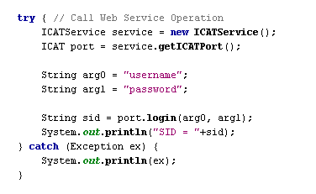
- All examples are located in examples.zip.

- Hints:

All searches and some of the get methods have overridden methods with InvestigationIncludes and DatasetIncludes as arguments. This is to allow the caller to define what they want to be returned in the results.

E.g. searchByKeywords(sid, keywords);

Will return all the investigations that the users can select but with no Investigators, Keywords, Datasets, Role, Publications or samples.

searchByKeywordsInclude(sid, keywords, InvestigationInclude.KEYWORDS_ONLY);

Will return all the investigations that the users can select together with a collection of keywords.

searchByKeywordsInclude(sid, keywords, InvestigationInclude.ALL);

Will return all the investigations that the users can select including all the Investigators, Keywords, Datasets, Role, Publications or samples

searchByKeywordsInclude(sid, keywords, InvestigationInclude. ALL_EXCEPT_DATASETS_DATAFILES_AND_ROLES);

Will return all the investigations that the users can select including all the investigation information except Datasets, Datafile and Role.

NB: The role is your role for the investigation, dataset or datafile.

You will want to limit the amount of data that is searched as the more information you ask to be sent back the slower the search will be.

ICAT Admin Web Service Tutorial

- Import the WSDL file to generate the client stubs.
  - Alpha release admin location
    - https://volga.dl.ac.uk:8181/ICATAdminService/ICATAdmin?wsdl
  - This contains a method loginAdmin(String username) in which you specify the user you wish to log in as into ICAT API

- This is protected using HTTP Basic Authentication so to make the Web Service call you need to provide it with a Username and Password.

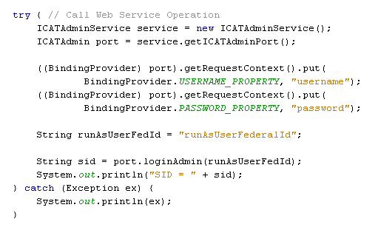
- The administrator responsible for the ICAT API authentication will provide you with the username and password when needed.

- Once you have the session id (sid), you can now use this to authenticate to the normal user web services and run the commands as the user you authenticated as.

