Data Portal and ICAT API Version 3.3 Design Document
Author(s): Glen Drinkwater and Richard Tyer
Company: Metataxa
Version: 1
Date: 14/08/2008

Aims & Objectives
Based on the requirements of the STFC facilities ISIS and DLS, Metataxa have created version 3.3 of the Data Portal and the companion ICAT API. In particular, version 3.3 addresses the following:
- ICAT API version 3.3 is the Grid aware software infrastructure that enables applications to exploit the capabilities of the ICAT system based on the requirements of the STFC facilities, with potential wider applicability to other research groups and institutions.
- Data Portal for version ICAT API 3.3 is the Grid aware software infrastructure that serves the Data Search and Retrieval (DSR) requirements of the STFC facilities, with wider potential applicability to other research groups and institutions. Internally it makes use of the ICAT API version 3.3.
The ICAT API provides a set of web services that the Data Portal uses internally to interact with the ICAT schema. In the primary Data Portal instance, the ICAT API web service capabilities are exposed to the user via a web portal where they can login using a STFC federal ID and password, search for data across facilities and retrieve the data.

Aims
The principle aims and objectives for Data Portal and ICAT API include to:
- Be developed in conjunction with the STFC facilities and their research groups so as to better serve their needs and user communities;
- Be installable by an e-Science system administrator;
- Use proven IT industry best practise, technologies and standards (e.g. EJB 3, JEE, Apache Ant, Subversion etc.);
- Have an architecture which is as simple as possible, subject to meeting all the functional and non-functional requirements;
- Be both robust and resilient;
- Allow simple yet rich programmatic access to the ICAT catalogue;
- Allow flexible search and retrieval of data.

Design

ICAT and Data Portal Architecture
The architecture of this system allows it to be very extensible and pluggable with custom interfaces and implementations. The Data Portal and ICAT API are hosted on a single application server, allowing both a web interface into the system, for search and retrieve of data, and programmatic access to the ICAT exposing a much richer set of functionality that other applications using the catalogue can be built upon.
The core of the system is the ICAT API. This web service interface layer offers a wide range of services to allow other applications to interact efficiently and securely with the ICAT. It provides around eighty methods to create, read, update and delete objects in the underlying schema. It also aims to insulate the applications from any changes to the underlying database system, database location and schema, subject to backwards compatible constraints. It is written using JAX-WS, which is Web Service Basic Profile compliant. The standards compliant nature of ICAT API offers potential interoperability with many other languages and hence provides the possibility of a multitude of other systems seamlessly integrating into the ICAT framework.
A UML deployment diagram showing the relevant system components for the Data Portal and ICAT API system and outlining how the different system components interact is shown in Figure 1.
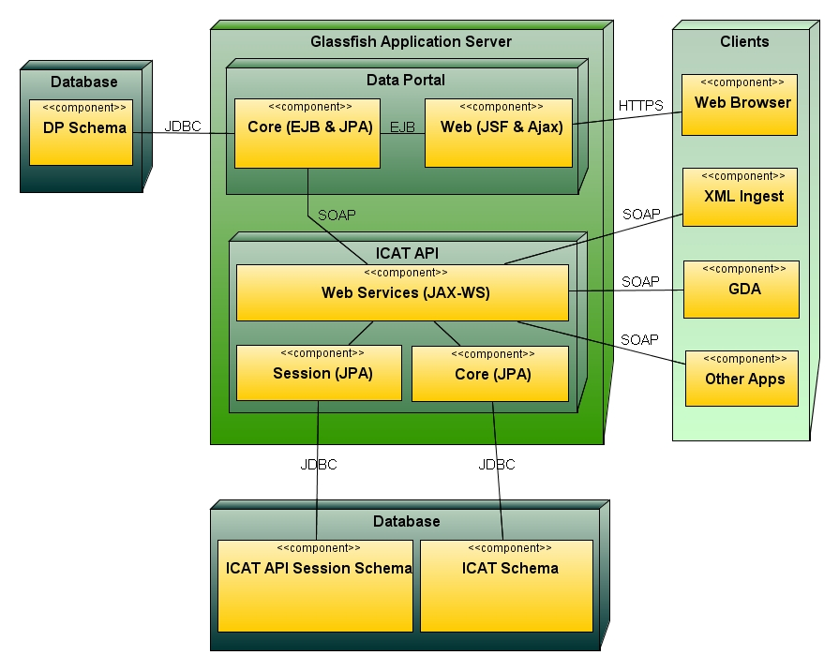
Figure 1: Data Portal and ICAT API UML deployment diagram
The Data Portal is a JSF web application that allows users to easily and securely search and retrieve data from anywhere with internet access. The Data Portal sits on top of the ICAT API and makes use of it to authenticate the user and find the data they are seeking within the ICAT through a variety of simple or advanced searches.
The actual downloading of the data is handled by a HTTP Interface that sits in front of a facility’s data archive and interacts with the ICAT API to authenticate the user and authorise their request for data. The ICAT API generates a URL that will be processed by the HTTP Interface and stream the data back to the application requesting the data.
The following sections provide more detailed information about the various system components.

ICAT API

Architecture
The ICAT API consists of three main modules:
- the Web Services module – this can be offered to any application wishing to interact with the ICAT. Figure 4 provides a complete list of the web service calls available through the ICAT API. Further details about these services and how to use them within other applications can be found in the ICAT Client Tutorial.
- the Core module – this handles all interaction with the ICAT schema itself.
- the Session module – this is responsible for the session management with the ICAT.
The ICAT API mostly uses JPA to interact with the underlying Oracle databases, although for performance reasons some SQL is also required. The core and session modules interact directly with the underlying databases and these two layers provide all interactions necessary to underpin the web services offered through the top layer interface of the ICAT API.
The ICAT 3.3 schema resides in an Oracle database and is accessed through the core module of the ICAT API. This core module abstracts all other components in the higher level application layers from changes in the underlying schema or database as long as the new schema is backwards compatible and until any additional features of the new ICAT version are required.
The session module provides the default implementation of the User interface found within the core module. Figure 2 shows the methods within the User interface that specifies the contract between the session management module and the core module. The implementation provided by the session module logs users on with their federal username and password, which is then used to authenticate with e-Science modified MyProxy server. Once the user is logged on, the web service module calls the getUserIdFromSessionId() method to look up the user’s federal id from the corresponding session id. This federal id is then used to authorise the user within the core module when it is interacting with the ICAT.
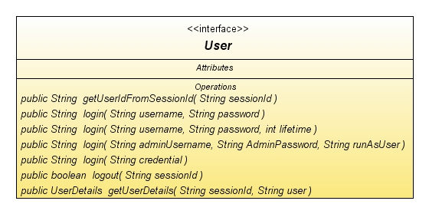
Figure 2: Core module’s User interface

The web service module is an example of the façade pattern that provides a simplified interface to both the session and core modules. Figure 3 shows an example of one of the advanced search web service methods. This method retrieves the user federal id from the session module and then executes a core module method and returns the results. The use of the façade pattern to abstract from the complexity of the session and core modules makes the web service module’s methods simple and also the module itself very extensible. New methods can readily be added to the module by either plugging additional modules or using their methods or by wiring together methods from the core module. In both cases, these should be combined with the getUserIdFromSessionId() method of the session module.

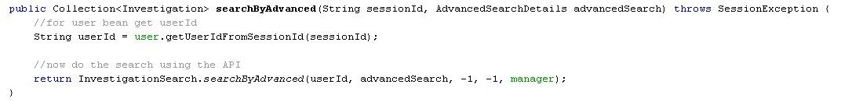
Figure 3: Web Service module’s search by advanced method

The ICAT API is the interface that all applications should use to interact with the core ICAT system. At present, it is used by a range of applications that includes ISIS XML ingest, the DLS Generic Data Acquisition System, the Facility’s HTTP Interfaces DDH and the Data Portal. The ICAT API offers a wide range of web services for easy interaction with the ICAT which are utilised by these applications.
Figure 4 shows a complete list of all the methods available via the ICAT web service module. There is a wide range of methods for searching, adding, removing and modifying investigations, datasets and datafiles as well as their child objects (publications, samples, investigators etc.). In addition, it includes methods for adding and removing authorisations, logging on and off the system and listing schema control data (i.e. dataset types, parameter types, etc.).

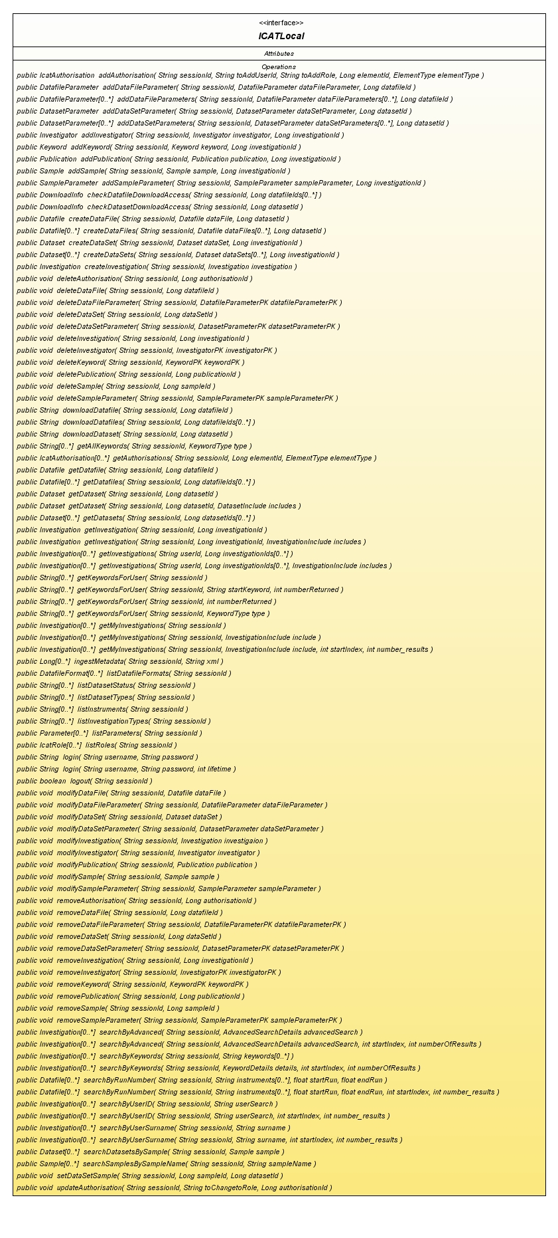
Figure 4: ICAT API Web Service interface

Data Portal

Architecture
The Data Portal was written using the new Java Enterprise Edition 5 technology stack. The Data Portal is a customisable web interface for secure data search and retrieval that consists of two main parts:
- the core module which provides all the requisite functionality and interacts with the ICAT API.
- a customisable Web Interface (WI) layer.
The Data Portal schema holds a range of information that is required for the management and administration of the Data Portal and its users. The Data Portal can be accessed by users via their web browser over a secure HTTPS connection.
The core module has been written using Enterprise JavaBean (EJB) 3 and is hosted using the open source Glassfish Application server. The WI communicates via the EJB's remote interfaces rather than use the local EJB's interfaces. This approach was taken in order to allow multiple front ends to be designed if ever the current JSF implementation were no longer sufficient (e.g. a JavaFX, Portlet or Struts 2 web or desktop application could be implemented to communicate to the core EJBs) and to allow rapid application development, since the core EJBs do not need to be reloaded every time a new WI is deployed. It should be noted that performance is not hindered by using the remote interfaces since all communication is performed inside the same JVM exploiting Glassfish’s feature of treating all collocated remote interfaces as if they were local interfaces.
The core EJBs could be exposed to other applications not wishing to communicate using EJBs via web services and JSR 181. It would be a simple task to expose the EJBs as web services and for other applications to interface to these. A prototype Data Portlet has been developed to demonstrate that exposing the Data Portal core EJBs as web services is achievable. This used the web services to deploy a portlet application that mimicked the functionality of the Data Portal.

Core Modules (EJB Session Beans)
The core modules are written as Stateless Session Beans (EJB 3). This means that after each invocation of a method, no state is kept by the bean, similar to web services. The advantage is gained by better performance and much simpler design and implementation of the core modules. This also creates a clean separation of client UI and business logic.
Figure 5 shows the main components within the core module, the session, query, lookup and the JMS messages and queues components.
The JMS Messages components do all the concurrent processing within the application. For logging onto and searching multiple facilities a JMS queue is used to process multiple requests and depending on the request it is severing caches the information in either the LogonCache or QueryCahe for retrieval later. Every thing from logging on, searching, downloading etc is logged by the core module. This is just a simple message that is sent to the EventQueue for processing asynchronously to be stored in the event table.
The Lookup component underpins all the other components allowing them to lookup information within the Data Portal schema (i.e. facility names, active facilities, facility WSDL locations etc). For example, the Query MDBs will receive a query to search ISIS, so it uses the lookup component to find the location of the ISIS ICAT API to send the query to.
The session component logs users on and off the Data Portal as well as setting and getting the users session and preference information. It uses the LogonCache to cache the information when a user would be logging onto more than one facility.
The query component facilitates all the queries, it receives and creates the query and sends them off to the query MDBs and then waits for the returned query to be put into the query cache.
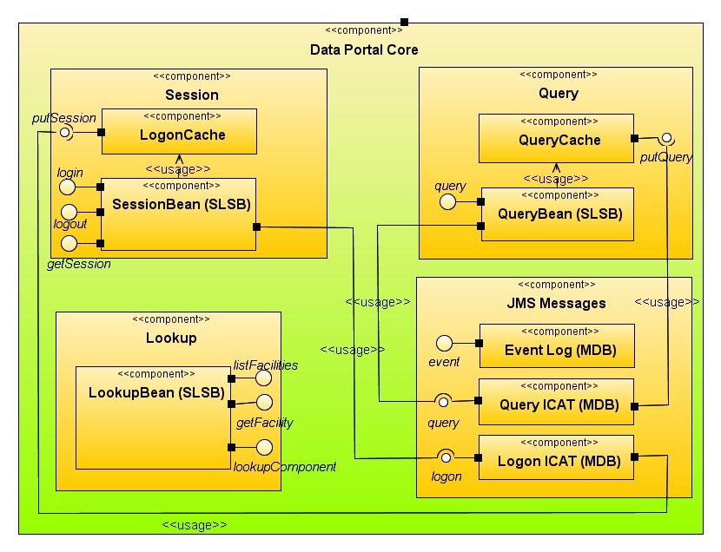
Figure 5: Data Portal UML component diagram

Entity Beans (Schema)
This is a schema design of the Data Portal core schema.
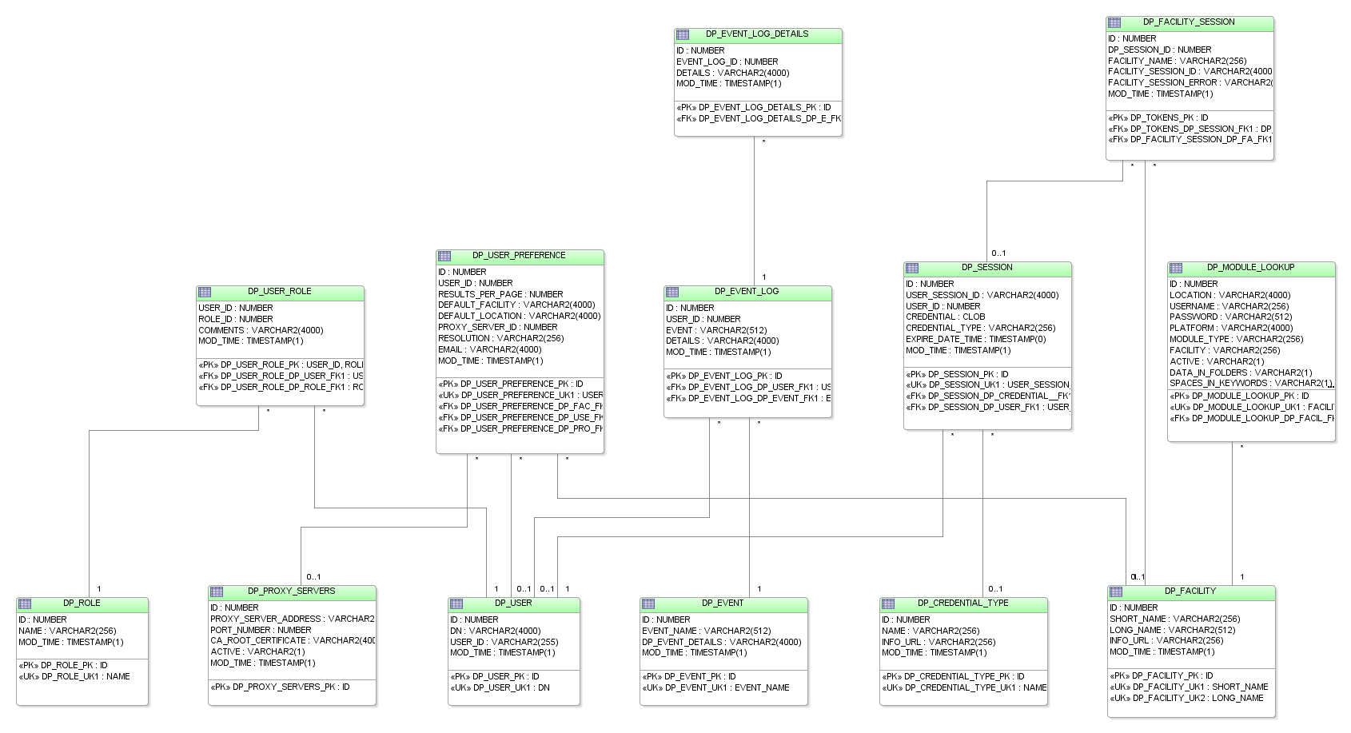
Figure 6: Data Portal Core schema

Figure 6 shows the Data Portal core schema. There are 3 parts to the schema:
- User and session information:
  - DP_USER_ROLE – Mapping table between DP_USER and DP_ROLE
  - DP_ROLE – Static lookup table with Data Portal roles
  - DP_USER – Users who have logged in
  - DP_SESSION – User’s sessions on Data Portal
  - DP_FACILITY_SESSION – For all of the ICAT API sessions associated with DP_SESSION
  - DP_USER_PREFERENCE – User’s preferences for Data Portal

- Event log information:

  - DP_EVENT – Static lookup table with all available event types
  - DP_EVENT_LOG – Log of event and some details
  - DP_EVENT_LOG_DETAILS – Many to 1 mapping for all details of the DP_EVENT_LOG

- Lookup information:

  - DP_MODULE_LOOKUP – Facility information including WSDL location
  - DP_FACILITY – Static lookup of all the facilities associated with Data Portal

There will be an Entity Bean for each table. For example, the Entity Bean corresponding to DP_SESSION is shown in Figure 7. This is a simple POJO that is turned into an Entity Bean by the container in EJB 3. Session Beans can then use this bean to search for data using the NamedQuery tag within the code. This query is specified using EJB QL, which is similar to SQL, but specified using classes rather than tables. Hence the examples shown in Figure 7 are simple queries that would return a List< Session> of all of the rows in this table matching various predicates.

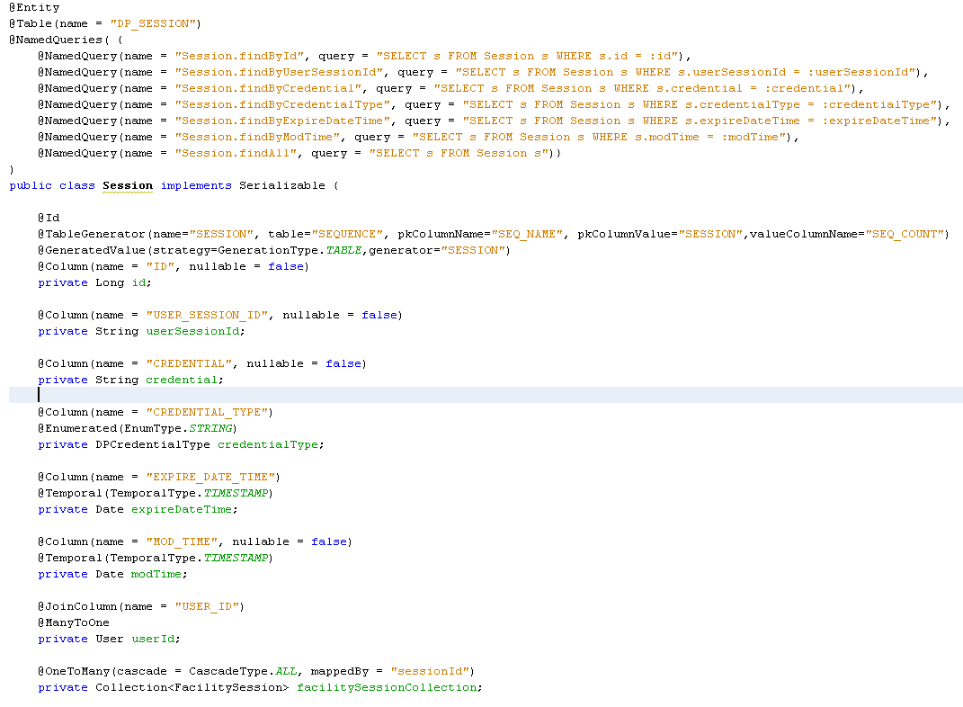
Figure 7: Data Portal Session Entity Bean

User Interface (Web Module)

Web Interface
The Web Interface was built using JSF 1.2 based in Glassfish. In addition, the added functionality of the Apache Tomahawk components is used for tables and trees, while Ajax4JSF is used to 'Ajaxify' JSF components that are not already Ajax enabled. The web interface is a thin layer built on top of the Data Portal core, which is in turn built on top of the ICAT API. This facilitates seamless integration with other commercial JSF component providers (e.g. RichFaces, ICEFaces, Woodstock etc.) or, as explained previously, would allow either a redesign or reimplementation of a web interface that would interact directly with the core EJBs.
The model that the Web Interface uses with JSF is for one backing bean per page. Each page actions and binding variables are present in the request scoped backing beans class. This allows new pages to be added simply. There are a few session scoped backing beans that the whole of the WI uses:
- Visit – This holds all the information regarding the users session (preferences, session id etc.);
- VisitData – This holds all of the user's search results so they can be accessed by each page;
- SessionHistory – This holds all the information about the previous search criteria.
Figure 8 is a screenshot from the Data Portal showing the Data page, which is where the user can view an investigation’s datasets and the dataset’s datafiles. In Figure 8, the user is viewing the datafiles belonging to the dataset ‘Default’.

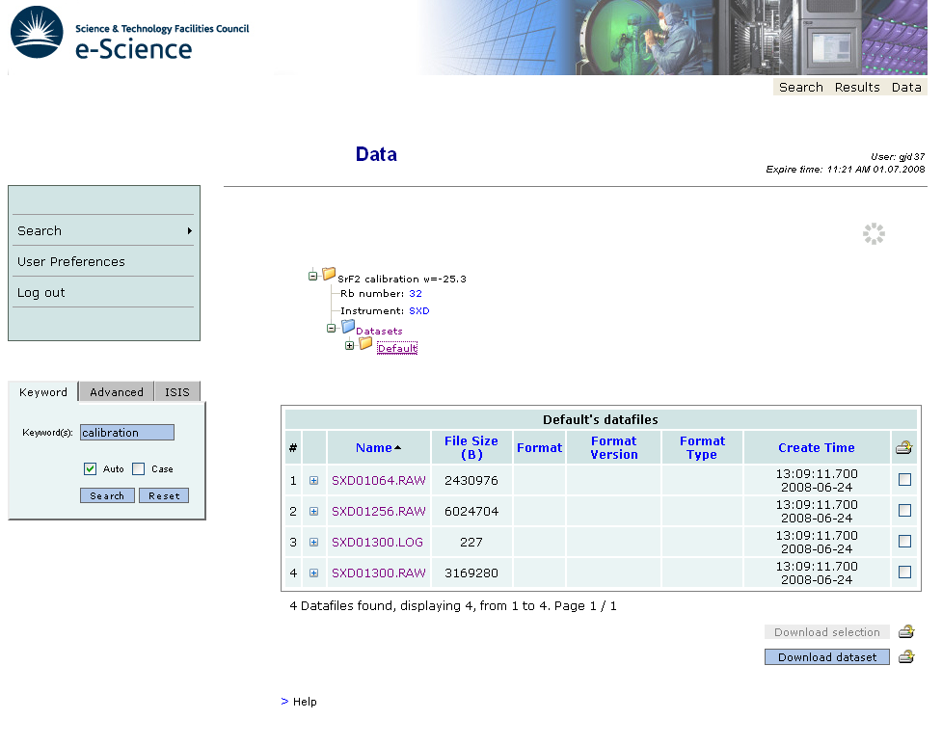
Figure 8: Data Portal Screen shot

User Interface Pages
The WI has the following views:
- Login
- Keyword Search
- Advanced Search
- Facility Search
- Results
  - Investigations
  - Datasets and Datafiles
- Preferences

When a user logs in, they are taken to the 'My Data Search' page by default, which lists all the investigations that they are an investigator of. This default location can be changed in the preferences page. A list of all of the functions and corresponding resulting pages are show in Table 1.

Function | JSF function (F) or link (L) | Display page | Comments
Login | F | Keyword search | User logins in and goes to keyword search page by default. Depending on configuration that could go to Advanced, MyData (Investigations) or Facility Search pages
Logout | F | Login | From all pages except login
Do Keyword Search | F | Investigations
Do Advanced Search | F | Investigations
Do Facility Search | F | Investigations
Do Run Number Search | F | Datasets and Datafiles | ISIS Search page only
Do Navigation Keyword Search | F | Investigations | Searches keyword from the navigation bar from all pages
Do Navigation Advanced Search | F | Investigations | Searches advanced from the navigation bar from all pages
Do Navigation Facility Search | F | Investigations | Searches facility from the navigation bar from all pages
Do Navigation Run Number Search | F | Datasets and Datafiles | ISIS Search page only
Do MyData Search | F | Investigations | Gets all users own investigations. From all pages except login
View Data | F | Datasets and Datafiles
DownloadDatafile(s) | F | Datasets and Datafiles
DownloadDataset | F | Datasets and Datafiles
View Prefs | L | Preferences
Update Prefs | F | Preferences
Goto Advanced Search | L | Advanced Search | From all pages except login
Goto Facility Search | L | Facility Search | From all pages except login
Goto Keyword Search | L | Keyword Search | From all pages except login
Goto Results | L | Investigations | Goes to last search results
Goto Data | L | Datasets and Datafiles | Goes to last data results
Table 1: Data Portal functions and what pages they result in

Workflow

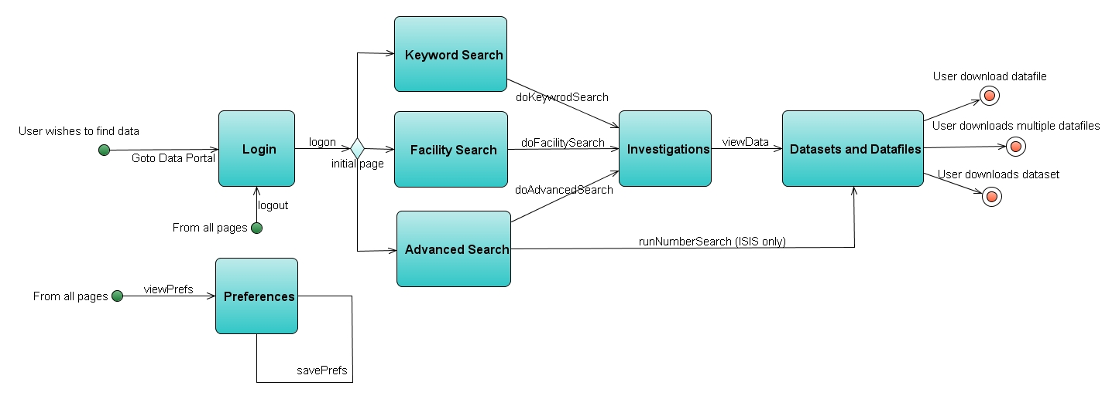
Figure 9: Basic Data Portal UML work flow

Figure 9 shows the basic workflow within the Data Portal. The basic workflow of the system is that the user logs in and is authenticated to the ICAT API and Data Portal. The user would then search for data through one of the available searches, which would present a list of returned investigations that matches their search criteria and that the user has access to view. The user would then drill down into an investigation and look at the datasets and datafiles of an investigation. At this point the user can choose to download the individual files or the whole dataset.
Every page, except the Login page, is accessible from all other page, using the navigation and tabs. These represent links and are not function calls.
A JSF link would be a static action link and a JSF function would be a dynamic action link. For example, link to view the Preferences would be:
<h:commandButton value=”View Preterences” action=”viewPreferences” />
but a dynamic action link to add bookmarks would be:
<h:commandButton value=”Add Preference” action=”#{prefsBean.addPref}” />
where prefsBean would be an instance of a backing bean and addPref would be a method call to dynamically call the prefsBean bean to add the data. If the data was added without an exception being thrown, then the JSF action result would be ‘viewPreferences’, i.e. the same as the static link.

Error Handling
In the event of an error, an error page within the WI should be displayed with a message that an error has occurred and that the user should try again. At no point should the user see any HTTP error code pages. This behaviour can be configured within the deployment descriptor file. Invalid URLs also should be handled similarly with the user being offered the choice to go to either the login or the previous page as appropriate.

Screens

Login
Screen name | Login
Purpose | Authenticates the user to the system,
URL | /index.jsp
Data Displayed | None
Session state | No
Effect on refresh | None
Effect on back | None

Keyword Search
Screen name | Keyword search
Purpose | Gives user input for keyword search
URL | /protected/basic_search.jsp
Data Displayed | None
Session state | Yes
Effect on refresh | None, screen showed again
Effect on back | None, back to last screen

Advanced Search
Screen name | Advanced Search
Purpose | Gives user input for advanced search etc
URL | /protected/advanced_search.jsp
Data Displayed | None
Session state | Yes
Effect on refresh | None, screen showed again
Effect on back | None, goes back to last screen

Facility Search
Screen name | Facility Search (Diamond or ISIS)
Purpose | Gives user input for isis or dls search etc
URL | /protected/isis_search.jsp, /protected/dls_search.jsp
Data Displayed | None
Session state | Yes
Effect on refresh | None, screen showed again
Effect on back | None, goes back to last screen

Investigations
Screen name | Investigations
Purpose | Shows all the investigation results in a table
URL | /protected/investigations.jsp
Data Displayed | Collection of Investigations
Session state | Yes
Effect on refresh | None, screen showed again
Effect on back | None, goes back to last screen

Datasets and Datafiles
Screen name | Datasets and Datafiles
Purpose | Shows all the datasets and datafiles in a table
URL | /protected/datasets.jsp
Data Displayed | Collection of datasets and datafiles
Session state | Yes
Effect on refresh | None, screen showed again
Effect on back | None, goes back to last screen

Preferences
Screen name | Preferences
Purpose | Shows all user preferences
URL | /protected/preferences.jsp
Data Displayed | Users preferences
Session state | Yes
Effect on refresh | None, screen showed again
Effect on back | None, goes back to last screen

Internationalization and Locale
Internationalisation can be readily implemented when using JSF. Currently only the locale 'EN' is supported.

Security
The application uses filters to ensure that the user is logged in and that their role is allowed to view the requested pages and directories. JSF PhaseEvents could also be used to check roles and logged in status.

Authorisation and Authentication
The Data Portal passes the username and password sent by the user to each of the active ICAT API instances. The ICAT API then uses these to retrieve a proxy from the MyProxy Server, which logs the user onto the ICAT API and sends the Data Portal the ICAT API’s user’s session id. This then authenticates the user when they are searching the ICAT. If a user logs on successfully to at least one ICAT API instance then they are logged onto the Data Portal.

Data Download
Data is accessible via the ICAT API using a HTTP interface to the facility’s data archives. ISIS and Diamond both have a HTTP server installed in front of Diamond’s SRB and ISIS’s DFS systems respectively. These both take requests in the form of a HTTP GET request for datafiles or datasets. The HTTP interface then checks with the ICAT API that the user is logged on and has access to download the files before zipping up the relevant files and streaming the zip file back to the user. The advantage of this approach is that the user/application is shielded from the complexities of the underlying data archive system and only has to use the URLs provided by the ICAT API to download the data. This can then be used programmatically or through a browser to download and stream the data back to the user/application.
Figure 10 shows the flow of information between Data Portal, ICAT API and the HTTP Interface. This scenario can be enacted by any application wishing to use the ICAT API to retrieve data. The ICAT API will return a URL when the download method is called for a particular datafile or dataset. This URL can be accessed by any HTTP aware tool or API in order to have the actual data streamed from the HTTP Interface.
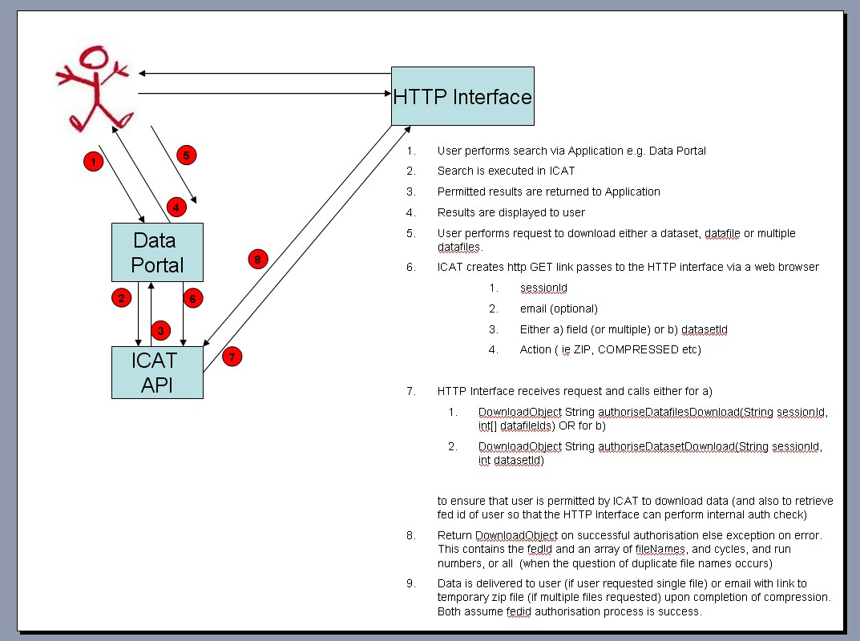
Figure 10: Basic Data Portal and ICAT interaction when downloading data

Future development

Data Portal edit functionality
The Data Portal core and WI needs to be updated to allow editing of the ICAT. The ICAT API currently allows add, modify and remove operations, but the corresponding functionality is not present within the Data Portal. The business rules defining the term editing will be different for each facility. For example, DLS might only want an investigator to be able to add and remove users or to be able to view and download data in their experiment, whilst ISIS might want to be able to modify names and add and upload files to data sets. The uploading of files to the Data Portal provides an additional problem in that the HTTP Interfaces would need to be modified or another means provided to transfer the data from a user's desktop to the facilities’ data archive.

ICAT API
Unlike the Data Portal, the ICAT API currently does not log event information. This would be a massive enhancement, as the ICAT API would be able to log the event information without incurring any performance hit in the same manner as the Data Portal. The logging could then form part of the ICAT schema so that the facility has a complete audit trail as to when information in the ICAT was updated, deleted etc. and by whom, in addition to having a complete record of all searches and downloads.
There are currently some issues with the performance of the XML Ingest tool, as the system does not queue the requests. This could be changed to allow the requests to be queued using MDBs and then executed when the load becomes lower and the ICAT API and database have time to fulfil the request. XML ingestion can be very intensive, hence too many concurrent requests to ingest investigations would cause a bottleneck within the database and ICAT API. A queue would manage this situation by simply queuing these requests, instead of trying to ingest them all the same time as currently happens.

Transition from ant to maven 2
Multi modular projects are difficult to manage within Netbeans within a collaborative environment since the project references to each other are absolute and not relative and therefore it is not a simple as it should be to check it out from subversion and compile. Maven 2 solves this problem and gives advantages regarding project site generation and reports on the quality of the code and unit tests. Metataxa has demonstrated that the two build systems can live side by side with the developer choosing the build system of choice whilst keeping the same project directory structure as currently used within Netbeans. Maven 2 is supported by Netbeans and Eclipse the code can be easily checkout from subversion and used by both IDEs.
For example reports can be generated for:
- JDepend – analyses relationships between classes and packages
- Unit test – generates reports for test converge
- PMD – potential bugs, unused or suboptimal code, over complicated expressions and duplicate code
- Findbugs – static code analysis of the java bytecode
- Checkstyle – enforces coding standard and best practises
- Java Docs – enforces javadocs conventions

ICAT Rich Client Applications
A prototype developed by Metataxa has successfully shown that it is possible to create a very rich application experience for searching and editing information by using the NetBeans Platform in conjunction with the ICAT API. This GUI was built on top of the NetBeans platform and resulted in a very professional 'look and feel' with all of the default tool/behaviour support expected for a GUI. In addition, it can be delivered via Java Web Start (i.e. from web pages) to the client. Compared to web applications, development time for GUI applications is much shorter, so additional features can be readily added. The performance of a GUI is also very good and the features supported within the demonstrator ‘proof of concept’ GUI are in some ways superior to those of the Data Portal (e.g. full display of all data is possible). The development with the NetBeans Platform also allows fully modular, concurrent development of features, displays and general work bug fixes, which can be difficult with web applications. The NetBeans platform would also allow additional service support to be hooked into the GUI though the DataPortal GUI, i.e. visualisation and analysis workflow could be integrated into the GUI.

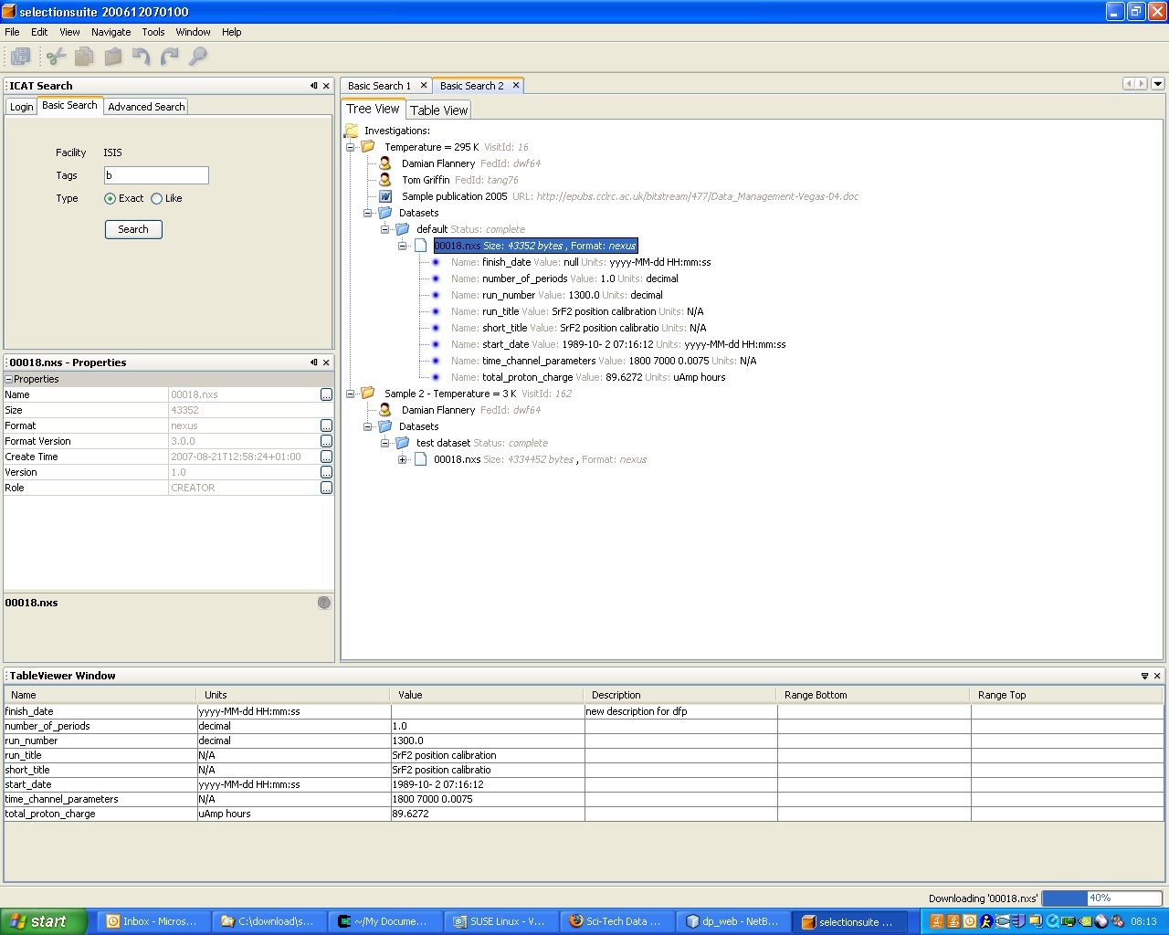
Figure 11: ICAT Netbeans Platform demo GUI
Figure 11 shows an example of a search that returns two investigations. A datafile within the 'default' dataset has been highlighted and its parameters can be seen within the table at the bottom of the window, as well as within the tree hierarchy of the datafile itself. The complete set of metadata associated with the datafile can be viewed in the properties box in the middle panel on the left of the GUI, which could easily be extended to provide editing functionality by updating the ICAT when the user changes the values. Both the properties and parameter tables are automatically updated when a user selects a different datafile or onto a dataset in the search results.

Hardware and Software
The current version 3.3 of ICAT API and Data Portal have been deployed on a Sun Application Server 9.1 (GlassFish v2) using a clustered Oracle 10G database as the persistence framework.

IDE
All modules and components of Data Portal and ICAT API were written using NetBeans 6.1. The NetBeans platform uses Apache Ant internally as the build system, so it is possible for the applications to be developed, compiled and deployed independently of the NetBeans platform.

Software Stack
Data Portal and ICAT API have leveraged heavily of a range of technologies, which include:
- Java Enterprise Edition 5 – EJB 3, JSF, JSP, JMS etc
- Java Standard Edition 6
- JAX-WS – Web Services
- JAXB2 – Java to/from XML for the Web Services.
- Java Cog Kit – Interaction with Grid and MyProxy
- MyFaces / Tomahawk – WI JSF components
- Ajax4jsf – JSF Ajax integration

